

**Semester Guidance**

**Name –** Pankaj Kumar

**Section –** KO138

**Roll Number –** 24

**Registration Number –** 11910254

**Course Name –** Product Development and Testing

**Teacher Name –** Sayantan Bhattacharya

**CA-3**

|  |  |  |
| --- | --- | --- |
| **S. No** | **Subject** | **Page No** |
| **1.)** | Introduction | 2 |
| **2.)** | Product Architecture | 2 |
| **3.)** | Prototyping | 3 |
| **4.)** | Literature Review | 3 |
| **5.)** | Working Model | 4 |
| **6.)** | Conclusion | 5 |
| **9.)** | References | 7 |

**Introduction**

Making an iOS app with the engineering curriculum for Computer Science and Engineering Hons, which includes each semester's syllabus, personal help, instructor guidance, etc., is the goal of this project. This app contains all of the things that are required. A user can excess all notes from any semester with only one click. able to view the app and guidance for placement preparation, as well as what is crucial this semester. It's necessary for you to install app. Without an internet connection, apps cannot operate. You may access all topic curriculums for each semester as well as instructor and personal guidance through these apps. The apps also provide placement-related information that will help you identify what is crucial for each semester. In addition, users have the option to modify the app to suit their needs. The user may additionally submit their personal experiences with the topic. The app also contains all the LPU faculty details like teacher ID, cabin number, mail ID, etc. In placement services, students can find all the free and paid study material sources. On-campus and off-campus companies list students with a single click.

**Product Architecture**

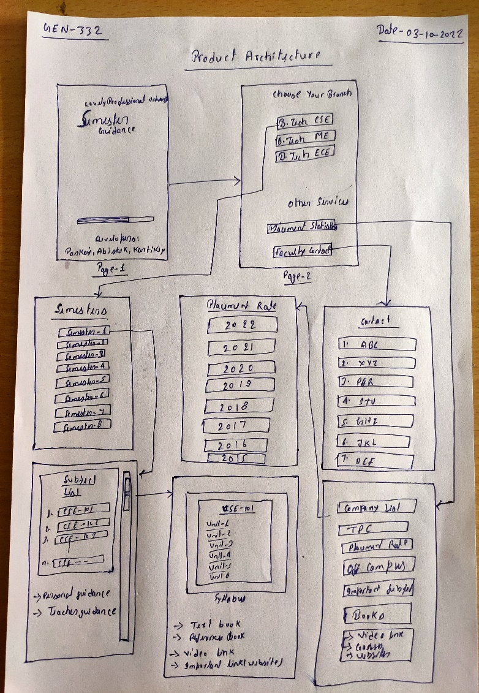

**Prototyping**

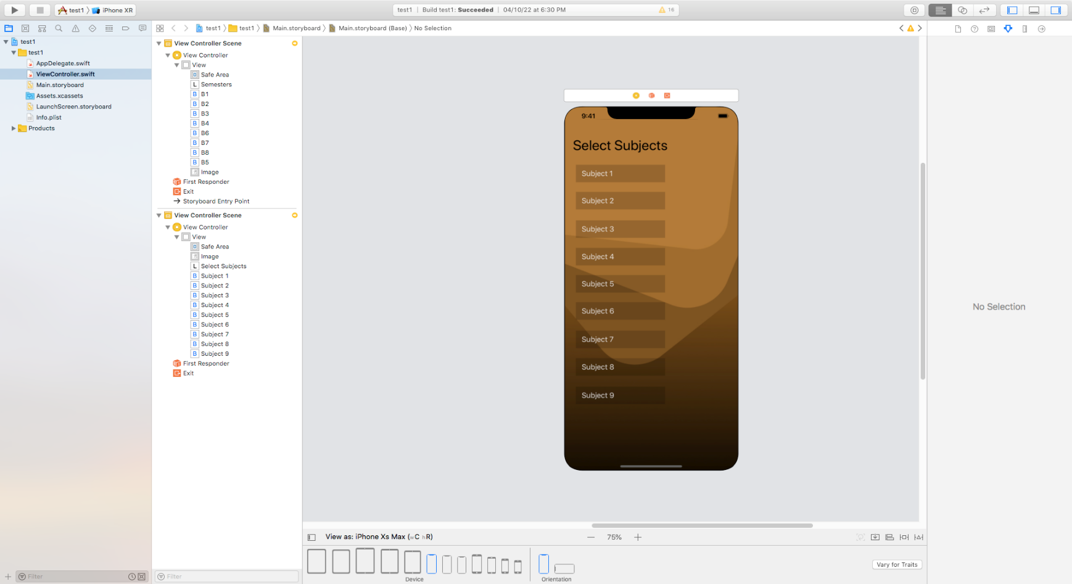

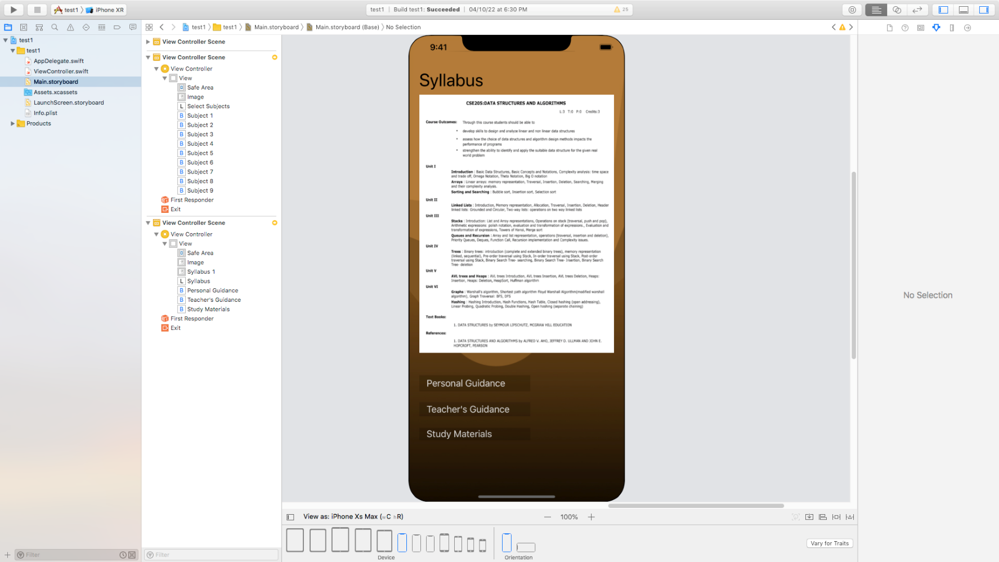

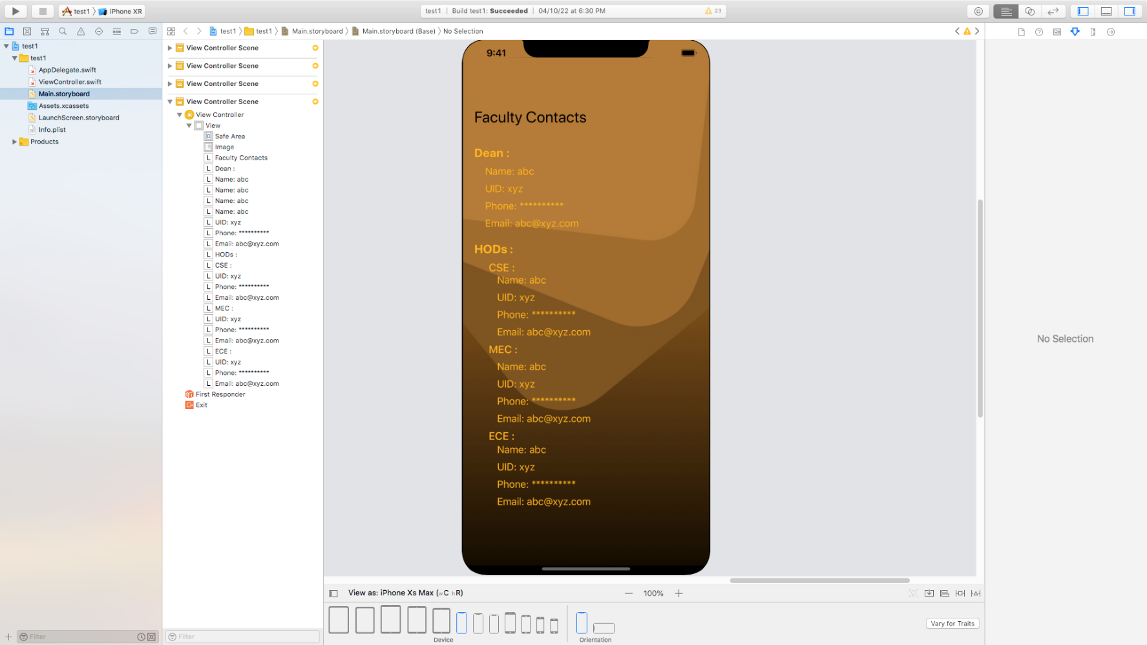

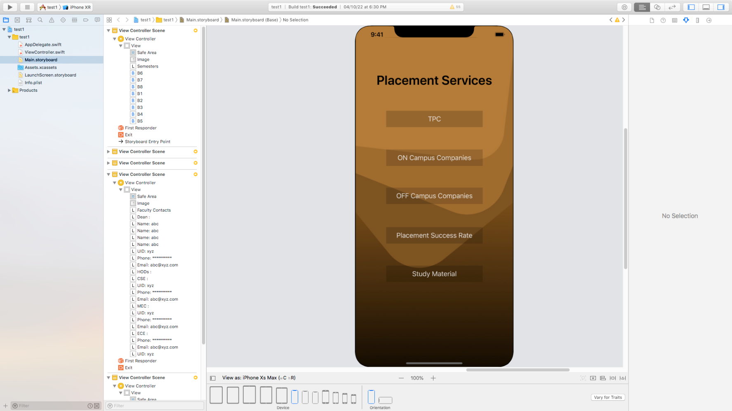

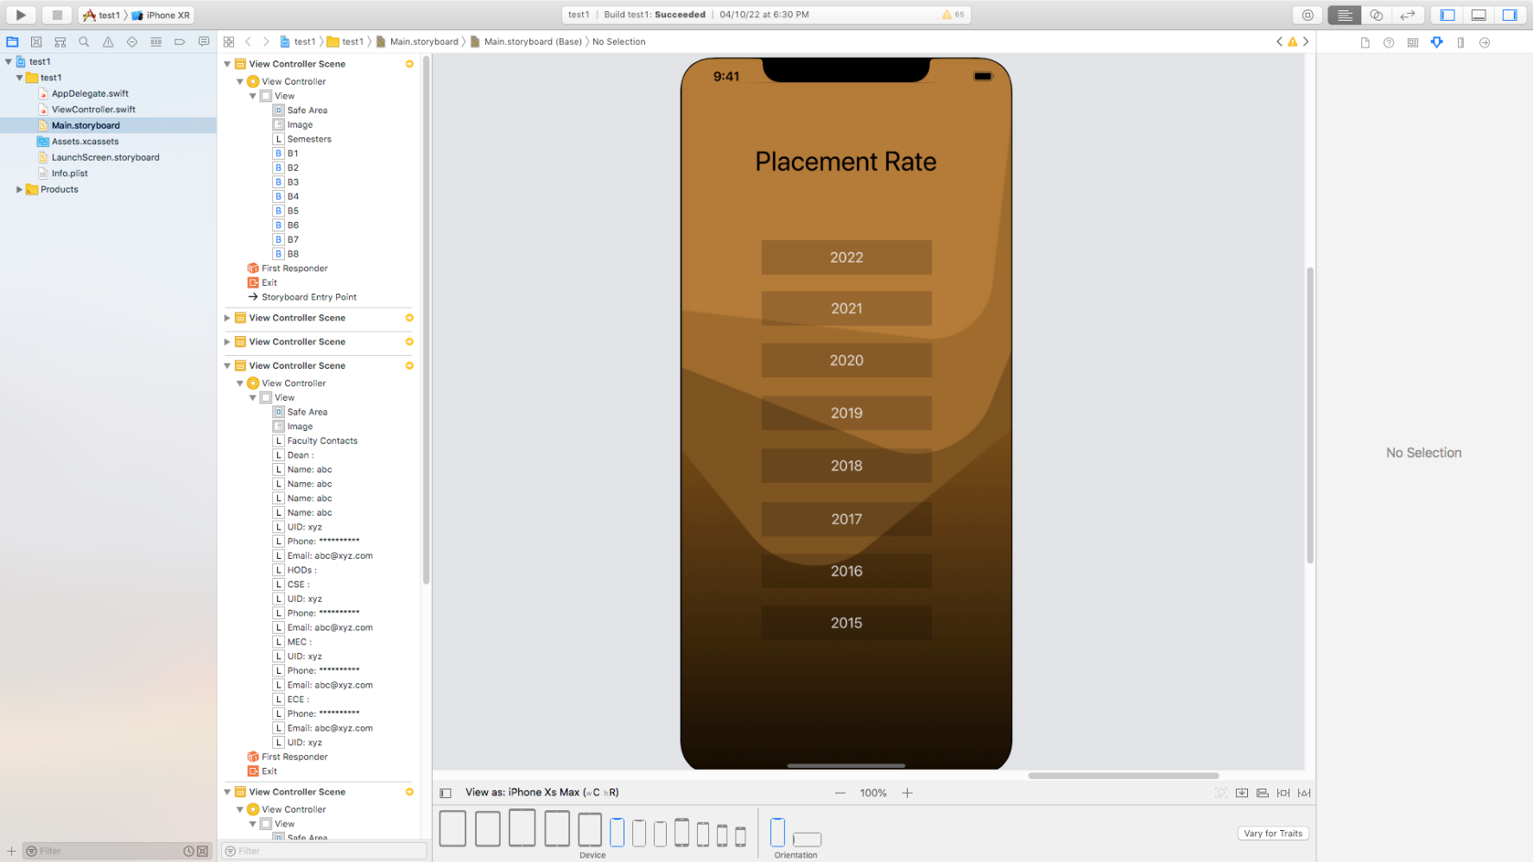

**Literature Review**

**Paper - 1**

Author Name- Reetu Malhotra **a**, Deepak Kumar **b\***, D.P Gupta **c**

Introductions- The availability of an online campus information system enables the students to get a better layout of education planning. It helps the university regarding well managed and strategic information management. In this paper, we describe and contextualize the model for an online campus information system for undergraduate students as well as university faculty. Information gathered employing structured interviews from a recognized University. The collected data enables us to prepare an android application for the campus information system, aims to help students as well as faculty in the best possible way.

**Paper - 2**

Author Name- Md Rakib Uddin**a**, Khandaker Takdir Ahmed **b**, Md Repon Hossen **c**

Introductions- The Android University Management System is an android app which is useful for students as well as the university faculty member and other academic staff. A paper-based system all the works are done manually. Paper based work is so time consuming. The main objective behind the use of University Management System is easy supervision of the Institute. Through our application students can search their results using Android mobile. All information is stored in the university server. The faculty member is authorized to log into University Management System database backend through administrator user id and password and update the student result. In this application, students have no administrative user id or password and no scope to update their results. The student can only search their result using their student’s id and password provided by the admin. Through this application student can also calculate their CGPA through CGPA calculator. Through this application notice board is all time updated by respective teachers and admin personnel. Student’s attendance is also collected by this application.

**Gap in Literature**

In above literature many things missing like personal guidance, teacher guidance, college placement success rate, all branch engineering courses on single platform.

**Working Model**

To View the working Prototype:

* Install **Expo Go** on your phone.
* Open Expo Go and click on “Enter URL manually”.
* Enter “expo://expo.host/@abhishek_8173/Semester_Guidance?release-channel=default”
* 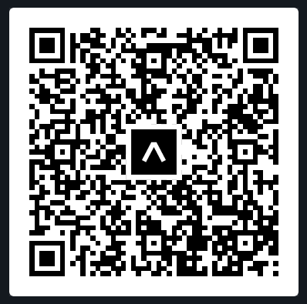Or



**Conclusion**

From this project, we learn many things, like how to find the requirements, generate ideas, select ideas, and test ideas. From scratch, we made our app. In the beginning, we created the architecture of the app on paper many times before selecting the best one among all of them. After we started working with the template for our project, then we collected the information from many sources and selected the best one. After we start implementing the project,

**References**

1. [**https://slejournal.springeropen.com/articles/10.1186/s40561-021-00159-6**](https://slejournal.springeropen.com/articles/10.1186/s40561-021-00159-6)
2. [**https://www.researchgate.net/publication/319328285_An_Android_App_for_University_Management_System**](https://www.researchgate.net/publication/319328285_An_Android_App_for_University_Management_System)