**JavaScript Basic & Dom**

**Prajapati Pavan**

1. **What is the JavaScript?**

* JavaScript is a scripting language and it is used to create and control dynamic content of the website.
* JavaScript is used for Web development, web application and game development.

1. **What is the use of isNaN function?**

* isNan function is use to check passed parameter is a number or other data type, if passed parameter is a number then it return “**False**”, otherwise it returns “**True**”.

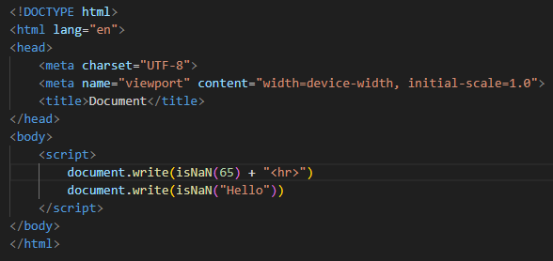

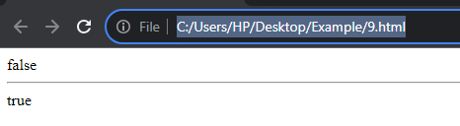

1. **What is negative infinity?**

* .NEGATIVE_INFINITY returns negative infinity.
* .NEGATIVE_INFINITY is a number smaller than any other number.

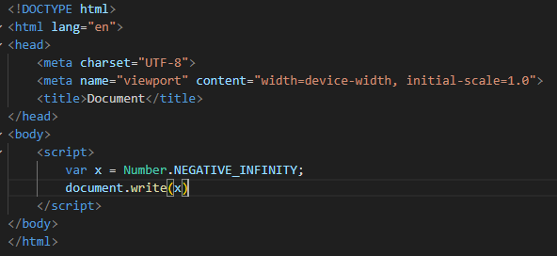

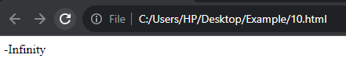

1. **Which company developed JavaScript?**

* JavaScript was developed at Netscape Communications by “**Brendan Eich”** in “**1995”**

1. **What are undeclared and undefined variables?**

* Undeclared variables are those variables which are not declared in the program but are used in the program.
* Undefined variables are variables that are defined but do not assign any value. There is no undefined keyword.

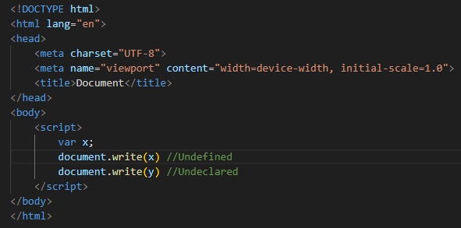

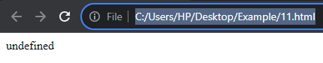

1. **Write the code for adding new elements dynamically.**

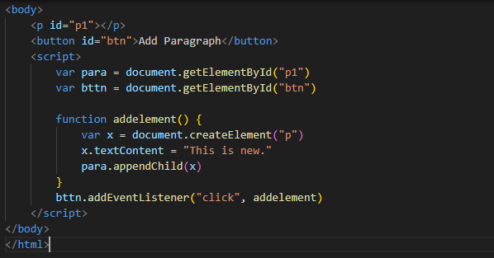

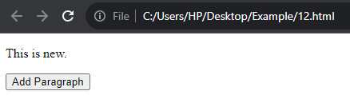

1. **What is difference between View State and Session State?**

|  |  |
| --- | --- |
| **View State** | **Session State** |
| Maintained at page level only. | Maintained at session level. |
| View state can only be visible from a single page. | Session state can visible across all pages. |
| Information is stored on the client’s end only. | Information is stored on the server. |
| View State values are cleared when new page is loaded. | Session State can be cleared by programmer or user or in case of timeouts. |

1. **What is === operator?**

* "===" is strict comparison between two values ​​and it checks both the value and data type, if the values ​​are same then it returns true otherwise false.

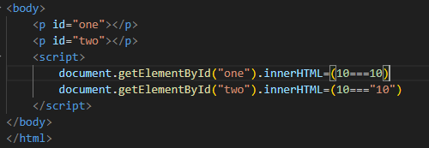

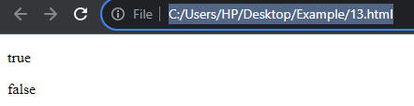

1. **How can the style/class of an element be changed?**

* With the use of style property we can change the style/class of an element.

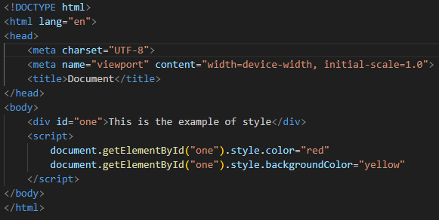

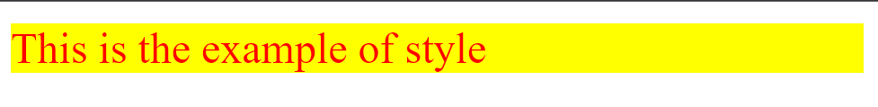

1. **How to read and write a file using JavaScript?**

* writeFile() is use to write a file using JavaScript.
* readFile() is use to read a file using JavsScript.

1. **What are all the looping structures in JavaScript?**

* There are three types of loops in JavaScript.
  + 1. For loop
    2. While loop
    3. Do while loop
* **Outputs:**

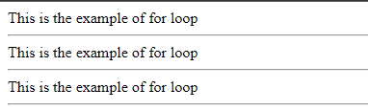

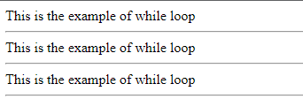

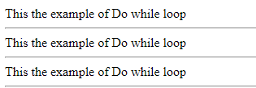

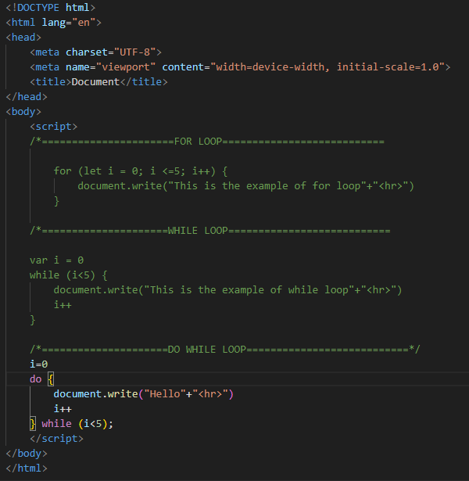

1. **How can you convert the string of any base to an integer in JavaScript?**

* To convert the string of any base to an integer parseInt() method is used.

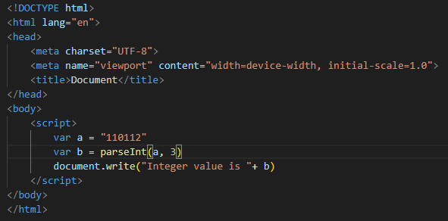

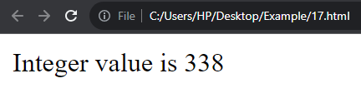

1. **What is the function of the delete operator?**

* Delete operator is used to remove a property of an object.

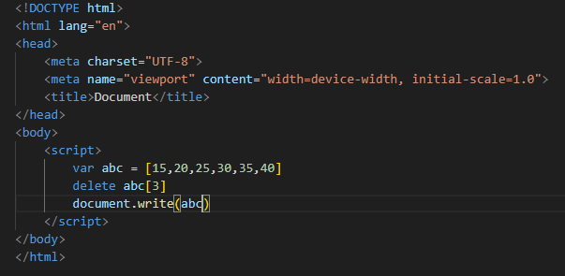

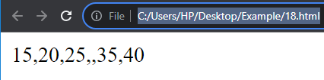

1. **What are all types of Pop up boxes available in JavaScript?**

* There are three types of pop up boxes.
  + 1. Alert box
    2. Confirm box
    3. Prompt box

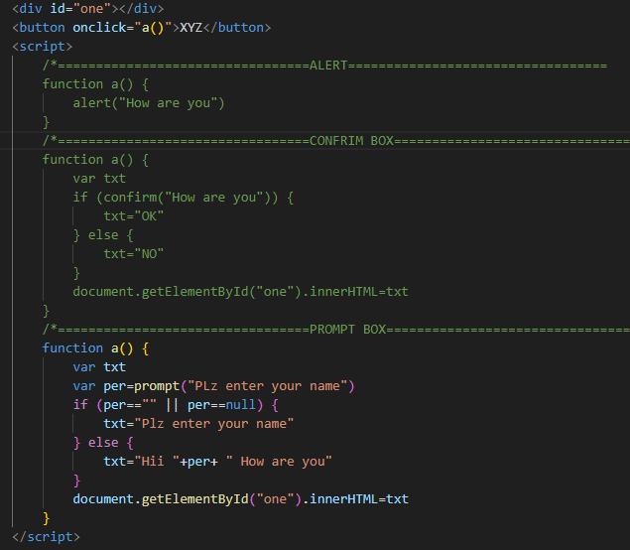

1. **What is the use of Void(0)?**

* In JavaScript-enabled browsers, <a href="javascript:void(0)"> prevents the default action of clicking a hyperlink, which is navigating to a new URL
* It is useful when we insert links which have some important role on the webpage without any reloading. Therefore, using void(0) on such a link prevents the page from being reloaded but allows a useful action such as updating a value on the web page.

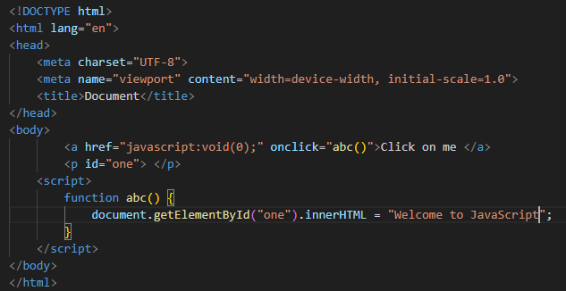

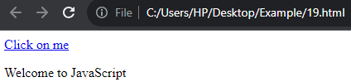

1. **How can a page be forced to load another page in JavaScript?**

* We can use **window.location** property inside the script tag to forcefully load another page in JavaScript.
* For example:

Window.location = https://www.JavaScriptexample .com/JavaScript.

1. **What are the disadvantages of using innerHTML in JavaScript?**

* It is very slow because as inner HTML already parses the content even we have to parse the content again so that’s why it takes time.
* When innerHTML property is used to modify, all the DOM nodes will have to be parsed and created again.

1. **Create password field with show hide functionalities.**

