1. Create A bar with rainbow colour using own lookup table:

Lookup Table for Rainbow colours:

Fig 1: Bars with Rainbow Colour

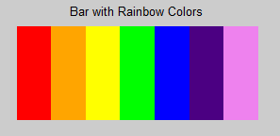

|  |  |  |
| --- | --- | --- |
| Colour Name | RGB Value [R,G,B] | Lookup Table Value |
| Red | [255,0,0] | [1,0,0] |
| Orange | [255,165,0] | [1,0.6471,0] |
| Yellow | [255,255,0] | [1,1,0] |
| Green | [0,255,0] | [0,1,0] |
| Blue | [0,0,255] | [0,0,1] |
| Indigo | [75,0,130] | [0.2941,0,0.5098] |
| Violet | [238,130,238] | [0.9333,0.5098,0.9333] |

Approach: To create rainbow bars, I have created a matrix of (100,0:255) & with equal increment in Y coordinates. And make a lookup table accordingly my matrix to form Fig 1.

1. Create 16 different pseudocolor bar image using own lookup table:

Lookup Table for 16 pseudocolors:

|  |  |  |
| --- | --- | --- |
| Colour Name | RGB Value [R,G,B]] | Lookup Table Value |
| Pigment Indigo | [75,0,130] | [0.2941,0,0.5098] |
| Electric Violet | [160,0,200] | [0.6275,0,0.7843] |
| Dark Purple | [110,0,220] | [0.4314,0,0.8627] |
| Blue Ribbon (Dark Blue) | [30,60,255] | [0.1176,0.2353,1] |
| Azure Radiance (Medium Blue) | [0,160,255] | [0,0.6275,1] |
| Robin’s Egg Blue (Light Blue) | [0,200,200] | [0,0.7843,0.7843] |
| Malachite | [0,220,90] | [0,0.8627,0.3529] |
| Japanese Laurel (Dark Green) | [0,128,0] | [0,0.5020,0] |
| Green | [0,255,0] | [0,1,0] |
| Inch Warm | [160,230,50] | [0.6275,0.9020,0.1961] |
| Sunflower (Yellow) | [230,220,50] | [0.9020,0.8627,0.1961] |
| Tulip Tree (Dark Yellow) | [230,175,45] | [0.9020,0.6863,0.1765] |
| Tango (Orange) | [240,130,40] | [0.9412,0.5098,0.1569] |
| Pink | [255,192,203] | [1,0.7529,0.7961] |
| Coral Red | [250,60,60] | [0.9804,0.2353,0.2353] |
| Maroon | [128,0,0] | [0.5020,0,0] |

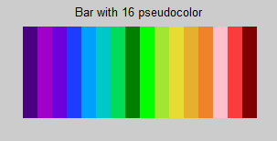

Fig 2: Bar with 16 pseudocolors

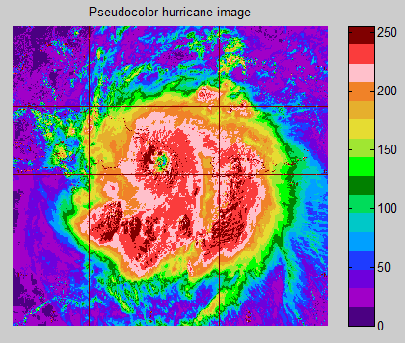

Fig 3: Pseudocolor hurricane Image

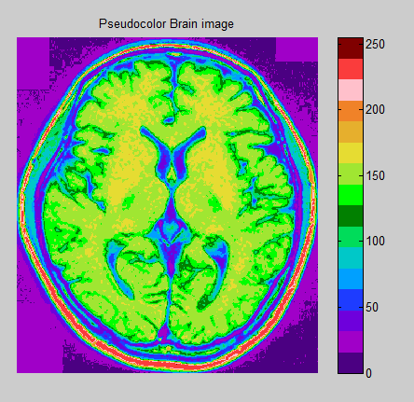

Fig 4: Pseudocolor Brain Image

Approach:

I have created the matrix of (100,0:255) to get 16 different pseudocolor and plot the fig 2. These colours have been chosen by evaluating different combination of rainbow colour in the Microsoft paint. And find the best 16 colour that will definitely create good gradient according to our image.

Pseudocolor map can easily distinguish intensity of the image so that human eye can see the gradient in the image perfectly as compare to gray scale image. And the colour map manipulation in the Pseudocolor is very efficient. But the major drawback of pseudocolor is less number of colours can create less gradient (observed when put rainbow colour in the colour map), and for some application large number of colours may reflects on each other.