The purpose of this filter is to remove the salt paper noise. In my understanding salt paper noise in the image is when there is a sharp disturbance in the Image, which has either extreme high pixel intensity value (White) or extreme Low pixel intensity value (Black). Hybrid median filter is non-linear filter. The basic advantage of using hybrid median filter is it is edge preserving and it is very much adaptive that it is giving us good information of edge as compare to Median Filter. So, by using the Hybrid Median Filter, we can remove the extreme values simply by doing median in fancy fashion. So, in the Hybrid median filter first, it takes the kernel, do the procedure to find the median value which will explain in later part. by doing this, we can remove all the extreme values pixel intensity (Known as Salt Paper Noise). Hybrid median filter is performing differently. The basic idea behind the Hybrid median filter is following.

My approach is:

1. Choose the kernel with odd number of kernel size (if the kernel size is even it will automatically increase by 1 make it odd).
2. Pick all the elements in kernel and make a single vector.
3. According to the central pixel choose the cross window on the kernel.
4. Here I make sure that the central pixel will not repeat twice.
5. Sort that vector of cross element.
6. Find the median for the cross element.
7. According to the central pixel choose the plus window on the kernel.
8. Here I make sure that the central pixel will not repeat twice.
9. Sort that vector of plus element.
10. Find the median for the plus element.
11. Arrange the median value form step 6 and step 10 with the central pixel value.
12. Sort this final vector.
13. Find the median.
14. Change the central pixel value with the step 13 median value.

The major disadvantage of this filter is If we use this filter to remove other than salt paper noise (Impulse Noise), the hybrid median filter will smooth out the noise (Like Gaussian and Poisson noise) but it is not removing the noise. Here in this filter, the kernel size is not much affecting the results, but one thing I want to mention, if we are increasing the kernel size more than 5, it will start to smooth out the edges. So we can see edges clearly. And that is why I am using 7 x 7 kernel size, we eliminate all the noise. For the handling of the edges, the flexibility was given to choose the 3 different method for edge processing:1) no processing of border pixels 2) padding with a fixed value 3) padding With image reflection. Sometimes we can see some of the distortion n the edges. But that can be cured by increase the kernel size. I have selected Image4A to perform this Filter analysis, because with the salt paper noise, the hybrid median is working efficiently. In image 4A, we have salt paper noise. In Image 4b, we have Gaussian noise. And Image 4C, we have passion noise.

Results discussion:

Fig 1: No processing at the border Hybrid Median Filter (Kernel = 7 x 7)

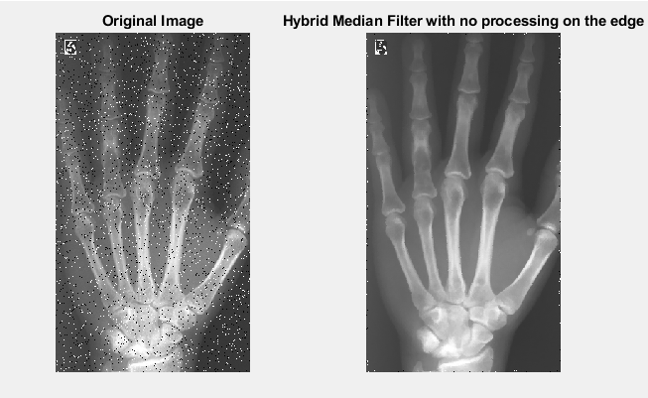

Fig 2: cropped Image of Fig 1

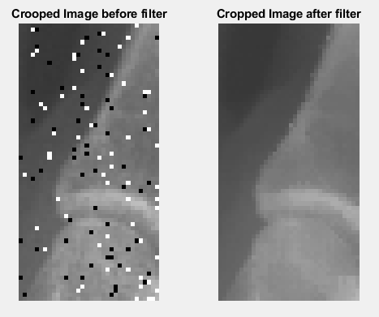

In fig 1, I am using the method 1 for Edge Processing (No processing on the Edge). For this we need to

Fig 3: Hybrid Median Filter padding with fixed value on the edge.

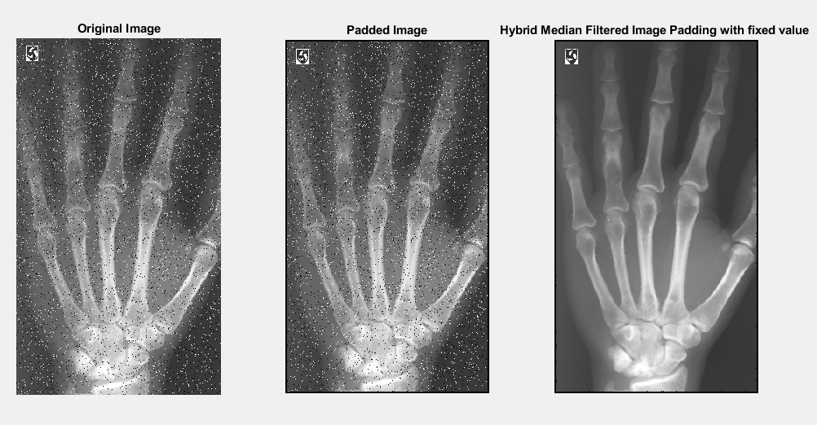

Fig 4: cropped Image of Fig 3.

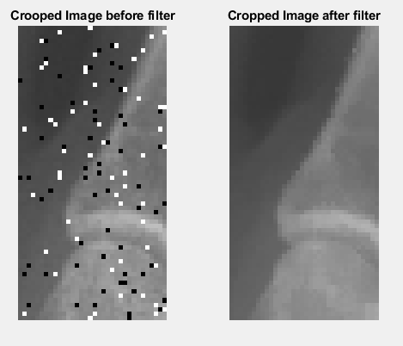

take kernel size = 7 to remove the salt paper noise completely from the Image.

In fig 3, I have used 5 x 5 kernel size, but by doing the padding with the fixed value on the edge, the edges are distorted at some point that will be cured by increase kernel size. Otherwise, Hybrid Median filter is good for salt-paper noise.

Fig 5: Hybrid Median Filter padding with reflection.

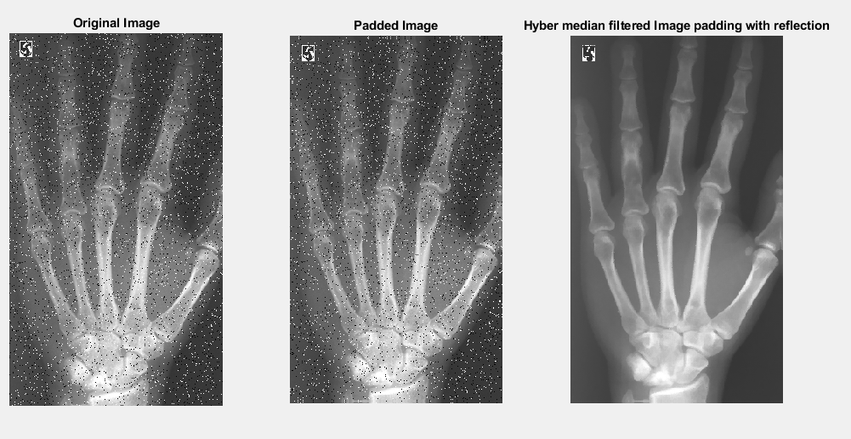

Fig 6: cropped Image of Fig 5.

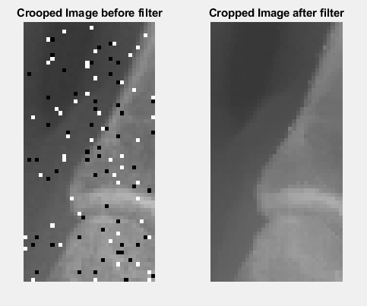

In fig 5, I have used 5 x 5 kernel size, that will give me better results At the edges(as compare to fig 4) and to remove the salt paper noise.

This is the final table, where by my understanding I gave the rank to the filters.

|  |  |  |  |
| --- | --- | --- | --- |
| Filter Type | Image A | Image B | Image C |
| Gaussian | 2 | 1 | 3 |
| Median | 1 | 2 | 3 |
| Iterated Median | 1 | 2 | 3 |
| Conditional Median | 1 | 2 | 3 |
| Horizontal Median | 1 | 2 | 3 |
| Vertical Median | 1 | 2 | 3 |
| Truncated Median | 1 | 2 | 3 |
| Hybrid Median | 1 | 2 | 3 |
| Mode | 2 | 2 | 1 |
| Olympic | 2 | 1 | 3 |
| Top Hat | 1 | 1 | 2 |
| Bilateral | 2 | 2 | 1 |
| Non – local Means | 3 | 2 | 1 |
| Grayscale Erosion/Dilation | 1 | 1 | 2 |
| Kuwahara | 2 | 2 | 1 |