Part A:

Q-6: Is Image A an 8 -bit, 12-bit, 16-bit or 24-bit image? How do you know?

Ans: Image A is 8-bit Image. Because grey scale level is [0 254]. So in binary 2^8 = 256. That is why it is 8-bit image.and we can use imfinfo matlab command

Q-7: Is this patient in trouble? Why or why not?

Ans: Yes, patient is in trouble. Because we detected 3 objects inside the body, which are deadly.

Q-1&2: Read and display the Image A.

Ans: I have used imread matlab command to read the image A. and used imshow matlab command to show the Image A.

Fig 1: Image A

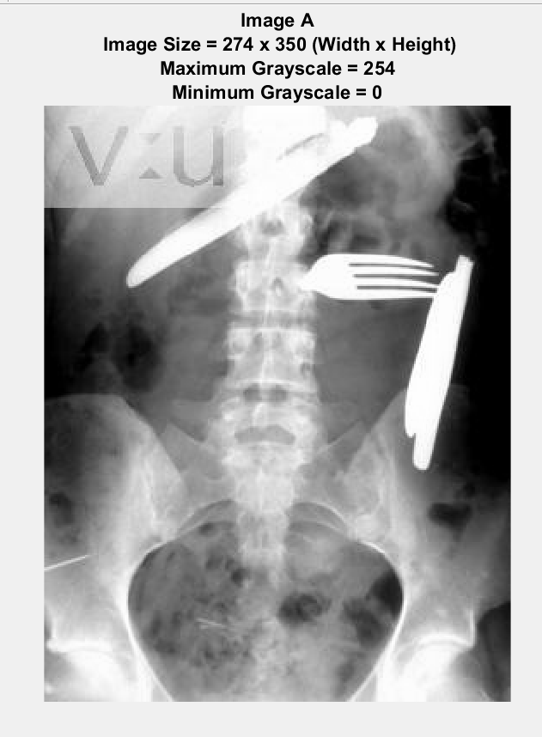

Q-4: Find the maximum and minimum grayscale values in Image A.

Ans: Maximum grayscale = 254, minimum grayscale = 0.for this I have used max & min matlab command for gray scale Image A.

Q-5: Find the size of Image A and the size of Image B and specify whether this is “height x width” or “width x height”. How do you know?

Ans: by using size matlab code for image A, will give us no. of row & no. of columns. & raw number = height & column number = width. For Image A, width x height = 274 x 350.

Q-3: in this image, there are three objects that “do not belong”; you should have no trouble in identifying these objects! Use the appropriate command(s) to interactively select one of the objects in Image A (your choice) and save only that portion of the image as a new image (“Image B”).

Ans: I have used imcrop matlab command to identify this object (shown in fig 2).

Fig 2: Image B (cropped image to identify the object)

