Fig 3: grayscale matrix with 30 gray scale level

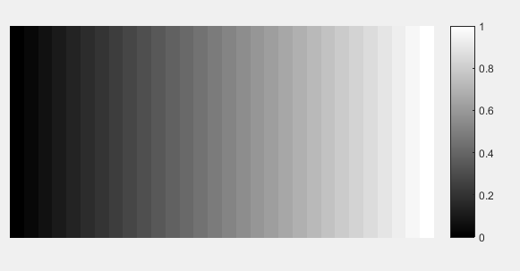

Fig 2: grayscale matrix with 20 gray scale level

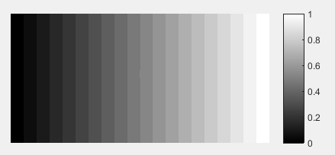

Fig 1: grayscale matrix with 10 gray scale level

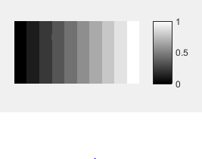

Fig 5: grayscale matrix with 26 gray scale level

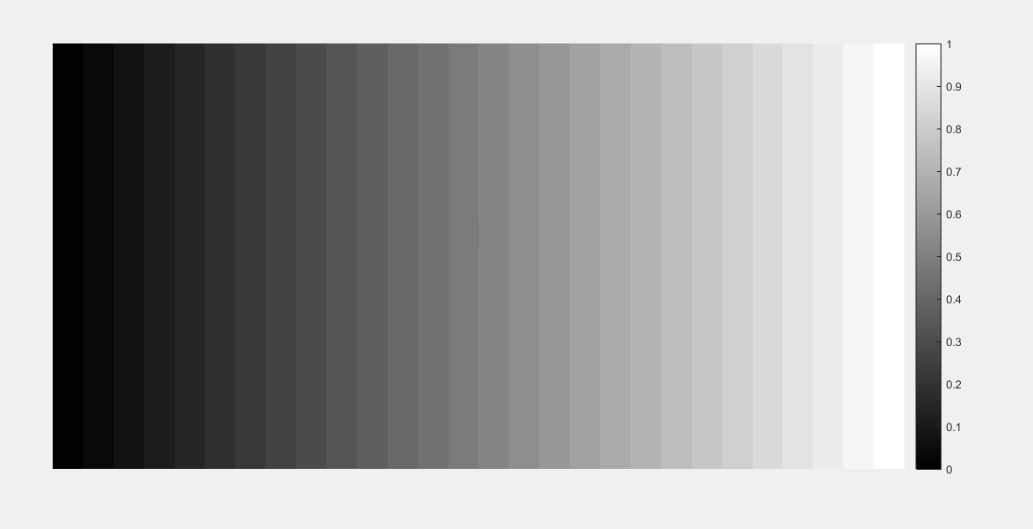

Fig 4: grayscale matrix with 40 gray scale level

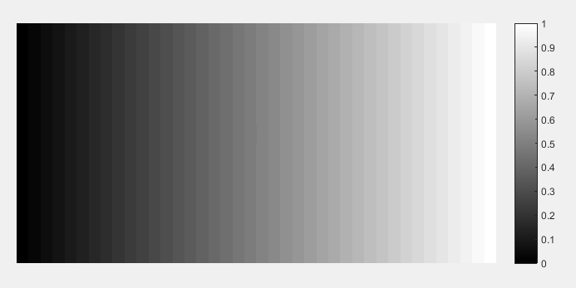

Ans 1: For finding the gray scale image matrix, I predefined the no. of gray scale level, and adding them equally according to the grayscale increasing. If gray scale is 10. So average is = (0+1)/10 = 0.1. And every time in the loop I am adding 0.10,0.20,0.30,….,1. So every increment is same.and this is how we can get different gray scale level with equal increments.

Here, for fig 1 & 2, we have grayscale level 10 & 20 respectively. We know at the center we can see the higher contrast. So by visually inspect these images are not smooth. Even in fig 3 & 4, it is looking like smoother. But I found that when we have 26 different gray scale level(fig 5), at that time it is very easily detect the contrast change and it is about to smooth. Minimum bit-depth = 5bit (2^5 = 32, we have 26 gray scale.)

Ans 2: Due to the background light, the contrast difference is less due to our eye cannot detect such a contrast where the ambient contrast is higher that image.

Ans 3: when we see the contrast in the middle of the image at that time we can differentiate higher contrast. And when we see the image from the edges, contrast is not good because it is going towards highest contrast or lowest contrast.