**Limb Employing Trans-Mechanism**

**L.E.T-WALK**

**A PROJECT REPORT**

***Submitted by:***

**HEMAL DAVE**

**MILAN PATEL**

**VISHAL PUROHIT**

***In fulfilment for the award of the degree***

***Of***

**BACHELOR OF ENGINEERING**

***In***

Bio-medical Engineering



LD College Of Engineering, Ahmadabad

**Gujarat Technological University, Ahmedabad**

MAY 2017

**L.D.COLLEGE OF ENGINEERING, AHMEDABAD**

BIO-MEDICAL ENGINEERING

2016

**Date:**

This is to certify that the dissertation entitled **“LIMB-EMPLOYING TRANSMECHANISM(LET-WALK)”** has been carried out by **HEMAL DAVE** under my guidance in fulfillment of the degree of Bachelor of Engineering in Bio-medical Engineering (7th Semester) of Gujarat Technological University, Ahmedabad during the academic year 2016-17.

Internal guide Head of the Department

.

**L.D.COLLEGE OF ENGINEERING, AHMEDABAD**

BIO-MEDICAL ENGINEERING

2016

**Date:**

This is to certify that the dissertation entitled **“LIMB-EMPLOYING TRANSMECHANISM(LET-WALK)”** has been carried out by **MILAN PATEL** under my guidance in fulfillment of the degree of Bachelor of Engineering in Bio-medical Engineering (7th Semester) of Gujarat Technological University, Ahmedabad during the academic year 2016-17.

Internal guide Head of the Department

.

**L.D.COLLEGE OF ENGINEERING, AHMEDABAD**

BIO-MEDICAL ENGINEERING

2016

**Date:**

This is to certify that the dissertation entitled **“LIMB-EMPLOYING TRANSMECHANISM(LET-WALK)”** has been carried out by **VISHAL PUROHIT** under my guidance in fulfillment of the degree of Bachelor of Engineering in Bio-medical Engineering (7th Semester) of Gujarat Technological University, Ahmedabad during the academic year 2016-17.

Internal guide Head of the Department

**ACKNOWLEDGEMENT**

If you confer a benefit

Never remember it

If you receive one

Never forget it

Before getting into our project work, I would like to express our gratitiude to the people who gave the interminable support and guidance at each stage of the project.

First of all I thank the omnipotent for showering his grace upon me to finish my desired task of our project successfully and also my Parents, without their bless and support we would be nothing.

//I pay my sincere gratitude to Miss Punam Patel , for his warm support and providing all necessary facilities.//

I am thankful to MR. Pancholi, assistance prof. , Biomedical Department, LDCE, Ahmedabad for his kind help, guidance and encouragement.

A special thanks must go to my project guide, MR K.B.Bhoyaniya, Head OF Department, Biomedical Department , LDCE , Ahmedabad ,who supported me with his vast knowledge, experience and suggestion. Only his inspiration made this project easy and interesting. .

My heart felt thanks to MR B.H.Parmar assistance prof. , Biomedical Department, LDCE,, him for support and motivation in making part of the project .

Last but not least I am thankful to all the Teaching and Non teaching Staffs of Biomedical Department for their continuous support and encouragement throughout of this project.

**ABSTRACT**

It is a fanciful time for the field of rehabilitation. Recent advances in batteries, sensors, materials, actuators, and computer processors have given new aspiration to invent the exoskeletons of genre science fiction. While the most common purpose of a LET-walk is to deliver superhuman strength or endurance, scientists and engineers around the world are construct exoskeletons with a wide range of manifold purposes. LET-walk can help patients with neurological disabilities like partial paralysis and physically impairment, to improve their motor performance by giving task specific practice. This paper talks about a newly developed paradigm for rehabilitation of paraplegics named L.E.T-walk. It's abbreviated as Limb Employing Trans-mechanism walk which provides resemblance of an artificial lower pelvis segment till the foot plate, with impedance controlled joints like knee and ankle, which will restrict the movement in either direction with a precise and well-programmed treadmill walk approach.

LET-walk can help physiologists better understand how the human lower body works by providing a novel experimental perturbation.. This special thematic series on robotic lower limb exoskeletons and orthosis includes eight papers presenting novel contributions to the field. The collective message of the papers is that robotic exoskeletons will contribute in many ways to the future benefit of humankind, and that future is not that distant.

**TABLE OF CONTENTS**

|  |  |  |
| --- | --- | --- |
| **Acknowledgement** | I | |
| **Abstract** | Ii | |
| **List of Figures** | Iv | |
| **List of Tables** | Vii | |
| **Table of Contents** | Xi | |
|  |  |
| |  |  |  | | --- | --- | --- | | **Chapter:1** | **INTRODUCTION.** |  | | **Chapter:2** | **HISTORY** | **13** | |  | 2.1 Introduction | **13** | |  | 2.2 Background | **17** | |  | 2.2.1 Traditional methods |  | |  | 2.3 Advancement in rehabilitation | **18** | | **Chapter:3** | **EMBEDDED SYSTEMS** | **20** | |  | 3.1 Introduction | **20** | |  | 3.2 Features of embedded system. | **20** | |  | 3.3 PIC18F4550 | **21** | | **Chapter:4** | **DESIGN: ANALYSIS , DESIGN METHODOLOGY & IMPLEMENTATION STRATEGY** | **24** | |  | 4.1 AEIOU Summary | **24** | |  | 4.2 Empathy Canvas | **24** | |  | 4.3 ideation canvas | **25** | | **Chapter:4** | **LIMB EMPLOYING TRANS-MECHANISM** | **27** | |  | 4.1 Components | **28** | |  | 4.1.1 Hardware components | **29** | |  | 4.1.2 Software components | **30** | | **Chapter:5** | **DESIGNING OF LET-WALK CIRCUITRY** | **32** | |  | 5.1 Working | **32** | |  | 5.1.1 Knee instability compensation | **32** | |  | 5.1.2 Ankle instability compensation | **33** | |  | 5.2 Coding. | **34** | | **Chapter:6** | **CHALLENGES AND OUTCOMES** | **37** | |  |  |  | |  |
| Reference  Appendics |  |
|  |  |
|  |  |
|  |  |
|  |  |
|  |  |
|  |  |
|  |  |
| **List of figure** |  |
|  |  |
|  |  |
|  |  |
| |  |  |  | | --- | --- | --- | | **Figure No.** | **Figure Description** | **Page No.** | | 1 | Human machine(LET-walk) interference | 12 | | 2 | Evolution of rehabilitation devices | 13 | | 3 | Ancients assistive devices for amputee person | 14 | | 4 | Wooden hand assistive device. | 14 | | 5 | lower limb prosthetic | 15 | | 6 | Pin diagram of Involved Embedded system | 21 | | 7 | AEIOU summary | 24 | | 8 | Empathy canvas | 24 | | 9 | Ideation canvas | 26 | | 10 | Product development canvas | 27 | | 11 | Block diagram of LET-walk | 28 | |  |
|  |  |
|  |  |
|  |  |
|  |  |
|  |  |
|  |  |
|  |  |
|  |  |
|  |  |
| **LIST OF TABLES** |  |
|  |  |
| |  |  |  | | --- | --- | --- | | **Table No.** | **Table Description** | **Page No.** | | 1 | Phases of gait analysis |  | | 2 |  |  | |  |
|  |  |
|  |  |
|  |  |

**Chapter 1**

**INTRODUCTION**

Rehabilitation missions is to recover back the patient’s physical, sensory and neural capabilities that were lost due to injury, illness, and disease, and to support the patient to compensate for deficits that may not be treated medically. After the spinal cord injury (SCI),stroke, muscle disorder, and surgical operation such as knee arthroplasticy, patients need rehabilitation to recover their movement capability (mobilization).

There is a huge demand of rehabilitation and alignment to this, equipment and techniques used in the field of rehabilitation are emerging more advanced and sophisticated. There are two basic materials in the total rehabilitation program: therapeutic modalities accompanied with therapeutic exercise. While the goal of therapeutic modalities is to resolve and treat the effects of pain, spasm and edema, the final goal of therapeutic exercise is to allow the injured patient to pain-free and fully functional activity. Specific parameters must be addressed in proper manner to an effective exercise program through the therapeutic exercise. In order to have the patients safely perform fully normal activity, each of these parameters must be regaining to at least pre-injury levels. In their genuine sequence these points are:

* flexibility accompanied with range of motion,
* Strength with high muscle endurance,
* Proprioception with coordination accompanied with agility.

They are sequentially related to each other. A past one is the precondition of the upcoming. As can be seen from these parameters, a rehabilitation program starts with a passive range of motion and continues with assistive exercises followed by resistive exercises and to restore the flexibility and range of passive range of motion activities are given to the disabled, for the strength and muscle endurance resistive exercises are performed by patient also for the proprioception, coordination and agility, strength exercises are applied to the patient by the physiotherapist. In general,a person with movement disabilities due to arm or leg problems needs to undergo periods of therapeutic exercise sessions spread over a long period of time[1].

The routine comprise a series of regular basis and routine physical movements with the assistance and under the concern of a physiotherapist also Transferring the patient to the medical center or calling a Physical Training to where the patient is located are factors that also increase the cost of this process.The process of powering muscles to their regular values is not that cheap also it need time with patience. Hence in order to solve these problems in rehabilitation, the many of studies about the usage of robots in rehabilitation had an increment, especially in the last decade. Some vital reasons for the utilization of robots in rehabilitation can be listed as follows: Robots easily fulfill the requirements of cyclic movements in rehabilitation; robots have precise control over introduced forces; They can precisely reproduce required forces in recurring exercises; and robots can be more precise regarding needs therapy conditions.

Devices called ‘‘Continuous Passive Motion’’ (CPM) are widely used in many medical centers for therapy and rehabilitation purposes.

The CPM concept was first introduced in the 1970s [1].During the rehabilitation process, patients sometimes move their extremities suddenly due to reflexes. Conventional machines such as CPMs do not respond in these kinds of situations and are hence not suitable for physical therapy. If a reflex causes a patient’s leg to move while the machine is operating, an improper load results and can damage the patient’s muscle or tendon tissue [1]. Because of this, there is a need for an intelligent device which can accomplish the rehabilitation of extremities based on the patient’s complaints

and real-time feedback during rehabilitation processes.

**Robots in rehabilitation can be classified into three groups** :

i.To provide mobility.

ii. To assist disabled people in special need with their routine life activities.

iii. To assist physio-therapists performing repetitive exercises with disabled.

There always have been practice to develop robotic systems for the motor rehabilitation of lower limb and arm extremities. These robotic systems can be said in terms of therapeutic exercise genre, movement ability (mechanical specifications) and control methods.

**Human–Machine Interface:**

Input O/P

Healthy Limb

LET-Mi

Conversion

And Implementation

DATA

ACQUISITION

**Fig 1:** Human machine (LET-walk) interference

The Human–Machine combo is the middle unit between the PT and the RM. Passive, isometric, and isokinetic, active assistive, isotonic, kinds of exercises are performed by the RM for which control is provided by the HMI. Also,especially with this architecture, the RM can imbibe the actions performed by the PT for each patient and copy these actions in the absence of the PT. In this journal, this exercise type is named ‘‘robotherapy’’.

Robotherapy has 2 phases: therapy and teaching. The teaching process is performed based on the physical characteristics of the patient & the position and force data collected from the patient. Treatment requirements change via patient to patient. On the contrary, the medical needs of a patient can also differ via day to day. That is the reason why PT teaches vital movements to the patient prior to each rehabilitation session via the robot manipulator. Today’s safety precautions were created to avoid abrupt situations that may occur during the rehabilitation trail. If a serious alterations occurs in the patient’s condition also a need arises for a change in the movements which are applied to the patient, the PT can easily re-teach the system and continue the rehabilitation. There are 2 modes in the therapy phase.

These modes are and reactive therapy and direct therapy . In the direct therapy mode the system will again movements taught it by the PT for any mandatory duration. In the reactive therapy mode, joint open exercise of Physical training with force is model and the system responds accordingly to the patient’s response. The boundary conditions of the exercise carried out simultaneously differ over the time of therapy.

**Chapter 2**

**HISTORY**

**2.1 Background:**

**2.1.1 Traditional methods:**

* A device designed to assist walking or improve the mobility of people having mobility impairment is called as mobility aid. There are many different walking aids which can assist people with disability to walk and wheelchairs for more severe disability or longer journeys which would otherwise be done by walking. Basically the phrase "mobility aid" has used mainly to low technology devices. It refers to those devices whose use gives a freedom of movement equal to that of independent walking or standing up from a chair. Technical advances can increase the scope of these, for example by use of sensors , audio and tactile feedback[3].
* Some traditional methods or assistive devices to improve mobility of patients are cane, crutches, walkers, etc. described below:

**[1] Cane:**

* The cane is the simplest form of walking aid. It is handheld and transmits load to the floor via a shaft. The weight which can be applied via a cane is passed through the user's hands and wrists which is limited by this[3].

**[2] Crutches:**

* A crutch also transfer loads to the ground via a shaft, but has two contact points with the arm, 1st at the hand and 2nd below the elbow or the armpit. This permits significantly greater loads to be utilize through a crutch with compared to cane[3].

**[3] Canes, crutches, and forearm crutch combinations:**

* Current devices include a many combinations for canes, crutches, and forearm crutches. These crutches have straps that cover the upper arms and handles for the person to hold and rest their hands to bear the body weight. The Forearm crutch usually gives a user the support of cane but with extra forearm support to help in mobility. The forearm portion helps in increasing of balance, lateral stability and also decrease the load on the wrist[3].

**[4] Walkers:**

* A walker also which is known as a Zimmer frame is the most steady walking aid and made up of a freestanding metal framework with more than three points of contact which is places in front of users and then grips during maneuver. The contact points may be either fixed rubber ferrules as with crutches and canes, or wheels, or a combination of both. Wheeled walkers are known as rollators[3].

**[5] Walker cane hybrid:**

* It was 1st introduced in , which is 2012 designed to fill the gap between a cane and a walker. The hybrid walker cane has two legs which provide side-to-side support which a cane does not provide. It generally used with two hands at front of the user, equal to a walker, and gives an increased level of assistance compared to cane. It can be modified for use with either one or both hands, at the front and at the side, also in stair climbing assistant. The hybrid is not made to replace a walker which generally has 4 legs and provides four-way support using both hands[3].

**[6] Gait trainers:**

* Gait trainer is another device to assist walking. it has entered the market in recent years. Gait trainer is a mobility aid that is more assistive than the standard walker. It basically offers support that helps weight-bearing and balance. The product parts that connected to the product frame provide support without weight and postural alignment for walking practice[3].

**[7]Wheelchairs and scooters:**

* Substitute for walking is provided by wheelchairs and mobility scooters  which is wheeled device on which the user sits. Wheelchairs either manually propelled or electrically powered . Mobility scooters are electrically powered, like motorized wheelchairs. They are normally recommended for any person due to significant mobility and/or balance impairment. An Occupational Therapist or Physiotherapist are able to provide object and clinical testing to assure proper device recommendations[3].
* Rehabilitation Engineering in the United States and Canada developed as a result of a need to help individuals with disabilities throughout the past half of the 20th century, as is described below. As a result, the word rehabilitation engineer and rehabilitation engineering started to appear in the use. Definition of rehabilitation engineering is “the application of engineering and other sciences in combination with medicine to improve the quality of life of disabled persons[3].”
* The goal of rehabilitation practice is to perform given movements that revoke motor plasticity to the person and therefore improve motor rehabilitation and minimal functional deficits. Movement restoration is depended on limb, thus the damaged limb has to be exercised. 33% of surviving patients from stroke lost independent walking and those ambulatory, walk in a general asymmetric manner. Rehabilitation therapies are hard to recover so many researches is currently on-going on the field. The rehabilitation development toward recover a meaningful maneuverability can be divided into three phases:

**(1)** The disabled patient is mobilized into the chair,

**(2)** Possible recreation of gait cycle,

**(3)** Improvement of gait.

* Conventional rehabilitation therapeutic techniques are labor critical especially for gait rehabilitation; often need more than three therapists together to assist manually the lower limb perform training. This fact appoints an enormous economic load to any country’s health care system thus inhibit its clinical acceptance. Analytical change (aging), shortages of health care personnel, and the need for higher quality care assume an increase in the average cost from first stroke to death in the future. All these factors increased innovation in the area of rehabilitation in such way it becomes more economical and available for more patients and for a long period of time.

**2.3 ADVANCEMENT IN REHABILITATION:**

* As we seen earlier about some assistive devices for paraplegic persons like canes, crutches, walkers and wheelchairs etc. to give patient the freedom of movement. But those devices are not enough supportive to give normal movement to patient. So to overcome the previous cons of traditional devices exoskeleton supportive devices and prosthetics are invented[4].
* The exoskeleton is a fixed framework that fits around the legs of patient, connected powered joints at hip and knee. A wide belt around the torso to keep the exoskeleton safe, and crutches helps the wearer to keep their balance. 10 years after in development and a clinical trial that involved around 1,200 sessions of patients, the US Food and Drug Administration has approved a robotic exoskeleton developed by a group of researchers at Vanderbilt University. The **Indego** exoskeleton is exoskeleton in America to receive FDA approval for clinical use as well as personal use, and it will allow people who have been paralyzed at lower limb to stand up and walk around. It's powered by a rechargeable power supply that can be taken out and replaced as per need. It will automatically adjust the required amount of robotic assistance to the individual. If the person has some mobility, the exoskeleton will supply comparatively less assistance, which not only saves the battery life, it will allow the person to use their own muscles. For wearers with no mobility, it will operate at full power[3].
* Another exoskeleton suit is named as **phoenix**; The Phoenix is the invented by UC Berkeley professor and SuitX CEO Dr. Homayoon Kazerooni. It’s designed to cuts the costs by focusing on doing a single action — walking — rather than replicate the full human activity. The Phoenix can’t do a twisting jump, but it can perform basic actions just fine. The motors in the suit are only at the hip joints, and these are controlled by an on-board computer. It uses a series of buttons mounted to the user’s crutches to control and drive the system. Hit the fwd button and a hip motor drives a leg fwd, while simultaneously allowing the knee to flex and clear the ground. If the system struck an obstacle mid-stride, the hook flexes and absorbs the impact[4].
* The latest exoskeleton is named as **ReWalk**. It is bionic walking assistance system that uses powered lower limb attachments to allow paraplegics to stand upside, walk and climb stairs[4].

**Chapter 3**

**EMBEDDED SYSTEMS**

**3.1 Introduction:**

* An Embedded system is basically a design that incorporates the power of a small microcontroller, like the dsPIC digital signal controller (DSC) or Microchip PIC®microcontroller (MCU).These microcontrollers mixes a microprocessor unit (like the CPU in a personal computer) with some additional circuits like peripherals, plus some other circuits on the same chip to make a little control module requiring few other external devices.This single unit can then be embedded into other mechanical and electronic devices for low-cost digital control.
* PIC families have incorporated 18F4550 Controller [4] that is used in our project for communicating with other devices.
* Microcontrollers and Microprocessors are majorily used in embedded products. An Embedded product is controlled by its own internal microprocessor (or Microcontroller) as opposed to an external controller.In Embedded system, the microcontroller’s ROM is burned with a motive for specific functions require for the system. [4]
* Any electronic system that uses a CPU chip but that is not a general –purpose desktop or laptop computer. It is a system with a dedicated function within a larger electrical or mechanical system.The different instances of Embedded System Products are shown in figure below which is a combination of software part and hardware part along with specific task.

**3.2 Feature of Embedded system:**

* **Application** –specific: The application of an Embedded System isfixed in advance
* **Reactive:** A reactive system is one which is in continual interaction with is environment and executes at a pace determined by that environment.
* **Hybrid systems**: Embedded system includes analog part along with digital parts .
* **Efficient:**

1. Energy efficient: Low Power Consumption
2. Code size efficient: Code Optimization should be used
3. Size efficient: Small in size and
4. Cost efficient: Low fabrication Cost ·

* **User Interface:** Various types of user interfaces are used in embedded systems for different functions.
* Real-time Every event should be responded within the time interval.

Types of Real Time System:

1. Hard Real Time System
2. Soft Real Time system

* **Security**: Embedded system provides confidential communication.

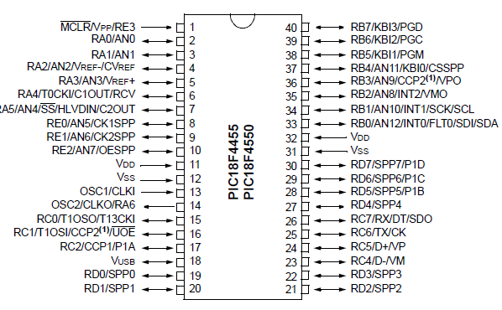

**FIG 6:** Pin diagram of Involved Embedded system

### 3.3 PIC18F4550:

### It originates to a class of 8- bit micro-controllers of RISC Architecture.

#### [1]Program Memory (FLASH):

#### This method is used for storing a written program. Though memory is made use of in FLASH technology, it can be cleared and programmed more than once, it makes this micro-controller convenient for LET-Walk development[4].

#### [2]RAM:

#### Data memory is used by a program during execution. In RAM are stored all inter-results on temporary data which are not crucial for running a device during the period of a loss of supply[4].

#### [3] EEPROM:

#### It is that device where in the data memory needs to be saved when there is no supply. It basically is used for storing vital data that must not be lost if supply suddenly stops. For example, one such data is an assigned pressure in pressure regulators. If during a loss of continues supply is lost, we will need to make the adjustment once again upon return of supply. Hence our device faces challenges on self-reliance[4].

#### [4] TIMER:

#### It is an 8-bit register inside a microcontroller that works freely of the program. On every 4th clock of the oscillator, it increments its value till it reaches near the maximum, and then its starts counting over again from zero. As we know the exact timing between each 2 increments of the timer values, timer can be used for measuring the time, which is very helpful with some devices[4].

#### [5]PORTA, PORTB AND PORTC:

#### These are physical connections between the outside the world and microcontroller. PORTA has 5 pins, PORTC & PORTB has eight pins[4].

**[6]CENTERAL PROCESSING UNIT:**

* It plays key role of connection of elements between other blocks in the microcontroller. It coordinates that work of other blocks and executes the user program.

**PIC devices generally feature:**

• It has Flash memory (program memory, programmed using MPLAB devices.

• It also has SRAM (data memory).

• EEPROM memory (programmable at run-time),

• Its special feature is Sleep mode (power savings),

• It also includes Watchdog timer.

• It has various types of crystal and RC oscillator configurations or an external clock.

**High Performance RISC CPU:**

• It has 77 instructions - Linear program memory addressing to 2 Megabyte

• It also has Linear data memory addressing up to 4 Kilobytes,

• It includes 16-bit wide instructions,

• It also includes 8-bit wide data path

**Peripheral Features: -**

1. It’s High current sink/source 25 mA /25 mA,
2. It has Up to four external interrupt pins,
3. It has Up to three 16-bit timer/counters

**Analog Features:**

• It includes 10-bit Analog-to-Digital Converter,

• It has Fast sampling rate,

• It has Programmable Low Voltage Detection (LVD) module,

• It also has Programmable Brown-out Reset (BOR).

**Special Microcontroller Features:**

1. It has special feature of Power-on Reset (POR), Other special features like Power-up Timer (PWRT) and - Oscillator Start-up Timer (OST),
2. It also includes Watchdog Timer (WDT) with its own on-chip RC oscillator for reliable operation,
3. Another special feature is Programmable code protection - In-Circuit Serial Programming TM (ICSPTM) via two pins.

**CMOS Technology:**

• CMOS technology includes Fully static design; it also has wide operating voltage range (2.0V to 5.5V); Industrial and Extended temperature ranges[5].

**Key features:**

The MPLAB IDE provides the ability to:

* It provides ability to Create and edit source code using the built-in editor.
* It Assemble, compile and link source code.
* It also Debug the executable logic by watching program flow with the built-in simulator or in real time with in-circuit emulators or in-circuit debuggers.
* It also make timing measurements with the simulator or emulator.
* We can view variables in Watch windows.
* It runs`program firmware into devices with device programmers

**The PICkit-3 features include:**

• It use full-speed USB support using Windows standard drivers

• It does Real-time execution

• Its processors run at maximum speeds

• It has built-in over-voltage/short circuit monitor

• It ranges from Low voltage to 5V (1.8-5V range)

• It includes diagnostic LEDs (power, active, status)

• It can Read/write program and data memory of microcontroller

• It can erase all off memory types (EEPROM, program and ID configuration) with verification

• It’s peripheral freeze at breakpoint.

**Chapter:4**

**DESIGN: ANALYSIS , DESIGN METHODOLOGY & IMPLEMENTATION STRATEGY**

**4.1: AEIOU Summary:**

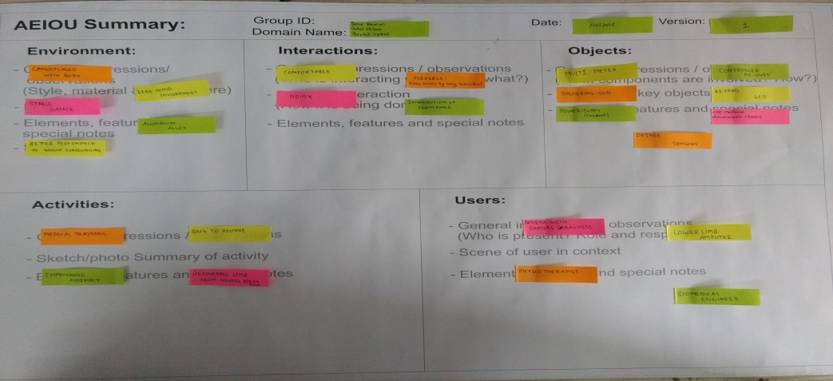

Fig 7: AEIOU summary

**4.2 Empathy Canvas:**

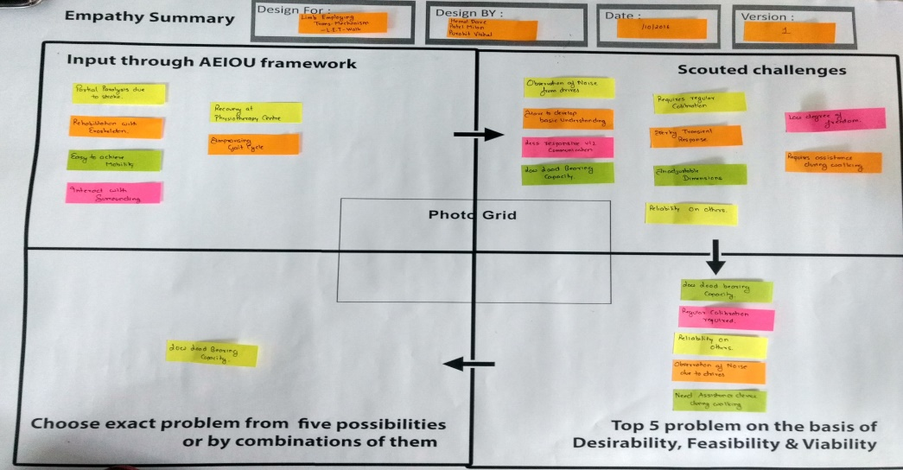

Fig:8 Empathy canvas

* **Input through AEIOU framework:**
* There are many points which are connecting to the framework. Firstly, stroke is occur due to partial paralysis. Secondly , we are making exoskeleton which is very beneficial for rehabilitation purpose. Apart from that to improve gait cycle , physiotherapy centre is useful for recovery.
* **Scouted Challenges :**
* There are many challenges which today’s assistive devices faced are bearing capacity , loading ratio , degree of freedom , dimensions , calibration. Moreover , we can say that apart from this, less response , noise from drives , pain in joints are also parameters of challenges for LET-Walk.
* **Top 5 problem on the basis of desirability , Feasibility & viability:**
* Top 5 problems are :1) low load bearing capacity for giving heigher weight on outer limb 2) calibration required for getting desirable output. So calibration is not accurate as per the requirments. 3) Reliability is the major factor which is used for giving compatible form of harness so it can be easily accessible by patients. But for some prospects it is not compactible to others 4) motors can create so much noise so some time it is very harmful to human to wear for those who have neurological problems. 5) for current assistive devices, we can say that they need any kind of assistance to drive harness.
* Among them, we can say that weight parameter is crucial for the exoskeleton . because if the weight is too high , there are many problem to drive the motors and level of pain the joint is shoted up.

**4.3 ideation canvas:**

* Ideation canvas is used to create the idea as per the requirments of the project
* **People:**
* In this section , they want to say that which people are physically connected towards our project. As far as we are concerning with LET-Walk , there are many people are connected like soldires , paraplegic patient biomedical engineers , lower limb amputee patient , partially impaired person.
* **Activities:**
* In this section , few activity are related towards our project like walking , seating, stamding ascending and desending stairs etc. as far as we will have to develop that \kind of harness which if useful to those people , which are mentined in people section. For their usual activity , this harness is beneficial.

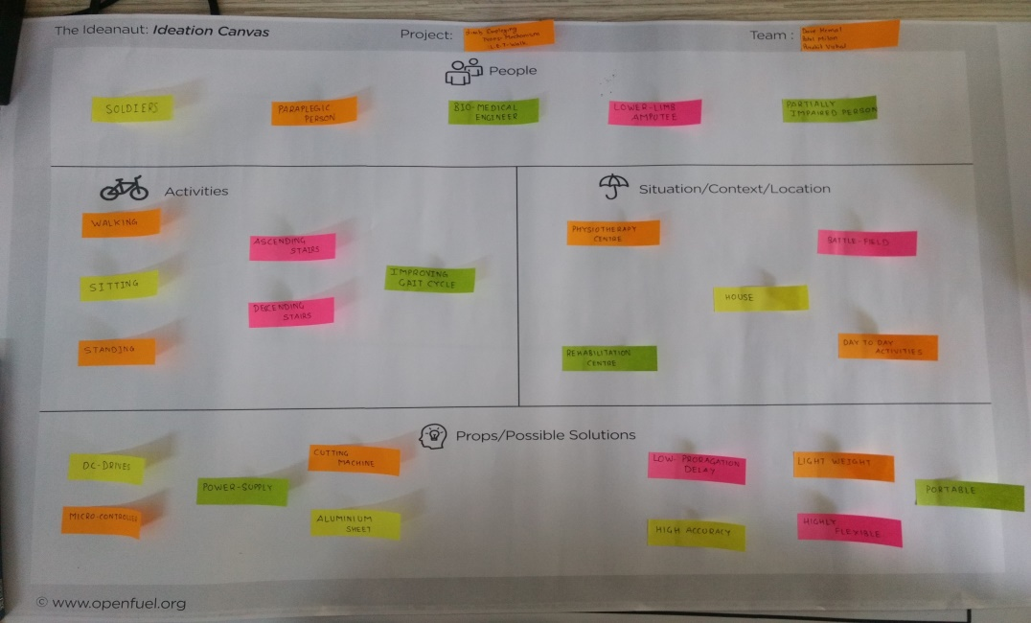

Fig:9 Ideaton canvas

* **Situation:**
* There are many situations where this harness can be used for improving their gait cycle. Some of them are physiotherapy center, battle field , house , rehabilitation centre. These are the situations where it is useful for the person.

**4.4 Product development canvas:**

* **Purpose:**
* The main purpose of the product name LET-Walk is to give the proper form of GAIT cycle for paraplegic patients. Morover, it is also useful in the physiotherapy centre for partially paralised patients to improve walking. Apart from that ,not only in rehabilitation but also assistive technology has the maximum use of this harness.

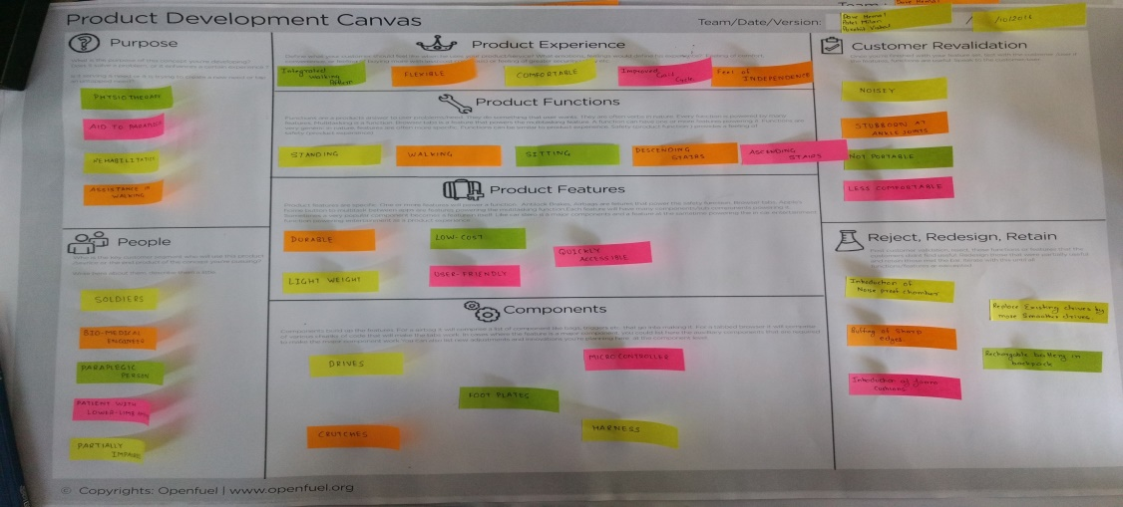

**Fig:10 product development canvas**

* **Product experience:**
* when this harness will developed , it should be compatible, flexible and easily acceseble for the patient. Secondly, it has minimal weight loading medium so that patient can easily were that harness without pain for longer period.Moreover, it can give the felling of independence, because after that no another person is needed to walk.
* **Product function:**
* In this section , few activity are related towards our project like walking , seating, stamding ascending and desending stairs etc. as far as we will have to develop that \kind of harness which if useful to those people , which are mentined in people section. For their usual activity , this harness is beneficial.
* **Product features:**
* LET-Walk has harness that has lower cost so can it can easily useful for the patients. Apart from this, it has not only light weights but also quickly accessible to the patient for improvation GAIT cycle.Lastly, it has durable so all age group patient can used it.

**Chapter 5**

**LET Walk**

**Overview:**

LET-walk abbreviated as Limb Employing Trans-Mechanism which imbibes several features including improvising the gait cycle also in case of some stroke due to heart attack which leads to neural dis-function and hence in order to over come such barrier we introduce LET-walk which will allow the ease of functioning in each and every domain and will be in no aspect be less than normal limb.

The main concern is to reach to masses and bring the change in field of affordability and in several other aspects which will make it easy to reach to masses rather than being it a piece of innovation with a selfish motive.

The diagram below depicts the assembly diagram of the product which not only bring down the criteria of the product but also make it easy to maintain,the keyboard of 16 pins is incorporated for several task to be achieved and giving the commands.

The Graphical user interface is situated in order to get better understanding of the visual understanding and increasing the flexibility domain for any individual.it is interconnected with the joystick for it to be more easily accessible and praticaly sound.

Sensors will fetch the signal in the form of change in angular change being occurred in the normal limb and apply the conjugate response on the artificial limb.the signal recived from sensors is then than transferred to data acquisation chamber for further conditioning.

Timing and control is being taken into major consideration for the purpose of accuracy and high reliability.

* **Sensor Module:**
* For further manipulation To perform signal conditioning and to transform it into a digital form. Form the computer Once the data are in a digital, they can be displayed , Fixed processed, compared, stored in a database, and than converted back in analog form for further process and control.
* store configuration settings can be storeded by The database and signal records. The sensor module, which interfaces a virtual external instrument to the, mostly analog world transforming Measured signals into computer readable form.
* A sensor module is consists of three main parts:
* The A/D converter
* The sensor
* The signal conditioning part

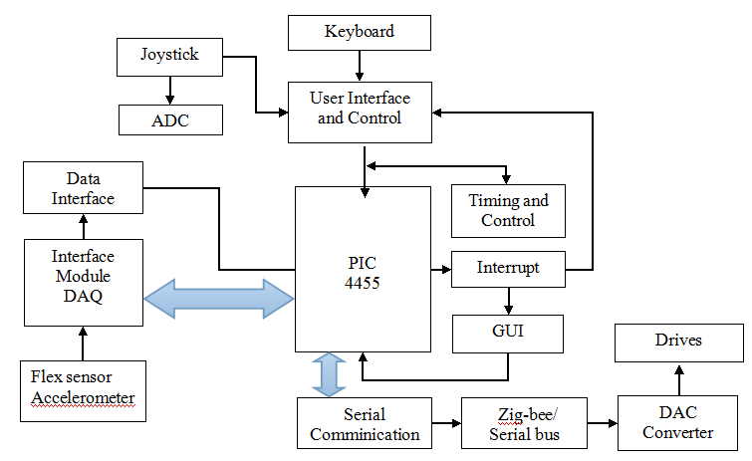

**FIG 8** :Block diagram of LET-walk

* **Sensor Interface:**
* There are many interfaces, which are used to communicate between sensors modules and the computer. According to the type of connection, sensor interfaces can be classified as wireless and wired.
* Mostly Wired Interfaces are standard parallel interfaces, such as GPIB, Small Computer Systems Interface, system buses (PCI extension or VME Extensions) or serial buses (RS232 or USB interfaces).
* Wireless Interfaces are mostly used because of flexibility. Typical interfaces include 8051 family of standards, GPRS/GSM interface, or Bluetooth.
* Wireless communication is especially important for implanting sensors where cable connection is not possible. In addition, standards, such as Bluetooth, define a protocol that is self-identification, that allows the network to configure dynamically and to describe itself. In this way, it is possible to decrease the cost of installation and creating plug-and-play like networks of sensors.

**4.1 Hardware Components:**

* ULN2003

It’s a monolithic huge current and high voltage array of Darling-ton transistor. It incorporates a total of seven NPN darling-ton pairs which features high-voltage outcomes with same-cathode clamp diode for changing inductive loads. The collector-current rating of a unit darling-ton pair is 500mA. The darling-ton pairs may be parallel for higher current capability. Applications include a hammer drivers lamp drivers,relay drivers,display drivers logic buffer,and line drivers.

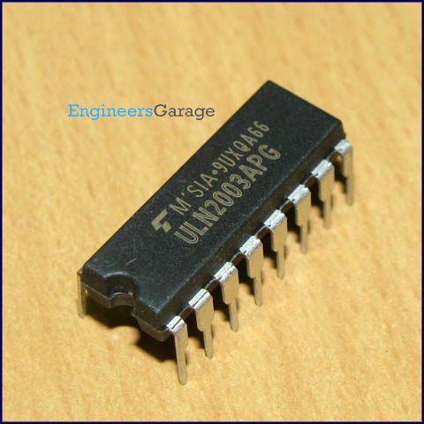

**FIG** :UNL200x Series

The ULN2003 consist a 2.7kiloWatt series base resistor for the individual darlington pair for working straightly with TTL logic and with a 5V CMOS devices.

* H Bridge:

In general an H-bridge is a rather simple circuit, containing four switching element, with the load at the center, in an H-like configuration:

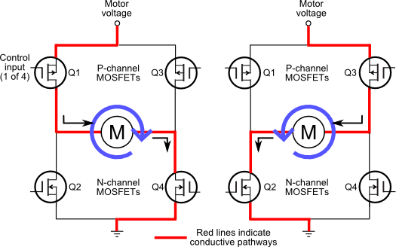  
fig: h bridge circuit

# The switching elements (Q1..Q4) are usually bi-polar or FET transistors, in some high-voltage applications IGBTs. Integrated solutions also exist but whether the switching elements are integrated with their control circuits or not is not relevant for the most part for this discussion. The diodes (D1..D4) are called catch diodes and are usually of a Schottky type.

# The top-end of the bridge is connected to a power supply (battery for example) and the bottom-end is grounded.

# In general all four switching elements can be turned on and off independently, though there are some obvious restrictions.

# Though the load can in theory be anything you want, by far the most pervasive application if H-bridges is with a brushed DC or bipolar stepper motor (steppers need two H-bridges per motor) load. In the following I will concentrate on applications as a brushed DC motor driver.

# Drive modes

# Previously we’ve only considered static operation, when nothing was changing. If less than full-speed operation is intended the switches are controlled in a PWM fashion. A [PWM signal](http://en.wikipedia.org/wiki/Pulse-width_modulation) has two phases, the ‘on-time’ and the ‘off-time’ as I’m calling them in the diagram below:

# [image](http://modularcircuits.com/blog/wp-content/uploads/2011/10/image4.png)

# It is a periodic signal, with a constant frequency. The information content – that is used to change the operating parameters of the bridge – is the ratio between the on-time and the off-time. The various drive modes differ in how the switches are set during the on-time and the off-time.

**4.2 Software Components:**

* **MPLAB:**
* Microchip has a software and hardware development tools integrated within one software package called MPLABIDE. MPLABIDE is a free, integrated set of tools that is used for the growth of embedded applications on PIC microcontroller. It is called an IDE, because it provides a single integrated environment to build code for embedded microcontrollers[5].
* MPLAB IDE runs as an application of 32-bi ton MS Windows, is easy to use and includes a host f software components that is used to develop for speedy application and super-charged debugging. MPLAB IDE also serves as a single, unified GUI for additional Microchip and to develop software and hardware tools used for 3rd party.
* Moving between tools is a ,upgrading and snap from the free software simulator to debug hardware and programming tools is done quickly because for all tools MPLAB IDE has the same user interface.
* **COMPONENTS OF MPLAB IDE**:

The MPLAB IDE has built-in components and plug-in modules,that are used to specify the system for a variety of hardware and software tools[5].

**Project Manager**: The project manager gives communication and integration between the the language tools and IDE[5].

**Editor:** The editor is a special programmer's text editor that also gives as a window into the debugger.

**Assembler/Linker and Language Tools:** Stand-alone can use the assembler to assemble a single file, or to build a project , that can be used with the linker from separate source libraries ,files, and recompiled objects. The linker is culpable to set the position of the compiled code[5].

**Debugger:** The Microchip has debugger that allows single stepping ,breakpoints, all the features of a modern debugger for the MPLAB IDE and watch windows. From the target being debugged back to the source code, It works with the editor to reference information[5].

**Execution Engines:** Some software simulators in MPLAB IDE that are used for all PICmicro MCU. To simulate the instructions and some peripheral functions of the PICmicro MCU, These pc are used in-circuit debuggers and Optional in-circuit emulators are also available to test code as it runs in-circuit emulators and in the applications hardware are also available to test code as it runs in the applications hardware[5].

**PIC KIT 3**

* The PIC-kit 3 programmer is a low-cost and simple, in-circuit debugger ,PC controls this by running MPLAB IDE software on a Windows platform. The PIC-kit 3 programmer is an essential part for developing the toolsuit of engineers.. The application usage can be changed to hardware integration from software development[1].

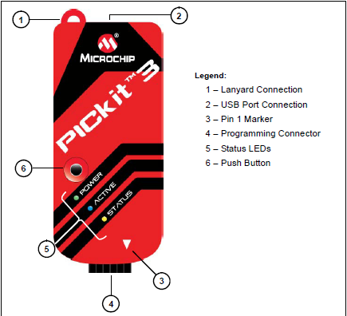

**FIG 11**:PICKit3 extension.

* The PIC-kit 3 programmer is a debugger system, that is used for software and hardware development of Microchip PIC micro-controllers and that are based on In-Circuit Serial Programming and increases In-Circuit Serial Programming 2-wire serial interfaces.More to debugger functions, the PIC-kit 3 programmer system also may be used as programmer that are using for developing. The PIC-kit 3 programmer is not used as a production programmer[5].
* The debugger system performs code like real device because it uses a device with built-in circuitry, instead of a special debugger chip. All features of a given device are accessible relatively, and can be modified and set by the MPLAB IDE interface.
* The PIC-kit 3 debugger was developed for following embedded processors with debugging facilities[5].

**Chapter 5**

**DESIGNING OF LET-WALK CIRCUITORY**

**5.1 Working:**

EVALUATION OF PERFORMANCE:

As per design described, LET-Walk is an exoskeleton, which is used to improve GAIT analysis deliver precise stance and stride phase. LET-Walk has a central concern with Rehabilitation of lower limb for paraplegia that will make user self-assisted.

In our design, we made a basic model of the lower-limb exoskeleton which is used by paraplegic patients for locomotion. In the traditional method, the patient used to wear the harness in their amputated leg for attaining stabilization while walking which is only used for patient’s movements with a rigid harness, without bothering about GAIT cycle. Initially, they used to walk, but not by giving any movements in their joints like knee and ankle. Hence to overcome this problem and to execute patient’s walk according to GAIT cycle, the concept of LET-Walk emerged.

LET-Walk has equipped with 2 major concepts of completely different domains, Rehabilitation and Embedded System. Rehabilitation is a keyword of LET-Walk, which describes the basic applications of lower limbs amputees. Embedded system is the heart of LET-Walk, which we used for making this harness self-assisted. Here we are focusing on convert this harness into electrical harness by the means of embedded system. In the traditional method, all the joints are locked so a person can walk, without moving any joints of the leg but we usedmotor (screw) which is indirectly attached with their respective joints.

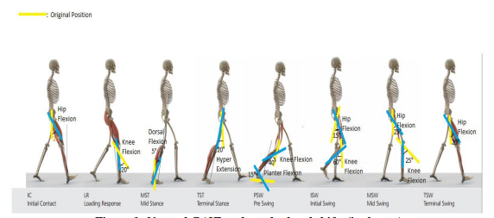

So, by using biomechanics techniques in LET-Walk one can achieve a natural GAIT Cycle, Also can know the perfect duration and angle of movements of each joint in each phase of GAIT Cycle. We found that normal walking required 4 major criteria: (1) Equilibrium. (2) Locomotion. (3) Musculoskeletal Integrity. (4) Neurological Control. The initial phase is known as IC (Initial Contact). In this phase, heel comes in contact with the ground at the hip flexion of 20 degrees. By using hip hardware design for giving flexion, LET-walk is equipped with a handlebar for achieving required angle change keeping the stability in concern. We also took care that all other joints are at fix position and we can alter the position of joints only by screw motor. LR (Loading Response) phase, knee and ankle have shock absorption and forward motion by heel rocker with 20-degree flexion in hip and knee and 10-degree planter flexion in the ankle joint. We have assembled an assembly that has been connected to ankle joint and hip (back side). From this, we can easily control knee joint by giving the revolution in screw motor of knee and ankle and get the desired pattern of GAIT Cycle. MST (Mid Stance) phase controls to a motion of the tibia and shifting to the gravity centre. In this phase knee and ankle has flexion of 5 degrees. This phase in LET-Walk has a major function. Tibia bone is connected with a motor (which is not possible in human but here we only concentrate only in lower part of the body so we have to add tibia bone). This bone and centre of gravity can be controlled by tibia motor. Further, we get phase named TST (Terminal Stance)whichis used for controlled dorsal extension at the ankle joint with lifting the heel from the ground with hyperextension in the hip of 20 degrees and 10-degree dorsal flexion in the ankle joint. We controlled this both ankles by their respective motors that are controlled by embedded system. PSW (Pre-Swing) phase has knee flexion of 40 degrees and planter flexion in ankle joint. This phase is forwarded by ISW (Initial Swing) that has min. 55° knee flexion for sufficient ground clearance. After that, MSW (Mid Swing) increasing hip flexion to 25° and dorsal extension of the ankle joint to neutral-zero-position. TSW (Terminal Swing) is the last stage of GAIT cycle. It has knee joint extension to neutral-flexion. This all events occur in exoskeleton phase. When the patient cannot drive their joints due to pain in the joints at that time this whole exoskeleton converted into wheelchair mode. That can easily drag the patient. The whole movement of joints is controlled by their respective motors and drives.

MODES OF LET-WALK:

User can mainly give 2 different types of commands to LET-walk: 1. Exoskeleton Mode 2. Wheelchair mode

1. Exoskeleton mode: Command for exoskeleton mode can be given by hand mounted control panel. User can control exoskeleton suit from control panel. User can control speed of motors which will result in walking speed of suit. Another command is stair command, which will increase the size of steps which will help in climbing steps of stairs. Object detection or height detection will detect obstacle of difference in height and alert the user.Some natural forces like gravitational force does affect the work load on motor. Additional forces like frictional force, ground reaction force, backward force on motor due to weight of user etc. are accountable and faced in exoskeleton mode.

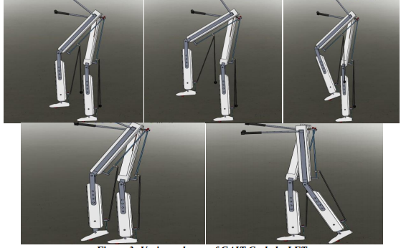

Fig: Exoskeleton mode

Paraplegic person can walk without help of another person just with little support of crutches. Using the stair mode user can climb up and down on stairs.Currently existing exoskeleton suits need external supports via crutches or other person. Also they can’t be transformed into wheelchair for rest of user.

1. Wheelchair mode: Due to more workout or exercise while walking using LET-walk in exoskeleton mode if user needs some rest he/she can turn the wheelchair mode on. It will convert into a wheelchair and there will be no need for support and user can rest on wheelchair and change the place by dragging.In wheelchair mode user can give some commands like move forward, move backward, turn left or right, Speed increase/decrease, obstacle detection etc.Some forces like gravitational force, frictional force with due to shaft of motors and wheels and surface friction force due to contact of wheels with surface

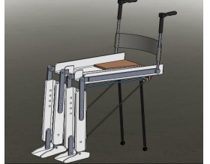

Fig: wheel-chair mode

Challenges are stable transformation of exoskeleton mode to wheelchair mode which should run smoothly. Another challenge is comfortable and durable structure which is comfortable even on uneven surfaces.An ultrasound sensor is installed which will calculate the height of the stairs and then perform motion during stair climbing mode.

Coading:

#include <xc.h>

#include "lcd.h"

#include "delays.h"

#include "keypad.h"

// CONFIG1L

#pragma config PLLDIV = 5//5//12//1 // PLL Prescaler Selection bits (No prescale (4 MHz oscillator input drives PLL directly))

#pragma config CPUDIV = OSC1_PLL2//OSC2_PLL3//OSC1_PLL2// System Clock Postscaler Selection bits ([Primary Oscillator Src: /1][96 MHz PLL Src: /2])

#pragma config USBDIV = 1//1 // USB Clock Selection bit (used in Full-Speed USB mode only; UCFG:FSEN = 1) (USB clock source comes directly from the primary oscillator block with no postscale)

// CONFIG1H

#pragma config FOSC = INTOSC_HS//INTOSC_HS//HSPLL_HS//INTOSC_HS//XT_XT//XT_XT // Oscillator Selection bits (XT oscillator (XT))

#pragma config FCMEN = OFF // Fail-Safe Clock Monitor Enable bit (Fail-Safe Clock Monitor disabled)

#pragma config IESO = ON//OFF // Internal/External Oscillator Switchover bit (Oscillator Switchover mode disabled)

// CONFIG2L

#pragma config PWRT = OFF // Power-up Timer Enable bit (PWRT disabled)

#pragma config BOR = ON // Brown-out Reset Enable bits (Brown-out Reset enabled in hardware only (SBOREN is disabled))

#pragma config BORV = 3 // Brown-out Reset Voltage bits (Minimum setting)

#pragma config VREGEN = OFF // USB Voltage Regulator Enable bit (USB voltage regulator disabled)

// CONFIG2H

#pragma config WDT = OFF//ON // Watchdog Timer Enable bit (WDT enabled)

#pragma config WDTPS = 32768 // Watchdog Timer Postscale Select bits (1:32768)

// CONFIG3H

#pragma config CCP2MX = ON // CCP2 MUX bit (CCP2 input/output is multiplexed with RC1)

#pragma config PBADEN = ON // PORTB A/D Enable bit (PORTB<4:0> pins are configured as analog input channels on Reset)

#pragma config LPT1OSC = OFF // Low-Power Timer 1 Oscillator Enable bit (Timer1 configured for higher power operation)

#pragma config MCLRE = OFF//ON // MCLR Pin Enable bit (MCLR pin enabled; RE3 input pin disabled)

// CONFIG4L

#pragma config STVREN = ON // Stack Full/Underflow Reset Enable bit (Stack full/underflow will cause Reset)

#pragma config LVP = OFF//ON // Single-Supply ICSP Enable bit (Single-Supply ICSP enabled)

#pragma config ICPRT = OFF // Dedicated In-Circuit Debug/Programming Port (ICPORT) Enable bit (ICPORT disabled)

#pragma config XINST = OFF // Extended Instruction Set Enable bit (Instruction set extension and Indexed Addressing mode disabled (Legacy mode))

// CONFIG5L

#pragma config CP0 = OFF // Code Protection bit (Block 0 (000800-001FFFh) is not code-protected)

#pragma config CP1 = OFF // Code Protection bit (Block 1 (002000-003FFFh) is not code-protected)

#pragma config CP2 = OFF // Code Protection bit (Block 2 (004000-005FFFh) is not code-protected)

#pragma config CP3 = OFF // Code Protection bit (Block 3 (006000-007FFFh) is not code-protected)

// CONFIG5H

#pragma config CPB = OFF // Boot Block Code Protection bit (Boot block (000000-0007FFh) is not code-protected)

#pragma config CPD = OFF // Data EEPROM Code Protection bit (Data EEPROM is not code-protected)

// CONFIG6L

#pragma config WRT0 = OFF // Write Protection bit (Block 0 (000800-001FFFh) is not write-protected)

#pragma config WRT1 = OFF // Write Protection bit (Block 1 (002000-003FFFh) is not write-protected)

#pragma config WRT2 = OFF // Write Protection bit (Block 2 (004000-005FFFh) is not write-protected)

#pragma config WRT3 = OFF // Write Protection bit (Block 3 (006000-007FFFh) is not write-protected)

// CONFIG6H

#pragma config WRTC = OFF // Configuration Register Write Protection bit (Configuration registers (300000-3000FFh) are not write-protected)

#pragma config WRTB = OFF // Boot Block Write Protection bit (Boot block (000000-0007FFh) is not write-protected)

#pragma config WRTD = OFF // Data EEPROM Write Protection bit (Data EEPROM is not write-protected)

// CONFIG7L

#pragma config EBTR0 = OFF // Table Read Protection bit (Block 0 (000800-001FFFh) is not protected from table reads executed in other blocks)

#pragma config EBTR1 = OFF // Table Read Protection bit (Block 1 (002000-003FFFh) is not protected from table reads executed in other blocks)

#pragma config EBTR2 = OFF // Table Read Protection bit (Block 2 (004000-005FFFh) is not protected from table reads executed in other blocks)

#pragma config EBTR3 = OFF // Table Read Protection bit (Block 3 (006000-007FFFh) is not protected from table reads executed in other blocks)

// CONFIG7H

#pragma config EBTRB = OFF // Boot Block Table Read Protection bit (Boot block (000000-0007FFh) is not protected from table reads executed in other blocks)

void Delay_ms(unsigned int a);

void run_motor();

void main()

{

unsigned int a = 0;

lcd_on();

int p = 0;

TRISB = 0xF0;

ADCON1 = 0x0F;

TRISB = 0xF0;

TRISD = 0;

PORTD=0;//LATD = 0;

// PORTD = 1;

INTCON2bits.RBPU = 0;

//1st motor

PORTDbits.RD0=1;

Delay_ms(8);

PORTDbits.RD0=0;

Delay_ms(8);

PORTDbits.RD1=1;

Delay_ms(8);

PORTDbits.RD1=0;

Delay_ms(8);

// 2nd motor

PORTDbits.RD2=1;

Delay_ms(8);

PORTDbits.RD2=0;

Delay_ms(60);

PORTDbits.RD3=1;

Delay_ms(60);

PORTDbits.RD3=0;

Delay_ms(60);

PORTDbits.RD4=1;

Delay_ms(60);

PORTDbits.RD4=0;

Delay_ms(60);

PORTDbits.RD5=1;

Delay_ms(60);

PORTDbits.RD5=0;

Delay_ms(60);

PORTDbits.RD6=1;

Delay_ms(60);

PORTDbits.RD6=0;

Delay_ms(60);

PORTDbits.RD7=1;

Delay_ms(60);

PORTDbits.RD7=0;

Delay_ms(60);

}

// run_motor();

}

void Delay_ms(unsigned int a)

{

int u=0,j=0;

for(j=0;j<a;j++)

for(u=0;u<220;u++);

}

void run_motor()

{

unsigned int i=0;

TRISD=0;

unsigned char a=0;

while(1){

a = is_key_pressed_ext();

if(a == 1)

{

lcd_on();

lcd_command(LCD_LINE1);

lcd_write_string("MOTOR ON");

while(1)

{

if(i==30)

{

a = is_key_pressed();

i=0;

}

if(a==2)

{

lcd_clear();

lcd_write_string("MOTOR OFF");

break;

}

// {

LATD=0x05; // 0101

Delay_ms(2);

LATD = 0x0A; //1010

Delay_ms(2);

LATD = 0x03; //0011

Delay_ms(2);

LATD = 0x0C; //1100

Delay_ms(2);

i++;

}

}

}

}

**Chapter 6**

**Challenges And Outcomes**

Several questions still need to be considered when designing the suit past the initial prototype invention:

1. **What will power the prototype?**

* Let-walk will be powered by the means of poratble media as well as wired media,if the need of it arises within the premises
* The constant supply to the controller will allow the accurate and precise flow of power which ultimately results into an efficient and interrupt free data communication via all peripherals
* ULN is also incorporated for a steady supply of current which is made possible due to darling-ton pair formed from five transistor
* Handling it,first prototype will be highly wired as we will consider the serial communication as our first priority.

**B.How will it know how high to step?**

* This question needs to be considered as a higher aspects as for now with a view of incorporation of IR sensors will be placed on the front part of limb for it will detect the height of the stairs and read the data accordingly and that will affect the degree of freedom the joints.
* Handling it,for our first priority to be walking it,despite stair climbing hence that is what we will.

**C.How much should it weight?**

* That totally depends the economic background of which people use it which will ultimately speak about the components which are incorporated will have their own weight. For instance if the price is quoted high then flexibility and compatibility will increase with portability and if not so than some fluffy malfunctioning may occur.
* Handling it,designer will note down the weight constarints and then choose the drives accordingly.

**D.What forces do the motors need to generate?**

* As we are concerning with LET-Mi, the control of the exoskeleton can be generated by the DC stepper motor. The main issue that we were facing is when the load on the exoskeleton does increase at that time when the (load on motor will increase and there are some possibilities that motor might not stay static and rotating in reverse manner)
* Different motor will perform differently at different location as at each joint the force.

**E.What are the user's weight limitations?**

* This is considered to bour major challenge as the availability of powerful drives will be needed and must vary according to the weight constraints of the user.
* Hence it must come with the worst case scenerio lifting barrier as its user specific hence it weight should be taken into consideration with center of gravity while designing it

**REFRENCES:**

[1]  Hofstoetter, US; Krenn, M; Danner, SM; Hofer, C; Kern, H; McKay, WB; Mayr, W; Minassian, K (October 2015). "Augmentation of Voluntary Locomotor Activity by Transcutaneous Spinal Cord Stimulation in Motor-Incomplete Spinal Cord-InjuredIndividuals.". ArtificialOrgans. **39** (10): E176–86. [doi](https://en.wikipedia.org/wiki/Digital_object_identifier):[10.1111/aor.12615](https://dx.doi.org/10.1111%2Faor.12615). [PMID](https://en.wikipedia.org/wiki/PubMed_Identifier) [26450344](https://www.ncbi.nlm.nih.gov/pubmed/26450344).

[2] Scherer, Marcia; Stefano Federici (2012). Assistive Technology Assessment Handbook. CRC Press. . [ISBN](https://en.wikipedia.org/wiki/International_Standard_Book_Number) [9781439838655](https://en.wikipedia.org/wiki/Special:BookSources/9781439838655).

[3]  ["Reduced-rate VAT on mobility aids for older people"](http://www.hmrc.gov.uk/vat/sectors/consumers/mobility-aids.htm). London: HM Revenue and Customs. Retrieved 25 September 2010.

[4] Heath, Steve (2003). [Embedded systems design](https://books.google.com/books?id=BjNZXwH7HlkC&pg=PA2). EDN series for design engineers (2 ed.). Newnes. p. 2. [ISBN](https://en.wikipedia.org/wiki/International_Standard_Book_Number) [978-0-7506-5546-0](https://en.wikipedia.org/wiki/Special:BookSources/978-0-7506-5546-0). An embedded system is a [microprocessor](https://en.wikipedia.org/wiki/Microprocessor" \o "Microprocessor)based system that is built to control a function or a range of functions.

[5] [Designing Embedded Systems with PIC Microcontrollers](https://books.google.com/books?id=dVW-PpvUcsgC&pg=PA86&dq=mplab&hl=en&sa=X), Newnes, 07-Nov-2009

Research paper:



**LIMB EMPLOYING TRANS-MECHANISM**

**Kunal Yogeshkumar Parikh1, Hiren Dave2, Vishal Purohit3, Hemal Dave4, Milan Patel5**

*1, 2Sr. R & D Engineer, Department of R & D, Hermes Technologies, Gandhinagar, Gujarat, India*

*3, 4, 5UG students, Department of Biomedical Engineering, L. D. College of Engineering, Ahmedabad, Gujarat, India*

**Abstract:** This paper talks about a newly developed paradigm for rehabilitation of paraplegics namedL.E.T-walk. It's abbreviated as Limb Employing Trans-mechanism walk which provides resemblance of an artificial lower pelvis segment till the foot plate, with impedance controlled joints like knee and ankle, which will restrict the movement in either direction with a precise and well-programmed treadmill walk approach. It is so designed in its mechanical ways that it can be easily translated into a wheelchair mode whenever the user feels. Enhanced mechanical strategy distanced it from immense electrical malware expenses. For the easy control, we used an embedded system as a medium for communication, which holds all the notifications on the display, the command control for flexibility and user-friendly interactions. The possibilities to using the paradigm improved the GAIT cycle also reduced the distance and height barriers due to the plasticity of impaired limbs.The goal of this prototype is to perform specific defined movements by the means of drives incorporated in according places that provoke motor plasticity to the patient andthus help in motor recovery and reducesfunctional deficits.

**Keywords:** Rehabilitation; Paraplegia; Lower-Limb Exoskeleton; Powered Lower Limbs

**I. INTRODUCTION**

Traditional exoskeletons are often stubborn and less comfortable which result in less convincing and the total purpose of what they are designed for remains un-served. Additionally their attachments and fixations are tedious at times hence it remains a huge loop between consumer satisfaction and their recovery. All these factors stimulate innovation inthe domain of rehabilitation in such way it becomesmoreaffordable and available for more patients and for a longerperiod of time, which is the base concern of L.E.T-walk team Passive assist devices like crutches; orthosis, although are less complex and inexpensive, cannot provide energy to the impaired limbs, hence are confined compared to active devices and are out of the scope of this work.

Robotics had played a sumptuous role in each commodity where human interaction is either tedious or meaningless. When it comes to the rehabilitation it has found its place in the form of exoskeleton. An exoskeleton is worn like attire and if designed impedance free, it soon becomes part of a body. Robotics has found its potential advantage when it comes to a person with lower limb disorders over conventional techniques for the following reasons: 1) it bypasses the neural activity needed for limb employment; 2) it provides well calculated and calibrated outcomes for precise recovery, which conventional paradigm often fails to deliver; 3) high mechanical investment made it less complicated, both in the terms of maintainability and durability.

**II. RELATED WORK DEATILS**

This century has witnessed a tremendous rise in the sector of health care and medicine due to invasion of technology. Although many of rehabilitation robotics are being developed or are in a stage to create history, but the basic principle remains unchanged. Each system mentioned in Table 1 lags is designed as per task specific which at times raise the demand for something more to the existing consumer. The cost for distribution remains omnipresent factor, which often give the people give a good reason to crawl and face problems despite purchasing it.

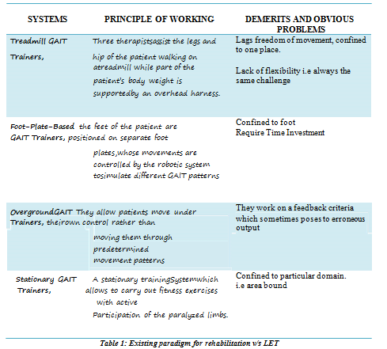

Our research work is to come over from the above demerits. The complete details of hardware and software parts of our project are given below.

**HARDWARE DETAILS:**

**PIC Development Board:** This is used to control and give command to the motor to run as perrequirement. PIC18F4550 Microcontroller is used as heart of the system. This microcontroller is used for interfacing other device like Keypad, DC Motor, LED, LCD etc.

**Primary chasy:** High Grade polymeric plastic and ultra lightaluminium, which are specially designedto serve for the purpose of reducing the dead weight of the system itself. Plastic is used for engulfing the limbs and aluminium for transferring the body weight of whatsoever forces towards the ground.

**Screw Motors:** Specially designed this motors were fastened with PWM coding in MP lab and on theshaft, a purposely designed screw with specific size via lathe and milling of high enduring steel rod of about 20 mm thick diameter.

**Ball Bearing:** They are being incorporated at all the existing joint for compliance free locomotion andnullifying the frictional errors and functional noises.

**Dual-Axis Mechanism:** This is inspired from the gyroscopic dual axis mechanism for enabling thelimb ankle and knee motion, in which one free axis is welded with a nut screwed in Screw motor to seek command in mechanical means with motor revolution and the other, is to be attached for holding the limb.

**Wheels:** They for the obvious reason for the transformation from an exoskeleton to a manual/electricwheel chair.

**SOFTWARE DETAILS:**

**MPLAB X IDE**: It is a software program that runs on to develop applications for Microchipmicrocontrollers and digital signal controllers. It is called an Integrated Development Environment (IDE), because it provides a single integrated "environment" to develop code for embedded microcontrollers.

**EVALUATION OF PERFORMANCE:**As per design described, LET-Walk is an exoskeleton,which is used to improve GAIT analysis deliver precise stance and stride phase. LET-Walk has a central concern with Rehabilitation of lower limb for paraplegia that will make user self-assisted.

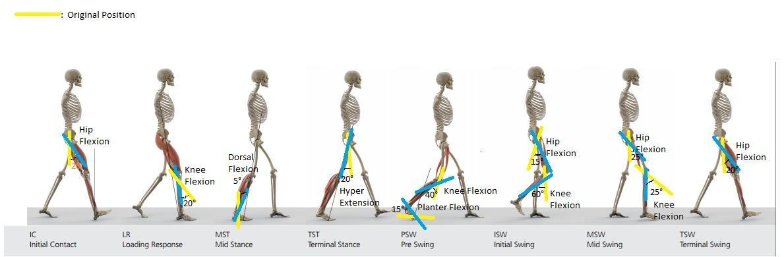

***Figure 1: Natural GAIT cycle and related shifts (in degree)***

In our design, we made a basic model of the lower-limb exoskeleton which is used by paraplegic patients for locomotion. In the traditional method, the patient used to wear the harness in their amputated leg for attaining stabilization while walking which is only used for patient’s movements with a rigid harness, without bothering about GAIT cycle. Initially, they used to walk, but not by giving any movements in their joints like knee and ankle. Hence to overcome this problem and to execute patient’s walk according to GAIT cycle, the concept of LET-Walk emerged.

LET-Walk has equipped with 2 major concepts of completely different domains, Rehabilitation and Embedded System. Rehabilitation is a keyword of LET-Walk, which describes the basic applications of lower limbs amputees. Embedded system is the heart of LET-Walk, which we used for making this harness self-assisted. Here we are focusing on convert this harness into electrical harness by the means of embedded system. In the traditional method, all the joints are locked so a person can walk, without moving any joints of the leg but we usedmotor (screw) which is indirectly attached with their respective joints.

So, by using biomechanics techniques in LET-Walk one can achieve a natural GAIT Cycle, Also can know the perfect duration and angle of movements of each joint in each phase of GAIT Cycle. We found that normal walking required 4 major criteria:

1. Equilibrium.
2. Locomotion.
3. Musculoskeletal Integrity.
4. Neurological Control.

The initial phase is known as IC (Initial Contact). In this phase, heel comes in contact with the ground at the hip flexion of 20 degrees. By using hip hardware design for giving flexion, LET-walk is equipped with a handlebar for achieving required angle change keeping the stability in concern. We also took care that all other joints are at fix position and we can alter the position of joints only by screw motor.

LR (Loading Response) phase, knee and ankle have shock absorption and forward motion by heel rocker with 20-degree flexion in hip and knee and 10-degree planter flexion in the ankle joint. We have assembled an assembly that has been connected to ankle joint and hip (back side). From this, we can easily control knee joint by giving the revolution in screw motor of knee and ankle and get the desired pattern of GAIT Cycle.

MST (Mid Stance) phase controls to a motion of the tibia and shifting to the gravity centre. In this phase knee and ankle has flexion of 5 degrees. This phase in LET-Walk has a major function. Tibia bone is connected with a motor (which is not possible in human but here we only concentrate only in lower part of the body so we have to add tibia bone). This bone and centre of gravity can be controlled by tibia motor. Further, we get phase named TST (Terminal Stance)whichis used for controlled dorsal extension at the ankle joint with lifting the heel from the ground with hyperextension in the hip of 20 degrees and 10-degree dorsal flexion in the ankle joint. We controlled this both ankles by their respective motors that are controlled by embedded system.

PSW (Pre-Swing) phase has knee flexion of 40 degrees and planter flexion in ankle joint. This phase is forwarded by ISW (Initial Swing) that has min. 55° knee flexion for sufficient ground clearance. After that, MSW (Mid Swing) increasing hip flexion to 25° and dorsal extension of the ankle joint to neutral-zero-position. TSW (Terminal Swing) is the last stage of GAIT cycle. It has knee joint extension to neutral-flexion.

This all events occur in exoskeleton phase. When the patient cannot drive their joints due to pain in the joints at that time this whole exoskeleton converted into wheelchair mode. That can easily drag the patient. The whole movement of joints is controlled by their respective motors and drives.

**IV. PROPOSED WORK**

In the practical side of LET-Walk, we have to dominate all the phases with insignificant error by the means of LET-Walk and its sheer coding of motors and drives by Embedded System. Each and every angle is calibrated while providing the code for Screw motors revolution, of which some are interactive and some are simply irreplaceable. While constraining these motors, we are able to give a degree of freedom to human joints. So patient’s can improve their GAIT cycle. Thus it fulfils its use as GAIT Trainer for giving assistance to the patients. When if the user is willing to switch mode from exoskeleton or he/she does not wish to move any longer or due to whatsoever circumstances at that time whole exoskeleton remodels achieving the maximum bending angle for knee motor into the wheelchair. So it can easily drag patient with castor wheels lying beneath.

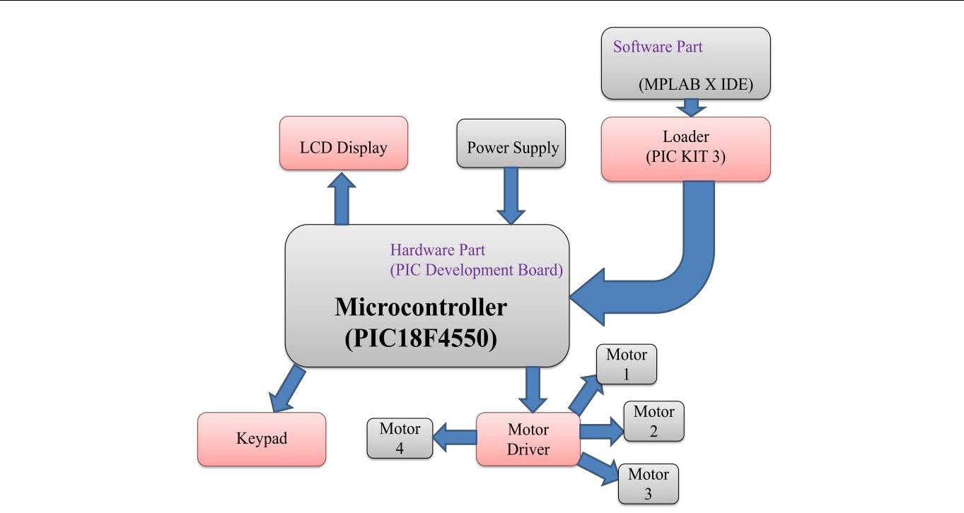

**MODES OF LET-WALK:**

User can mainly give 2 different types of commands to LET-walk:

1. Exoskeleton Mode
2. Wheelchair mode

**1. Exoskeleton mode:** Command for exoskeleton mode can be given by hand mounted control panel.User can control exoskeleton suit from control panel. User can control speed of motors which will result in walking speed of suit. Another command is stair command, which will increase the size of steps which will help in climbing steps of stairs. Object detection or height detection will detect obstacle of difference in height and alert the user.Some natural forces like gravitational force does affect the work load on motor. Additional forces like frictional force, ground reaction force, backward force on motor due to weight of user etc. are accountable and faced in exoskeleton mode.

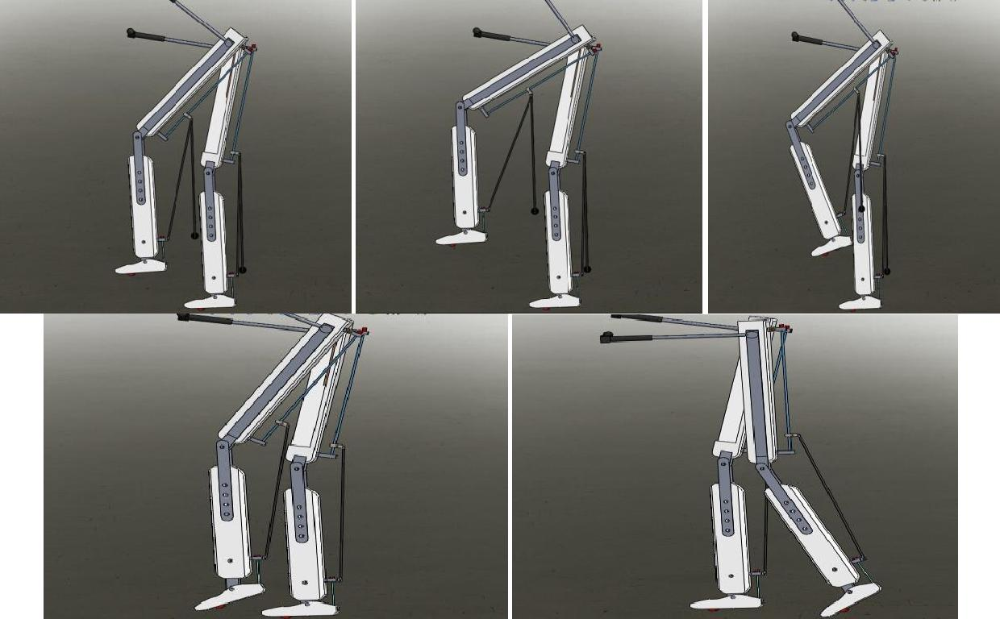

***Figure 3: Various phases of GAIT Cycle by LET***

Paraplegic person can walk without help of another person just with little support of crutches. Using the stair mode user can climb up and down on stairs.Currently existing exoskeleton suits need external supports via crutches or other person. Also they can’t be transformed into wheelchair for rest of user.

**2. Wheelchair mode:** Due to more workout or exercise while walking using LET-walk inexoskeleton mode if user needs some rest he/she can turn the wheelchair mode on. It will convert into a wheelchair and there will be no need for support and user can rest on wheelchair and change the place by dragging.In wheelchair mode user can give some commands like move forward, move backward, turn left or right, Speed increase/decrease, obstacle detection etc.Some forces like gravitational force, frictional force with due to shaft of motors and wheels and surface friction force due to contact of wheels with surface.

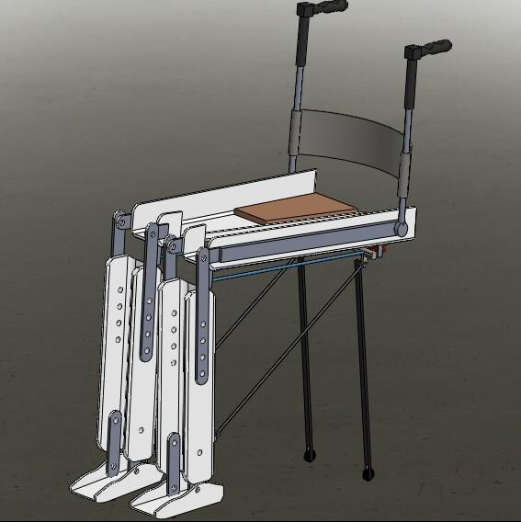

***Figure 4: Wheelchair Mode of LET***

Challenges are stable transformation of exoskeleton mode to wheelchair mode which should run smoothly. Another challenge is comfortable and durable structure which is comfortable even on uneven surfaces.An ultrasound sensor is installed which will calculate the height of the stairs and then perform motion during stair climbing mode.

**V. CONCLUSION**

L.E.T is really motivated by the certain incidencesand experiences to be nullified, incidents like impaired person facing height and distance barrier. It was purposely crafted for the gratitude of those helpless people, who wants to achieve no less than a normal human being.LET is a challenge to existing Rehabilitation paradigms to be available at this cost, yet being this flexible and robust simultaneously.Regardless of it, we respect the existing commodities for giving us the loop holes and feel them with success named Limb Employing Trans-mechanism.

**REFERENCES**

1. M.A. Mazidi, R. McKinley and D. Causey, PIC Microcontroller and Embedded Systems: Using Assemble and C for PIC, ISBN: 0-13-600902-6, 2008
2. PIC18F2455/2550/4455/4550 Data Sheet from Microchip Technology Inc, DS39632C, 2006
3. MPLAB® ICD 3 In-Circuit Debugger User’s Guide For MPLAB X IDE from Microchip Technology Inc, DS52081A, 2012

[4] PICkit™ 3 Programmer/Debugger User’s Guide from Microchip Technology Inc, DS51795A, 2009

1. Effects of training with the Re-Walk exoskeleton on quality of life in incomplete spinal cord injury: a single case study, Spinal Cord Series and Cases (2016) 3
2. Force Sustainment: Rehabilitation, Regeneration and Prosthetics for Re-Integration to Duty. (pp. 6-1 – 6-14). Meeting Proceedings STO-MP-HFM-228, Paper 6. Neuilly-sur-Seine, France: Apr 2013