**Abstract:**

The purpose of the project is to design a robot that repels the pests like locusts, birds as well as to notify/send an alert, if a blue bull (*nilgai)* appears to come in the direction of the field. The device is mobile, and it does not cause any pollution unlike the other chemical repellents.

**Introduction:**

It is possible that pests like locusts, birds are repelled by ultrasonic frequency in the range of 30kHz to 50kHz. Human beings can't hear these high- frequency sounds. Our project repels pests by emitting pulse ultrasonic waves. Using ultrasonic waves creates a nostile environment which repels pests, while safe for human ears. Unfortunately, all pests do not react at the same frequency. While some pests (like locusts) repel at 50kHz to 100kHz, others like birds repel at 15kHz to 25kHz or even higher frequencies. Thus, to increase the effectiveness, the frequency of ultrasonic oscillator has to be continuously varied between certain limits so that pests do not adapt to it.

**Background:**

"Ultrasound and Arthropod Pest Control", an extensive Kansas State University study confirmed that ultrasonic sound devices do have both repellent effect as well as a reduction in maintaining and reproduction of various insects.

A 2002 study by Genesis Laboratories Inc. does lend some credence to the ability of electronic repellent devices to repel certain pests in controlled environments.

**Design of Circuit:**

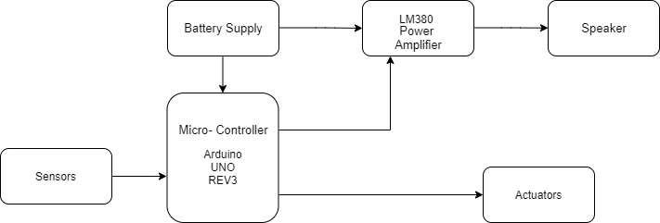

Block diagram of the circuit

**Components:**

**a) LM380 Ultrasonic Transducer:**

We are using it as an audio power amplifier circuit that is capable of producing sound in the frequency range upto 80kHz. Basically, it is used as a phonograph amplifier(Phonograph Amplifiers amplifies sound, just like your main amplifier does but the phono amp is a specialised piece of kit, designed to amplify those tiny signals, only detectable by trained dogs and a few curious mosquitos). This is a 2.5W audio power amplifier. Its gain is internally fixed at 34dB. Some of the important features are:

o Supply voltage - 10V to 22 V

o Peak current - 1.3 A

o Minimum output power (rms) - 2.5 W (RL= 8Ω; THD = 3 %)

o Av (Gain) - 40 – 60 V/V

o Typical Av - 50 V/V

o Zin (Input Resistance) - 150 kΩ

o Bandwidth - 100 kHz

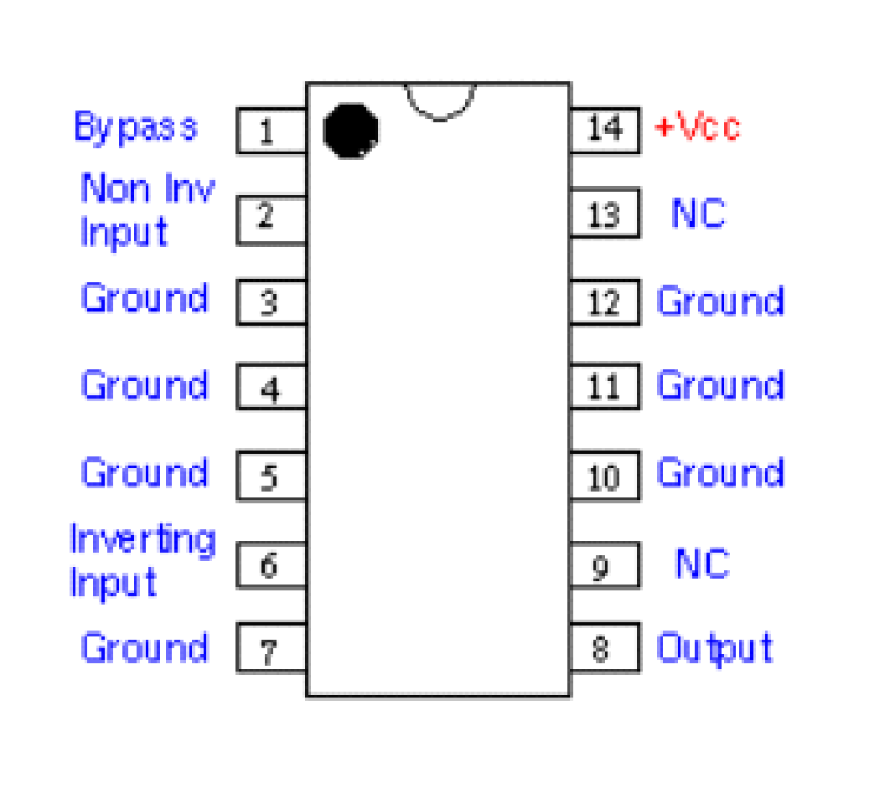

LM380 Pin Diagram

**b) Speaker:**

The Speaker we are using here is from Kemo Electronics, Piezo Loudspeaker for Ultrasonic Power Cannon (M161) Kemo part L010. The reason using this speaker is because the frequency required to repel the pests, can come as output from it. Other features are :

* Rated Voltage- 16Vp-p
* Max. Rated Long Power- 30 Vp-p
* Frequency Range(approx.)-2-60kHz
* Sound Pressure level(max)- 120dB(± 15%)

**c)Ardinuo( as Microcontroller):**

The Arduino Uno is an [open-source](https://en.wikipedia.org/wiki/Open-source) [microcontroller board](https://en.wikipedia.org/wiki/Microcontroller_board) based on the [Microchip](https://en.wikipedia.org/wiki/Microchip_Technology) [ATmega328P](https://en.wikipedia.org/wiki/ATmega328P) microcontroller and developed by [Arduino.cc](https://en.wikipedia.org/wiki/Arduino). The board is equipped with sets of digital and analog [input/output](https://en.wikipedia.org/wiki/Input/output) (I/O) pins that may be interfaced to various [expansion boards](https://en.wikipedia.org/wiki/Expansion_board) (shields) and other circuits.The board has 14 digital I/O pins (six capable of [PWM](https://en.wikipedia.org/wiki/Pulse-width_modulation) output), 6 analog I/O pins, and is programmable with the [Arduino IDE](https://en.wikipedia.org/wiki/Arduino#Software) (Integrated Development Environment), via a type B [USB cable](https://en.wikipedia.org/wiki/USB_cable).It can be powered by the USB cable or by an external [9-volt battery](https://en.wikipedia.org/wiki/9-volt_battery), though it accepts voltages between 7 and 20 volts.

* [Microcontroller](https://en.wikipedia.org/wiki/Microcontroller): [Microchip](https://en.wikipedia.org/wiki/Microchip_Technology) [ATmega328P](https://en.wikipedia.org/wiki/ATmega328P)
* Operating Voltage: 5 Volts
* Input Voltage: 7 to 20 Volts
* Digital I/O Pins: 14 (of which 6 can provide PWM output)
* Analog Input Pins: 6
* DC Current per I/O Pin: 20 mA
* DC Current for 3.3V Pin: 50 mA
* [Flash Memory](https://en.wikipedia.org/wiki/Flash_Memory): 32 KB of which 0.5 KB used by [bootloader](https://en.wikipedia.org/wiki/Booting#BOOT-LOADER)
* Clock Speed: 16 MHz

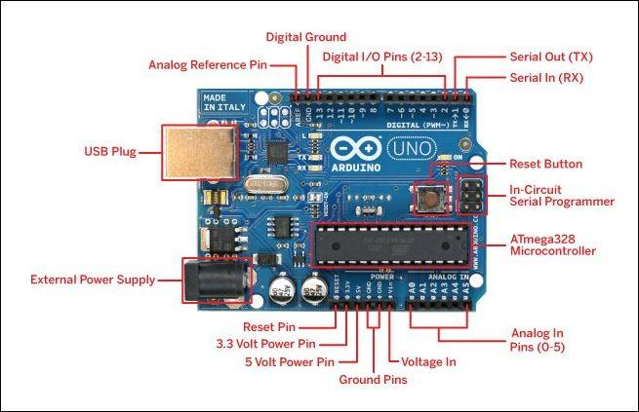

arduino uno rev 3 pin diagram

**d)Ultrasonic Sensor:**

This is used to sense the frequency produced by birds, locusts etc. Model used is MURATA MA40A5R 0.6-20FT range ultrasonic sensor Transducer.

Product Features:

* Maximum input voltage: 20Vrms

* Range: 0.6 to 20ft

*Sound pressure: 112dB min

*Sensitivity: -67dB min

*Frequency: 40kHz

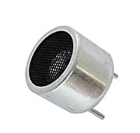

Ultrasonic Sensor

**e)PIR Sensor:**

PIR sensors allow you to sense motion, almost always used to detect whether a human has moved in or out of the sensor's range. They are small, inexpensive, low-power, easy to use and don't wear out. Here, they are used to detect obstacles that might come in the path of the robot when it’s moving to the desired location. Other features include,

* Operating voltage(V): (approx.)5V
* Operating current(μA): 170
* Sensing Distance: 12m
* Output Type: Digital

**f)Power Supply:**

For power supply, we are using LIPO battery which includes the following features:

* Capacity: 6000mAh
* Output Voltage: 22.2V
* Config Discharge: 6S1P
* Length: 35mm
* Width: 59mm
* Weight: 885g

**g)Actuators:**

Motor drivers acts as an interface between the motors and the control circuits. Motor require high amount of current whereas the controller circuit works on low current signals. So the function of motor drivers is to take a low-current control signal and then turn it into a higher-current signal that can drive a motor. Driver model we are using is L298N 2A.

**ROBOT DESIGN**

For designing the robot we have used a prototype of a tank for base and wheel.Since the farmland is not smooth or plain we used the caterpillar wheel to overcome all these things.

we have considered following things to design the Robot Prototype :-

⦁ As compared to real life caterpillar wheel(as used in Panzer IV- Army Tank) the number of wheel drives are reduced to 3 as the model is itself small, so as to be engaged in a continuous without compromising the stability of the robot.

⦁ The front and rear drive wheels here are used as a mean to climb over the small obstacles such as pebbles etc to be over runned

⦁ Since the robot is being turned by giving opposite motion to the motors on both side, the idler wheel has also been removed.

⦁ The shape of the belt unit has been changed to a thinner version and the material is rubber to facilitate the motion on farm land due to reduced requirement of frictional force because of the small size of the robot.

⦁ This wheelbase was chosen so as to provide stability to the robot in case of encounter with fauna trading off at its speed which is affordable as the robot doesn't actually have to chase the animal but get near it.

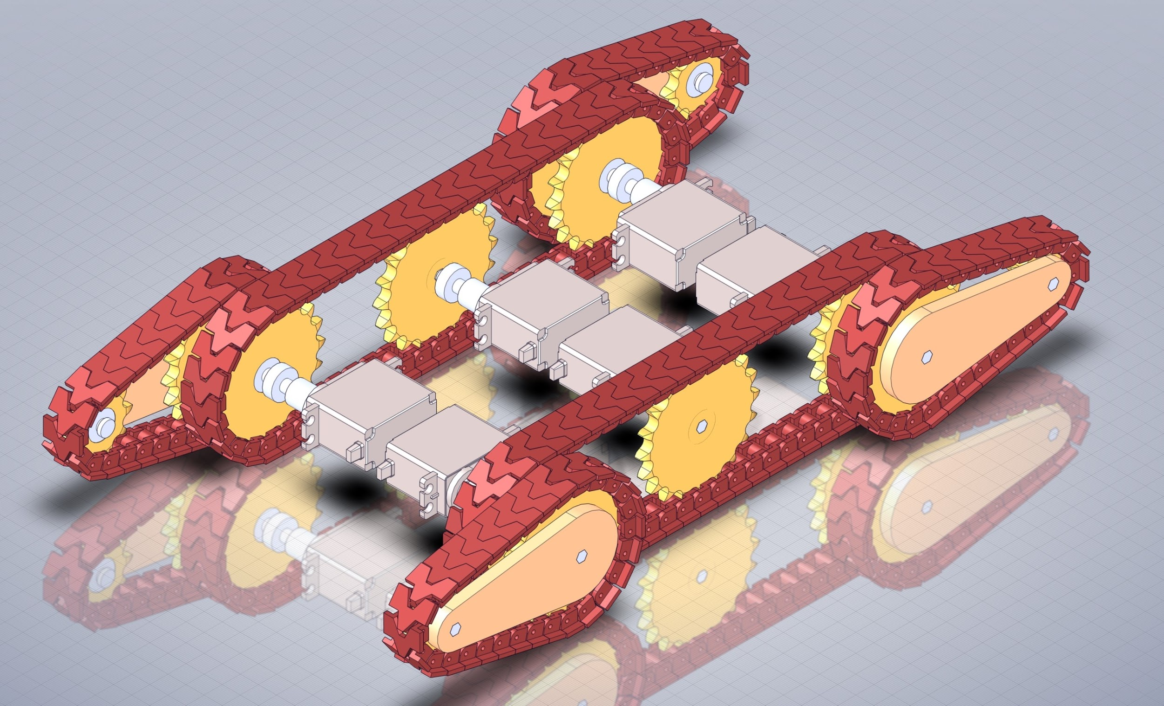

**WORKING**

The main objective of our robot is to guard the farm against different pest mainly birds, blue bull, locust.

The principal of working of our robot lies in the detection and then counter measure, it can be further divided in three subparts each for above pest.

**1.LOCUST**

As we all know locust come in huge herd so they easily identified from far with their specific voice, For detection we are majorly focusing on detecting their voice frequency with the help ultrasonic sensor and various deep learning datasets.For counter measure bot will emit certain range of frequency which act as repellent for them.

Upon detecting locust our bot will first move around the whole farm in specific path provided by A* algorithm and in the same time emitting the repelling frequency on completion of the whole round of farm the bot will to its base station and it will repeat the same process until there are locusts present in the farm.

**2.BIRDS**

Similarly as birds also have some specific voice frequency and we will detect them by using Ultrasonic sensors and deep learning datasets that include clear representations of the possible variations in vocalisations of each bird that will be fed in the system. .Upon detection we will again emit repelling frequency with help of Ultrasonic Power Cannon (M161) Kemo part L010 sensor and LM380 Ultrasonic Transducer sensor.

For path planning against Birds we will be

Using deep learning it will detect the birds and its position using a machine learning model and if the bird is within range the robot will move towards the goal position which is the nearest reachable position to the bird and it will start radiating required frequency.

**3.BLUE BULL(*nilgai)***

For Blue Bull we are focusing on motion sensing, since they are big animals they are easily detectable.We are using PIR sensor for detecting any movements in farm field.Upon detecting any activity in field,bot will use its camera to capture the image of any animals and after capturing it will use image processing with the help of deep learning datasets that help to confirm the animal.After detecting and image processing the bot will use speaker to produce such a noise to make them go away.

**Datasets**

1. **Field recordings, worldwide ("freefield1010")** - a collection of 7,690 excerpts from field recordings around the world, gathered by the [FreeSound](http://freesound.org/) project, and then [standardised](https://arxiv.org/abs/1309.5275) for research. This collection is very diverse in location and environment, and for the BAD Challenge we have annotated it for the presence/absence of birds.

- Download: [[**data labels**](https://ndownloader.figshare.com/files/10853303)] • [[**audio files (5.8 Gb zip)**](https://archive.org/download/ff1010bird/ff1010bird_wav.zip)] (or [[via bittorrent](https://archive.org/download/ff1010bird/ff1010bird_archive.torrent)])

2. **Crowdsourced dataset, UK ("warblrb10k")** - 8,000 smartphone audio recordings from around the UK, crowdsourced by users of [Warblr the bird recognition app](http://warblr.net/). The audio covers a wide distribution of UK locations and environments, and includes weather noise, traffic noise, human speech and even human bird imitations.

- Download: [[**data labels**](https://ndownloader.figshare.com/files/10853306)] • [[**audio files (4.3 Gb zip)**](https://archive.org/download/warblrb10k_public/warblrb10k_public_wav.zip)] (or [[via bittorrent](https://archive.org/download/warblrb10k_public/warblrb10k_public_archive.torrent)])

3. **Remote monitoring flight calls, USA ("BirdVox-DCASE-20k")** - 20,000 audio clips collected from remote monitoring units placed near Ithaca, NY, USA during the autumn of 2015, by [the BirdVox project](http://wp.nyu.edu/birdvox). [More info about BirdVox-DCASE-20k](https://zenodo.org/record/1208080)

- Download: [[**data labels**](https://ndownloader.figshare.com/files/10853300)] • [[**audio files (15.4 Gb zip)**](https://zenodo.org/record/1208080/files/BirdVox-DCASE-20k.zip)

#### S3 Video

**The visual results for the Locust migration with different density of the group.**

(MP4)

[Click here for additional data file.](https://www.ncbi.nlm.nih.gov/pmc/articles/PMC4871504/bin/pone.0155698.s023.mp4)(7.4M, mp4)

#### S2 Video

**The visual results for the aggregation of moths swarm and mosquitoes swarm.**

(MP4)

[Click here for additional data file.](https://www.ncbi.nlm.nih.gov/pmc/articles/PMC4871504/bin/pone.0155698.s022.mp4)(8.4M, mp4)