# Supplementary File — CODEFORGE

## 1. Team Information

Team Name: CODEFORGE

Members:

- VIJAY M

- THANGA PALANI K

* MANJULAA G V
* A A SOORAJ
* PRANESH P K

## 2. System Architecture

Workflow Overview

1. Twilio WhatsApp → forwards incoming text/image/audio.  
2. Express Webhook → handles `/whatsapp`.  
3. Branching logic:  
 - Text → Sent to OpenRouter (DeepSeek) for triage.  
 - Image → Download → Sent to Roboflow → Output passed to OpenRouter for triage.  
 - Voice → Download → Sent to AssemblyAI → Transcript passed to OpenRouter for triage.  
4. Immediate Response → 'Processing your request...' (to avoid Twilio timeout).  
5. Async Follow-up → Final triage result via Twilio REST API.  
  
3. Sample Interaction

User sends text:  
  
> 'I have red itchy patches on my skin.'  
  
Bot replies:  
> 🟡 YELLOW — Possible eczema. Monitor condition, avoid scratching, apply moisturizer. Visit a doctor if it worsens.

User sends image:  
(Skin rash photo)  
  
Bot replies:  
> 🟢 GREEN — Detected mild acne. Keep skin clean, avoid oily creams. Home care recommended.

User sends audio:  
'My child has high fever and rash since morning.'  
  
Bot replies:  
> 🔴 RED — Possible measles or severe infection. Seek medical care immediately.

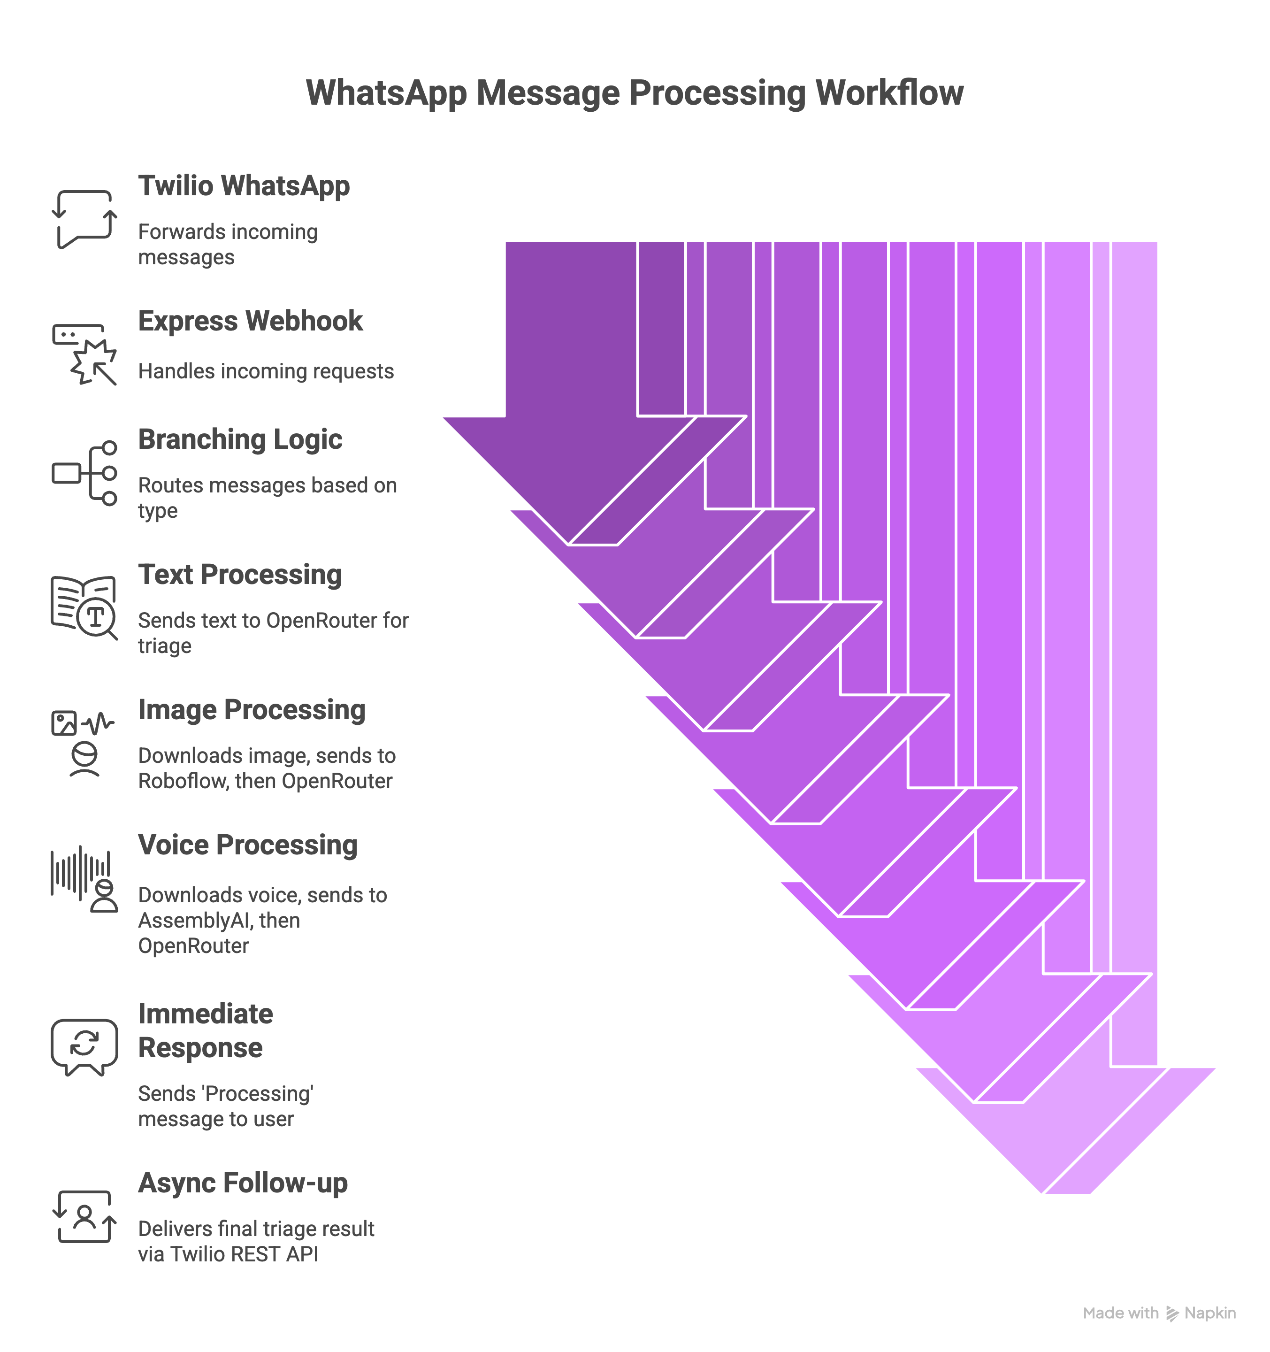

## 4. Environment & Dependencies

* Node.js  
  - Express  
  - Twilio SDK  
  - Axios  
  - dotenv  
  - FormData  
  - AssemblyAI API  
  - Roboflow API  
  - OpenRouter API

## 5. Deployment Notes

* Use ngrok for local testing.  
  - Configure webhook under Twilio Console → Messaging.  
  - Ensure `.env` contains valid API keys.  
  - Avoid hardcoding secrets.

## 6. Limitations & Future Improvements

- Currently supports single image/audio/text per request.  
- No database integration (stateless system).  
- Could extend with:  
 - Multi-turn conversation memory  
 - Doctor-on-call integration  
 - Richer UI (dashboard)  
 - Patient record management

## 7. References

- Twilio WhatsApp API Docs: https://www.twilio.com/docs/whatsapp  
- Roboflow API Docs: https://docs.roboflow.com  
- AssemblyAI API Docs: https://www.assemblyai.com/docs  
- OpenRouter API Docs: https://openrouter.ai/docs