**Personal Finance Tracker**

**(Technical Documentation)**

**Version:** 1.0.0 **Last Updated:** June 23, 2025

**Project Overview**

The Personal Finance Tracker is a full-stack web application designed to help users manage their finances effectively. It allows users to track income and expenses, set monthly budgets, and view analytics on their spending habits. The application features a secure RESTful API backend built with Spring Boot and a responsive, modern frontend built with React.

**Core Features**

* **User Authentication:** Secure user registration and login using JWT (JSON Web Tokens).
* **Transaction Management:** CRUD operations for income and expense transactions.
* **Budgeting:** Ability for users to set monthly spending limits for various categories.
* **Recurring Expenses:** Manage and track recurring bills and subscriptions.
* **Financial Analytics:** A dashboard with charts visualizing monthly income vs. expenses and spending breakdowns.
* **Expense Forecasting:** A simple forecast of upcoming expenses based on recurring items.

**Technology Stack**

|  |  |
| --- | --- |
| **Layer** | **Technology & Libraries** |
| **Frontend** | React 18, Vite, TypeScript, Tailwind CSS, React Router, Redux Toolkit, Axios, Recharts |
| **Backend** | Java 17, Spring Boot 3, Spring Security 6, Spring Data JPA, PostgreSQL, JWT, BCrypt |
| **Database** | PostgreSQL |
| **DevOps** | Docker, Nginx, Railway (Backend Hosting), Vercel (Frontend Hosting) |
| **Tools** | Git, GitHub, Postman, Maven |

**System Architecture**

The application follows a decoupled, client-server architecture.

* **Frontend (Client):** A React Single-Page Application (SPA) that runs in the user's browser. It is responsible for the UI and user experience. It communicates with the backend via REST API calls.
* **Backend (Server):** A Spring Boot application that exposes a set of RESTful API endpoints. It handles all business logic, data persistence, and user authentication.
* **Database:** A PostgreSQL database stores all user data, including credentials, transactions, and budgets.

**Personal Finance Tracker: Backend Documentation**

This document provides a detailed overview of the backend architecture, modules, and deployment process for the Personal Finance Tracker application.

**Backend Technology Stack**

The backend is built using a robust and modern Java-based technology stack, designed for security, scalability, and maintainability.

|  |  |
| --- | --- |
| **Technology/Library** | **Purpose in this Project** |
| **Java 17** | The core programming language. LTS version ensures long-term support and stability. |
| **Spring Boot 3** | The primary application framework. It radically simplifies the development of stand-alone, production-grade Spring-based applications. |
| **Spring Security 6** | Provides comprehensive security services, including authentication and authorization. It is used to protect API endpoints and manage user sessions. |
| **Spring Data JPA** | Simplifies data access by providing a familiar repository-based abstraction over the Java Persistence API (JPA). |
| **PostgreSQL** | A powerful, open-source object-relational database system used for all data persistence. |
| **Hibernate** | The JPA provider used by Spring Data JPA. It maps Java objects to database tables (ORM - Object-Relational Mapping). |
| **JWT (jjwt library)** | JSON Web Tokens are used for stateless authentication. The jjwt library is used to create and validate these tokens. |
| **BCrypt** | The password-hashing algorithm implemented via Spring Security's BCryptPasswordEncoder. It securely stores user passwords. |
| **Lombok** | A Java library that automatically plugs into your editor and build tools to reduce boilerplate code (e.g., getters, setters, constructors). |
| **Maven** | A powerful project management and comprehension tool. It manages the project's build, reporting, and documentation from a central piece of information. |
| **OpenAPI (Swagger)** | Used for generating interactive API documentation, allowing developers and frontend clients to easily understand and test the REST endpoints. |
| **Docker** | The containerization platform used to package the application and its dependencies into a standardized unit for deployment. |

**Architectural Overview**

The backend follows a classic a mixture **of microservices (module-based approach) &** **three-tier layered architecture**, promoting a strong separation of concerns.

* **Controller Layer:** Exposes the REST API endpoints. It is responsible for handling incoming HTTP requests, validating them, and delegating business logic to the service layer.
* **Service Layer:** Contains the core business logic of the application. It orchestrates operations, interacts with the repository layer, and ensures data integrity.
* **Repository (Data Access) Layer:** Responsible for all communication with the database. Spring Data JPA provides repository interfaces that abstract away the boilerplate code for data access.

**Component Diagram**

This diagram shows the high-level components and their dependencies.

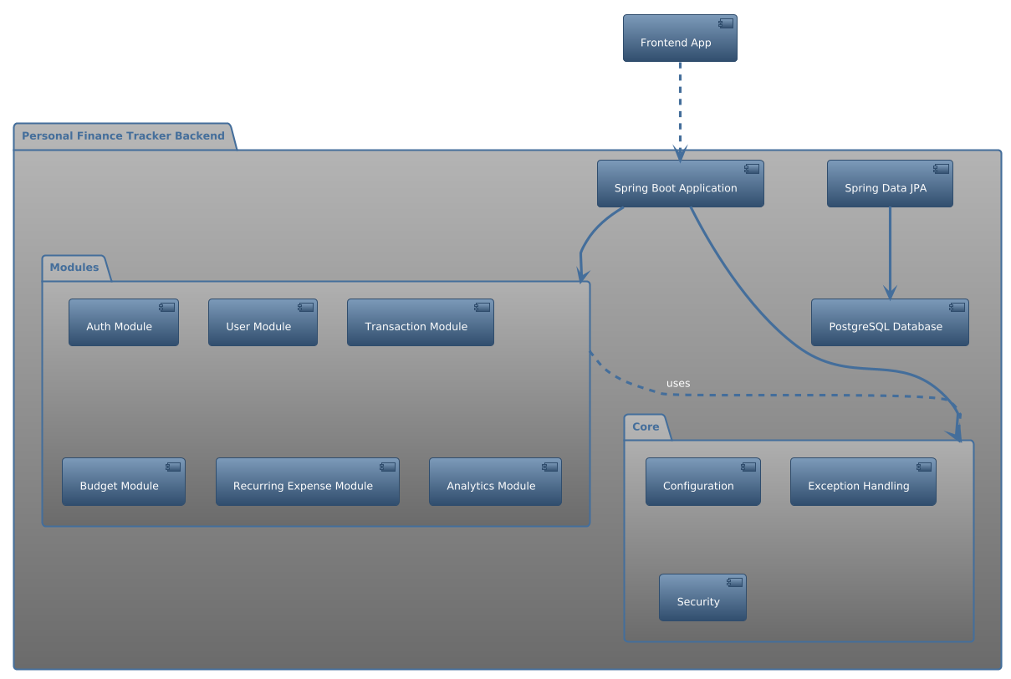

**Module Breakdown**

The project is structured by features (modules) to promote separation of concerns.

src/main/java/com/tracker/finance/

├── core/ # Cross-cutting concerns

│ ├── config/ # Spring configurations (Security, CORS, OpenAPI)

│ ├── exception/ # Global exception handling

│ └── security/ # JWT logic, UserDetailsService

└── modules/ # Feature modules

├── auth/ # Authentication and User Profile

├── transaction/ # Transaction management

├── budget/ # Budget management

├── recurringexpense/ # Recurring Expense management

└── analytics/ # Data aggregation for charts and forecasts

**Core Module**

This module contains cross-cutting concerns that are used by all other feature modules.

* **config**: Contains Spring configurations for Security (SecurityConfig), Cross-Origin Resource Sharing (WebConfig), and API documentation (OpenApiConfig).
* **exception**: Provides a GlobalExceptionHandler to catch exceptions and return standardized JSON error responses.
* **security**: Manages all aspects of security.
  + jwt: JwtProvider for creating/validating tokens and JwtAuthFilter to process tokens on incoming requests.
  + service: UserDetailsServiceImpl loads user-specific data for Spring Security.

**Feature Modules**

**Auth Module**

* **Purpose**: Handles user authentication (login).
* **Components**: AuthController, AuthService, LoginRequest DTO, JwtResponse DTO.
* **Flow**: A user submits credentials via the /api/auth/login endpoint. The AuthService validates them using Spring Security's AuthenticationManager and, if successful, returns a JWT.

**User Module**

* **Purpose**: Manages user registration, profile retrieval, updates, and deletion.
* **Components**: UserController, UserService, User entity, UserRepository, UserMapper, and various DTOs.
* **Relationships**: The User entity is the central entity in the database, linked to all other main entities (Transaction, Budget, etc.).

**Transaction, Budget, and Recurring Expense Modules**

* **Purpose**: These modules provide full CRUD (Create, Read, Update, Delete) functionality for their respective domains.
* **Structure**: They all follow a consistent structure with a Controller, Service, Repository, Entity, Mapper, and DTOs.
* **Security**: All endpoints in these modules are protected. The services contain authorization logic to ensure a user can only access or modify their own data.

**Analytics Module**

* **Purpose**: Provides aggregated data for financial insights.
* **Components**: AnalyticsController, AnalyticsService.
* **Functionality**:
  + **Monthly Summary**: Calculates total income, expenses, and budget status for a given month.
  + **Expense Forecast**: Projects upcoming expenses for the next month based on recurring expenses.
* **Relationships**: This is a read-only module that aggregates data from the Transaction, Budget, and RecurringExpense repositories.

**Sequence Diagram: User Login**

This diagram illustrates the process of a user logging in.

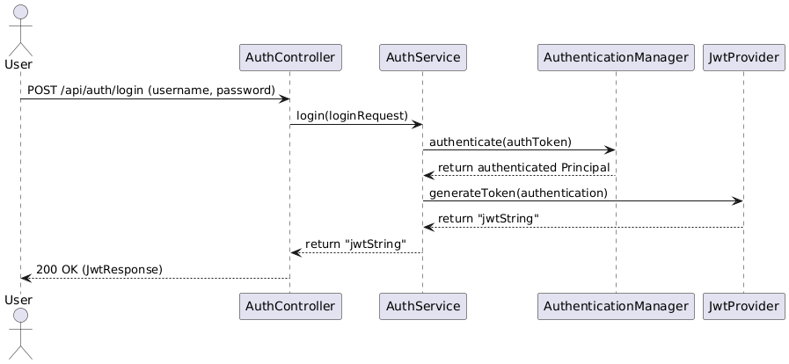

**Entity-Relationship Diagram (ERD)**

This diagram shows the database schema and the relationships between tables.

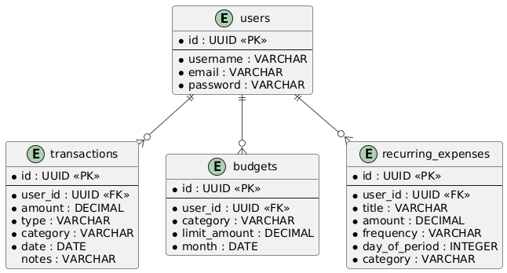

**Database Schema**

The database consists of four main tables linked by user ID.

* **users**: Stores user credentials.
* **transactions**: Stores all income and expense records.
* **budgets**: Stores monthly budget limits per category.
* **recurring_expenses**: Stores recurring payment information.

**API Endpoints**

All endpoints are prefixed with /api. Authentication is required for all endpoints except /auth/register and /auth/login.

|  |  |  |  |
| --- | --- | --- | --- |
| **Endpoint** | **Method** | **Auth** | **Description** |
| /auth/register | POST | ❌ | Registers a new user. |
| /auth/login | POST | ❌ | Authenticates a user and returns a JWT. |
| /auth/me | GET | ✅ | Gets the profile of the currently logged-in user. |
| /auth/profile | PUT | ✅ | Updates the current user's profile. |
| /auth/profile | DELETE | ✅ | Deletes the current user's account. |
| /transactions | GET | ✅ | Retrieves all transactions for the user. |
| /transactions | POST | ✅ | Adds a new transaction. |
| /transactions/{id} | PUT | ✅ | Updates an existing transaction. |
| /transactions/{id} | DELETE | ✅ | Deletes a transaction. |
| /budgets | GET | ✅ | Retrieves all budgets for the user. |
| /budgets | POST | ✅ | Adds a new budget for a specific month. |
| /recurring-expenses | GET | ✅ | Retrieves all recurring expenses for the user. |
| /recurring-expenses | POST | ✅ | Adds a new recurring expense. |
| /recurring-expenses/{id} | DELETE | ✅ | Deletes a recurring expense. |
| /analytics/monthly-summary?month=YYYY-MM | GET | ✅ | Gets a financial summary for the specified month. |
| /analytics/forecast | GET | ✅ | Gets a forecast of expenses for the next month. |

**Security**

* **Authentication:** Handled by Spring Security using a custom JWT filter (JwtAuthFilter). A JWT is generated upon successful login and must be included as a Bearer token in the Authorization header for all protected requests.
* **Password Hashing:** Passwords are hashed using BCryptPasswordEncoder before being stored in the database.
* **CORS:** Cross-Origin Resource Sharing is enabled in WebConfig and is configurable via environment variables to only allow requests from the deployed frontend.
* **Exception Handling:** A GlobalExceptionHandler provides consistent, structured JSON error responses for different exception types.

**Frontend Details**

The frontend is a modern React SPA built with Vite and TypeScript.

**Project Structure**

The project follows a feature-sliced design.

src/

├── api/ # Central Axios instance configuration

├── components/ # Global, reusable UI components (e.g., Layout, Header)

├── features/ # Feature-based modules

│ ├── auth/ # Auth pages, components, and logic

│ ├── transactions/ # Transaction pages and components

│ └── ...

├── hooks/ # Custom hooks (e.g., useAppDispatch)

├── routes/ # Application routing configuration

├── store/ # Redux Toolkit store and slices

└── utils/ # Utility functions and validation schemas

**State Management (Redux Toolkit)**

Global application state is managed using Redux Toolkit.

* **Store:** The single source of truth, configured in src/store/index.ts.
* **Slices:** State logic is co-located by feature. Each slice (authSlice, transactionSlice, etc.) defines its initial state, reducers, and async thunks for interacting with the API.
* **Async Thunks:** Used for all asynchronous operations (API calls). They handle the pending, fulfilled, and rejected states of a request, allowing the UI to display loading indicators and error messages.

**Routing**

Client-side routing is handled by react-router-dom.

* **Public Routes:** Login and Register pages are accessible to everyone.
* **Private Routes:** All other pages (Dashboard, Transactions, etc.) are protected by the PrivateRoute component, which checks for a valid user session in the Redux store. If no user is authenticated, it redirects to the login page.

**Future Enhancements**

|  |  |
| --- | --- |
| **Feature** | **Description** |
| AI Categorization | Use OpenAI to suggest categories |
| Notification Engine | Alert users on overspending or recurring bills |
| Export to Excel/PDF | Generate downloadable reports |
| Multi-Currency Support | Convert using real-time exchange rates |
| OAuth2 Google Login | Easier signup/login |
| Offline Mode (PWA) | Cache recent data with service workers |