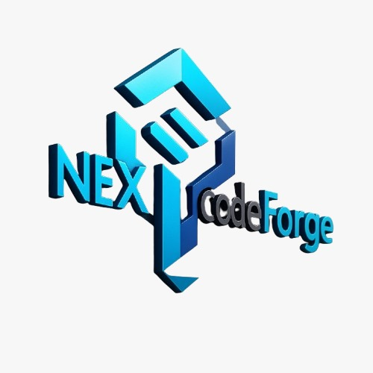

NexCodeForge – Pricing Specification

Website Development
- Starter Website (Basic): ₹7,999
- Business Website (Standard): ₹19,999
- Premium Corporate Website: ₹34,999
- E-Commerce Website: ₹29,999

Mobile App Development
- Basic App (Android Only): ₹24,999
- Standard App (Android + iOS): ₹74,999
- Advanced Application: ₹1,20,000+

Custom Software (CRM / ERP / LMS)
- CRM Systems: ₹24,999 – ₹1,20,000
- ERP Systems: ₹49,999 – ₹2,50,000
- LMS (Learning Management System): ₹34,999 – ₹1,50,000

MLM Software
- Single/Direct Level Plan: ₹34,999 – ₹75,000
- Binary Level Plan: ₹49,999 – ₹1,25,000
- Matrix Level Plan: ₹45,000 – ₹1,00,000
- Binary + E-commerce/Reselling: ₹85,000 – ₹2,00,000

UI/UX Design
- Landing Page: ₹3,999 – ₹6,999
- Website UI Kit / Design System: ₹9,999 – ₹18,999
- Mobile App UI (10–20 screens): ₹14,999 – ₹34,999

Hosting & Maintenance
- Basic Maintenance: ₹999 / month
- Advanced Maintenance: ₹2,999 / month
- Premium Maintenance: ₹6,999 / month

Contact Information
Email: support@nexcodeforge.com
Mobile: +91 76691 66975

