Manual Test Plan

04 / 12 / 2020

Requirements:

* OS: Windows/Mac/Linux
* Python 3.7+
  + Pandas module (most recent)
  + Numpy module (most recent)
  + Tkinter module (most recent)

Test 1:

1. Run ‘main.py’ using python. 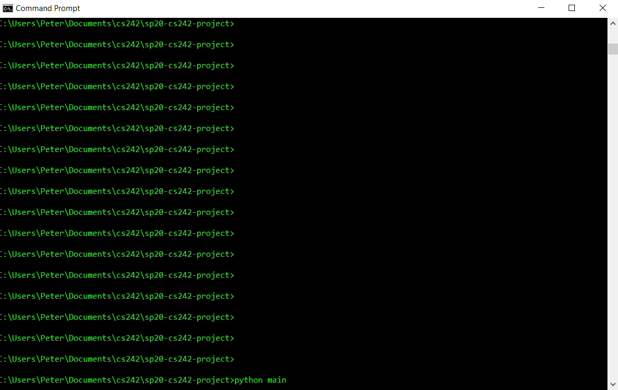
2. Navigate to and click the open button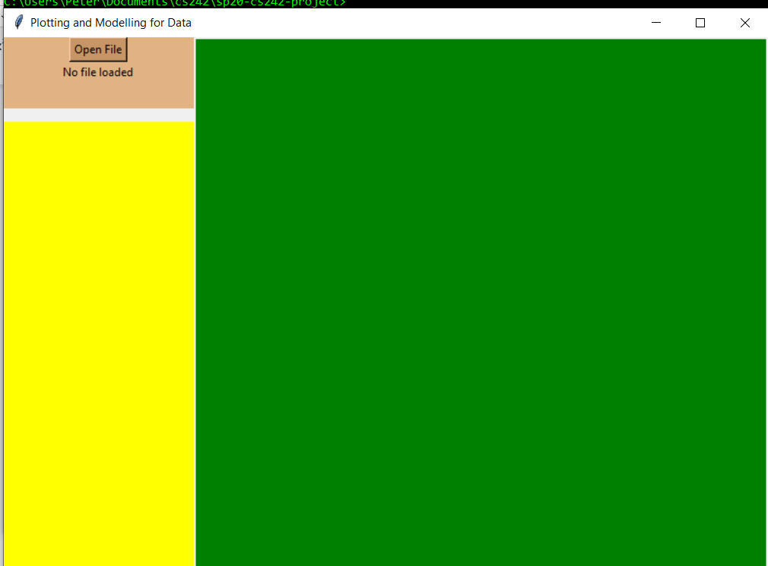
3. Choose csv as file type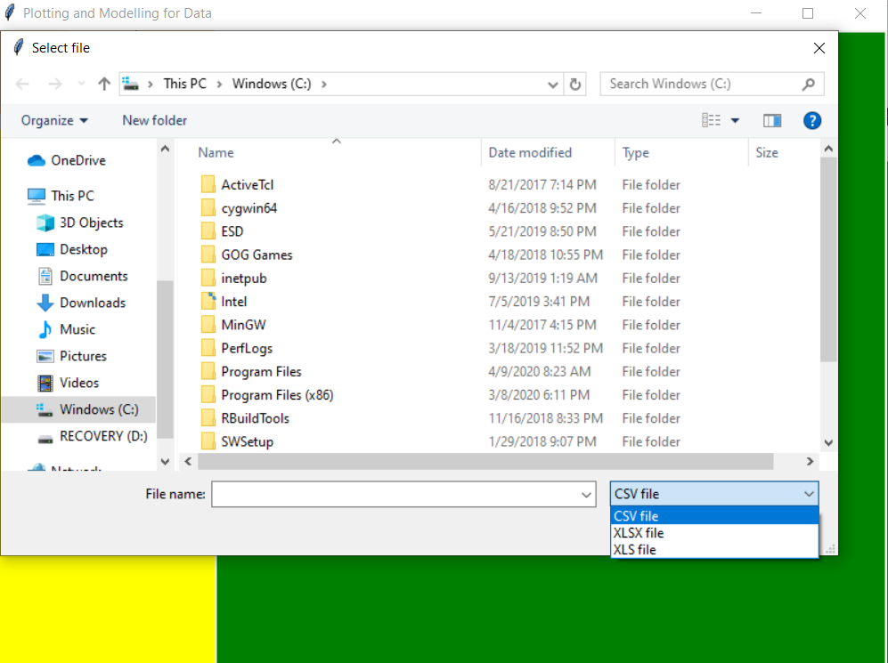
4. Open unit_1.csv
5. Ensure the table name appears below the button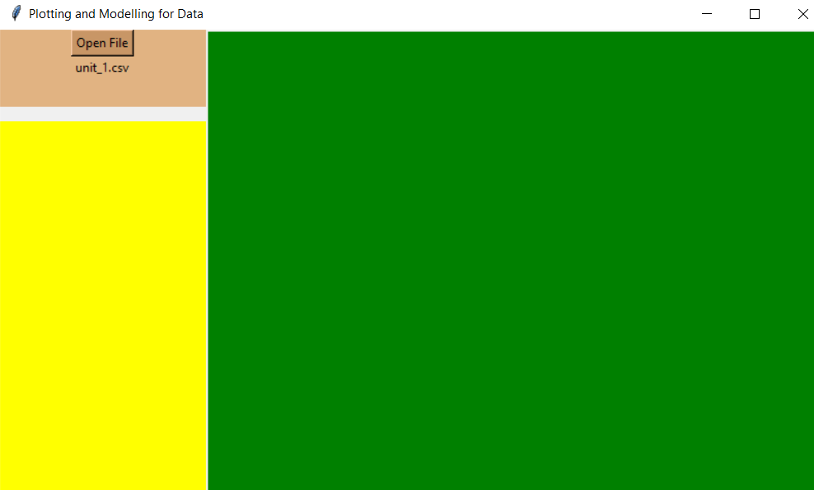

Test 2:

1. Run ‘main.py’ using python.
2. Navigate to and click the open button
3. Choose xlsx as filetype
4. Open unit_2.xlsx
5. Ensure the table name appears below the button

Test 3:

1. Run ‘main.py’ using python.
2. Navigate to and click the open button
3. Choose xls as filetype
4. Open unit_3.xls
5. Ensure the table name appears below the button

Test 4:

1. Run ‘main.py’ using python.
2. Navigate to and click the open button
3. Ensure cannot choose txt such as unit_4.txt
4. Ensure the ERROR code appears upon cancel