# Powerup Coding Challenges

DRAFT

## Introduction

|  |  |  |
| --- | --- | --- |
| **Experience** | **Level** | **Challenge** |
| New Programmers | 1 | Variables |
|  | 2 | Loops and conditionals |
| Intermediate | 3 | Basic autonomous movement |
|  | 4 | Advanced autonomous movement |
| Advanced | 5 | Game server enhancements |
|  | 6 | Graphics enhancements |
|  | 7 | Game client enhancements |
|  | 8 | Basic team project |
|  | 9 | Advanced team project |

New programmers will be introduced to Java development using Eclipse and will be eligible to compete in weekly tournaments using their robots in manual mode.

Intermediate programmers should be comfortable with the basics of Java development and will focus on adding autonomous capabilities to their robots.

Advanced programmers should be willing to take on a larger role, learn all the subsystems of the game, propose new features and organize a team to implement and test them.

## Setup and Game Play

1. Install and configure Eclipse
2. Add project to workspace
3. Review rules and game play
4. Play a game using the manual controls against a computer controlled robot
5. Play a multiplayer game against other human controlled robots

Run MyClient to start the game

* Select MyClient in the Package Explorer
* Right click, choose Run As, Java Application

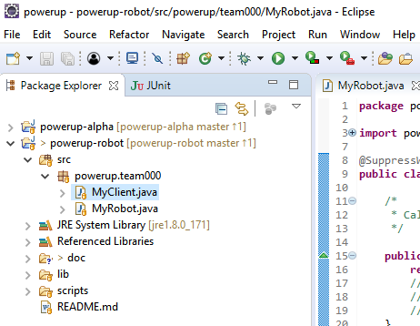

When the game starts the field is empty.

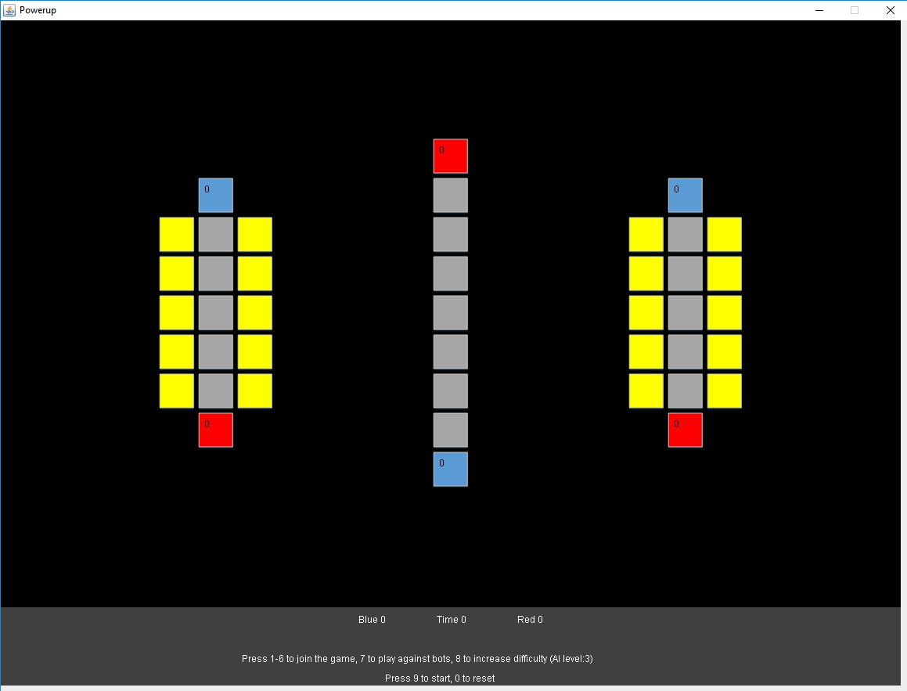

Press 1 to spawn your robot in position 1

Press 7 to spawn an autonomous robot to play against

The robot starts with a cube (as indicated by yellow body) and should move to a spot directly adjacent to the target. From position 1 the robot should target the blue scale directly ahead of the robot.

Use the WASD keys or the directional arrow keys to move up, down, left or right

Use the space bar to pickup a cube or place a cube

Scoring is similar to FRC. If you control the scale or your switch you will earn points

Each scale/switch is color coded and displays the number of cubes that have been placed

The scale/switch will flash the color of the controlling alliance

If you control your opponents switch you prevent them from earning points

Press 9 to start the game

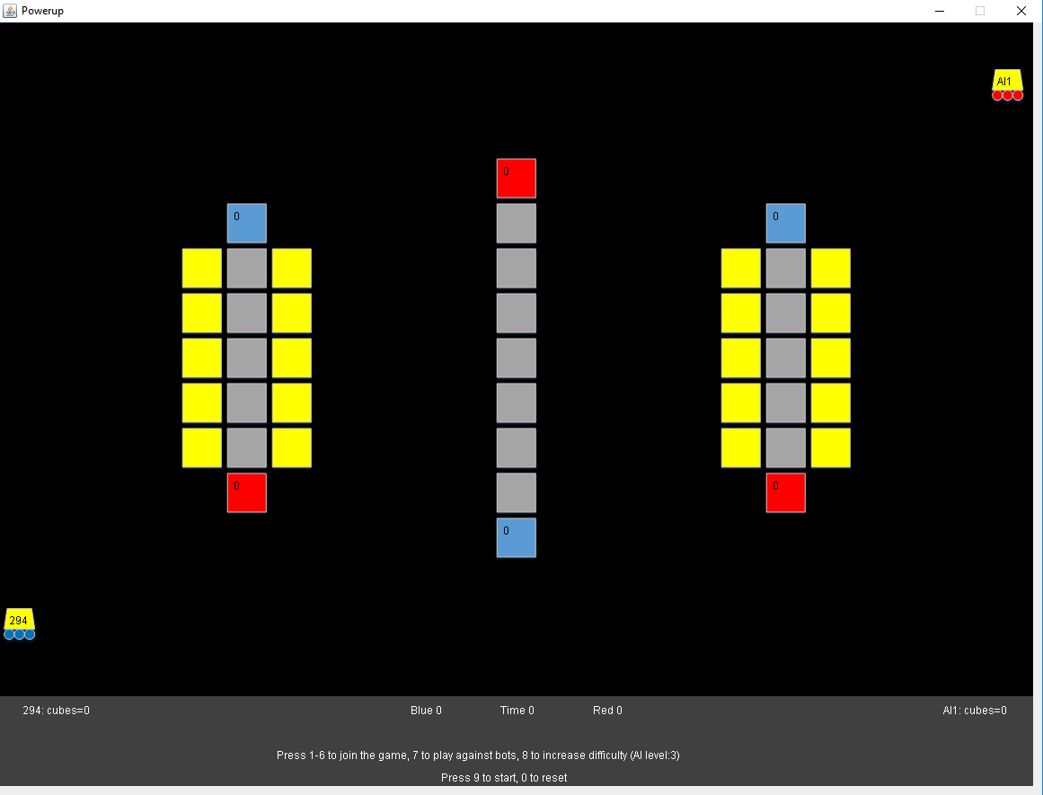

When the game is over press 0 to reset the field

Pressing 8 increases the difficulty of the AI

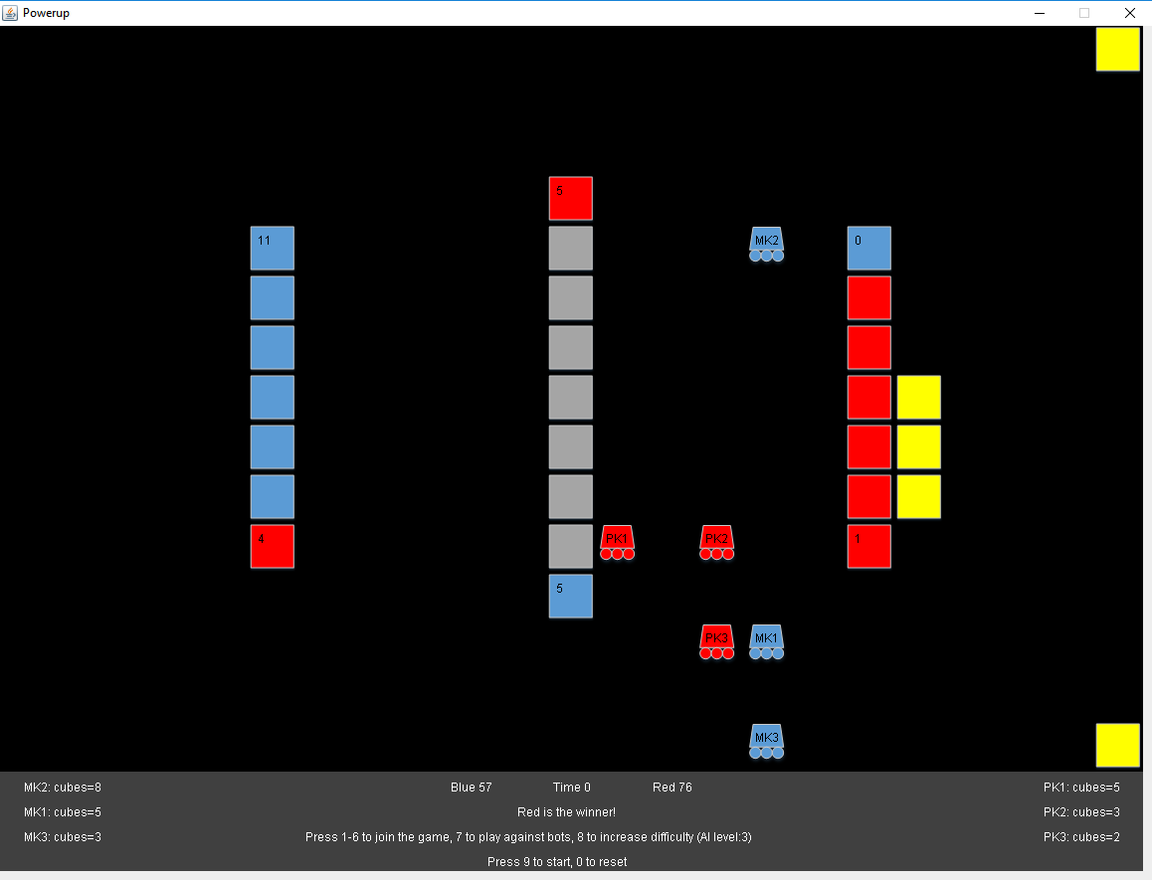

## Challenge 1 - Variables

1. Create a variable to keep track of how many moves the robot makes in a game and print it to the console

## Challenge 2 – Loops and Conditionals

1. Create a routine that moves the robot east until it reaches column 11

## Challenge 3 – Basic Autonomous Movement

1. Get the current location of the robot and store it in two variables (one for the row and one for the column)
2. Get the location of the scale and store it
3. Compare the current row to the target row to determine if the robot should move north or south
4. Compare the current column to the target column to determine if the robot should move east or west
5. Compare the current location to the target location and place the cube if arrived
6. Consider what would happen if the path to the target was blocked

## Challenge 4 – Advanced Autonomous Movement

1. Create a routine to locate a cube on the field
2. Create a routine to find a path to a given location
3. Create a routine to pickup a cube
4. Create a routine to select a target for the cube
5. Create a routine to place the cube

## Challenge 5 – Game Server Enhancements

1. Add logic to the game server to make placing cubes on the scale increasingly difficult based upon the number of cubes that have already been placed.
2. Add logic to the game server to make it possible to drop a cube or fail to pick one up

## Challenge 6 – Graphics Controller Enhancements

1. Add a vault to the field
2. Modify the scoring algorithm to score cubes placed in the vault

## Challenge 7 – Game Client Enhancements

1. Add logic to the game client to allow the players to use powerups
2. Add logic to the game server to manage the powerups and adjust the score as needed