Veer Narmad South Gujarat University, Surat.

Department of Information and Communication Technology

M.Sc. (Information and Communication Technology) Programme

Project Report
2nd Semester
M.Sc. (Information and Communication Technology)
2 Year Course

Year 2025 – 2026

Project Title: VerisqAI

Guided By:  Dr. Dhaval Joshi (Internal Guide) | Submitted By:  Krishna Parekh (48)  Vignesh Chitroda (20)  Sahil Kanjariya (39)

Company Name:
Kyara Infotech

Veer Narmad South Gujarat University, Surat.

Department of Information and Communication Technology

M.Sc. (Information and Communication Technology) Programme

Certificate

This is to certify that Mr./Ms. Krishna Parekh with Exam Seat Number: 48 and Enrollment Number: R25110018000710043 has worked on his/her part time project work entitled VerisqAI – AI-Powered Vendor Risk Assessment System at Kyara Infotech as a partial fulfillment of the requirements for 2nd Semester - M.Sc. (Information and Communication Technology), during the academic Year 2025-2026.

Date:
Place: Department of ICT, VNSGU, Surat.

Internal Project Guide  M.Sc.(I.C.T.) 2nd Semester  Department of I.C.T.  Veer Narmad South Gujarat University, Surat | Course Coordinator  M.Sc.(I.C.T.) Programme  Department of I.C.T.  Veer Narmad South Gujarat University, Surat | Head of the Department  Department of I.C.T.  Veer Narmad South Gujarat University, Surat

Veer Narmad South Gujarat University, Surat.

Department of Information and Communication Technology

M.Sc. (Information and Communication Technology) Programme

Certificate

This is to certify that Mr./Ms. Vignesh Chitroda with Exam Seat Number: 20 and Enrollment Number: R25110018000710008 has worked on his/her part time project work entitled VerisqAI – AI-Powered Vendor Risk Assessment System at Kyara Infotech as a partial fulfillment of the requirements for 2nd Semester - M.Sc. (Information and Communication Technology), during the academic Year 2025-2026.

Date:
Place: Department of ICT, VNSGU, Surat.

Internal Project Guide  M.Sc.(I.C.T.) 2nd Semester  Department of I.C.T.  Veer Narmad South Gujarat University, Surat | Course Coordinator  M.Sc.(I.C.T.) Programme  Department of I.C.T.  Veer Narmad South Gujarat University, Surat | Head of the Department  Department of I.C.T.  Veer Narmad South Gujarat University, Surat

Veer Narmad South Gujarat University, Surat.

Department of Information and Communication Technology

M.Sc. (Information and Communication Technology) Programme

Certificate

This is to certify that Mr./Ms. Sahil Kanjariya with Exam Seat Number: 39 and Enrollment Number: R25110018000710032 has worked on his/her part time project work entitled VerisqAI – AI-Powered Vendor Risk Assessment System at Kyara Infotech as a partial fulfillment of the requirements for 2nd Semester - M.Sc. (Information and Communication Technology), during the academic Year 2025-2026.

Date:
Place: Department of ICT, VNSGU, Surat.

Internal Project Guide  M.Sc.(I.C.T.) 2nd Semester  Department of I.C.T.  Veer Narmad South Gujarat University, Surat | Course Coordinator  M.Sc.(I.C.T.) Programme  Department of I.C.T.  Veer Narmad South Gujarat University, Surat | Head of the Department  Department of I.C.T.  Veer Narmad South Gujarat University, Surat

I N D E X
1. Introduction 1
1.1 Company Profile 1
1.2 Customer Profile 1
1.2.1 Current System – About the Existing System 1
1.2.2 Customer Detail – Working Style of the Client 2
2. Proposed System 3
2.1 Scope 3
2.2 Objective 3
2.3 Constraints 4
2.3.1 Hardware Constraints 4
2.3.2 Software Constraints 4
2.4 Advantages 4
2.5 Limitations 5
3. Environment Specification 6
3.1 Hardware & Software Requirements 6
3.2 Development Description 7
4. System Planning 8
4.1 Feasibility Study 8
4.2 Software Engineering Model 8
4.3 Risk Analysis 9
4.4 Project Schedule 9
4.4.1 Task Dependency 9
4.4.2 Timeline Chart (Gantt Overview) 10
4.4.3 Project Table 11
5. System Analysis 12
5.1 Detailed SRS (Software Requirements Specification) 12
Module 1: Authentication & User Management 12
Module 2: Vendor Management 12
Module 3: Assessment Template Builder 12
Module 4: Questionnaire Dispatch & Vendor Response 13
Module 5: Scoring Engine & Risk Assessment 13
Module 6: AI Assessment Engine 14
Module 7: PDF Report Generation 14
5.2 UML Diagrams 15
5.2.1 Use Case Diagram 15
5.2.2 CRC (Class Responsibility Collaborator) 16
5.2.3 Class Diagram (Key Entities & Relationships) 17
5.2.4 Activity Diagram 18
5.2.5 Sequence Diagram 20
5.3 E-R Diagram 22
6. Software Design 24
6.1 Database Design 24
6.2 Interface Design 37
6.2.1 Sitemap 37
6.2.2 Page Snapshots 38
6.2.2.1 Landing Page 38
6.2.2.2 Login / OTP Verification Page 39
6.2.2.4 Vendor List & Vendor Details Page 41
6.2.2.5 Template Builder Page 42
6.2.2.6 Vendor Questionnaire Page 45
6.2.2.7 Admin Dashboard & AI Monitoring Page 46
6.2.2.8 Admin / User PDF 51
6.3 Architecture Design 51
6.3.1 Presentation Layer (Client Tier) 51
6.3.2 Application / Business Logic Layer (Server Tier) 52
6.3.3 Data Layer 52
6.3.4 Three-Tier Architecture Diagram 53
7. Testing 54
7.1 Unit Testing 54
7.2 Integration Testing 55
8. Future Enhancement 57
9. Glossary 58
10. References 60

1. Introduction
This document presents the complete technical and functional documentation of VerisqAI, an AI-Powered Vendor Risk Assessment System developed as part of the M.Sc. (ICT) 2nd Semester project at Veer Narmad South Gujarat University, Surat. The project was developed at ABC Company Pvt. Ltd., Surat during the academic year 2025-2026.

1.1 Company Profile
ABC Company Pvt. Ltd. is a technology services organization based in Surat, Gujarat, specializing in software development, enterprise solutions, and IT consulting. The company provides end-to-end software development services to clients across various industries including finance, healthcare, and manufacturing. With a dedicated team of engineers and domain experts, the company focuses on building scalable and secure enterprise-grade applications. Their areas of expertise include web application development, AI/ML integration, cloud computing, and cybersecurity solutions.
The company follows industry-standard development practices including Agile methodology, CI/CD pipelines, and DevSecOps, enabling them to deliver high-quality software products within stipulated timeframes. The organization maintains partnerships with cloud providers and third-party security vendors to ensure their delivered products meet global compliance and security standards.

1.2 Customer Profile

1.2.1 Current System – About the Existing System
Currently, most organizations managing third-party vendor relationships rely on manual, spreadsheet-based processes to perform vendor risk assessments. Procurement teams send questionnaires to vendors via email, and responses are manually reviewed by risk analysts. The existing process involves creating questionnaires in Microsoft Word or Google Forms, emailing them to vendors, and then manually compiling the responses into Excel spreadsheets for scoring.
This manual approach is time-consuming, error-prone, and lacks consistency. There is no standardized scoring mechanism, and risk prioritization is entirely subjective, depending on the analyst reviewing the data. The absence of an AI-driven analysis layer means that subtle risk patterns across multiple vendor responses often go undetected. Audit trails are incomplete, and generating comprehensive vendor risk reports requires considerable manual effort, often taking several days per vendor.

1.2.2 Customer Detail – Working Style of the Client
The client in this case is an enterprise-level organization that manages relationships with multiple third-party vendors across different operational domains such as cloud infrastructure, software tools, logistics, and financial services. The organization has a dedicated Vendor Risk Management (VRM) team responsible for assessing and monitoring vendor compliance with internal security policies and regulatory requirements.
The VRM team uses a periodic assessment cycle where vendors are evaluated quarterly or annually based on their risk tier. Higher-risk vendors (those with access to sensitive data or critical systems) undergo more frequent and comprehensive assessments. The organization's key requirements include automated questionnaire dispatch and tracking, consistent risk scoring across all vendors, AI-powered insights to identify critical findings, and the ability to generate professional PDF reports for executive stakeholders.

2. Proposed System

2.1 Scope
VerisqAI is a web-based, AI-powered vendor risk assessment platform designed to automate and streamline the entire third-party risk management lifecycle. The system enables organizations to onboard vendors, design dynamic assessment templates, dispatch questionnaires via secure tokenized email links, collect and automatically score responses, and generate AI-driven risk insights along with comprehensive PDF reports. The platform serves two primary user types: administrators who manage the platform and oversee all vendors system-wide, and regular users (risk analysts) who manage their own vendor portfolios. The system integrates with external AI providers (OpenRouter/Gemini) to deliver intelligent risk analysis and recommendations, making it suitable for enterprise-grade vendor risk management operations.

2.2 Objective
- To provide a centralized platform for managing end-to-end vendor risk assessment workflows, eliminating manual, spreadsheet-based processes.
- To enable users to design flexible, reusable assessment templates with dynamic question types, scoring weights, and conditional logic.
- To automate questionnaire dispatch to vendors via secure, tokenized email links with expiration controls.
- To implement an automated scoring engine that calculates vendor risk scores, risk tiers (1-4), and generates structured findings based on vendor responses.
- To integrate AI capabilities (via OpenRouter and Gemini) for generating executive summaries, identifying top risk drivers, and producing prioritized actionable recommendations.
- To provide an administrative dashboard with system-wide analytics including user growth trends, AI usage monitoring, audit logs, and risk distribution statistics.
- To generate professional, formatted PDF assessment reports for executive stakeholders with complete findings and AI insights.
- To implement secure authentication using JWT tokens with OTP-based two-factor verification for all users.

2.3 Constraints

2.3.1 Hardware Constraints
- The system requires a server with a minimum of 4 GB RAM and a multi-core processor to handle concurrent API requests and AI processing.
- A stable internet connection is mandatory for AI provider integration (OpenRouter/Gemini APIs) since AI analysis is performed via external API calls.
- Client machines (user browsers) require a modern browser supporting ES2020+ JavaScript features and a minimum screen resolution of 1280x720.
- PDF generation using QuestPDF requires additional CPU resources during report compilation; dedicated server resources are recommended for production environments.

2.3.2 Software Constraints
- The backend is built exclusively on .NET 8.0 and cannot run on older .NET Framework versions or non-Microsoft runtimes.
- The database layer is tightly coupled with Microsoft SQL Server via Entity Framework Core; migration to other database engines would require significant schema modifications.
- AI-powered features depend entirely on external API availability (OpenRouter/Gemini); any downtime in these services will render AI assessment features unavailable.
- The frontend is built with React 19 using Vite; Internet Explorer and legacy browsers are not supported.
- Email dispatch functionality requires a valid SMTP server configuration; without it, questionnaire tokens cannot be sent to vendors.

2.4 Advantages
- Eliminates manual, error-prone spreadsheet-based vendor assessment workflows by providing a fully automated digital platform.
- Consistent, weighted scoring ensures that all vendors are evaluated against the same standardized criteria regardless of which analyst processes the data.
- AI-generated executive summaries, risk drivers, and prioritized recommendations save analyst time and improve the quality of risk reporting.
- Tokenized questionnaire links with expiry controls ensure that vendors can only access valid, active assessments, enhancing security.
- The template builder allows organizations to create domain-specific assessment templates (e.g., cloud security, financial compliance, data privacy) and reuse them across multiple vendors.
- Role-based access control (Admin vs. User) ensures that system-wide data remains accessible only to authorized administrators.
- Comprehensive audit logging tracks all critical system actions, providing a complete audit trail for compliance and governance purposes.
- Real-time dashboard analytics provide visibility into vendor portfolio risk distribution, assessment completion rates, and AI processing statistics.

2.5 Limitations
- The system currently does not support multi-language questionnaires; all assessment content is presented in English only.
- There is no native mobile application; the platform is accessible only through web browsers, which may affect usability on small-screen devices.
- Bulk vendor import via CSV or Excel files is not yet implemented; vendors must be added individually through the interface.
- The AI analysis relies on external LLM APIs and is subject to rate limits and token usage costs associated with those providers.
- Vendor self-registration is not supported; all vendors must be manually added by the risk analyst before a questionnaire can be dispatched.
- The breach alert module, while present in the interface, is currently a static information page and does not yet integrate with live threat intelligence feeds.

3. Environment Specification

3.1 Hardware & Software Requirements
Hardware Requirements:
Component | Specification
Processor | Intel Core i5 (8th Gen) or equivalent, Minimum 2.0 GHz
RAM | Minimum 8 GB (16 GB recommended for production)
Storage | Minimum 50 GB SSD for OS, application, and database
Network | Broadband internet connection (minimum 10 Mbps) for AI API access
Display | 1280 x 720 resolution or higher
Operating System (Server) | Windows Server 2019/2022 or Ubuntu 22.04 LTS
Operating System (Client) | Windows 10+, macOS 12+, Ubuntu 20.04+

Software Requirements:
Software | Version / Details
ASP.NET Core (Backend) | .NET 8.0 Runtime
Microsoft SQL Server | SQL Server 2019 or 2022 (Express or Standard)
Entity Framework Core | EF Core 9.x with SQL Server provider
React.js (Frontend) | React 19.x with Vite 7.x build tool
Node.js | v20 LTS (for frontend build)
QuestPDF | Community Edition (for PDF generation)
OpenRouter API / Gemini API | External AI provider for LLM-based risk analysis
SMTP Server | Any SMTP-compatible email server (e.g., Gmail SMTP, SendGrid)
Web Browser | Google Chrome 120+, Mozilla Firefox 120+, Microsoft Edge 120+
Development IDE | Microsoft Visual Studio 2022 / VS Code
API Testing | Swagger UI (integrated) / Postman

3.2 Development Description
VerisqAI follows a modern full-stack architecture with a clear separation between the backend API layer and the frontend client application. The backend is built using ASP.NET Core 8 Web API following RESTful principles. It uses Entity Framework Core as the ORM layer for database interactions with Microsoft SQL Server. The application employs ASP.NET Identity for user management and JWT (JSON Web Token) authentication for securing all API endpoints.
The frontend is a built with React 19 and bundled using Vite. It uses React Router DOM for client-side routing, Recharts for data visualization, and Axios for HTTP communication with the backend API. The UI is organized into two distinct portals: the Admin Portal (for super-users) and the User Portal (for risk analysts), each with its own layout, navigation, and role-specific features.
The AI integration layer is implemented as a provider pattern with the IAiProvider interface, allowing easy switching between AI providers. The current implementation uses OpenRouter (which provides access to multiple LLMs) as the primary provider. The AI service receives structured assessment data (vendor information, question-answer pairs, scores, findings) and returns a JSON response containing an executive summary, risk drivers, and prioritized recommendations.

4. System Planning

4.1 Feasibility Study
Technical Feasibility:
VerisqAI is technically feasible as it leverages widely adopted, well-documented technologies. ASP.NET Core 8 is a mature, high-performance framework with extensive community support. React 19 is the industry-leading frontend framework for building interactive UIs. Entity Framework Core simplifies database operations. OpenRouter and Gemini provide readily accessible AI APIs with comprehensive documentation. The integration of these technologies is straightforward and well within the team's capability.

Operational Feasibility:
The system is operationally feasible as it addresses a real, well-defined business problem faced by enterprise risk management teams. The user interface is designed to be intuitive, minimizing the learning curve for risk analysts. The automated workflows (questionnaire dispatch, scoring, AI analysis) replace time-consuming manual tasks, making adoption beneficial for end-users from day one.

Economic Feasibility:
The system is economically feasible. The backend framework (.NET 8), database (SQL Server Express for development), and frontend stack (React/Vite) are either free or low-cost. The primary recurring cost involves AI API usage, which scales with the number of vendor assessments processed. For small to medium enterprises, the cost savings from eliminating manual analyst hours significantly outweigh the AI API costs.

4.2 Software Engineering Model
VerisqAI was developed using the Agile (Iterative) software development methodology, structured into clearly defined phases. Development proceeded through six incremental phases: Phase 1 – Core infrastructure, authentication, and vendor management; Phase 2A – Template builder and questionnaire engine; Phase 2B – Template preview; Phase 3 – Dynamic questionnaire runtime for vendors; Phase 4 – Automated scoring engine; Phase 5 – AI assessment engine; and Phase 6 – Report generation. Each phase delivered a working, testable increment, and subsequent phases were planned based on the outcomes of earlier ones.

4.3 Risk Analysis
Risk | Impact | Probability | Mitigation
AI API unavailability or rate limits | High – AI features non-functional | Medium | Implement fallback to secondary provider; cache results
SMTP configuration failure | Medium – Questionnaire emails not sent | Low | Provide manual token link sharing as alternative
SQL Server connection failure | Critical – System unusable | Low | Connection pooling, retry policies, database backups
JWT token interception | High – Unauthorized access | Low | HTTPS enforced, short token expiry, OTP 2FA
Questionnaire token abuse | Medium – Unauthorized submissions | Low | One-time-use tokens with expiry dates
Scope creep | Medium – Delivery delays | Medium | Strict phase-based planning, backlog management

4.4 Project Schedule

4.4.1 Task Dependency
The project tasks follow a sequential dependency chain where each phase depends on the completion of the prior phase. Database schema design and authentication (Phase 1) is the foundation upon which all subsequent modules depend. The template builder (Phase 2A) must be complete before the questionnaire runtime (Phase 3) can be developed, since the runtime reads template definitions. The scoring engine (Phase 4) depends on completed questionnaire responses. The AI engine (Phase 5) depends on scoring data. PDF report generation (Phase 6) depends on both scoring and AI data.

4.4.2 Timeline Chart (Gantt Overview)
Phase / Module | Start | End | Duration | Status
Phase 1: Auth, Vendor Management, DB Design | Jan 2026 | Jan 2026 | 3 weeks | Completed
Phase 2A: Template Builder, Questionnaire Engine | Jan 2026 | Feb 2026 | 3 weeks | Completed
Phase 2B: Template Preview Mode | Feb 2026 | March 2026 | 2 week | Planned
Phase 3: Vendor Questionnaire Runtime | March 2026 | March 2026 | 2 weeks | Completed
Phase 4: Dynamic Scoring Engine | March 2026 | April 2026 | 3 weeks | Completed
Phase 5: AI Assessment Engine | April 2026 | April 2026 | 2 week | Completed
Phase 6: PDF Report Generation | May 2026 | May 2026 | 1 week | Completed
Admin Dashboard & Monitoring | May 2026 | May 2026 | 2 week | Completed
Testing & Bug Fixing | May 2026 | Jun 2026 | 1 week | In Progress

4.4.3 Project Table
No | Task | Owner | Dependency
1 | Database Schema Design & EF Core Migrations | Backend Developer | None
2 | JWT Authentication & ASP.NET Identity Setup | Backend Developer | Task 1
3 | OTP / TOTP Two-Factor Authentication | Backend Developer | Task 2
4 | Vendor CRUD Operations & Dashboard API | Backend Developer | Task 2
5 | Assessment Template Builder API | Backend Developer | Task 4
6 | Template Builder UI (React) | Frontend Developer | Task 5
7 | Questionnaire Dispatch & Token System | Full Stack | Task 5
8 | Vendor Questionnaire Form (Public) | Frontend Developer | Task 7
9 | Dynamic Scoring Engine | Backend Developer | Task 8
10 | AI Assessment Service (OpenRouter/Gemini) | Backend Developer | Task 9
11 | AI Intelligence UI (Frontend) | Frontend Developer | Task 10
12 | PDF Report Generation (QuestPDF) | Backend Developer | Task 9,10
13 | Admin Dashboard & Monitoring | Full Stack | Task 4,10
14 | Audit Logging System | Backend Developer | Task 2
15 | Testing & Quality Assurance | QA / All | All Tasks

5. System Analysis

5.1 Detailed SRS (Software Requirements Specification)

Module 1: Authentication & User Management
Description: This module handles all user registration, login, and session management operations. It implements JWT-based authentication combined with OTP (One-Time Password) email verification for two-factor authentication.
Input: User email, password, OTP code
Events: User registration, login attempt, OTP verification, token refresh
Output: JWT access token, user role, authentication status
Validations: Email format validation, password strength check, OTP expiry check, duplicate email check
Constraints: OTP expires after 10 minutes; JWT tokens have configurable expiry

Module 2: Vendor Management
Description: This module enables risk analysts to maintain their vendor portfolio. Each vendor is associated with the authenticated user and tracks assessment status, risk tier, and questionnaire state.
Input: Vendor name, domain, contact email, risk tier
Events: Add vendor, view vendor details, update vendor status, delete vendor
Output: Vendor list with risk scores, questionnaire statuses, scorecard history
Validations: Vendor name and domain required; email must be valid format
Constraints: Vendors are user-scoped; users can only view/manage their own vendors

Module 3: Assessment Template Builder
Description: This module provides a drag-and-drop-style interface for creating reusable assessment templates. Templates consist of sections, and each section contains questions with configurable types, scoring weights, severity levels, and answer options.
Input: Template name, description, sections, questions, question options, weights, question type (boolean, multiple-choice, text, scale)
Events: Create template, add section, add question, reorder sections/questions, import section from library
Output: Saved template with complete section/question hierarchy, template version
Validations: Template name required; questions must have at least one option for choice-type questions; weight values must be numeric
Constraints: Templates are user-owned; users cannot modify other users' templates

Module 4: Questionnaire Dispatch & Vendor Response
Description: This module manages the lifecycle of a questionnaire from dispatch to completion. A questionnaire is created by linking a vendor to an assessment template, generating a unique tokenized link, and emailing it to the vendor's contact. The vendor accesses a public form via the token and submits responses.
Input: Vendor ID, template ID, contact email, questionnaire responses (question key-answer pairs)
Events: Send questionnaire, vendor opens link, vendor submits responses, decline questionnaire, cancel questionnaire
Output: Questionnaire record with status (Sent/Pending/Completed/Declined/Cancelled), stored responses
Validations: Token must be valid and non-expired; required questions must be answered before submission
Constraints: Each token is single-use per questionnaire session; questionnaires expire after a configurable period

Module 5: Scoring Engine & Risk Assessment
Description: Upon questionnaire submission, the scoring engine evaluates vendor responses against the template's predefined preferred answers, weights, and severity levels. It calculates a composite risk score, assigns a risk tier (1-4), and identifies findings.
Input: Completed questionnaire responses, assessment template with scoring configuration
Events: Automated trigger on questionnaire completion
Output: Scorecard with risk score (0-100), risk tier (1-4), findings list with severity levels (Critical, High, Medium, Low)
Validations: All required questions must have responses before scoring proceeds
Constraints: Scoring is deterministic based on template configuration; cannot be manually overridden

Module 6: AI Assessment Engine
Description: This module sends structured assessment data to an external LLM (via OpenRouter) to generate AI-powered insights. The AI returns an executive summary, list of top risk drivers, and prioritized recommendations with rationale.
Input: Vendor details, scorecard data, findings, questionnaire Q&A pairs
Events: User triggers AI analysis from vendor details page
Output: Executive summary text, risk drivers array, recommendations (title, description, priority, category, rationale), confidence score
Validations: AI response must be valid JSON matching the expected schema; malformed responses are rejected
Constraints: Dependent on external AI API availability; results are stored in database to prevent repeated API calls

Module 7: PDF Report Generation
Description: This module generates a comprehensive, professionally formatted PDF assessment report using QuestPDF. The report includes vendor overview, risk scores, findings table, AI executive summary, risk drivers, and prioritized recommendations.
Input: Scorecard ID, vendor data, findings, AI insights
Events: User clicks download report button on vendor details page
Output: Downloadable PDF file containing full vendor risk assessment report
Constraints: PDF generation requires completed scorecard; unavailable if no assessment has been processed

5.2 UML Diagrams

5.2.1 Use Case Diagram
The primary actors in VerisqAI are: Administrator, Risk Analyst (User), and Vendor. The Administrator can manage all users, view all vendors system-wide, monitor AI activity, review audit logs, and access the global admin dashboard. The Risk Analyst (User) can manage their own vendors, design assessment templates, send questionnaires to vendors, view vendor scorecards and AI insights, and download PDF reports. The Vendor (external actor) can access the questionnaire via a tokenized link, fill out and submit the assessment form, or decline the questionnaire with a reason.
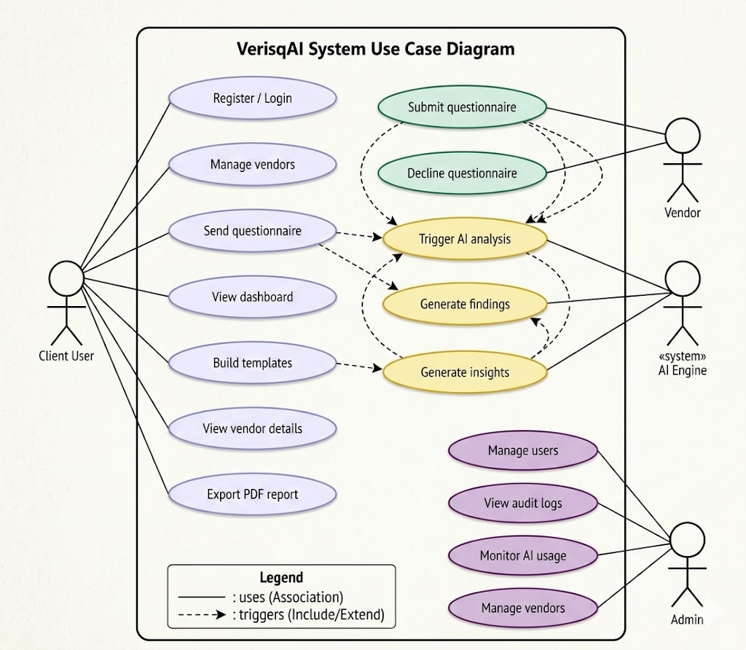

5.2.2 CRC (Class Responsibility Collaborator)
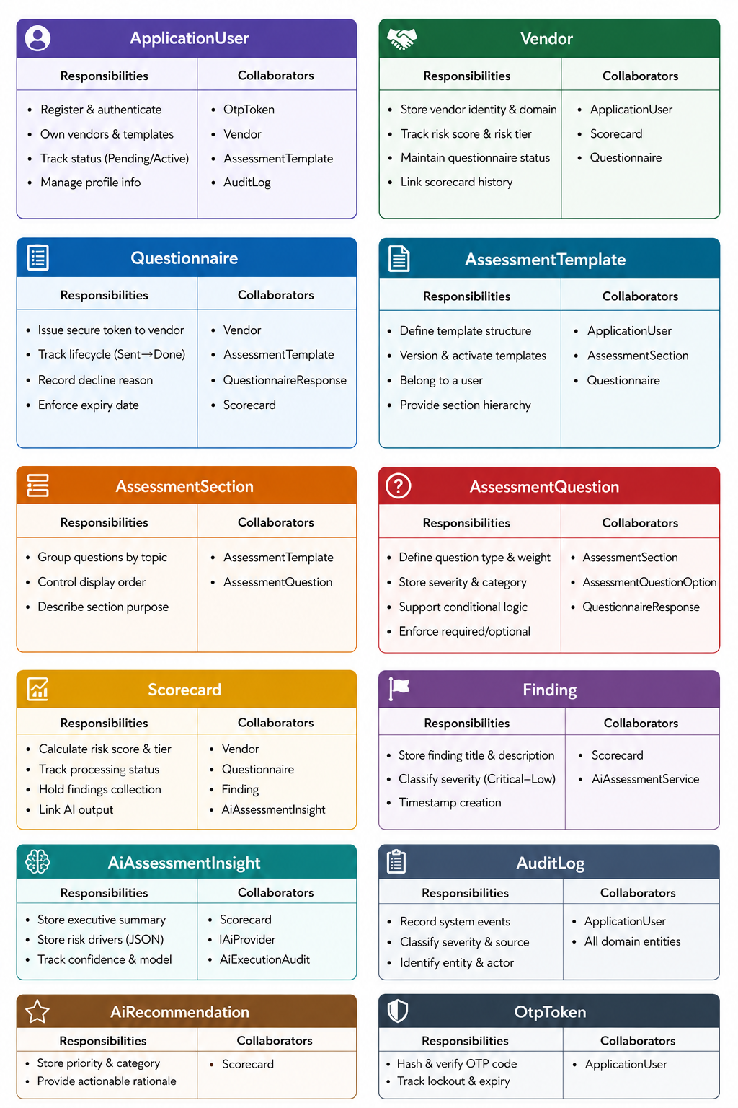

5.2.3 Class Diagram (Key Entities & Relationships)
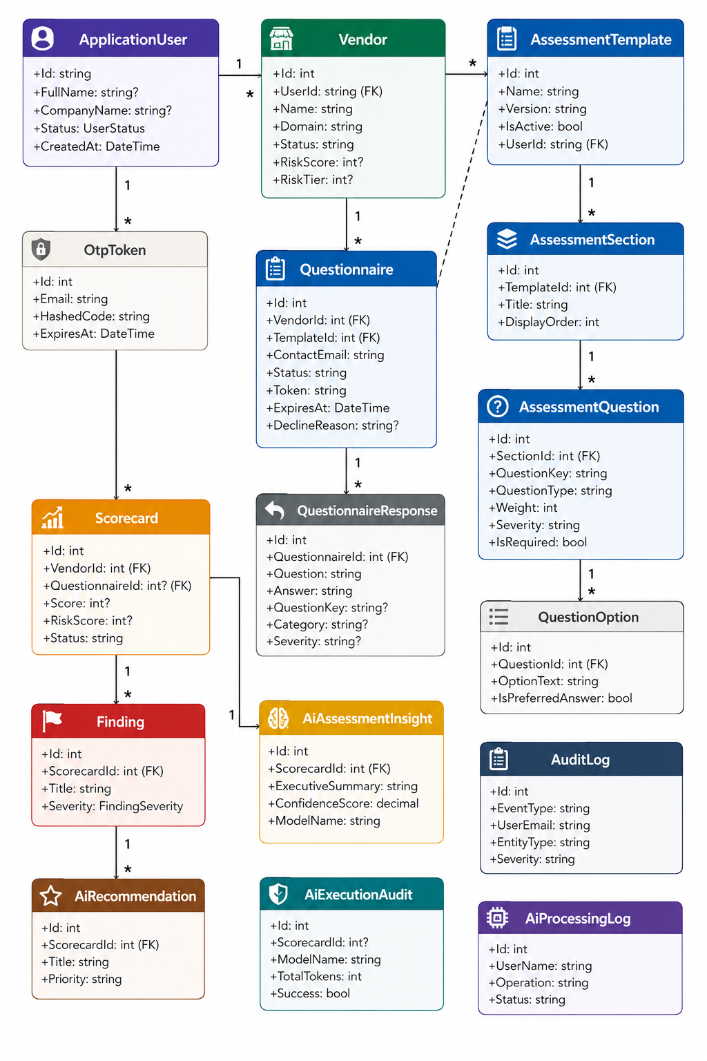

5.2.4 Activity Diagram
5.2.4.1 User Side - Activity Diagram
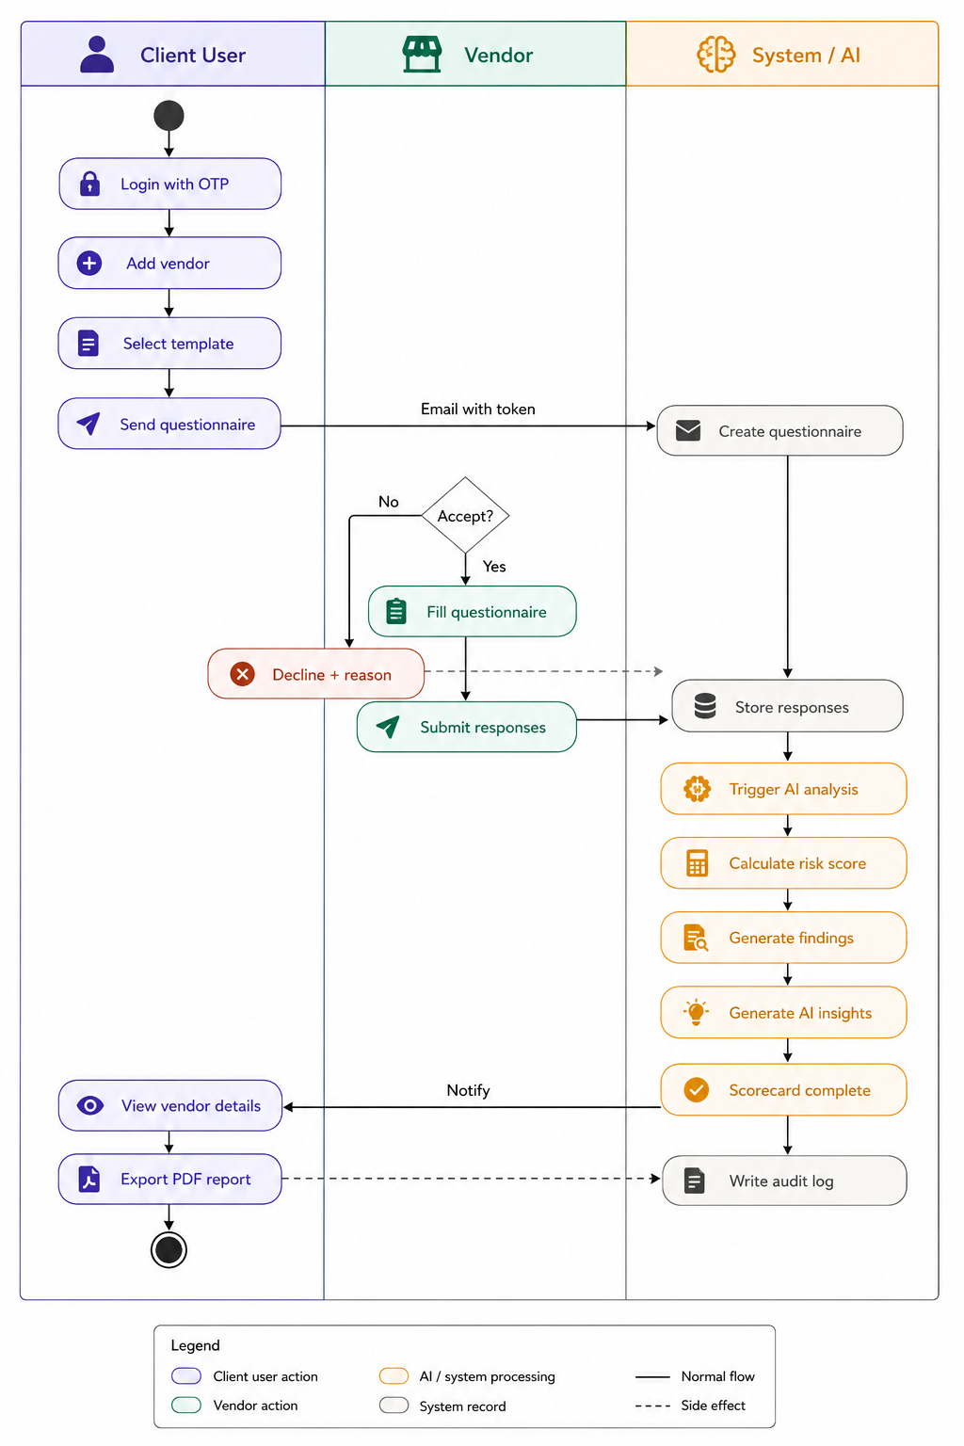
5.2.4.2 Admin Side - Activity Diagram
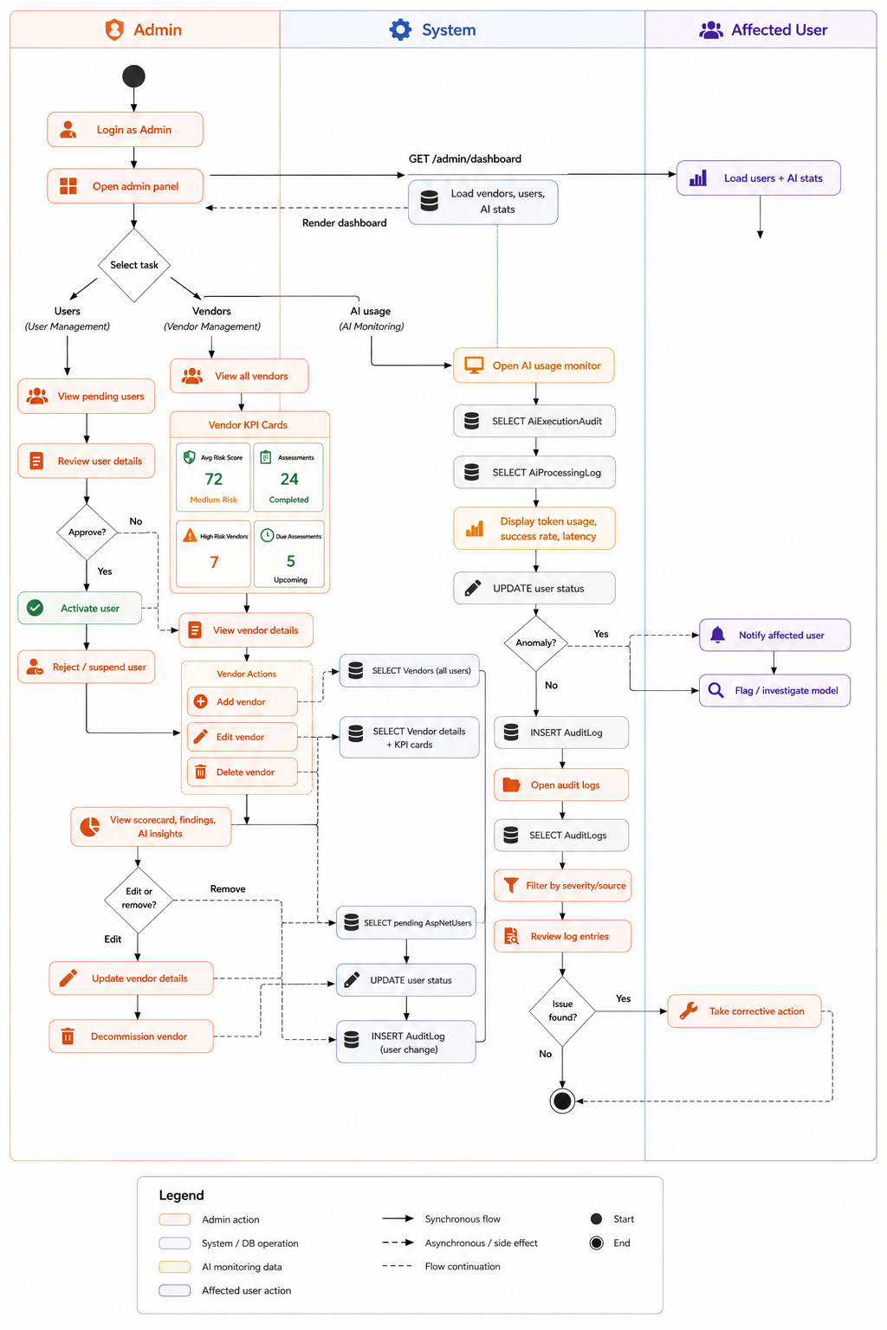

5.2.5 Sequence Diagram
5.2.4.1 User Side - Activity Diagram
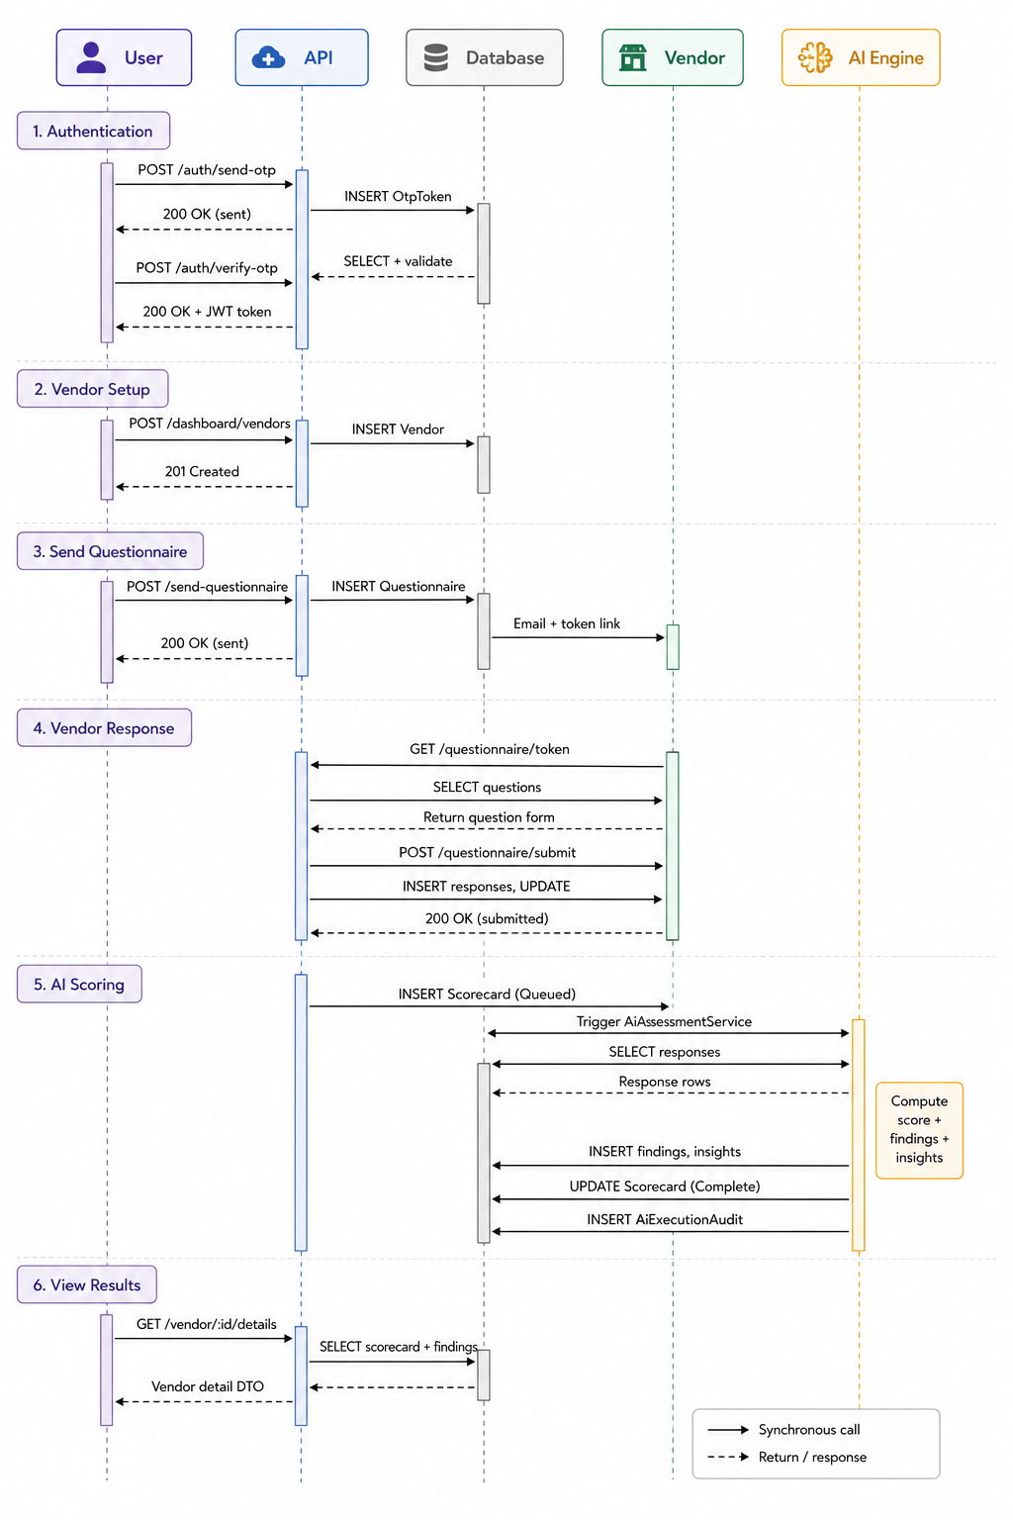
5.2.4.2 Admin Side - Activity Diagram
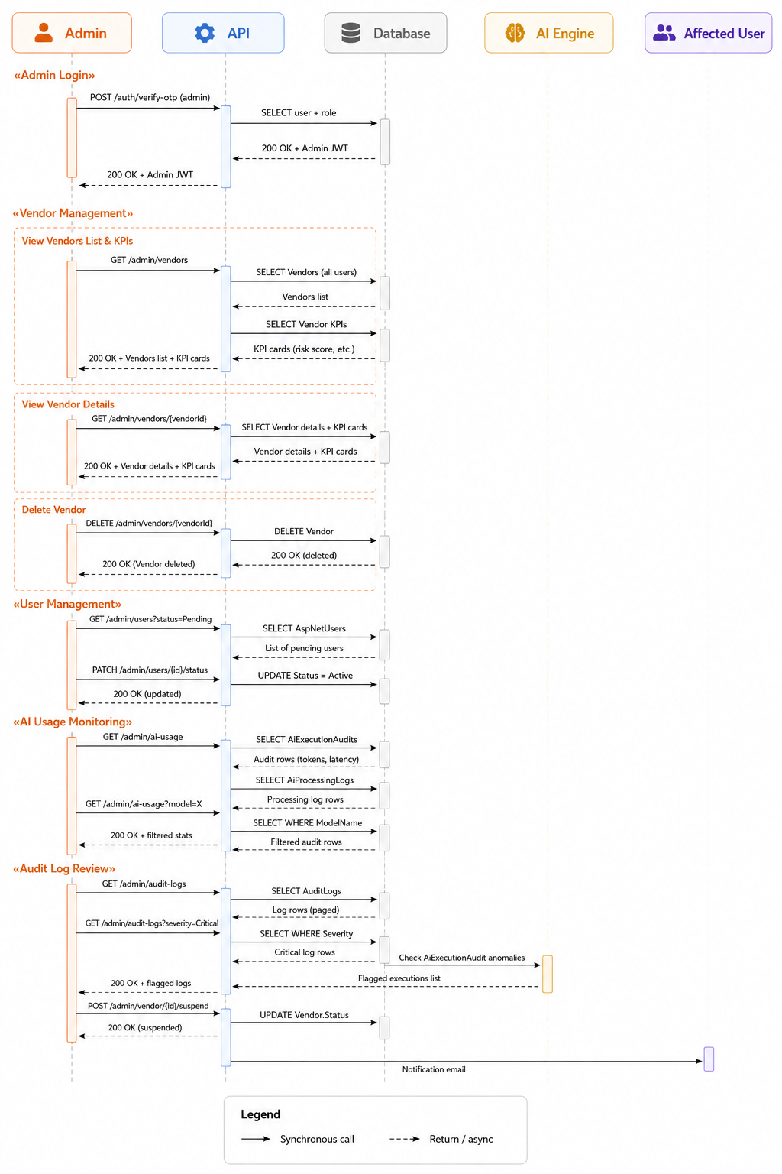

5.3 E-R Diagram
The Entity-Relationship model of VerisqAI encompasses the following key entities and their relationships:
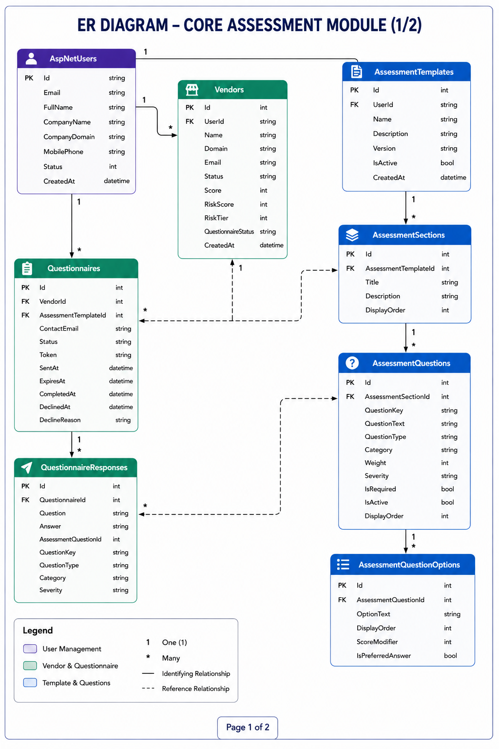

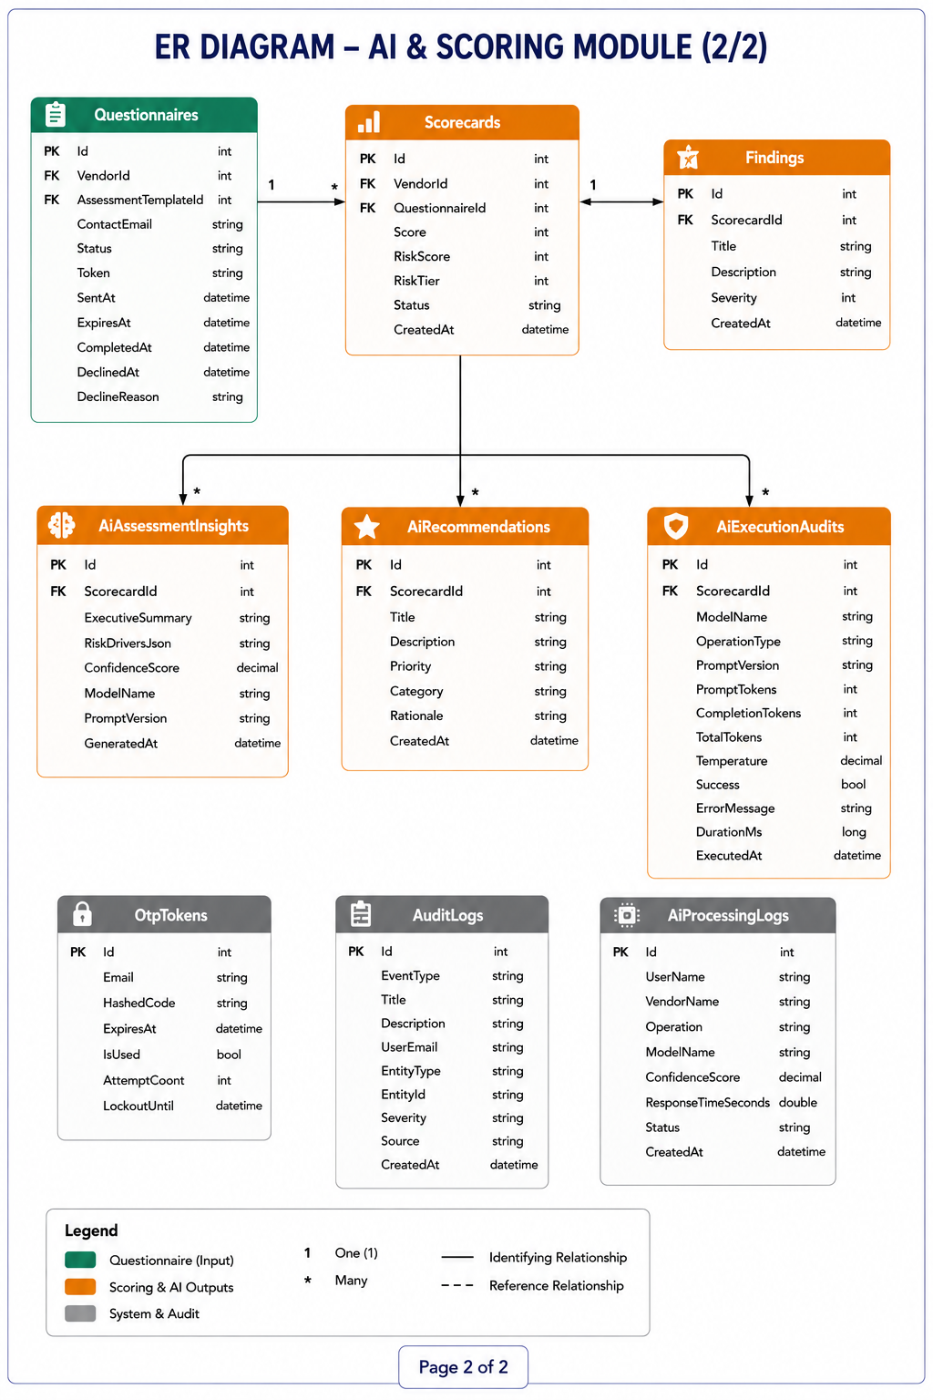

6. Software Design

6.1 Database Design
AiAssessmentInsights
Column Name | Data Type | Nullable | Description
Id | int | No | Unique identifier for the AI assessment insight record
ScorecardId | int | No | References the associated scorecard
ExecutiveSummary | nvarchar(max) | Yes | AI-generated executive summary of assessment results
RiskDriversJson | nvarchar(3000) | Yes | JSON representation of key risk drivers identified by AI
ConfidenceScore | decimal(5,4) | No | Confidence level of the AI-generated assessment
ModelName | nvarchar(100) | No | Name of the AI model used for analysis
PromptVersion | nvarchar(50) | No | Version of the prompt used for AI generation
GeneratedAt | datetime2(7) | No | Date and time when the AI insight was generated

AiExecutionAudits
Column Name | Data Type | Nullable | Description
Id | int | No | Unique identifier for the AI execution audit record
ScorecardId | int | No | References the associated scorecard being analyzed
ModelName | nvarchar(100) | No | Name of the AI model used for execution
OperationType | nvarchar(100) | No | Type of AI operation performed (e.g., Insight Generation, Recommendation Generation)
PromptVersion | nvarchar(100) | No | Version of the prompt template used
PromptTokens | int | No | Number of input tokens sent to the AI model
CompletionTokens | int | No | Number of output tokens generated by the AI model
TotalTokens | int | No | Total token count consumed during execution
Temperature | decimal(3,2) | No | Temperature setting used for AI generation
Success | bit | No | Indicates whether the AI execution completed successfully
ErrorMessage | nvarchar(max) | Yes | Error details if execution failed
ExecutionTimeMs | int | Yes | Total execution time in milliseconds
CreatedAt | datetime2(7) | No | Date and time when the execution occurred

AiProcessingLogs
Column Name | Data Type | Nullable | Description
Id | int | No | Unique identifier for the processing log record
UserName | nvarchar(200) | No | Name of the user who initiated the AI operation
VendorName | nvarchar(200) | No | Name of the vendor being analyzed
Operation | nvarchar(200) | No | Type of AI operation performed
ModelName | nvarchar(100) | No | Name of the AI model used
ConfidenceScore | decimal(18,2) | Yes | Confidence score returned by the AI model
ResponseTimeSeconds | float | Yes | Time taken by the AI model to generate the response
Status | nvarchar(50) | No | Processing status (e.g., Success, Failed, In Progress)
CreatedAt | datetime2(7) | No | Date and time when the processing activity occurred

AiRecommendations
Column Name | Data Type | Nullable | Description
Id | int | No | Unique identifier for the recommendation record
ScorecardId | int | No | References the associated scorecard
Title | nvarchar(200) | No | Short title of the recommendation
Description | nvarchar(max) | No | Detailed recommendation provided by the AI model
Priority | nvarchar(50) | No | Priority level of the recommendation (High, Medium, Low)
Category | nvarchar(100) | No | Recommendation category (e.g., Security, Compliance, Governance)
Rationale | nvarchar(max) | No | AI-generated reasoning explaining why the recommendation was created
CreatedAt | datetime2(7) | No | Date and time when the recommendation was generated

AspNetRoleClaims
Column Name | Data Type | Nullable | Description
Id | int | No | Unique identifier for the role claim record
RoleId | nvarchar(450) | No | References the associated role
ClaimType | nvarchar(max) | Yes | Type of claim assigned to the role
ClaimValue | nvarchar(max) | Yes | Value of the claim assigned to the role

AspNetRoles
Column Name | Data Type | Nullable | Description
Id | nvarchar(450) | No | Unique identifier for the role
Name | nvarchar(256) | Yes | Role name used within the application
NormalizedName | nvarchar(256) | Yes | Normalized version of the role name used for lookups and comparisons
ConcurrencyStamp | nvarchar(max) | Yes | Value used for optimistic concurrency checking during updates

AspNetUserClaims
Column Name | Data Type | Nullable | Description
Id | int | No | Unique identifier for the user claim record
UserId | nvarchar(450) | No | References the associated user
ClaimType | nvarchar(max) | Yes | Type of claim assigned to the user
ClaimValue | nvarchar(max) | Yes | Value of the claim assigned to the user
AspNetUserLogins
Column Name | Data Type | Nullable | Description
LoginProvider | nvarchar(128) | No | Name of the external authentication provider
ProviderKey | nvarchar(128) | No | Unique identifier provided by the external authentication provider
ProviderDisplayName | nvarchar(max) | Yes | Friendly display name of the authentication provider
UserId | nvarchar(450) | No | References the associated user account

AspNetUserRoles
Column Name | Data Type | Nullable | Description
UserId | nvarchar(450) | No | References the user account
RoleId | nvarchar(450) | No | References the assigned role

AspNetUsers
Column Name | Data Type | Nullable | Description
Id | nvarchar(450) | No | Unique identifier for the user
FullName | nvarchar(200) | Yes | Full name of the user
CompanyName | nvarchar(200) | Yes | Organization or company associated with the user
CompanyDomain | nvarchar(200) | Yes | Company website or domain name
MobilePhone | nvarchar(20) | Yes | User's mobile contact number
Status | nvarchar(50) | Yes | Current account status (Active, Inactive, Pending, etc.)
UserName | nvarchar(256) | Yes | Username used for login
NormalizedUserName | nvarchar(256) | Yes | Normalized username for searching and comparisons
Email | nvarchar(256) | Yes | User email address
NormalizedEmail | nvarchar(256) | Yes | Normalized email address
EmailConfirmed | bit | No | Indicates whether the user's email has been verified
PasswordHash | nvarchar(max) | Yes | Encrypted password hash
SecurityStamp | nvarchar(max) | Yes | Security token used to invalidate authentication sessions
ConcurrencyStamp | nvarchar(max) | Yes | Value used for optimistic concurrency control
PhoneNumber | nvarchar(max) | Yes | User's phone number
PhoneNumberConfirmed | bit | No | Indicates whether the phone number has been verified
TwoFactorEnabled | bit | No | Indicates whether two-factor authentication is enabled
LockoutEnd | datetimeoffset(7) | Yes | Date and time when account lockout expires
LockoutEnabled | bit | No | Indicates whether account lockout is enabled
AccessFailedCount | int | No | Number of failed login attempts
CreatedAt | datetime2(7) | No | Date and time when the user account was created

AspNetUserTokens
Column Name | Data Type | Nullable | Description
UserId | nvarchar(450) | No | References the associated user account
LoginProvider | nvarchar(128) | No | Authentication provider associated with the token
Name | nvarchar(128) | No | Name or type of the token
Value | nvarchar(max) | Yes | Token value or security credential

AssessmentQuestionOptions
Column Name | Data Type | Nullable | Description
Id | int | No | Unique identifier for the question option
AssessmentQuestionId | int | No | References the associated assessment question
OptionText | nvarchar(500) | No | Text displayed as the answer option
DisplayOrder | int | No | Determines the display sequence of options
ScoreModifier | int | No | Score adjustment applied when the option is selected
IsPreferredAnswer | bit | No | Indicates whether the option represents the preferred or recommended answer
AssessmentQuestions
Column Name | Data Type | Nullable | Description
Id | int | No | Unique identifier for the assessment question
AssessmentSectionId | int | No | References the section to which the question belongs
QuestionKey | nvarchar(150) | No | Unique key used to identify the question
QuestionText | nvarchar(2000) | No | The actual question displayed to the vendor
QuestionType | nvarchar(50) | No | Type of question (Text, Radio, Checkbox, Dropdown, Yes/No, etc.)
Category | nvarchar(100) | Yes | Classification category of the question
Weight | int | No | Weight assigned for scoring calculations
Severity | nvarchar(50) | No | Risk severity level associated with the question
IsRequired | bit | No | Indicates whether answering the question is mandatory
IsActive | bit | No | Indicates whether the question is currently active
DisplayOrder | int | No | Determines the display sequence within the section
DependsOnQuestionKey | nvarchar(150) | Yes | Question key on which this question depends
DependsOnValue | nvarchar(500) | Yes | Value required to display this question

AssessmentSections
Column Name | Data Type | Nullable | Description
Id | int | No | Unique identifier for the assessment section
AssessmentTemplateId | int | No | References the assessment template to which the section belongs
Title | nvarchar(200) | No | Name of the assessment section
Description | nvarchar(1000) | Yes | Detailed description of the section
DisplayOrder | int | No | Determines the display sequence of sections within the assessment template

AssessmentTemplates
Column Name | Data Type | Nullable | Description
Id | int | No | Unique identifier for the assessment template
Name | nvarchar(200) | No | Name of the assessment template
Description | nvarchar(1000) | Yes | Detailed description of the assessment template
Version | int | No | Version number of the assessment template
IsActive | bit | No | Indicates whether the template is active and available for use
CreatedAt | datetime2(7) | No | Date and time when the template was created
UserId | nvarchar(450) | No | References the user who created the template

AuditLogs
Column Name | Data Type | Nullable | Description
Id | int | No | Unique identifier for the audit log record
EventType | nvarchar(100) | No | Type of event being recorded (Create, Update, Delete, Login, Logout, etc.)
Title | nvarchar(200) | No | Short title describing the event
Description | nvarchar(1000) | No | Detailed description of the event activity
UserEmail | nvarchar(200) | No | Email address of the user who performed the action
EntityType | nvarchar(200) | No | Name of the entity affected by the action
EntityId | nvarchar(200) | No | Identifier of the affected entity
Severity | nvarchar(100) | No | Severity level of the event (Info, Warning, Error, Critical)
Source | nvarchar(100) | No | Source module or component that generated the event
CreatedAt | datetime2(7) | No | Date and time when the event occurred

Findings
Column Name | Data Type | Nullable | Description
Id | int | No | Unique identifier for the finding record
ScorecardId | int | No | References the associated vendor assessment scorecard
Title | nvarchar(200) | No | Short title describing the finding
Description | nvarchar(max) | No | Detailed explanation of the identified issue or risk
Severity | int | No | Severity level assigned to the finding
CreatedAt | datetime2(7) | No | Date and time when the finding was generated

OtpTokens
Column Name | Data Type | Nullable | Description
Id | int | No | Unique identifier for the OTP record
Email | nvarchar(256) | No | Email address associated with the OTP request
HashedCode | nvarchar(max) | No | Hashed version of the generated OTP code
ExpiresAt | datetime2(7) | No | Date and time when the OTP expires
IsUsed | bit | No | Indicates whether the OTP has already been used
AttemptCount | int | No | Number of verification attempts made using the OTP
CreatedAt | datetime2(7) | No | Date and time when the OTP was generated
LockoutUntil | datetime2(7) | Yes | Date and time until which verification is temporarily locked after excessive failed attempts

QuestionnaireResponses
Column Name | Data Type | Nullable | Description
Id | int | No | Unique identifier for the questionnaire response
QuestionnaireId | int | No | References the questionnaire being completed
Question | nvarchar(max) | No | Text of the assessment question
Answer | nvarchar(max) | No | Vendor's response to the question
AssessmentQuestionId | int | Yes | References the original assessment question
Category | nvarchar(100) | Yes | Category associated with the question
QuestionKey | nvarchar(150) | Yes | Unique key identifying the question
QuestionType | nvarchar(50) | Yes | Type of question (Text, Radio, Dropdown, Yes/No, etc.)
Severity | nvarchar(50) | Yes | Risk severity associated with the question

Questionnaires
Column Name | Data Type | Nullable | Description
Id | int | No | Unique identifier for the questionnaire
VendorId | int | No | References the vendor receiving the questionnaire
ContactEmail | nvarchar(max) | No | Email address where the questionnaire invitation is sent
Status | nvarchar(max) | No | Current status of the questionnaire
SentAt | datetime2(7) | No | Date and time when the questionnaire was sent
CompletedAt | datetime2(7) | Yes | Date and time when the questionnaire was completed
Token | nvarchar(max) | No | Unique access token used to securely access the questionnaire
AssessmentTemplateId | int | No | References the assessment template assigned to the questionnaire
CancelledAt | datetime2(7) | Yes | Date and time when the questionnaire was cancelled
DeclineReason | nvarchar(1000) | Yes | Reason provided when the questionnaire is declined
DeclinedAt | datetime2(7) | Yes | Date and time when the questionnaire was declined
ExpiresAt | datetime2(7) | Yes | Date and time when the questionnaire access expires
StartedAt | datetime2(7) | Yes | Date and time when the vendor begins completing the questionnaire

Scorecards
Column Name | Data Type | Nullable | Description
Id | int | No | Unique identifier for the scorecard
VendorId | int | No | References the vendor being assessed
Score | int | Yes | Overall assessment score calculated from questionnaire responses
RiskScore | int | Yes | Calculated risk score representing vendor risk exposure
RiskTier | int | Yes | Risk classification tier assigned to the vendor
Status | nvarchar(max) | No | Current assessment status (Completed, In Progress, Pending, etc.)
CreatedAt | datetime2(7) | No | Date and time when the scorecard was generated
QuestionnaireId | int | Yes | References the questionnaire used for the assessment

Vendor
Column Name | Data Type | Nullable | Description
Id | int | No | Unique identifier for the vendor
UserId | nvarchar(450) | No | References the user who created or manages the vendor
Name | nvarchar(200) | No | Name of the vendor organization
Domain | nvarchar(200) | No | Vendor website domain
Status | nvarchar(50) | No | Current status of the vendor
Score | int | Yes | Overall assessment score
RiskScore | int | Yes | Calculated vendor risk score
Findings | int | Yes | Total number of findings identified
RiskTier | int | Yes | Risk classification tier
QuestionnaireStatus | nvarchar(50) | Yes | Current questionnaire status
CreatedAt | datetime2(7) | No | Date and time when the vendor record was created
Email | nvarchar(256) | Yes | Primary contact email address of the vendor

6.2 Interface Design
The user interface of VerisqAI is developed using React.js with a component-based structure, styled using custom CSS and Tailwind-based utility classes, and uses React Router for client-side navigation. The interface is divided into three major areas: the public-facing landing/marketing pages, the authenticated user dashboard (for organisations managing vendors and assessments), and the admin panel (for platform administrators to monitor users, vendors, AI activity and audit logs). The sitemap below shows the overall navigational structure of the application.

6.2.1 Sitemap
Module | Pages / Routes | Description
Public / Marketing | Landing Page (/), How It Works (/how-it-works) | Introduces VerisqAI, its features and value proposition to prospective users
Authentication | Login / Signup, OTP Verification (/send-code, /otp_verification), Verify (/verify), Trial Request (/request-received), Admin Trial Requests (/admin/trial-requests) | Handles user registration, email/OTP verification and trial access requests
Dashboard Module | Dashboard (/dashboard) | Displays summary widgets: total vendors, risk distribution, recent findings and quick actions
Vendor Management | Vendors list, Vendor Details (/vendor-details) | Lists onboarded vendors and shows detailed vendor profile, risk score, findings and questionnaire status
Questionnaire Module | Questionnaires (/Questionnaires), Questionnaire Welcome (/questionnaire/:token), Assessment (/questionnaire/:token/assessment), Decline (/questionnaire/:token/decline), Declined (/questionnaire/:token/declined) | Manages sending questionnaires to vendors and the vendor-facing flow for completing or declining a questionnaire
Template Builder | Template Builder (/template-builder), Template Details (/template-details) | Allows users to create and edit assessment templates, sections and questions
Risk & Scorecards | Scorecards (/Scorecard), Risk Tiering (/RiskTiering), Breach Alerts (/BreachAlerts) | Displays computed scorecards, risk tier classification and breach/alert notifications
Admin Panel | Admin Dashboard, Users, Vendors, AI Monitoring, Audit Logs | Administrative pages for managing users, vendors, monitoring AI activity and reviewing system audit logs

6.2.2 Page Snapshots
This section presents representative screenshots of the key pages of the VerisqAI application, illustrating the layout, navigation and design consistency across modules. (Insert the corresponding screenshots below each heading.)

6.2.2.1 Landing Page
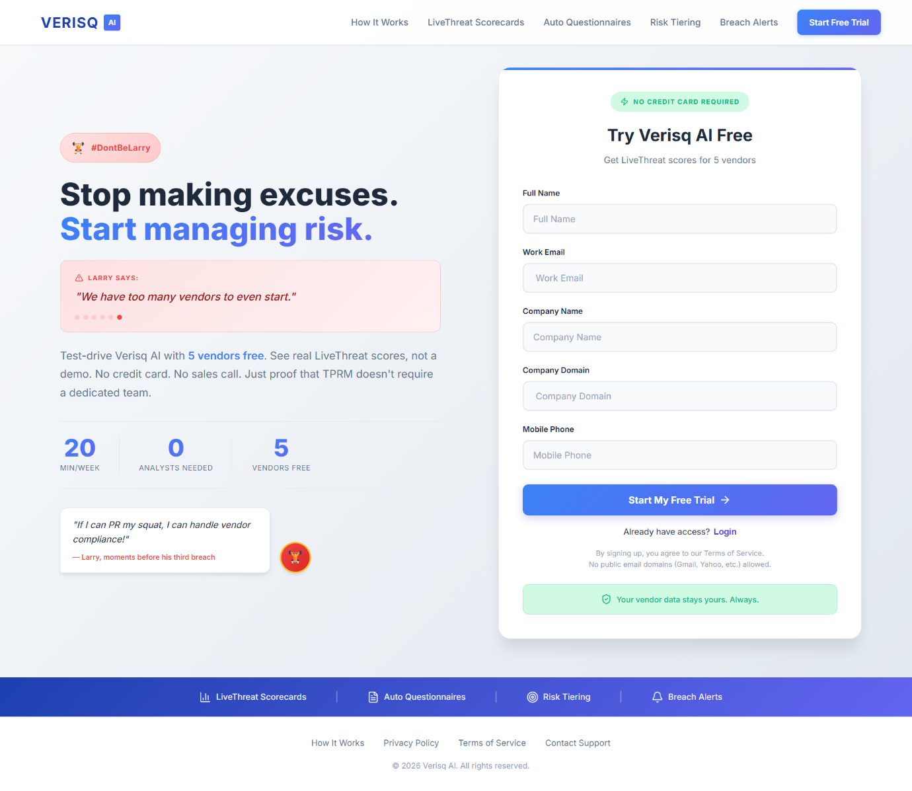

6.2.2.2 Login / OTP Verification Page
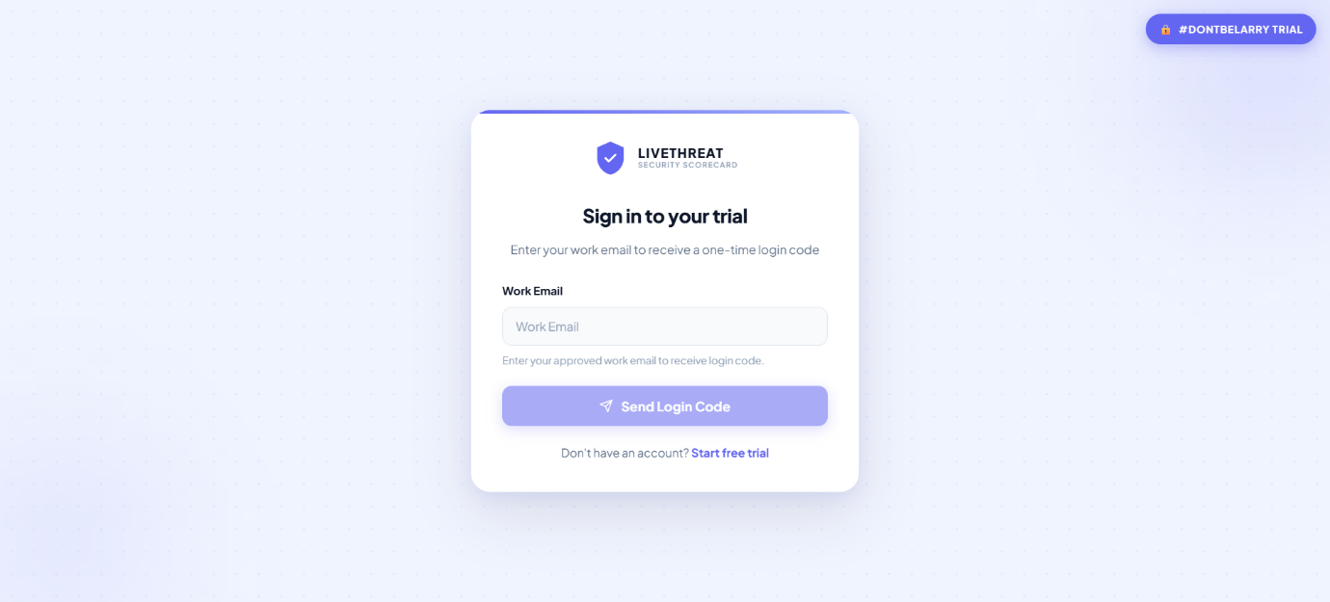

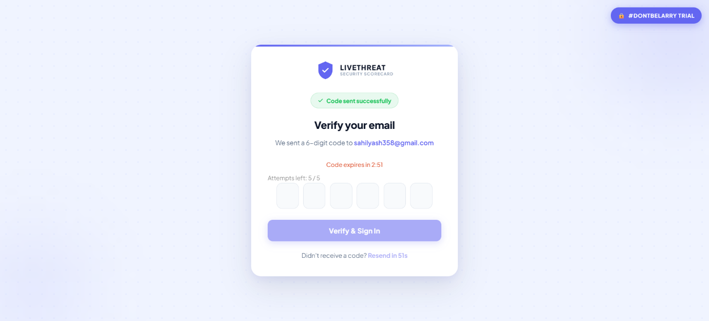

6.2.2.3 Dashboard Page
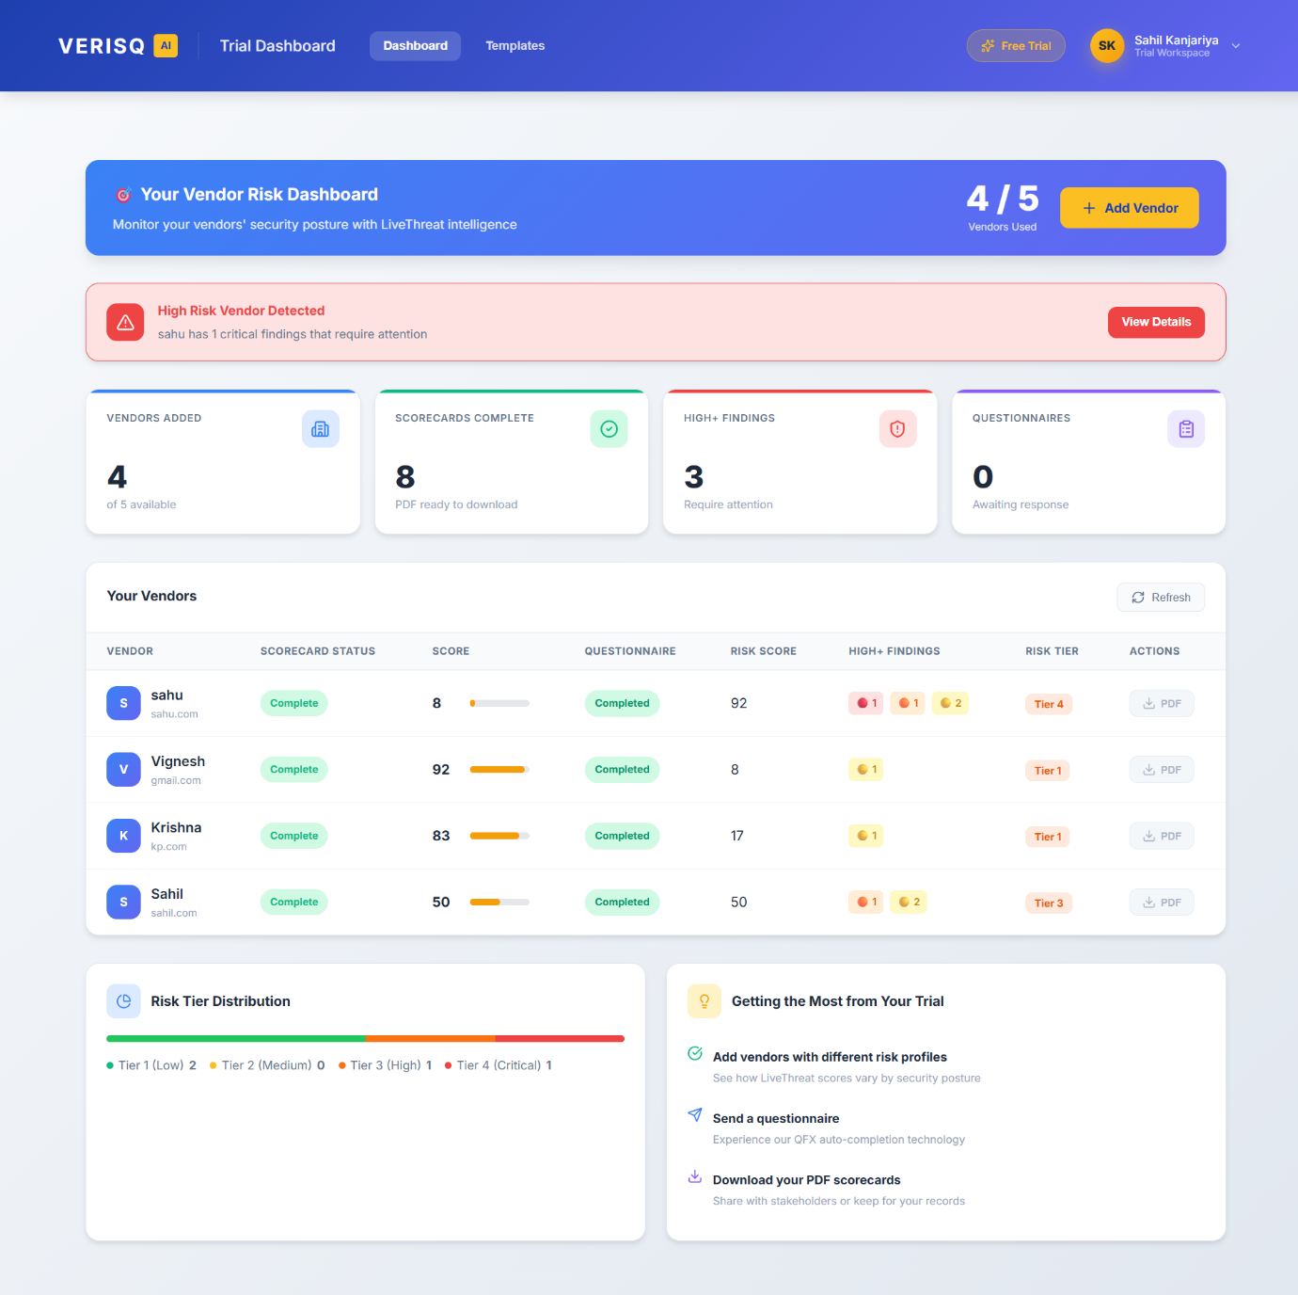

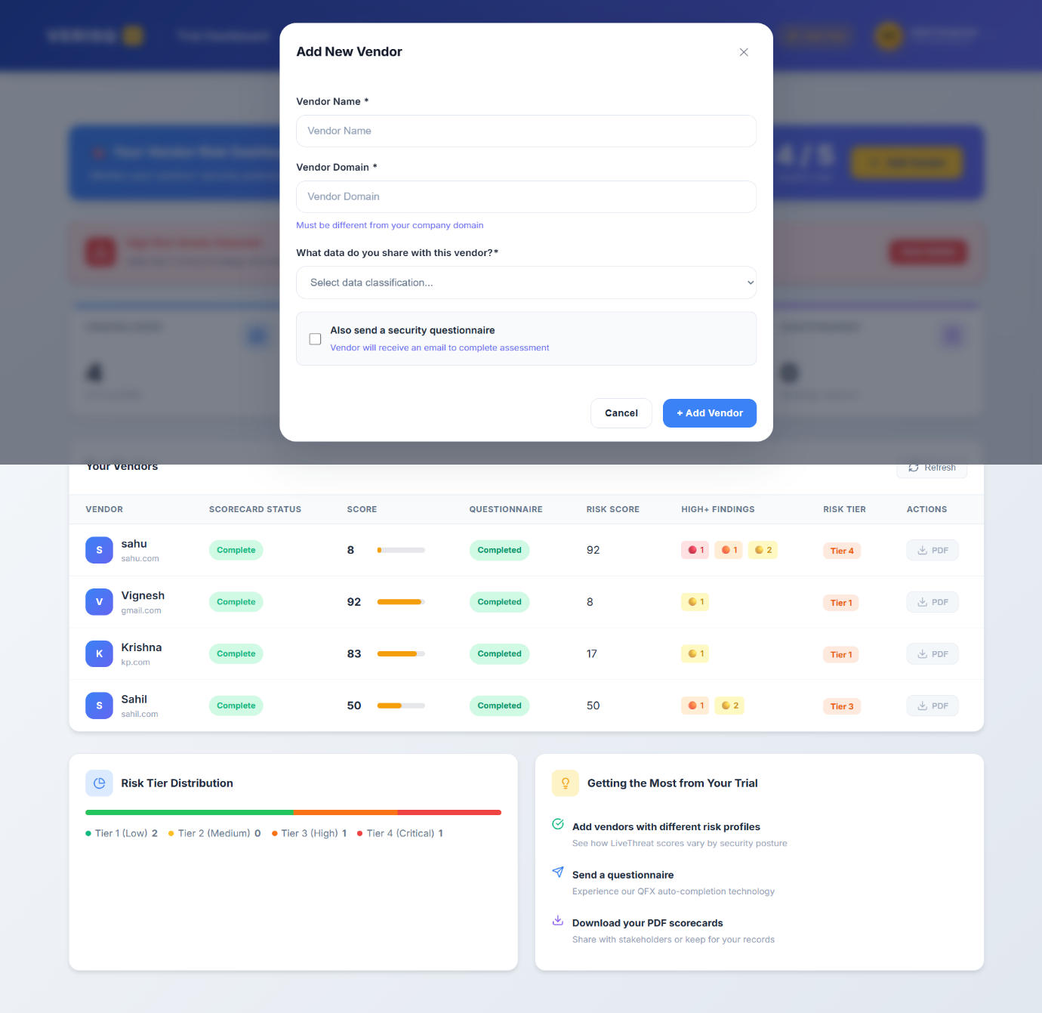

6.2.2.4 Vendor List & Vendor Details Page
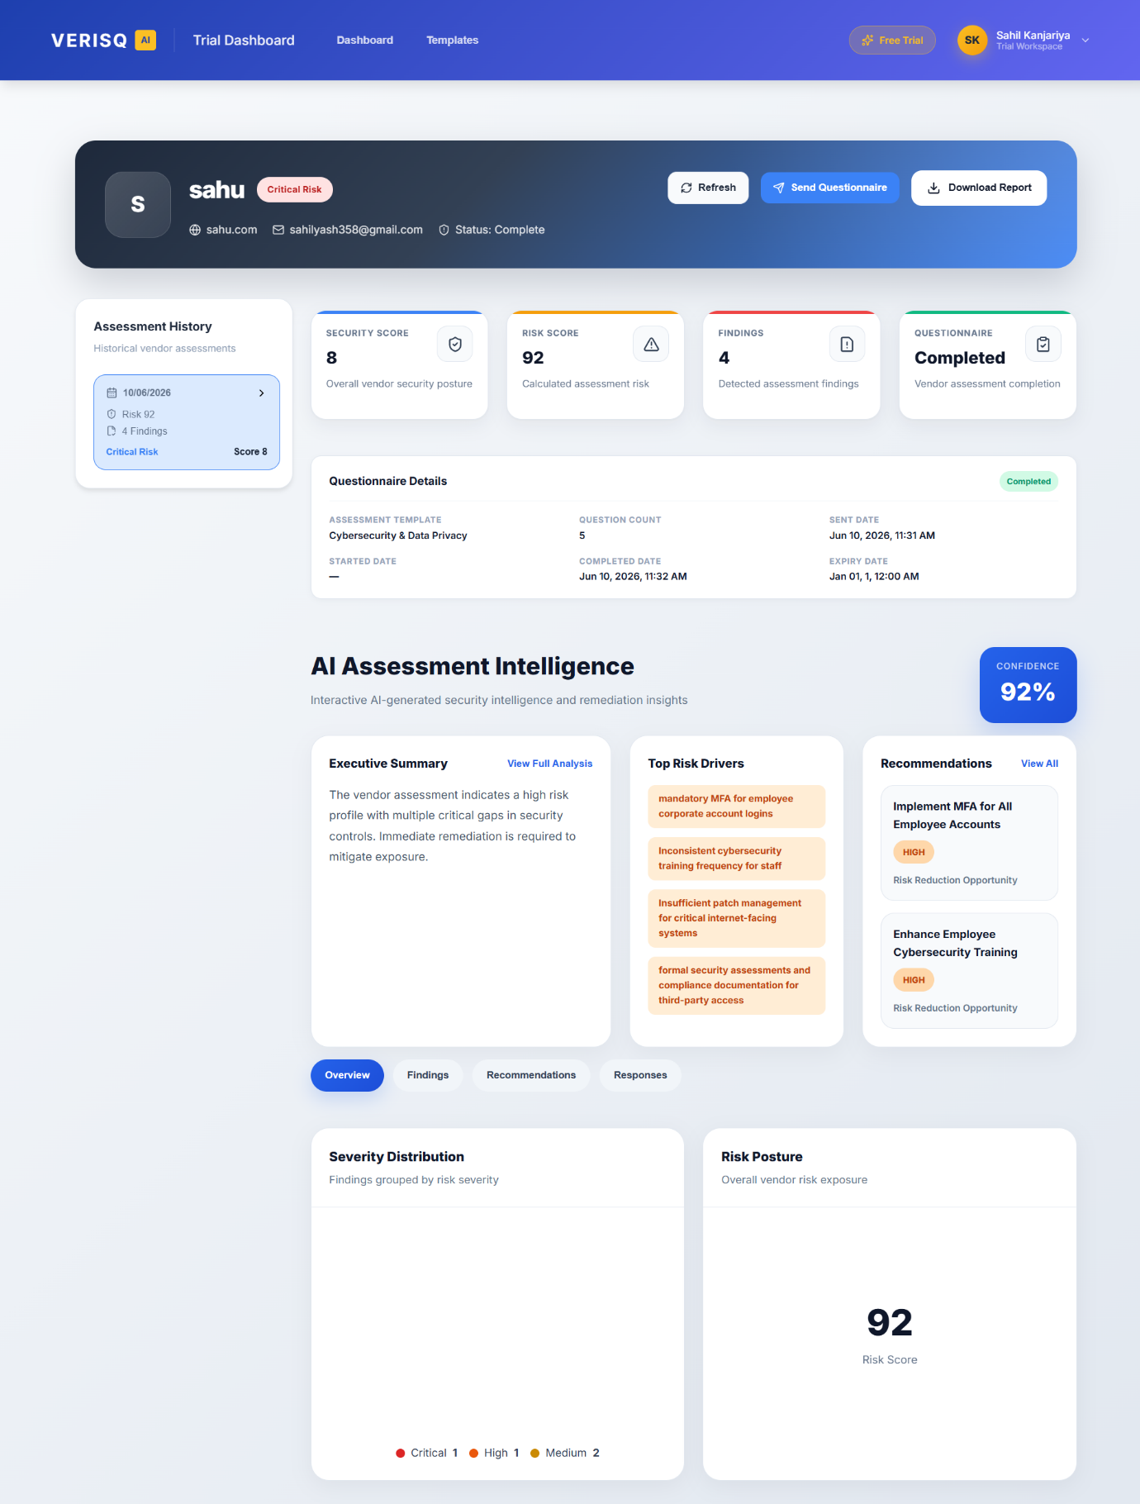
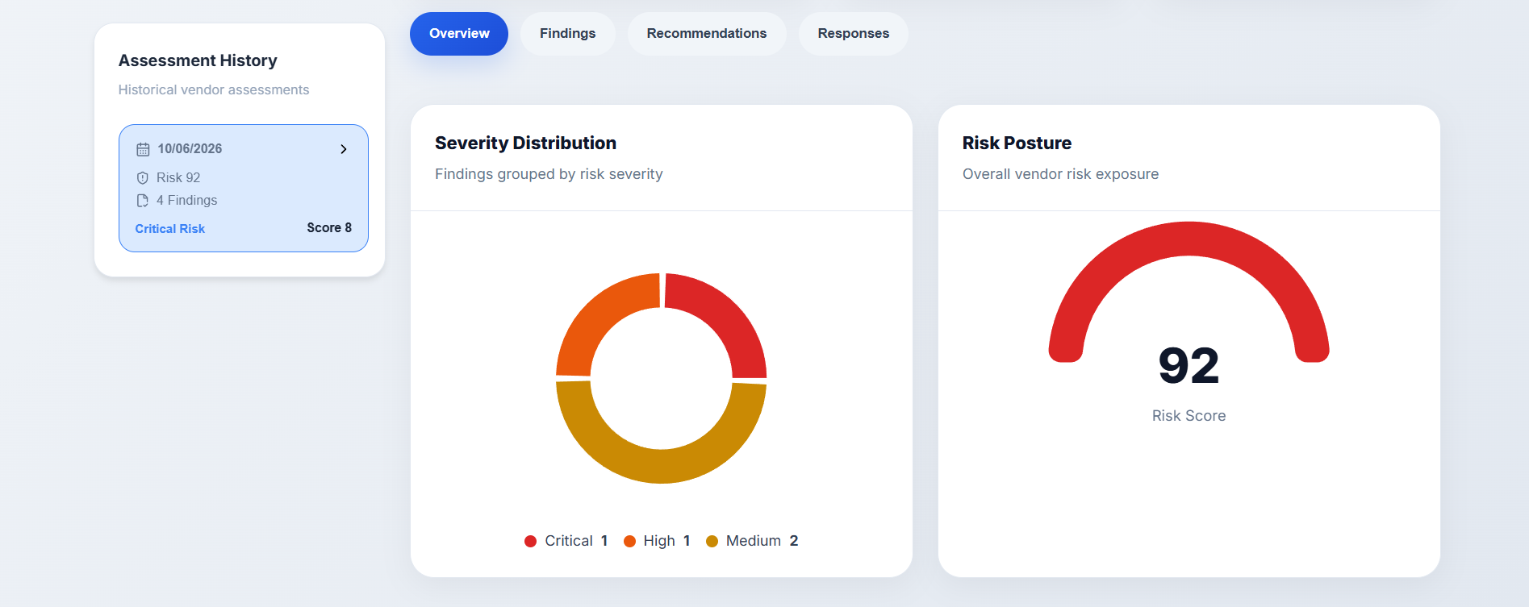
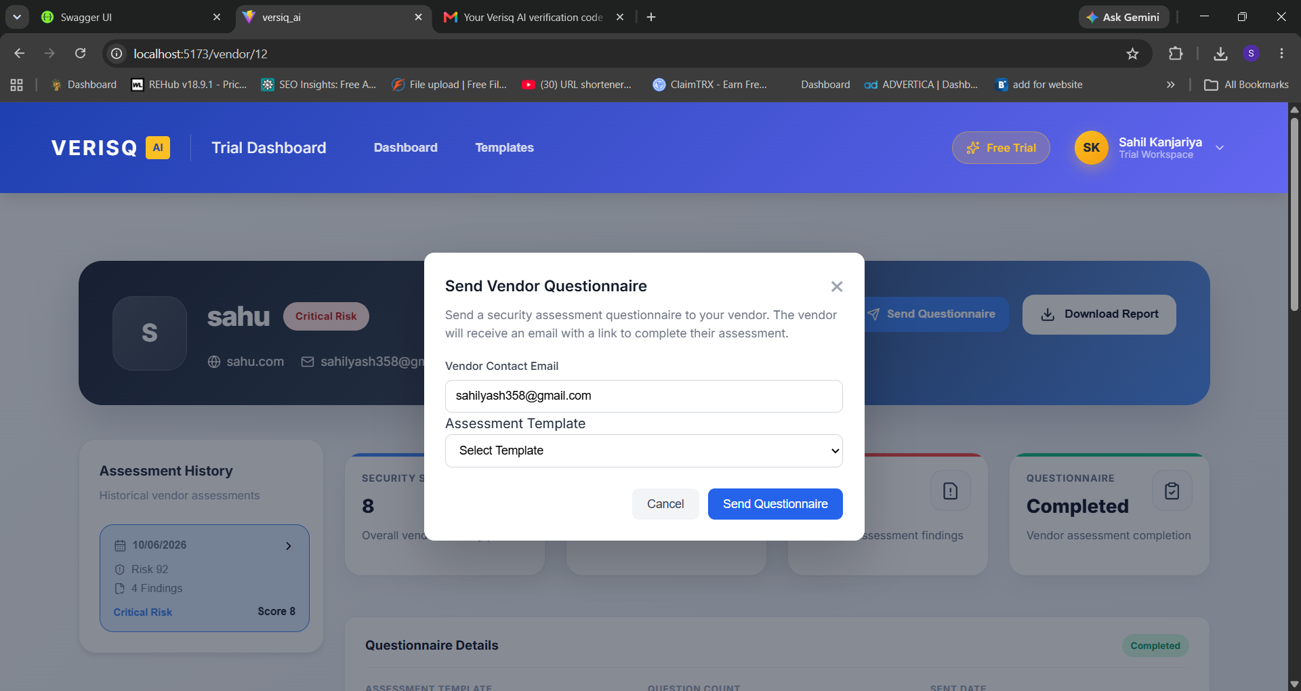

6.2.2.5 Template Builder Page
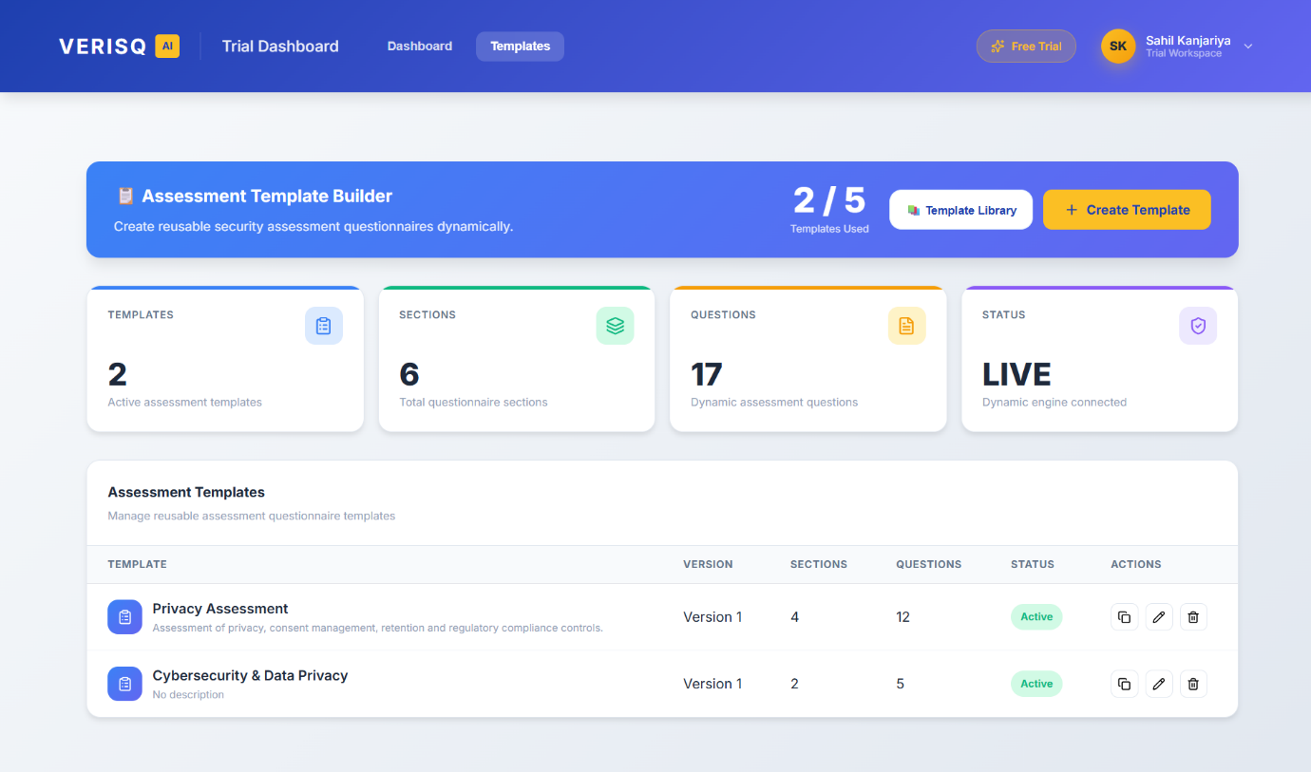

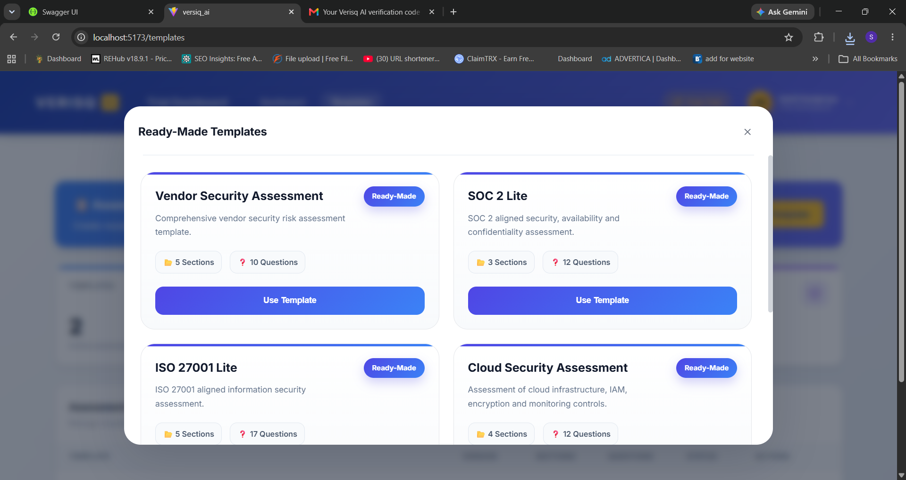
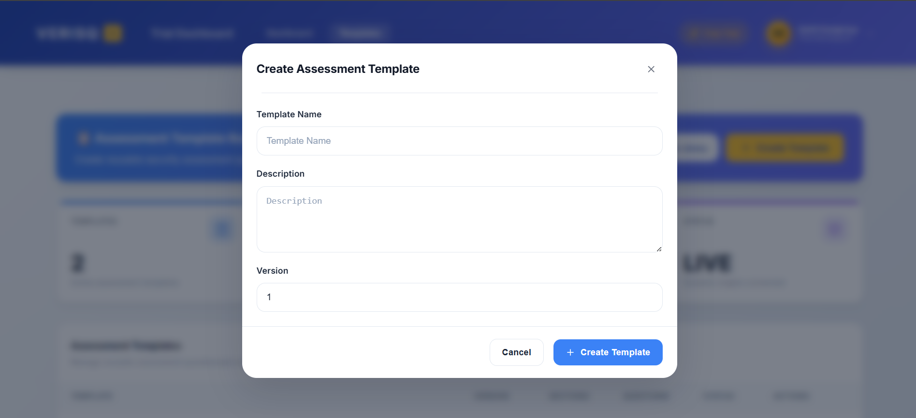
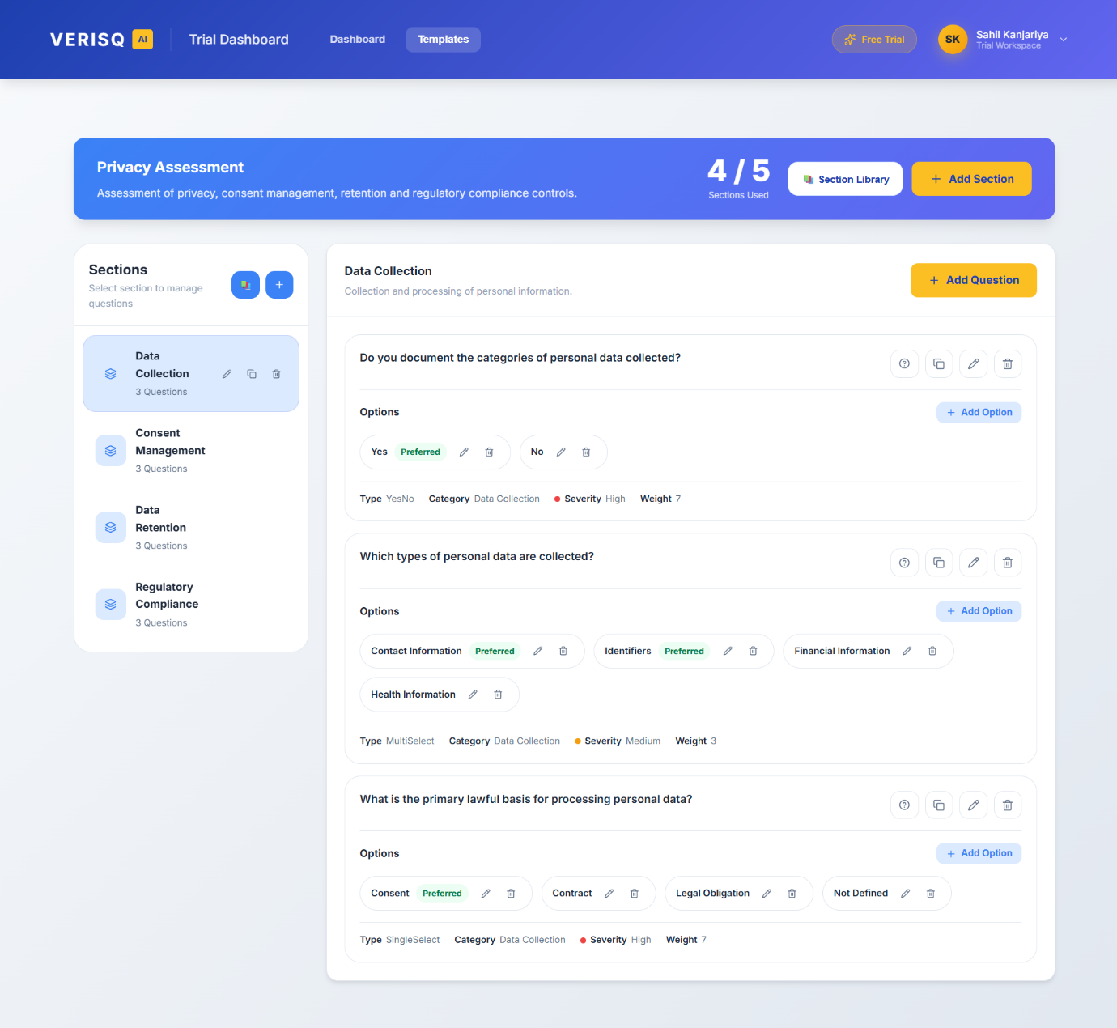
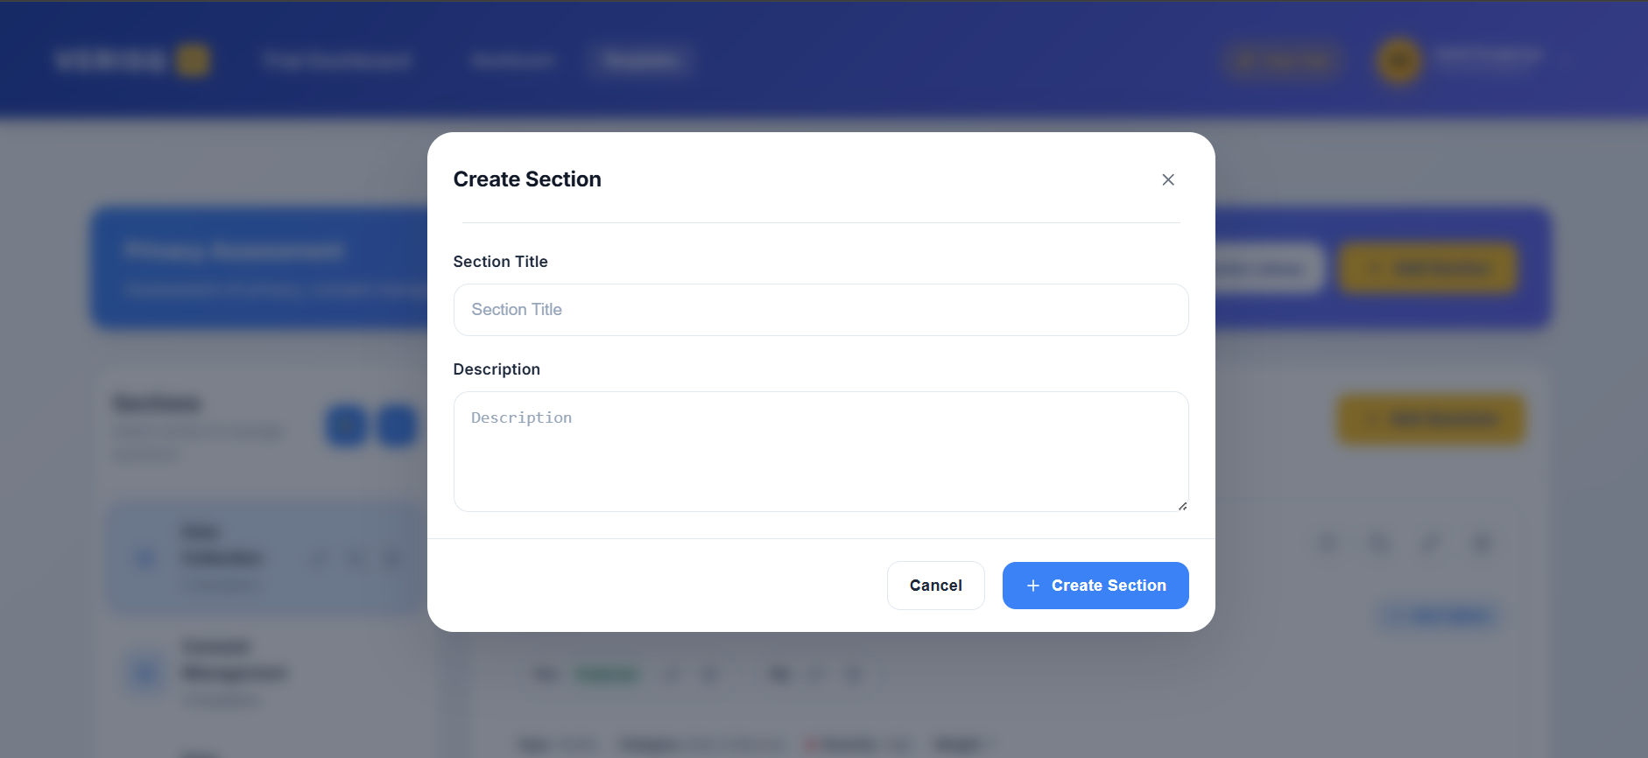
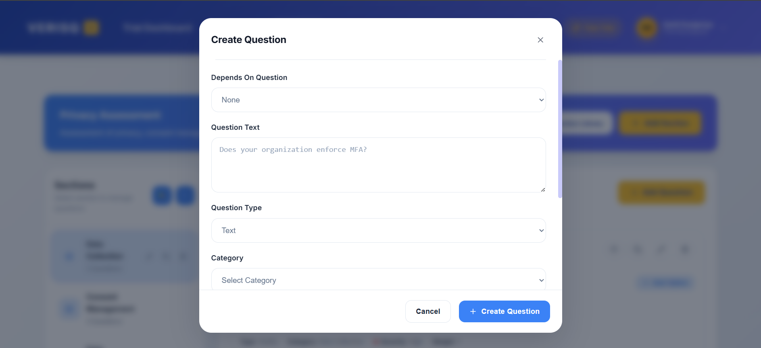

6.2.2.6 Vendor Questionnaire Page
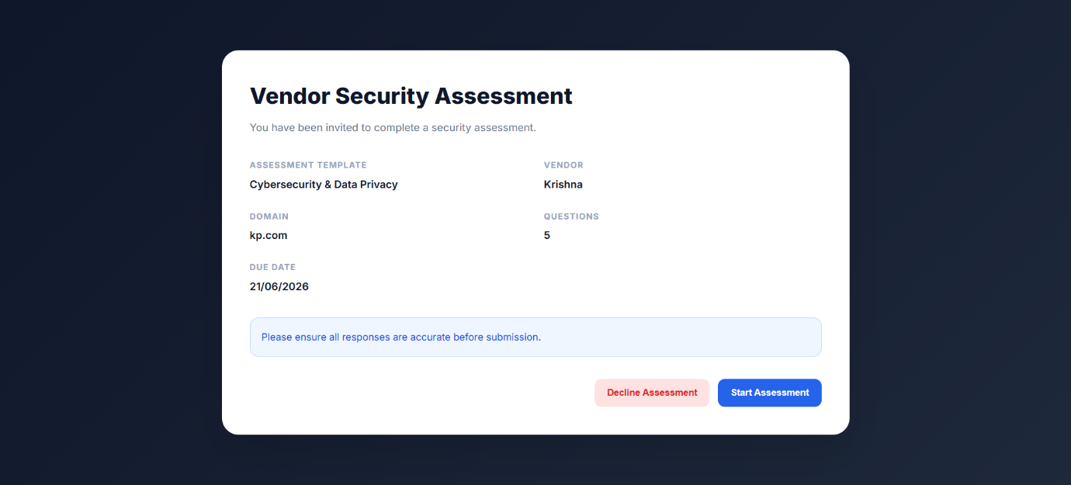
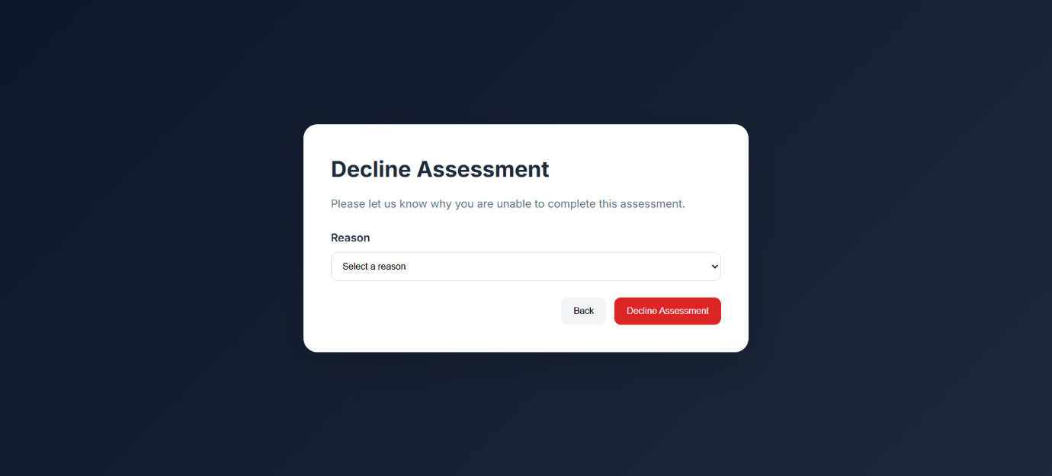
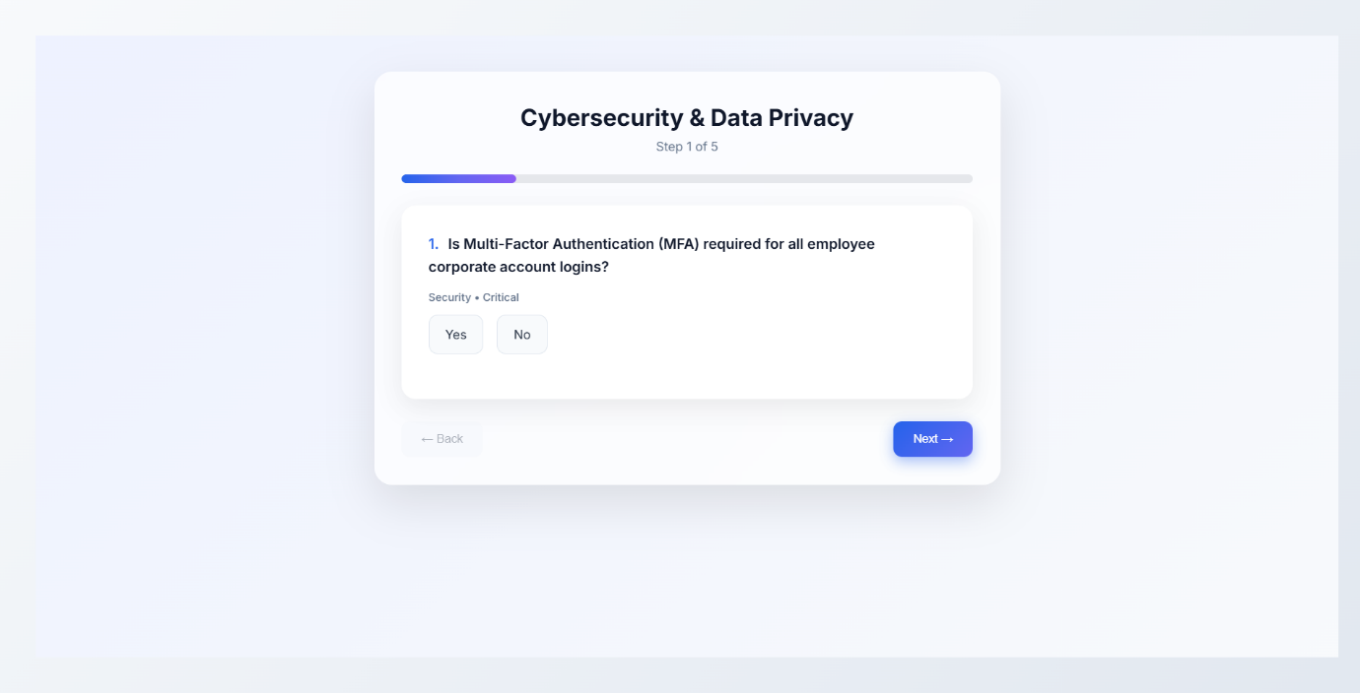

6.2.2.7 Admin Dashboard & AI Monitoring Page
Dashboard
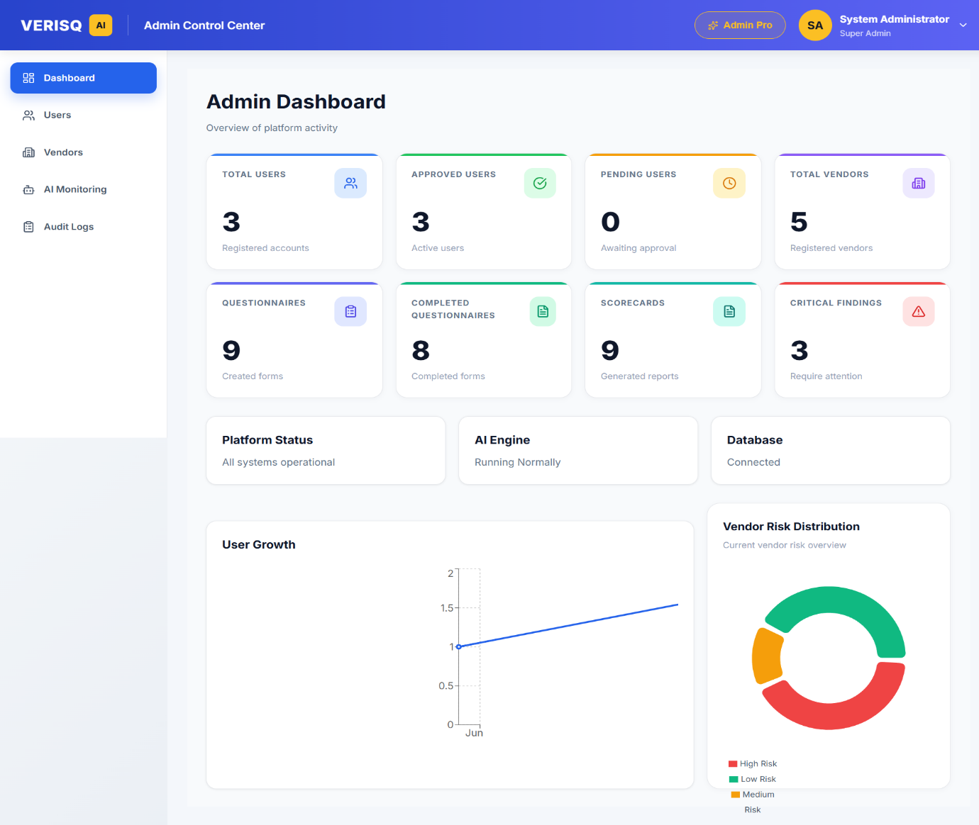
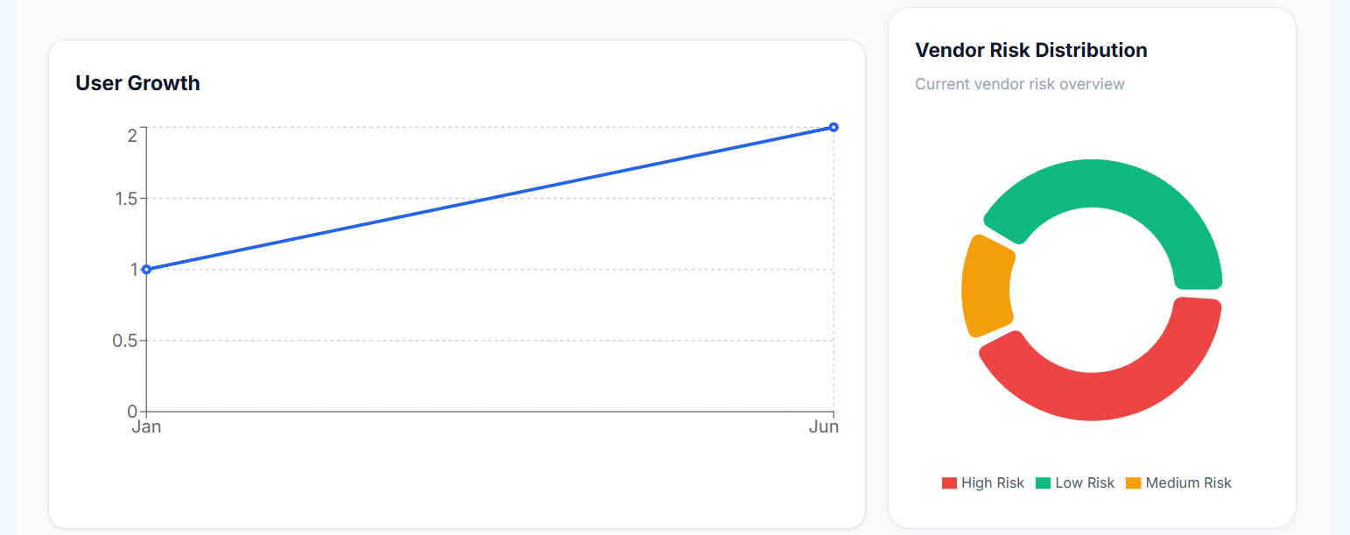

User Management
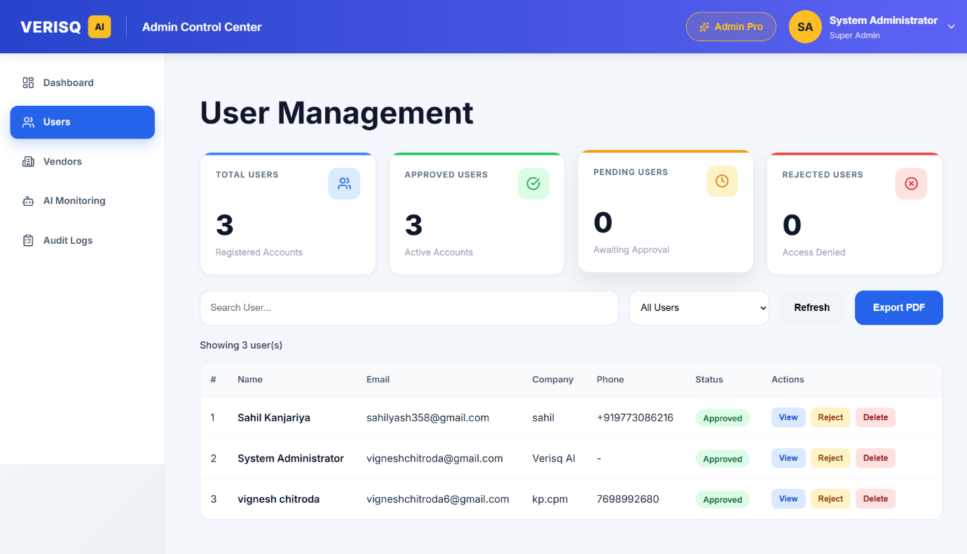

Vendor Management
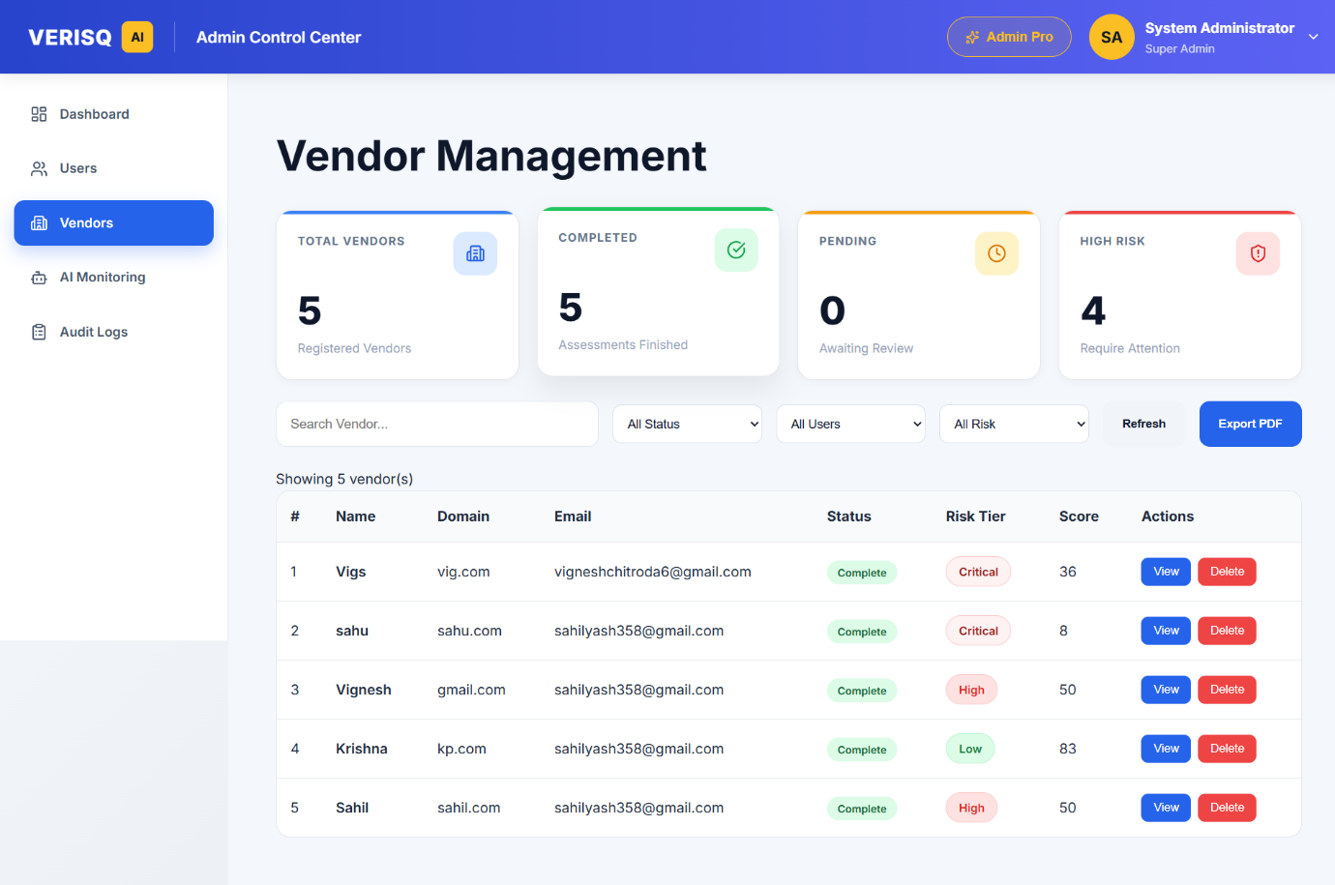

Ai Monitoring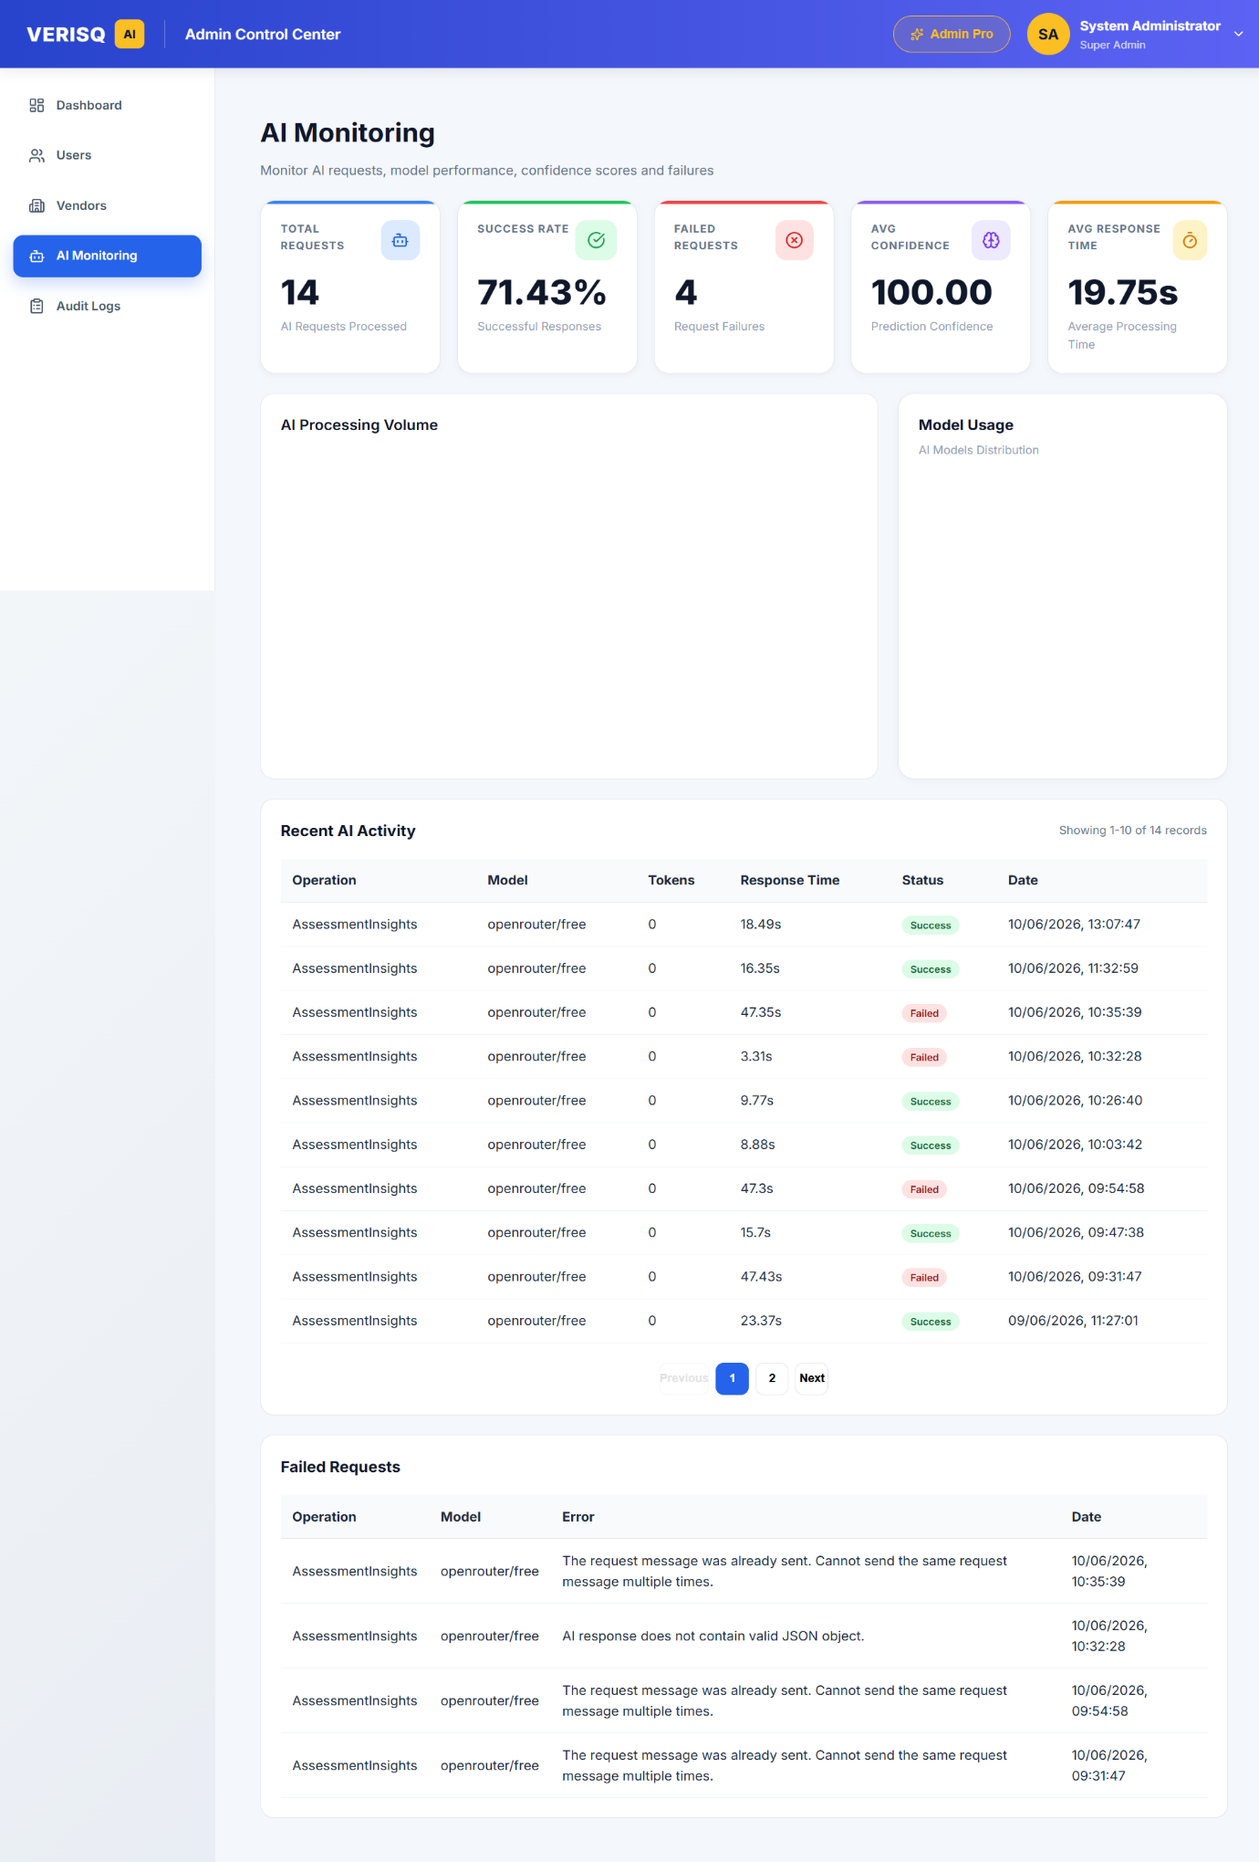
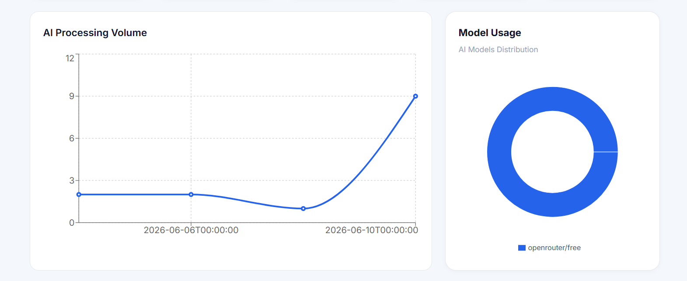

Audit Logs
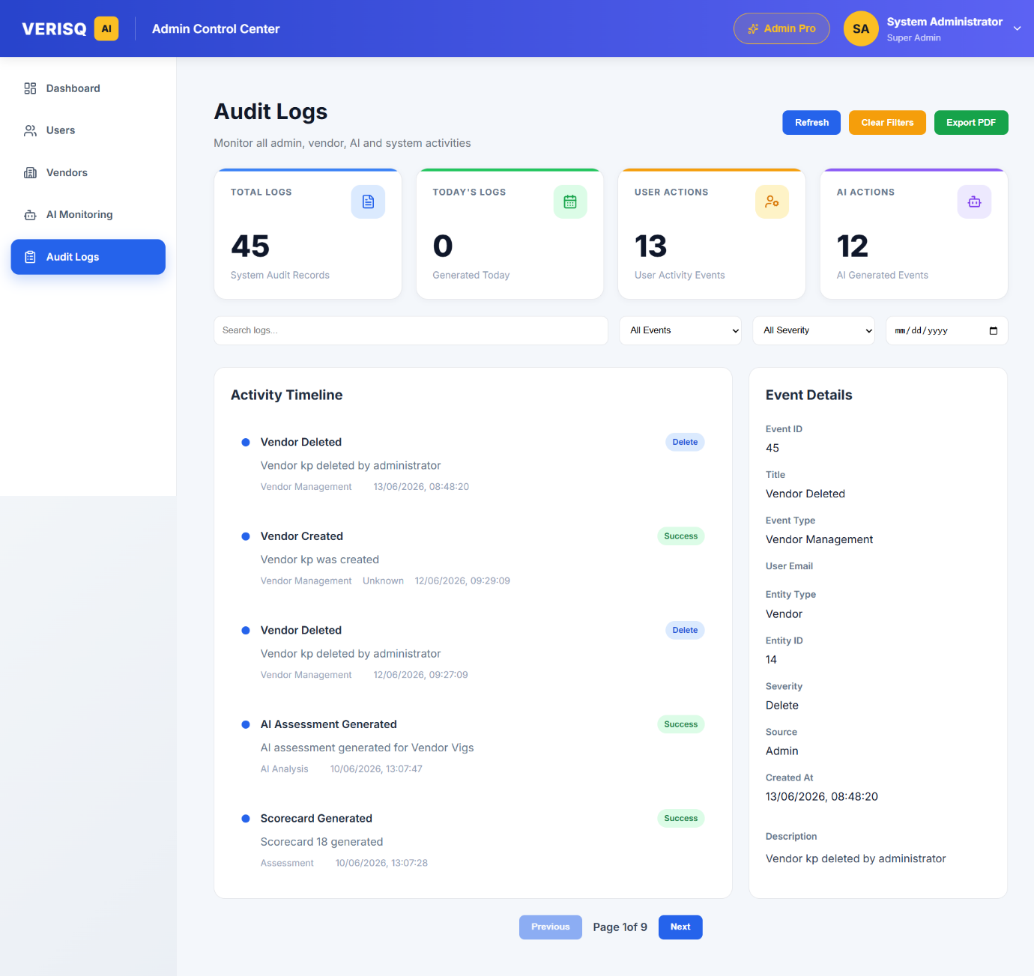

6.2.2.8 Admin / User PDF
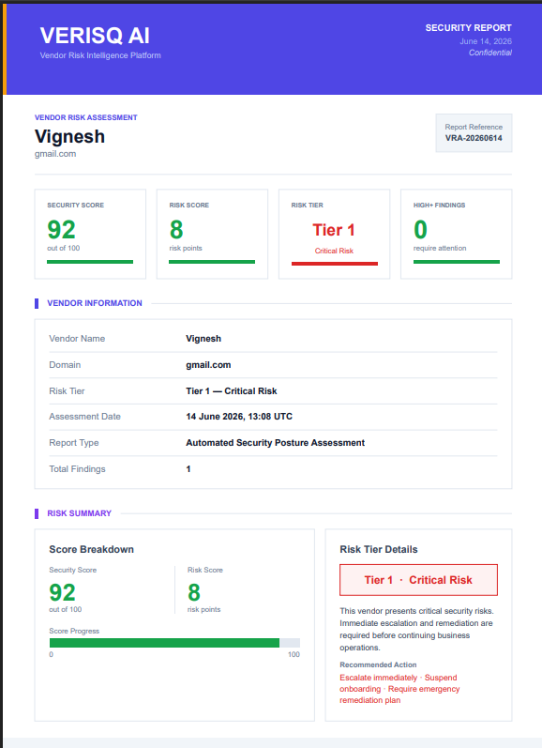
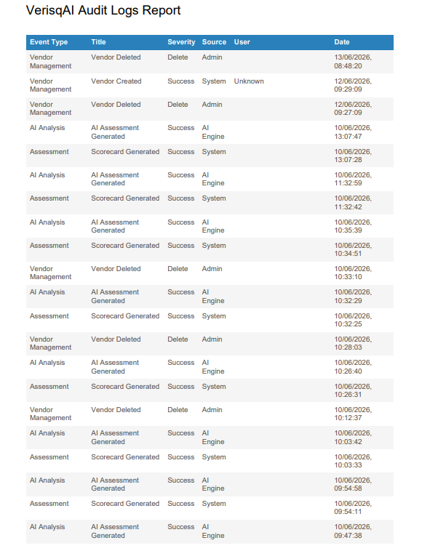

6.3 Architecture Design
VerisqAI follows a three-tier (3-tier) architecture, which separates the system into the Presentation Layer, the Application/Business Logic Layer, and the Data Layer. This separation improves maintainability, scalability and security, as each layer can be developed, tested and deployed independently.

6.3.1 Presentation Layer (Client Tier)
The presentation layer is built using React.js (with Vite as the build tool) and is responsible for rendering the user interface and handling user interactions. It communicates with the backend exclusively through RESTful API calls made using Axios.
- Built with React.js, organised into reusable components such as the dashboard, questionnaire builder, template builder, vendor details and admin panels.
- Uses React Router for client-side routing, with separate routes for public pages, authenticated user pages (protected via ProtectedRoute) and admin pages (protected via AdminRoute, restricted to users with the Admin role).
- Uses libraries such as Recharts for data visualisation (risk distribution, scorecards), jsPDF/jspdf-autotable for exporting reports, and lucide-react/react-icons for UI icons.
- User authentication state and role information are stored client-side (JWT token, decoded using jwt-decode) and attached to API requests for authorisation.

6.3.2 Application / Business Logic Layer (Server Tier)
The middle tier is implemented as an ASP.NET Core Web API (built on .NET 8) that exposes RESTful endpoints consumed by the React front-end. This layer contains the core business logic, authentication and AI processing services.
- Controllers (e.g., AuthController, DashboardController, QuestionnaireController, AssessmentTemplateController, AdminVendorsController, AdminAiMonitoringController, AdminAuditLogsController) handle incoming HTTP requests and return JSON responses.
- Authentication and authorisation are handled using ASP.NET Core Identity together with JWT Bearer tokens, with role-based access control distinguishing between regular users and Admin users.
- Service classes encapsulate business logic such as risk score calculation, scorecard generation, questionnaire token generation/validation, and OTP verification for vendor email confirmation.
- An AI module (under the AI folder) integrates with an external AI service to analyse vendor questionnaire responses, generate AI-based risk insights (AiAssessmentInsight) and remediation recommendations (AiRecommendation), and logs all AI activity via AiProcessingLog and AiExecutionAudit for monitoring through the Admin AI Monitoring dashboard.
- QuestPDF is used on the server side to generate downloadable PDF reports such as vendor scorecards.
- All significant actions (vendor onboarding, questionnaire sent/completed, AI processing, admin actions) are recorded in the AuditLog table for compliance and traceability.

6.3.3 Data Layer
The data layer consists of a Microsoft SQL Server database accessed through Entity Framework Core using a Code-First approach with migrations. ApplicationDbContext serves as the single entry point for all database operations, mapping the entities described in Section 6.1 to corresponding tables (Vendors, Questionnaires, AssessmentTemplates, AssessmentSections, AssessmentQuestions, QuestionnaireResponses, Scorecards, Findings, AuditLogs, AI-related tables, and ASP.NET Identity tables).
- EF Core Migrations maintain the database schema and allow incremental, version-controlled changes (e.g., AddCoreEntities, AddDynamicAssessmentEngine, AddAiAssessmentInfrastructure, AddAuditLogs).
- Seed data classes pre-populate default assessment templates, sections and questions so that new organisations can immediately start sending vendor questionnaires.
- Data integrity is enforced through primary/foreign key constraints linking Vendors, Questionnaires, Scorecards, Findings and AssessmentTemplates.

6.3.4 Three-Tier Architecture Diagram
Figure 6.11 illustrates the flow of data between the three tiers: a user interacts with the React-based presentation layer in the browser, which sends HTTPS/REST requests to the ASP.NET Core Web API (application layer). The application layer processes business logic, communicates with the AI engine for risk analysis, and performs CRUD operations on the SQL Server database (data layer) via Entity Framework Core. Responses flow back through the same path to update the user interface.

Tier | Technology / Components | Responsibility
Presentation Tier (Client) | React.js, Vite, React Router, Axios, Recharts, jsPDF | Renders UI, handles navigation and user input, sends REST API requests, displays dashboards, scorecards and reports
Application Tier (Server) | ASP.NET Core 8 Web API, Identity + JWT, AI integration module, QuestPDF | Implements business logic, authentication/authorization, risk scoring, AI-based insight generation, PDF report generation, audit logging
Data Tier (Database) | Microsoft SQL Server, Entity Framework Core (Code-First, Migrations) | Persistent storage of vendors, questionnaires, templates, scorecards, findings, AI insights and audit logs

This three-tier separation allows the front-end to be deployed independently (e.g., on Netlify) from the back-end API and database, supports horizontal scaling of the application layer, and ensures that sensitive data access and AI processing logic remain secured within the server tier, away from direct client access.

7. Testing

7.1 Unit Testing
Unit testing for VerisqAI was performed on individual service and controller methods to verify that each component performs its intended function correctly in isolation. The following key unit tests were conducted:
Test Case | Description | Expected | Result
Auth_Login_ValidCredentials | User logs in with correct email/password | JWT token returned | Pass
Auth_Login_InvalidPassword | User logs in with wrong password | 401 Unauthorized | Pass
Auth_OTP_ExpiredToken | OTP verification with expired token | 400 Bad Request | Pass
Vendor_Add_ValidData | Add vendor with all required fields | Vendor created with status Queued | Pass
Vendor_Add_DuplicateName | Add vendor with same name twice | Vendor added (no unique constraint) | Pass
Template_Create_ValidTemplate | Create template with sections and questions | Template saved with hierarchy | Pass
Questionnaire_Send_ValidVendor | Send questionnaire to existing vendor | Token generated, status Sent | Pass
Questionnaire_Submit_ValidToken | Submit questionnaire with valid token | Responses saved, status Completed | Pass
Questionnaire_Submit_ExpiredToken | Submit questionnaire with expired token | 400 Bad Request | Pass
Scoring_CalculateScore_AllCorrect | All preferred answers selected | Score = 100, Tier = 1 | Pass
Scoring_CalculateScore_AllWrong | All non-preferred answers selected | Score = 0, Tier = 4 | Pass
Scoring_FindingGeneration | Critical question answered incorrectly | Critical finding created | Pass
AI_ParseResponse_ValidJSON | AI returns well-formed JSON | Insight and recommendations stored | Pass
AI_ParseResponse_InvalidJSON | AI returns malformed response | Error handled, no crash | Pass
PDF_Generate_CompletedScorecard | Generate PDF for completed vendor | PDF file returned | Pass

7.2 Integration Testing
Integration testing was performed to verify that the various modules of VerisqAI work correctly together as a complete system. The following integration test scenarios were executed:
Integration Test | Flow Tested | Expected | Result
End-to-End Vendor Assessment | User login → Add vendor → Create template → Send questionnaire → Vendor submits → Scorecard generated → AI analysis → PDF download | Complete scorecard with AI insights and PDF | Pass
Auth + Vendor Management | Login with JWT → Access protected vendor endpoints → Unauthorized access attempt without token | Correct 401 on unauthorized access | Pass
Template → Questionnaire Link | Create template → Send questionnaire using that template → Verify correct questions appear in vendor form | Questions match template definition | Pass
Scoring → AI Integration | Submit questionnaire → Score calculated → AI analysis triggered → Insights stored in same scorecard | Scorecard has both scores and AI insights | Pass
Admin Dashboard Data | Multiple users add vendors → Admin accesses dashboard → Correct aggregated statistics shown | Admin sees all vendor risk distribution | Pass
Audit Log Generation | User performs login, adds vendor, sends questionnaire → Audit logs created for each action | Three audit log entries created | Pass
Questionnaire Expiry | Send questionnaire with past expiry → Vendor attempts to access → Form is rejected | Token rejected with appropriate message | Pass
Concurrent Questionnaire Submissions | Two vendors submit at the same time → Both scorecards generated independently | No data mixing; correct scorecards | Pass

8. Future Enhancement
The following enhancements are planned for future phases of VerisqAI development:
- Template Preview Mode (Phase 2B): Allow risk analysts to preview exactly how a questionnaire will appear to the vendor before dispatching it, enabling quality review of question flow and formatting.
- Bulk Vendor Import: Support CSV/Excel-based bulk vendor onboarding so that organizations with large vendor portfolios can import hundreds of vendors at once without manual data entry.
- Multi-Language Questionnaire Support: Add internationalization support so questionnaires can be presented in vendors' preferred languages, improving response rates for global vendor ecosystems.
- Mobile Application: Develop native iOS and Android applications for risk analysts to monitor vendor statuses and receive push notifications about questionnaire completion.
- Vendor Self-Registration Portal: Allow vendors to self-register on the platform so they can proactively submit compliance documentation without waiting for a manual invitation.
- Third-Party Security Ratings Integration: Integrate with external security rating services (e.g., SecurityScorecard, BitSight) to enrich vendor risk profiles with externally sourced data.
- Scheduled Re-Assessment: Implement automated questionnaire scheduling to trigger periodic re-assessments for high-risk vendors at configurable intervals (quarterly, annually).

9. Glossary
Term | Definition
AI (Artificial Intelligence) | Technology that enables machines to simulate human intelligence for tasks such as analysis, decision-making, and natural language understanding.
API (Application Programming Interface) | A set of rules that allows different software applications to communicate with each other over a network.
ASP.NET Core | A cross-platform, high-performance, open-source framework for building modern, cloud-based web applications by Microsoft.
Audit Log | A chronological record of system events and user actions used for security monitoring and compliance purposes.
CRC (Class Responsibility Collaborator) | A UML design technique that identifies classes, their responsibilities, and which other classes they collaborate with.
CRUD | Create, Read, Update, Delete – the four basic operations performed on database records.
DTO (Data Transfer Object) | An object used to transfer data between software layers without exposing internal entity structures.
EF Core (Entity Framework Core) | An open-source ORM (Object-Relational Mapper) for .NET that allows developers to work with databases using .NET objects.
Finding | A specific security risk or compliance gap identified during a vendor assessment, categorized by severity (Critical, High, Medium, Low).
JWT (JSON Web Token) | A compact, URL-safe token format used for securely transmitting authentication information between parties.
LLM (Large Language Model) | A type of AI model trained on large amounts of text data capable of generating human-like text and performing analysis tasks.
ORM (Object-Relational Mapper) | A programming technique that converts data between incompatible type systems (objects and relational databases).
OTP (One-Time Password) | A password that is valid for only one login session or transaction, used as a second factor in authentication.
OpenRouter | An AI API aggregation service that provides access to multiple LLM providers through a unified API interface.
QuestPDF | An open-source .NET library for generating professional PDF documents using a fluent API.
React | A JavaScript library for building user interfaces, maintained by Meta (Facebook) and widely used for SPAs.
Risk Score | A numeric value (0-100) calculated based on vendor assessment responses indicating the overall risk level of a vendor.
Risk Tier | A categorical risk classification (1-4) assigned to a vendor based on their risk score: Tier 1 (Low), Tier 2 (Medium), Tier 3 (High), Tier 4 (Critical).
Scorecard | A comprehensive record containing a vendor's risk score, risk tier, findings, and AI-generated insights from a completed assessment.
SRS (Software Requirements Specification) | A document that describes the behavior, functionalities, and constraints of a software system.
TOTP (Time-based One-Time Password) | An OTP algorithm that generates a password valid only for a short time window, typically 30 seconds.
Vendor | A third-party organization or supplier whose security practices and compliance posture is being assessed.
VRM (Vendor Risk Management) | The process of identifying, assessing, and mitigating risks associated with third-party vendors and suppliers.

10. References
- Microsoft Corporation. (2024). ASP.NET Core 8.0 Documentation. https://docs.microsoft.com/en-us/aspnet/core/
- OpenRouter. (2024). OpenRouter API Documentation. https://openrouter.ai/docs
- Google Search Engine — Used for searching solutions, concepts, and implementation ideas during project development. https://www.google.com
- ChatGPT (OpenAI) — Used for getting help with code logic, debugging, and documentation writing. https://chat.openai.com
- Google Gemini — Used for assistance in understanding concepts and documentation. https://gemini.google.com
- Claude (Anthropic) — Used for documentation writing and project-related guidance. https://claude.ai
- GitHub — Referred to an open-source e-commerce project repository for understanding project structure and implementation approach. https://github.com
- Stack Overflow – Used for solving errors. https://stackoverflow.com/questions

