Session 6: Intraday Setup

Opening Range
- Mainly used for Nifty/Banknifty
- 3 Mins Time frame
- Rule: The point where it stops making higher high or lower lows
- After Market Opens, Is it LL or HH?
- Mark ORH and ORL
- Use Futures Chart always 99% of cases. When there is freak lows and highs then use spot charts

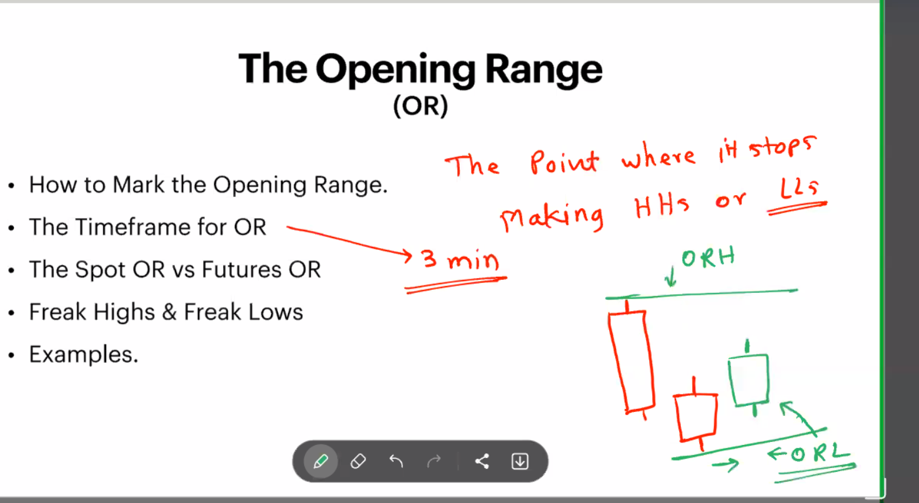
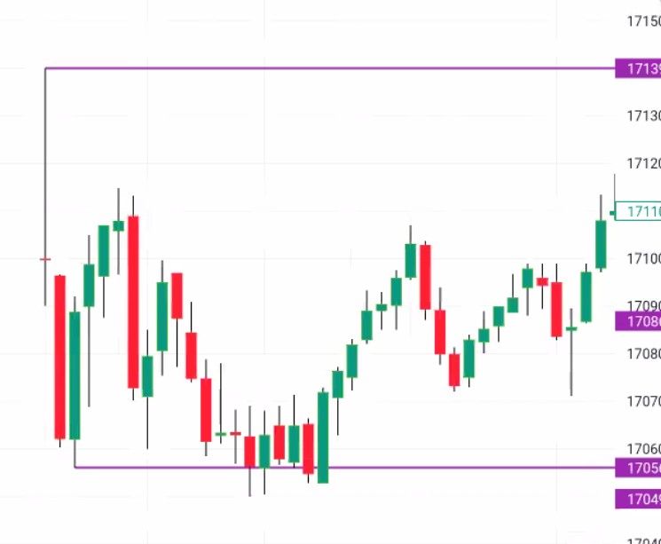
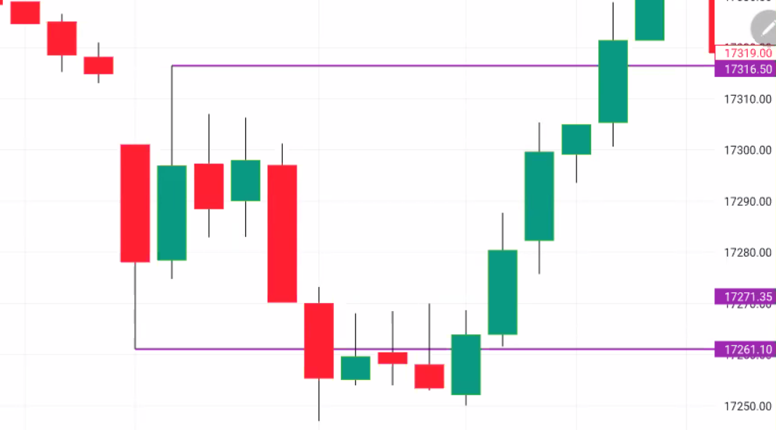
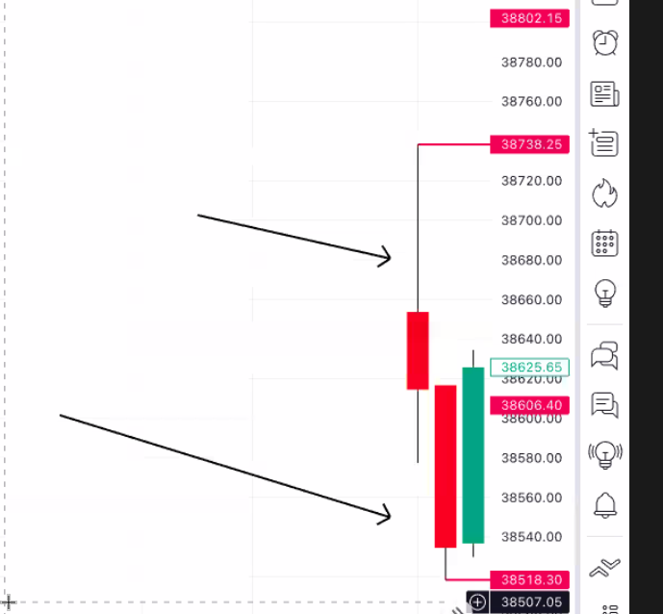
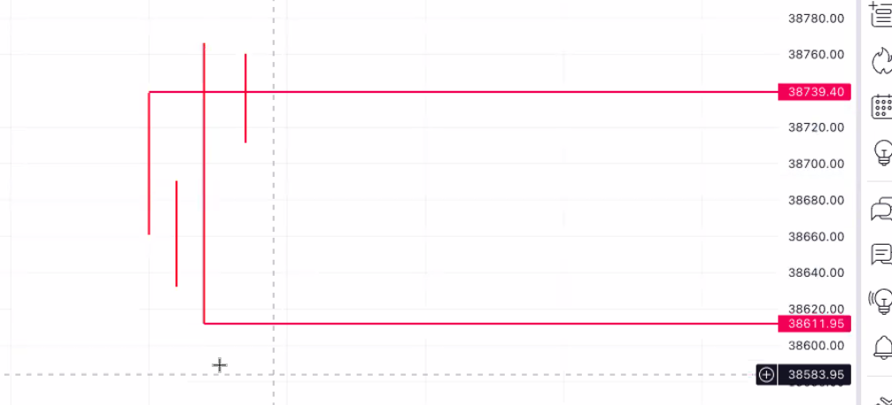
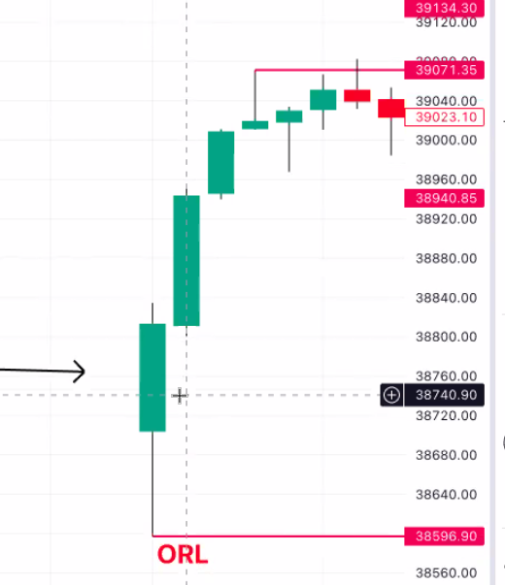

Standard Opening Rage Breakout
- Whenever a 3 mins candle closes over ORH, it is a sign of OR Breakout.
- After OR BO, If the price comes down and retests ORH and makes high to previous swing/candle then it is a confirmation of OR BO(breaking is enough, closing is not required)
- Entry will be at the confirmation of ORB(Previous candle low)
- SL: Either close below ORH or Max 35 Points for Nifty and 100 points BNF on Futures, Options: 20 points

Standard Opening Rage Breakdown
- Whenever a 3 mins candle closes below ORL, it is a sign of OR Breakdown.
- After OR BD, If the price comes up and retests ORL and makes low to previous swing/ candle then it is a confirmation of ORL BD(breaking is enough, closing is not required)
- Entry will be at the confirmation of ORB(Previous candle low)
- SL: Either close above ORL or Max 35 Points for Nifty and 100 points BNF on Futures, Options: 20 Points

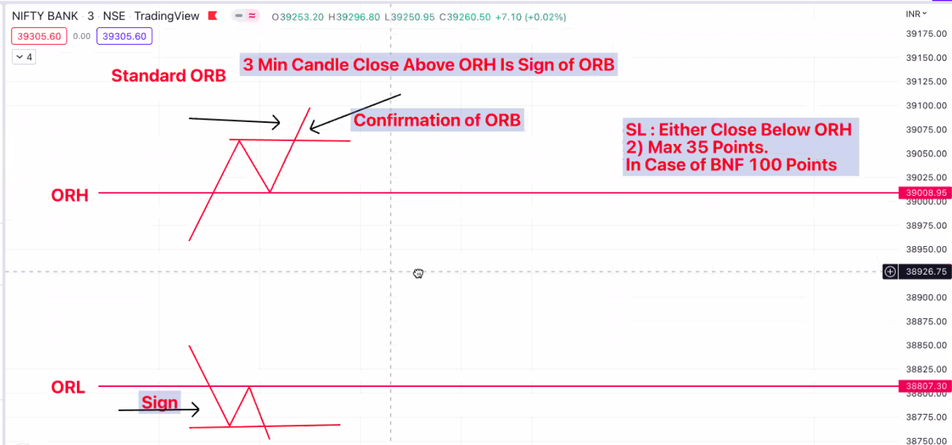

Entry & SL:
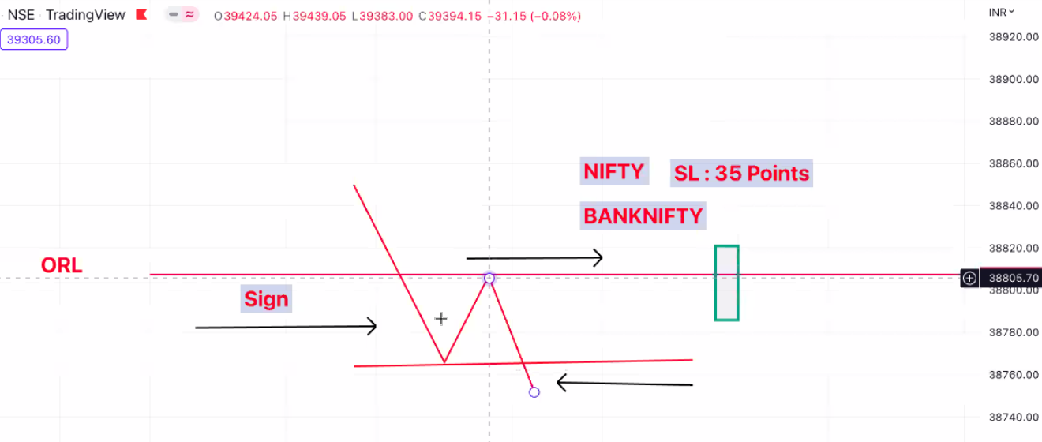
BULL TRAPS:
- Sign of Bull Trap: After Breakout, if the candle closes below ORH then it is a Bull trap
- If the candle breaks the previous swing low then it will be confirmation of a bull trap
- Short entry at the confirmation of bull trap
- SL: ORH or 35 Points
- Target will ORL

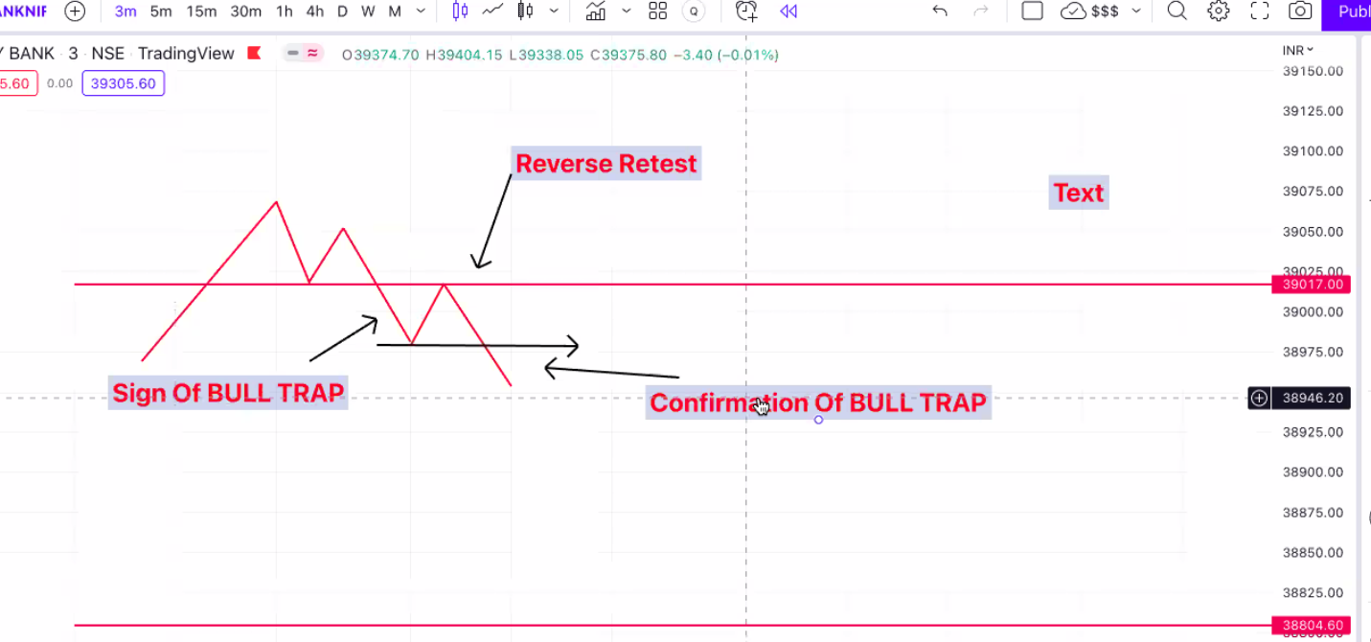

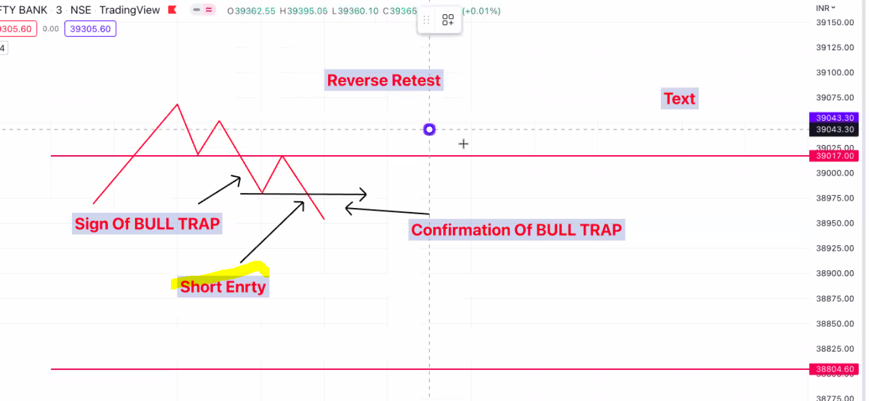
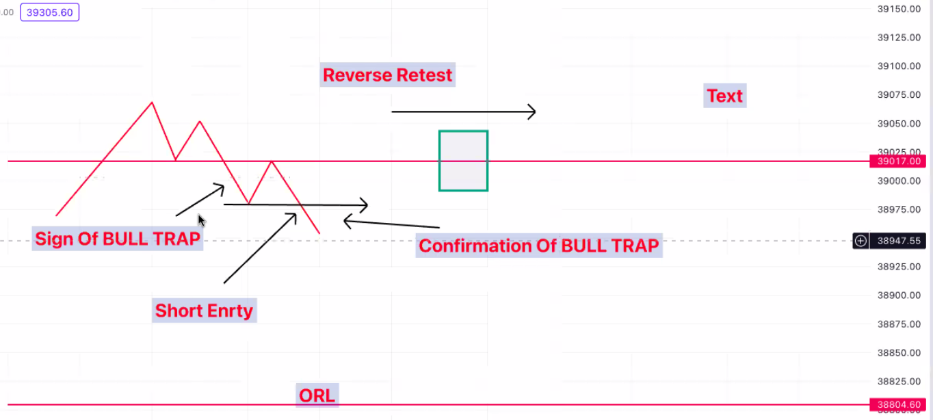

BEAR TRAPS:
- Sign of Bear Trap: After Breakdown, if the candle closes above ORL then it is a Bear trap
- If the candle breaks the previous swing high then it will be confirmation of a bear trap(Reverse Retest)
- Long entry at the confirmation of bear trap
- SL: ORL or 35 Points
- Traget will ORH

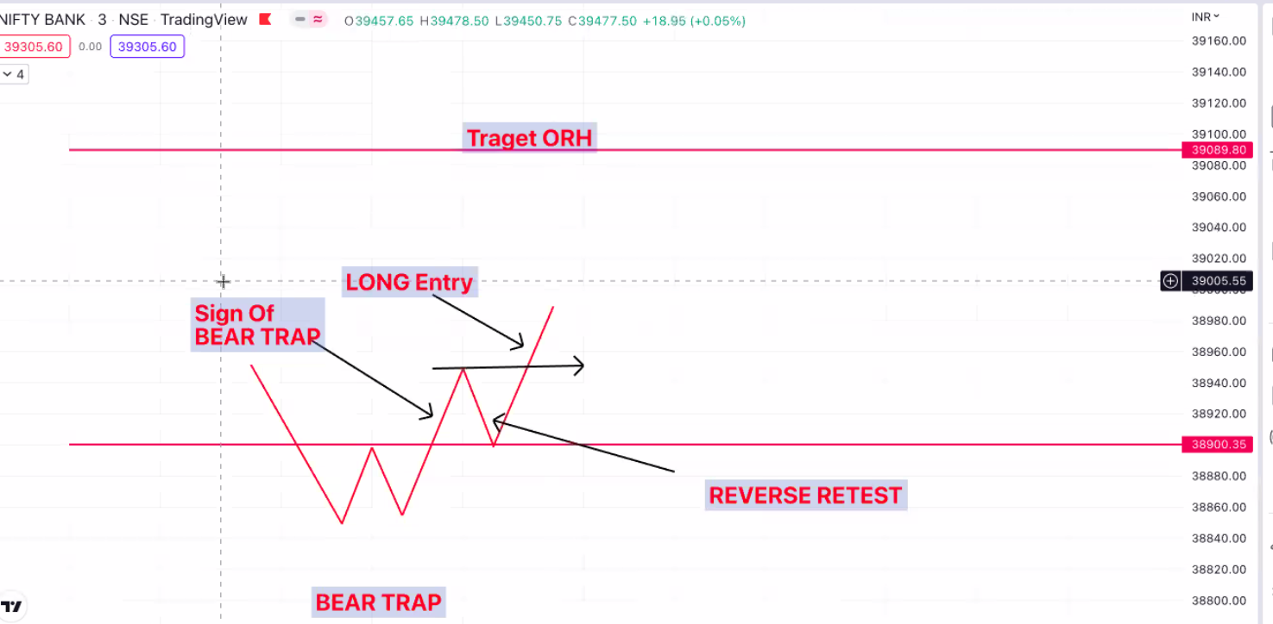
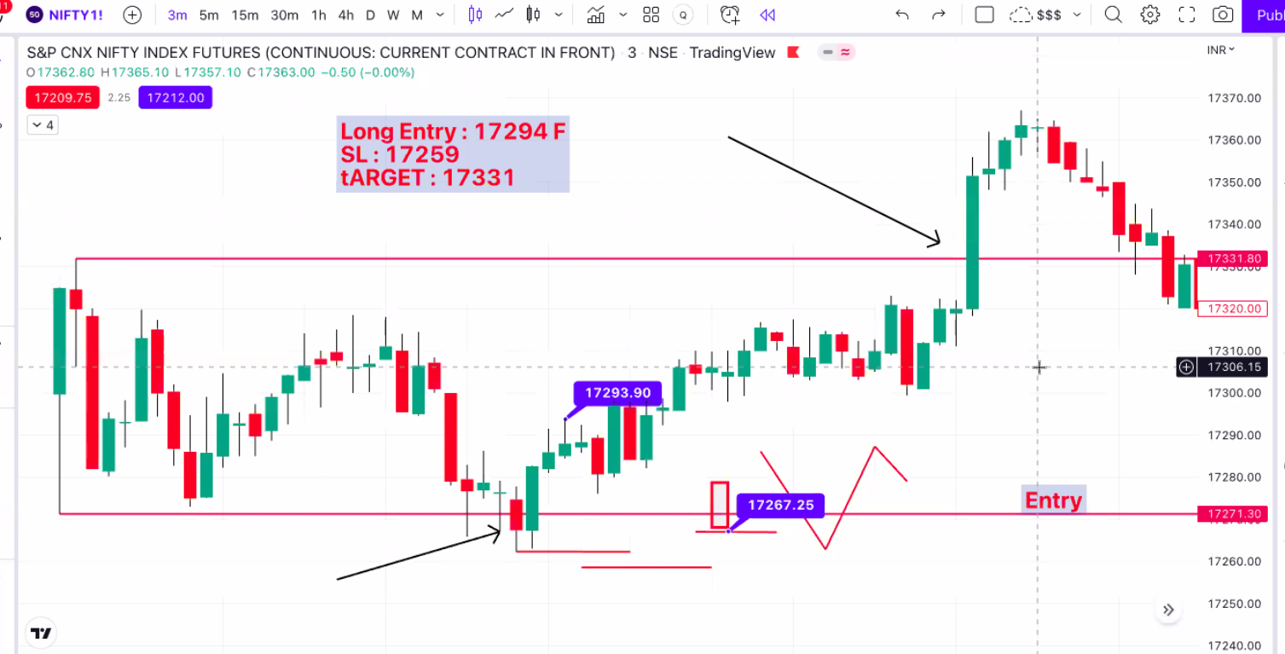

Additional Whipsaws:
Price momentum will come after the whipsaws

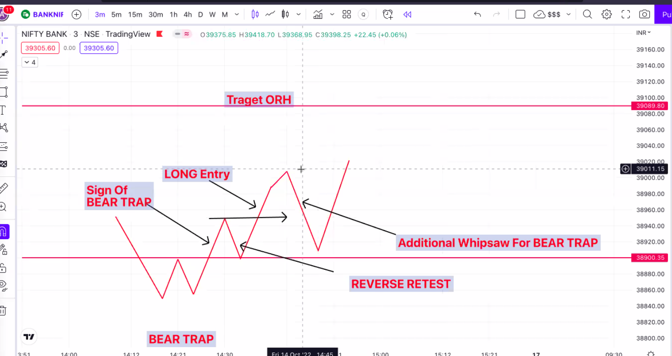
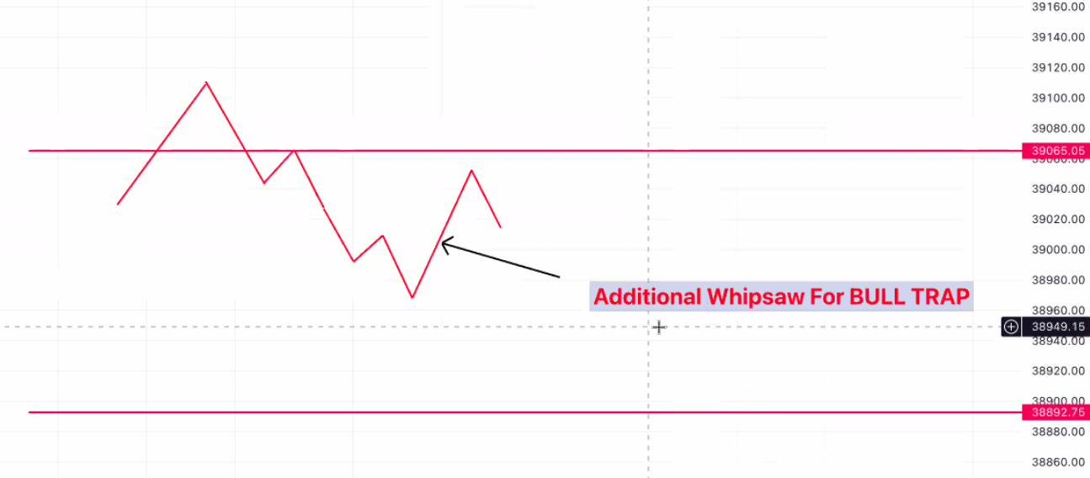

Additional whipsaw for OR Breakout. SL will not hit
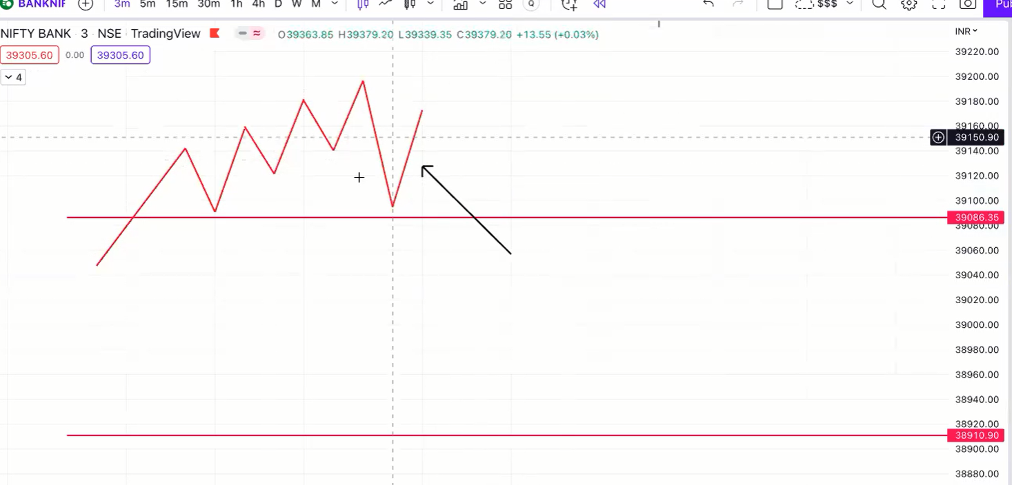
Additional whipsaw for OR Breakdown. SL will not hit
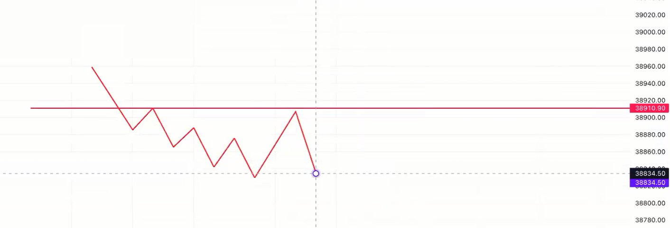
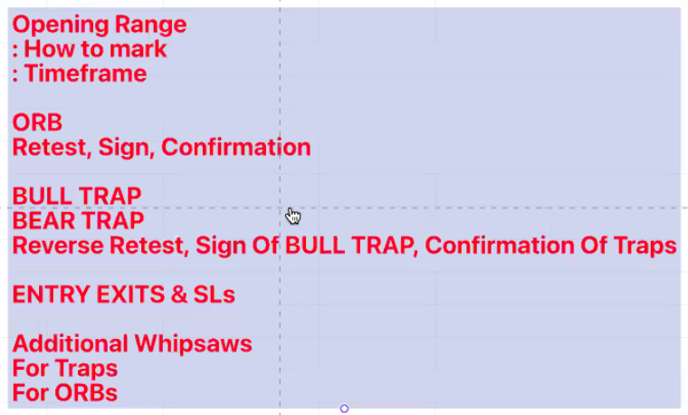

Consolidation at ORH & ORL:
- Multiple rejections in the OR(Consolidation) for 45 mins to 1 hour and then there is a breakout(candle closes above ORH/below ORL), then enter directly at breakout and don’t wait for retest.
- There will be good momentum in price in consolidation cases
- SL will be same 35 points on F and 20 points on options
- Target can be the range of the OR from ORH/ORL or Pivots targets
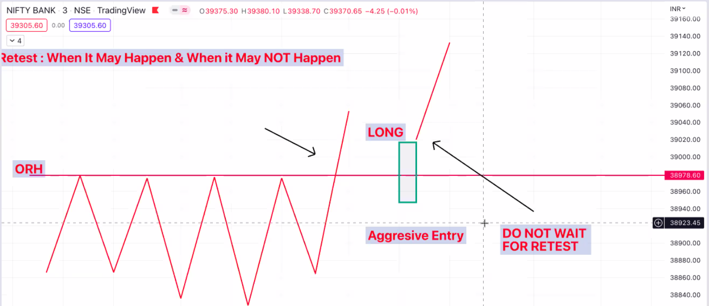
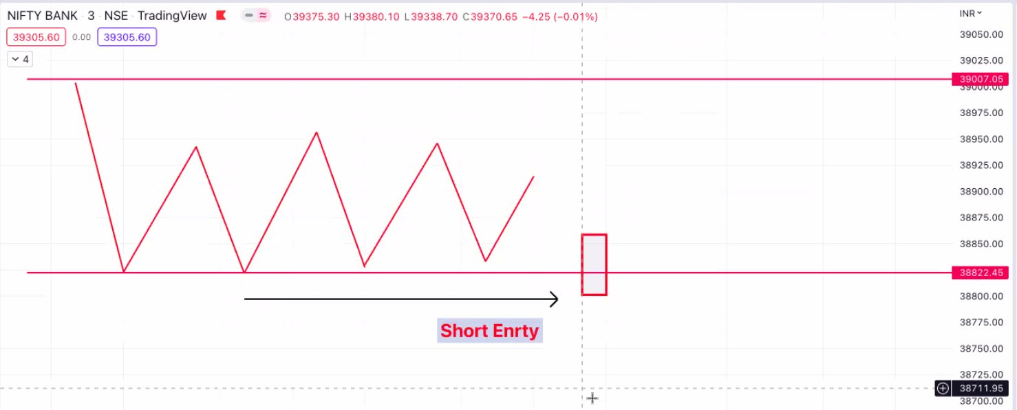

ORB Followup Failure & Bull Trap:
- In case 1, ORB confirmation candle did not come and became a bull trap
- In case 2, ORB confirmation candle has come(reverse retest) and follow up failed and became a bull trap
- In Case 2 more bulls are trapped when compared to case 1
- In case 1 there will be a chance for retest and in case 2 there will not be any reverse retest
- Entry: Short at candle closed below ORH and make an aggressive entry
- SL: Standard SL(35 points)
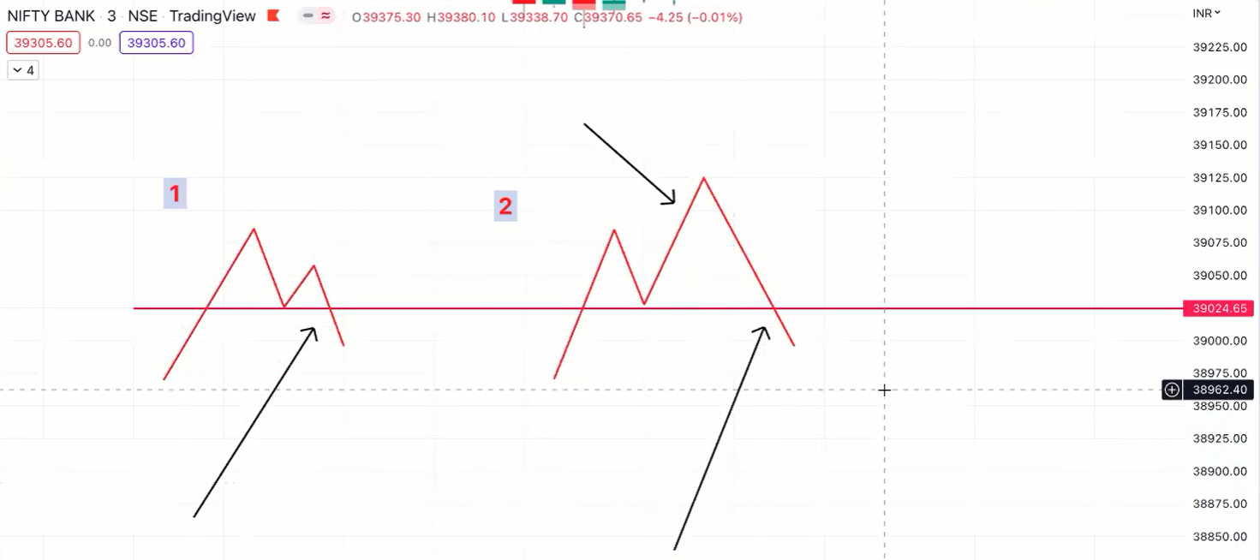

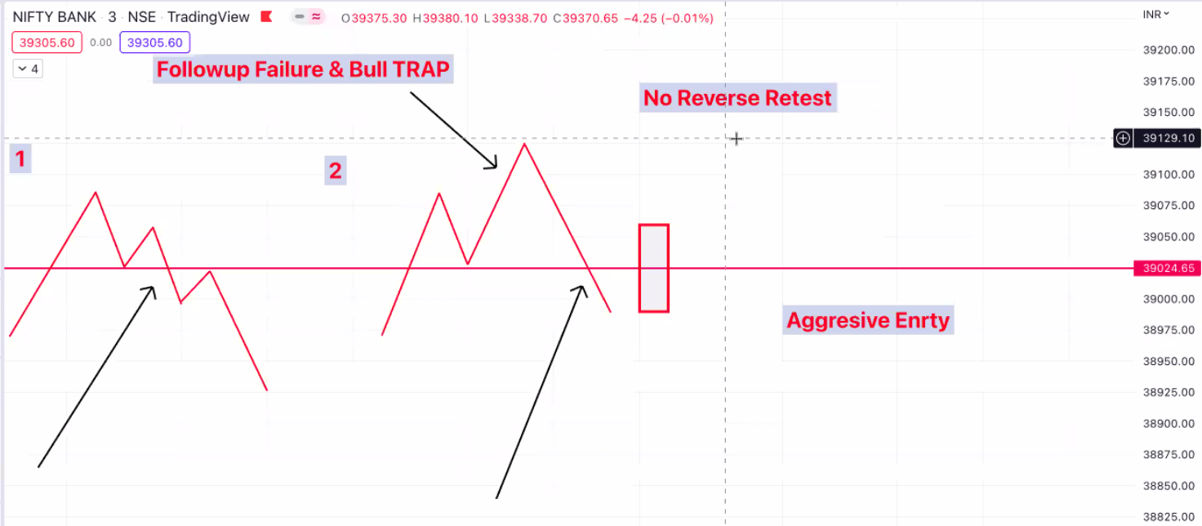

ORB Followup Failure & Bear Trap

- In case 1, there is chance of reverse retest and case 2 there will not be any retest as lot of sellers are trapped
- Momentum will be high in these kind of cases
- Entry: Candle closed above ORL and make an aggressive entry

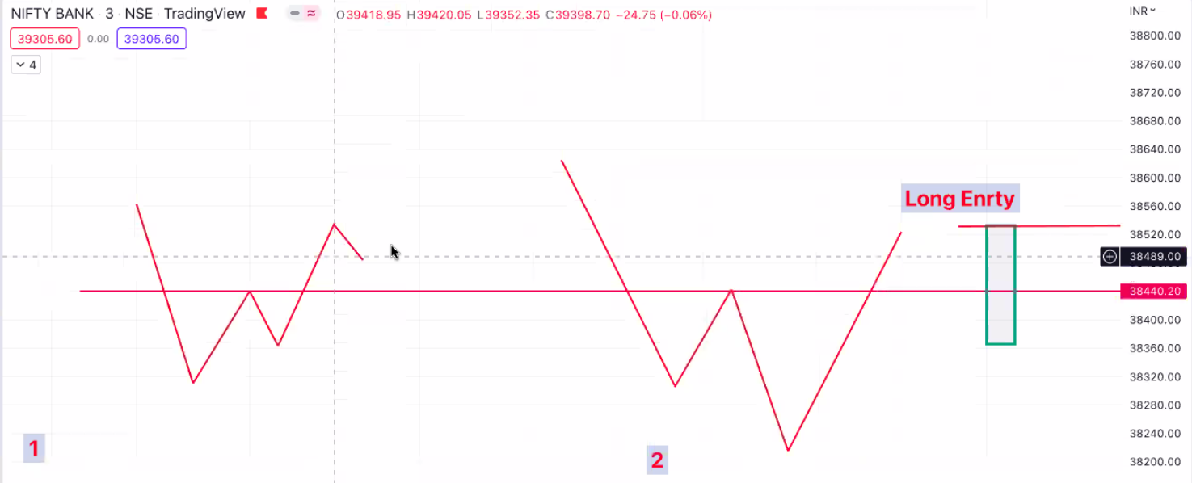

- There are high chances of additional whipsaws in case 1 for removing the weak hands/to take SLs/to do premium killing as there are less sellers trapped and no panic in case 1

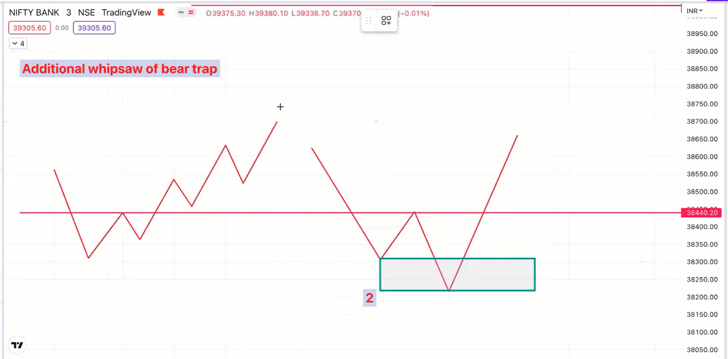

Examples on charts:

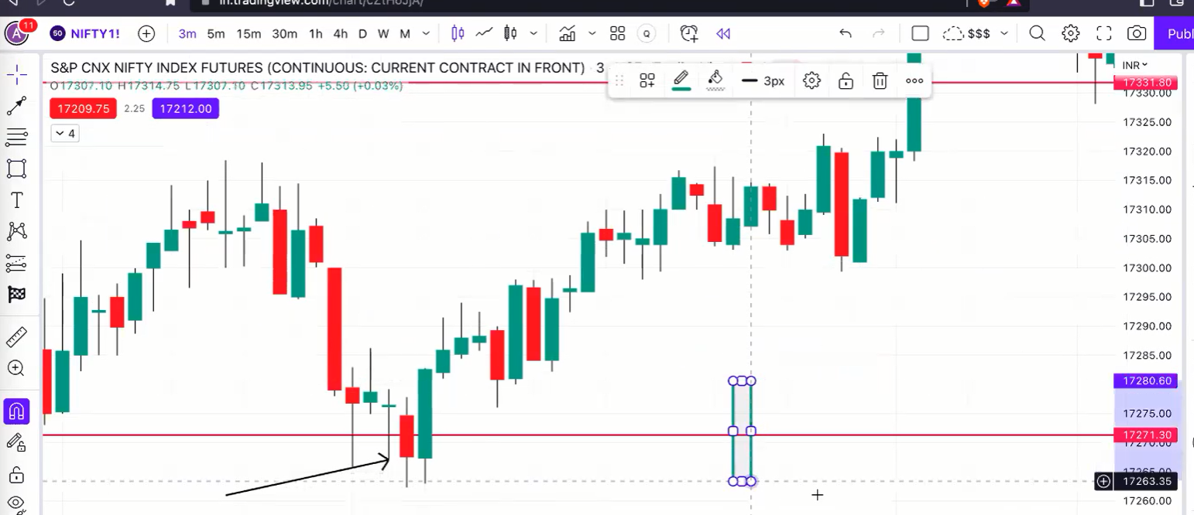
- Candle closed below ORL, Next candle close inside OR. This is a standard bear trap.
- Bear trap happens when OR breakdown is failed
- Entry at horizontal arrow when a candle makes a high over after the pull back(red candle)
- Red candle is the reverse retest and retest need not touch the ORL. It can be a pull back

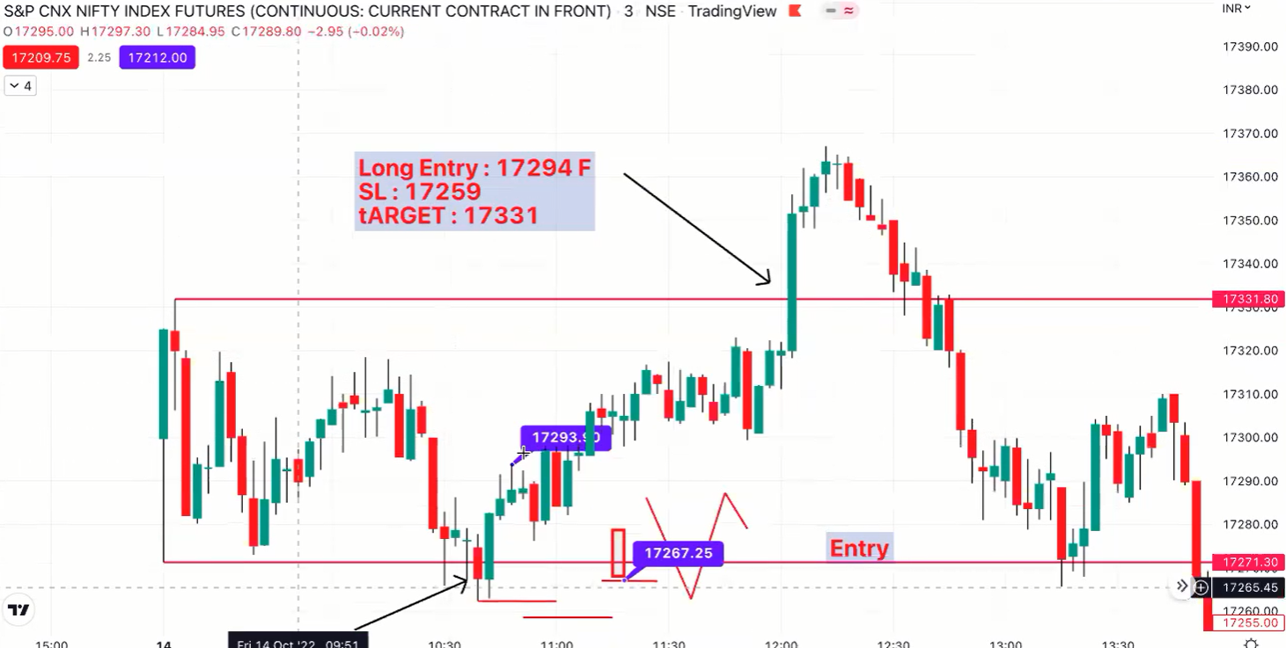
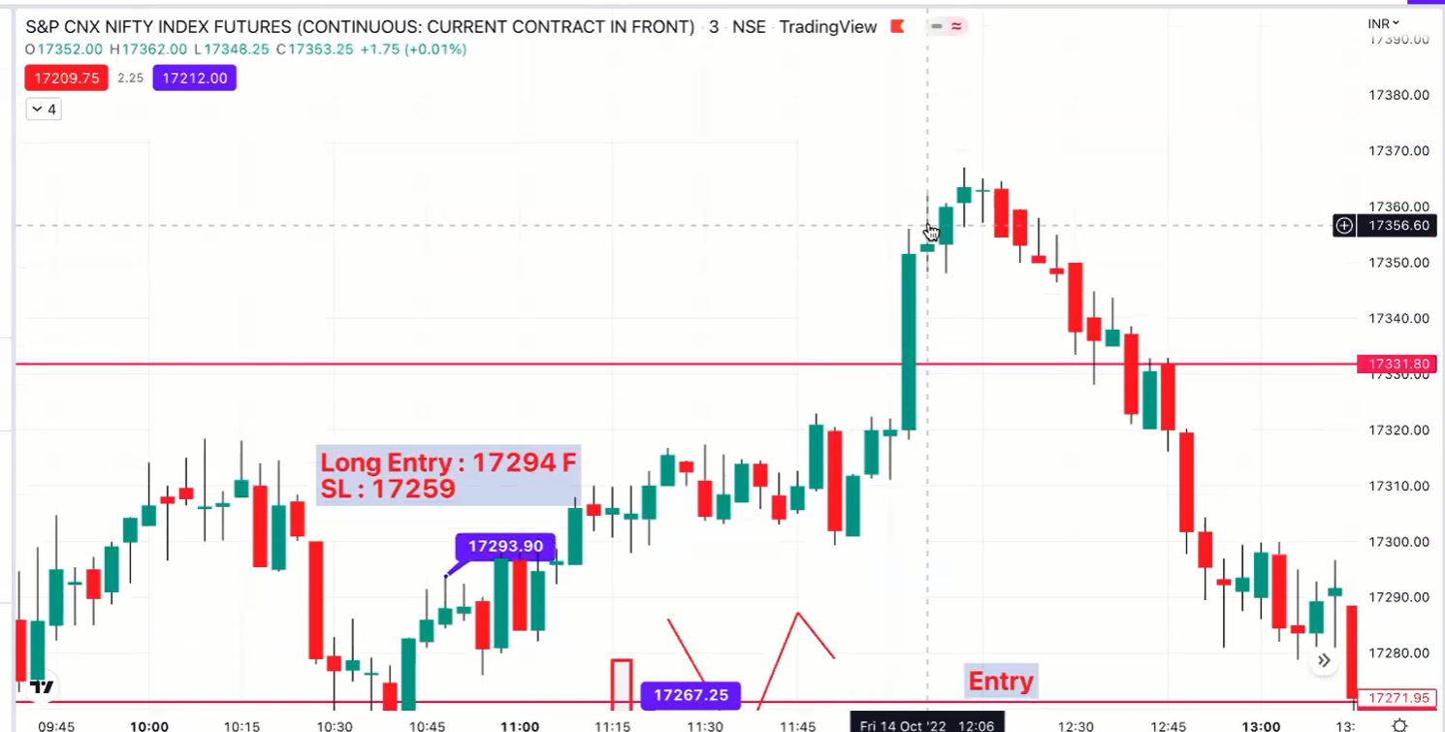

- Bull Trap(Close below ORH)
- Confirmation: Next green candle is the reverse retest candle
- Entry at low of the green candle

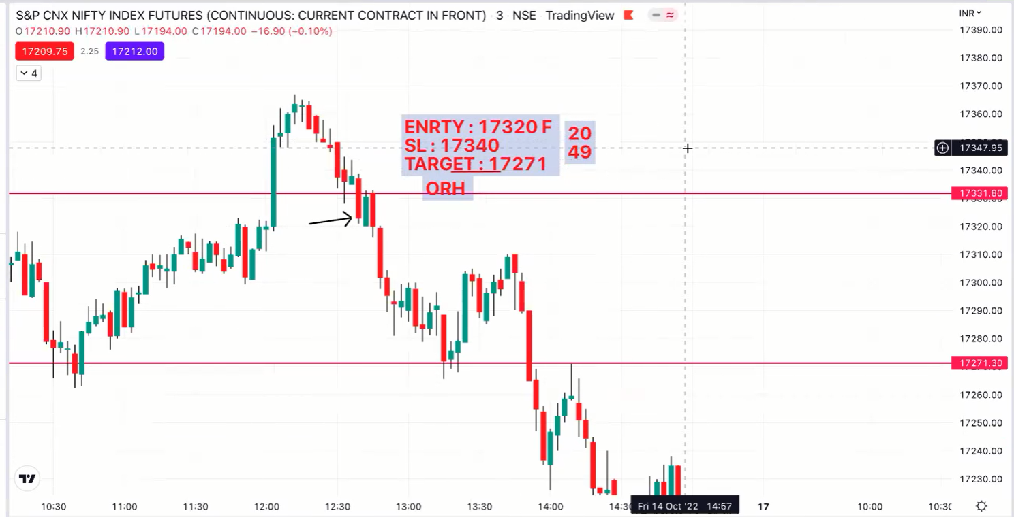

Execution of the setup

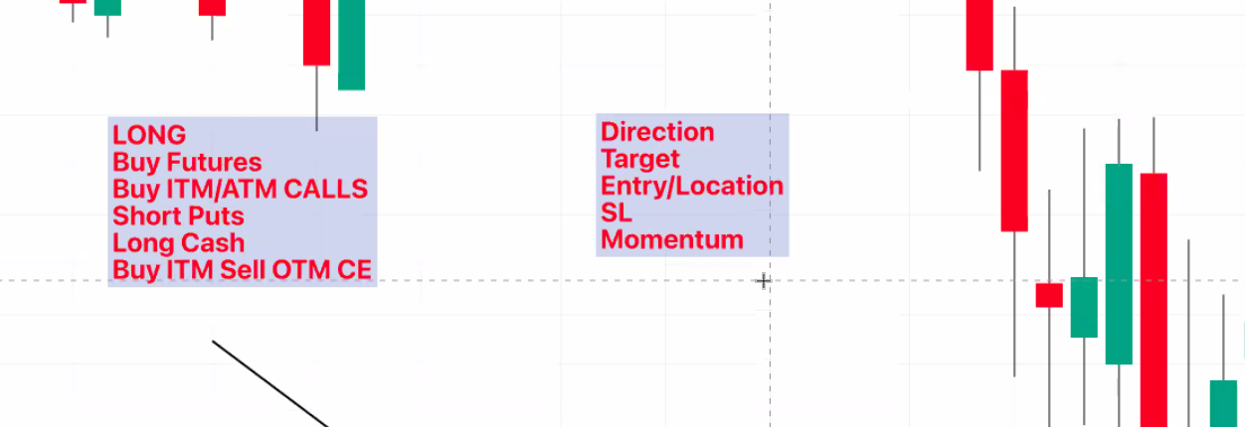

Conditions of trending Day
- Two OR more setups on the same direction
- BULL TRAP + ORL BD
- BEAR TRAP + ORH BO
- Failed BEAR TRAP + ORL BD
- Failed BULL TRAP + ORH BO
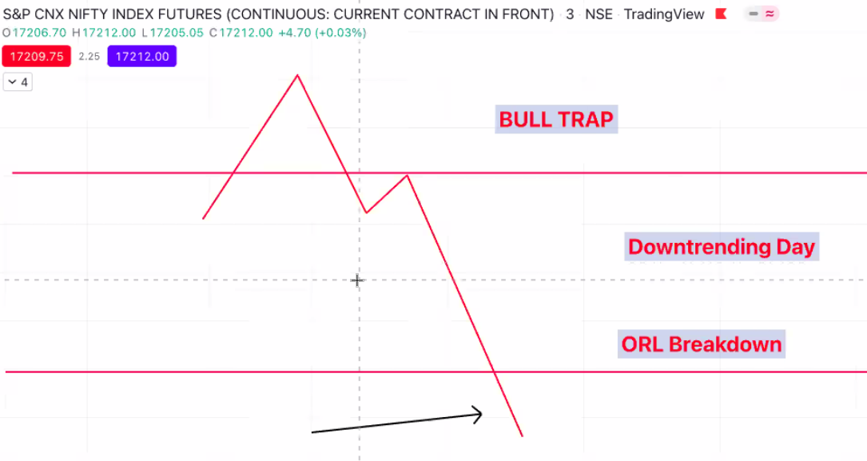
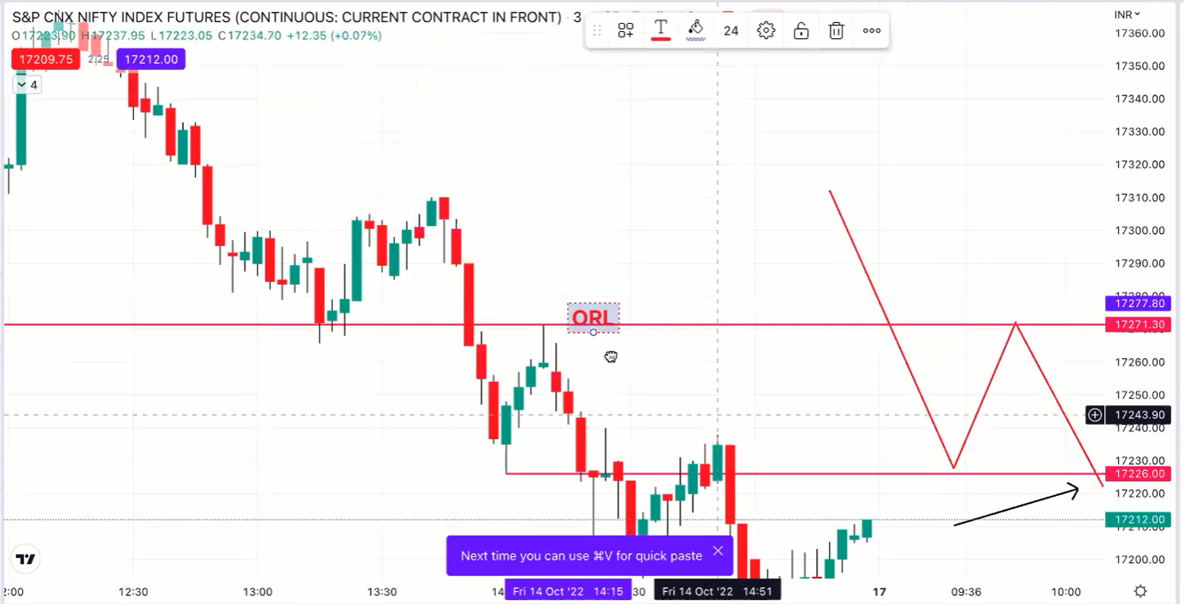

Bull Trap + ORL Breakdown = Downtrending
Bear Trap + ORH Breakout = Uptrending

Pivots
- Piovts are for references only and all entry and exit should be based on OR rules
- OR Location
- R1-P-S1 is Neutral Zone
- No aggressive trading in neutral zone
- Above R1 - Price is Bullish. High probability that it may reach R2
- R1 to R2 - Standard Bullish Trade - Aggressive trade and should not miss it
- Below S1 - Price Bearish. High probability that it may reach S2
- S1 to S2 - Standard Bearish, Aggressive trade and should not miss it
- R2 and S2 - When touched, all positions should be closed aggressively

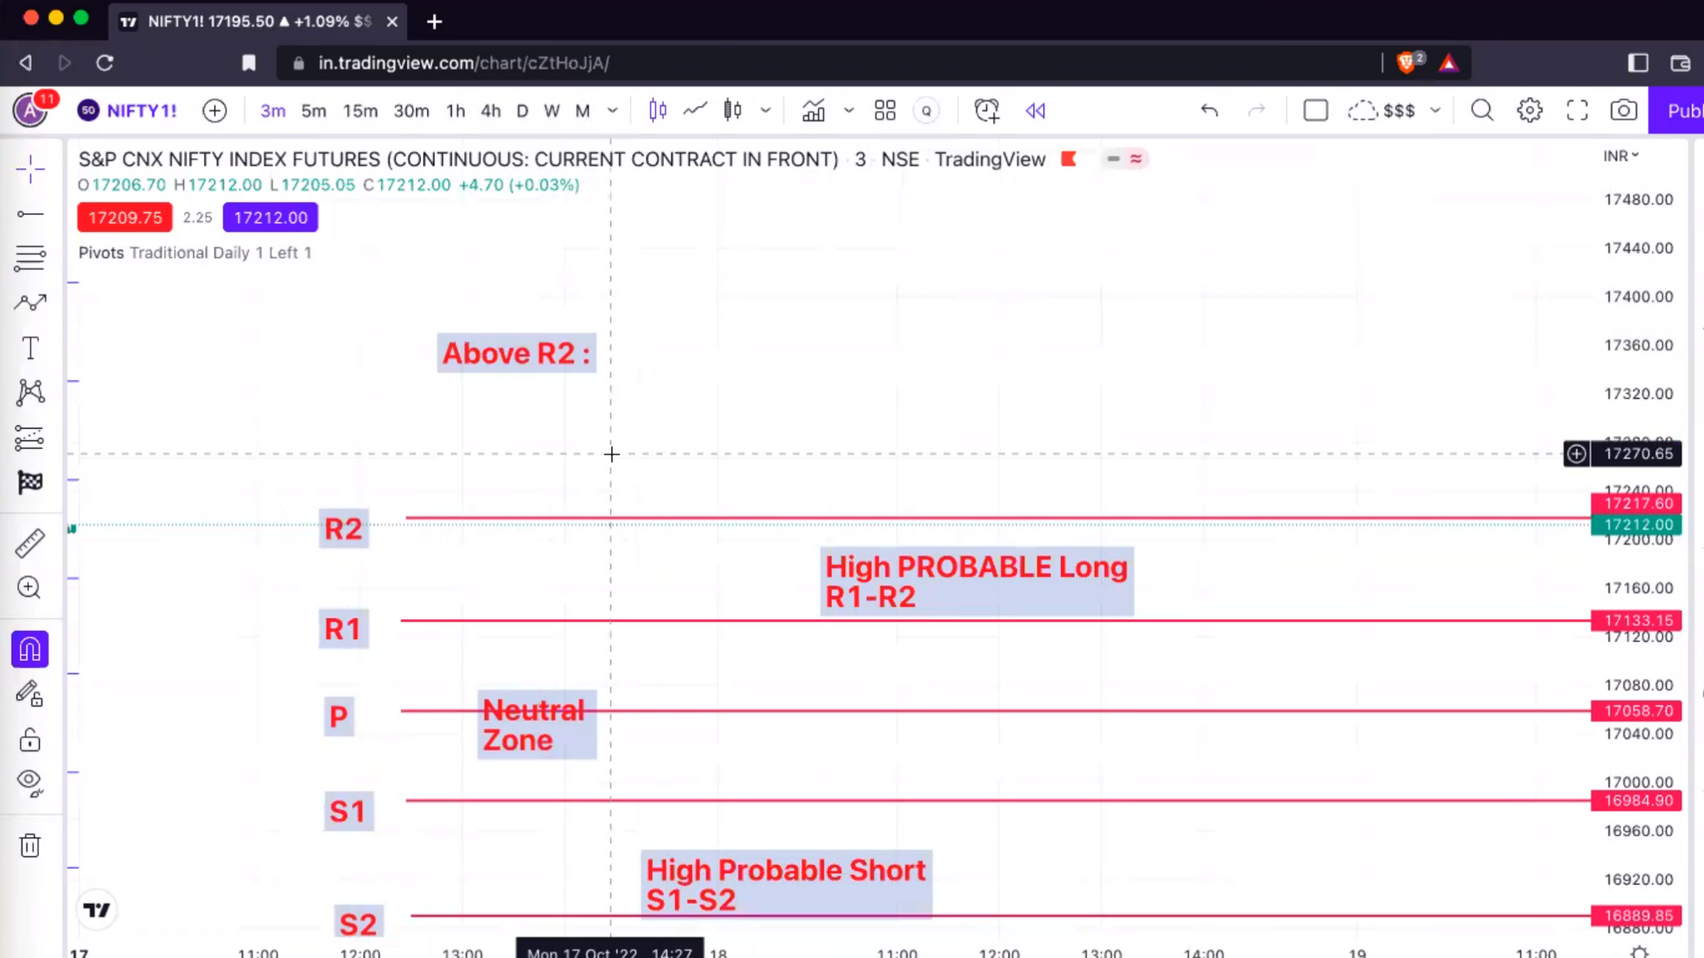

R2 Breakouts:
- R2 is very strong resistance. Usually will not break in a single attempt
- Lot of consolidation and rejections at R2
- If R2 is broken, it will easily break R3 and go to R4 directly
- R2 & R4 - Book all profits
- Dont trade the rejections from R2 & R4
- R2 can traded as ORH

S2 Breakouts:
- S2 is very strong support. Usually will not break in a single attempt
- Lot of consolidation and rejections at S2
- If S2 is broken, it will easily break S3 and go to S4 directly
- S2 & S4 - Book all profits
- Dont trade the bounces from S2 and S4
- S2 should be traded as ORL

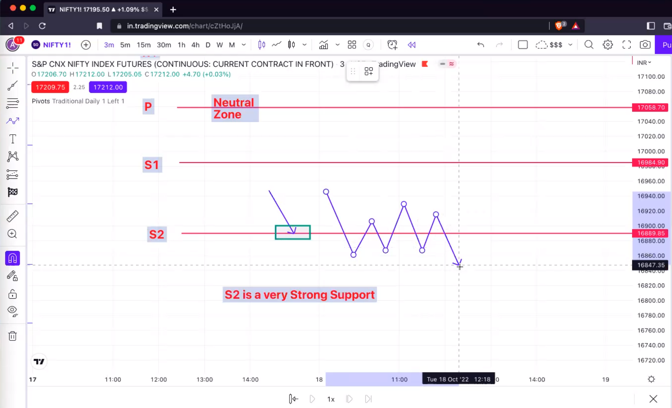

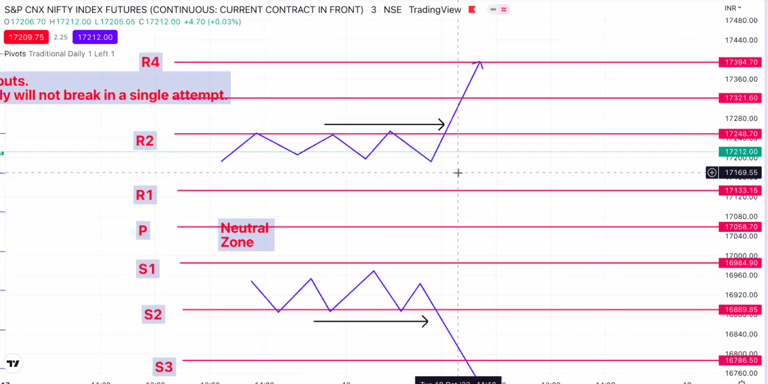

- Avoid all types of shorts above R1
  - Bull Traps
  - ORL Breakdown
  - Failed Bear Trap
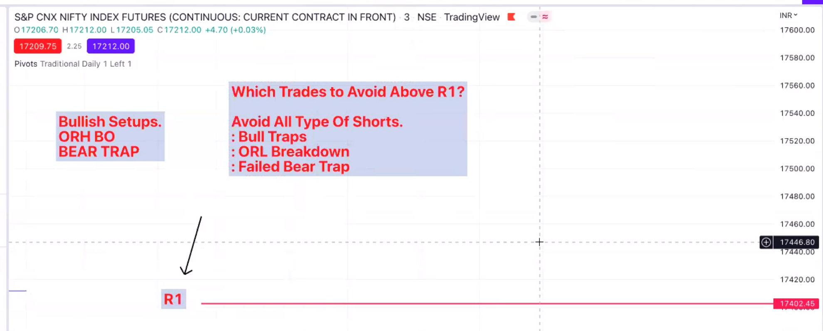
- Take only Bullish trades above R1
  - ORH Breakout
  - Brear Trap
- Avoid all types of Bullish trades below S1
- Take only Bearish trades below S1
  - ORL Breakdown
  - Bull Trap
  - Failed Bear Trap

- Hard Rules
  - Above R1, NO SHORTS
  - Below S1, NO LONGS
  - No Aggresive trades between R1-P-S1
  - Scalp and Run mode in Neutral Zone based on OR Setup

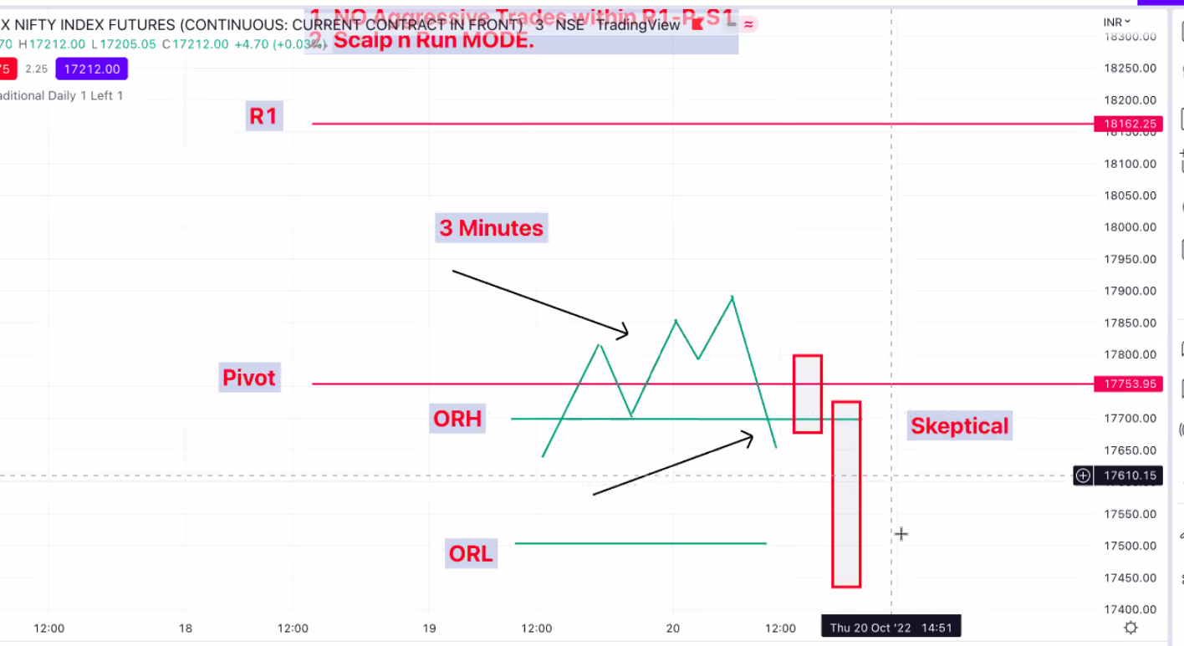

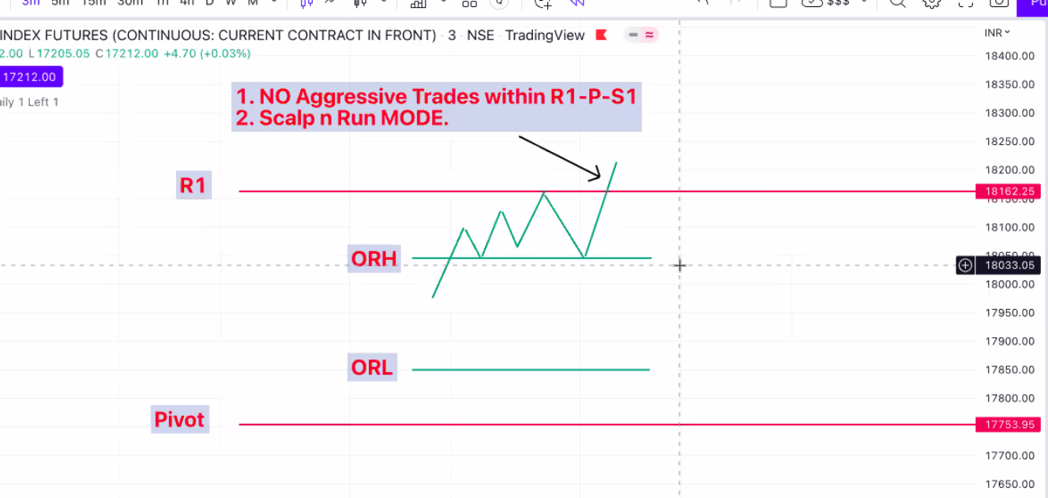
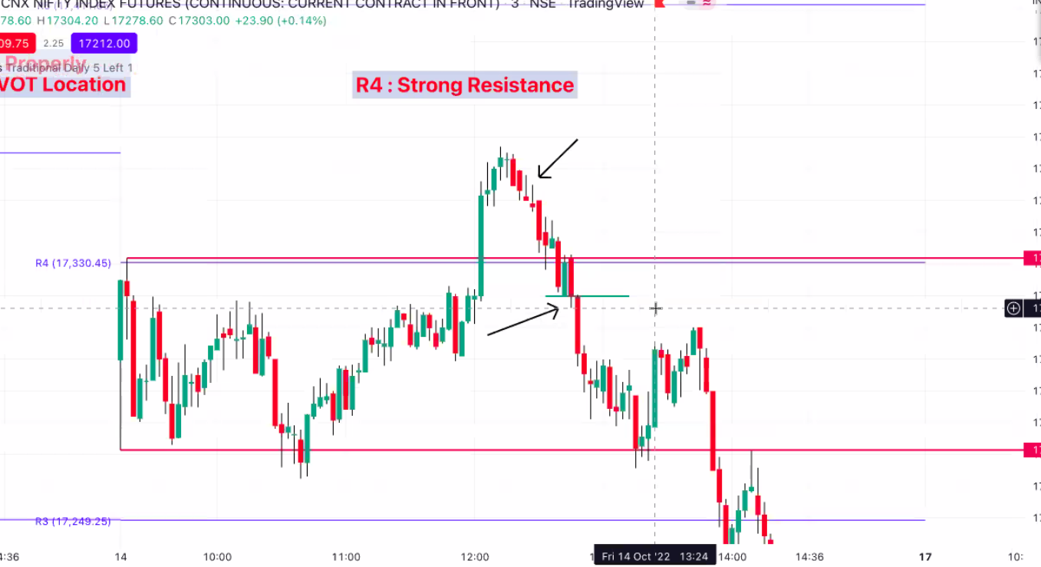

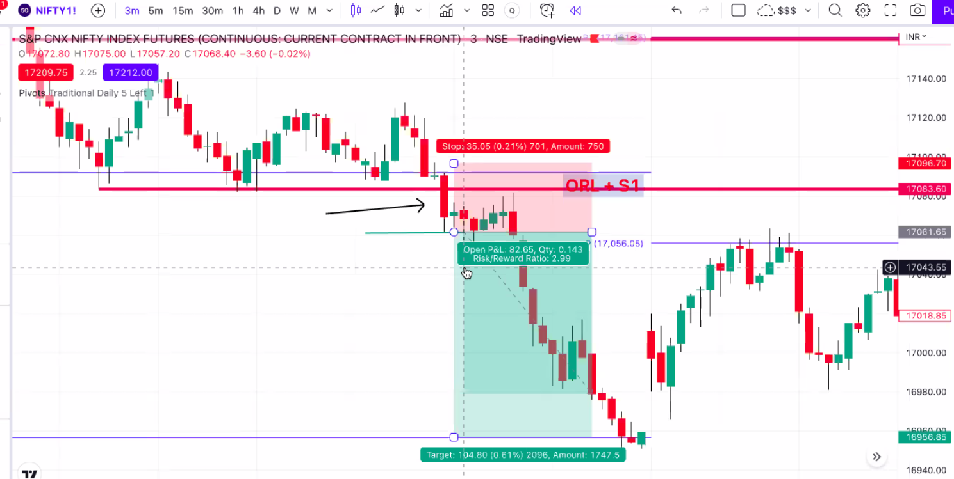
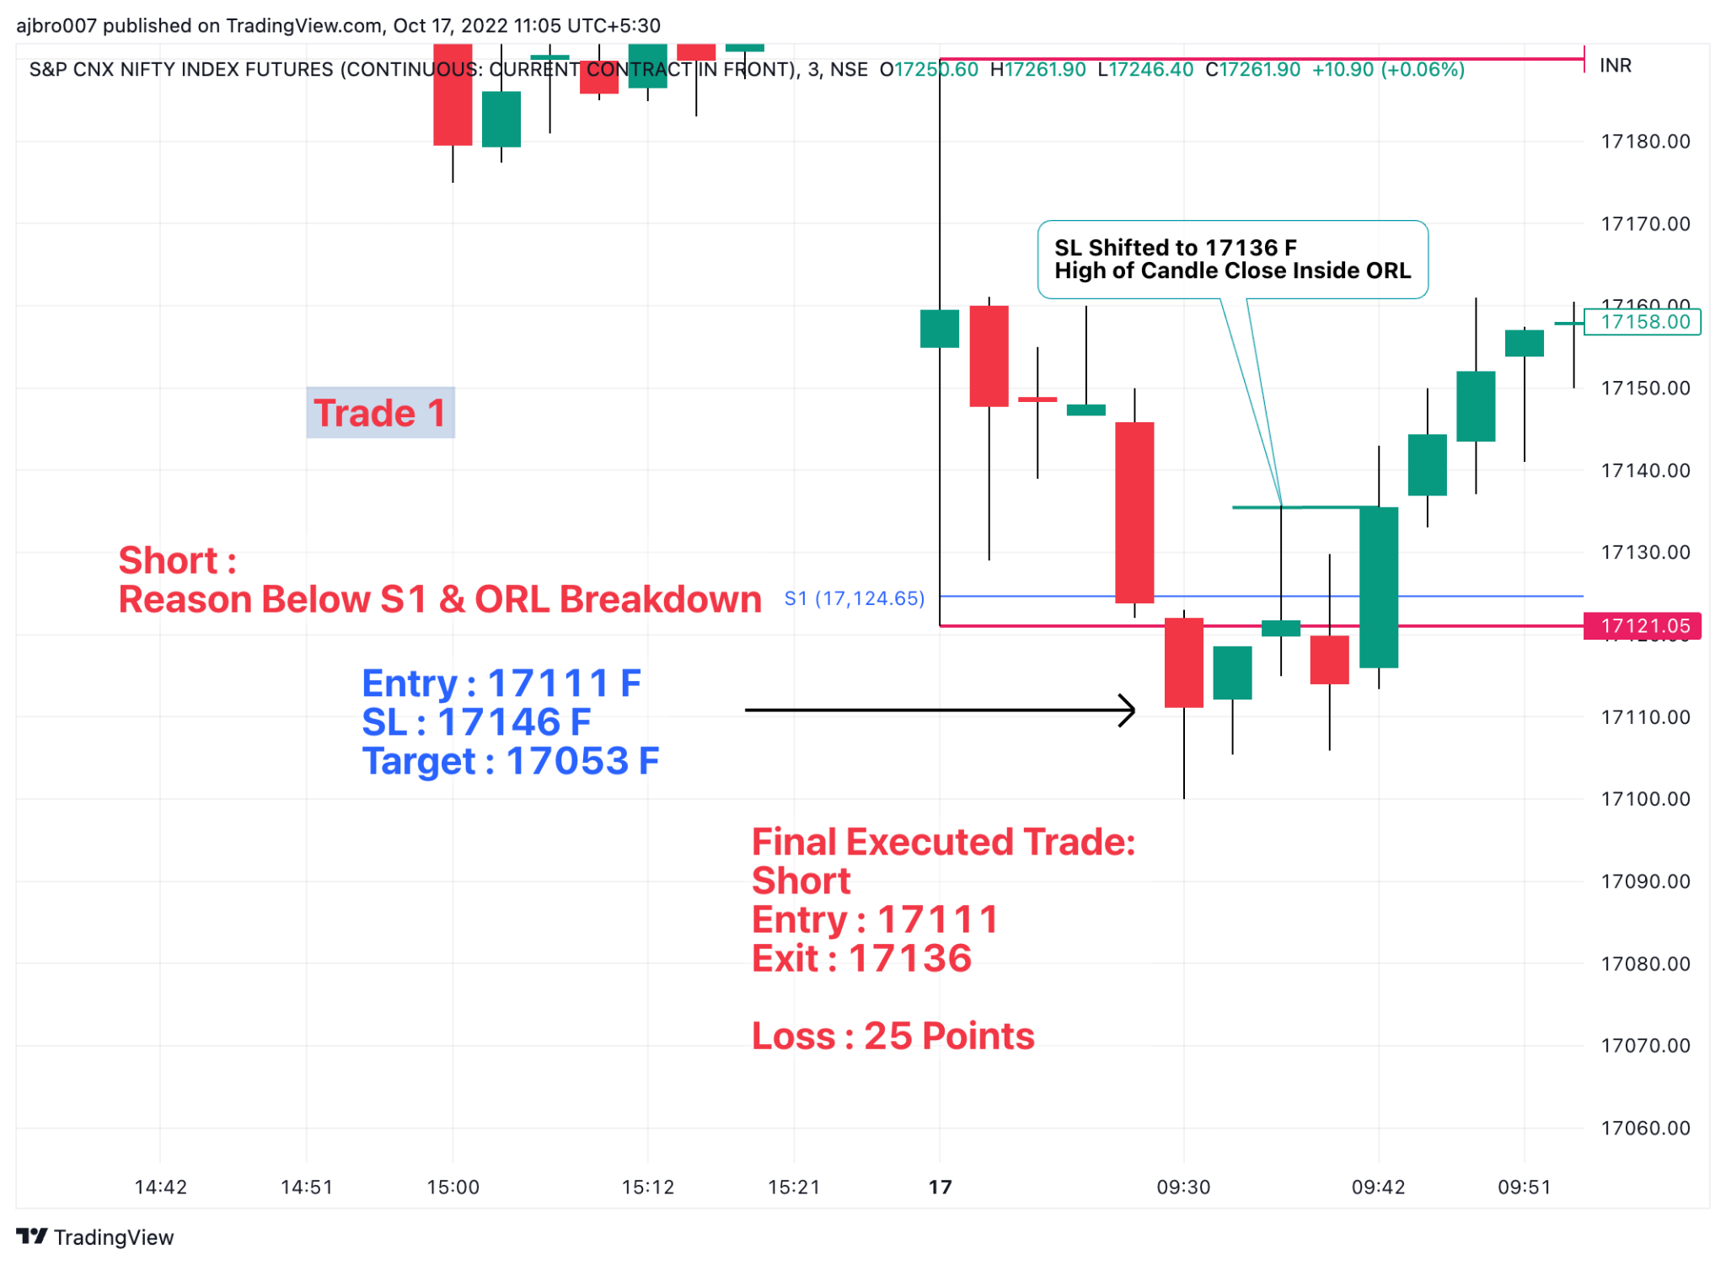
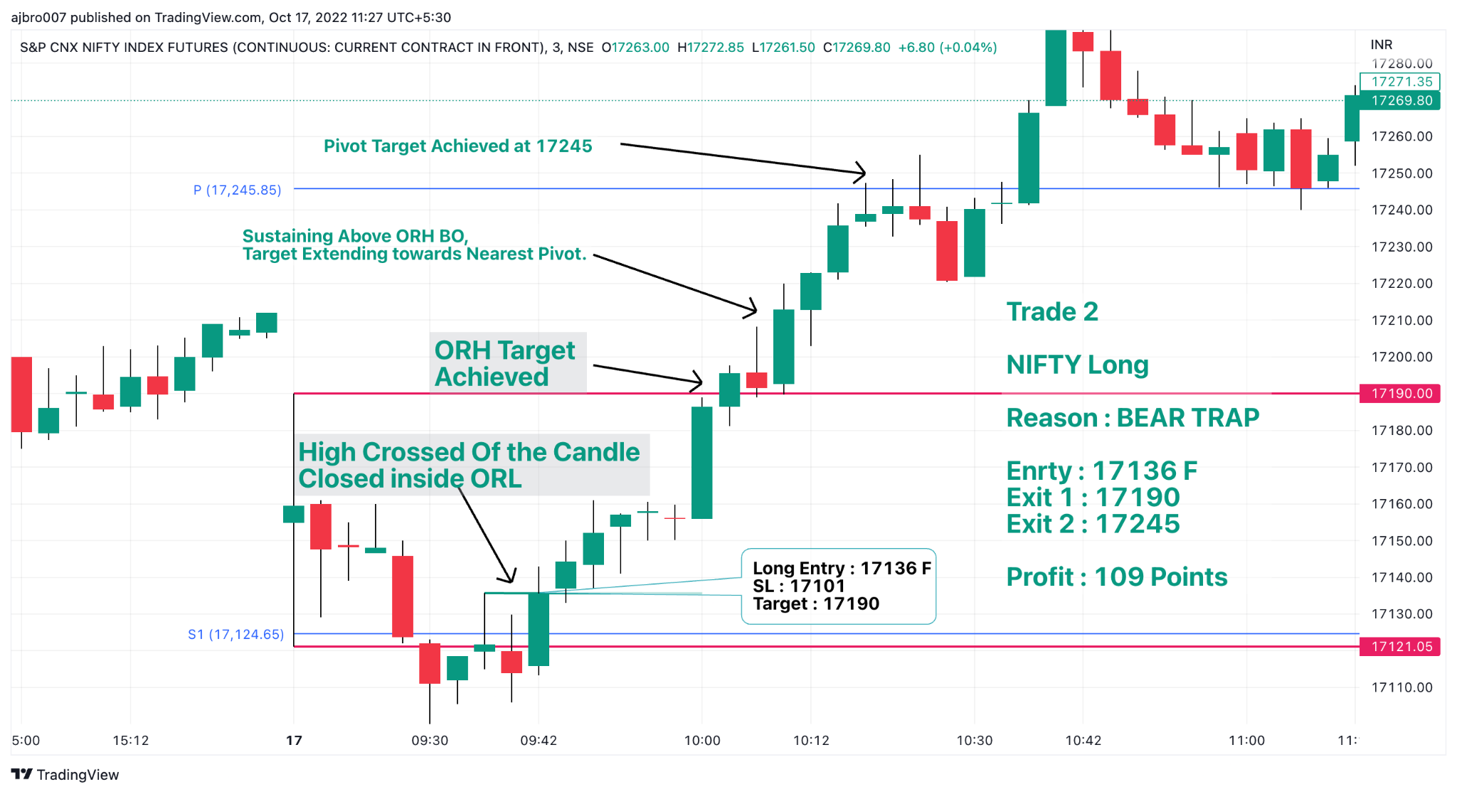
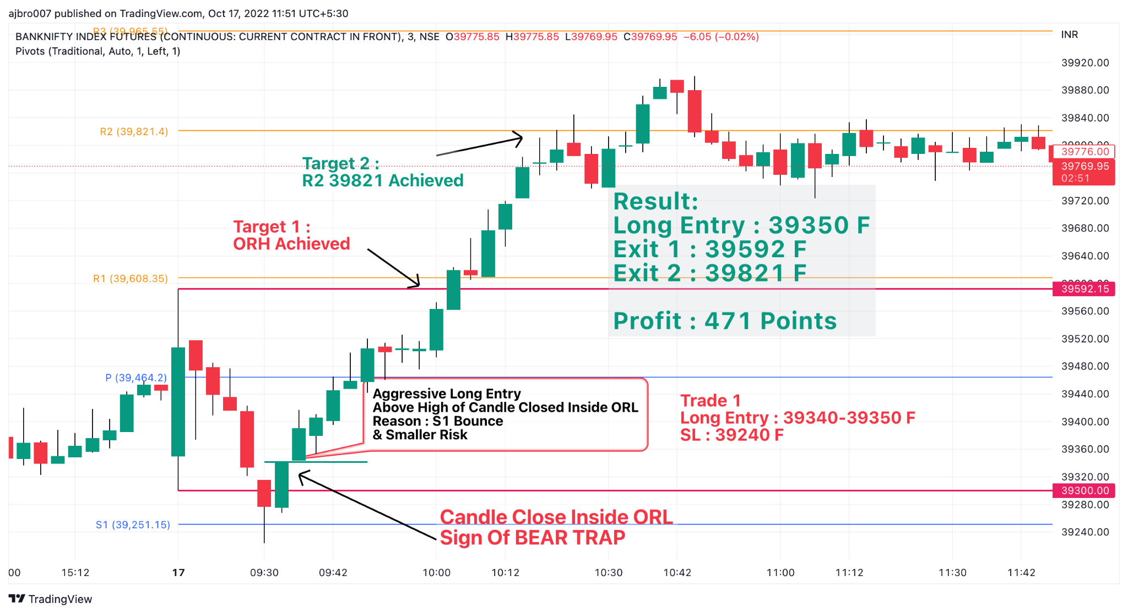
Session: Whipsaws and Minor PA

Rule of LL & HH

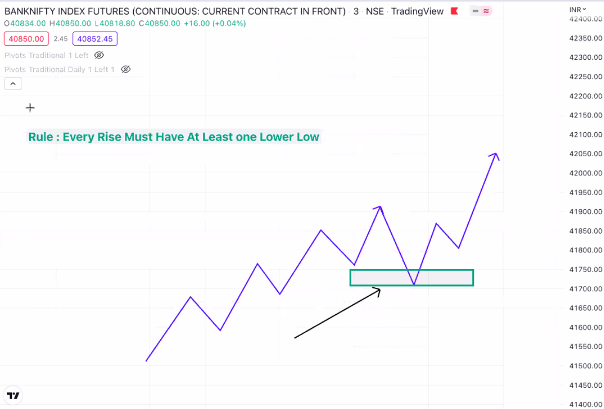
Types of Whipsaws:
- 2LL and 3 LL
- 2HH and 3 HH
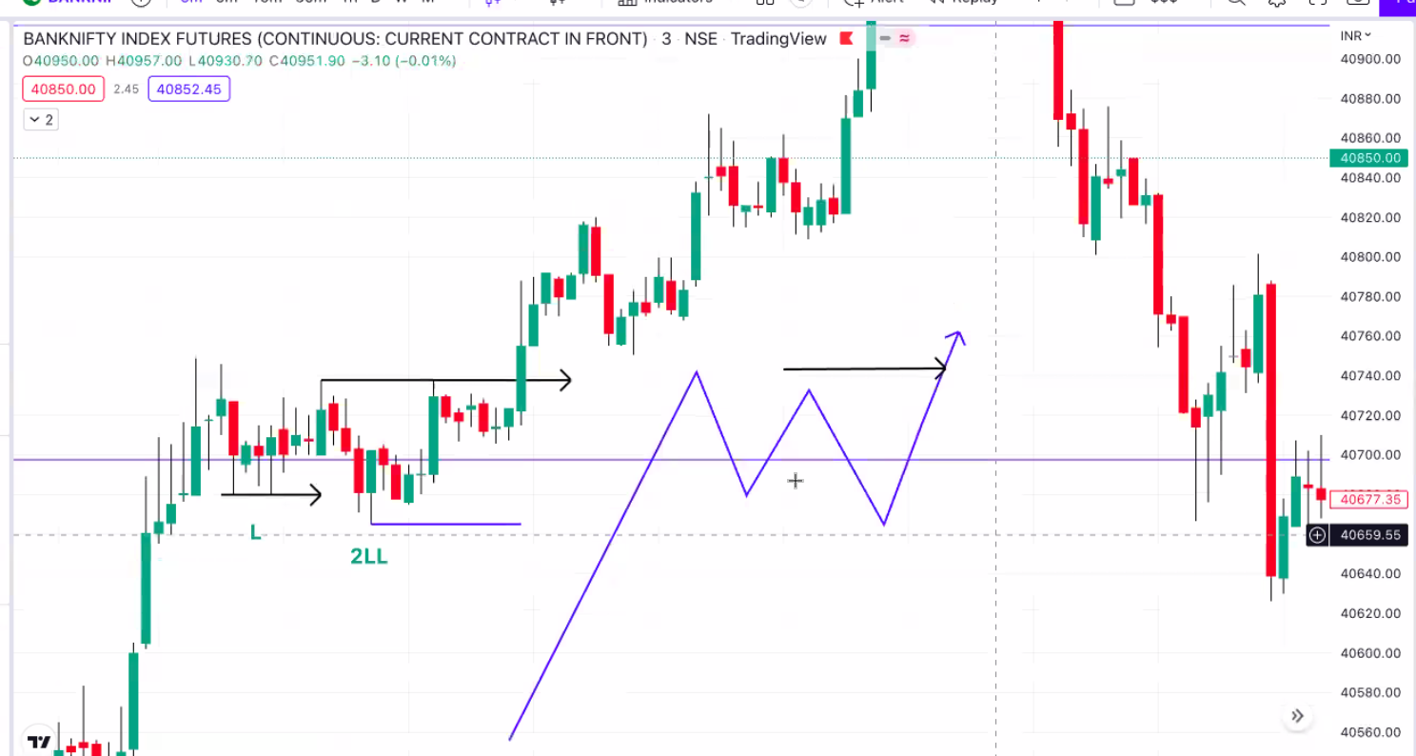
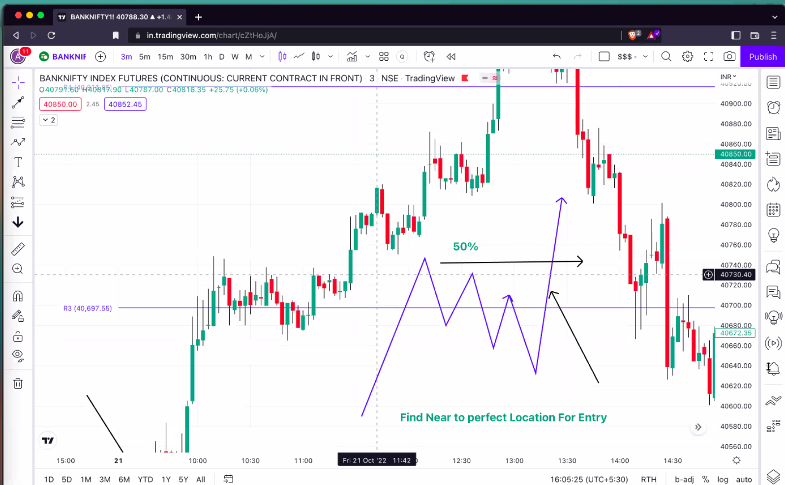
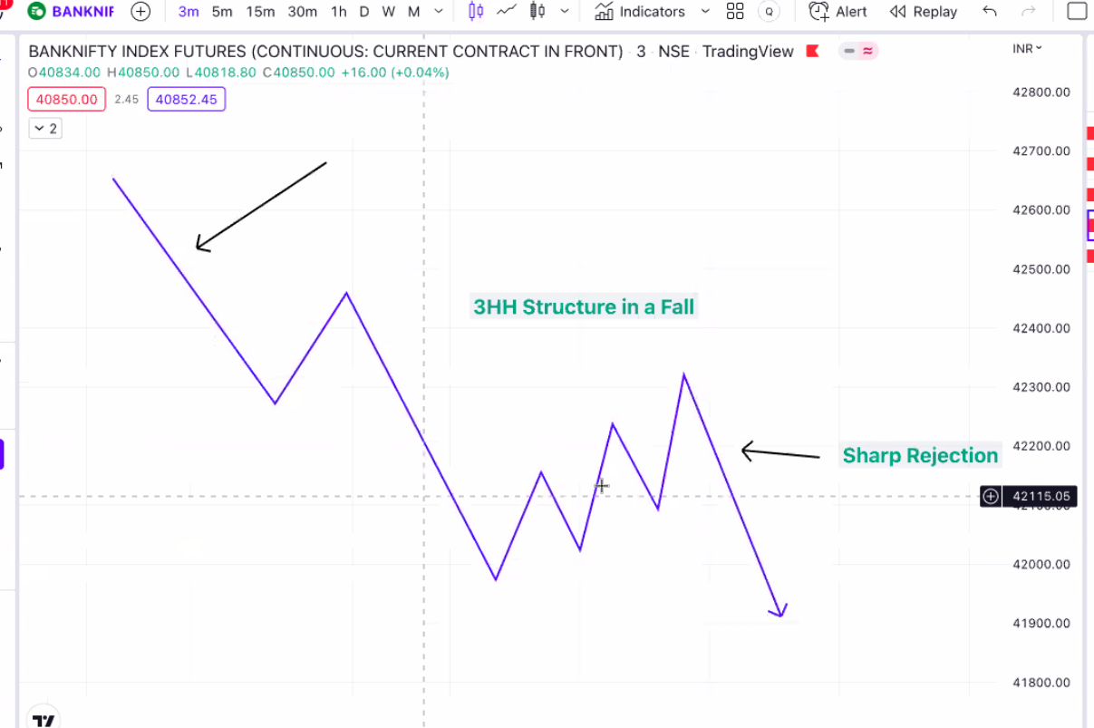

Consolidation , Fake Breakdown and Sharp Move up
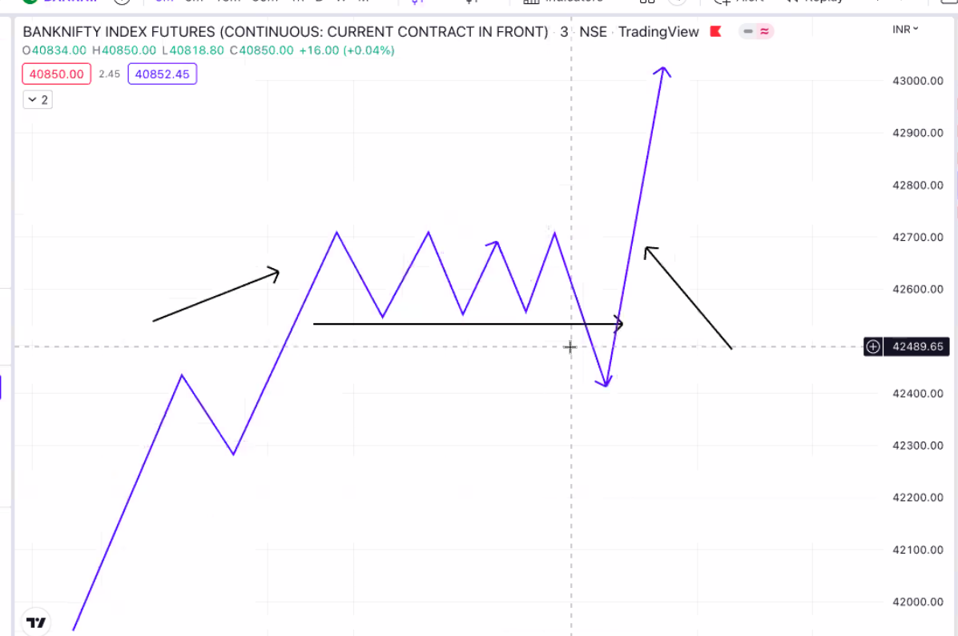
Consolidation , Fake Breakout and Sharp Move down

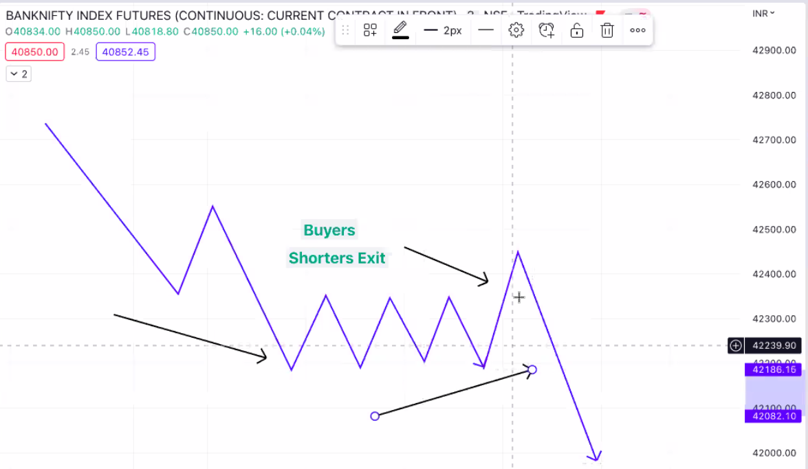
Both sides trap and move

Stock Intraday Setup

- NSE Top Gainers & Losers by percentage : F&O Securities at 9:15

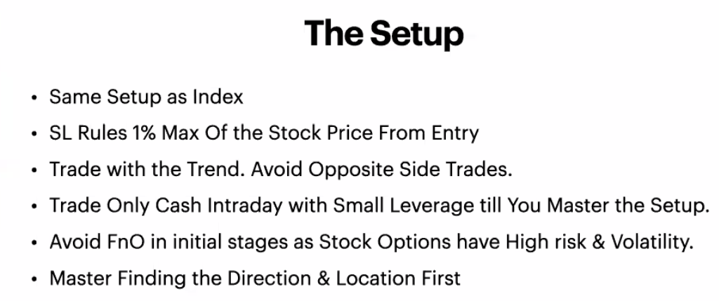

https://chartink.com/screener/bullish-herozero-scanner-4

https://chartink.com/screener/bearish-herozero-scanner-3

