|  |  |  |
| --- | --- | --- |
| https://basin.cbu.edu.tr/db_images/site_500/web/cbu_logo_dik.png | **T.C.**  **MANİSA CELAL BAYAR ÜNİVERSİTESİ**  **MÜHENDİSLİK FAKÜLTESİ**  **BİLGİSAYAR MÜHENDİSLİĞİ BÖLÜMÜ** |  |

**Ringtones**

**Software Engineering**

**HAZIRLAYANLAR**

**180316058 – Zafer Say**

**180316057 – Yusuf Burak Peker**

**180316036 – Mehmet Emre Yılmaz**

**180316030 – İsmail Tosun**

**180316013 – Dilara Kıratlı**

**180316003 – Aleyna Kıyak**

**180316016 – Eda Çelebi**

**Table Of Content**

**1.Introduction** 3

**2.Feasibility & Plan** 3

**3.User Requirements** 3

**4.System Requirements** 4

**5.System Stakeholders** 4

**6.Functional Requirements** 4

**7.Non-functional Requirements and Classify** 4

**8. Usability Requirements** 5

**9.Engineering process order (Elicitation, Analysis, Validation and Management)** 5

**10.Possible Problems in Process Steps** 6

**11.Stories and User Scenarios** 6

**12.Structured Specification for Requirements** 8

**13.Requirements Checking** 9

**14.Foresee Changes** 9

**15.System Boundaries in Detail** 9

**16.Current Project Station** 10

**17.Data and Sequence Diagram** 12

**18.Database Schema** 13

**19.Testing Stage** 13

# **1.Introduction**

The aim of this project is to create a database and web site to provide downloaded ringtones to cell phones. The ringtones would be based on natural sounds in the wild, such as bird calls, crickets, running water, and other sounds that capture the beauty of the natural environment.

# **2.Feasibility & Plan**

* Market survey
  + Highly competitive
  + High demand in young people
  + 75% of target customer want own voice in right tone
  + Provide the most popular songs
* Financial analysis
  + Need extra 1,000₺ for initial investment
  + Another 3,000₺ for first 4 months operation
* Software & Hardware
  + Hardware needs high quality & on site service
  + Select local ringtone software due to need contactable service
  + Purchase computer and peripheral from good reputation’s computer shop
  + Direct contact to local ringtone software maker in order to ensure service

# **3.User Requirements**

* Users should be able to listen to demo of ringtones.
* Users should be able to purchase ringtones.
* Users should be able to save purchased ringtones to their library.
* Users should be able to download their purchased ringtones whenever they want.

# 

# **4.System Requirements**

* Users should be able to register to the system with their email and password, and this information should be recorded in the relevant database.
* Users should be able to listen to the first 10 seconds of mp3s as a demo.
* Users should be able to buy mp3s and the mp3s they buy should be recorded in the user's database. Users should be able to download purchased mp3s whenever they want.

# 

# **5.System Stakeholders**

* User
* Mp3s owners
* Developer Team
* System Owners
* System Managers

# **6.Functional Requirements**

* The user must be able to register with her/his e-mail address.
* The user must be able to login to the system with the username and password.
* User should be able to add mp3 to cart.
* The user should be able to listen to mp3 demos through the embedded media player.
* The user should be able to buy the products in the basket at once.
* User should be able to filter mp3s by categories.
* User should be able to download mp3s purchased.

# **7.Non-functional Requirements and Classify**

* Users' passwords should be stored in a hashed form in the database.
* Frontend will be written using HTML CSS JavaScript and backend will be written using python.
* 50GB of storage space is required to store mp3 files and user data.
* The product that the user adds to her/his cart and the product you buy must be the same.
* System should run on linux server.

# **8.** **Usability Requirements**

* The system should be easy to use by the user and should be organized in such a way that user errors are minimized.

# **9.Engineering process order (Elicitation, Analysis, Validation and Management)**

* **Elicitation**
  + Brainstorming Sessions
    - Knowledge of the overall area where the systems is applied.
    - The details of the precise customer problem where the system are going to be applied must be understood.
    - Interaction of system with external requirements.
    - Detailed investigation of user needs.
    - Define the constraints for system development.
* **Validation**
  + The requirements should be consistent with all the other requirements i.e no two requirements should conflict with each other.
  + The requirements should be complete in every sense.
  + The requirements should be practically achievable.
* **Management**
  + It is ensured that it can be changed as much as possible, including the changes in the requirements specified by the end users in the later stages.

# **10.Possible Problems in Process Steps**

* The user may want to return the downloaded mp3.
* The user can try to sell the mp3 she/he has downloaded to others.
* The mp3 file that the user downloaded may be corrupt.

# **11.Stories and User Scenarios**

Scenarios 1.

Nazif complained a lot about not being able to hear the ringing tone on his phone. Searched the Internet for a new ringtone. Decided to buy a new ringtone from Zilsepeti.com. He added 2 ringtones he chose from the nature category to his cart and bought it.

**Use case name:** Scenario 1

**Participent actor:** User

**Flow of events:**

**1.**The user logged into the website.

**2.**Filtered by selecting the nature category.

**3.**Added selected ringtones to the cart.

**4.**Made the payment.

Scenario 2.

Eda decided to buy a different ringtone because she was bored with the ringtones on her phone. She became a member of Zilsepeti.com. She then logged into the website with the password and e-mail she set. Then she began to search for the styles of music she had in mind. Added some favorite ringtones to the cart. She listened again to the sounds she had chosen before she bought it. She decided to remove some of them from the cart. Bought the remaining three ringtones.

**Use case name:** Scenario 2

**Participent actor:** User

**Flow of events:**

**1.** The user registered.

**2.** Logged in with the password and e-mail she set.

**3.** Filtered ringtones based on their category.

**4.** Added ringtones to the cart.

**5.** He/she listened to the demos of the sounds he/she added again.

**6.** Deleted some ringtones from the cart.

**7.** Bought the ringtones in the cart.

Scenario 3.

Dilara really likes the ringtone she heard from a friend. She learns that she bought the ringtone from Zilsepeti.com. She decides to try the website. Becomes a member and log in. Then she searches for the ringtone she likes from the search section. She decides to listen to the demo version of the ringtone one last time and get it. Adds to cart, makes the payment, and buys.

**Use case name:** Scenario 3

**Participent actor:** User

**Flow of events:**

**1.** The user registered and logged in.

**2.** Searched for ringtone by name.

**3.** Plays the demo version of the ringtone.

**4.** Added to cart.

**5.** Made payment.

Scenario 4.

Aleyna had discovered Zilsepeti.com before and was satisfied with the website. She decided to buy new ringtones. She logged into the website. However, since his budget was limited, she filtered by price. She chose one among them by listening to the ringtones that fit his budget. Then she purchased it by adding it to the cart. She downloaded the ringtone she bought. The website has been logged out.

**Use case name:** Scenario 4

**Participent actor:** User

**Flow of events:**

**1.** The user is logged in.

**2.** Filtered by price.

**3.** He/she listened to the demo version of the ringtones.

**4.** Added to cart and bought.

**5.** He downloaded the sounds he bought.

**6.** Logged out of the website.

Use Case

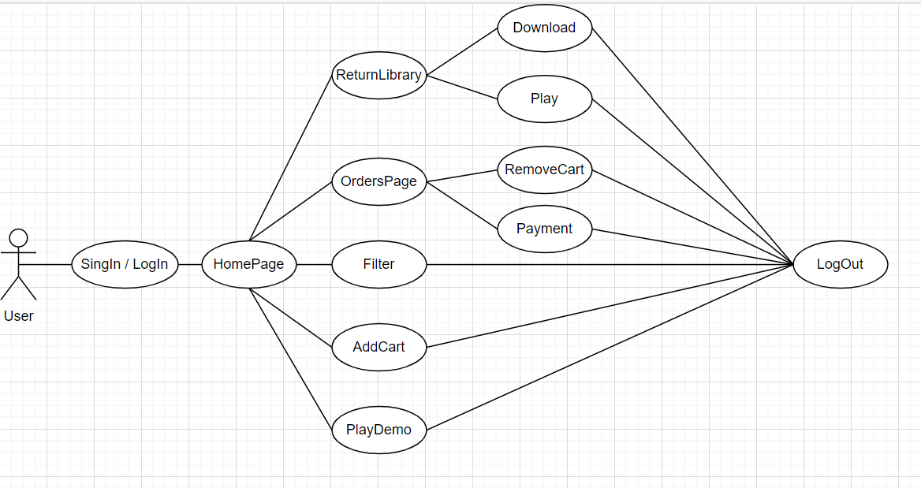

# **12.Structured Specification for Requirements**

* **Function:** Listen demo.
* **Description:** The user should be able to listen to the demo of the Mp3 they want.
* **Inputs:** User choice Mp3.
* **Source:** Mp3 database.
* **Output:** Play selected Mp3.
* **Destination:** Main control loop.
* **Function:** Buy Mp3.
* **Description:** The user should be able to permanently buy the mp3 they want.
* **Inputs:** User choice Mp3.
* **Source:** Mp3 database.
* **Output:** Buy selected Mp3.
* **Destination:** Main control loop.

# **13.Requirements Checking**

After defining requirements we check requirements validiti, consistency, comptutness, realizm and verifiablity.

# **14.Foresee Changes**

Stakeholders has certained requirements so we did not expect any change in short time.

# **15.System Boundaries in Detail**

* Payment System
* Mp3 Play System
* Shooping Cart System
* Signup Login System

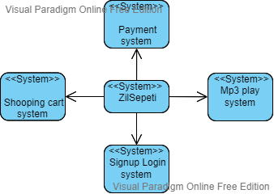

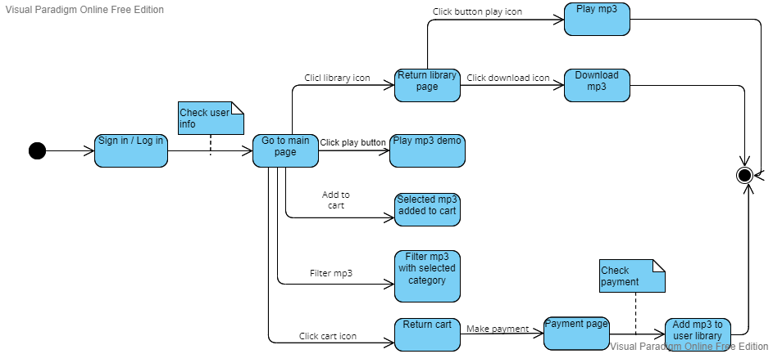

# **16.Current Project Station**

We use Trello to planning Sprints

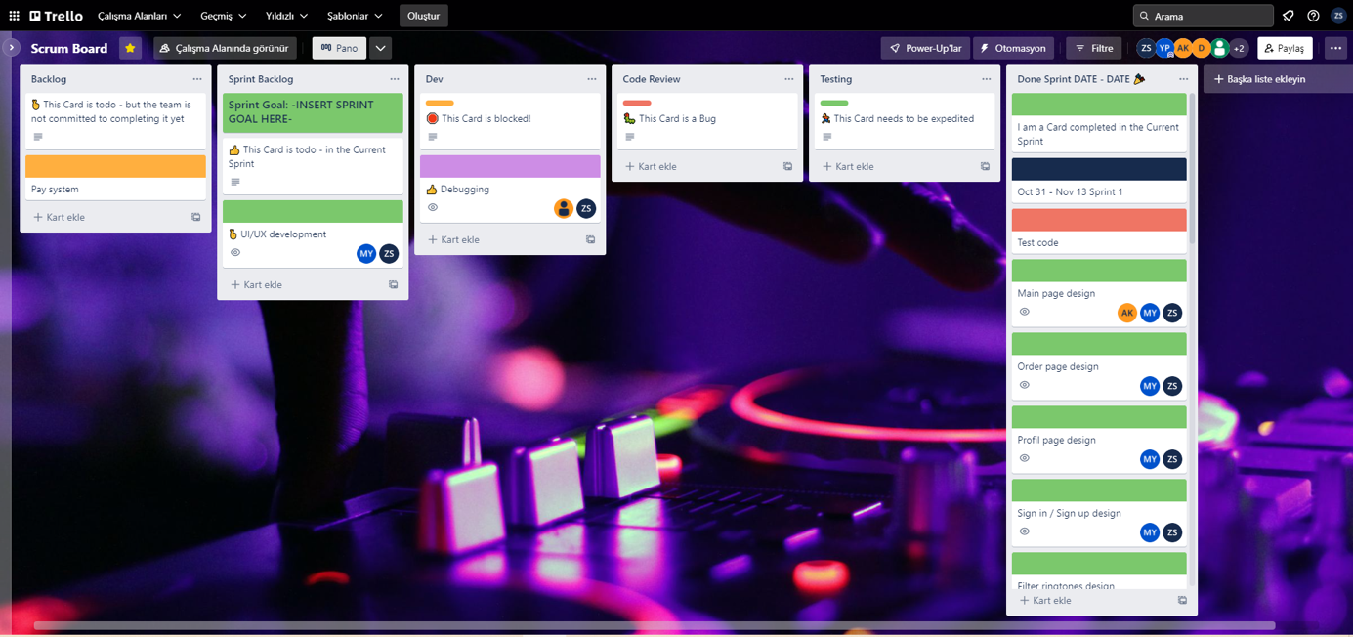

|  |  |
| --- | --- |
| **Sprint 1** | **31 October – 13 November** |
| **Test Code** | İsmail Tosun |
| **Main Page Design** | Mehmet Emre Yılmaz – Aleyna Kıyak- Dilara Kıratlı |
| **Order Page Design** | Eda Çelebi – Dilara Kıratlı – Aleyna Kıyak |
| **Owned Ringtones Page Design** | Dilara Kıratlı – Eda Çelebi – Yusuf Burak Peker |
| **Sign-up / Sign-in Design** | Aleyna Kıyak – Dilara Kıratlı – Eda Çelebi |
| **Filter Ringtones Design** | Yusuf Burak Peker – Eda Çelebi |
| **Sprint 2** | **28 November – 11 December** |
| **Owned Ringtones Implementation (Frontend)** | Zafer Say – Mehmet Emre Yılmaz |
| **Main Page Implementation (Frontend)** | Mehmet Emre Yılmaz – Yusuf Burak Peker – Zafer Say |
| **Order Page Implementation (Frontend)** | Dilara Kıratlı – Aleyna Kıyak |
| **Search Method implementation** | Ismail Tosun – Zafer Say |
| **Filter Method Implementation** | Ismail Tosun – Zafer Say |
| **DataBase Design** | Mehmet Emre Yılmaz – Zafer Say – Ismail Tosun |
| **Sprint 3** | 12 December – 25 December |
| **Sign-up / Sign-in Implementation (Frontend)** | Mehmet Emre Yılmaz – Yusuf Burak Peker – Eda Çelebi |
| **Main Page Implementation (Backend)** | Ismail Tosun – Zafer Say |
| **Order Page Implementation (Backend)** | Ismail Tosun – Zafer Say - Dilara Kıratlı |
| **DataBase Implementation** | Ismail Tosun – Zafer Say - Mehmet Emre Yılmaz |
| **Sprint 4** | **26 December – 30 December** |
| **Owned Ringtones Page Implementation (Backend)** | Yusuf Burak Peker - Eda Çelebi |
| **Sign-up / Sign-in Implementation (Backend)** | Zafer Say - Dilara Kıratlı |
| **Add to Cart Method Implementation (Backend)** | Mehmet Emre Yılmaz |

# **17.Data and Sequence Diagram**

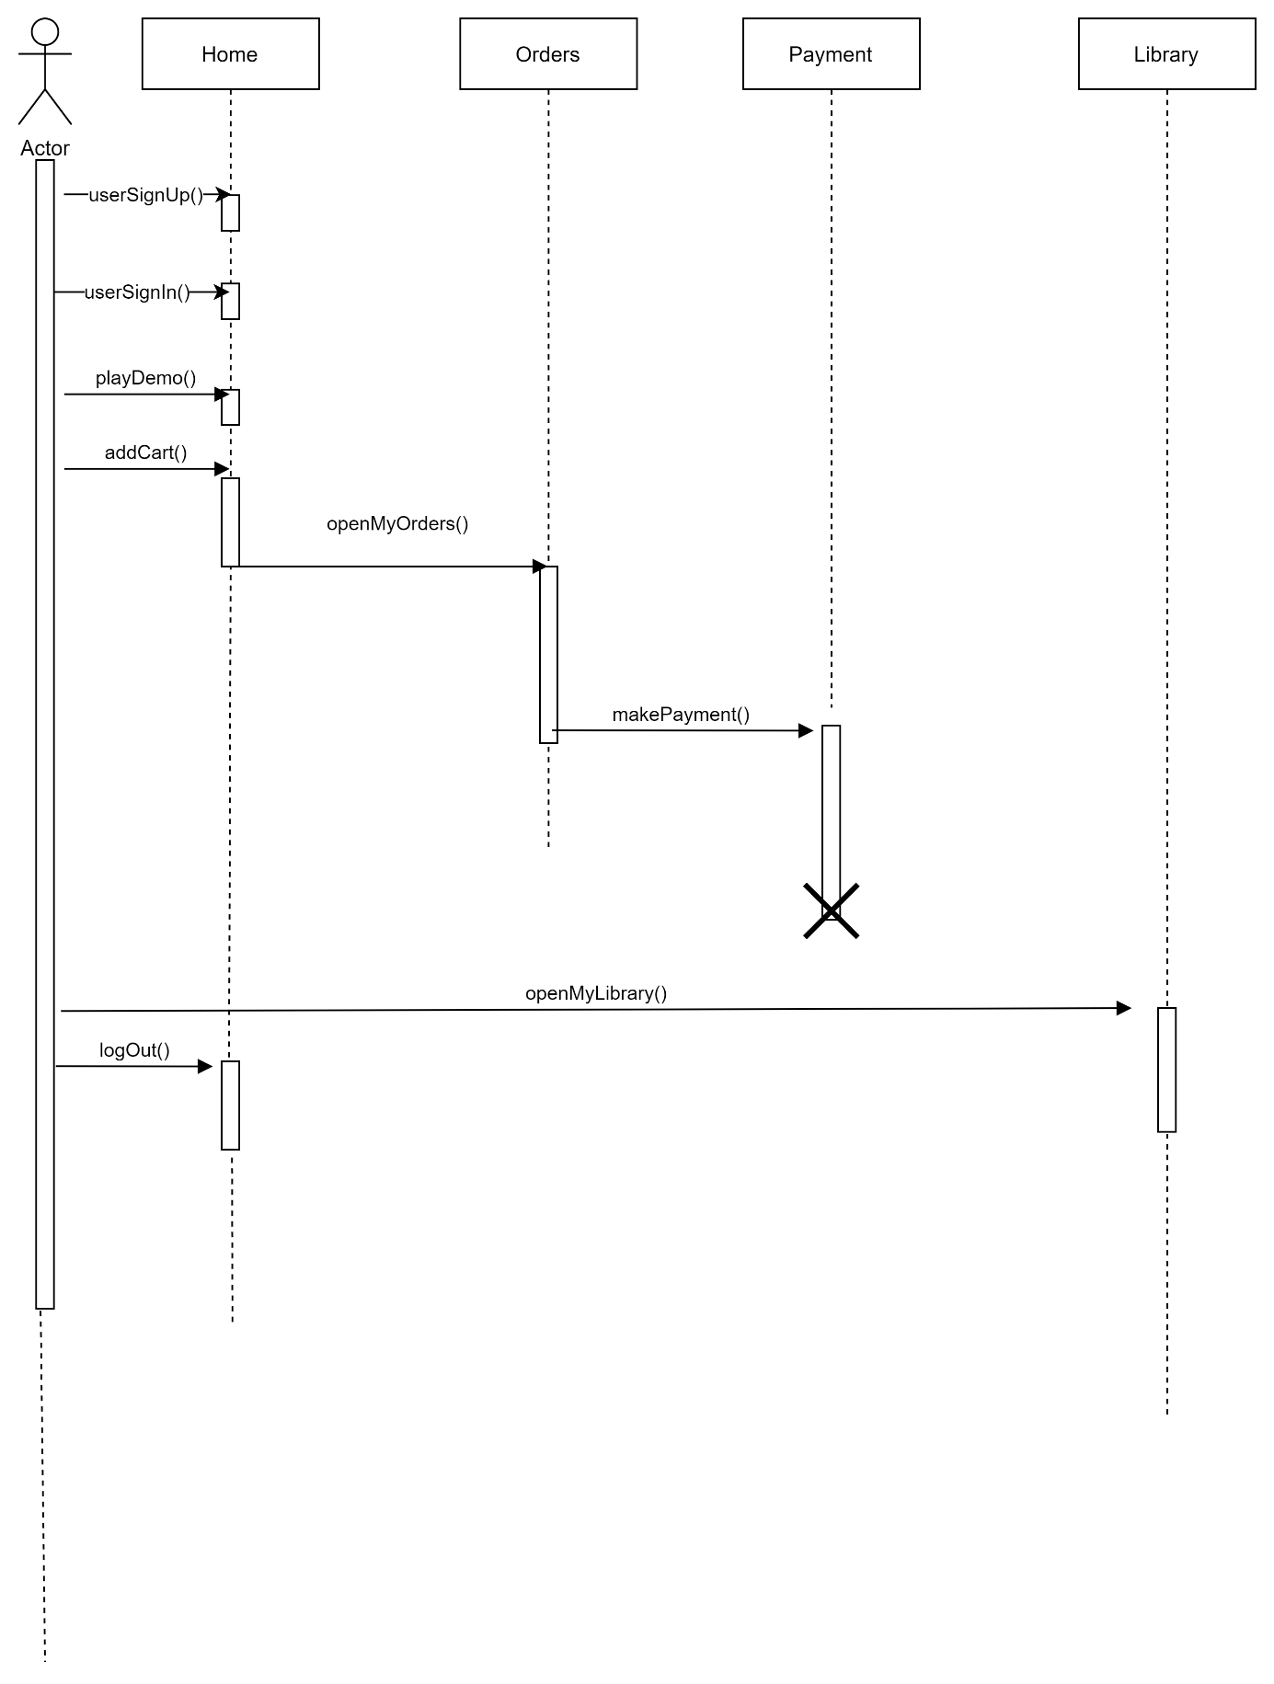

# **18.Database Schema**

Schema showing the database structure. We use SQLite3 local database.

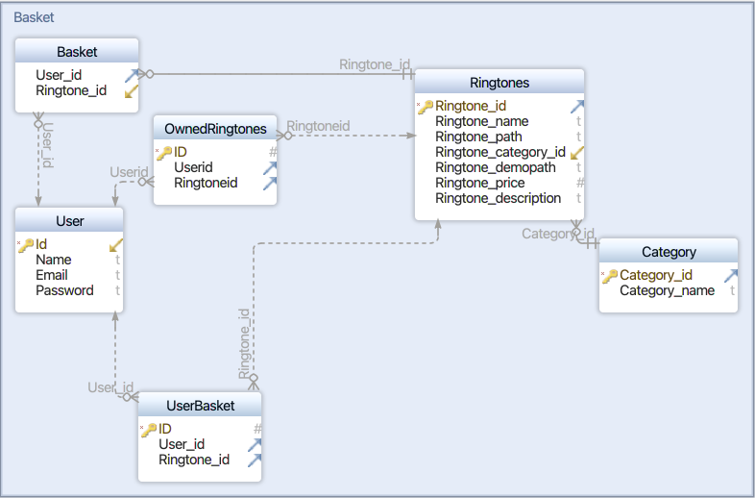

# **19.Testing Stage**

We done 15 automated test during development process and use Test-Driven-Development. Our test tools are pytest library with selenium.

These are our most common error messages, some of the these messages came from pytest and some of the errors show itself before run the test.

|  |  |  |
| --- | --- | --- |
| Error Name | Description | Count |
| Syntax error (Backend) | Writing wrong keywords or indend errors in python | >50 |
| Connection lost | Pytest cannot connect the server | 10-20 |
| Cannot Load Static Files | Static files link writed wrong into html | 10-20 |
| Sqlite3 connection Error | Database connection loss sometimes due to possible overloading | 2-3 |
| Http 404 | Page cannot | 6-5 |
| Logical Error | Some filtering and Database process work anormal | 5-10 |
| Syntax error(Frontend) | Html-Css Layouts look different then usual | >40 |