**How To Sync Your Data**

**1. Download Syncing Plugin:**

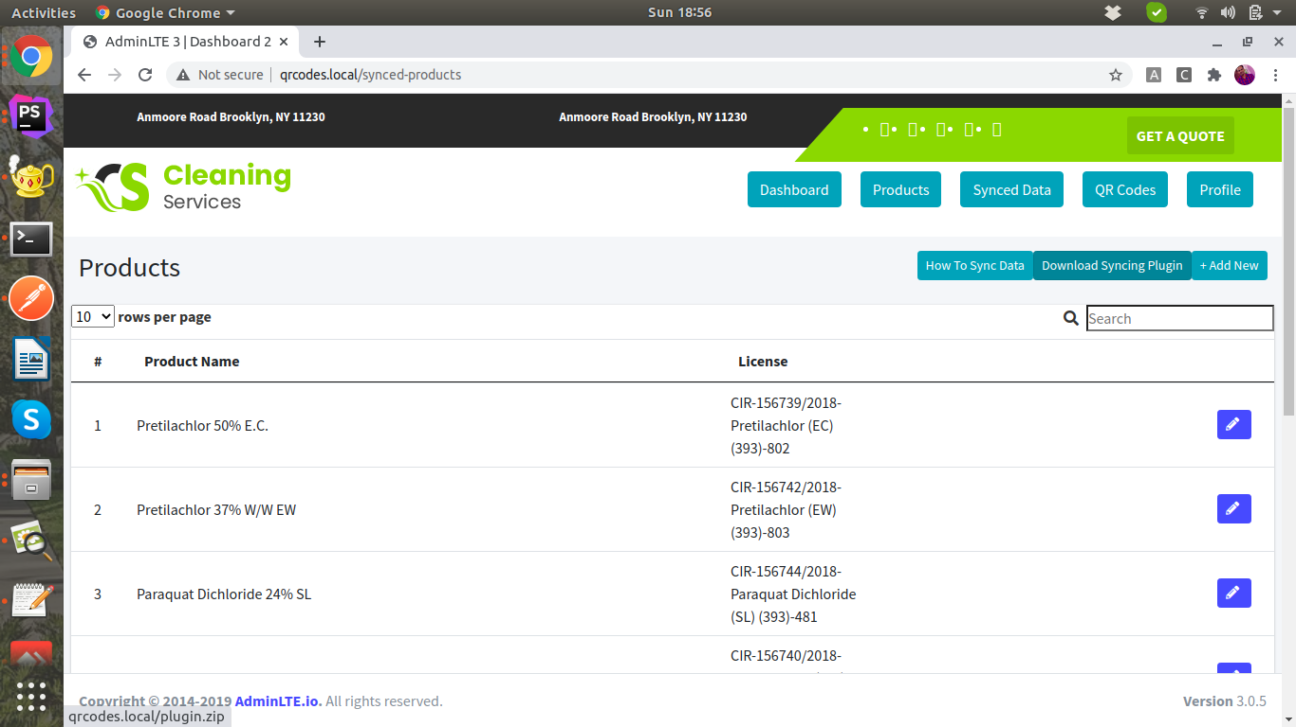

**2. Extract Plugin:**

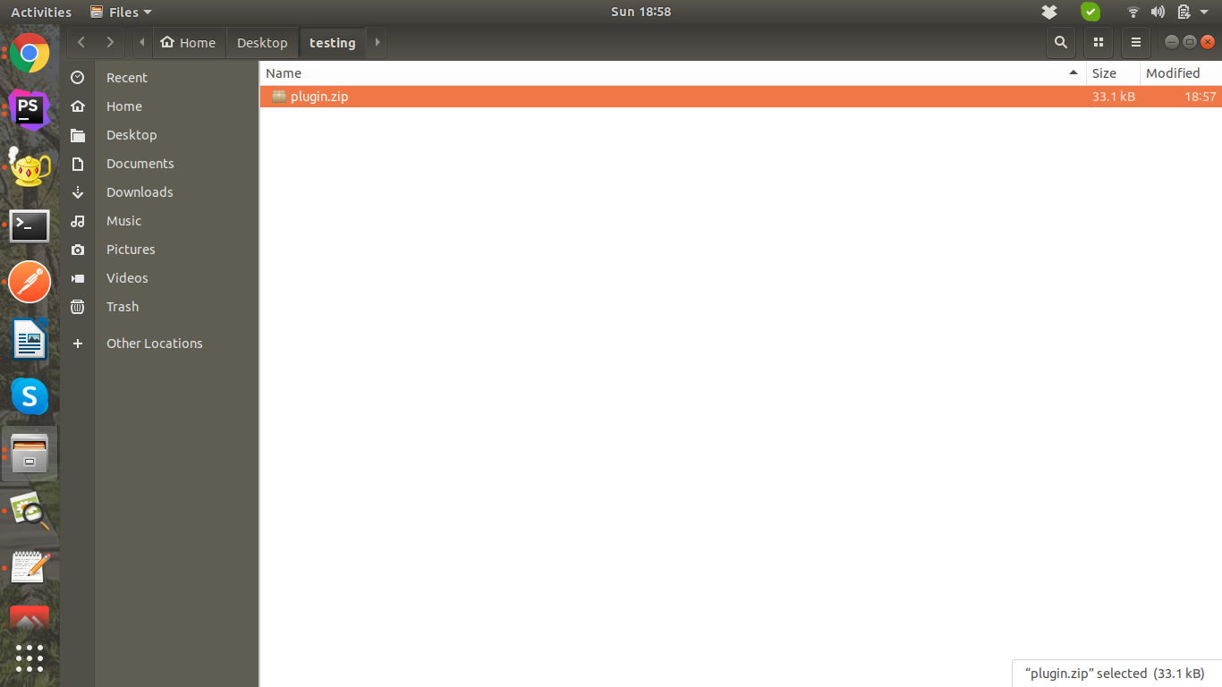

**3. Open Extentions In Chrome Browser**

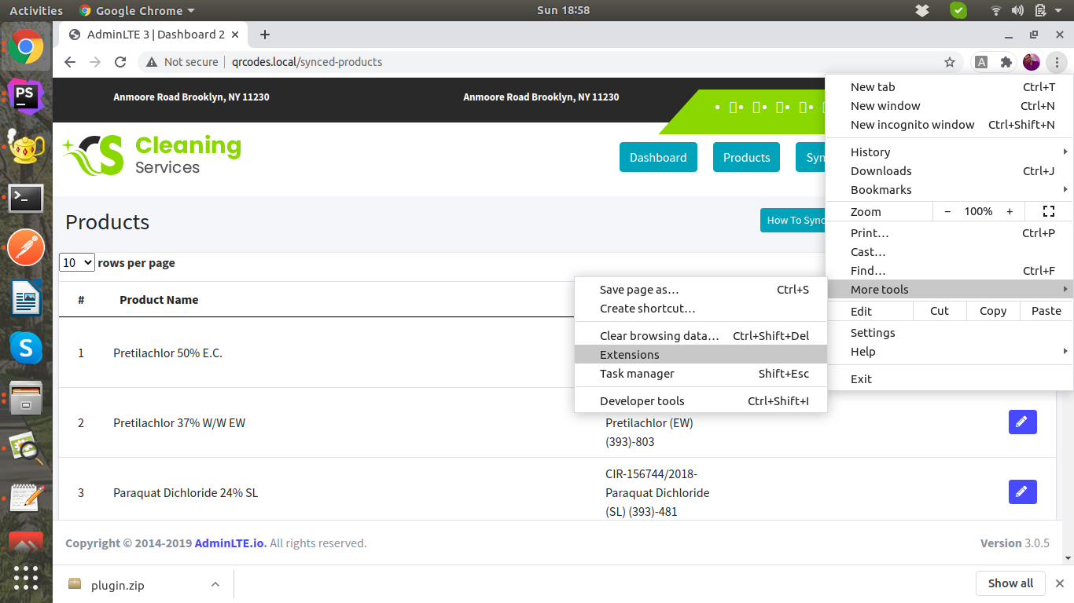

**4. Activate Developer Mode in Chrome Browser**

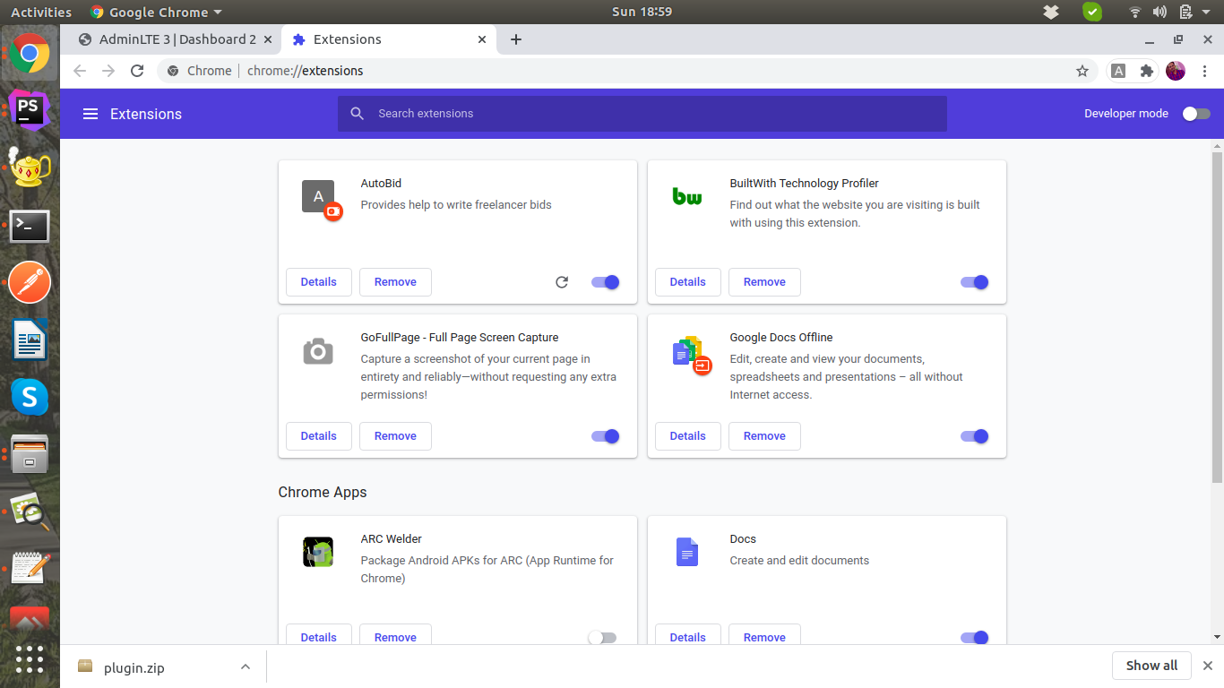

**5. Load Unpacked Extension:**

**Click on Load Unpacked and select extracted plugin main folder**

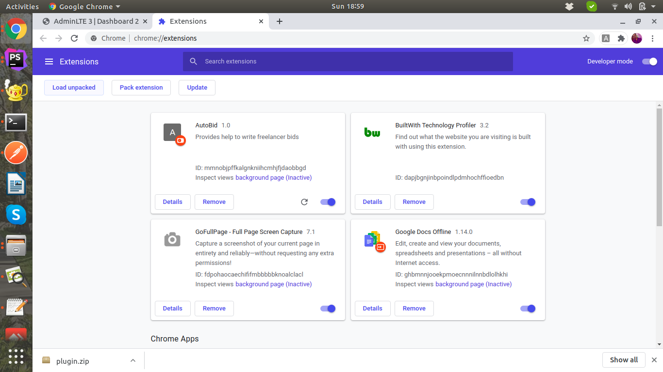

**6. Pin Extension To Browser Toolbar**

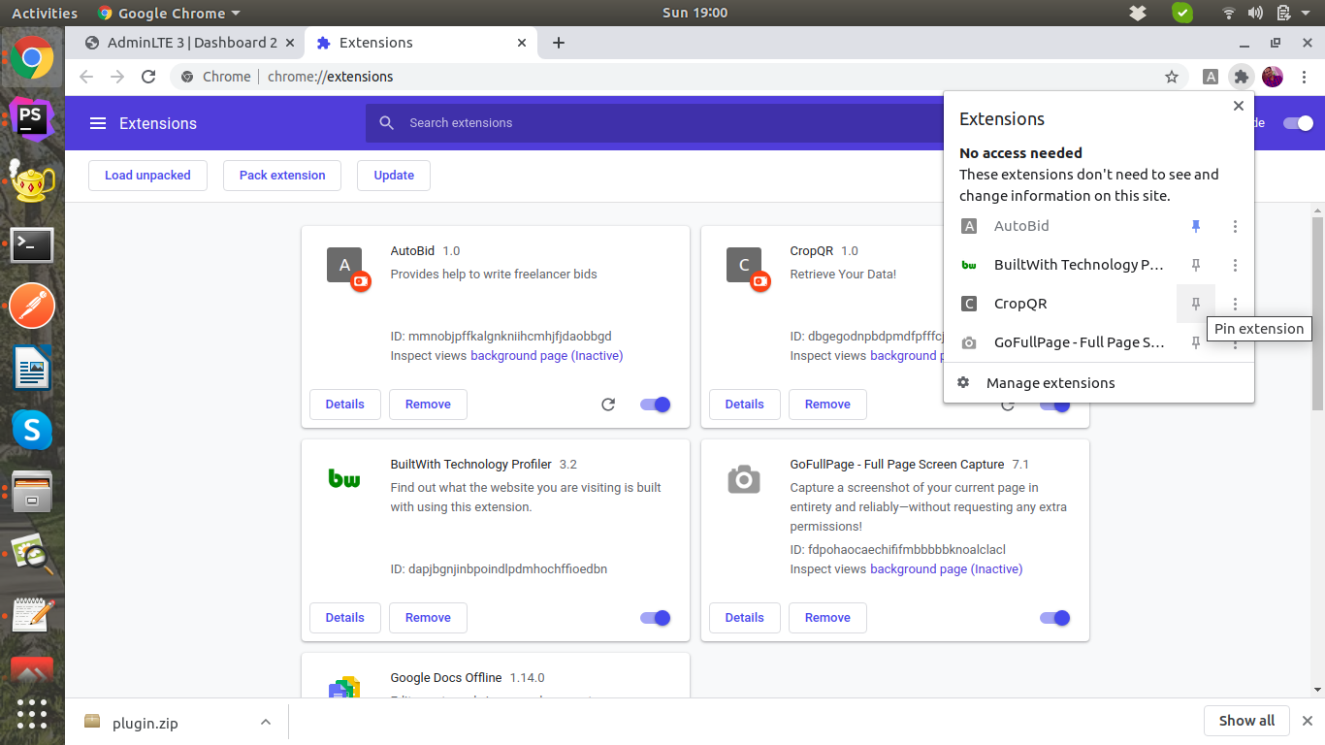

**7. Open Page from which you want to sync data & click Sync Button:**

