

**Advanced Recurring Billing System (ARBS)**

**USER GUIDE**

|  |  |  |  |
| --- | --- | --- | --- |
| **Version Number** | **Author** | **Date** | **Description** |
| **1.0** | **G Rennie** | **11/12/13** | **First version** |
|  |  |  |  |
|  |  |  |  |

ARBS is a billing system, designed to prepare and process items for recurring and one-off billing. This is the system Advanced uses for all billing, except for billing Service Days.

If you have any issues or queries with how this system works, please contact Gillian Rennie who will be able to help you.

**SET UP**

Users are registered by Gillian Rennie, and access will be limited to relevant Companies. Also, a user can be ‘Read Only’ or ‘Update’.

**SUPPORT**

If you experience any problems with the system, please contact Gillian Rennie, or in her absence Dinesh Joshi ([dinesh.j@advanced-india.com](mailto:dinesh.j@advanced-india.com))

**IMPROVEMENT**

We are eager that the ARBS system keeps up to date with user’s requirements, so if there are any functions or reports that you would like to improve or have added, could you please email your suggestion to Gillian Rennie, who will contact you to discuss further.

**There are 2 Drop Down Menu’s – ‘Contracts’ and ‘Reports’**

1. **CONTRACTS**

This menu option has 5 further options:

CONTRACTS – where all invoice billing rules are created and amended

APPROVE MAINTENANCE – where invoice items are selected and processed for invoicing

CUSTOMER COMMENTS – notes and comments can be entered against a Customer, and Invoice Grouping selected

END USER MAINTENANCE – End Users of Business Partners are maintained from this screen

OA SYNCH DATA – Synchronise function with Open Accounts

* 1. **Contracts** This set of screens, is the main data entry for ARBS. It is where all Billing Rules are created and updated.

**Contract Creation**

When creating a new entry into ARBS, you must decide if the item is to be ADDED to an existing contract (ie: a new item on an existing invoice), or to be created as a new Contract (i.e. a separate invoice to other billing for that Customer). If you are adding to an existing contract then find the contract, and enter details as below (go to ‘Coding Detail’). To create a NEW contract you complete the Contract Header (Select ‘New’ from the Contracts screen)

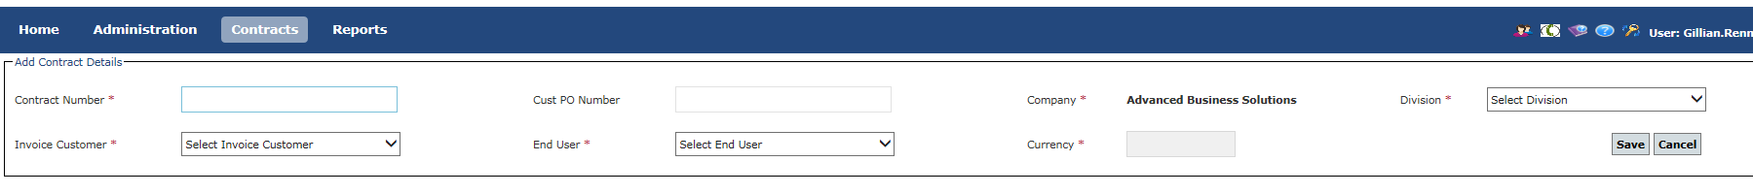

**Contract Number** – a reference that will identify this contract – we usually use the JOB CODE, followed by a brief description. This reference is for identification only, and does not appear on the invoice.

**Cust PO Number** –this will appear on the header of the invoice that goes to the Customer. If this is a recurring item, you may put ‘Contract’, remember if you use a PO number it will appear year after year, unless it is changed.

**Company** – This is set to the company you are logged into and cannot be changed

**Division** – The sub division of the Company. This is a way of separating items for different business areas within the same company. We also use it if items need to be held for billing, because they may require manual intervention before processing – in this case you will put in a division called ‘HOLD’.

**Invoice Customer** – The Customer to whom the invoice is sent – this must exist on the Open Accounts finance system

**End User** – If the Customer is a Business Partner, then this is the name of the End User for this item. If the End User does not exist already, then it must be created, before you can enter it here (see ‘End User Maintenance’)

**Currency** – This currency is a lookup from Open Accounts, and cannot be changed. If the currency is not what you are expecting, then you must query with Credit Control Manager.

**Once all details are completed, click ‘Save’**.

**Coding Details**

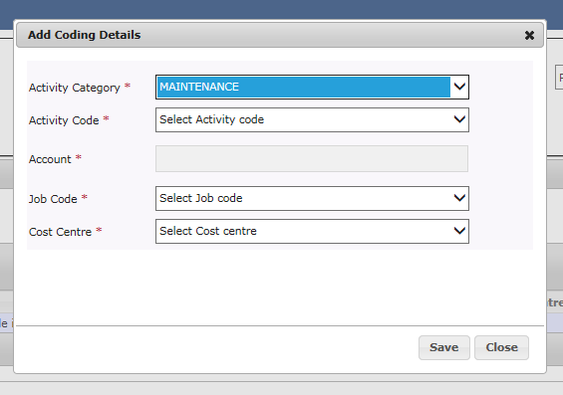

After the Contract header is created. You must create the coding lines. The coding details determine how the invoice will be coded in the General Ledger in OA, once the invoice is posted. You need one coding line, for every different combination of codes on the invoice. If you have 2 invoice items, that both go to the same set of codes, then you only need to create the coding line once – as you can allocate the same coding line to more than one billing line.

Please note, that all new items must be allocated a new Job Code prior to adding to ARBS. If you do not have a Job Code allocated to the order, then you must obtain one prior to adding the item to ARBS.

**Once the codes have been selected, click ‘Save’**

**Billing Details**

Once all the coding combinations have been created, click on Billing Details, then ‘New’ to create a new Billing Item. You need one billing item for every item that is to be invoiced. All billing items created under this contract, and processed at the same time, will appear on ONE invoice. If a Customer requires separate invoices for certain items, then you must create a separate contract.

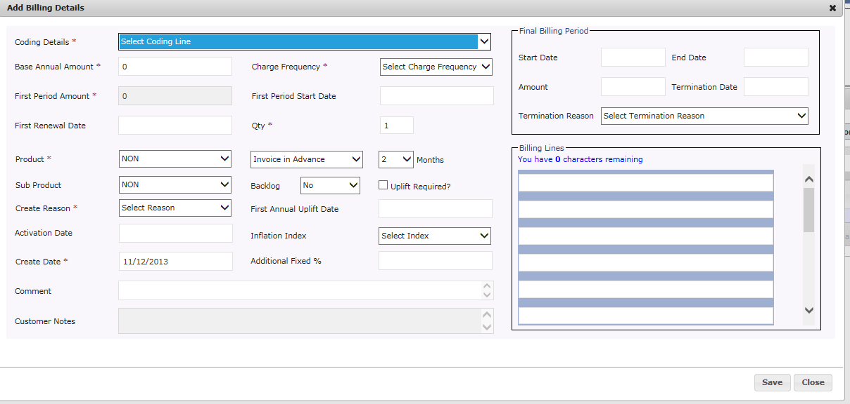

**Coding Details -** Using the drop down arrow, select the appropriate set of coding details for this item.

**Base Annual Amount** – The ANNUAL value for the item or if this is a non-recurring item, then the exact value for the item.

**Charge Frequency –** the frequency the item is to be billed. If this is a non-recurring item then select ‘Ad-hoc’, and if this item is a Credit, select ‘Credit’ (all credit items must have negative values).

**First Period Amount –** is automatically calculated depending on the Annual Value and charge frequency entered

**First Period Start Date** – The start date for the renewal, or if Ad-hoc, the order date of the item. If not known (the item may not have been delivered/installed yet) leave BLANK as it will go on ‘Backlog’

**First Renewal Date –** If you want to align the renewal of this item to a common date for this contract/Customer, then enter the date you want to align to. If no alignment is required, then repeat the same date as ‘First Period Start Date’. If you enter a different date here, the system will create a pro-rata billing line, based on the number of days between the 2 dates.

**Qty –** Defaults to 1. This will not be printed on the invoice but can be printed on reports etc. so could be number of users etc. If you want the quantity of an item to appear on the invoice, you must also include it in the invoice narrative.

**Product and Sub Product** – can be left blank

**Invoice in Advance –** the number of months in advance of renewal that an invoice will be produced - this defaults to the setting for your Company/Division. Do not overwrite it unless special payment terms have been agreed for this item.

**Backlog –** defaults to ‘No’ however, if you do not yet know the bill dates for this item, change to ‘Yes’ and this item will appear on Backlog reports.

**Uplift Required? –** check this box if this item attracts an annual inflationary uplift

**First Annual Uplift Date –** the date to apply the inflationary uplift for the FIRST time (this must be an anniversary of ‘First Renewal Date’

**Inflation Index –** the name of the inflationary index to be applied to this item

**Additional Fixed %** - if a separate fixed percentage has been agreed – you can enter it here

**Create Reason** – select an appropriate item from the drop down list

**Activation Date** – enter today’s date – not required if an item is on Backlog

**Comment –** Any narrative you wish to add that may be useful for this item for future reference.

**Billing Lines –** The actual narrative to appear on the invoice – no line should contain more than 48 characters, or it will not print on the invoice. Never type actual from and to dates on the Billing Lines – the system generates them automatically – always use:

From [RENEWAL_START_DATE] to [RENEWAL_END_DATE]

And then the generated invoice will contain the correct dates each time

The maximum number of narrative lines you can have on one invoice items is 14

**Final Billing Period Box – only needs to be completed if the item is Ad-hoc or Credit**

**Start Date -** Repeat the same date as entered in First Renewal Date and First Period Start Date

**End Date** – the end Date of the bill – if all revenue to be recognised then this is the same date as the Start Date, however, if revenue is to be spread, then this is the end date for the revenue recognition

**Once the billing details have been completed click ‘Save’**

**Milestones**

Finally from the Billing Detail summary screen, you can now create the actual billing milestones (or invoice items)

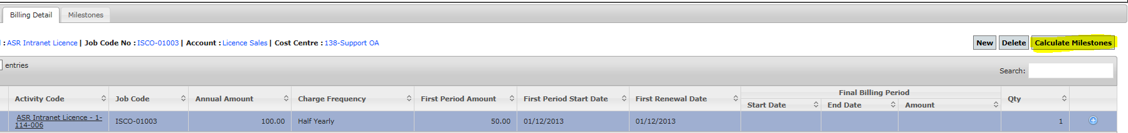

Highlight the relevant billing item, and click ‘Calculate Milestones’. This will then generate the relevant recurring billing lines for 3 years. If the item is ‘Ad-hoc’ or ‘Credit’ this will create a single milestone.

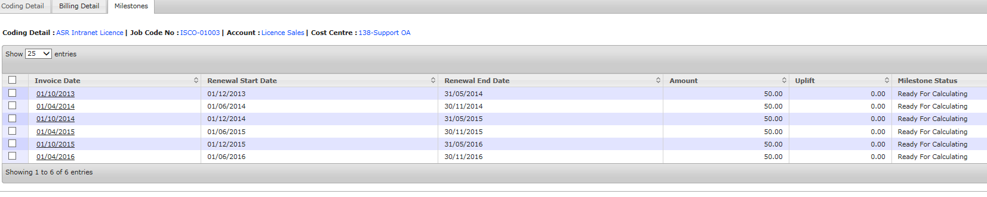

* 1. **Approve Maintenance**

This screen is where items for invoicing are selected and processed into the Open Accounts finance system.

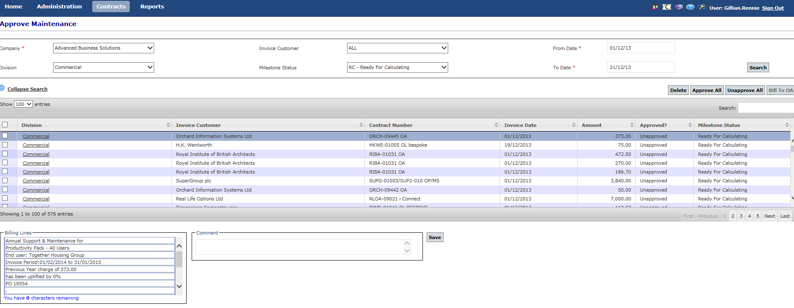

By entering the selection parameters at the top of the screen, the system will display all items due to be billed between 2 dates. The dates are derived from the actual Renewal Date of the Item, and the number of months in advance it is set to bill. So, for example, if a renewal date is 01/02/14, then the invoice date will be 01/12/13 – if the items were set to bill 2 months in advance. Remember, if you create an item whose renewal date is in the past, then the system will generate the invoice date as 2 months prior to that, so to included such an item on the selection screen you have to enter a ‘From Date’ that goes back far enough to pick up any ‘late added’ items.

ALL selected items can be approved (100 at a time) by checking the box on the screen next to ‘Division’ and then clicking ‘Approve All’. Alternatively you can select individual items for billing by checking the individual line, and then clicking ‘Approve All’

Once you have approved all required items to be billed, re-query ‘Approved for Payment’ items (by changing Milestone Status in the selection parameters). After you are sure you have all the items for billing, click ‘Bill to OA’ and the Approved items will generate an Invoice interface batch in Open Accounts (processing the invoices in OA, is not included in this user guide).

After the items have been successfully invoiced (an invoice batch created in Open Accounts) the Milestone Status is changed to ‘Link Loaded’

* 1. **Customer Comments**

This screen allows you to create and update comments regarding a Customer, which will then be displayed on the Contracts screen when you use that Customer. It can be used for reminders or advice as to any special requirements this Customer may have.

The other function on this screen is the ‘Group’ function. If ‘Group’ is checked (True), then all items for this Customer, if approved for invoicing at the same time, will be produced on ONE invoice, irrespective of the number of contracts that they cover.

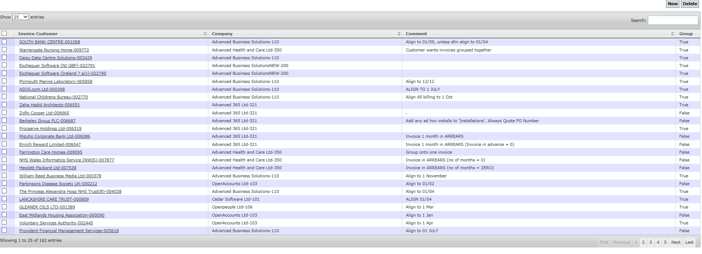

* 1. **End User Maintenance**

This screen is used for creating and maintaining End User names, belonging to our Customers. It usually only applies to Business Partners, who we invoice, and they in turn, invoice their own Customers. The End Users are for our own internal analysis, and only the Business Partner is actually invoiced. An End User must exist on this screen before it can be used on a contract. All Business Partner Invoices should nominate an End User. However, as the end user is never printed on the invoice, the end users name should also be written onto the narrative of a Billing Line.

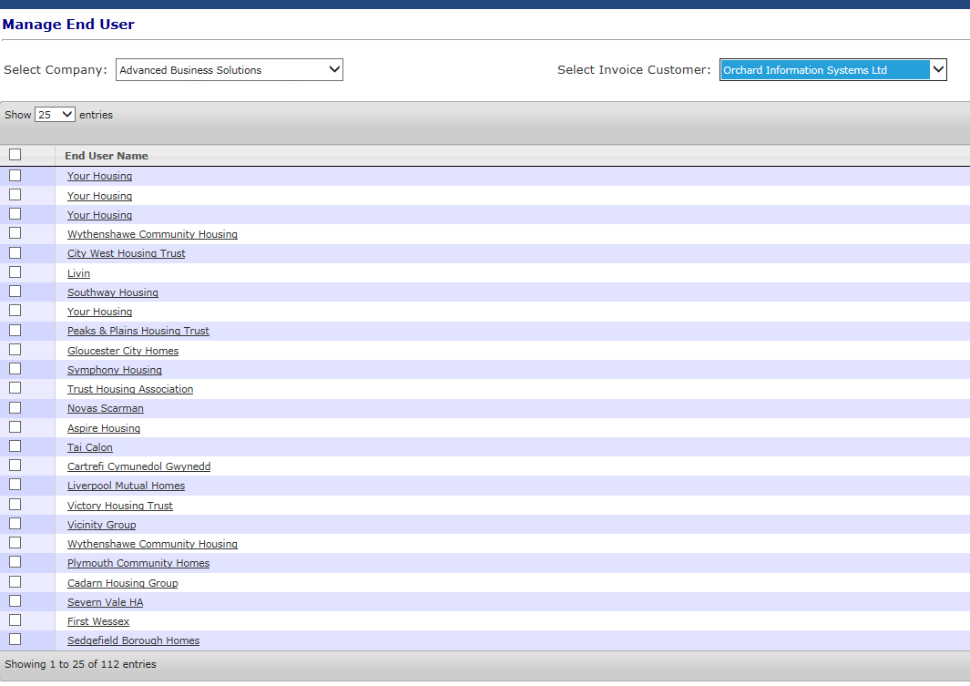

* 1. **OA SYNCH Data**

This function refreshes the data available to ARBS from Open Accounts. For example, if a Customer or Job Code has been newly created in Open Accounts, but you cannot see it in ARBS, run this Synchronise function, and the new items should appear.

(This takes approximately 2 – 3 minutes to run)

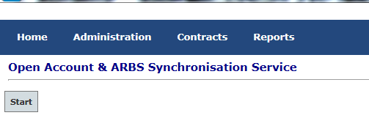

**2.0 Reports**

After entering parameters and running any report, the results will be displayed onto the screen. The format for saving the report can then be selected by clicking the drop down window (see highlighted below) and choosing the desired option:

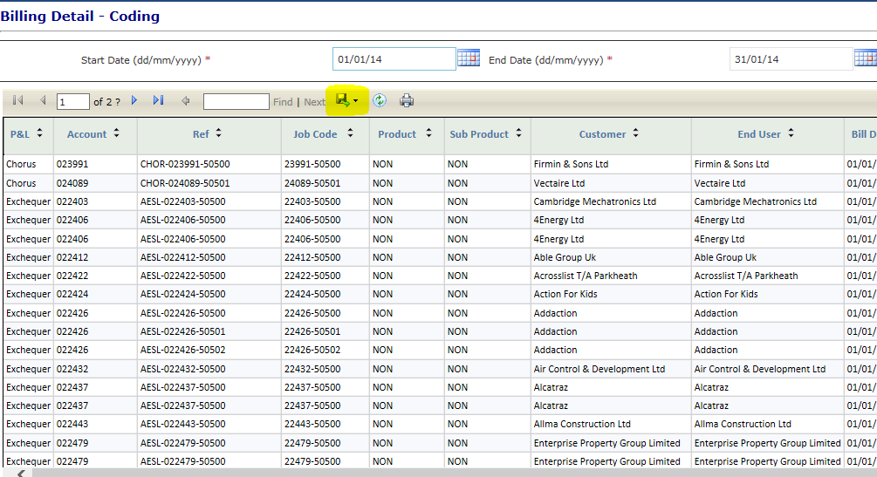

**2.1 Billing Detail – Coding**

This report prints every billing milestone for a selected company whose Invoice Date falls between the chosen parameters. It displays the billing attributes mainly connected with coding.

**2.2 Billing Detail – Customer**

This report selects the same items as the ‘Coding’ report, but displays the invoice narrative instead of the coding attributes. This report is useful to send to Customers or Account Managers, if they want to have a summary of billing for a particular Customer.

**2.3 Backlog Report**

This report displays all items currently on ‘Backlog’ – i.e. entered on the ARBS system, with no Start Date and Backlog set to ‘Yes’. This report should be circulated on a monthly basis to those in the organisation who can advise when items can be set to commence billing.

**2.4 Completed Contracts**

This report displays all items where the billing line ENDS between the 2 selected dates. It should be used to report if any Customers need to be contacted to renew their contracts with us.

**2.5 Inflation Report**

This report displays the percentage uplift applied to all items for the selected company between 2 dates

**2.6 Unapproved Items**

This report displays all unapproved items between 2 dates