**Topics: Descriptive Statistics and Probability**

1. Look at the data given below. Plot the data, find the outliers and find out $μ, σ, σ^{2}$

|  |  |
| --- | --- |
| **Name of company** | **Measure X** |
| Allied Signal | 24.23% |
| Bankers Trust | 25.53% |
| General Mills | 25.41% |
| ITT Industries | 24.14% |
| J.P.Morgan & Co. | 29.62% |
| Lehman Brothers | 28.25% |
| Marriott | 25.81% |
| MCI | 24.39% |
| Merrill Lynch | 40.26% |
| Microsoft | 32.95% |
| Morgan Stanley | 91.36% |
| Sun Microsystems | 25.99% |
| Travelers | 39.42% |
| US Airways | 26.71% |
| Warner-Lambert | 35.00% |

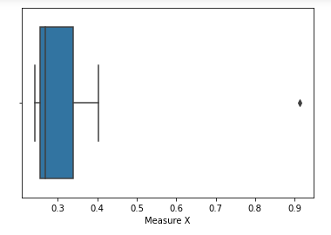

Morgan Stanley is an outlier with 91.36%.

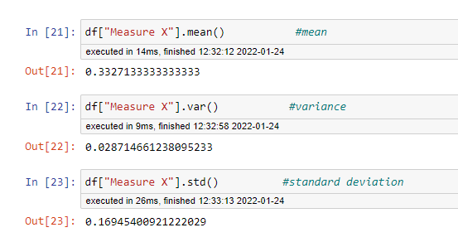

1. 

Answer the following three questions based on the box-plot above.

1. What is inter-quartile range of this dataset? (please approximate the numbers) In one line, explain what this value implies.

IQR=Q3-Q1

=12-5

=7

Here IQR is 7 which represents that 50% of the data points lie in the range between 5 and 12.

1. What can we say about the skewness of this dataset?

The data is right skewed. And the skewness value is +ve.

1. If it was found that the data point with the value 25 is actually 2.5, how would the new box-plot be affected?

There would be no outlier if the value is 2.5 instead of 25.



Answer the following three questions based on the histogram above.

1. Where would the mode of this dataset lie?

The mode would lie between the range 4 and 12 as majority for the data points lie in this range.

1. Comment on the skewness of the dataset.

The data is right skewed. And the skewness value is +ve.

1. Suppose that the above histogram and the box-plot in question 2 are plotted for the same dataset. Explain how these graphs complement each other in providing information about any dataset.

Boxplot helps in understanding the datasets by determining the quartile and inter quartile range and helps in easily indicating the median value.

Histogram helps in understanding the dataset by determining the skewness and kurtosis of the data. It also helps in understanding the frequency distribution of the data.

1. AT&T was running commercials in 1990 aimed at luring back customers who had switched to one of the other long-distance phone service providers. One such commercial shows a businessman trying to reach Phoenix and mistakenly getting Fiji, where a half-naked native on a beach responds incomprehensibly in Polynesian. When asked about this advertisement, AT&T admitted that the portrayed incident did not actually take place but added that this was an enactment of something that “could happen.” Suppose that one in 200 long-distance telephone calls is misdirected. What is the probability that at least one in five attempted telephone calls reaches the wrong number? (Assume independence of attempts.)

Probability of call misdirecting = 1/200

= 0.005

Probability of call not misdirecting = 1-0.005

= 0.995

Probability that at least one in five attempted telephone calls reaches the wrong number

=1 - none of the call reaches the wrong number

=1-(0.995)5

=1-0.97524875312

=0.02475124687

1. Returns on a certain business venture, to the nearest $1,000, are known to follow the following probability distribution

|  |  |
| --- | --- |
| x | P(x) |
| -2,000 | 0.1 |
| -1,000 | 0.1 |
| 0 | 0.2 |
| 1000 | 0.2 |
| 2000 | 0.3 |
| 3000 | 0.1 |

1. What is the most likely monetary outcome of the business venture?

= ∑x*P(x)

= (-2000*0.1) + (-1000*0.1) + (0*0.2) + (1000*0.2) + (2000*0.3) + (3000*0.1)

= 800

1. Is the venture likely to be successful? Explain

As the expected value is +ve the venture is likely to be successful.

1. What is the long-term average earning of business ventures of this kind? Explain

= ∑x*P(x)

= (-2000*0.1) + (-1000*0.1) + (0*0.2) + (1000*0.2) + (2000*0.3) + (3000*0.1)

= 800

1. What is the good measure of the risk involved in a venture of this kind? Compute this measure

The good measure of the risk can be calculated using the standard deviation. As the value of standard deviation value increases the risk also increases.

