Java-Rajib-01

Tuesday, 28 February · 7:10 – 8:10pm

Google Meet joining info

Video call link: https://meet.google.com/dzr-nkdt-cxe

Or dial:

More phone numbers: <https://tel.meet/dzr-nkdt-cxe?pin=2381790135027>

Needs to be covered the below points:

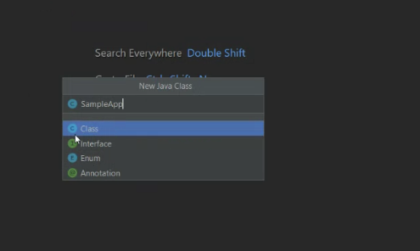

To get the hints in IntelliJ: alt + enter

Ctrl + Y : to delete the line

Alt + left / right arrow to use to navigate in the Classes.

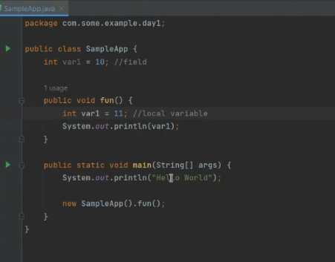

ctrl + d: for duplicating the line