Java-Rajib-03

Friday, 10 March · 7:35 – 8:35pm

Google Meet joining info

Video call link: https://meet.google.com/nen-oiru-fah

Or dial:

More phone numbers: <https://tel.meet/nen-oiru-fah?pin=9204824441035>

Git commands

Folder used:

D:\PKS\Performance\Java_Docs\RD-Java

Remote path:

<https://github.com/pksPriyankSharma/RD-Java>

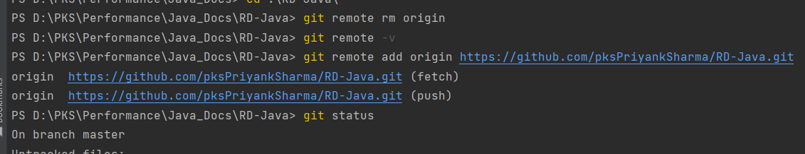

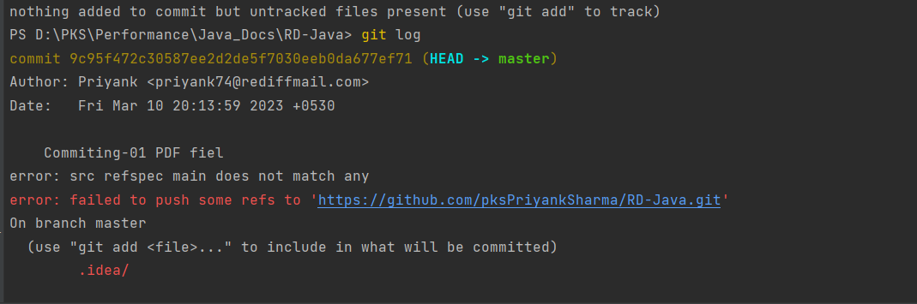

nothing added to commit but untracked files present (use "git add" to track)

PS D:\PKS\Performance\Java_Docs\RD-Java> git log

commit 9c95f472c30587ee2d2de5f7030eeb0da677ef71 (HEAD -> master)

Author: Priyank <priyank74@rediffmail.com>

Date: Fri Mar 10 20:13:59 2023 +0530

Commiting-01 PDF fiel

error: src refspec main does not match any

error: failed to push some refs to 'https://github.com/pksPriyankSharma/RD-Java.git'

On branch master

(use "git add <file>..." to include in what will be committed)

