Project Overview
The purpose of this project was to develop an interactive dashboard for an organization called Grazioso Salvare. It identifies dogs suitable for search-and-rescue training. The dashboard uses animal shelter records from the Austin Animal Center Outcomes dataset stored in MongoDB.
The application allows users to view animal records and filter dogs based on different rescue categories. The dashboard also includes an interactive data table, a pie chart showing the distribution of animal breeds, and a geolocation map showing the location of a selected animal. These features help users find and review potential rescue dogs more efficiently.
Tools and Technologies Used
Several tools and technologies were used to develop the Grazioso Salvare Rescue Dashboard.
- MongoDB was used to store and manage the animal shelter records. https://www.mongodb.com/
- Python was used to develop the application. https://pymongo.readthedocs.io/
- Dash was used to build the interactive web application. https://dash.plotly.com/
- Dash Leaflet was used to create the geolocation map. https://www.dash-leaflet.com/
- The application was developed and tested in the Codio environment using Jupyter Notebook. https://jupyter.org/
Development Process
The project was completed by building on the MongoDB database and Python CRUD module developed in Project One. I started by using the AnimalShelter Python class to connect the dashboard to MongoDB. The read() method was used to retrieve animal shelter records and display them in the application. I then created an interactive data table using Dash DataTable. I added pagination to display 10 records per page, along with sorting, filtering, and single-row selection to make the table easier to use.
Next, I created four radio-button options: Water Rescue, Mountain or Wilderness Rescue, Disaster or Individual Tracking, and Reset. Each rescue category uses a MongoDB query to retrieve dogs that match the required breeds, sex, and age ranges provided in the Dashboard Specifications Document. The Reset option allows users to return to the complete dataset. I also used Plotly to create a pie chart showing the distribution of animals by breed. The chart updates automatically when a different rescue category is selected.
After that, I used Dash Leaflet to create a geolocation map that displays an animal's location using latitude and longitude coordinates. Users can select an animal from the data table, and the map updates to show its location. I also added the Grazioso Salvare logo, a link to the SNHU website, and my name as the dashboard developer.
Finally, I tested all four rescue filters to make sure the data table and pie chart updated correctly. I also tested the map by selecting different animals from the table and confirming that their locations were displayed. Screenshots were captured to demonstrate the dashboard's functionality.

Dashboard Functionality and Screenshots
The dashboard includes an interactive data table, a pie chart showing breed distribution, and a geolocation map displaying the location of a selected animal.
1. Initial Dashboard (Reset)
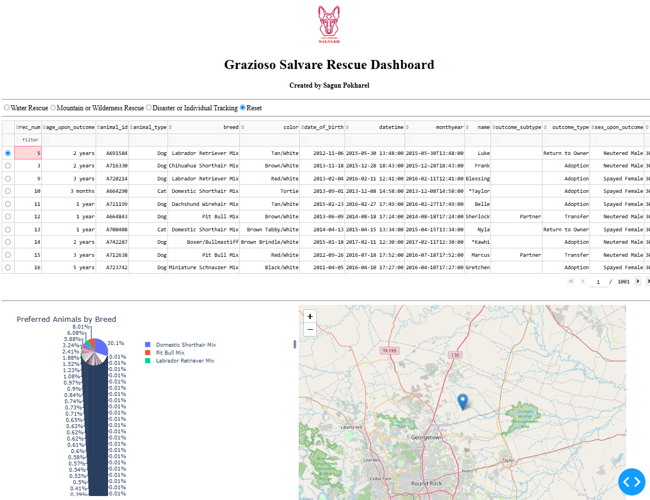
When the dashboard first opens, the Reset option is selected by default. The data table displays all available animal records from MongoDB. The pie chart shows the overall distribution of animal breeds, while the geolocation map displays the location of the selected animal.

2. Water Rescue
The Water Rescue filter displays dogs that meet the required breed, sex, and age criteria. The preferred breeds are Labrador Retriever Mix, Chesapeake Bay Retriever, and Newfoundland.
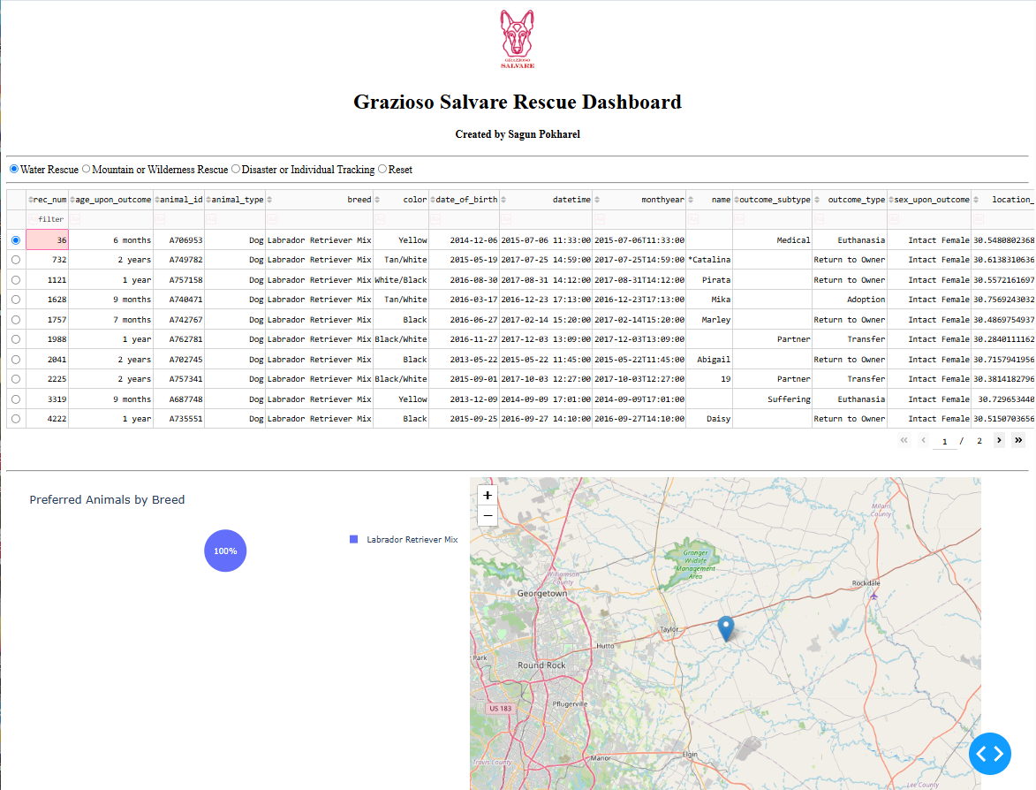

3. Mountain or Wilderness Rescue
The Mountain or Wilderness Rescue filter displays dogs suitable for mountain and wilderness rescue training. The preferred breeds include German Shepherd, Alaskan Malamute, Old English Sheepdog, Siberian Husky, and Rottweiler.
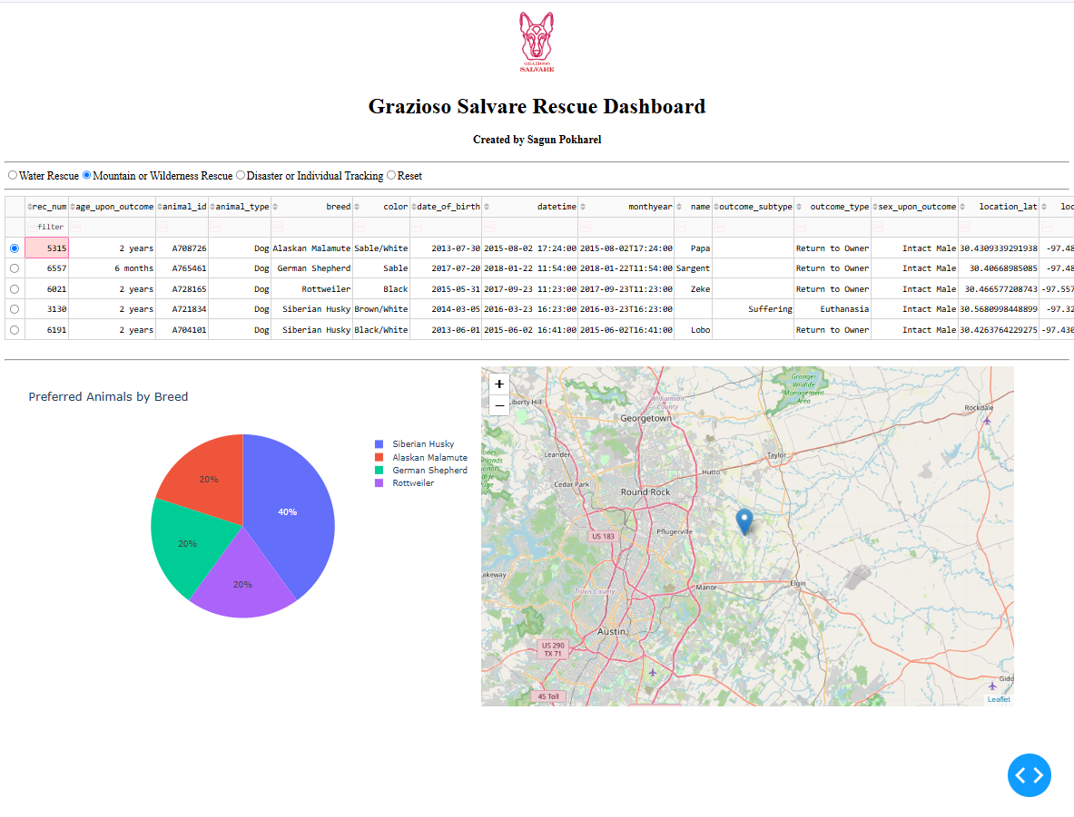

4. Disaster or Individual Tracking
The Disaster or Individual Tracking filter displays dogs suitable for disaster rescue or locating individuals. The preferred breeds are Doberman Pinscher, German Shepherd, Golden Retriever, Bloodhound, and Rottweiler.
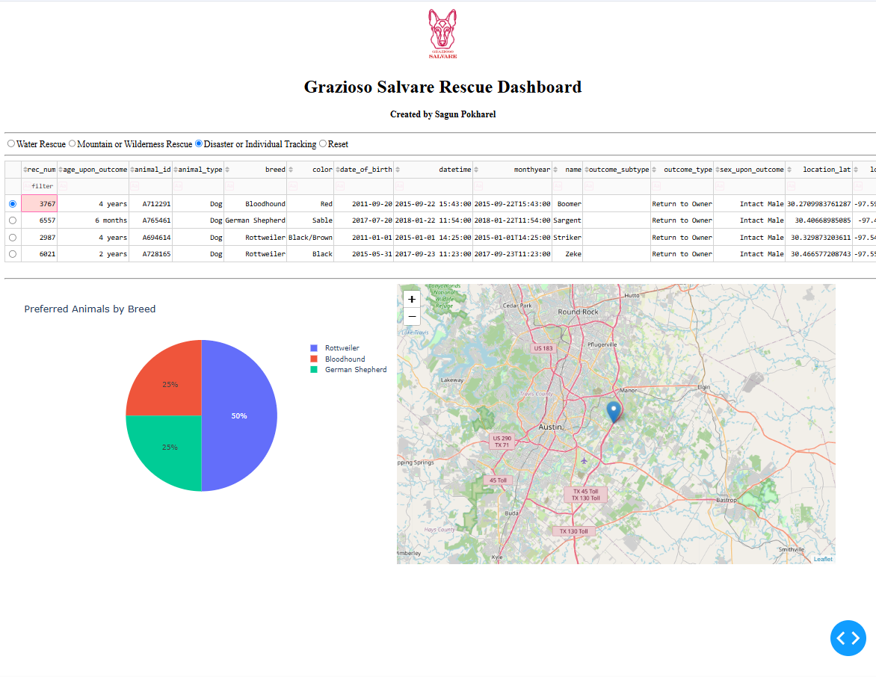

5. Reset
The Reset option removes the rescue-specific filtering and restores the full animal shelter dataset. The data table and pie chart return to their unfiltered state, and the map continues to display an animal's location.

Challenges and Solutions
During the development of the Grazioso Salvare Rescue Dashboard, I encountered several challenges while connecting the database and making the dashboard components work together.
1. Python Indentation and Syntax Errors
One challenge was fixing indentation and missing brackets in the Python code. These errors prevented the dashboard from running properly. I reviewed the code, corrected the indentation, and made sure all brackets and parentheses were closed.
2. Dashboard Callback Errors
I encountered callback errors when the dashboard first loaded. One issue occurred because the table styling function received an empty selection. I fixed this by updating the function to handle cases where no columns were selected.
3. Geolocation Map Issues
The geolocation map was one of the most challenging parts of the project. At first, the map did not display correctly or update when an animal was selected. I reviewed the callback function, corrected how it handled selected rows, and adjusted the map layout. After these changes, the map successfully displayed the location of the selected animal.
4. Connecting Dashboard Components
Another challenge was making sure the data table and pie chart responded to the rescue filters. I used Dash callbacks and MongoDB queries to connect these components. After testing each rescue category, I confirmed that the table and chart displayed the matching animal records.
These challenges helped me better understand Python debugging, MongoDB queries, and how Dash callbacks connect different parts of a web application.
Instructions for Reproducing the Project
The Grazioso Salvare Rescue Dashboard can be reproduced by following these steps.
1. Set Up MongoDB
Install MongoDB and make sure the database server is running. Create or use the aac database and the animals collection. Import the Austin Animal Center Outcomes dataset into the collection.
2. Configure the CRUD Module
Place the animal_shelter.py file in the same directory as the dashboard notebook. This module contains the AnimalShelter class, which connects Python to MongoDB and provides CRUD functionality.
Configure a MongoDB user with permission to read the aac.animals collection. Use the appropriate username and password in the dashboard connection settings.
3. Install the Required Python Libraries
We need the Python environment which includes the following libraries such as pymongo, pandas, dash, jupyter-dash, plotly, dash-leaflet, and jupyter. These libraries are required for database connectivity, data processing, interactive dashboard components, charts, and the geolocation map.
4. Open the Dashboard Notebook
Open ProjectTwoDashboard.ipynb in Jupyter Notebook through Codio or another compatible Python environment. Make sure the animal_shelter.py module and Grazioso Salvare Logo.png are accessible from the notebook's working directory.
5. Run the Dashboard
Run the notebook code after confirming that MongoDB is running and the database credentials are correct. The application will start a Dash server and provide a URL for accessing the dashboard. Then open the URL in a web browser to view the application.
6. Test the Dashboard
Select each rescue filter to confirm that the data table and pie chart update correctly. Select different animals in the table to verify that the geolocation map displays their locations. Finally, select Reset to return the dashboard to its original unfiltered state.
Conclusion
This project helped me understand how MongoDB, Python, and Dash work together to create an interactive web application. I successfully developed a dashboard that allows users to filter animal shelter records, view breed distributions, and locate selected animals on a map. I also gained experience using MongoDB queries, connecting dashboard components through callbacks, and troubleshooting Python errors. Overall, this project improved my understanding of client/server development and how database information can be presented in a useful and interactive way.

