Air Fryer Vege Pizza

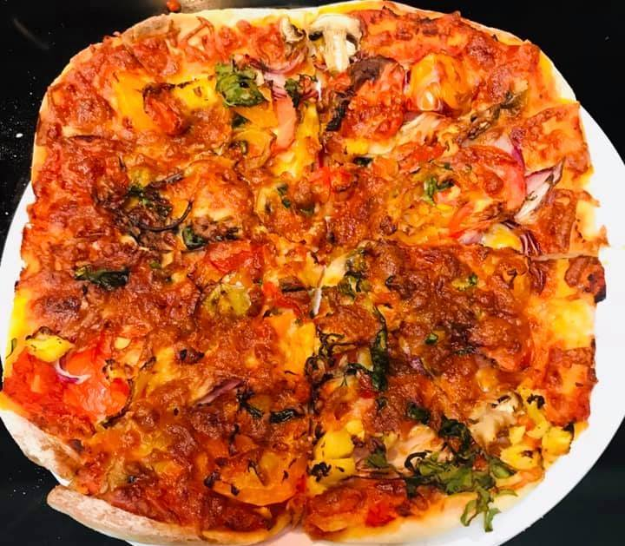

**Ingredients for Pizza Dough**

* All-purpose flour 2 ¼ cups
* Yeast 2 ½ tsp
* Sugar 1 tbsp
* Garlic powder 1 tsp
* Warm water 3/4 cup
* Olive oil 2 - 3 tbsp
* Salt ½ tsp

**Ingredients for Toppings**

* Swiss chard or any spinach roughly chopped
* Mushroom sliced
* Bell pepper cubed
* Pineapple cubed
* Hot banana peppers as needed
* Red onions sliced
* Pizza sauce 4 tbsp
* Shredded mozzarella and cheddar cheese 1 cup

**Method**

**Pizza Dough:**

In a deep bowl add **just one cup** of flour to begin with. To the flour, add yeast, sugar, garlic powder, and salt and mix well.  Add 2 tbsp of olive oil and warm water. Mix well with a spatula. Keep adding rest of the flour little at a time. When it’s all mixed, then use your hand to knead it into a smooth dough. Move it into another bowl greased with olive oil. Cover and set aside for 30 minutes.

**Pizza Crust:**

Two pizzas can be made from the dough. Once the dough rises, drizzle flour on your kitchen counter-top and knead the dough again. Divide the dough to two portions. Take one portion and with a rolling pin flatten the dough to a crust roughly the size of air fryer basket and about ¼“thickness.

Move the crust to the rack in the air fryer basket. Prick the crust all over, with a fork.

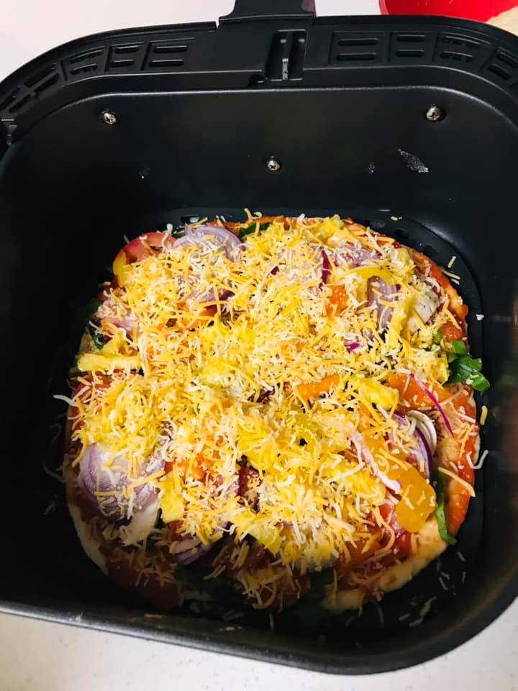

**Toppings:**

Begin topping by evenly spreading pizza sauce on the crust (about 2 or 3 tbsp). Sprinkle a layer of cheese. Take a handful of all the chopped vegetables listed one after the other and spread it evenly, followed by a final top layer of cheese. Bake at 380 ° F for 12 to 15 minutes or till crust is golden and cheese is melted. When done, use a turner spatula and tongs to carefully lift the pizza on to a cutting board. Repeat the same process for the second pizza with the other half of the dough. Enjoy with crushed chili peppers or your favourite sides!

**Notes**:

* The Air fryer used here is 6 QT Instant Vortex Air Fryer.
* Build the pizza inside the air fryer basket itself because transferring a topped uncooked pizza is difficult.
* The recipe gives roughly about 8 slices of pizza.
* If using meat, prior to baking, meat should be semi-cooked on stovetop with desired spices.
* Pizza toppings can be same as listed above or changed as per preferences.
* Crust can be thick or thin as preferred.