# Air Fryer Potatoes

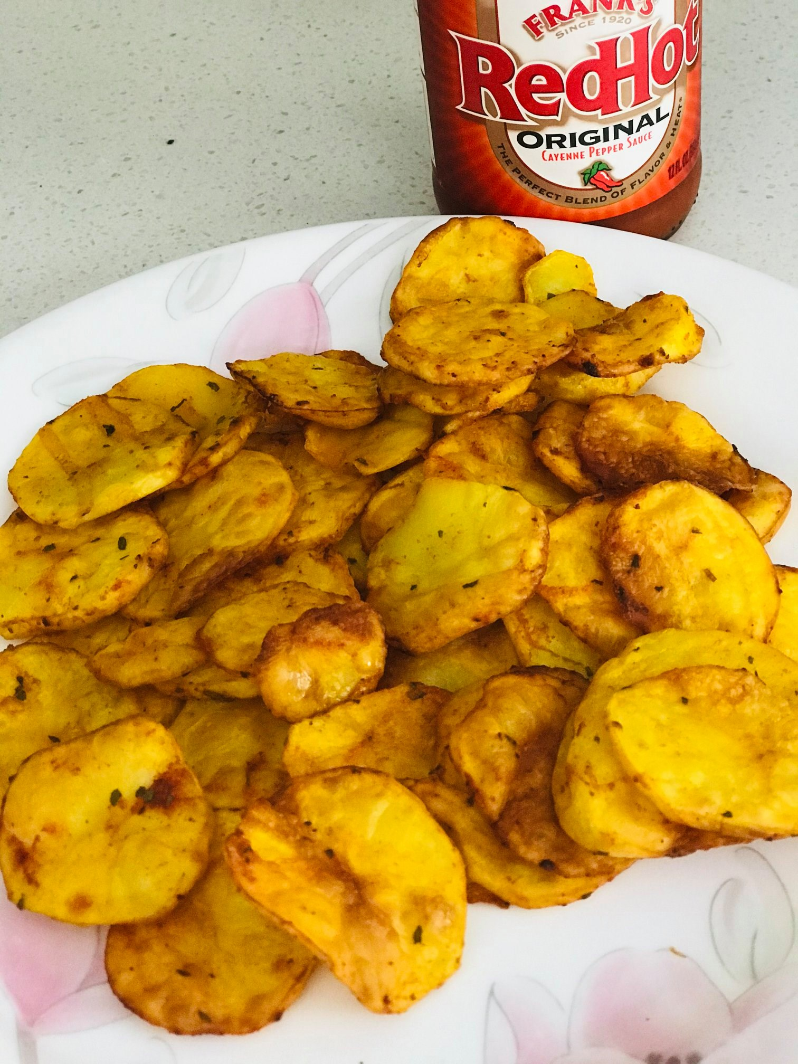

## Ingredients

* Potatoes 2 or more as needed (1 per person)
* Chili powder 1 tsp
* Turmeric ¼ tsp
* Salt as needed
* Oil 1 tbsp
* Dried Parsley ½ tsp
* Garlic powder ½ tsp

## Method

Peel potatoes and cut to very thin slices. Wash and drain. In a bowl mix all the other ingredients including oil and add the potato into it. Mix well to coat.

**Air Fryer method:**

Preheat airfryer by choosing air fry option to 380 ° F for 10 minutes. When heated spray oil and place the potatoes in the fryer. Do not stack on top of each other, each slice of potato needs to be separate. Flip sides halfway through and continue till the potatoes start to brown. Add couple more minutes if necessary (Different air fryers have different cooking times).

**Pan Fry method:**

Heat about 2 or 3 tbsp cooking oil in a non-stick pan and fry the potato slices for about 2 minutes on each side. When done, drain on paper towel.