Air Fried Battered Fish

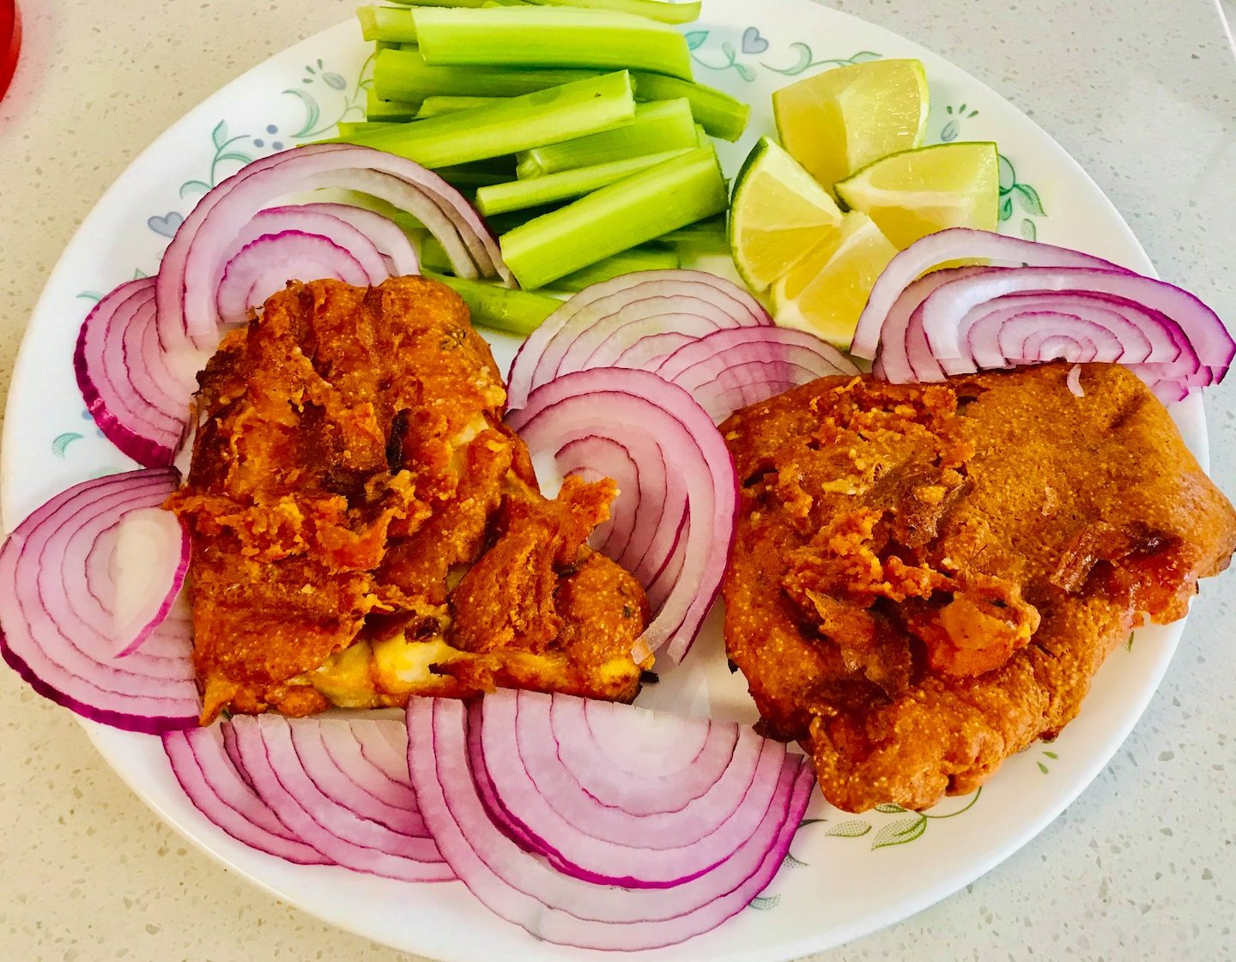

Ingredients

* Cod fillet 1 lb cut to slices
* All-purpose flour or chickpea flour ¾ cup
* Semolina ¼ cup
* Chili powder 1 tsp
* Garam masala a pinch
* Garlic powder 1 tsp
* Ginger shredded 1 tsp
* Black pepper powder 1 tsp
* Cumin powder ¼ tsp
* Asafoetida/Hing ¼ tsp
* Kasoori methi (Dry fenugreek leaves) a pinch
* Salt 1 tsp
* Olive oil 2 tbsp
* Lemon juice of one lemon
* Water about 2-4 tbsp

Method

Wash and pat dry the fish. In a bowl, make a thick batter from all the above ingredients using as little water as possible and marinate the fish.  
Turn on the air fryer using Air fry option to 400 ° F for 10 minutes. Spray the air fryer tray with cooking spray and fry the fish till they turn brown and crisp. After about 8 minutes flip sides and grease the fish

with cooking spray. Continue cooking. Add more time if needed. Serve on a bed of onions and lemon wedges. Eat with rice or make it a meal by itself just by adding veges on the side!  
  
**Note:**  
To avoid dripping in the air fryer, make sure the batter is thick and not runny.