Air Fryer Murukku/Chakli

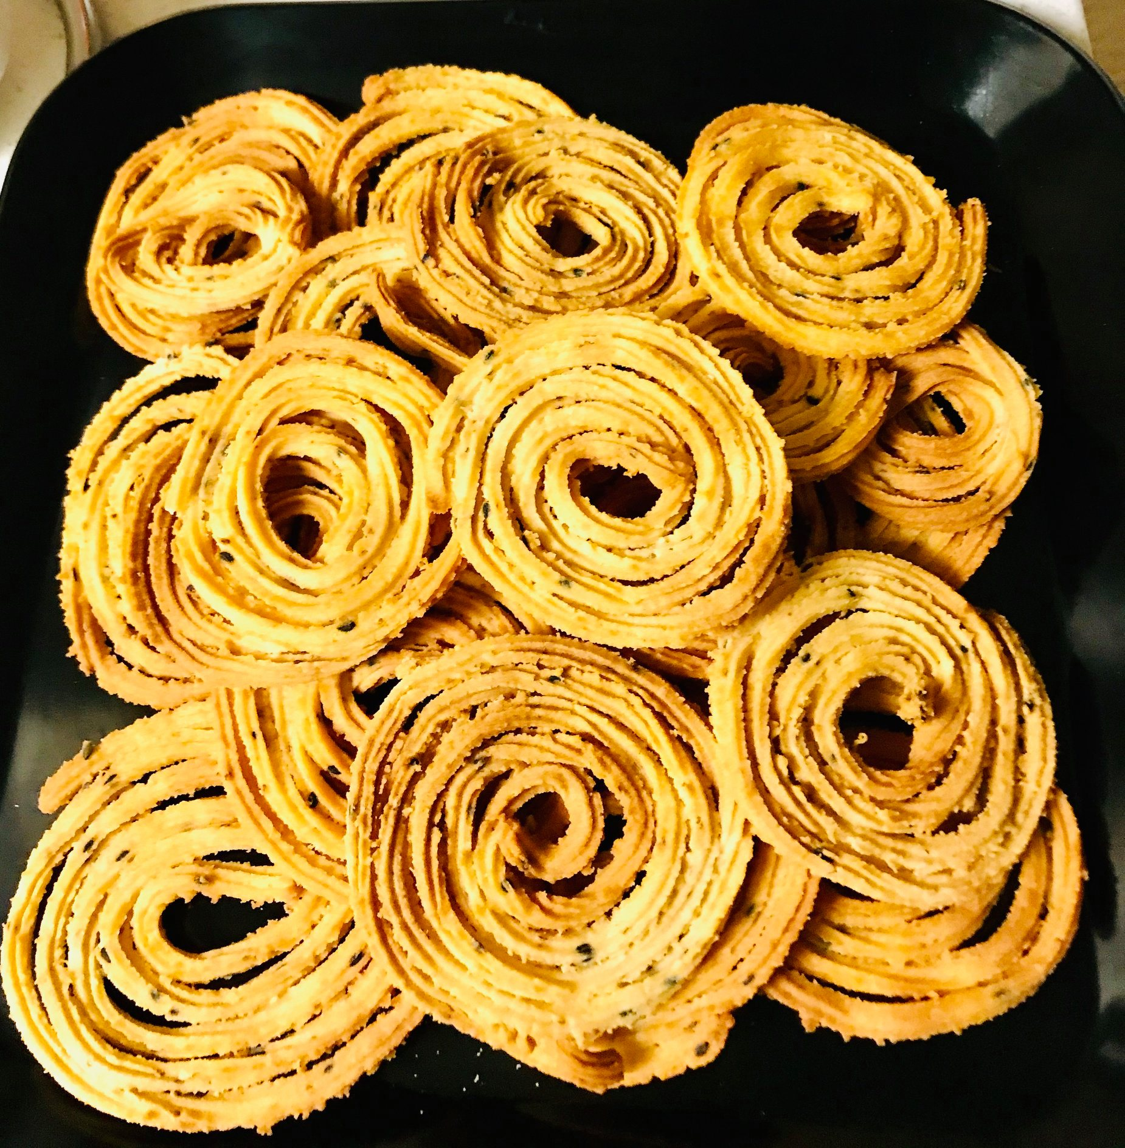

Murukku is a crunchy, savoury South Indian snack made of rice, lentil flour and spices. It is usually deep fried in oil. I have made this in the air fryer. Deep fry method is also included. Try this recipe, make murukku at home and you will stop buying them from stores which are loaded with salt!

Ingredients

* Rice flour 2 cups
* White lentil flour (Urad dal flour) 4 tbsp
* Asafoetida ¼ tsp
* Salt 1 tsp or as needed
* Chili powder ½ tsp
* Carraway seeds ¼ tsp
* Black sesame seeds ½ tsp
* Roasted cumin seeds ½ tsp
* Butter 1 tbsp
* Olive Oil 1 tbsp
* Water 1 cup or as needed

Method:

In a bowl, mix all the dry ingredients first. Then add butter and oil and mix. Add water little by little and make a soft dough.

**Air Fryer Method:**

Grease the air fryer tray with cooking spray. Add the dough into the murukku press, spiral in the dough on the tray in circular shape. Spritz the murukku with cooking spray. Place the tray in air fryer. Select air fry mode with temperature set to 350° F and set the time for 10 minutes. After about 8 minutes or so keep checking and make sure the murukku is not getting burnt. Flip them when the air fryer prompts to turn food. Use cooking spray in between if it is too dried up. Once done, transfer to a plate and let it cool. Savour the crunchy snack with a hot cup of tea!!

**Deep Fry Method:**

Heat oil in a deep pan. Add the dough into the murukku press, spiral in the dough in circular shape on to a non-stick surface like a zip lock top or plastic wrap sheet greased with oil. Gently scoop off the murukku and deep fry in oil. Drain on paper towel.