**Flatbread Pizza in Airfryer**

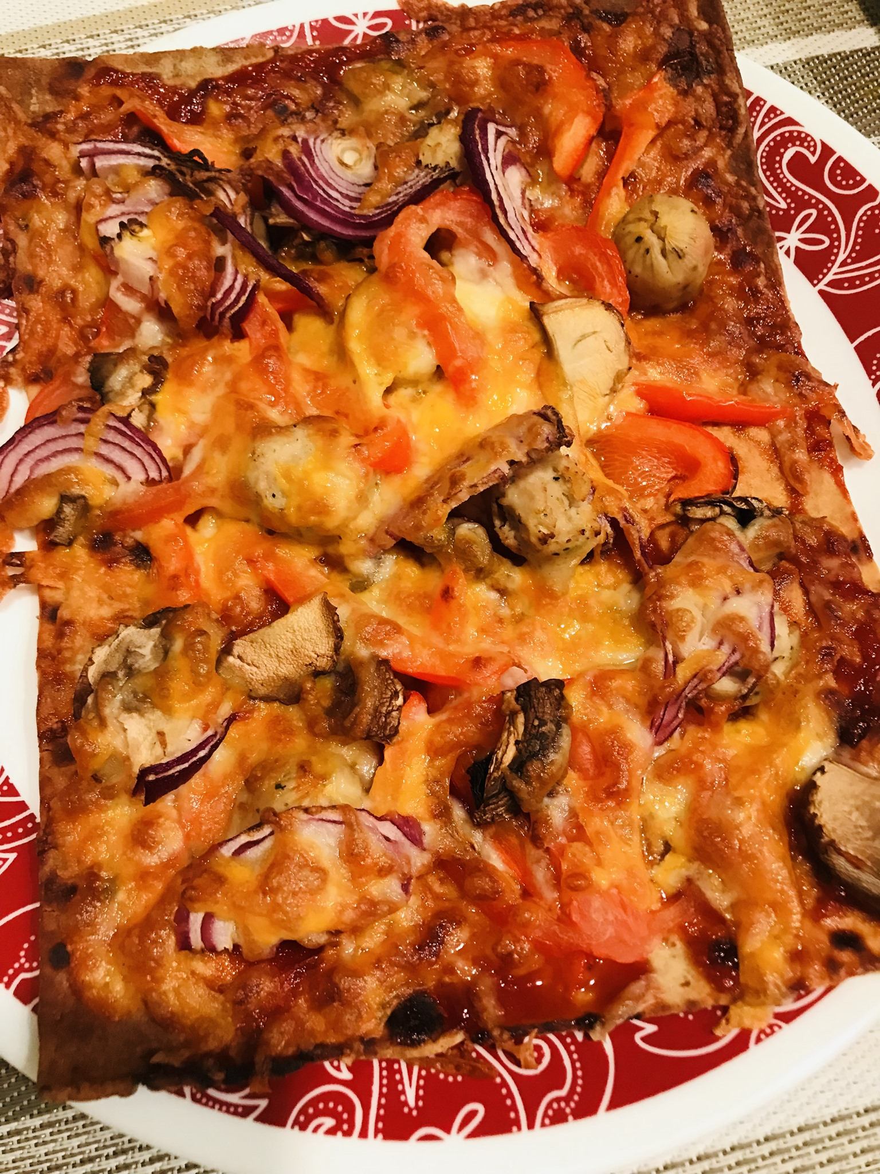

**Ingredients (for 2 pizzas)**

Any kind of Flatbread like Nan or Mediterranean flatbreads – 2

**Ingredients for Toppings**

* Chicken sausages – 2- cooked and cut to round slices of ¼ “thickness
* Mushrooms - 2 - sliced
* Tomatoes sliced – couple slices for each pizza
* Bell Pepper - any color- half of one – long slices
* Red Onion - 1 small - long slices
* Pizza sauce - 4 tbsps. or as needed
* Shredded mozzarella and cheddar cheese - ½ cup or as needed

**Method**

Preheat the Airfryer to 380 degree for 5 minutes. When preheated, place the flatbread in the airfryer tray. Spread 2 tbsps of pizza sauce on the flatbread. Sprinkle cheese. Top with the cooked sausages, tomatoes, mushrooms, onions and bell peppers. Sprinkle another layer of cheese on top. Bake for 5 minutes or till the cheese melts and the pizza starts to brown.

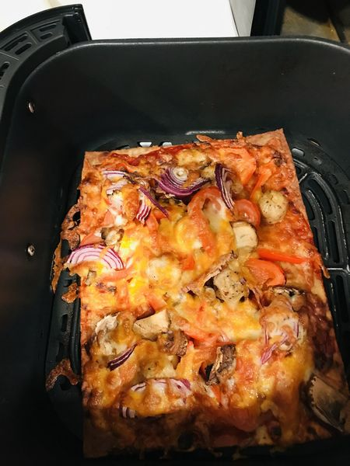

Notes:

1. The above-mentioned toppings can be replaced with your favorite ones
2. Do not cook for too long because flatbreads get too crispy too fast
3. Do not turn the pizza at the airfryer prompt to turn food