Four Weeks Industrial Training Project Report on
Housing Price Prediction Using Machine Learning
Submitted in the partial fulfilment of the requirement for the award of degree of
Bachelor of Technology
in
Computer Science and Engineering
Batch (2025-26)


Submitted to: Submitted by:
Dr. Ridhi Kapoor Prabhjot Kaur
(12300402)

DEPARTMENT OF COMPUTER SCIENCE AND ENGINEERING
DAV UNIVERSITY
JALANDHAR- PUNJAB 144012

1. Certificate of Training



2. ABSTRACT

This project focuses on Predicting Housing Prices Using Machine Learning Techniques by analyzing key factors that influence property values. The objective is to develop an accurate and reliable model capable of estimating house prices based on essential features such as total rooms, total bedrooms, median income, housing median age, and number of households.
The dataset underwent thorough cleaning, preprocessing, and feature selection to retain only the most relevant variables. It was then split into training and testing sets, followed by feature scaling to enhance model performance and ensure consistency across numerical attributes.
Three machine learning models—Linear Regression, Random Forest Regressor, and XGBoost Regressor—were implemented to predict housing prices. Model performance was evaluated using metrics such as the R² Score and Mean Squared Error (MSE). Among the three, the XGBoost and Random Forest models delivered superior accuracy and stability due to their ability to capture nonlinear patterns and complex interactions within the data.
The results demonstrate how machine learning can effectively support decision-making in the real estate sector by providing data-driven and reliable price predictions. This project reflects the practical application of ML techniques learned during the training at AppTechies, Mohali, and highlights their relevance in solving real-world problems related to housing price estimation.

3. ACKNOWLEDGEMENT

I would like to extend my heartfelt gratitude to everyone who supported us during the various stages of this project’s development. I am deeply thankful to Mr. Rahul Hans (Coordinator), DAV University, for granting me the opportunity to undertake the 45-day summer training at AppTechies, Mohali.
I am also grateful to all the faculty members of the Department of Computer Science and Engineering for their guidance, encouragement, and assistance, which proved invaluable in the preparation of the final report and presentation.
Finally, I express my sincere thanks to the entire team at AppTechies, Mohali, especially Mr. Amandeep Singh, our guider, for their constant support, mentorship, and for making this training experience meaningful, productive, and truly beneficial.

4. DECLARATION

I, Prabhjot Kaur (Reg. No.: 12300402), hereby declare that the work presented in this project/training titled “Predicting Housing Prices Using Machine Learning” is an authentic record of my own work carried out under the guidance of Mr. Amandeep Singh (AppTechies, Mohali). This project is submitted in partial fulfilment of the requirements for the award of the Bachelor of Technology (B.Tech) Degree in Computer Science and Engineering.
To the best of my knowledge, the content of this report has not been submitted to any other University or Institute for the award of any degree or diploma.

Student Name: Prabhjot Kaur
Reg. No.: 12300402
Signature: ______________________
Date: __________________________

Table of Contents

- Certificate of Training .................................................... 2
- Abstract ............................................................................ 3
- Acknowledgement ........................................................... 4
- Declaration ...................................................................... 5
- Introduction .....................................................................7
- Title of the Project .......................................................... 8
- Objectives ......................................................................... 9
- Steps to Achieve Objectives ........................................... 10
- Artificial Intelligence and Machine Learning .............. 11
9.1 Introduction to Artificial Intelligence (AI) ................. 11
9.2 Understanding Machine Learning (ML) .................. ...12
9.3 Supervised Learning and Regression ......................... 13
- Dataset Description and Data Collection ...................... 14
- Data Preprocessing Steps ............................................... 15
- Exploratory Data Analysis (EDA) ................................ 17
- Feature Selection and Engineering ............................... 19
- Data Scaling and Train-Test Split ................................ .21
- Model Training ............................................................... 22
15.1 Linear Regression ..................................................... 22
15.2 Decision Tree Regression ......................................... 23
15.3 Random Forest Regression ....................................... 23
- Model Evaluation ............................................................ 24
- Visualization and Interpretation ................................... 25
- Skills and Knowledge Gained ........................................ 26
- Conclusion and Recommendations ............................... 27
- Appendices ...................................................................... 28
- Appendix A: Dataset Information (Kaggle) ..................... 28
- Appendix B: Code Snippets ............................................. 28
- Appendix C: Graphs and Visual Outputs ....................... ..32
- Appendix D: Model Performance Results ........................ 35
- Appendix E: Tools, Technologies, and Platforms …........ 36
- Appendix F: Project and Professional Links .................... 36
- References ....................................................................... 36

5. INTRODUCTION

This report presents the work completed during my 45-day summer training at AppTechies, Mohali, undertaken as part of the academic requirements of the Department of Computer Science and Engineering, DAV University. During this training period, I worked on the project titled “Housing Price Prediction Using Machine Learning.”
The primary objective of the project was to apply machine learning techniques to accurately predict housing prices using key features such as total rooms, total bedrooms, number of households, median income, and housing median age. With the growing availability of real estate datasets, machine learning offers an effective solution for analyzing market trends and generating reliable price estimates.
The workflow included several major steps: data preprocessing, feature selection, model training, and model evaluation. Multiple algorithms were implemented, including Linear Regression, Random Forest Regressor, and XGBoost Regressor. Performance metrics such as R² Score and Mean Squared Error (MSE) were used to assess model accuracy. Among these models, Random Forest and XGBoost provided superior results due to their ability to capture nonlinear patterns and complex relationships in the data.
This project offered valuable hands-on exposure to machine learning methodologies and demonstrated their practical application in solving real-world challenges in the real estate domain. The training experience not only enhanced my technical skills but also strengthened my understanding of data-driven decision-making in modern predictive systems.

6. TITLE OF THE PROJECT
Housing Price Prediction Using Machine Learning

7.OBJECTIVES

- To identify the core training area of Artificial Intelligence and Machine Learning and develop a strong understanding of how ML models are designed, trained, and implemented in real-world scenarios.

- To successfully complete the 45-day summer training program at AppTechies, Mohali, gaining practical exposure to industry-relevant tools, technologies, and development practices.

- To work on the assigned project “Housing Price Prediction Using Machine Learning,” which involves analyzing real estate data and building a predictive model capable of estimating housing prices with accuracy.

- To perform all major tasks involved in the ML workflow, including:
  - Data loading and cleaning
  - Handling missing values
  - Feature selection and extraction
  - Exploratory data analysis
  - Train-test splitting
  - Feature scaling
  - Model development and optimization
  - Evaluation and performance comparison of models

- To apply and compare multiple machine learning algorithms, particularly Linear Regression and Random Forest Regressor, to identify which model provides better predictive performance for housing price estimation.

- To gain hands-on experience with essential Python libraries such as Pandas, NumPy, Scikit-Learn, Matplotlib, and Seaborn, and understand their role in data preprocessing, modeling, and visualization.

- To understand the importance of evaluation metrics, including R² Score and Mean Squared Error (MSE), and learn how they reflect the efficiency and accuracy of a regression model.

- To develop the ability to interpret model outcomes, visualize actual vs predicted values, and understand the strengths and limitations of the chosen algorithms.

- To enhance technical competence and analytical skills, preparing for future roles in machine learning, data science, and AI-driven problem solving.

- To demonstrate the practical application of academic knowledge gained during coursework and apply it effectively in an industry-based training environment.

8.STEPS TO ACHIEVE OBJECTIVES

- Understanding the Training Area
  - Began by studying the basics of Artificial Intelligence and Machine Learning.
  - Understood the core concepts such as supervised learning, regression techniques, feature selection, and evaluation metrics.
  - Attended sessions and discussions guided by the training mentor at AppTechies, Mohali.
- Analyzing the Training Program Requirements
  - Understood the expectations of the 45-day summer training program.
  - Identified the tools, datasets, and technologies required for the assigned project.
  - Planned the workflow for completing the project within the training duration.
- Studying the Project Problem Statement
  - Explored the goal of predicting housing prices using ML algorithms.
  - Reviewed real estate datasets and identified relevant features affecting house prices.
  - Understood the scope, limitations, and desired outcomes of the project.
- Data Collection and Preparation
  - Loaded the dataset and performed data cleaning.
  - Handled missing values, removed irrelevant columns, and organized data for analysis.
  - Conducted exploratory data analysis (EDA) to understand relationships among features.
- Feature Selection and Processing
  - Selected the most important and relevant variables from the dataset.
  - Applied feature scaling techniques (Standardization) to normalize the data.
  - Prepared training and testing datasets using train-test splitting.
- Model Implementation
  - Implemented Linear Regression as the basic predictive model.
  - Trained and tested the model using scaled features.
  - Developed a second model using Random Forest Regressor to improve prediction accuracy.
- Model Evaluation and Comparison
  - Evaluated both models using R² Score and Mean Squared Error (MSE).
  - Compared actual and predicted values to assess performance visually.
  - Identified the Random Forest model as the better-performing algorithm.
- Result Interpretation and Visualization
  - Created scatter plots to visualize prediction accuracy.
  - Analysed model outputs to understand feature influence on housing prices.
  - Documented findings and insights gained from the algorithms used.
- Skill Enhancement and Learning
  - Practiced Python libraries such as Pandas, NumPy, Scikit-Learn, Matplotlib, and Seaborn.
  - Strengthened knowledge of ML workflows, real-world datasets, and regression models.
  - Improved analytical thinking, debugging skills, and model development capabilities.
- Documentation and Report Preparation
  - Organized all code, results, and observations into a structured project report.
  - Summarized methods, outcomes, and learning experiences.
  - Ensured the report met academic and training guidelines.

Artificial Intelligence and Machine Learning:
Housing Price Prediction Project

9.1. Introduction to Artificial Intelligence (AI)
Artificial Intelligence (AI) is a multidisciplinary branch of computer science focused on designing and developing systems that can perform tasks typically requiring human intelligence. These tasks include problem-solving, decision-making, learning, reasoning, perception, understanding natural language, and even visual recognition. The goal of AI is to create machines that can mimic cognitive functions of the human brain, allowing them to interact with the environment, adapt to changes, and operate autonomously with minimal human intervention.
AI can be broadly classified into narrow AI and general AI. Narrow AI refers to systems designed to perform specific tasks efficiently, such as speech recognition, image classification, or recommendation engines. General AI, on the other hand, represents machines capable of performing any intellectual task that a human can do, though this remains largely theoretical at present.
The development of AI relies on several key technologies:
- Machine Learning (ML): ML is a subset of AI where algorithms learn patterns from data and improve their performance without explicit programming. Techniques like regression, classification, clustering, and reinforcement learning allow systems to make predictions, classify information, and optimize decisions.
- Natural Language Processing (NLP): Enables machines to understand, interpret, and generate human language, facilitating applications such as chatbots, virtual assistants, and translation services.
- Expert Systems: AI programs that emulate the decision-making ability of a human expert, often used in medical diagnosis or industrial troubleshooting.
- Robotics and Computer Vision: Combines AI with physical systems to perform tasks such as autonomous navigation, object recognition, and human-robot interaction.
AI has found applications in almost every sector of modern life. In healthcare, AI systems assist in disease diagnosis and personalized treatment planning. In finance, AI predicts stock market trends, detects fraudulent transactions, and manages risk. In retail and e-commerce, AI enhances customer experience through recommendation systems and demand forecasting.
For instance, in housing price prediction, AI and ML models analyze large datasets containing features such as location, size, number of rooms, and historical prices. These models identify patterns, correlations, and trends, enabling accurate predictions of property values. This helps buyers, sellers, and real estate agencies make informed decisions.
The evolution of AI continues to be driven by increasing computational power, the availability of massive datasets, and advances in algorithms. With ongoing research in deep learning, reinforcement learning, and generative AI, the potential applications of AI are expanding rapidly, promising smarter, more autonomous, and efficient systems soon.

9.2. Understanding Machine Learning (ML)
Machine Learning (ML) is a critical subset of Artificial Intelligence that enables computers to learn from data and make decisions or predictions without being explicitly programmed for specific tasks. In contrast to traditional programming, where the developer must define every rule and instruction, ML systems identify patterns, relationships, and trends within historical data and use this knowledge to make informed decisions. This ability to learn and improve over time makes ML a powerful tool across industries ranging from healthcare and finance to real estate and robotics.
ML algorithms are broadly categorized into three primary types:
- Supervised-Learning:
In supervised learning, the model is trained using labelled datasets, which means each input comes with a corresponding output. The algorithm learns the mapping function between inputs and outputs so that it can predict the output for new, unseen inputs. Supervised learning can be further divided into:
  - Regression: Predicting continuous values, such as predicting the price of a house based on its features.
  - Classification: Predicting discrete labels or categories, such as identifying whether an email is spam or not.
- Unsupervised-Learning:
Unlike supervised learning, unsupervised learning deals with unlabelled data. The algorithm tries to uncover hidden patterns or structures within the data. Common techniques include:
  - Clustering: Grouping data points into clusters based on similarity, such as customer segmentation in marketing.
  - Dimensionality Reduction: Reducing the number of features in the dataset while preserving essential information, using methods like Principal Component Analysis (PCA).
- Reinforcement-Learning:
In reinforcement learning, an agent learns by interacting with an environment. The system takes actions and receives feedback in the form of rewards (positive reinforcement) or penalties (negative reinforcement). Over time, the agent learns an optimal strategy to maximize cumulative rewards. This type of learning is widely used in robotics, gaming, and autonomous navigation.
In this project, supervised learning was applied because the target variable—housing price—is known. The objective was to develop a predictive model capable of estimating house prices accurately based on various features such as area, number of bedrooms, location, age of the property, and other relevant attributes. By analyzing historical data, the ML model can identify relationships between these features and the property prices, enabling real estate agencies, buyers, and sellers to make data-driven decisions.
The process involves several steps: data collection, data preprocessing, feature selection, model training, and evaluation. Techniques such as regression analysis (linear regression, decision trees, or ensemble methods) are commonly used for price prediction. Proper evaluation metrics, such as Mean Absolute Error (MAE), Mean Squared Error (MSE), and R-squared, help measure the model’s accuracy and reliability.

9.3. Supervised Learning and Regression
Supervised learning is a branch of machine learning where the model is trained using labelled datasets, meaning that each input data point is paired with a known output or target value. The model’s objective is to learn the mapping between input features and the corresponding target so that it can accurately predict the output for new, unseen data. Supervised learning problems are broadly divided into classification (where the target variable is categorical) and regression (where the target variable is continuous).
In regression problems, the target variable is numerical, and the goal is to estimate its value based on one or more input features. Housing price prediction is a classic example of a regression problem, as the aim is to predict numeric prices of properties based on attributes such as area, number of bedrooms, location, age of the house, and other relevant factors. Regression algorithms attempt to identify a mathematical function that best captures the relationship between the features and the target, minimizing the difference between predicted and actual values.
Types of Regression Models Used
- Linear-Regression:
Linear Regression is one of the simplest and most widely used regression techniques. It assumes a linear relationship between independent features (input variables) and the dependent target variable. The model determines coefficients for each feature such that the sum of squared errors—the difference between predicted and actual values—is minimized. Linear regression is easy to implement and interpret, making it a good starting point for regression tasks. However, it is limited in handling complex, non-linear relationships between features and target, which may reduce prediction accuracy for more intricate datasets.
- Decision-Tree-Regression:
Decision Tree Regression uses a tree-like structure to model decisions and their possible outcomes. The data is recursively split into smaller subsets based on the values of input features. Each leaf node in the tree represents a predicted value of the target variable. Decision trees can capture complex non-linear relationships between features and the target, making them effective for datasets where simple linear assumptions fail. However, they are prone to overfitting, especially when the tree becomes too deep or is trained on small datasets. Overfitting can lead to poor generalization to unseen data.
- Random-Forest-Regression:
Random Forest Regression is an ensemble learning method that combines multiple decision trees to improve prediction performance. Each tree is trained on a random subset of the data and features, and the final prediction is obtained by averaging the predictions of all trees. This approach reduces overfitting compared to a single decision tree and provides more stable and accurate predictions. Random Forests are particularly useful for handling high-dimensional data and capturing complex relationships while maintaining good generalization to new data.
Regression analysis in supervised learning is essential for predictive modelling, as it provides a quantitative understanding of how input features influence the target variable. In housing price prediction, applying these regression techniques allows the model to provide reliable and interpretable estimates, helping real estate stakeholders make informed decisions based on data-driven insights.

10. Dataset Description and Data Collection
For this project, the dataset comprises real-estate information collected from multiple sources. The dataset includes a variety of features relevant to housing price prediction, such as:
- House Size: The total area of the property (e.g., in square feet or square meters).
- Number of Bedrooms and Bathrooms: Indicates the capacity and functional layout of the house.
- Age of the Property: The number of years since the house was built — an important factor often affecting market value.
- Location / Locality: Geographic information about the neighbourhood or locality, which significantly influences property prices.
- Amenities and Additional Features: Information on property facilities and features, such as parking, swimming pool, garden, security arrangements, and proximity to schools, hospitals, and other important landmarks.
The collected data is stored in a tabular format (e.g., CSV — Comma-Separated Values), which offers ease of use and broad compatibility with data analysis tools. We used Python’s pandas library to load and manipulate the data efficiently. Pandas DataFrames provided powerful data structures that facilitated easy filtering, exploration, and manipulation of the dataset.
In addition to loading the data, we performed Exploratory Data Analysis (EDA). This helped in:
- understanding the distribution of features,
- detecting anomalies and missing or inconsistent values,
- visualizing relationships between different variables, and
- identifying potential outliers that could impact model performance.
Conducting EDA ensured a deep understanding of the underlying data structure before proceeding to preprocessing and model training — a crucial step for building reliable and accurate predictive models.

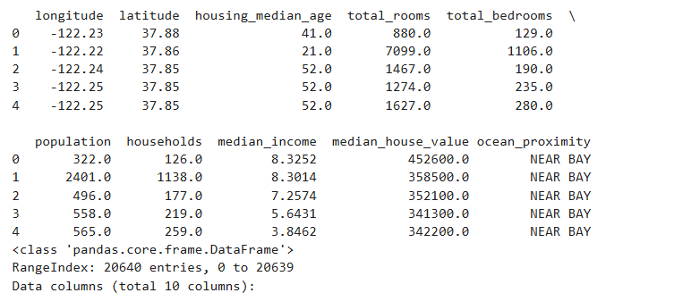

11. Data Preprocessing Steps
Data preprocessing is one of the most critical phases in any machine learning project, as the quality of input data directly influences the accuracy and reliability of the model. In this project, several systematic preprocessing steps were applied to ensure that the housing dataset was clean, structured, and suitable for predictive analysis. The following steps outline the complete preprocessing approach:

1. Handling Missing Values
Real-world datasets often contain incomplete or missing entries due to human errors, lack of documentation, or inconsistent data collection processes. To ensure the integrity of the dataset:
- Columns or rows with excessive missing values were removed to prevent distortion in model training.
- For features with minor missing values, imputation techniques were applied:
  - Mean imputation for normally distributed numerical data.
  - Median imputation for skewed numerical data to avoid the influence of outliers.
  - Mode imputation for categorical variables, preserving the most frequent category.
- Additional checks were performed to ensure that no invalid or placeholder values (like “N/A”, “-”, or empty strings) remained in the dataset.
Handling missing values ensured that no gaps or inconsistencies weakened the learning process of the ML models.

2. Removing Irrelevant or Redundant Features
Not all columns in the dataset contribute useful information for prediction. Some features either do not affect the house price or introduce unnecessary noise.
- Columns such as property ID, record number, or internal codes were removed as they do not influence the dependent variable (house price).
- Features that showed no variance (same value repeated everywhere) were dropped because they do not add meaningful information to the model.
- Any duplicate features or highly correlated columns were identified and carefully handled to reduce redundancy, which helps in simplifying the model.
This step ensured that the model trains only on meaningful and influential attributes.

3. Correcting Data Inconsistencies
Real-world housing data often contains inconsistencies due to different data entry formats. To maintain uniformity across the dataset:
- Units of measurement were standardized (e.g., converting all area values into square feet).

- Typographical errors, inconsistent spellings, and mixed-case text (like “delhi”, “Delhi”, “DELHI”) were corrected using normalization techniques.
- Categorical values were standardized to ensure uniform representation of regions, property types, and amenities
- Duplicate records were detected and removed using Pandas functions to avoid bias during training.
Correcting inconsistencies ensured data reliability and prevented errors during feature encoding and model building.

4. Encoding Categorical Variables
Machine learning models operate on numerical data, so categorical information must be encoded properly.
- One-hot encoding was applied to convert categorical variables such as location, property type, furnishing status, etc., into binary columns.
- Label Encoding was used where categories had an inherent order.
- Care was taken to avoid dummy variable traps by dropping one redundant column from each encoded group when necessary.
Encoding transformed textual data into a machine-understandable format, enabling the models to interpret key patterns and relationships.

5. Final Data Processing and Verification
After completing all preprocessing steps, the dataset was carefully reviewed to ensure readiness for model training.
- The shape of the dataset (rows and columns) was verified before and after cleaning.
- Summary statistics were generated using Pandas to check the consistency of feature ranges.
- Feature distributions were visualized using histograms, box plots, and pair plots to confirm that preprocessing improved data quality.
- A final correlation heatmap was created to understand feature-target relationships and identify potential strong predictors.
These verification steps helped ensure that the dataset was clean, balanced, and structured effectively for machine learning.
A well-preprocessed dataset significantly improves model performance by removing noise, inconsistencies, and redundancies. This structured preprocessing approach ensured that the Linear Regression, Random Forest, and XGBoost models built in this project received high-quality input data, ultimately leading to more accurate and reliable housing price predictions.

12. Exploratory Data Analysis (EDA)
Exploratory Data Analysis (EDA) is a critical step in any data science or machine learning project, as it helps in understanding the underlying structure and characteristics of the dataset. EDA allows us to summarize the main features of the data, detect patterns, spot anomalies, and test underlying assumptions before applying any machine learning models. This step ensures that the model is trained on meaningful and clean data, improving both accuracy and reliability.

In this project, Python libraries Matplotlib and Seaborn were extensively used to perform EDA. These libraries provide tools for creating various plots and visualizations that help in understanding relationships among variables and the distribution of data points. The following types of visualizations were commonly employed:
- Scatter Plots: Used to examine the relationship between two numerical variables, such as house size and price. Scatter plots often reveal trends, such as positive linear relationships, which can guide model selection.
- Histograms: Display the frequency distribution of individual features, helping identify skewness, normality, and potential data imbalance.
- Box Plots: Provide a visual summary of the distribution of numerical data, highlighting the median, quartiles, and potential outliers that could adversely affect model performance.
- Correlation Heatmaps: Show pairwise correlations between numerical features. Highly correlated features may need to be handled carefully to avoid multicollinearity in regression models.

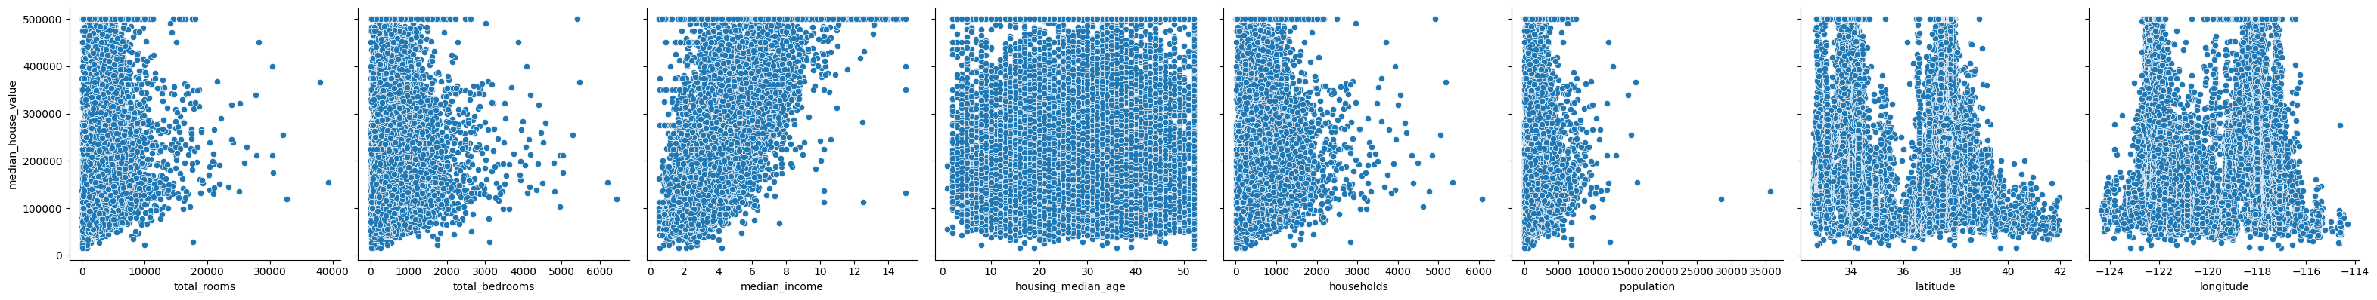

Purpose of EDA
- Identify-Trends-and-Patterns:
Visualizations help detect how features relate to the target variable. For example, larger houses generally tend to have higher prices, revealing a positive correlation.
- Detect-Outliers-and-Anomalies:
Outliers can distort model learning, especially in regression tasks. Box plots and scatter plots help in identifying these extreme values for further treatment.
- Understand-Feature-Importance:
By examining correlations and visual trends, one can assess which features have the strongest influence on the target variable, guiding feature selection for model training.
- Guide-Feature-Engineering:
EDA provides insights that help in creating new features, transforming existing ones, or removing irrelevant attributes to improve model performance.
For instance, scatter plots between house size and price often show a clear positive trend, indicating that larger houses tend to be more expensive. Similarly, correlation heatmaps reveal which features are strongly associated with the target variable and which are redundant, allowing for more informed preprocessing and model-building decisions. Overall, EDA serves as a foundation for data-driven decision-making, ensuring that subsequent machine learning models are built on well-understood, high-quality data.
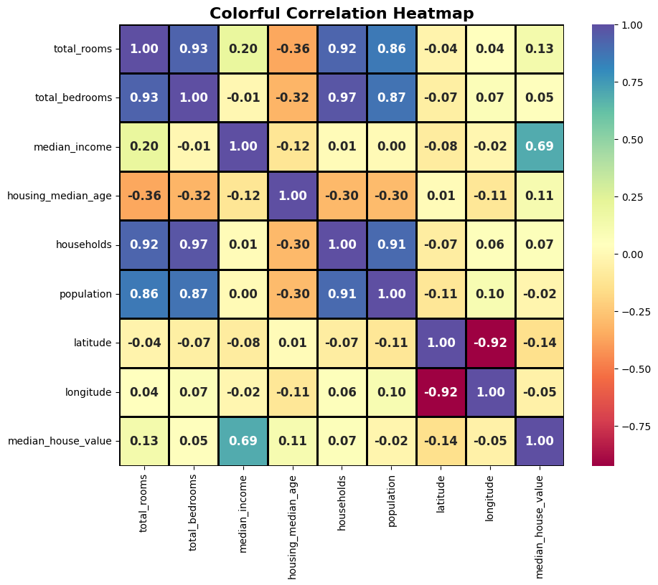

13. Feature Selection and Engineering
Feature selection and feature engineering are two essential phases in the development of any machine learning model. Both processes significantly influence the model’s performance, efficiency, and ability to generalize to unseen data.

Feature Selection
Feature selection refers to the process of identifying the most relevant and significant input variables that directly contribute to predicting the target variable. The primary objective is to remove redundant, irrelevant, or noisy features that may negatively impact model accuracy.
Theoretical benefits of feature selection include:
- Improved-Model-Accuracy:
By eliminating unnecessary variables, the model focuses only on meaningful patterns, resulting in better predictive performance.
- Reduced-Overfitting:
Fewer irrelevant features reduce the risk of the model memorizing insignificant details in the training data.
- Lower-Computational-Cost:
With fewer variables to process, training becomes faster and more efficient.
Typical methods used in feature selection include:
- Correlation Analysis: Identifies the strength of relationships between input variables and the target.
- Statistical Measures: Techniques like chi-square tests, ANOVA, and mutual information help determine the relevance of features.
- Model-Based Selection: Tree-based models and regularized algorithms naturally highlight important features.
In the context of this project, features related to house area, number of bathrooms, locality, and proximity to essential services were retained because theoretical understanding and EDA indicated their strong influence on housing prices.

Feature Engineering
Feature engineering involves transforming existing features or creating new ones to better represent underlying patterns in the data. It is a creative and analytical process that often determines the overall effectiveness of a machine learning model.
Key theoretical objectives of feature engineering include:
- Enhancing-Predictive-Power:
New features derived from existing variables help capture complex or hidden relationships.
- Handling-Non-Linearity:
Transformations and grouping can help linear models learn non-linear trends in the data.

- Improving-Data-Representation:
Converting data into machine-readable formats ensures that algorithms can correctly interpret categorical or mixed-type variables.
Common feature engineering techniques include
- Feature-Transformation:
Applying logarithmic, square root, or polynomial transformations to handle skewness or non-linearity.
- Feature-Creation:
Deriving new variables such as
  - Area per Room to represent usable space per room,
  - Age Categories (0–10 years, 11–20 years, etc.) to represent housing age more effectively.
- Encoding-Categorical-Data:
Converting qualitative attributes into numerical format using
  - One-Hot Encoding for nominal features,
  - Label Encoding for ordinal features.
- Discretization-and-Binning:
Grouping continuous variables into intervals helps models capture segmented patterns.

Both feature selection and feature engineering play a vital theoretical role in preparing a dataset for machine learning. By carefully selecting meaningful variables and engineering new informative features, the resulting dataset becomes more structured, more interpretable, and more capable of allowing the model to learn patterns effectively.
These steps ultimately improve model accuracy, reduce errors, and enhance the overall reliability of housing price predictions.

14. Data Scaling and Train-Test Split
Before training machine learning models, it is essential to prepare the data to ensure optimal model performance. Two important steps in this preparation are feature scaling and splitting the dataset into training and testing sets.

Data Scaling
Numerical features in the dataset, such as house area, number of rooms, or median income, may have values in widely varying ranges. If left unscaled, features with larger numeric ranges can dominate the learning process, causing algorithms like Linear Regression, Support Vector Machines, and K-Nearest Neighbors to perform poorly. To address this, StandardScaler from Scikit-Learn was used to standardize the features.
StandardScaler transforms the features such that they have a mean of zero and a standard deviation of one, using the formula:
$$X_{\text{scaled}}=\frac{X-μ}{σ}$$
where $X$is the original feature, $μ$is the mean, and $σ$is the standard deviation. Standardizing the data ensures that all features contribute equally during model training, improving convergence speed and model accuracy.

Train-Test Split
Once the data was scaled, it was split into training and testing sets, typically using an 80-20 or 70-30 ratio. This step is critical for evaluating the model’s ability to generalize to unseen data:
- Training Set: This subset is used to train the machine learning models. The model learns the relationships between features and the target variable using this data.
- Testing Set: This subset is kept separate during training and is used to evaluate the model’s performance. Testing on unseen data provides an unbiased estimate of how well the model will perform in real-world scenarios.
The split also ensures that the model does not overfit the training data. Overfitting occurs when the model learns not only the underlying patterns but also the noise in the training data, resulting in poor performance on new data. By evaluating the model on a separate testing set, we can detect overfitting and select the model that generalizes best.
Together, data scaling and train-test splitting form a foundational step in machine learning workflows. Scaling ensures fair contribution of all features, while splitting provides a robust framework for model evaluation and validation, ensuring reliable and accurate predictions

15. Model Training
After completing data cleaning, preprocessing, feature engineering, and feature selection, the next step was to train machine learning models capable of accurately predicting housing prices. The dataset was divided into training and testing subsets (typically 70–80% for training and 20–30% for testing). This splitting ensures that the model learns patterns from one portion of the data while being evaluated on unseen data, thereby measuring its real-world performance.
The models were implemented in Python, using popular machine learning libraries such as:
- pandas for data handling
- NumPy for numerical operations
- scikit-learn for building regression models
- XGBoost / tree-based methods (if applicable)
Tree-based models like Random Forest and XGBoost were first run using default hyperparameters to establish a baseline performance before tuning.

Trained Machine Learning Models
Three major regression models were trained and evaluated in this project.
15.1. Linear Regression (Baseline Model)
Linear Regression served as the foundational model. It assumes a linear relationship between the input features and the target price. The model learns coefficients for each feature and constructs a predictive equation:
$$\hat{y}=b_{0}+b_{1}x_{1}+b_{2}x_{2}+...+b_{n}x_{n}$$
where:
- $\hat{y}$= predicted house price
- $b_{0}$= intercept
- $b_{1}…b_{n}$= learned coefficients
- $x_{1}…x_{n}$= input features
Advantages:
- Simple to implement
- High interpretability—coefficients show how each feature impacts price
Limitation:
- Unable to capture complex non-linear patterns in housing data

15.2. Decision Tree Regression
Decision Tree Regression is a non-linear model that recursively splits the dataset based on feature values. Each split aims to minimize prediction error, ultimately forming a tree structure where each leaf node contains a predicted value.
Strengths:
- Captures non-linear relationships
- Easy to visualize and interpret
Challenges:
- Highly prone to overfitting if not pruned or regularized

15.3. Random Forest Regression
Random Forest is an ensemble technique that builds multiple decision trees on random subsets of data and features. The final prediction is the average of all tree predictions.
Advantages:
- Reduces overfitting compared to a single tree
- Handles complex feature interactions well
- Offers high predictive accuracy
Why it works well:
Ensembling smooths out individual tree errors, creating a more stable and robust model.

Training Process and Optional Enhancements
- Each model was trained on the training set, learning relationships between the selected features and housing prices.
- Predictions were evaluated on the testing set to measure performance.
- Additional steps like hyperparameter tuning (e.g., tree depth, number of trees, learning rate in XGBoost) and cross-validation can further improve robustness and accuracy.

16. Model Evaluation
After training the models, it is essential to evaluate their performance to determine how accurately they predict housing prices. In this project, standard regression metrics and visualization techniques were used for model evaluation.

Evaluation Metrics
- R²-Score-(Coefficient-of-Determination):
The R² score measures the proportion of variance in the target variable that is explained by the model. It ranges from 0 to 1, with higher values indicating a better fit. An R² score close to 1 suggests that the model can accurately capture the underlying relationship between input features and house prices.
- Mean-Squared-Error-(MSE):
MSE calculates the average squared difference between the predicted values and the actual house prices. A lower MSE indicates better predictive accuracy, as it reflects smaller deviations from the true values
.
Visual Assessment
In addition to numerical metrics, visualizations were used to assess model performance. Scatter plots of actual vs predicted house prices allow for a quick visual check. Ideally, the points should lie close to the diagonal line, indicating that predictions closely match the actual values. Deviations from the line highlight areas where the model may be underperforming or overestimating/underestimating prices.
Comparison of Models
- Linear Regression: Provided a simple baseline but struggled to capture non-linear relationships, resulting in moderate accuracy.
- Decision Tree Regression: Improved performance by capturing complex patterns but was prone to overfitting on the training data.
- Random Forest Regression: Delivered the best performance, combining multiple trees to reduce variance and improve prediction stability. It consistently achieved higher R² scores and lower MSE, making it the most reliable model for housing price prediction in this project.
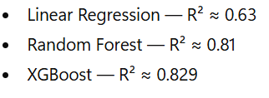
This indicates that ensemble / boosting methods (Random Forest and XGBoost) outperform the linear baseline, likely because they better capture nonlinear relationships and interactions among features.
Analysis of Results: The stronger performance of Random Forest and XGBoost suggests that housing price depends on complex, possibly non-linear interactions (e.g. area, age, locality, number of rooms/bathrooms). Linear Regression, being a simple linear model, fails to capture such complexity fully, which results in lower accuracy.

17.Visualization and Interpretation
Visualization is an important part of any Machine Learning workflow. It helps in understanding the dataset, checking model performance, and explaining results in a clearer way. Numerical metrics like accuracy, R², or MSE are useful, but visualizations make the patterns and relationships easier to interpret. In this project, Matplotlib and Seaborn were used for different types of plots.

1. Scatter Plot (Actual vs Predicted Values)
A scatter plot compares true values with the model’s predicted values. It shows how close the predictions are to the actual outputs. If the model is good, the points lie near a diagonal line.
- Used to evaluate regression model performance
- Actual prices on one axis, predicted prices on the other
- Linear Regression showed more scattered points
- Random Forest predictions were closer to the diagonal
- Helps detect outliers and weak prediction areas

2. Feature Importance Chart (Random Forest)
Random Forest automatically calculates how important each feature is by checking how much it reduces prediction error. A bar graph is used to display these importance scores.
- Shows which features influence house prices the most
- Features like total area and number of bedrooms ranked highest
- Less important features can be removed to simplify the model
- Helps stakeholders understand why the model gives certain predictions
- Useful for feature selection and model improvement

3. Correlation Heatmap
A heatmap visualizes the correlation between numerical variables. It uses color intensity to show strong or weak relationships.
- Shows positive and negative correlations between features
- Helps identify multicollinearity (features that provide similar information)
- Useful for cleaning and selecting features
- Helps understand overall structure of the dataset
- Simplifies decision-making about which variables matter most

4. Visual Interpretation of Model Performance
Graphs make it easier to compare different models visually, not just through numerical scores.
- R² and MSE alone are not enough
- Visuals show how models behave on different types of data
- Linear Regression struggled on non-linear patterns
- Decision Trees fit well but showed signs of overfitting
- Random Forest showed the best overall performance visually and numerically

5. Importance of Visualization in Machine Learning
Visualization converts raw data and complex model behaviour into easy-to-understand insights.
- Helps identify hidden patterns
- Supports better decision-making
- Makes results clear for non-technical users
- Ensures transparency and trust in model outputs
- Strengthens the validity of conclusions

Visualization is a powerful tool that enhances model understanding, highlights important features, and makes results easier to explain. By using scatter plots, feature importance charts, and heatmaps, the project achieved a deeper understanding of the dataset and model performance, helping to draw clear and meaningful conclusions.

18. Skills and Knowledge Gained
Through this project, several skills were enhanced:
- Data handling and manipulation using Pandas and NumPy.
- Model building with Scikit-Learn for Linear Regression, Decision Tree, and Random Forest.
- Data preprocessing, feature selection, and scaling.
- Visualization techniques using Matplotlib and Seaborn.
- Understanding real-world applications of ML for regression problems.
Additionally, the project improved analytical thinking, debugging skills, and the ability to interpret and explain results.

19. Conclusion
This project successfully demonstrated how Machine Learning techniques can be applied to predict housing prices with good accuracy. By using models such as Linear Regression, Decision Tree, and Random Forest, the study highlighted how different algorithms perform on the same dataset and how preprocessing steps directly affect the results. Through careful data cleaning, feature selection, and visualization, the project provided a deeper understanding of the patterns present in the data.
Among the models used, Random Forest proved to be the most accurate and stable because of its ability to reduce overfitting and capture complex relationships. Visualization tools like scatter plots, heatmaps, and feature importance charts helped interpret the results clearly and made the model outputs easier to understand. Overall, the project strengthened knowledge of AI/ML concepts and showed how data-driven approaches can support real-world decision-making.

Recommendations
Based on the findings and observations from this project, the following recommendations are suggested:
- Use-More-Data:
Increasing the dataset size can improve model accuracy and help the model learn more patterns.
- Improve-Feature-Engineering:
Creating new features (like price per square foot, age categories, location groups) may improve prediction quality.
- Try-More-Advanced-Models:
Algorithms such as Gradient Boosting, XGBoost, or Neural Networks can be tested for even better performance.
- Apply-Hyperparameter-Tuning:
Techniques like Grid Search or Random Search should be used to optimize model parameters and increase accuracy.
- Use-Cross-Validation:
Performing k-fold cross-validation can provide more reliable and generalized model performance results.
- Deploy-the-Model:
The trained model can be integrated into a web application to provide live house price predictions to users or stakeholders.
- Future-Work-on-Visualization:
Adding dashboards or interactive charts (using tools like Power BI, Tableau, or Plotly) can make the results easier for non-technical users to understand.

20.Appendices
Appendix A: Dataset Information (Kaggle)
The dataset used in this project was downloaded from Kaggle, containing California housing data.
It includes geographical information, demographic data, and important factors influencing housing prices.
Sample dataset entries:
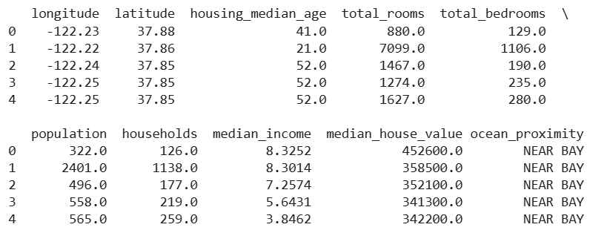
Key features include:
- Geographical: longitude, latitude
- Demographic: population, households, median income
- Housing details: total_rooms, total_bedrooms, housing_median_age
- Target variable: median_house_value
- Categorical feature: ocean_proximity

Appendix B: Code Snippets
This appendix contains the core Python code used in the project, including:
1. Importing Required Libraries
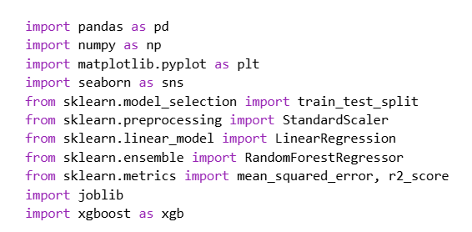

2. Data Loading and Initial Cleaning
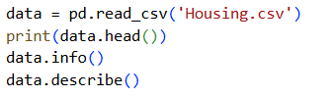

3. Handling Missing Values
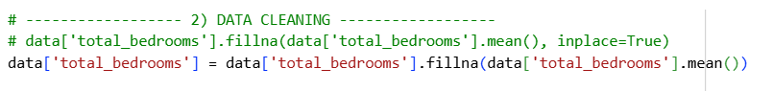

4. Exploratory Data Analysis (EDA)
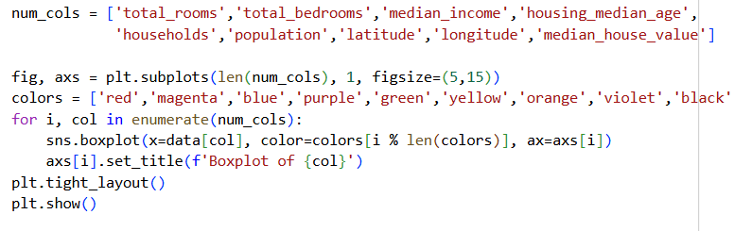
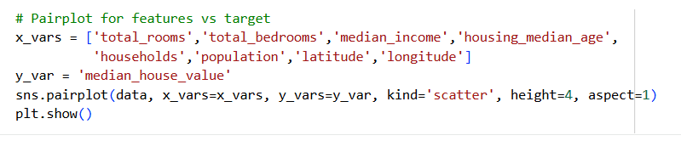
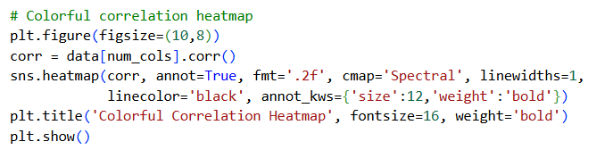

5. Model Training, Feature Selection & Standarization
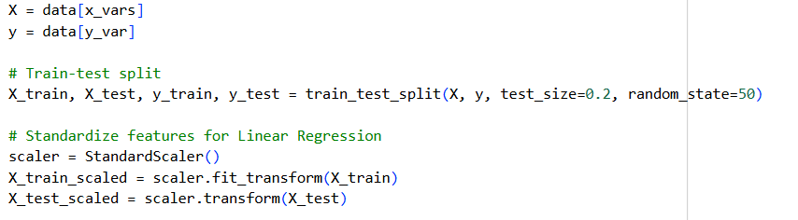
6. Linear Regression
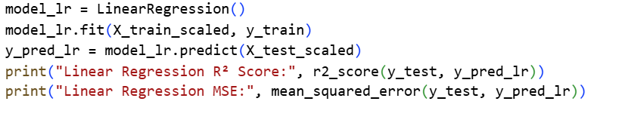
7. Random Forest Regressor
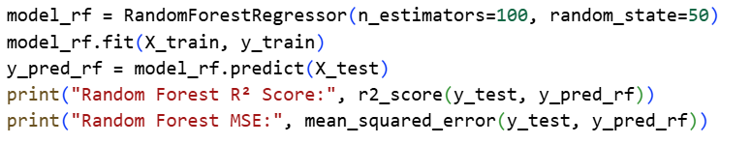
8. XGBoost Regression
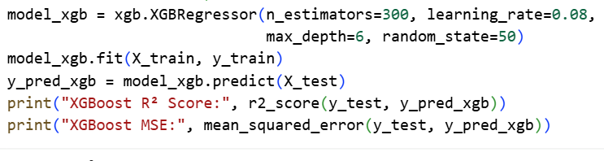

9. Regression Points
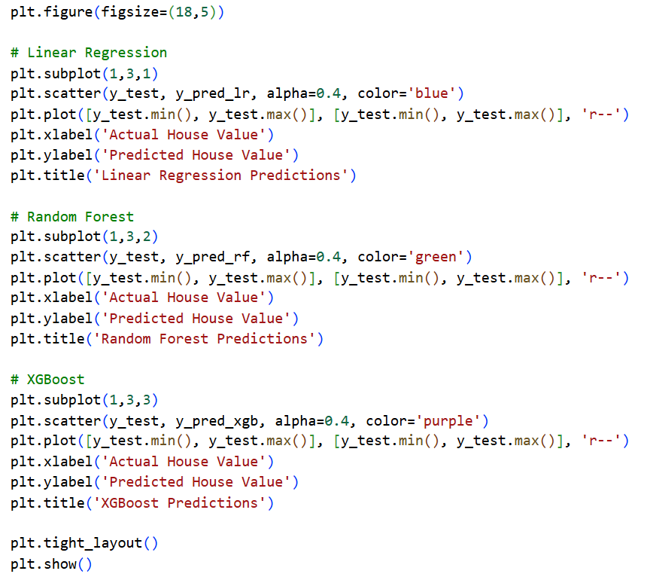

10. Feature Importance
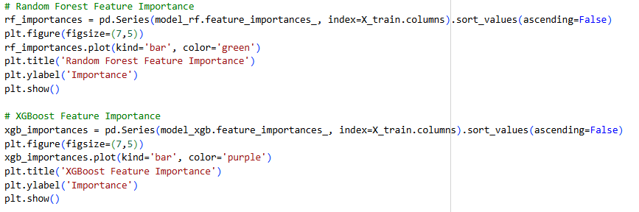

11.Save Cleaned Data
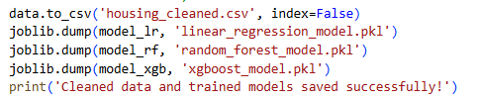

12.Combined Regression Plot
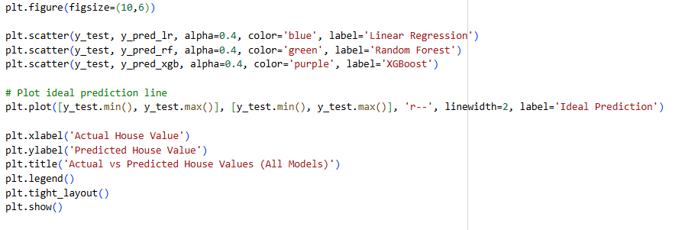
Appendix C: Graphs and Visual Outputs
This section contains all visualizations generated during the project:
- Scatter plot of Actual vs Predicted values
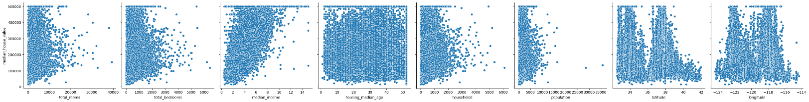

- Correlation heatmap of dataset features:
- Correlation analysis helps identify how strongly each feature is related to the target (median_house_value) and with other features. Strong correlations can guide feature selection and engineering.

- Regression Plots
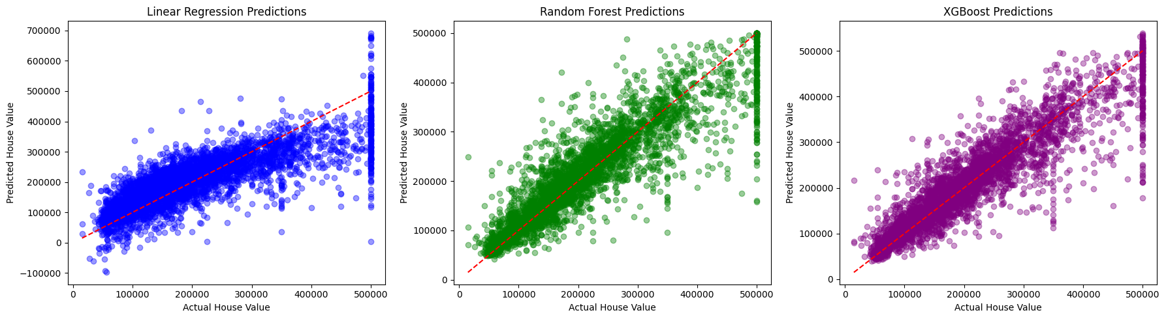
Regression plots help visualize how closely each model’s predictions match the actual housing prices. Points near the diagonal line indicate accurate predictions.

- Feature Importance of Random Forest & XGBoost
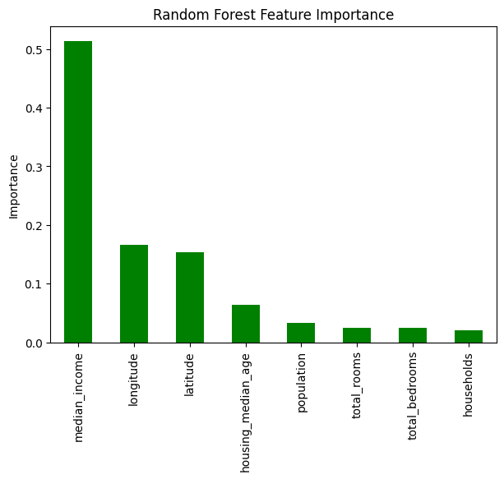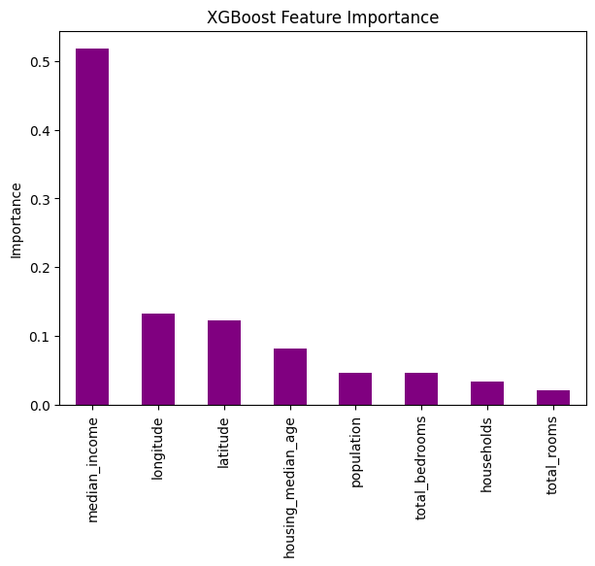

- Box plots: Box plots are a powerful visualization tool to understand the distribution of features and detect outliers that may affect model performance.
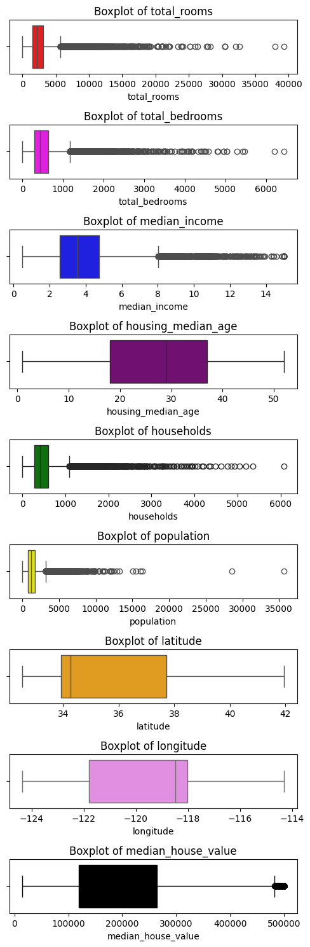

- Combined Regression Plots:
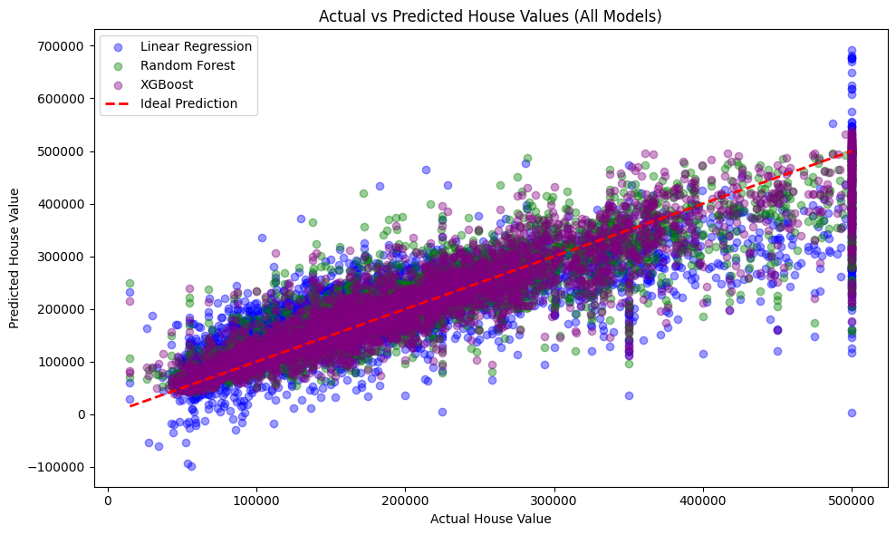
The regression plot compares actual versus predicted house prices for Linear Regression, Random Forest, and XGBoost models. Points close to the red dashed line indicate accurate predictions. Random Forest and XGBoost predictions (green and purple) cluster tightly around the line, demonstrating better performance, while Linear Regression (blue) shows greater spread, especially at high and low price ranges. Deviations above the line indicate over-predictions, and below indicate under-predictions; Linear Regression exhibits more extreme deviations in both directions. Overall, tree-based ensemble models capture complex relationships more effectively and provide more reliable predictions, whereas linear models serve as a basic baseline but struggle with non-linear interactions and outliers. This visual insight aligns with the reported R² and MSE metrics, confirming that Random Forest and XGBoost outperform Linear Regression.

Appendix D: Model Performance Results
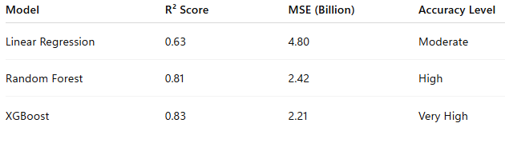

Appendix E: Tools, Technologies, and Platforms
- Programming Language: Python
- Development Environment: Google Colab
- Libraries Used: NumPy, Pandas, Matplotlib, Seaborn, Scikit-Learn
- Dataset Source: Kaggle (California Housing Dataset)

Appendix F: Project and Professional Links
- GitHub Repository: https://github.com/pksaraiii/12300402
  - Contains the full project code, dataset processing, and model implementations.
- LinkedIn Profile: https://www.linkedin.com/in/pksaraiii
  - For professional profile, networking, and more details about projects and internships.

21.References
- Géron, A. (2019). Hands-On Machine Learning with Scikit-Learn, Keras, and TensorFlow. O’Reilly Media.
- Raschka, S., & Mirjalili, V. (2019). Python Machine Learning. Packt Publishing.
- Chen, T., & Guestrin, C. (2016). XGBoost: A Scalable Tree Boosting System. KDD Conference.
- Kaggle Dataset: https://www.kaggle.com/datasets

