AAI 646 – Pattern Recognition and Classification
Fall 2025

Final Project
SDG Text Classification with Resource-Efficient Language Models
“By fine-tuning compact language models, this work demonstrates that effective SDG text classification can be achieved without reliance on large, compute-intensive models.”

Team members:
- Tilak Chandana S P (tsp@stevens.edu)
- Palak Sood (psood1@stevens.edu)

Introduction:
The Sustainable Development Goals (SDGs) represent humanity's most ambitious collective commitment: 17 interconnected objectives designed to address poverty, inequality, climate change, and social justice by 2030.
Yet tracking progress toward these goals remains profoundly challenging. The evidence of impact whether from groundbreaking research, technological innovation, or policy reform is scattered across millions of unstructured documents: scientific publications, patent filings, government reports, and corporate sustainability disclosures. Without scalable methods to identify and classify this work, we risk flying blind in our pursuit of global sustainability.

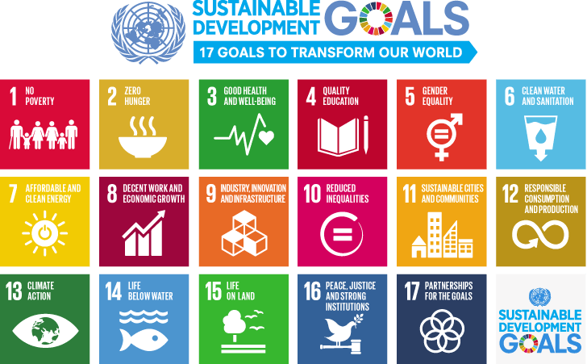

This is fundamentally a pattern recognition problem at massive scale. Traditional manual classification is both prohibitively expensive and impossibly slow when confronted with the exponential growth of relevant literature.
Recent breakthroughs in large language models (LLMs) have transformed this landscape, demonstrating unprecedented ability to understand semantic relationships and extract meaning from complex text.
State-of-the-art models like GPT-5.2 and Claude Sonnet 4.5 can classify SDG-relevant content with remarkable accuracy but at a cost. These systems demand enormous computational resources, creating a critical barrier: the institutions and regions most in need of SDG monitoring tools often have the least access to high-performance computing infrastructure.
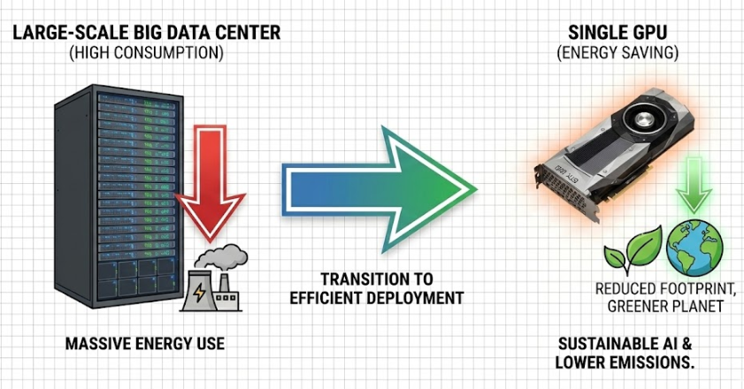

This creates a paradox at the heart of AI-enabled sustainability tracking: the most powerful tools are accessible only to those with substantial resources, while resource-constrained organizations often working directly on SDG implementation are left behind. Recent work has begun to challenge this paradigm.
Emerging model families like DeepSeek, Qwen, and Ministral have shown that sophisticated language understanding doesn't require massive scale. More importantly, targeted fine-tuning techniques including adapter layers, low-rank adaptation (LoRA), and selective parameter updates enable small models to achieve task-specific performance that rivals or exceeds their larger counterparts.
In this project, we investigate a critical question: Can carefully optimized small language models deliver production-grade SDG classification while remaining deployable in resource-constrained environments?
Our approach combines end-to-end fine-tuning of a compact language model with advanced optimization techniques. We employ supervised fine-tuning (SFT) enhanced with GSPO (Group Relative Policy Optimization), a recently introduced method from Alibaba that has shown promising results in aligning model behavior with specific task objectives. By focusing on computational efficiency without sacrificing performance, we aim to demonstrate that effective SDG classification doesn't require choosing between accuracy and accessibility.
The implications extend beyond academic exercise. If small, fine-tuned models can match the performance of resource-intensive alternatives, we can democratize access to AI-powered sustainability tracking. Universities in developing nations, small NGOs, and government agencies with limited budgets could deploy these tools locally, enabling real-time monitoring of research impact and policy outcomes. This work represents a step toward making AI for sustainable development not just powerful, but practical and equitable.
Our contribution is threefold: we establish a rigorous fine-tuning pipeline for SDG classification, we empirically evaluate the performance-efficiency trade-off in compact language models, and we demonstrate that thoughtful model optimization can bridge the gap between cutting-edge AI capabilities and real-world deployment constraints.

Dataset Description & Preparation:
The Challenge of SDG Classification Data Quality
SDG classification presents a uniquely subjective pattern recognition challenge. Unlike tasks with objective ground truth such as named entity recognition or syntax parsing—determining whether a text passage addresses a particular sustainability goal requires nuanced human judgment. A paragraph discussing renewable energy infrastructure might simultaneously contribute to SDG 7 (Affordable and Clean Energy), SDG 9 (Industry, Innovation and Infrastructure), and SDG 13 (Climate Action). This inherent ambiguity makes data quality paramount: models trained on noisy or inconsistent labels will learn to replicate human disagreement rather than meaningful patterns.
For fine-tuning small language models, this challenge intensifies. While large models can sometimes overcome label noise through sheer scale and pre-training knowledge, compact models have limited capacity to distinguish signal from noise in their training data. High-quality, consistently labeled examples become not just desirable but essential for effective learning.
Source Dataset: OSDG Community Annotations
Links: ( https://github.com/osdg-ai/osdg-tool ), (https://osdg.ai/ )
To address this challenge, we turned to the OSDG (Open-Source SDG) Community Dataset, a large-scale human annotation project specifically designed for SDG text classification. The dataset's key strength lies in its annotation methodology: rather than relying on single annotators, each paragraph was evaluated by multiple independent human reviewers who voted on whether the text belonged to each SDG category. This multi-annotator approach provides not just labels, but confidence scores a measure of inter-annotator agreement that serves as a proxy for label quality.
The full OSDG dataset contains over 30,000 annotated paragraphs spanning diverse sources including research abstracts, policy documents, and organizational reports. However, for fine-tuning applications, dataset quality matters far more than quantity. Noisy or ambiguous labels can mislead a model during training, particularly when working with small, efficient architectures that have limited capacity to filter signal from noise.
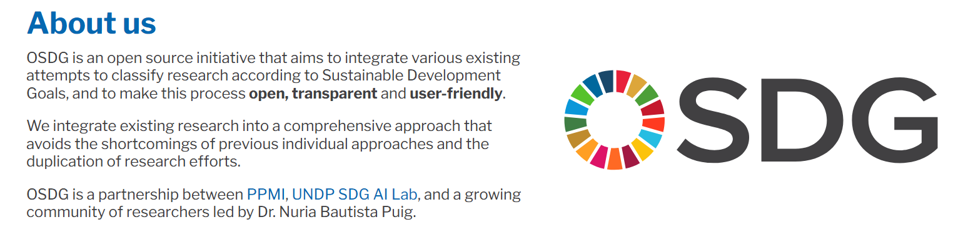

Constructing a High-Confidence Training Set
To ensure maximum label reliability, we applied a stringent filtering criterion: we retained only examples where annotator agreement exceeded 95%. This threshold guarantees that our training data represents cases where human experts reached near-unanimous consensus, effectively creating a "golden dataset" of unambiguous SDG associations.
From this filtered pool, we selected 200 examples per SDG category to maintain class balance a critical consideration for multi-class classification. Imbalanced datasets can bias models toward overrepresented classes, degrading performance on minority categories. Our balanced sampling strategy ensures the model receives equal exposure to patterns associated with each goal during training.
Addressing Dataset Gaps 1:
Despite its high quality, the OSDG dataset exhibited two critical gaps. First, it lacked sufficient high-agreement examples for SDG 17 (Partnerships for the Goals), which focuses on global partnerships and multi-stakeholder collaboration. Second, it contained no negative examples, increasing the risk of false positives when classifying SDG-irrelevant text.
To address these issues, we adopted a hybrid data collection strategy. We augmented SDG 17 by manually curating partnership-focused paragraphs from sustainability reports published by multinational organizations and development agencies, then screening them with a large language model. From these, we retained 200 paragraphs confidently classified as SDG 17. Using the same corpus, we also collected 200 paragraphs classified as belonging to no SDG, consisting mainly of administrative and financial content. This “No SDG” category enables the model to learn the boundary between SDG-relevant and irrelevant text, which is essential for real-world deployment.

Dataset Composition 1:
Our complete training dataset comprises 3,600 labeled examples:
3,200 positive examples: 200 per SDG (SDGs 1-16 from OSDG, SDG 17 from curated sources)
200 negative examples: 200 "No SDG" instances, plus the implicit negative signal from multi-label examples

Multi-Label Expansion via Ensemble Classification
A critical limitation of the OSDG dataset is its single-label annotation structure—each paragraph is assigned to only one SDG. However, sustainable development challenges are inherently interconnected: a paragraph discussing clean energy infrastructure may simultaneously address climate action (SDG 13), affordable clean energy (SDG 7), and sustainable cities (SDG 11). Training on single-label data would teach our model to ignore these natural overlaps, reducing its ability to capture the multi-dimensional nature of SDG work.
To address this, we employed an LLM ensemble voting strategy to expand single labels into multi-label annotations:
Ensemble Classification Pipeline
We classified each paragraph using five diverse language models:
- GPT-4o Mini & GPT-4o Nano (OpenAI)
- Grok-3 Mini & Grok-4 Fast (xAI)
- Phi-4 Mini (Microsoft)

Each model received the same prompt template incorporating:
- Chain-of-thought reasoning: Models were instructed to explain their classification logic before outputting labels
- Few-shot in-context learning: 3 examples demonstrating multi-label assignment patterns

Majority Voting Consensus
Vote Count | Decision Rule
≥3 models (including original) | Accept as valid SDG label
<3 models | Reject label

This conservative threshold (50%+ agreement across 6 votes: 5 LLMs + original label) ensures only high-confidence multi-label associations are retained, maintaining data quality while capturing realistic SDG overlaps.

Final Dataset Statistics:
- Total examples: 3,600
- Primary classes: 18 (SDGs 1-17 + No SDG)
- Examples per class: 200
- Label confidence: >95% agreement (OSDG) + ensemble validation
- Multi-label coverage: [Insert percentage after processing]
- Source composition: OSDG Community (94.4%) + Curated augmentation (5.6%)

PROMPT STRUCTURE ( CoT + Few Shot Learning):
"""You are an expert SDG classifier. Your task is to classify text according to the UN's 17 Sustainable Development Goals.

**CRITICAL RULES:**
1. Base your classification ONLY on what is EXPLICITLY stated in the text
2. DO NOT make assumptions or inferences beyond what is written
3. DO NOT classify based on what "could be" or "might be" related
4. Maximum 3 SDGs - only those with DIRECT, EXPLICIT connection
5. If no strong SDG connection exists in the text → classify as NOSDG

**THE 17 UN SDGs:**
SDG1: No Poverty - Eradicating poverty in all forms
SDG2: Zero Hunger - Food security, nutrition, sustainable agriculture
SDG3: Good Health and Well-Being - Health services, disease prevention, mental health
SDG4: Quality Education - Inclusive, equitable education and lifelong learning
SDG5: Gender Equality - Women's empowerment, gender rights
SDG6: Clean Water and Sanitation - Water access, sanitation, hygiene
SDG7: Affordable and Clean Energy - Renewable energy, energy access, efficiency
SDG8: Decent Work and Economic Growth - Employment, labor rights, economic growth
SDG9: Industry, Innovation, Infrastructure - Infrastructure, industrialization, innovation
SDG10: Reduced Inequalities - Economic/social inequality reduction
SDG11: Sustainable Cities and Communities - Urban development, housing, transportation
SDG12: Responsible Consumption and Production - Sustainable production, waste reduction
SDG13: Climate Action - Climate change mitigation and adaptation
SDG14: Life Below Water - Ocean conservation, marine resources
SDG15: Life on Land - Ecosystem protection, biodiversity, forests
SDG16: Peace, Justice, Strong Institutions - Rule of law, governance, justice access
SDG17: Partnerships for the Goals - Global cooperation for SDGs

**STEP-BY-STEP CLASSIFICATION PROCESS:**

**STEP 1: EXTRACT EXPLICIT CONTENT**
List the concrete facts, actions, topics, or programs explicitly mentioned:
- What specific activities/programs/issues are described?
- What populations or sectors are explicitly mentioned?
- What outcomes or impacts are directly stated?
- What keywords or phrases directly relate to SDG themes?

**STEP 2: CHECK FOR SDG RELEVANCE**
For each SDG, ask:
- Does the text EXPLICITLY mention topics central to this SDG?
- Are there DIRECT actions/programs/outcomes related to this SDG's core goals?
- Can I point to specific words/phrases that clearly connect to this SDG?

If you cannot answer YES with specific evidence from the text → EXCLUDE that SDG

**STEP 3: APPLY STRICT INCLUSION CRITERIA**
Only include an SDG if the text shows:
✓ Direct mention of the SDG's core issues (poverty, hunger, health, education, etc.)
✓ Explicit programs/actions advancing that SDG's objectives
✓ Clear outcomes/impacts related to that SDG's targets
✓ Specific data/evidence tied to that SDG's focus areas

EXCLUDE an SDG if:
✗ Connection requires assumptions or reading between lines
✗ Relationship is indirect or tangential
✗ Generic or vague connection (e.g., "economic activity" ≠ automatically SDG8)
✗ Only mentioned in passing without substantive focus

**STEP 4: SELECT TOP SDGs (Maximum 3)**
- Rank SDGs by strength of explicit textual evidence
- Include only those with STRONG, DIRECT evidence
- When in doubt → exclude it
- Fewer SDGs is better than over-classification

**CLASSIFY AS NOSDG IF:**
- Text is purely commercial/financial with no sustainability focus
- No explicit connection to development, social, or environmental topics
- Content is technical/procedural without SDG-relevant outcomes
- Generic business/organizational content without SDG themes

**OUTPUT FORMAT:**

STEP1_EXPLICIT_CONTENT: [List key facts/topics/actions explicitly stated]

STEP2_SDG_EVIDENCE: [For each potentially relevant SDG, cite specific text evidence or state "no direct evidence"]

STEP3_FINAL_REASONING: [Explain which SDGs have strongest explicit evidence and why others are excluded]

JUSTIFICATION: [One concise sentence summarizing the classification]

SDG_CLASSIFICATION: [SDG#, SDG#, SDG# OR NOSDG]

**EXAMPLES:**
---
**Example 1:**
Text: "The solar energy program trained 200 women in rural areas to install and maintain solar panels, providing clean electricity to 50 villages."

STEP1_EXPLICIT_CONTENT: Solar energy program, training women, rural areas, solar panel installation/maintenance, clean electricity to villages

STEP2_SDG_EVIDENCE:
- SDG7: Direct mention of "solar energy," "clean electricity," renewable energy access
- SDG5: Explicit focus on training women, women's empowerment through skills
- SDG4: Training/skills development mentioned

STEP3_FINAL_REASONING: SDG7 is primary (renewable energy is the main focus). SDG5 is secondary (explicit women's empowerment component). SDG4 is weaker (training is mentioned but education/learning is not the primary focus). Limit to top 2.
JUSTIFICATION: Renewable energy program with explicit women empowerment component
SDG_CLASSIFICATION: SDG7, SDG5
---
**Example 2:**
Text: "Company Q3 revenue reached $3.2B, up 18% YoY, driven by consumer electronics and cloud services expansion."
.
.
…..
are supported by explicit mentions of fair-trade/income and sustainable practices.
JUSTIFICATION: Agricultural program directly improving food security, farmer incomes, and sustainable production
SDG_CLASSIFICATION: SDG2, SDG8, SDG12

Fine-Tuning Methodology
Training Strategy: SFT + GSPO
We employ a two-stage fine-tuning approach combining Supervised Fine-Tuning (SFT) with Group Relative Policy Optimization (GSPO), a recent alignment technique from Alibaba Research in their Qwen models.
This hybrid methodology enables the model to first learn task-specific classification patterns through supervised examples, then refine its decision boundaries through preference optimization balancing accuracy with reasoning quality.

Data Format Requirements
Both SFT and GSPO require conversational data structured as message exchanges. Each training example must follow this schema
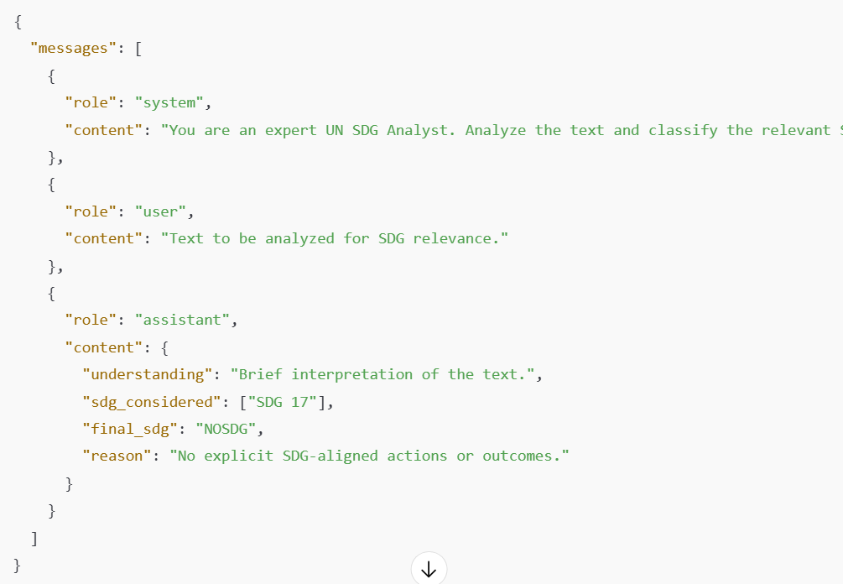
This format enforces structured reasoning: the model must articulate its understanding, enumerate candidate SDGs, select final classifications, and justify its decision mirroring expert annotation workflows.

Generating Structured Training Data
Since our labeled dataset contains only paragraph-label pairs, we generated the full reasoning chains using DeepSeek-V3, a frontier-class model capable of producing consistent, high-quality explanations.
Generation Pipeline
For each of the 3,600 examples, we prompted DeepSeek-V3 to:
- Understand the paragraph: Summarize key themes and context
- Consider candidate SDGs: Identify potentially relevant goals with brief justification
- Classify and justify: Select final SDG(s) based on evidence strength

Example Output (Condensed)
Step 1: Let me Understand the paragraph
[LLM analysis]
Step 2: Based on the analysis the possible SDG's are
[LLM potential SDG mappings with evidence]
Step 3: From my analysis here are the final SDG classification and Justification
[LLM final reasoning]
Conclusion:
[LLMconclusion]
Final Classification: [SDG labels only, e.g., "SDG1, SDG8" or "NOSDG"]

STAGE1: SFT – Supervised Fine Tuning:
Data Split Strategy
From our 3,600 structured examples, we created two independent training sets:
- SFT Dataset (50%): 1,800 examples for initial supervised learning
- GSPO Dataset (50%): 1,800 examples reserved for preference optimization
This split prevents data leakage and ensures the GSPO stage refines behavior on unseen examples, reducing overfitting risk.

Supervised Fine-Tuning Fundamentals
Supervised Fine-Tuning adapts a pre-trained language model to a specific task by training it on labeled input-output pairs. Unlike pre-training (which learns general language patterns from massive unlabeled text), SFT teaches the model task-specific behavior through direct supervision.
Mathematical Formulation
Given a pre-trained model with parameters $θ$and a dataset of $N$training examples
$D=\{(x_{i},y_{i})\}_{i=1}^{N}$,
SFT minimizes the negative log-likelihood loss:
$$L_{\text{SFT}}(θ)=-\frac{1}{N}\sum_{i=1}^{N}{log⁡}P_{θ}(y_{i}∣x_{i})$$
Where:
- $x_{i}$is the input context (system prompt + user message)
- $y_{i}$is the target response (assistant's reasoning + classification)
- $P_{θ}(y_{i}∣x_{i})$is the model's predicted probability of generating the correct output
For autoregressive models, this expands to:
$$L_{\text{SFT}}(θ)=-\frac{1}{N}\sum_{i=1}^{N}{\sum_{t=1}^{∣y_{i}∣}{log⁡}}P_{θ}(y_{i}^{t}∣x_{i},y_{i}^{<t})$$
Where $y_{i}^{t}$is the $t$-th token in response $y_{i}$, and the model learns to predict each token conditioned on the input and all previous tokens.

Model Selection & Architecture
Base Model: Qwen2.5-4B-Instruct (unsloth/Qwen3-4B-Instruct-2507)
We selected Qwen2.5-4B for three reasons:
- Efficiency: 4 billion parameters enable fast inference on consumer hardware
- Instruction-following capability: Pre-trained on chat data, aligned with our conversational format
- Strong reasoning baseline: Qwen models exhibit robust logical reasoning in multi-step tasks
Configuration:
- Precision: bfloat16 (no quantization—maximizes quality on A100 GPU)
- Context window: 4,096 tokens
- Chat template: Qwen3-Instruct format

Parameter-Efficient Fine-Tuning with LoRA
Training all 4 billion parameters would be computationally prohibitive. Instead, we apply Low-Rank Adaptation (LoRA), which freezes the base model and trains small adapter matrices injected into attention layers.
LoRA Methodology
For each weight matrix $W∈R^{d×k}$in the attention mechanism, LoRA learns a low-rank update:
$$W^{'}=W+ΔW=W+BA$$
Where:
- $B∈R^{d×r}$and $A∈R^{r×k}$are trainable low-rank matrices
- $r≪min⁡(d,k)$is the rank (we use $r=64$)
- Only $B$and $A$are updated during training, keeping $W$frozen

LoRA Configuration:
Parameter | Value | Purpose
Rank ($r$) | 64 | High rank for complex reasoning tasks
Alpha ($α$) | 64 | Scaling factor (typically $α=r$)
Dropout | 0.05 | Regularization to prevent overfitting
Target Modules | All linear layers | q_proj, k_proj, v_proj, o_proj, gate_proj, up_proj, down_proj
Trainable Parameters | 132M (3.18%) | Only 3% of total model parameters updated

Training Configuration
Dataset Preparation
- Total examples: 1,797 samples (SFT split)
- Format: ChatML with system/user/assistant roles
- Training strategy: Masked training—loss computed only on assistant responses, not user prompts

Hyperparameters
Parameter | Value | Justification
Epochs | 3 | Balance learning vs. overfitting risk
Learning Rate | 5×10⁻⁵ | Conservative rate for fine-tuning
LR Scheduler | Cosine decay | Smooth convergence in final epochs
Warmup Steps | 100 | Stabilize training in early iterations
Optimizer | AdamW (8-bit) | Memory-efficient adaptive optimization
Weight Decay | 0.01 | L2 regularization
Gradient Clipping | 1.0 | Prevent exploding gradients
Per-device Batch Size | 4 | Limited by GPU memory
Gradient Accumulation | 4 steps | Effective batch size = 16

Computational Resources
- GPU: NVIDIA A100-SXM4-80GB
- Final training loss: 0.7268

Post-Training Evaluation (SFT)
We evaluated the SFT model on a held-out test set of 29 diverse examples spanning all SDG categories.
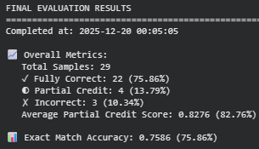
Performance Metrics
Metric | Score | Description
Exact Match Accuracy | 75.86% | Complete agreement with ground truth labels
Partial Credit Score | 82.76% | Weighted score accounting for overlapping labels
Fully Correct | 22/29 (75.86%) | All predicted SDGs match ground truth
Partial Credit | 4/29 (13.79%) | Some overlap with ground truth (multi-label cases)
Incorrect | 3/29 (10.34%) | No overlap with ground truth
Failed Extractions | 0/29 (0%) | All predictions successfully parsed

Key Observations
- Strong baseline performance: 75.86% exact match on a challenging multi-class task demonstrates effective knowledge transfer
- Robust reasoning: Zero failed extractions indicate the model learned to produce valid structured outputs
- Multi-label handling: The 82.76% partial credit score shows the model captures SDG overlaps, even when not perfectly aligned with ground truth
- Room for refinement: 10.34% error rate suggests further optimization potential—motivating the GSPO stage

STAGE2: GSPO – Group Sequence Policy Optimization:

While SFT achieved 75.86% exact match accuracy, it optimizes only for likelihood training the model to mimic the exact tokens in training examples. This approach has limitations: it treats all errors equally, cannot distinguish between "close" and "wrong" predictions, and lacks mechanisms to refine decision boundaries beyond the training distribution.
Group Sequence Policy Optimization (GSPO) addresses these limitations by framing fine-tuning as a reinforcement learning problem. Instead of maximizing likelihood of single ground truth responses, GSPO samples multiple candidate outputs and learns to prefer higher-quality predictions through reward-based feedback.

GSPO Methodology
Core Algorithm
GSPO extends the policy gradient framework with group-based sampling:
- Generate multiple candidates: For each input $x$, sample $K$responses: $\{y_{1},y_{2},...,y_{K}\}∼π_{θ}(⋅∣x)$
- Compute rewards: Assign scalar rewards $r(x,y_{k})$to each candidate based on quality metrics
- Relative ranking: Normalize rewards within each group to compute advantages
- Policy update: Increase probability of high-reward generations, decrease low-reward ones
Mathematical Formulation
The GSPO objective combines reward maximization with KL regularization to prevent the model from drifting too far from the SFT initialization:
$$L_{\text{GSPO}}(θ)=E_{x∼D,\{y_{k}\}_{k=1}^{K}∼π_{θ}}\left[\sum_{k=1}^{K}{A_{k}}log⁡π_{θ}(y_{k}∣x)\right]-β⋅D_{\text{KL}}(π_{θ}∥π_{\text{ref}})$$
Where:
- $A_{k}=r(x,y_{k})-\frac{1}{K}\sum_{j=1}^{K}{r(x,}y_{j})$is the advantage (reward relative to group average)
- $β$controls the strength of KL penalty (we use $β=0.01$)
- $π_{\text{ref}}$is the SFT model (reference policy)

Reward Function Design
We designed a custom reward function that captures both classification accuracy and reasoning quality:
Reward Components
Component | Value | Description
Partial Credit | +0.5 per correct label | Encourages multi-label recall
Perfect Match Bonus | +0.5 | Rewards exact ground truth alignment
False Negative Penalty | -0.4 per missing label | Penalizes incomplete predictions
False Positive Penalty | 0.0 | No penalty for extra labels (conservative approach)
Format Bonus | +0.1 | Rewards 3-step reasoning structure
Reasoning Bonus | +0.1 | Rewards use of causal language ("because", "analyzes")

Training Configuration
Dataset
- Source: 60 examples randomly sampled from split_2_final_classification_SFT_ChatML.jsonl
- Seed: 42 (reproducibility)
- Constraint: Limited by computational budget GSPO requires 4× generation overhead per training step.
- Implication: Training on the full 1,800 example split would require ~54 GPU-hours, exceeding project resources availability.

GSPO Hyperparameters
Parameter | Value | Justification
Optimization Steps | 150 | Sufficient for convergence on small dataset
Group Size (K) | 4 | Generate 4 candidates per prompt for comparison
Learning Rate | 1×10⁻⁶ | Very low—RL fine-tuning requires stability
KL Penalty (β) | 0.01 | Prevents catastrophic forgetting of SFT knowledge
Temperature | 0.7 | Encourages diverse exploration during generation
Max Completion Length | 1,500 tokens | Accommodates full reasoning chains
Batch Size | 1 per device | Memory constraints with 4× generation overhead
Gradient Accumulation | 4 steps | Effective batch size = 4
Precision | bfloat16 | Maintains numerical stability

Model Behavior Analysis: Consistency Tests
To assess whether GSPO improved prediction stability, we tested the model's consistency by generating 4 independent outputs for the same input.
Test Results
Test 1: Multi-label case (Solar panels on campus)
Generation | Predicted SDGs
1-2, 4 | SDG 13, SDG 7
3 | SDG 13, SDG 7, SDG 9
- Core labels consistent: SDG 13 and SDG 7 appeared in 100% of generations
- Minor variation: SDG 9 appeared in 25% (infrastructure-related, plausible but not primary)
Test 2: Negative case (Ambiguous policy text)
Generation | Predicted SDGs
All 4 | NOSDG
Perfect consistency: 100% agreement on negative classification
Test 3: Health intervention case (Rural vaccination program)
Generation | Predicted SDGs
All 4 | SDG 3, SDG 10

Perfect consistency: 100% agreement on health (SDG 3) and equity (SDG 10) themes
Analysis: The model exhibits high consistency on clear-cut cases while showing minor exploration on boundary examples ideal behavior for a calibrated classifier.

Final Performance Evaluation
We evaluated the GRPO-optimized model on 20 held-out test examples spanning all SDG categories.
Performance Metrics
Metric | SFT Baseline | GSPO | Change
Exact Match Accuracy | 75.86% | 40.0% | -35.86%
Average Recall | ~76% | 82.5% | +6.5%
Average Reward Score | ~0.73 | 0.980 | +0.25

Interpretation: The Accuracy-Recall Trade-off
The results reveal a critical shift in model behavior:
- Lower exact match accuracy: GSPO's 40% exact match represents a significant drop from SFT's 75.86%
- Higher recall: The model now predicts more SDG labels per example, capturing 82.5% of ground truth labels on average (vs. ~76% for SFT)
- Near-optimal reward scores: 0.980 indicates the model learned to maximize the custom reward function effectively
GSPO optimized the reward function's objectives which prioritized recall, reasoning quality, and penalized false negatives heavily. The model learned to predict more SDG labels to avoid missing relevant categories, trading precision for completeness.

Critical Limitation: Sample Size Constraint
The 60-sample training set is a major confounding factor. While SFT trained on 1,797 examples, GRPO saw only 3.3% of that data due to computational constraints. This creates several issues:
- Insufficient coverage: 60 samples cannot adequately represent the full diversity of SDG patterns across 18 classes (~3.3 examples per class)
- Overfitting risk: With only 150 optimization steps on 60 samples, the model may have overfit to the specific reward patterns in this small subset
- Biased evaluation: Testing on 20 samples means we're evaluating a limited view of the model's true capabilities
Computational bottleneck: GSPO's 4× generation overhead makes it ~4× more expensive than SFT per sample. Training on the full 1,800 example split would require approximately 54 GPU-hours—infeasible within project constraints.

Key Takeaways
- GSPO successfully refined the policy: The model learned to maximize reward signals, achieving near perfect reward scores (0.980)
- Reward design is critical: The observed accuracy drop demonstrates how RL fine-tuning amplifies the objectives encoded in the reward function for better or worse
- Sample efficiency limitations exposed: Training on only 60 samples (3.3% of SFT dataset) due to computational constraints likely prevented GSPO from reaching its full potential. The 4× generation overhead makes GRPO significantly more resource-intensive than SFT.
- Complementary approaches: SFT and GSPO optimize for different objectives. Hybrid deployment (SFT for precision, GSPO for comprehensive discovery) may be optimal
- Consistency improvements: GSPO reduced output variance, producing stable predictions across multiple generations

Both the models are available on Hugging face:
SFT – https://huggingface.co/Tilakcsp/qwen3-4b-sdg-16bit

GSPO - https://huggingface.co/Tilakcsp/qwen3-4b-sdg-gspo


References:
- https://unsloth.ai/
- https://osdg.ai/
- https://claude.ai/
- https://huggingface.co/
- https://colab.research.google.com/
- https://gemini.google.com/
- https://azure.microsoft.com/en-us
- https://ai.azure.com/foundryProject
- https://qwen.ai/

