**Appdynamics** is an Application Performance Management (APM) tool. **We** need **to** deploy **the Appdynamics** agents on the server machine which continuously monitor each server activity and reports it **to** controller(dashboard) **to** represent **the** data in graphical view.

The main competitors as pointed out are typically New Relic and Dynatrace, but there is a load of smaller competitors who may also fit your use cases.

**AppDynamics's Competitors, Revenue, Number of Employees, Funding and Acquisitions**

NAME AND DETAILS:-

<https://www.owler.com/company/appdynamics>

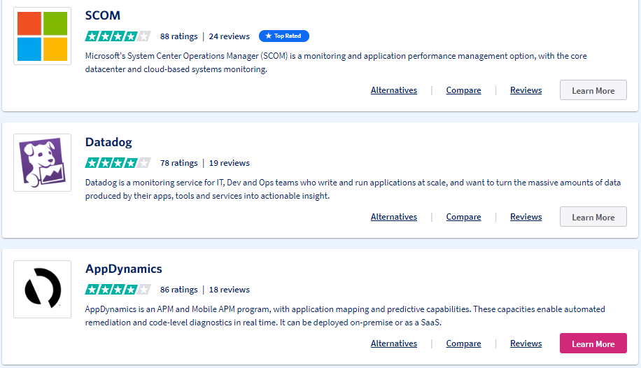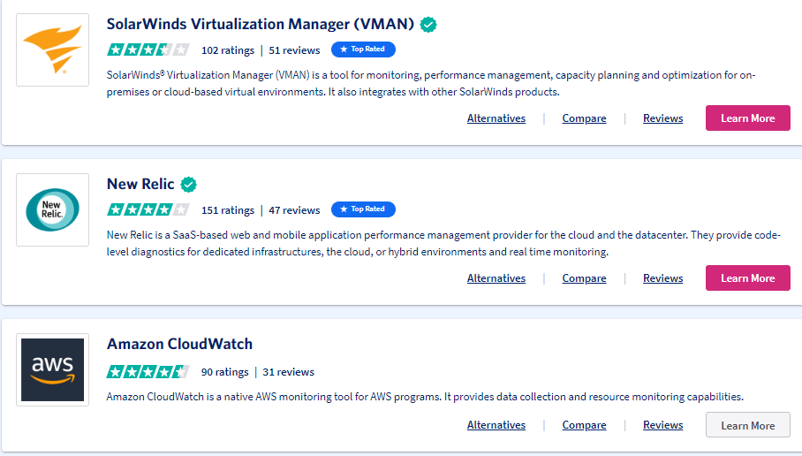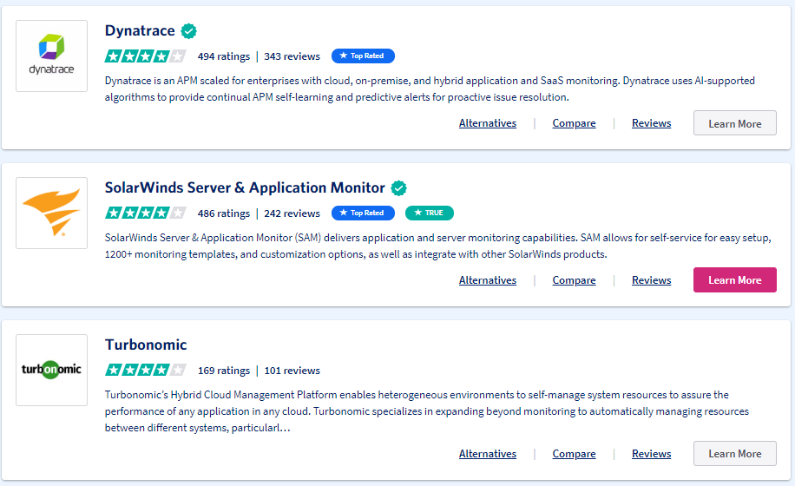

Study and setup the appdynamics

<https://www.perfrunners.com/p/appdynamics.html?m=1>

<https://www.quora.com/Is-the-future-of-AppDynamics-good-and-what-are-the-competetors>

### Pros and Cons

* I like the display. It is easy to understand and shows you the lines where something is wrong.
* I think that in the beginning the dashboards are a little hard to understand and confusing but over time you get to know them better

**COMPARISION OVER OTHER TOOL**

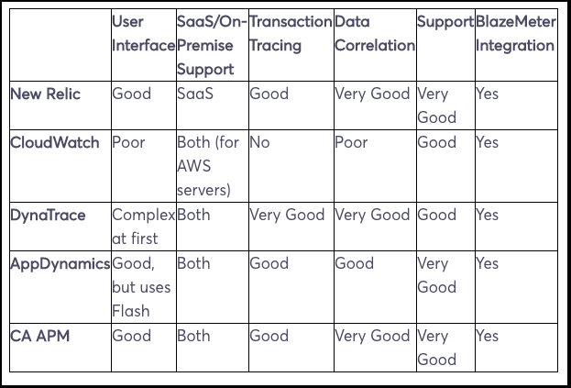

**Appdynamics Agents:**There are three types of appdynamics agents

·     **App Agent:** This agent is responsible to collect the application-specific data like server load, response time, errors, etc. We can have different-different types of app agent (Java agent, .NET agent, PHP agent, etc) based on application technology.

·     **Machine Agent:** Machine agents are responsible to collect the server hardware matrices like server CPU utilization, memory utilization, disk usage etc.

·    **DB Agent:** Database agents are responsible to collects performance metrics about your database instances and database servers. It tracks your queries, stored procedures etc.

**1.Server Monitoring** is the process of **monitoring** a **server's** system resources like CPU Usage, Memory Consumption, I/O, Network, Disk Usage, Process etc. **Server Monitoring** also helps in capacity planning by understanding the **server's** system resource usage.

2. **End User Experience Monitoring** (EUEM) Definition

**End User Experience Monitoring** enables teams to **monitor** the impact of application and device performance from the **end user's** point of view. EUEM products help IT ensure the quality of key IT services across an enterprise.

**3.Analytics:** The APM solution must provide domain-centric artificial intelligence for IT operations (AIOps) functions, using AI/machine learning (ML), here referred to as analytics.

**AIOps** (Artificial Intelligence for IT Operations) **AIOps** combines big data and machine learning to automate IT operations processes, including event correlation, anomaly detection and causality determination.

4. Database monitoring is the tracking of database performance and resources in order to create and maintain a high performance and highly available application infrastructure.  For example, categories for SQL Server, MySQL and Oracle database monitoring include:

* Query details (top CPU, slow running, and most frequent)
* Session details (current user connections and locks)
* Scheduled jobs
* Replication details
* Database performance

|  |  |
| --- | --- |
| Riverbed | Aternity |
| Instana | Instana |
| Microfocus | Microfocus |