SpiritForms 1.0

User Manual
Jan. 2026

SpiritForms was written with Paranormal Investigators and their clients in mind. Team members need a central location where they can collaborate, share information, and record the results of their investigations. And clients need an easy way to have immediate access to the investigation data and final reports. SpiritForms gives them just that - direct access. All the time. Anytime.

In a hosted environment, globeadmin (superuser) and Team Members can log in and create new investigations, add details, view reports, and send emails. Clients can log in, view their case investigations data, export and download it, and also view and download completed Reports.

This user manual assumes that you have completed ALL steps in the SpiritForms 1.0 Installation Manual. If you have not done so, please do it now.



Key Concepts

Case: A named situation or location (e.g., “Smith Residence”)
Investigation: A single visit or session related to a case
Case Investigation #: The sequence number of an investigation within a case
Investigation #: The global, system-wide investigation identifier

Requirements:

There are just two user requirements to use SpiritForms:

1. Google Chrome browser
2. custom Chrome extension: ‘Capture Page Chrome Extension’ (for downloading Reports). Please see the README.txt file included in the .zip file for complete instructions for installing this extension. It is recommended that all users (especially clients) read the instructions and install the extension.
The Chrome extension is only required for downloading reports as ZIP files. Reports can still be viewed in the browser without the extension.

Users

globeadmin

Upon installation of nuBuilder Forte 4.9.2, a ‘master user’ called ‘globeadmin’ is created. This user has access to everything in nuBuilder and has access to everything in the SpiritForms application. globeadmin in nuBuilder is considered equivalent to ‘God Mode’ on a Windows computer.

***WARNING TO GLOBEADMIN USER:***
Unless you know exactly what you are doing (at a programming level), DO NOT CHANGE ACCESS LEVELS OR ACCESS LEVEL SETTINGS for ANY USER. Doing so can create instability and or break functionality for those users.

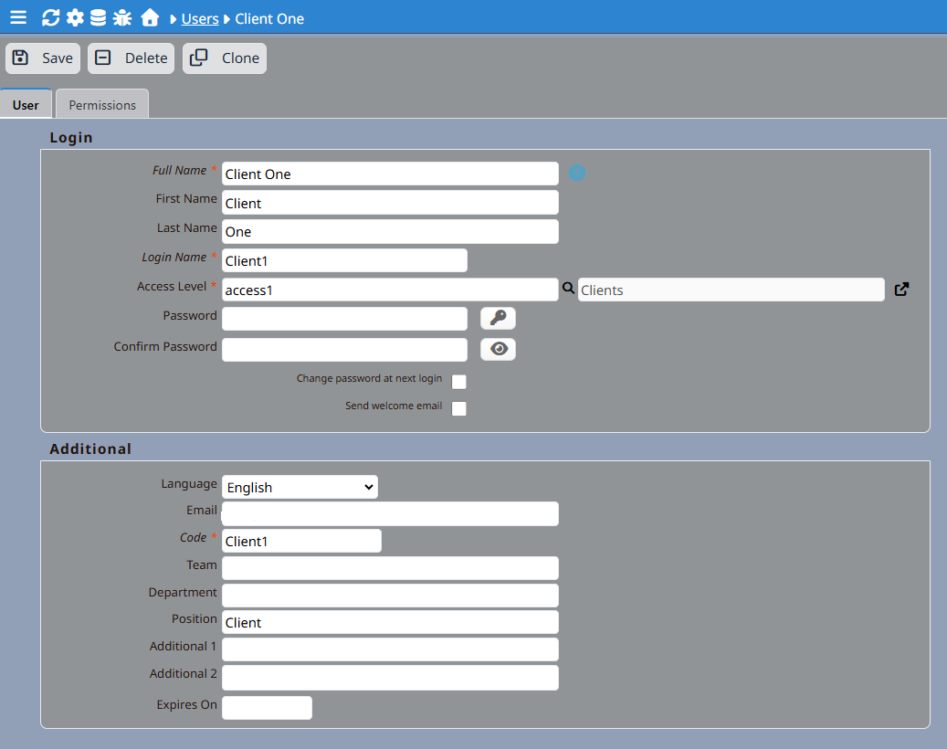

‘access1’ Access Level (Clients only)

‘access1’ Access Level in nuBuilder allows clients to 1) login, 2) view their case investigation(s) information, 3) export all the investigation(s) data to their computer, and 4) view & download their completed Reports.

Creating Client Users

When creating new ‘Client’ users (done by globeadmin only), you must assign them Access Level ‘access1’. No exceptions.

Full Name, Login Name, Access Level and Code are all required. If left blank, the Code field will automatically be populated with the Login Name as the Code. Although the nuBuilder user interface does not explicitly require ‘Position’ or ‘Email’ to be populated for saving the new user record, they are both required fields for Email functionality in SpiritForms. You must enter Client as the Position for all new Clients and you must also enter their email address. When entering the email address, do NOT enable the Send welcome email checkbox. This nuBuilder functionality is not used. See ‘Sending Email’ later in this guide.

‘Admin’ Access Level (Team Members)

Consider ‘Admin’ Access Level a ‘Team Member’ access level. You must assign the ‘Admin’ Access Level to any new Team Member. This access level allows access to some things that the globeadmin user can do, but not all:

1. Admin level users (or any other user besides globeadmin) cannot upload files to the application. Their access to Tiny File Manager (the file upload and management tool) is locked and prevents this. This is a built-in nuBuilder constraint. (See ‘User Access to Tiny File Manager (Advanced / High-Risk)’ . The reason for blocking Admin level users from Tiny File Manager is to protect data integrity, establish audit control, and provide consistency across the application.

2. Admin level users do not have access to the Report Editor tab. Why? Because by nuBuilder design, they don’t have access to Tiny File Manager. Without access to the files in Tiny File Manager, they cannot insert multimedia into SpiritForms Reports. Admin level users can only view SpiritForms reports.

3. Admin level users do not have access to User creation or maintenance. Only globeadmin has access. This is a security precuation.

4. Admin level users do not have access to ‘Email Manager’ (mass delete of emails) of SpiritForms. Only globeadmin has access. That is by design. They can, however create and send emails.

5. Admin level users do not have access to ANY nuBuilder form creation or editing or any other ‘superuser’ functionality. This is by inherent nuBuilder design and is established for security purposes.

Adding a New Investigation

When a user clicks on the plus sign to add a new Investigation, they are taken to the first tab (‘Location and Contact’) of the Edit form.

Location and Contact Tab

Case Name

If entering a new case name, type the name. If you are entering a new investigation regarding an existing case, then select the appropriate case name from the Select an Existing Case drop-down.

Edit Case Name (What this means)
If you accidentally selected the wrong Case Name when creating the investigation record (and the correct Case Name already exists in the drop-down list), then simply select the correct case name from the drop-down and save the record. The internal associated Case Name ID will be automatically applied.
In some situations, however, you may realize that an existing investigation record actually represents a different case that does not already exist in the drop-down.
The “Edit Case Name” option exists for exactly that reason.

When to use it
Use this option only for existing records when:
- A Case Name was entered incorrectly
- A record was accidentally linked to the wrong case
- An investigation should be reassigned as a separate case
- The desired Case Name did not already exist in the Case Name drop-down, but an existing case was accidentally selected and the record was already saved

How it works
- Check Edit Case Name
- Edit the Case Name as needed
- Save the record
When saved, the system will:
- Assign a new internal case identity to the record
- Detach it from the previously selected case
- Treat the edited Case Name as a new, independent case

Important notes
- This action affects only the current record
- The previous Case Name is replaced, not preserved
- No duplicate case record is created automatically
- Simply changing the Case Name does not create a new case unless this box is checked
- After saving, the option automatically resets

In short
“Edit Case Name” reassigns the current record to a new case. It does not keep a copy of the previous case name.

Initial Contact Date

The date entered here is the date/time when contact was first made with the client.

Investigation #

This number represents the unique investigation number. It is automatically generated upon new record creation and is read-only.

Case Investigation #

Each case may have several investigations associated with it. This number represents the number of the investigation that is associated with the current case. It is automatically created when a new investigation is created and is associated with an existing case. It is also read-only.

Location Name

The name entered here is not required, but can help identify the location. There may be several buildings on the same property and each investigation may be conducted entirely in different buildings.

Compare

This field is for selecting and viewing another investigation that is associated with the current case and comparing the details with the current investigation. When the user selects a case from the drop-down, the other case is opened in a popup window. Users can adjust the popup settings as desired.

Street, City, State/Province, Country, Directions, Contact Phone

These fields are self explanatory.

Contact Name

After a client user is added to the system, a client name is selected from this field to associate the selected client with the investigation.

Resident/Property Owner’s Name, Owner’s Phone

If the current resident of the property is different than the client, enter that person’s name and phone number here.

Owner Contacted, Permission Waiver Signed, Privacy Notice Requested

If these actions have been taken, enable the check-boxes.

Notes

Add any notes that are relevant to the investigation.

Sending Email

The fastest (and simplest) way to send a welcome email to new users is by using the ‘Send Email’ button on the main form. SpiritForms does NOT use nuBuilders’ native email system. Instead, a separate email system was added when SpirirtForm was created. It is easy to use and does not require complicated setup. No hassle with templates or codes or special code-writing sessions. Just click a couple of buttons, and your email is ready to go. You can access email from the User Home or from an investigation record. When creating an email from an investigation record, the email address is automatically populated with the clients’ email address and the subject is also automatically populated with the case name and investigation number.

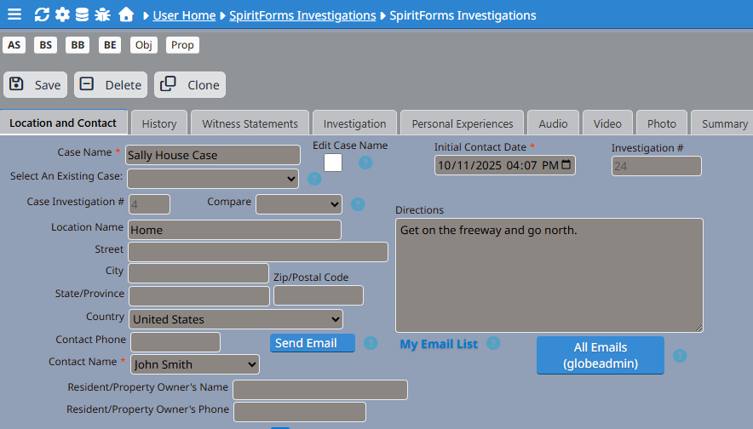

Email Visibility
When users click on the ‘Open Email List’ link, they see only the emails they personally created, including drafts and sent messages. Globeadmin users can view all emails for auditing and support purposes. This prevents accidental exposure of draft emails while still allowing globeadmin administrators full oversight.
Client Email Responses
Replies to emails sent from SpiritForms are delivered to the system email inbox configured in Setup → Email.
Client responses are not imported automatically. Relevant replies should be reviewed and then manually added to the associated investigation using Emails From The Client on the Location and Contact tab. This ensures that only appropriate, relevant, and verified communications become part of the investigation record.
The suggested way to add them is to:
1.) In the email client, select an email. Use the ‘Forward’ feature of the email client to open a new email.
2.) Copy the entire email including the message header
3.) Paste the message into the WYSIWYG editor using CTRL-SHIFT-V (Windows) or CMD-SHIFT-V (Mac). This pastes the message in plain text format.
4.) Enter a horizontal line at the top and bottom of the email to create a visual separator (enter three dashes --- and then the space bar).
5.) Save the record.
Now you have a chronological history of all emails from the client in one place. When clicking the ‘Send Email’ button, the Email Composer window will be situated to the left of the WYSIWYG editor.

History Tab

Location History

Enter a brief history of the property. If there are supporting research documents, use the Upload History/Research Documents button to upload them to the server. Only users with Tiny File Manager permissions have this feature available to them. Once the documents have been uploaded, users can create a .zip file containing all of the history research documents using Tiny File Manager. The .zip file can then be downloaded using the Download Documents button.

User Access to Tiny File Manager (Advanced / High-Risk)

If you don’t fully understand nuBuilder’s file structure, do not enable Tiny File Manager for any user.

By default, nuBuilder users (other than globeadmin) do NOT have access to Tiny File Manager (TFM).
This restriction exists for good reason.

It is possible to grant access to individual users, but doing so carries security risks.

⚠ WARNING — RISK
Granting Tiny File Manager access allows the user to browse the entire nuBuilder file system, including sensitive files such as:

-nuconfig.php

-PHP core files

-third-party libraries

-uploaded files belonging to all cases and users

This is equivalent to granting partial server-level access.
Apply this setting only to trusted technical users and never to clients.

⚠️ IMPORTANT: Access-Level Side Effects

SpiritForms contains custom access-level logic and JavaScript restrictions that assume:

-Only globeadmin has unrestricted file-system access

-Other users are sandboxed via form logic, buttons, and permissions

-Granting Tiny File Manager access bypasses many of those assumptions.

This may result in:

-Users seeing files they were never meant to access

-Inconsistent behavior between forms

-Access paths that ignore SpiritForms’ role-based safeguards

In short:
TFM access operates outside SpiritForms’ normal security model.

How to Grant Access (If You Absolutely Must)

1️. Modify nuconfig.php

Add the following line, replacing the ID with the User Record ID of the person you are granting access to.

For example:
//Tiny File Manager users - Edit CAREFULLY.
$nuConfigFileMangerUsers = "65046e167e07b56,58f0e5fb18f0e21"; // User IDs with Tiny File Manager permission (comma-separated)

These are User Record IDs, not usernames

2️. To Retrieve the User Record ID

Log in as globeadmin

In the Users form:

Open the relevant user

Press CTRL + SHIFT + M

Copy the Record ID (primary key)

3️. Restart Your Browser

Changes to nuconfig.php are cached.
You must fully restart your browser before the new permissions take effect.

🧠 Recommended Best Practices

✅ Prefer controlled upload buttons inside SpiritForms whenever possible

✅ Restrict Tiny File Manager access to:

-globeadmin

-trusted technical administrators only

❌ Never grant TFM access to clients or non-technical users

❌ Do not assume SpiritForms access levels will protect files once TFM is enabled

📌 Summary (Plain English)

Tiny File Manager access is powerful, global, and blunt.
SpiritForms access control is granular and intentional.
Mixing the two should be done rarely, knowingly, and cautiously.

Historical Researcher/Compiler
Select the Team Member(s) who conducted the research.
Building & Property Description, Rooms, Other Structures
Enter the descriptions for the property and buildings (homes, garages, sheds, sheds, etc.).
Areas of Reported Paranormal Activity
List all areas of reported paranormal activity here, including brief descriptions of the activity.
Recent Remodel/Construction/Renovations?
If there have been any recent modifications/updates or renovations to any of the buildings, tick the check-box and briefly list them in the Remodel/Construction/Renovation Notes field.
Has a priest blessed the home?
If true, tick the check-box. If the priest had mentioned any odd activity during the blessing, make note of it in the Priest Blessing Notes field.

Witness Statements Tab
Enter witness names and their experiences on this tab.
Investigation Tab
Investigation Start Time, Investigation End Time
If an investigation has been done, it is important to enter the start and end times of the investigation in the appropriate fields (Investigation Start Time and Investigation End Time). If Investigation Start Time is not entered, then the Report (on the Report Editor tab) cannot be marked as complete.
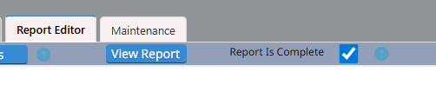

Investigators Present
Select the investigators that were present during the investigation.

Others Joining the Investigation
If there were any others (the client, friends or relatives of the client, etc.) present during the investigation, enter their names here.
Weather Conditions
Enter the weather conditions that existed during the investigation (rain, wind, temperature, precipitation, etc.).
Moon Phase at Time Of Investigation
Select the moon phase that existed at the time of the investigation. A “Lunar Calendar” link to an external web site is provided to assist with this information. Because web sites come and go frequently on the internet, this link may or may not work. Enter the hyperlink to the image of the moon phase in the Moon Phase Image URL field. It may be necessary to download the moon phase image, upload it to the server, and enter that link in the Moon Phase Image URL field. A field and upload button are provided for that purpose.
Devices Used
Select the devices that were used during the investigation. If a device is not listed, it can be added (with globeadmin user only) by editing using the Edit Devices List button on the Maintenance tab.
Phone Apps Used
Select the phone apps used during the investigation. If an App is not listed, it can be added (with globeadmin user only) by editing using the Edit Phone Apps List button on the Maintenance tab.
Computer Apps Used
Select the computer apps used during the investigation. If an App is not listed, it can be added (with globeadmin user only) by editing using the Edit Computer Apps List button on the Maintenance tab.
Anomalous Readings, Anomalous Readings Date/Time
Enter anomalous readings measured from devices. Add the Date/Time provided in the Date/Time field provided.
Additional Notes & Observations
Enter any additional notes and observations from the investigation.
Personal Experiences Tab
Enter personal experiences here. Be sure to also select the investigator(s) who had the experience and the date/time the experience took place.

Audio Tab
Audio Description, Audio Time
Enter a detailed description and date/time of the audio recording. Use the Upload Audio Files button to upload the file(s). Only globeadmin or users with Tiny File Manager permissions may upload files. Once files are uploaded, copy the urls of the files from Tiny File Manager into the spaces provided in the form, then click each Listen button to listen to the audio files. In Tiny File Manager, create a .zip file of all the uploaded audio files. Then click the Download Audio Files button to download the .zip file. All users have access to the Download Audio Files button.
Video Tab
Video Description, Video Time
Enter a detailed description and date/time of the video recording. Use the Upload Video Files button to upload the file(s). Only globeadmin or users with Tiny File Manager permissions may upload files. Once files are uploaded, copy the urls of the files from Tiny File Manager into the spaces provided in the form, then click each Watch button to watch the video files. In Tiny File Manager, create a .zip file of all the uploaded video files. Then click the Download Video Files button to download the .zip file. All users have access to the Download Video Files button.
Photo Tab
Photo Description, Photo Time
Enter a detailed description and date/time of the photo. Use the Upload Photo Files button to upload the file(s). Only globeadmin or users with Tiny File Manager permissions may upload files. Once files are uploaded, copy the urls of the files from Tiny File Manager into the spaces provided in the form, then click each View button to view the photos. In Tiny File Manager, create a .zip file of all the uploaded photo files. Then click the Download Photo Files button to download the .zip file. All users have access to the Download Photo Files button.
Summary Tab
Enter a brief summary of the investigation.

Report Editor Tab (globeadmin only)
Report Templates
Before creating a Report, select a template from the Select a Template drop-down. The SpiritForms application comes with pre-defined templates, but they are used as placeholders only. Only the globeadmin user can create/edit templates. They are accessed from the Maintenance tab.
After selecting a report template, click the Copy HTML Template button. This places the HTML template into the clipboard. Now click Tools > <> Source Code in the WYSIWYG editor. This opens the Source Code window. Paste the source code into the window using CTRL-V. Now you can edit the source code to complete the report. Get multimedia urls from Tiny File Manager by clicking the Get Media URL’s button or by copying them from the Audio, Video and Photo tabs.
To view the report as it will appear to the client, click on the View Report button. It will open a new tab with the report. The report header will provide Investigation Number, Case Name, Contact Name, and Investigation Date.
When the report is complete, click the Report Is Complete check box. This allows the client to view and download the report. Be aware that Investigation Start Time (Investigation tab) must be entered before the Report can be marked as complete. A reminder will be triggered if Investigation Start Time has not been populated.
A quick, but very important distinction here between SpiritForms ‘Reports’ and nuBuilder ‘Reports’. SpiritForms Reports are NOT nuBuilder reports. nuBuilder has its own built-in Reports functionality which is not user friendly AT ALL. Hence the reason why I adapted the nuBuilder ‘Notes’ functionality for creating SpiritForms Report templates.

Maintenance Tab (globeadmin only)
Add/Edit All Users
This is where all users are added or maintained. It is accessible by globeadmin users only.
Edit Devices List
Devices used in investigations are added, modified, or removed here. It is accessible by globeadmin users only.
Edit Phone Apps List
Phone apps used in investigations are added, modified, or removed here. It is accessible by globeadmin users only.
Edit Computer Apps List
Computer apps used in investigations are added, modified, or removed here. It is accessible by globeadmin users only.
Manage Report Templates and Notes
Clicking this button takes the globeadmin user to a Notes page. ‘Notes’ in nuBuilder are intended for notes only, but they have been repurposed in the SpiritForms application for use as Report Templates. You will notice that each of the pre-existing SpiritForms templates have been placed in the ‘Reports’ category and regular Notes are placed in the Notes category. This separation allows the Reports creator to select the template in the Select a Template drop-down in the Report Editor tab.

User Workflows
When logging in, each user type will see different things. This is intended.

Login
Because globeadmin users have access to everything, they will initially see this:
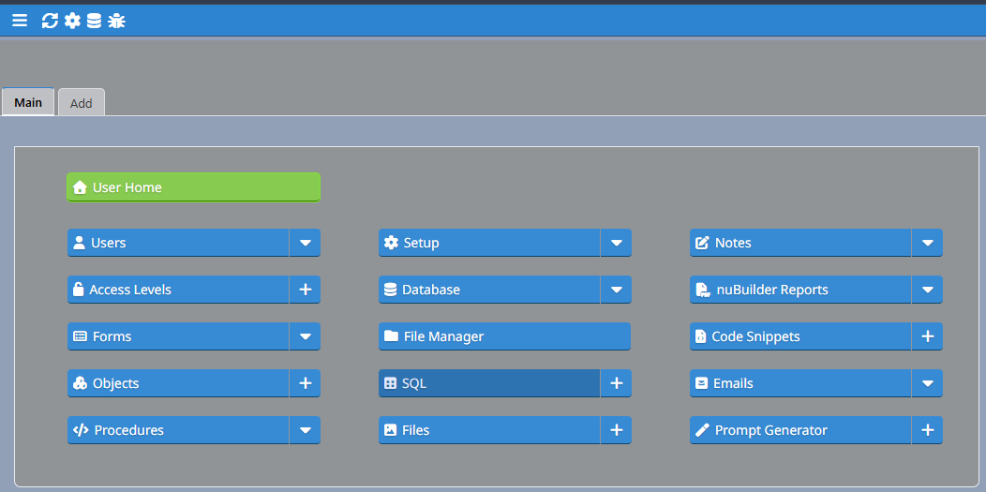

User Home
When globeadmin clicks on the green User Home button, they see this:
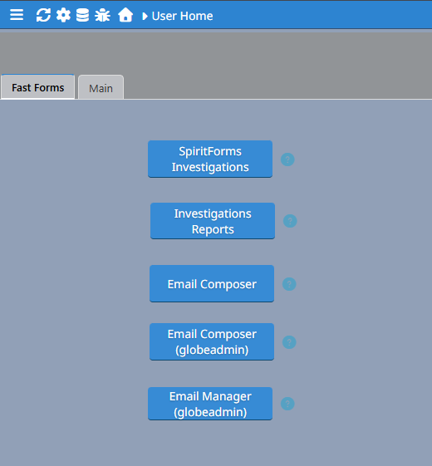

Email Composer (globeadmin)

This button is only visible to globeadmin users. When clicked, the user is taken to the Email Composer where globeadmin sees not only their own emails, but also all emails created by everyone else. This is by design for administrative purposes.

Email Manager (globeadmin)

This button is also only visible to globeadmin users. When clicked, the user is taken to the Email Manager where globeadmin sees all emails by all users and also sees their status (sent, draft). This is by design for administrative purposes. In this view, the globeadmin has permissions to delete old sent (or draft) emails.

Admin and Client User Home

Admin and client users have different User Home pages, which limits their access. Admin users have access to the first three buttons, while client users have access to just the first two.

Admin User Home:

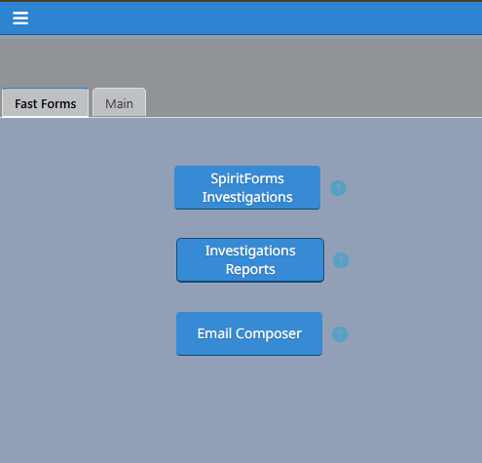

SpiritForms Investigations

When any user clicks on the blue SpiritForms Investigations button from User Home, they see the Investigations ‘Browse’ form. This is the list of all SpiritForms Investigations and their related cases.

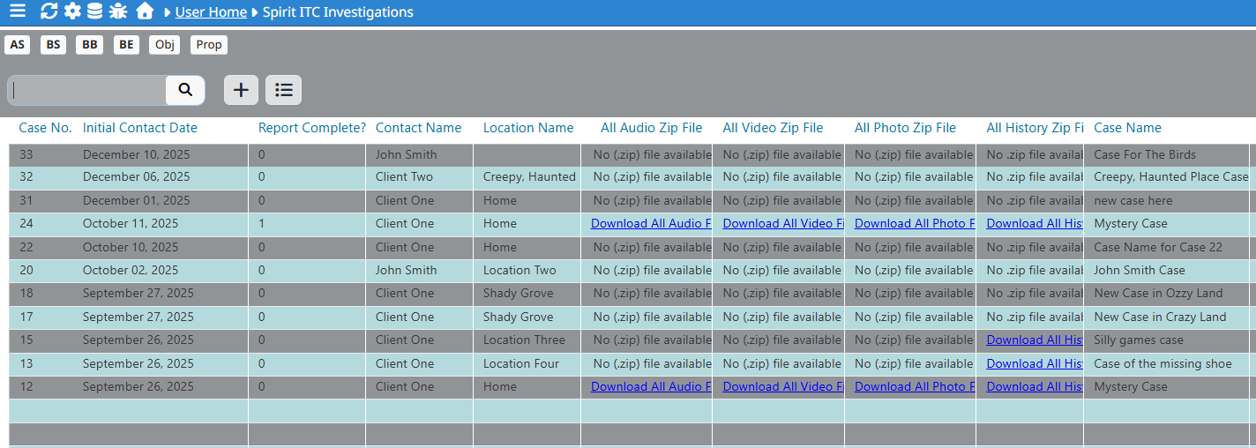

From here, globeadmin (and ‘Admin’ users) can browse most of the data for every investigation. At a glance, you can see details quickly for every case. Both globeadmin and Admin users can Search, Add and Export investigations. Client users, however, can only export their own investigations data. This is by design.

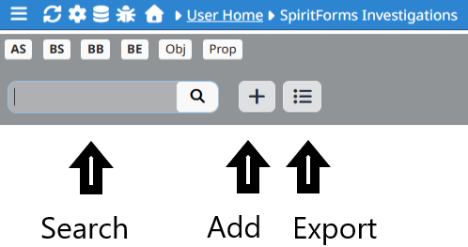

Investigations Reports
When globeadmin clicks on the Investigations Reports button, he/she sees all Reports. Admin users can browse and view reports, but do not have permissions to create them unless specifically given access to Tiny File Manager which is required for reports.
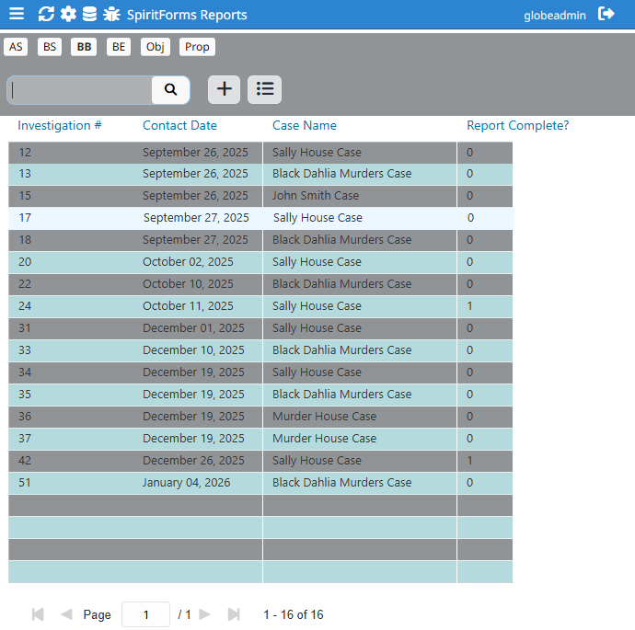

When clients are logged in, they see only Reports that are marked as ‘Complete’.

Client User Home

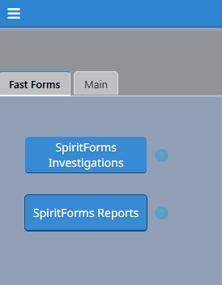

Client User SpiritForms Investigations

When Client users access the SpiritForms Investigations area, they see only the investigations that are associated with their case(s). For example, in the image below, we see that ‘Client One’ sees investigations for two different cases that are associated with them.

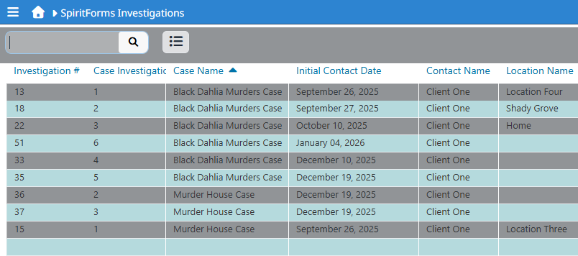
When a Client user clicks on any of the investigations, an ‘Access Denied’ message appears. This is by design. We don’t want clients changing any data. However, Client users have permissions to download all of the investigations data associated with all of their case(s) by clicking on the Print icon (highlighted in red above). When Client users click on the Print button, they are presented with a new browser tab.
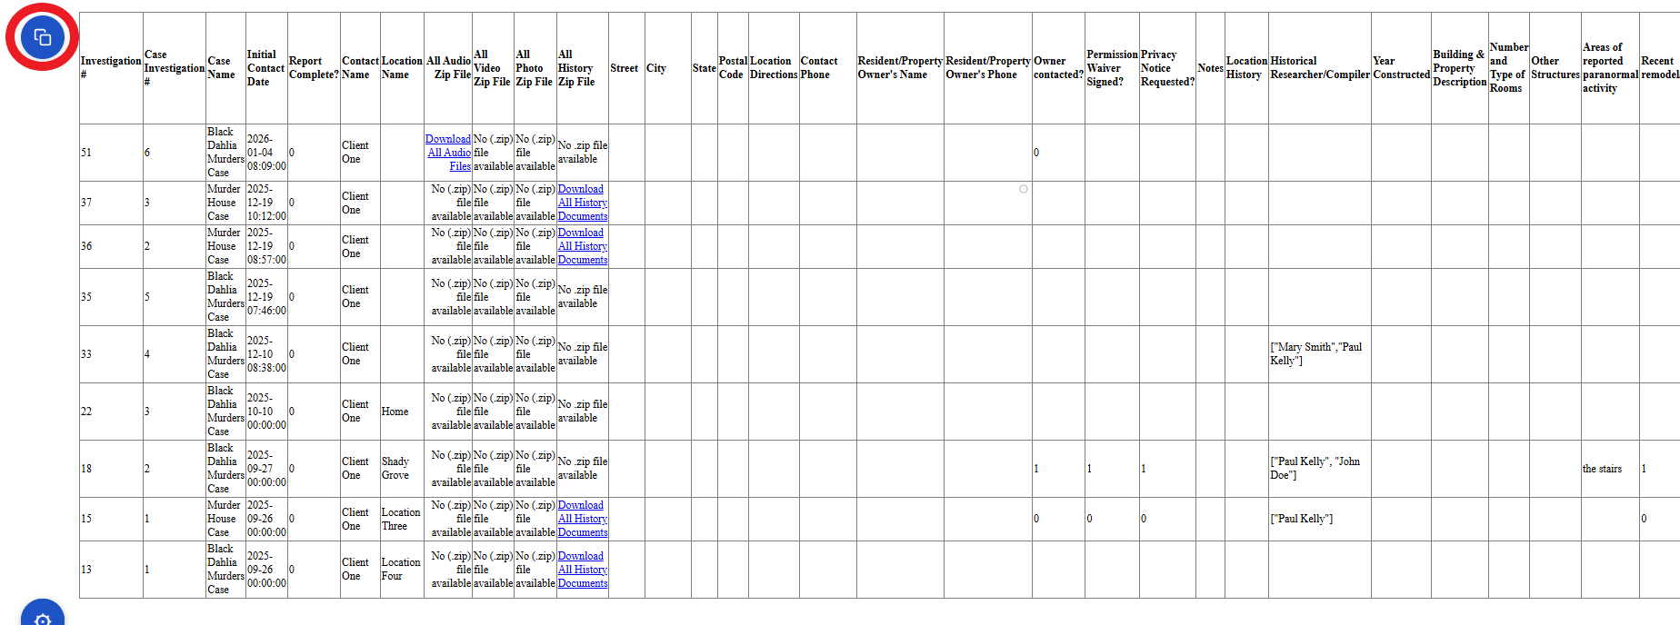
There will be a blue icon in the upper left corner of the new window (highlighted in red above). When the Client user clicks on this button, the data will be copied to the clipboard and this message will appear:
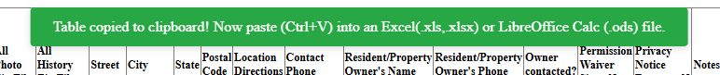
To save the data, the user must have either
1. Microsoft Excel or
2. LibreOffice Calc (free)
installed on their computer.

With either of the two clients installed, the user can then:
1. open a new Excel or Calc document
2. paste the data into the new document (CTRL-V).

Within the browser window, Hyperlinks to the individual multimedia documents and .zip files will allow the Client user to either download the evidence files individually or download the .zip files to their computer.

Client User SpiritForms Reports

When the Client user clicks on the SpiritForms Reports button, they are taken to the list of Reports that have been completed. If the Report for an investigation is not marked as complete, it will not be available to the client.

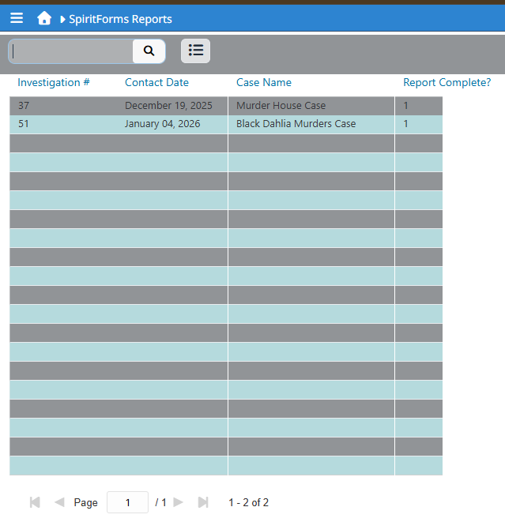

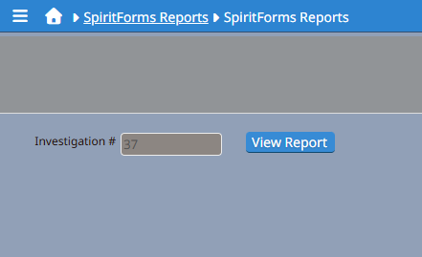
When a Client user clicks on one of the Reports from this window, another window will appear.

Clicking on the ‘View Report’ button will open the Report in a new browser tab.
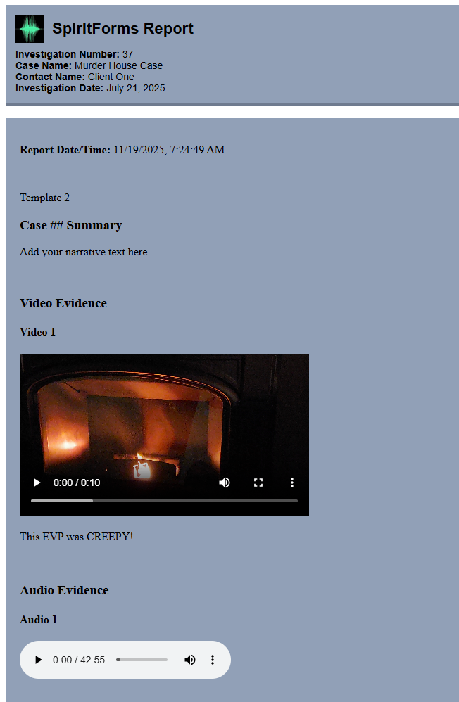

If the Client user has properly installed and configured the ‘Capture Page Chrome Extension’, they will see an ‘S’ icon in the upper left of the Chrome browser.
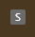

Clicking on this icon will display the ‘Capture page as ZIP’ button. Clicking on the ‘Capture page as ZIP’ button will launch the Report capture and download sequence. Once the capture and download is complete, there will be a message ‘Capture Complete. Zip downloaded.’ followed by a new download window that will allow the user to save the .zip file. The files can then be extracted from the .zip file for viewing the Report on the users’ computer.

Tiny File Manager (Uploading files)

As previously stated (see User Access to Tiny File Manager (Advanced / High-Risk)), access to Tiny File Manager (which allows for uploading files to the server) only exists for globeadmin and specific users who have been granted this special access. This section outlines the use of Tiny File Manager in SpiritForms.

When Investigations are created, SpiritForms automatically creates upload folders for each investigation at the same time. Each investigation then has its own set of upload folders. For example, case 12 folders are:

/uploads/Investigation 12/Evidence/
/uploads/Investigation 12/Evidence/Audio
/uploads/Investigation 12/Evidence/Video
/uploads/Investigation 12/Evidence/Photo
/uploads/Investigation 12/History/

When a user with Tiny File Manager credentials clicks the ‘Upload Audio Files’ button, they are automatically taken to the Audio folder for that investigation. The same applies when uploading videos, photos, and history documents.
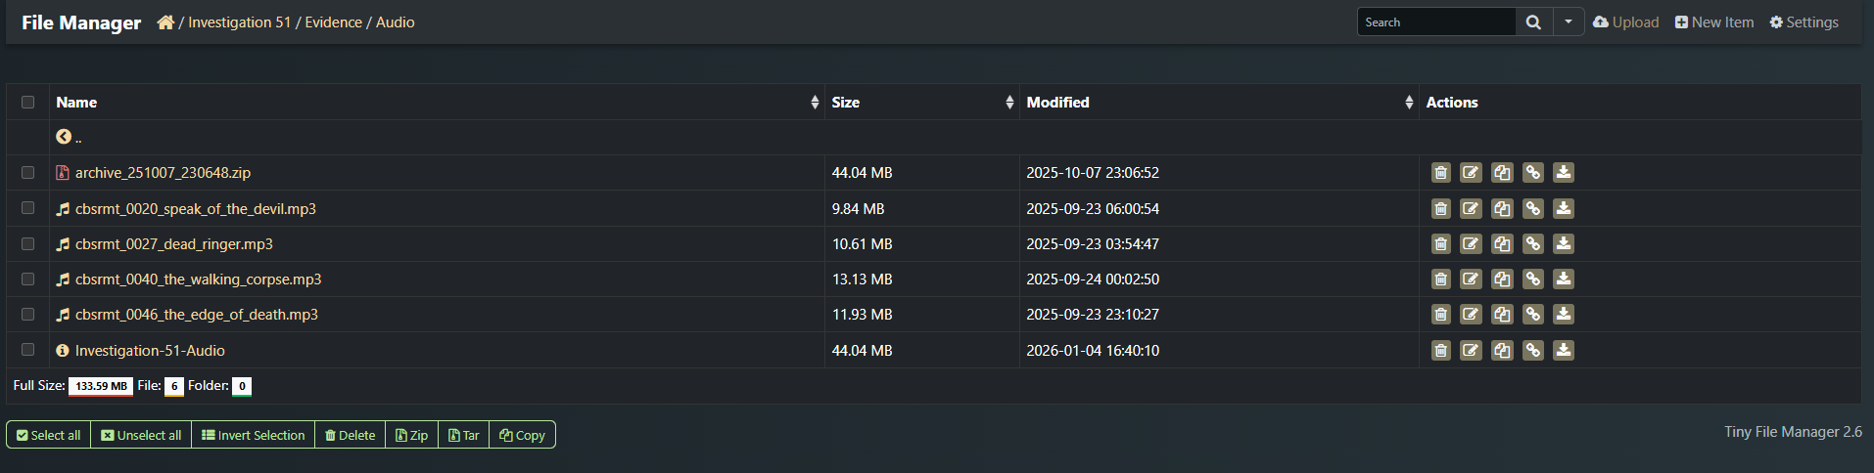
To the left is the list of audio files that have been uploaded. To the right, there are ‘Actions’ icons that represent what the user can do with each file. Right-clicking on the link icon allows copying the hyperlink to that selected file. The other buttons are self-explanatory. Play with it. Learn what you can do by using it. It is a powerful tool and it is easy to use – not rocket science.

