**Assignment :613**

Name : Prashant kumar

Scholar number : 192120044

MCA : 3rd semester

Subject : Windows Programming and Scripting languages

**Hypertext Mark-Up Language (HTML)**

HTML stands for Hyper Text Mark-up Language.  
HTML is the standard Mark-up language for creating Web pages.  
HTML describes the structure of a Web page.  
HTML consists of a series of elements.  
HTML elements tell the browser how to display the content

**HTML Elements Used in the Website :-**

**< !DOCTYPE html>**

It shows that this is a html document.

**<html>**

This element represent the root of an html document.

**<head>**

It represents a collection of metadata for the document , and title , and internal style.

**<meta>**

It represents various kinds of metadata.

**<title>**

It represents title of the document.

**<charset=”UTF-8”>**

It is an attribute which declares the page’s character encoding.

**<body>**

It represents the content of the document.

**<header>**

The <**header**> **element** represents a container for introductory content or a set of navigational links

**<! - - comment - - >**

For comment,

**<link rel=” “ href=”” >**

To include external css

**<script src=”” > </script>**

To include external js.

**<h1> to <h6>**

Heading tags

**<p>** paragrapgh tag

**<strong>** to bold characters.

**<br>** to break line

**<ul>**

The **HTML** <**ul**> **element** represents an unordered list of items, typically rendered as a bulleted list

**<a href=”” alt=””> </a>**

Anchor tag : It is used to define the beginning and end of **a** hypertext link. Search engines use the **tag** to determine the subject matter of the destination URL. Users click on the **anchor** text to reach the link target.

**<style>**

The <**style**> **tag** is used to define **style** information (CSS) for a document. Inside the <**style**> element you specify how HTML elements should render in a browser.

**Block Element:**

The <**div**> **tag** defines a division or a section in an HTML document. The <**div**> **tag** is used as a container for HTML elements - which is then styled with CSS or manipulated with JavaScript. The <**div**> **tag** is easily styled by using the class or id attribute

**Inline Element:**

An inline element does not start on a new line and it only takes up as much width as necessary.

This is a <span> element inside a paragraph.

**<footer>**

The <**footer**> **tag** defines a footer for a document or section ,Tips , Contact information.

**Cascading stylesheet ( CSS ) :**

CSS stands for Cascading Stylesheets.  
CSS is used to give style to our web pages.  
CSS is used to make website responsive.  
CSS takes responsibility of design.

**CSS Elements used in this Website:-**

**Css syntax:**

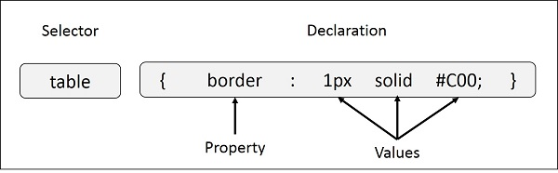

**Three ways to add css to the markup**INLINE CSS :  
CSS is added to the element directly using style attribute.  
INTERNAL CSS :  
CSS is kept inside the head tags in style tag.  
EXTERNAL CSS:  
CSS is kept separately inside a .css stylesheet.

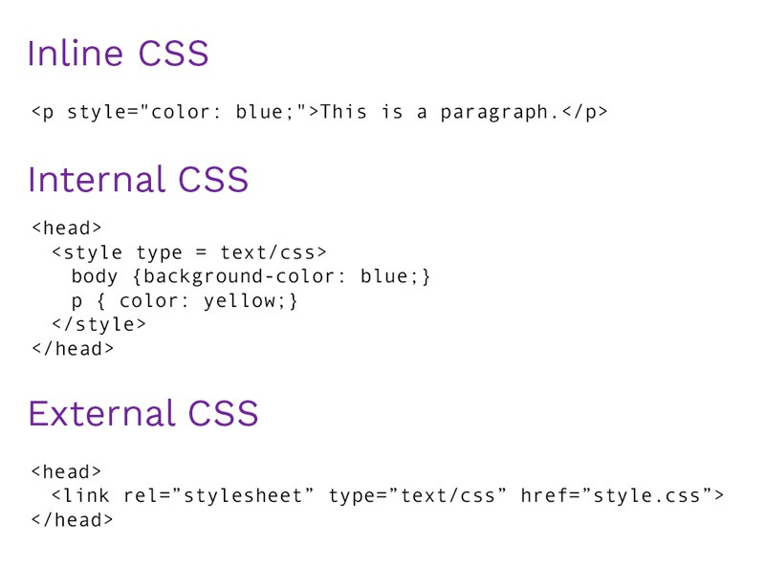

**CSS Selectors**  
CSS Selector are used to find the element whose properties will be set.  
Selector are used to target the HTML.

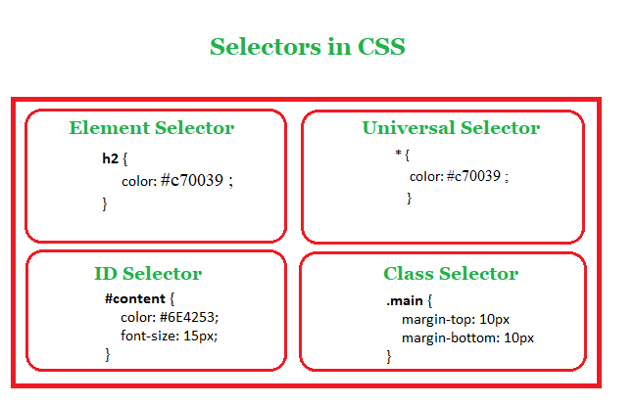

**CSS Margin :**

The **CSS margin** properties are used to create space around elements, outside of any defined borders. With **CSS**, you have full control over the **margins**. There are properties for setting the **margin** for each side of an element (top, right, bottom, and left).

**CSS Padding:**

The CSS padding properties are used to generate space around an element's content, inside of any defined borders. With CSS, you have full control over the padding. There are properties for setting the padding for each side of an element (top, right, bottom, and left).

**CSS Fonts:**

The **CSS font** properties define the font family, boldness, size, and the style of a text.

**CSS Border:**

The **border** property is a shorthand property for: **border**-width · **border**-style (required); **border**-color.

**CSS Background :**

The **background** property in **CSS** allows you to control the **background** of any element (what paints underneath the content in that element). It is a shorthand property, which means that it allows you to write what would be multiple **CSS** properties in one.

**CSS Display:**

The **display** property specifies the **display** behavior (the type of rendering box) of an element.

**CSS Text Formatting:**

CSS text formatting properties is used to format text and style text.  
CSS text formatting include following properties:  
1.Text-color  
2.Text-alignment  
3.Text-decoration  
4.Text-transformation  
5.Text-indentation  
6.Letter spacing  
7.Line height  
8.Text-direction  
9.Text-shadow  
10.Word spacing

**JavaScript:-**

JavaScript an object-oriented computer programming language commonly used to create interactive effects within web browsers.

**What is JAVASCRIPT**  
JavaScript was initially created to “make web pages alive”. The programs in this language are called scripts. They can be written right in a web page’s HTML and run automatically as the page loads. Scripts are provided and executed as plain text. They don’t need special preparation or compilation to run. In this aspect, JavaScript is very different from another language called Java.

**Why Use JAVASCRIPT**  
Add new HTML to the page, change the existing content, modify styles. React to user actions, run on mouse clicks, pointer movements, key presses. Send requests over the network to remote servers, download and upload files (so-called AJAX and COMET technologies). Get and set cookies, ask questions to the visitor, show messages. Remember the data on the client-side (“local storage”).

**The script Tag**In HTML, JavaScript code is inserted between script tags. We can place any number of scripts in an HTML document. Scripts can be placed in the body , or in the head section of an HTML page, or in both.