

**PROJECT**

**oN**

**PLANT AND CORP MONITORING SYSTEM**

**(based on Iot)**

**MEMBER:-**

Pawan Vishwakarma (B.tech 2nd year)

Siddharth Singh (BCA 2nd year)

**Idea:-**

Farming in India is done using the mundane ways.  A large portion of farming and agricultural activities are based on the predictions, which at times fail. Since we know the benefits of proper soil moisture and its quality, air quality and irrigation, in the growth of crops, such parameters cannot be ignored. We, therefore, have come up with a new idea of crop monitoring and smart farming using IoT. We believe that our concept will be a benchmark in the agribusiness due to its reliability and remote monitoring.

Our idea tries to digitalize farming and agricultural activities so that the farmers can check on the requirements of the crops and accurately predict their growth.

**Features:-**

The aim of this project is to introduce the latest technology into the agriculture business and better crop production by collecting real-time status of crop and informing the farmers about it.

**The Features are:-**  
1) SMS Notifications  
2) Valuable information collection.  
3) Detailed Data analysis  
4) Cost effective  
5) Easy to implement

**Tool Required:-**

1. Arduino Uno
2. ESP 8266 Module
3. Analog Soil Moisture Sensor
4. DHT22 Digital Temperature and Humidity Sensor
5. MQ-135 Air Quality Gas Sensor Module
6. MQ-7 Gas Tester Carbon Monoxide Detecting Sensor Module 4P 180mA 5V DC
7. MQ2 Gas Sensor, Methane, Butane, LPG, Smoke Sensor
8. LCD 16×2 Alphanumeric Display(JHD162A)
9. Jumper Wires Male to Male, male female, female to female
10. GSM Modem Module for Arduino
11. Batteries to
12. Motor
13. 1kilo-ohm Resistances

**Tool Working :-**

1. **Arduino Uno:-** The Arduino UNO is an open-source microcontroller board based on the Microchip ATmega328P microcontroller and developed by Arduino.ccThe board is equipped with sets of digital and analog input/output (I/O) pins that may be interfaced to various expansion boards (shields) and other circuits.

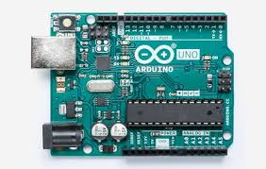

1. **Analog Soil Moisture Sensor:-** Soil moisture sensors measure the volumetric water content in soil. soil moisture sensors measure the volumetric water content indirectly by using some other property of the soil, such as electrical resistance, dielectric constant, or interaction with neutrons, as a proxy for the moisture content.

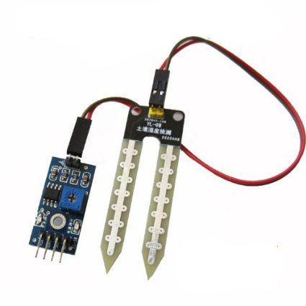

1. **DHT22 Digital Temperature and Humidity Sensor:-** The DHT22 is a basic, low-cost digital **temperature and humidity sensor**. It uses a capacitive **humidity sensor** and a thermistor to measure the surrounding air, and spits out a digital signal on the data pin.

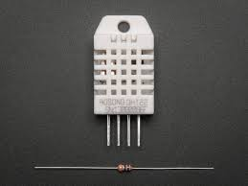

1. **MQ-135 Air Quality Gas Sensor Module:-** MQ-135 gas sensor canbe implementation to detect the smoke, benzene, steam and other harmful gases. It has potential to detect different harmful gases.

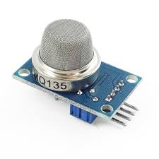

1. **LCD 16×2 Alphanumeric Display (JHD162A**)**:-** An **LCD** is an electronic display module which uses **liquid crystal** to produce a visible image. The **16**×**2 LCD** display is a very basic module commonly used in DIYs and circuits. The **16**×**2** translates a display **16** characters per line in **2** such lines.

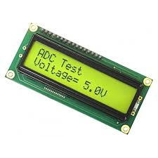

1. **Jumper Wires Male to Male, male to female, female to female:-**

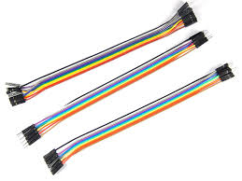

1. **GSM Modem Module for Arduino:-** A GSM Module is basically a GSM Modem connected to a PCB with different types of output taken from the board – say TTL Output (for Arduino, 8051 and other microcontrollers) and RS232 Output to interface directly with a PC

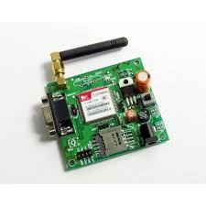

**Procedure:-** From use of all this module we can calculate the Soil moisture , Soil Humidity , Temperture and Water Level. And Provide the Fatilizer according to the need. We can **do C Programming on Ardunio Uno** , And create a website where the all Given data is stored. By Using **GSM Modem Module** we can get the notification on our **email.**

**Our Esstimate:-**

1. Arduino Uno ₹ 299 /-
2. Analog Soil Moisture Sensor ₹ 80/-
3. DHT22 Digital Temperature and Humidity Sensor ₹ 254/-
4. MQ-135 Air Quality Gas Sensor Module ₹ 449/-
5. MQ-7 Gas Tester Carbon Monoxide Detecting Sensor Module 4P 180mA 5V DC ₹ 199/-
6. MQ2 Gas Sensor, Methane, Butane, LPG, Smoke Sensor ₹ -----
7. LCD 16×2 Alphanumeric Display(JHD162A) ₹ 149/-
8. Jumper Wires Male to Male, male to female, female to female
9. GSM Modem Module for Arduino
10. Batteries
11. Motor
12. 1kilo-ohm Resistances
13. Esp 8266 Module ₹ 185