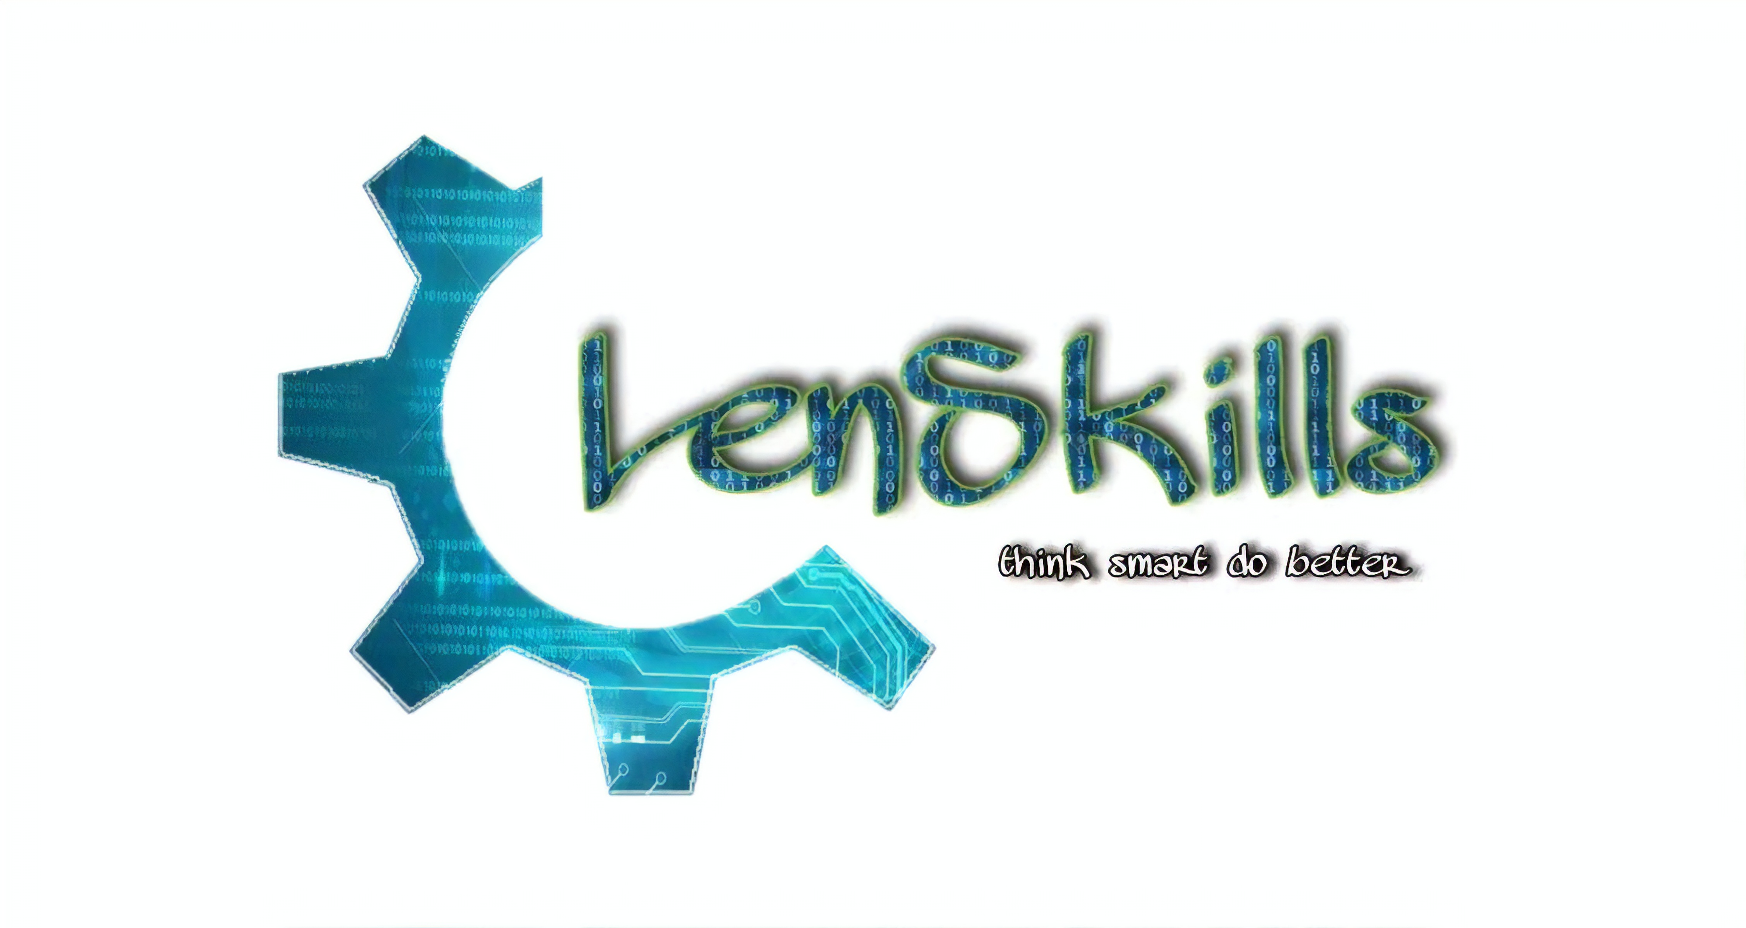

**About us**:-

**At Lenskills, we make aware people about the various opportunities in the field of technology. Our aim is to get the youth interested in the technical skills. Our educated youth have a lack of skills be it technical or behavioural; hence we have formed a community to make people richer in skills.**

**We provide competitive and practical training in the field of computer science.**

**Our talented team develops software solutions in different domains of computer science technologies like Data Science, IoT, AI, Full-stack web development, etc. for our trusted clients.**

**Our Services:-**

**Our Sponosors**

**Their logos: -**

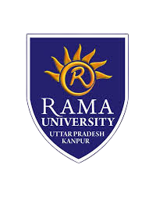

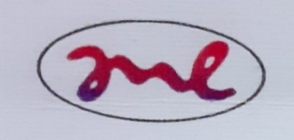

**Our Client: -**

**Examination Cell of Rama University** – Our team has successfully developed a Question Generator.

**Brain** - An automated health system.

**Taxationer** - We are developing a website for them.

**Mievo Technologies Pvt Ltd** - We are working on two IoT projects: -

a) RTD Temperature Logger.

b) Low power nrf52840 dongle.

**Requirement: -**

* We need Sponsorship of Rama University.
* We need legal advice and financial support to register our community as a start-up company.
* Our community wants to conduct a Hackathon on "IoT and Automation" on behalf of LenSkills in our Rama Campus, Kanpur, where we are inviting a student from a different college.
* We need news and radio channel support to spread our LenSkills moto to others.
* We are going to colleges and schools in January to aware of modern technologies. So, to fulfill the requirement, we have to buy a projector, rewards, and posters, etc. There is a need of *Rs 21000*.

**Contact us: -**

Prabhakar Singh

+91 9559880983

[www.lenskills.com](http://www.lenskills.com)