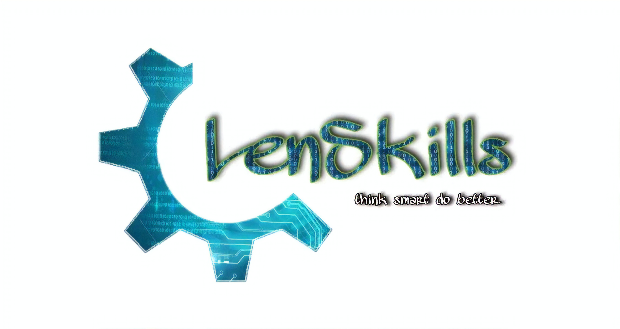

**About us**: -

**At Lenskills, we aware people about the various opportunities in the field of technology. Our aim is to get the youth interested in the technical skills. Our educated youth have a lack of skills be it technical or behavioural; hence we have formed a community to make people richer in skills.**

**We provide competitive and practical training in the field of computer science.**

**Our team develops software solutions in different domains of computer science technologies like Data Science, IoT, AI, Full-stack web development, etc. for our trusted clients.**

**Our Services: -**

**Our Sponosors**

**Their logos: -**

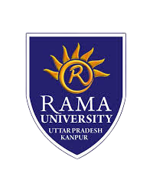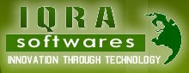

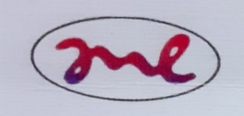

**Our Client: -**

**Examination Cell of Rama University** – Our team has successfully developed a Question Generator.

**Brain** - An automated health system.

**Taxationer** - We are developing a website for them.

**Mievo Technologies Pvt Ltd** - We are working on two IoT projects: -

a) RTD Temperature Logger.

b) Low power nrf52840 dongle.