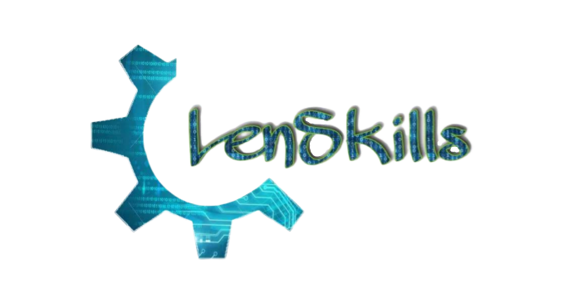

**At lenskills, we aware people to get interested in the field of technologies. Our educated youth have a lack of skills; we formed a community to make people richer in skills.**

**We provide competitive and practical training in the field of computer science.**

**Our talented team develops software solutions in different domains of computer science technologies like Data Science, IoT, AI, Full-stack web development, etc. for our trusted clients.**

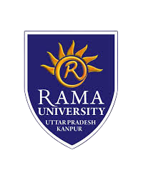



 



Contact us: -

visit: <https://lenskills.com/>

mob. No: 7355139897, 8303871828