**Creating a Bar Graph in Excel 2010**

Create a bar graph showing the mean differences for each group. Note that you must calculate the means and organize them appropriately for each condition.

To create a bar graph in Excel 2010, complete the following steps:

1. Select the data you want to include in the bar graph. Recall you must graph OSI means categorized by participant group and condition. Consider creating a new workbook with the OSI means for each group (i.e., female employees in the PMR group, male employees in the PMR group, female employees in the biofeedback group, male employees in the biofeedback group).
2. Click “Insert,” and then click on the arrow next to the “Column” option:

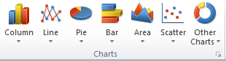

1. Select “2-D Column.” When you click on “2-D Column,” your bar chart will be created for you. Now, format the chart appropriately. The chart should be selected; if not, click on the chart and you will be presented with formatting options in the “Design” tab. Click on the arrow next to “Chart Layouts,” and then you will be presented with a variety of options.

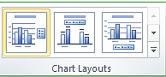

1. Select “Layout 9” because it gives you the option to label the x-axis and y-axis and allows labels for the levels of the independent variable. Label the variables accordingly.

* The text “Axis Title” constitutes text boxes. You can click on that text to change the label for the x-axis and y-axis; remember, to correctly label the variable (typically the dependent variable) on the y-axis and the variable (typically the independent variable) is on the x-axis.
* If you would like, you can also remove the horizontal lines, which are located across the graph. You can do this by clicking on **one** of the lines. This step should select all lines, and then you can press the delete key on your computer.
* You can also change the font type and size of the font by selecting the entire graph and then selecting the appropriate font style and size.