**How to Add the Option for Data Analysis to Excel 2016**

Complete the following steps to add the option for data analysis to Excel 2016.

1. Open Excel 2016.
2. Click “File.”
3. Click “Options.”
4. Select “Add-ins” from the list of Options that appear on the left side of your screen.

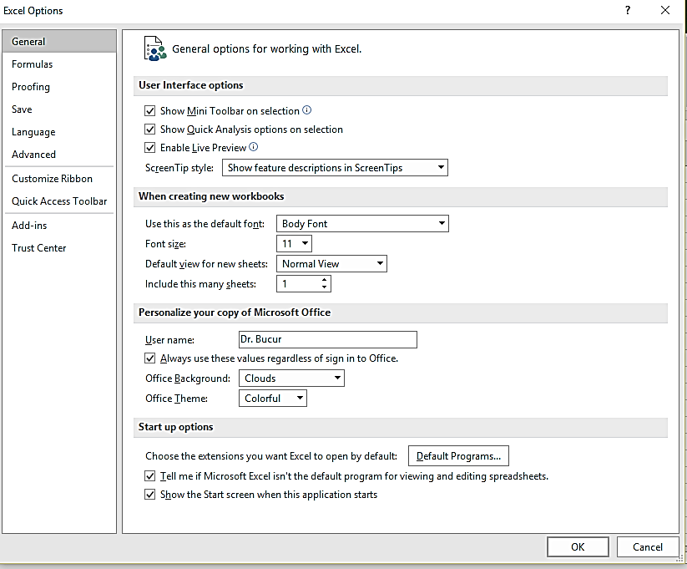

1. In the “Manage” area, click “Go.”

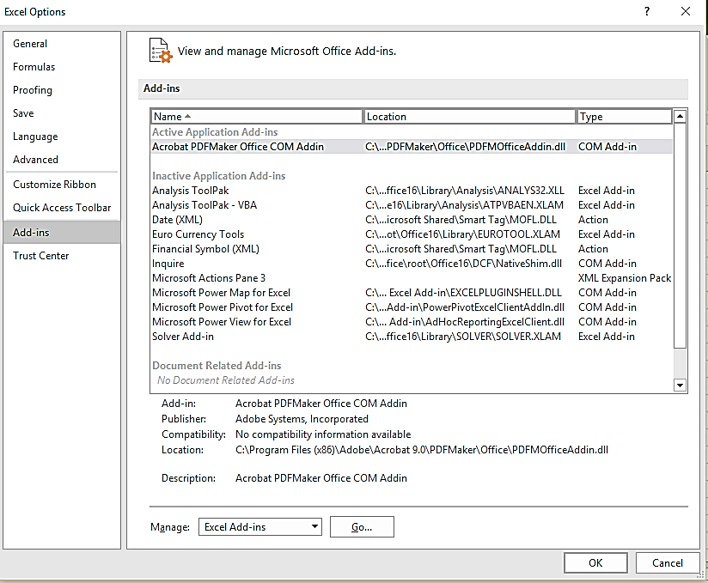

1. The following screen will appear. Then, make sure that Analysis ToolPak and Analysis ToolPak - VBA are checked.

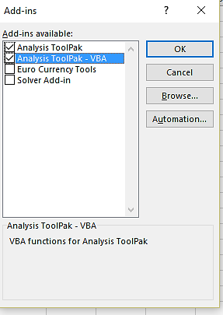

1. Click OK.

The “Data Analysis” area will now appear in the “Data” tab. This is the last option in this row and to the right of “Outline”:

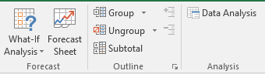

1. Click on “Data Analysis” to view the options for inferential statistical tests, as well as options for descriptive statistics:

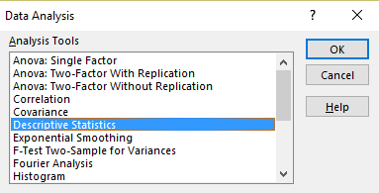

1. Select the “Descriptive Statistics” option; then, complete the following field:

The “Input Range” consists of the cells you want included in the analysis. To obtain the means for each stress management condition, be sure to select each set of OSI scores separately (i.e., progressive muscle relaxation-PMR group, biofeedback group).

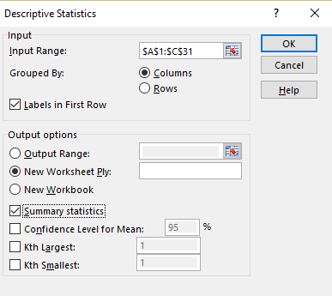

1. Click OK.