1.

Replace

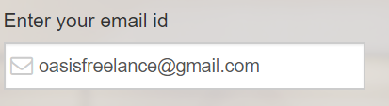

With

C:\Users\Willy\Desktop\Capture1.PNG

2.

Replace



With

C:\Users\Willy\Desktop\Capture4.PNG

Deadline has the following attribute data

* 6 hours
* 12 hours
* 24 hours
* 36 hours
* 2 days
* 3 days
* 5 days
* 7 days
* 10 days
* 14 days