Q1, on customer (business or normal ) dashboard , you told us in latest changes file that ,Leads submitted by leads generator ,so i wan to ask ,that there should be only that submissions shown which will be submitted by that user only or by Lead generator user ?because it makes no sense to show them lead generator submitted request ,here is a screenshot of your file.  
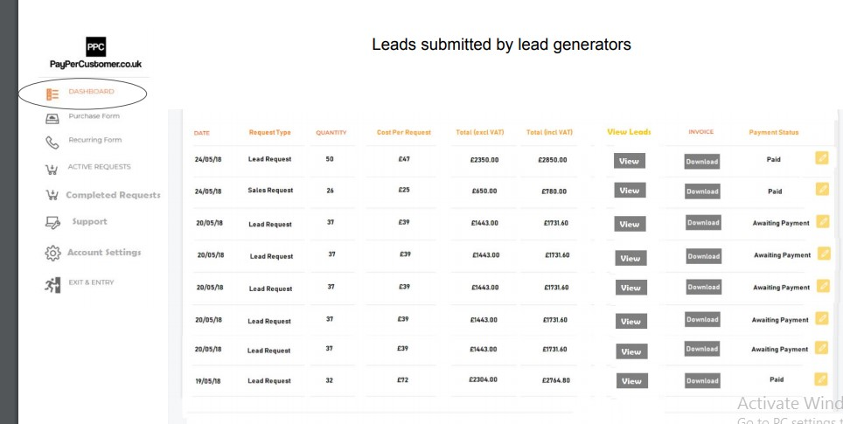

**ANSWER:** The customer generates a 'lead request'. This is essentially an order... Then, the lead generators can then click on each request and do a 'lead submission' which will show on the customers front dashboard as 'Active Leads'.  
  
  
  
  
  
  
  
  
  
Q3, confirm me that below are the exact fields for purchase or recurring forms for (business or normal or lead generator ) ,if not then correct me if yes then also tell me that i am right :  
date Placed, request Type, Level,Quantity ,cost per request, total(exclude VAT),total (include VAT),upload invoice,comments  
  
**ANSWER:**  all correct, however no need for invoice upload

Q4, can a (business or normal or lead generator) can EDIT there submitted forms ?or only admin can ? and if they can then what fields will you allow then to edit .

**ANSWER:** Only admins  
  
  
Q5, Who is responsible to change status of submitted requests by (Normal or business or lead gerneator ) from pending to completed ?

**ANSWER:** once the number of leads have been submitted by lead generators. For example, if the request was for 50 leads, once 50 leads have been submitted by lead gens it should change to completed.

Q6, Who is responsible to change status of submitted requests by (Normal or business or lead gerneator ) from unpaid to paid ?

**ANSWER:**  Admins only.

Q7, does all user have balance amount ? where to show it and how it will be calculated or added or subtracted ,when and where ?

**ANSWER:** don't worry about a balance. As long as every business and lead gen has a transaction history (TC) then its fine. The payment status should only be able to be changed by an admin

---------------------------------------------------------------

Also, an additional point is that the lead request form, must mean that the customer cannot edit the "Cost per Lead" box and that should be set per business customer by the admin in the settings for each business