1. **Connecting and disconnecting**
   1. When trying a random username, it returns “Access denied” and continues to ask for the password until the window is closed. It needs to be reopened in order to attempt a new user.

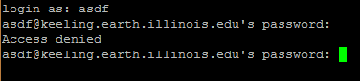

1. **Directories**
   1. cd blah
      1. Returns “bash: cd: blah: No such file or directory”
   2. cd ..  
      pwd
      1. It moved me to the parent directory, from ‘Week2answers’ to ‘ATMS-305’



* 1. Ls
     1. I see the contents of ATMS-305



* + 1. Using ls –l reveals the details (permissions, last revisions, owner, size, etc.)

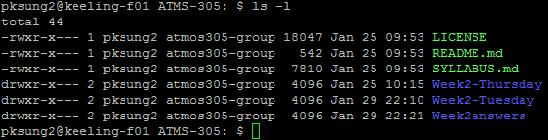

* 1. cd
     1. It moves me to ~



* 1. Repeating step two.
     1. Moved to the / directory. Seems like the top!

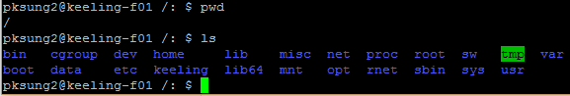

* 1. cd root
     1. Moves to root. No directories are listed with ls.
  2. If step 4 is doing cd again, then simply typing cd will always get me to this directory. If step 4 is doing cd .. constantly, then doing that will always get me to the top.

1. **Directories**
   1. The file type of my inittab is:
      1. 
   2. Default mode is 3: full multiuser mode
      1. 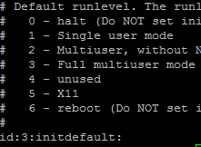
   3. file .
      1. 
      2. It does help.
   4. Look at . using the cat command
      1. Yes.
   5. --help option for cat
      1. 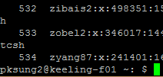
      2. 534 users listed in the file
2. **Getting help (when you don’t have Google)**
   1. I think I’ve been having too much fun with this.. xD

