**Deploy Model in SageMaker and use S3 Bucket**

**Steps to perform:**

1. Create a notebook instance
2. In the notebook, create an S3 bucket to push your train and test data
3. Also, create preprocessing of data to make it suitable for Sagemaker to train.
4. Train, validate, and deploy the model.

First type ‘Amazon Sagemaker’ in the search bar on the Home page:

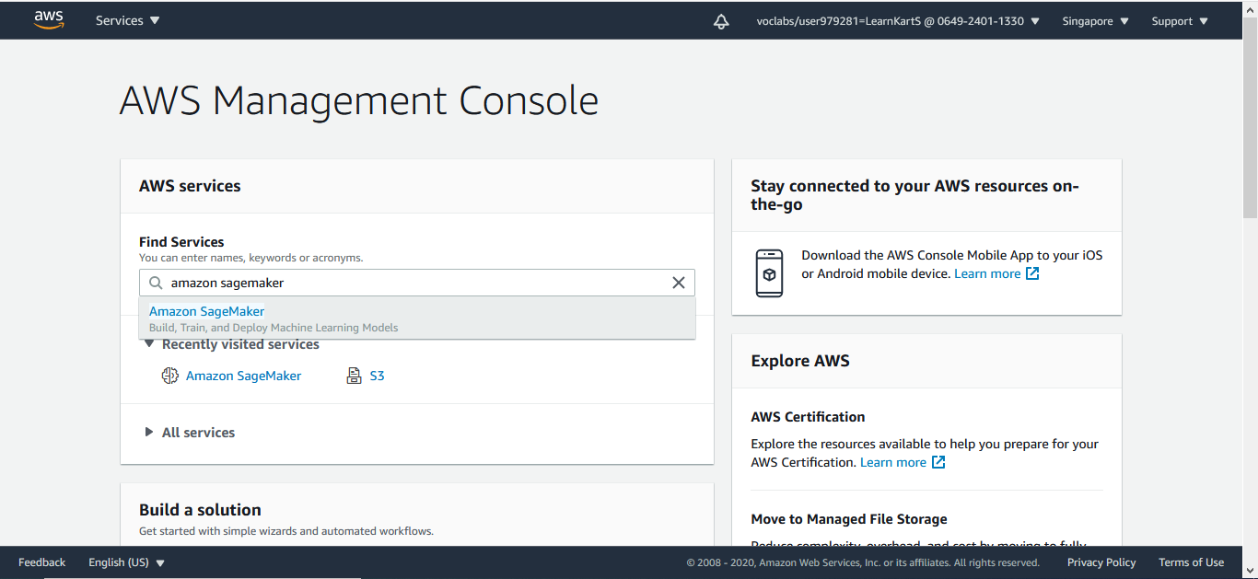

Select Notebook Instance on the next page:

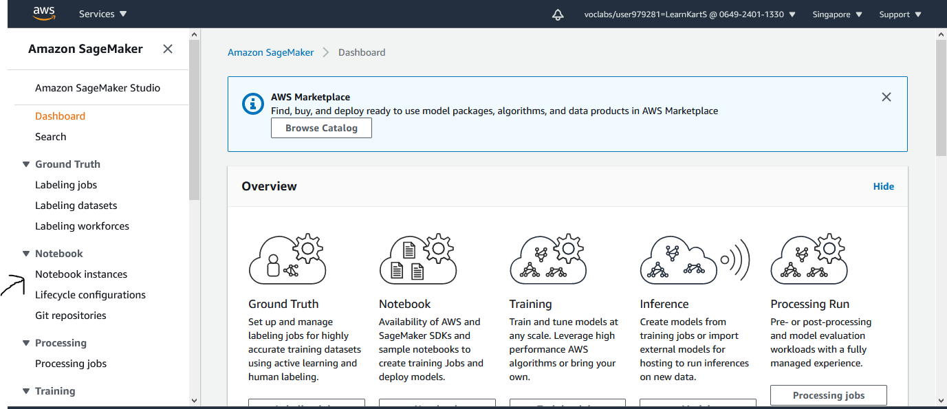

This will open a page where we can create a notebook instance:

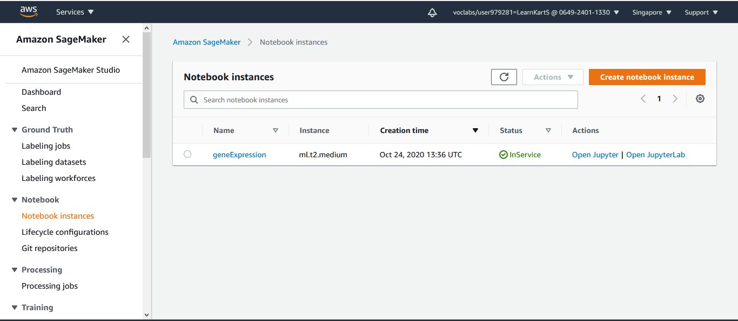

Just give the name of your notebook instance. The instance you have already created will be shown here and scroll down, keeping the default settings and creating the notebook instance.

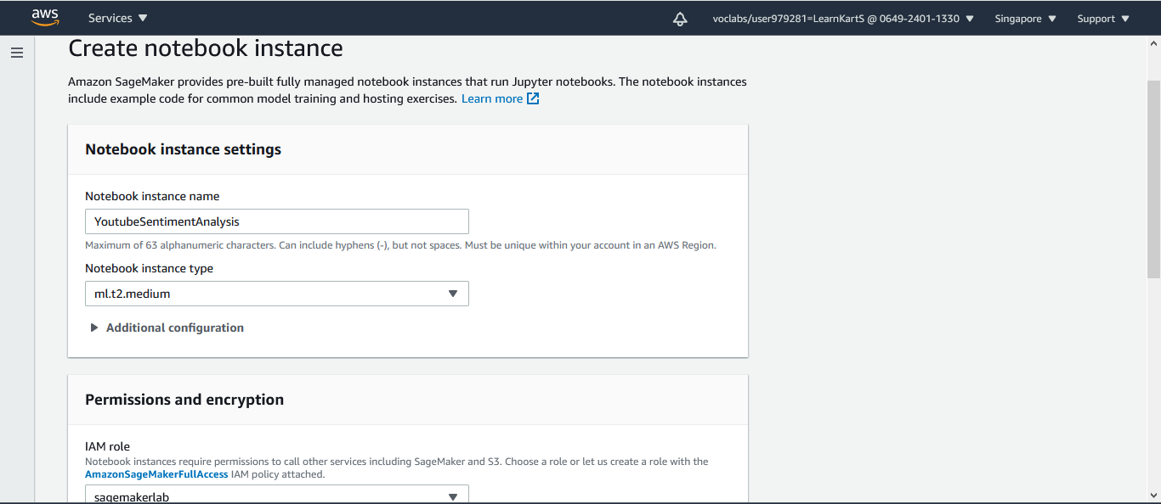

Now, wait till the status of your notebook converts to in service.

After that, you can open a Jupyter lab or Jupyter notebook as Action preference. This will open for your Jupyter instance, and you can upload your dataset and run the program.

In the code section, you can see the S3 bucket creation.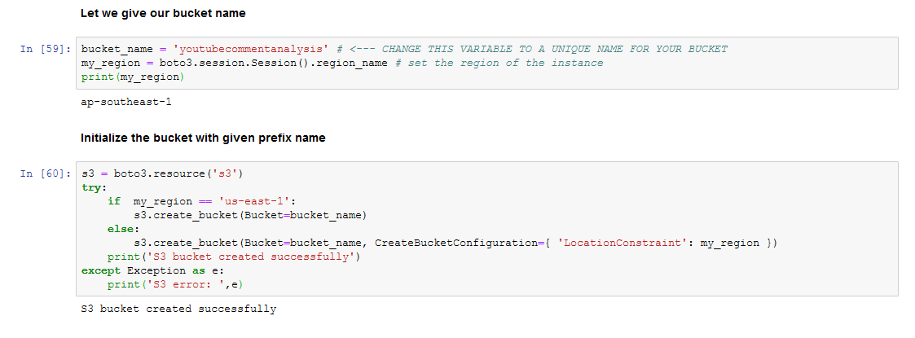

Once this step is working correctly, you will observe in the S3 instance your bucket will be created.

To see it, go to AWS home page and search S3.

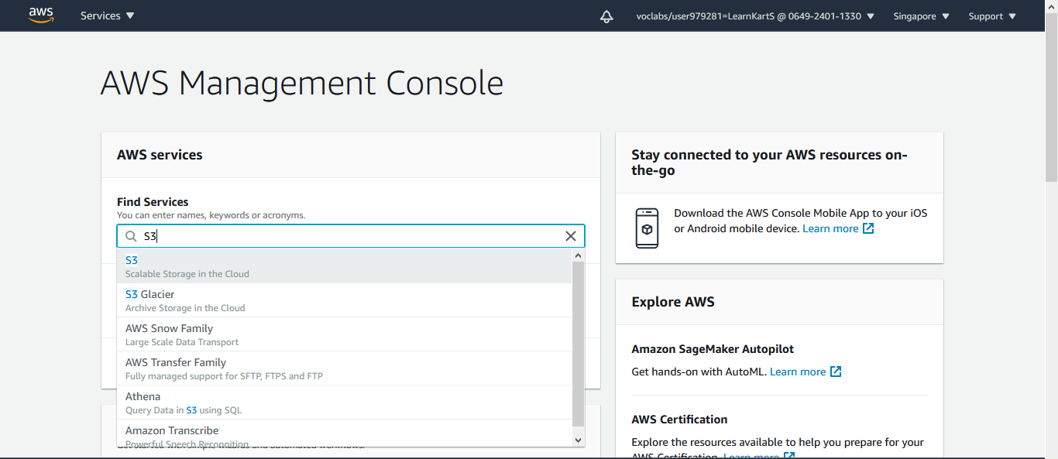

In clicking S3 ->> check your bucket name.

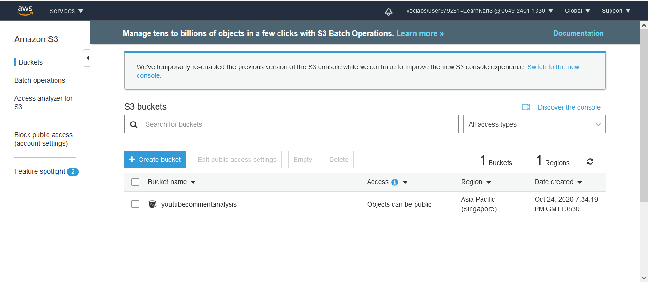

Now in your code, you can observe the output, and train test files will be saved in this cloud storage S3.

Regarding the details of cleaning the data and deployment is mentioned in the Notebook itself.