Trường TH:Nguyễn Văn Siêu

Lớp:5/4

Ôn tập HKII

**I/Odd one out(chọn từ không cùng nhóm)**

1. A. went                   B. took                          C. explored            D. saw

1. 2. A. Vietnamese      B.England          C. Japan               D.America

3. A father                 B. mechanic          C. astronaut         D. architect

4. A June                  B. Sunday            C. July                  D. September

5. A happy                B. party                 C. my                   D. family

II**/ Choose the correct answer***(Chọn câu trả lời đúng)*(4 marks)

1. What’s your house………? - It’s a big house. It’s got a small garden.

 A. look                   B. like                  C. likes                           D. liked

2. . ……….you go to Mai’s birthday party?       - Yes, I did.

 A. Do                     B. Does                C. Did                             D. Doing

3. Zack is fromMalaysiaand his nationality is……………….

 A. Malaysian         B. Australian        C. Combodian                D. Japanese

4. Where………..Japanis she from?         -She’s fromTokyo.

 A. at                      B. on                     C. in                                D.to

5. Tony lives ………..52 Ba Trieu Streetwith his family.

 A. in                     B. at                       C. on                               D.to

6. Mai lives…….. the third floor of Ha Noi Tower.

 A. at                      B. on                     C. in                                D.to

7. Tony’s birthday is ……..October.

  A. in                     B. at                       C. on                               D.to

8. What do you often do ……..the morning?

 A. at                      B. on                     C. to                                D.in

9. I’ll ……..a singer in the future.

 A. be                     B. is                      C. am                               D. being

10. What ……. you be in  the future? – I’ll be an astronaut.

A. is                     B. am                    C. being                           D. will

**II/ Please circle the letter A, B, or C before the correct answer to the following questions.**

Do you like music?

Yes, it is. B.Yes, please. C.Yes, I do.

Why do you like monkeys?

A.Because it can swing. B.Because they can swing. C.Because they can swings.

Where did you go last Sunday?

A.I went to Ho Chi Minh city. B.I went Ho Chi Minh city. C. I go to Ho Chi Minh city.

Where is Peter from?

A.He is from America. B.He is from American. C.He is from England.

**III / Please use the words given in the box to complete the following paragraph**.

|  |
| --- |
| Because science having subject reading |

This is Mary. She is a student at Doan Thi Diem primary school. Now she is (1)___________ a (2)__________ lesson. It is her favourite (3)______________ . She is (4)_____________ a text on zoo annimals. Yesterday, she didn’t go to school (5)___________ she had a fever.

IV/ **Put the words into the correct column.**

|  |  |  |  |
| --- | --- | --- | --- |
| Chicken, fever, headache, chocolate, teacher , Bai Dinh Pagoda, post office, sore throat, beef, a carton of milk , Hoan Kiem Lake, backache , earache , Hue Imperial City , toothache, architect , The Temple of Literature, a piece of meat, stomach ache, Suoi Tien Amusement Park , tailor, engineer, Ha Long Bay, Trang Tien Bridge, pilot, farmer, gardener , sausage, egg, a packet of biscuits, Ben Thanh Market, Temperature, writer , chips, flu, pork , Huong River. | | | |
| **Food** | **Heath problems** | **Some places** | **jobs** |
|  |  |  |  |
|  |  |  |  |
|  |  |  |  |
|  |  |  |  |
|  |  |  |  |
|  |  |  |  |
|  |  |  |  |
|  |  |  |  |
|  |  |  |  |
|  |  |  |  |
|  |  |  |  |
|  |  |  |  |

**V/Read the text. Fill in the blank with the correct word in the box. (4marks)**

My name is Lin and I’m from Viet nam. I(1)………. with my parents and my two brothers. We all get up early every morning. I have a bowl of rice soup for(2)………….. . After breakfast, my brothers and I take the (3)…………to school. We sing the(4) …………. song before our lessons start. We play games at lunch time and then(5) ………… have more lessons. School (6)………….. at four o’clock . In the evening, my mom(7) ……….. dinner.We usually eat rice with vegetables and fish or meat. After dinner, I do (8)………….. homework. I go to bed at ten o’clock.

|  |  |  |  |
| --- | --- | --- | --- |
| 1. We | 3. finishes | 5. cooks | 7. my 9. our |
| 2. live | 4. breakfast | 6. bus | 8. national |

**VI/Read again the text and answer the questions (3marks)**

1/ How many brothers does Lin have?…………………………………………………….

2/ What does Lin eat for breakfast ? …………………………………………………….

3/ How does Lin get to school? ……………………………………………………

4/ Where is Lin from ? …………………………………………………….

5/ What does Lin do after dinner ? …………………………………………………….

6/ what time does Lin go to bed ? …………………………………………………….

**VII/Look and read , write yes or no. There are two examples (3 marks )**

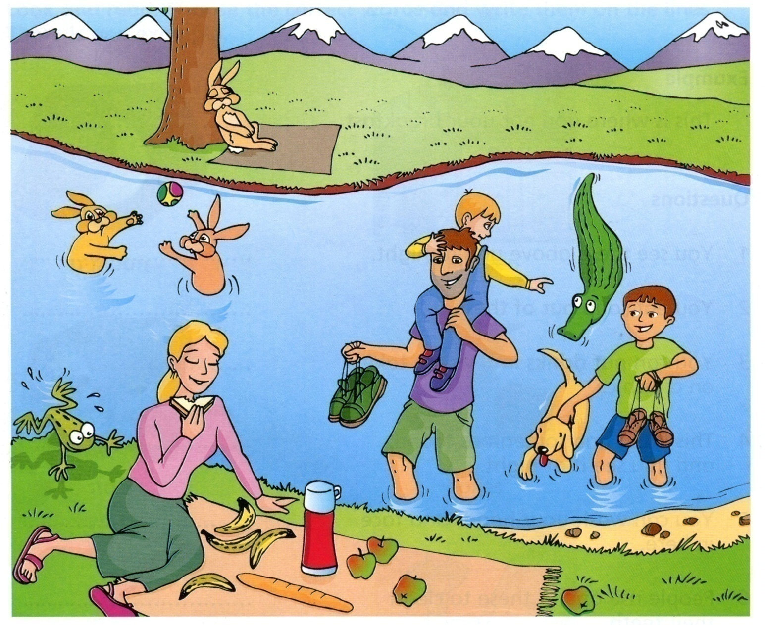**Examples :**

The mother is eating a sandwich. ………yes……………

The boy has got some green shoes ………no……………..

**Questions**

1/ A frog is jumping out of the river. ………………………………………………

2/ There are four apples on the blanket ……………………………………………...

3/ Some rabbits are play in with a ball in the river. …………………………………………

4/ There’s a crocodile behind the dog. ………………………………………………

5/ There are six mountains in the picture. ………………………………………………..

6/ The man is holding a drink. ………………………………………………..

**IX/Translate into English.**

1. Địa chỉ của bạn là gì?

1. Bạn sống cùng với ai?

1. Quê của bạn ở đâu?

1. Quê của bạn trông như thế nào?

1. Bạn có sống cùng với ông bà không?

1. Địa chỉ của anh ấy là gì?

1. Anh ấy sống cùng với ai?

1. Quê của anh ấy ở đâu?

1. Cô ấy sống ở một ngôi làng nhỏ ở vùng quê.

1. Làng của cô ấy nhỏ và yên bình.

X/Find and correct mistakes in the following sentences

1. What is your first class in Monday?
2. I goes to school on 6:45.
3. She have her breakfast at home.
4. Does you play sports?
5. When do we has history?
6. Does she wash she face?
7. What time she get up?
8. How many floors does your school has?
9. This is Nga school.