|  |  |
| --- | --- |
| **PHÒNG GD&ĐT PHÚC YÊN** | **ĐỀ THI GIAO LƯU HỌC SINH GIỎI**  **MÔN: TIẾNG ANH 8** |
| **ĐỀ THI CHÍNH THỨC** | **Năm học: 2018-2019** |
| ***(Đề thi gồm 05 trang)*** | ***Thời gian thi: 150 phút (Không kể thời gian phát đề)*** |

**SECTION A: LISTENING COMPREHENSION**

**Part 1: There are 7 questions in this part. For each question there are three pictures and a short recording. Choose the correct picture and put a tick in the box below.**

**1. Where did Peter give Joanna the book?**

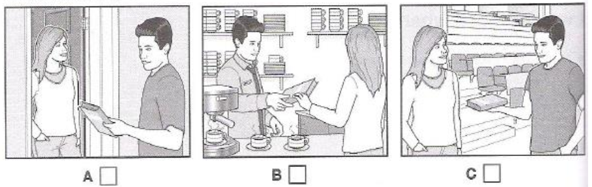

**2. What did the girl buy at the market?**

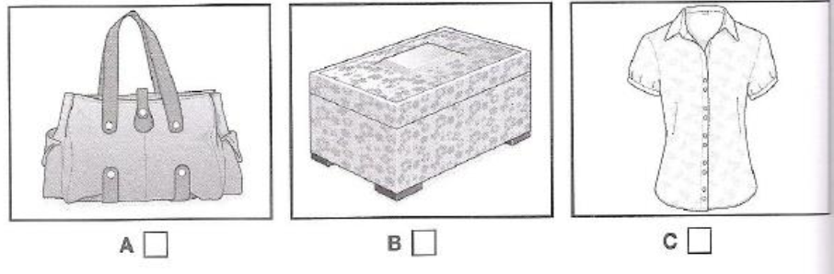

**3. What will the weather be like for the race?**

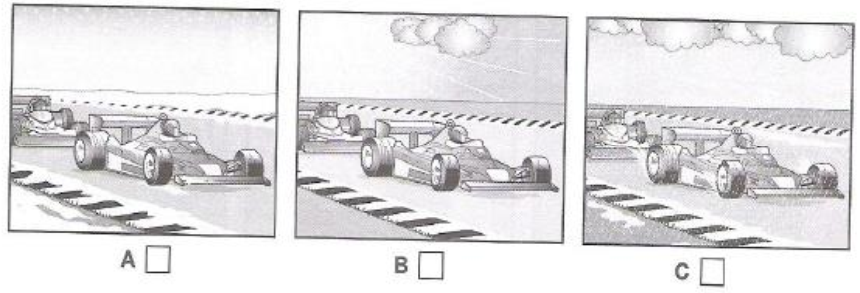

**4. What does the girl like best about the city?**

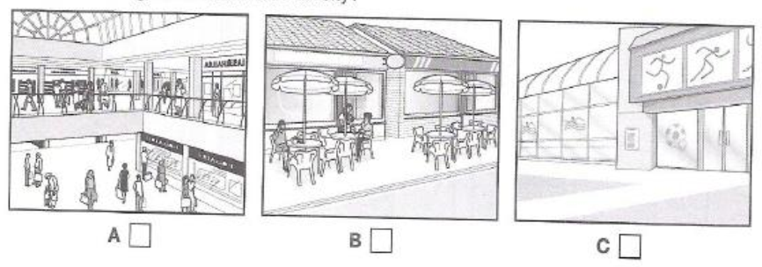

**5. What does the boy think was unusual about the film?**

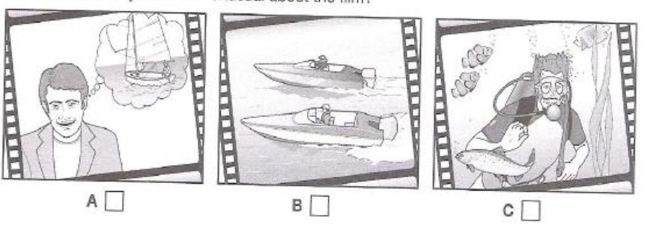

**6. What happened during the football match?**

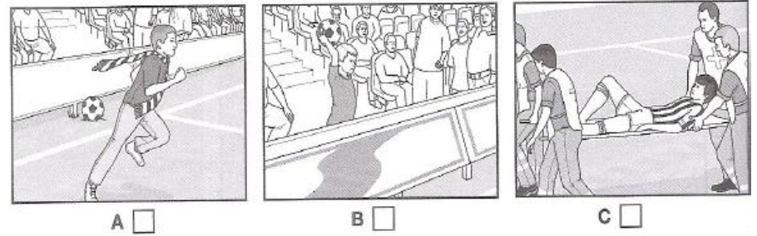

**7. Which part of the gallery did the man visit?**

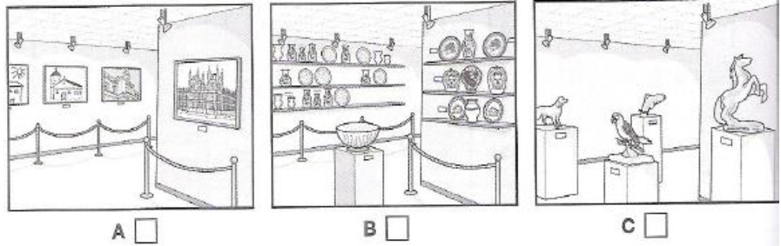

**Part 2: Listen to three teenagers talking about diet and lifestyle. Are the statements true (T) or false (F)?**

1. Tony likes watching films.

2. Tony walks, plays football and goes surfing.

3. Tony never eats junk food.

4. Karen doesn’t watch TV if there aren’t any good programs on or she has to do a lot of homework.

5. The only exercise Karen does is at school.

6. Karen’s mum heats up TV dinners for her.

7. Chris watches TV before and after school.

8. Chris’s family sometimes have a takeaway meal in the evening.

**Part 3: Listen to the recording and answer the following questions. Write NO MORE THAN three words.**

1. When does Sarah’s exhibition start?

2. How long does the exhition last?

3. How much does the entrance to the exhibition cost?

4. What is the venue for the exhibition?

5. What does the exhibition have in the entrence hall?

**SECTION B: LANGUAGE**

**I. Pick out the word whose stress partern is different from that of the others.**

1. A. private B. provide C. arrage D. advise

2. A. resurface B. knowledge C. technical D. gravity

3. A. temperature B. experiment C. atmosphere D. literature

4. A. recipe B. cinema C. similar D. expertise

5. A. picture B. stranger C. export D. idea

**II. Choose the best answer to complete the sentences.**

1. She couldn’t perform well once she was ______.

A. under pressure B. out of mind C. in the mood D. over the moon

2. Pick me up at 4 p.m. . I ______ my bath by then.

A. will have B. will be having C. will have had D. must have had

3. As I can earn money by myself. I am independent ______ my parents financially.

A. on B. of C. upon D. from

4. ______ of my family, I would like to thank you very much for your help.

A. On behalf B. On account C. In person D. Instead

5. The accident ______ was the mistake of the driver.

A. causing many people to die B. caused great human loss

C. to cause many people to die D. which causes many people to die

6. It was clear that the young couple were ______ of taking charge of the new restaurant.

A. responsible B. reliable C. capable D. able

7. She was guilty ______ cheating in the examination.

A. to B. with C. of D. for

8. If it’s raining tomorrow afternoon, we’ll have to ______ the match till next Sunday.

A. put out B. put off C. put up D. put away

9. It was so foggy that the climbers couldn’t ______ the nearest shelter.

A. make out B. break out C. take out D. run out

10. Due to ever more spreading poaching, there ______ a dramatic decline in the number of elephants over the last decade.

A. was B. is C. has been D. had been

11. Anna is holding her shopping bag with one hand and turning the door handle with _______.

A. others B. another C. the other D. other

12. She is wearing a/an ______ ring.

A. expensive nice gold B. nice gold expensive

C. gold nice expensive D. nice expensive gold

13. The longer he waited, ______ impatient he got.

A. the better B. better C. more D. the more

14. His face looks ______, but I can’t remember his name.

A. similar B. alike C. memorial D. familiar

15. There’s a beautiful ______ of the old city from the terrace of their mountain house.

A. view B. aspect C. vision D. appearance

**III. Supply the correct form of the word in brackers.**

1. Remind me of my appoinment. I am __________. **(FORGET)**

2. Recently health foods have increased in __________. **(POPULAR)**

3. Unless something is done about unemployment, the __________ for the **(LOOK)**

future is not good.

4. He had the __________ habit of borrowing books and then forgetting to ret- **(ANNOY)**

urn them.

5. It is much __________ to buy large size packets. **(ECONOMY)**

6. Earth Hour is a __________ event organized to raise people’s awareness **(WORLD)**

7. Jenny has sent me a very __________ letter explaining why she didn’t do **(APOLOGY)**

what she promised.

8. For the sake of convenience, please do not _______ the Internet after use. **(CONNECT)**

9. You must realize that such __________ cannot be tolerated. **(OBEY)**

10. It is dangerous for an __________ driver to drive a car in the center of **(EXPERIENCE)**

Paris duting the mid-day rush.

**SECTION C: READING**

**I. Read the passage, and then choose the best answer to the questions below.**

The food we eat seems to have profound effects on our health. Although science has made enormous steps in making food more ***fit*** to eat, it has, at the same time, made many foods unfit to eat. Some research has shown that perhaps eighty percent of all human illnesses are related to diet and forty percent of cancer is related to the diet as well, especially cancer of the colon. People of different cultures are more ***prone*** to contact certain illnesses because of the characteristic foods they consume.

That food is related to illness is not a new discovery. In 1945, government researchers realized that nitrates nitrites (commonly used to preserve color in meat) as well as other food additives caused cancer. Yet, ***these carcinogenic*** additives remain in our food, and it becomes more difficult all the time to know which ingredients on the packaging label of processed food are helpful or harmful.

The ***additives*** that we eat are not all so direct. Farmers often give penicillin to cattle and poultry, and because of this, penicillin has been found in the milk of treated cows.

Sometimes similar drugs are administered to animals not for medical purposes, but for financial reasons. The farmers are simply trying to fatten the animals in order to obtain a higher price on the market. Although the Food and Drug Administration (FDA) has tried repeatedly to control these procedures, the practices continue.

A healthy diet is directly related to good health. Often we are unaware of detrimental substances we ingest. Sometimes well-meaning farmers or others who do not realize the consequences add these substances to food without our knowledge.

**1**. How has science done to disservice to people?

A. As a result of scientific intervention, some potentially harmful substances have been added to our food

B. The scientists have preserved the color of meats, but not of vegetables

C. It caused a lack of information concerning the value of food

D. Because of science, disease caused by contaminated food has been virtually eradicated.

**2**. The word “***prone***” is nearest meaning to_________.

A. healthy B. unlikely C. supine D. predisposed

**3**. The word “***carcinogenic***” is closest in meaning to_________.

A. trouble-making B. money-making C. cancer-causing D. color retaining

**4**. What are nitrates used for?

A. They preserve the color of meat B. They preserve flavor in package food

C. There are objects of research D. They cause the animals become fatter

**5**. FDA means____________.

A. Federal Dairy Additives B. Food and Drug Administration

C. Final Difficult Analysis D. Food Direct Additives

**6**. All of the following statements are TRUE except

A. Drug are always given to animals for medical reasons

B. Food may cause forty percent of the cancer in the world

C. Researchers have known about the potential hazard of food additives for more than 45 years

D. Some of the additives in our food are added to the food itself and some are given to the living animals

**7**. What is best title for this passage?

A. The food you eat can affect your health B. Harmful and Harmless substances in food

C. Avoiding injurious substances in food D. Improving health through a Natural Diet

**8**. The word “***fit***” could be best replaced by which of the following?

A. suitable B. tasty C. athletic D. adaptable

**9**. The word “***these***” refers to___________?

A. researchers B. nitrates and nitrites C. meats D. colors

**10**. The word “***additives***” is closest meaning to__________.

A. begin substance B. natural substance C. dangerous substance D. added substance

**II. Choose the best answer from A, B, C or D to fill in the gaps in the following passage.**

**PROBLEMS OF WATCHING TELEVISION IN BRITAIN**

British parents are always complaining that their children spend too much time glued to the telly and not enough time on other activities (1)_________ sports and reading. A survey recently (2)_________ on people’s viewing habits does not disprove this. It shows that young people in Britain spend on average 23 hours a week in front of the television, (3)_________ works out at over three hours every day.

(4)__________ is surprising, however, is the fact that the average adult watches even more: incredible 28 hours a week. We (5)__________ to have become a nation of addicts. Just about every household in the country has a television and over half have two or more. According to the survey, people nowadays don’t just watch television sitting in their living-rooms, they watch it in the kitchen and in bed (6)_________.

The Education Minister said a few weeks ago that Britain’s pupils (7)_________ spend more time reading. Unfortunately, parents are not setting a good example: adults do (8)_________ reading than young people. In fact, reading is at the (9)_________ of their list of favourite pastimes. They would (10)_________ listen to the radio, go to the cinema or hire a video to watch on their televisions at home.

1. A. such                         B. like                 C. as                 D. alike  
2. A. investigated               B. researched     C. carried           D. carried out  
3. A. that                           B. which             C. this               D. it  
4. A. What                         B. It                   C. The thing       D. This  
5. A. seem                         B. ought             C. used             D. would like  
6. A. in addition                   B. as well           C. more             D. moreover  
7. A. might                         B. could             C. should           D. would  
8. A. more                         B. less               C. little               D. fewer  
9. A. tail                             B. top                 C. beginning       D. bottom  
10. A. better                         B. rather               C. prefer           D. like

**III. Read the passage and fill in each blank with ONE suitable word. There is ONE example.**

**EVOLUTION**

It is generally accepted that present-day animals and plants differ from those of the past, (0) ...*having* ... changed by a general process called evolution. But this theory has been widely accepted for little (1) ................ than a hundred years. The present theory of evolution was developed by two naturalists – Charles Darwin and Alfred Russell Wallace – working independently.

When he was a young man (2) ................ 22, Darwin went as naturalist on a round-the-world, map-making cruise aboard a British naval survey ship, *HMS Beagle*. The cruise began in 1831 and lasted to 1836. In the Galapagos islands, Darwin came (3) ................ a group of birds, later to become known as “Darwin’s finches”. They were similar to one (4) ................ in their colour, song, nests and eggs, and were clearly descended (5) ................ the same finch stock, (6) ................ each had a different kind of beak and was adapted (7) ................ a different way of life. There were seed-eaters, fly-catchers, woodpeckers and various other types.

Darwin assumed that the ancestors of all these types had been blown to the islands in bleak weather, had survived and changed somehow (8) ................ the various forms. In the years after the voyage, Darwin gradually came to the conclusion that individuals better suited (9) ................ their environment would tend to leave more offspring while those (10) ................ well adapted would die out.

**SECTION D: WRITING**

**I. Finish the second sentence in each pair in such a way that it means the same as the sentence before it.**

1. The house was so badly damaged in the fire that it couldn’t be repaired.

*⭢ The house was too ____________________________________________________*

2. You won’t reach the station in less than twenty minutes.

*⭢ It will take __________________________________________________________*

3. I took my car to the garage last Saturday and they resprayed it.

*⭢ I had ______________________________________________________________*

4. Although Christopher was the stronger of the two, his attacker soon overpowered him.

*⭢ Despite his __________________________________________________________*

5. What a surprise to see you here!

*⭢ Fancy ______________________________________________________________*

**II. Write an eassay on the following topic:**

**“ Some people think that it is more effective for students to study in groups, while others believe that it is better for them to study alone.” Write an essay of about 180 to 200 words to express your opinion.**

**------------------------ THE END ------------------------**

*Thí sinh không được phép sử dụng tài liệu kể cả từ điển*

*Giám thị coi thi không giải thích gì thêm*

*Họ và tên thí sinh/Name: __________________________________ SBD/Candidate number: __________*