**SCREENSHOT01 “Build”:**

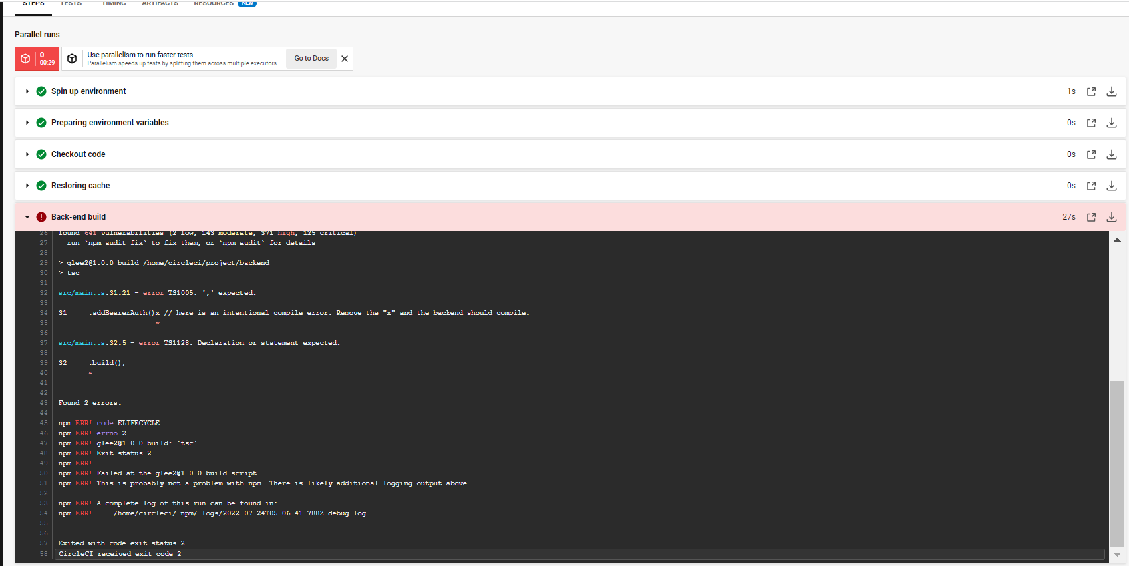

**SCREENSHOT02 “Test”:**

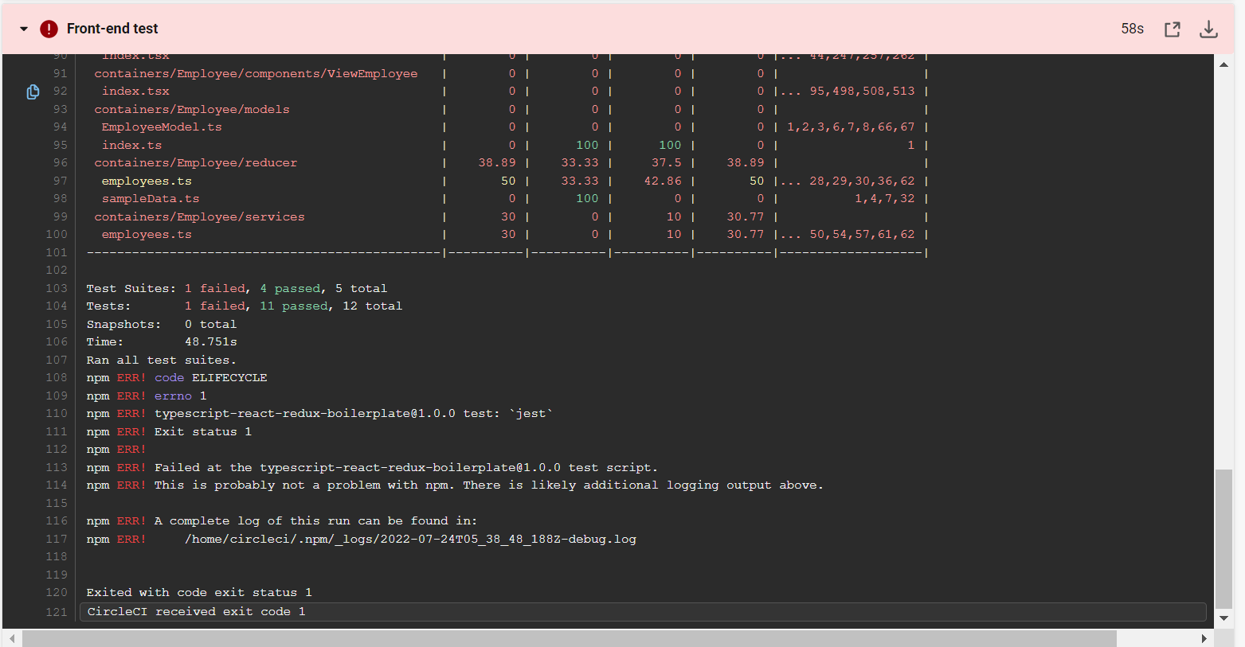

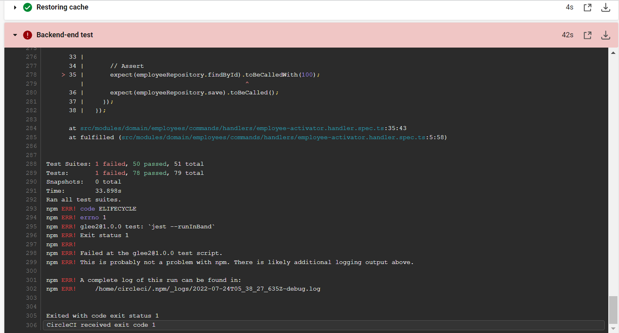

**SCREENSHOT03 “Analyze”:**

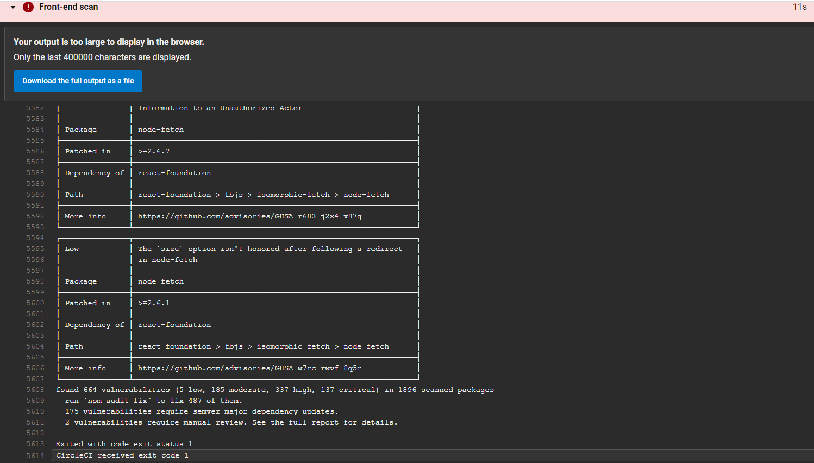

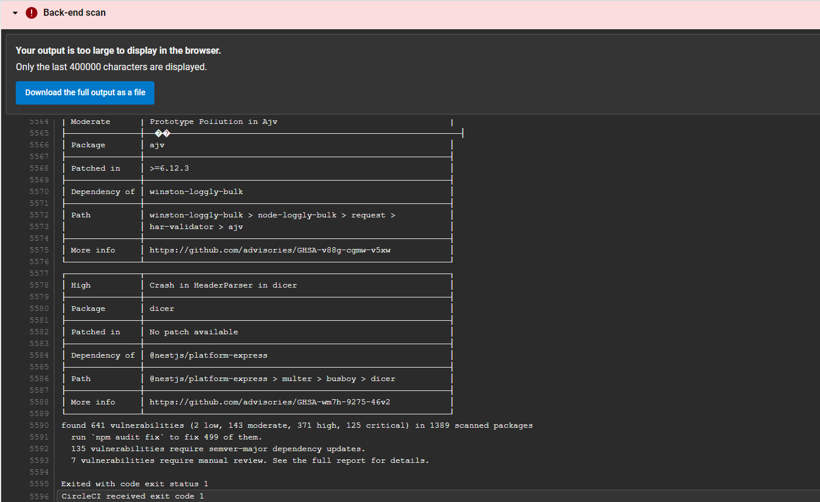

**SCREENSHOT04 “Failure Notification”:**

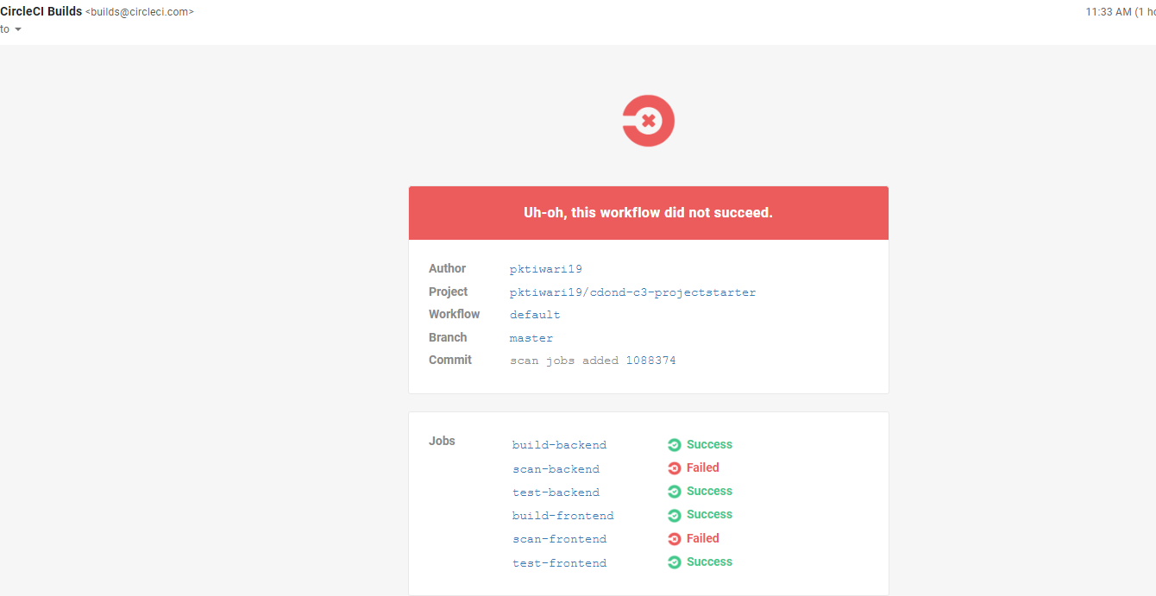

**SCREENSHOT05 “Deploy Infrastructure”:**

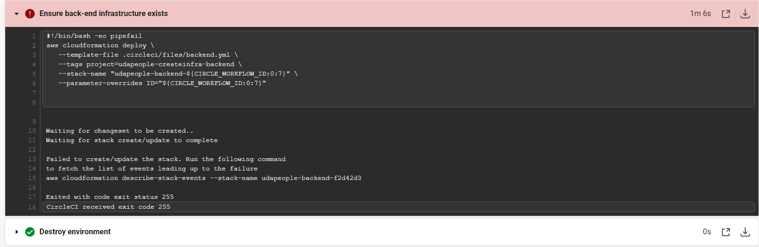

**SCREENSHOT06 “Smoke Test”:**

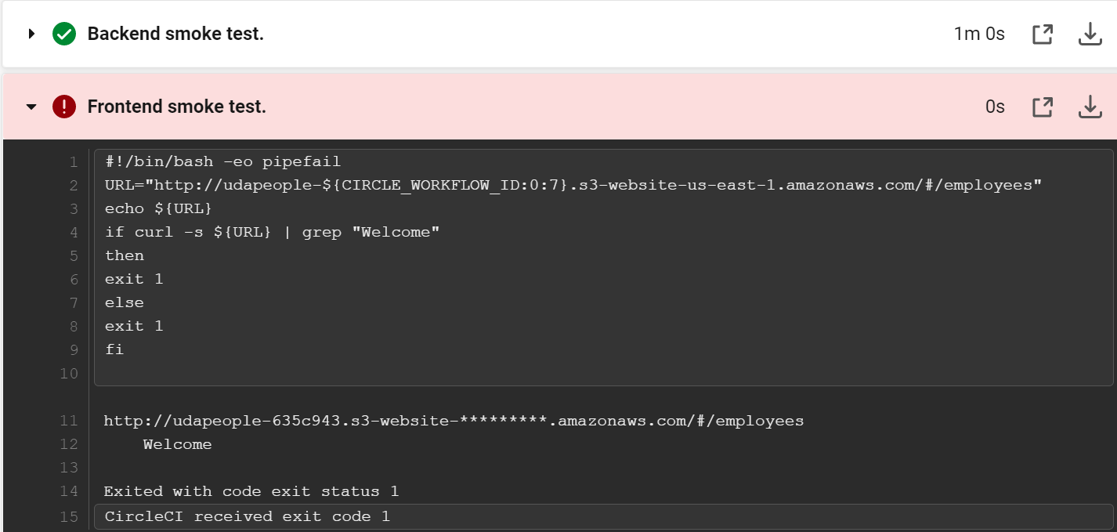

**SCREENSHOT07 “Rollback”:**

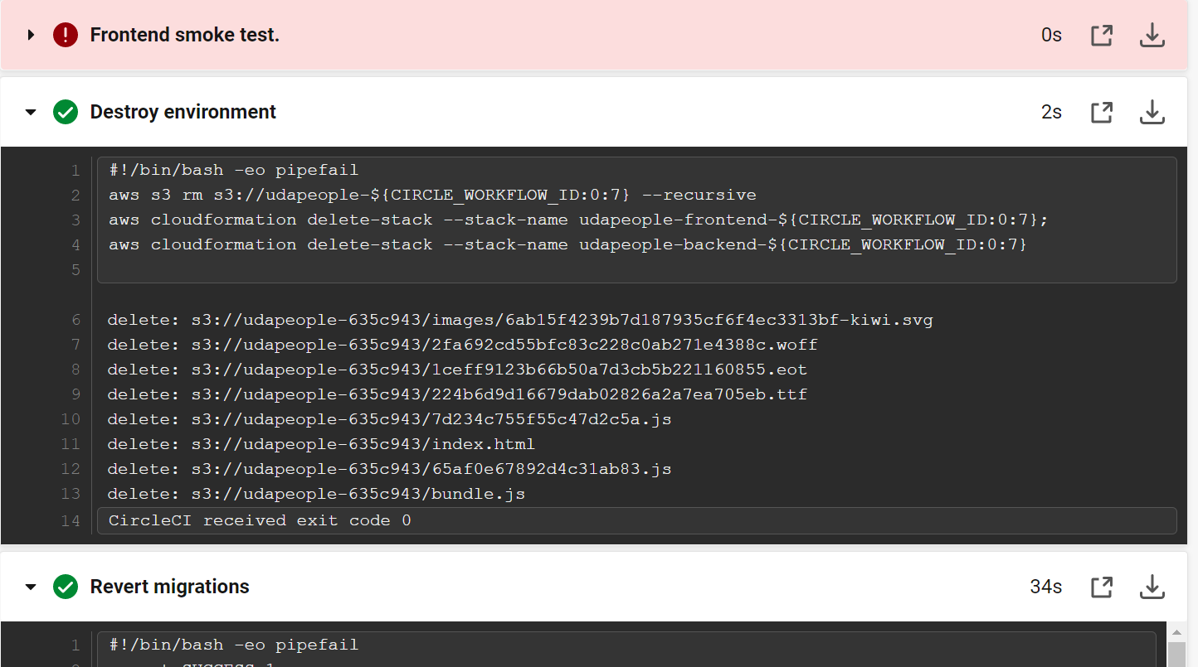

**SCREENSHOT08 “Promotion Phase”:**

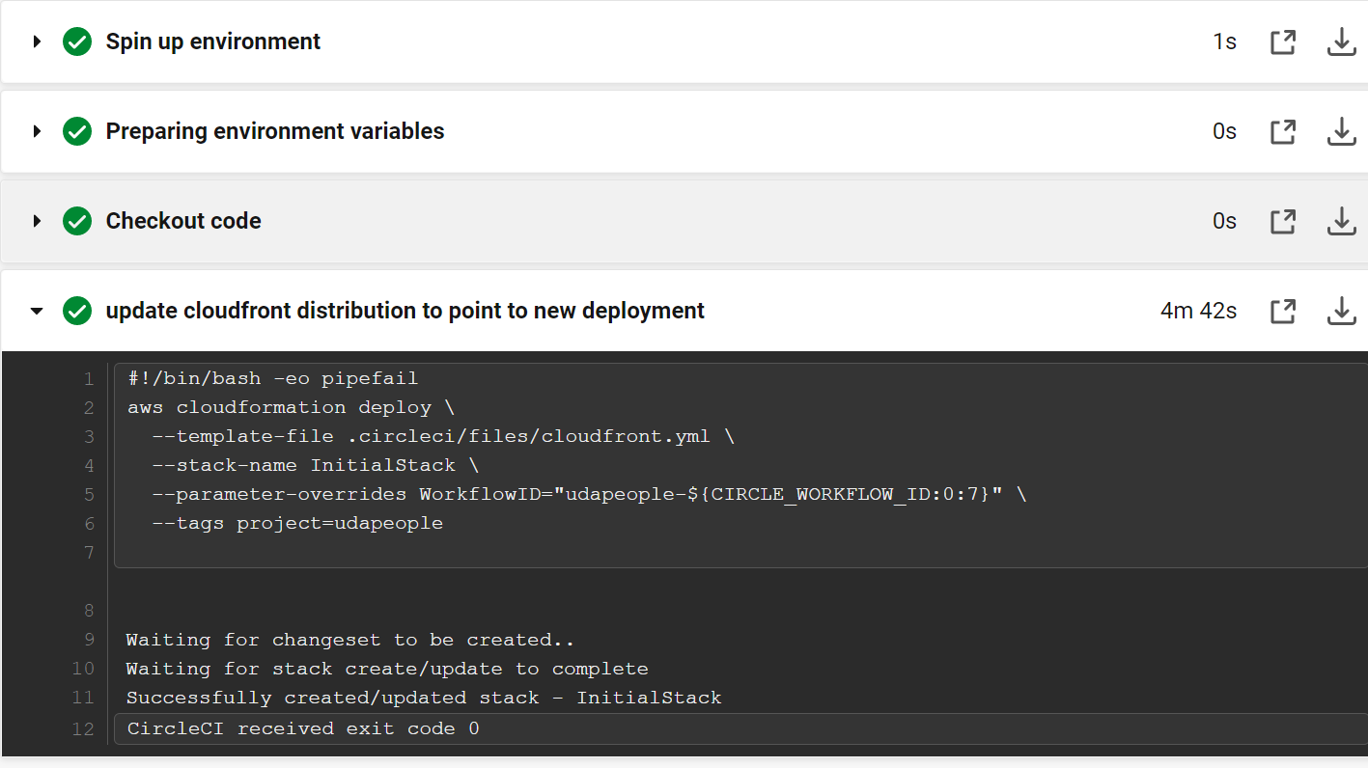

**SCREENSHOT09 “Cleanup Phase”:**

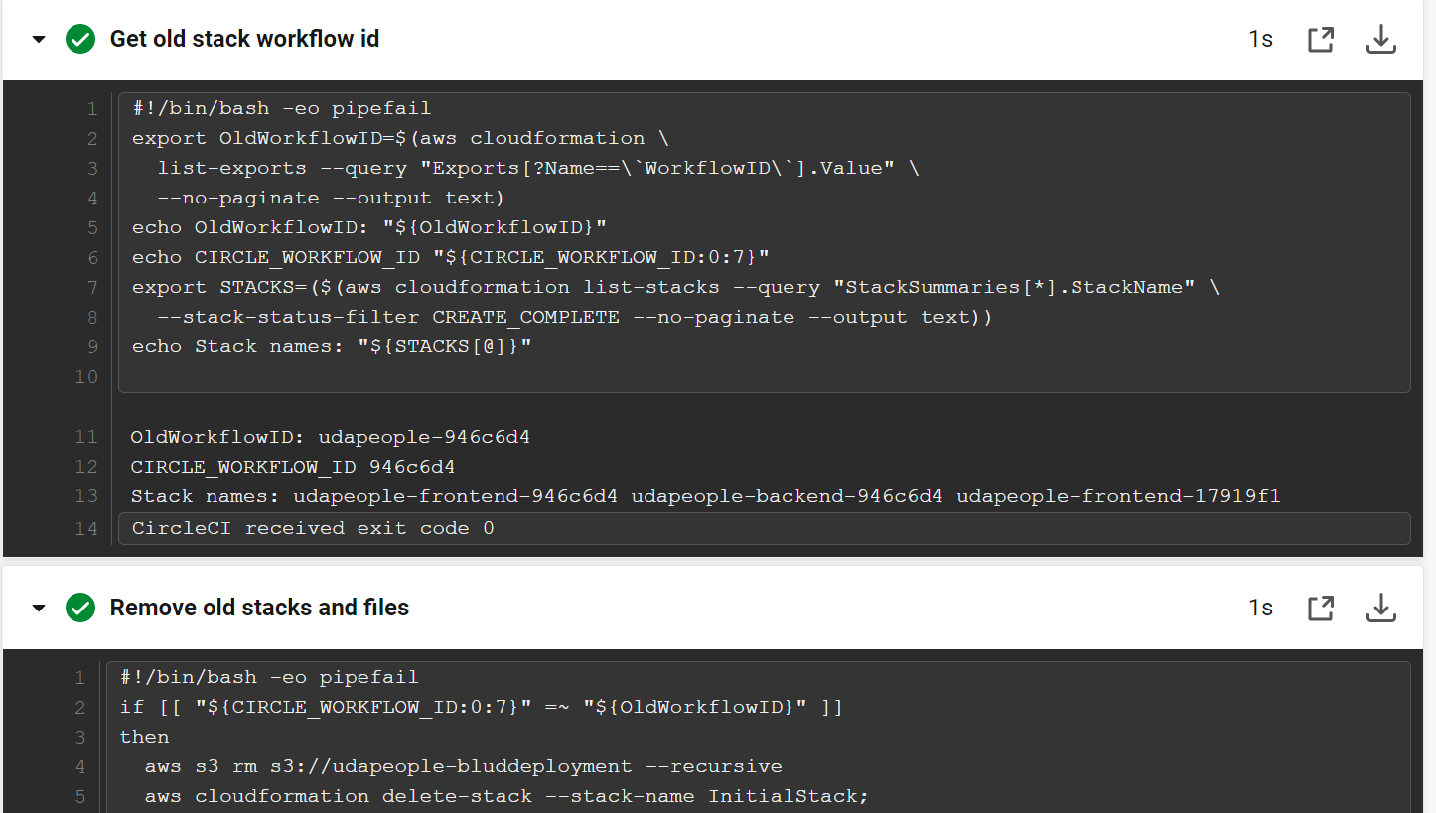

**SCREENSHOT10 “Deploy on pushed to main branch only, no deployment on dev branch”:**

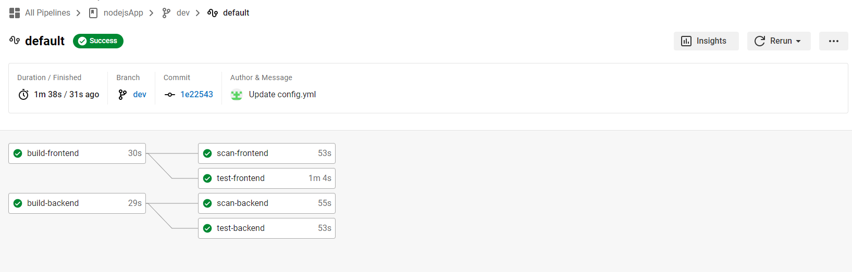

**SCREENSHOT11 “Node Exporter”**

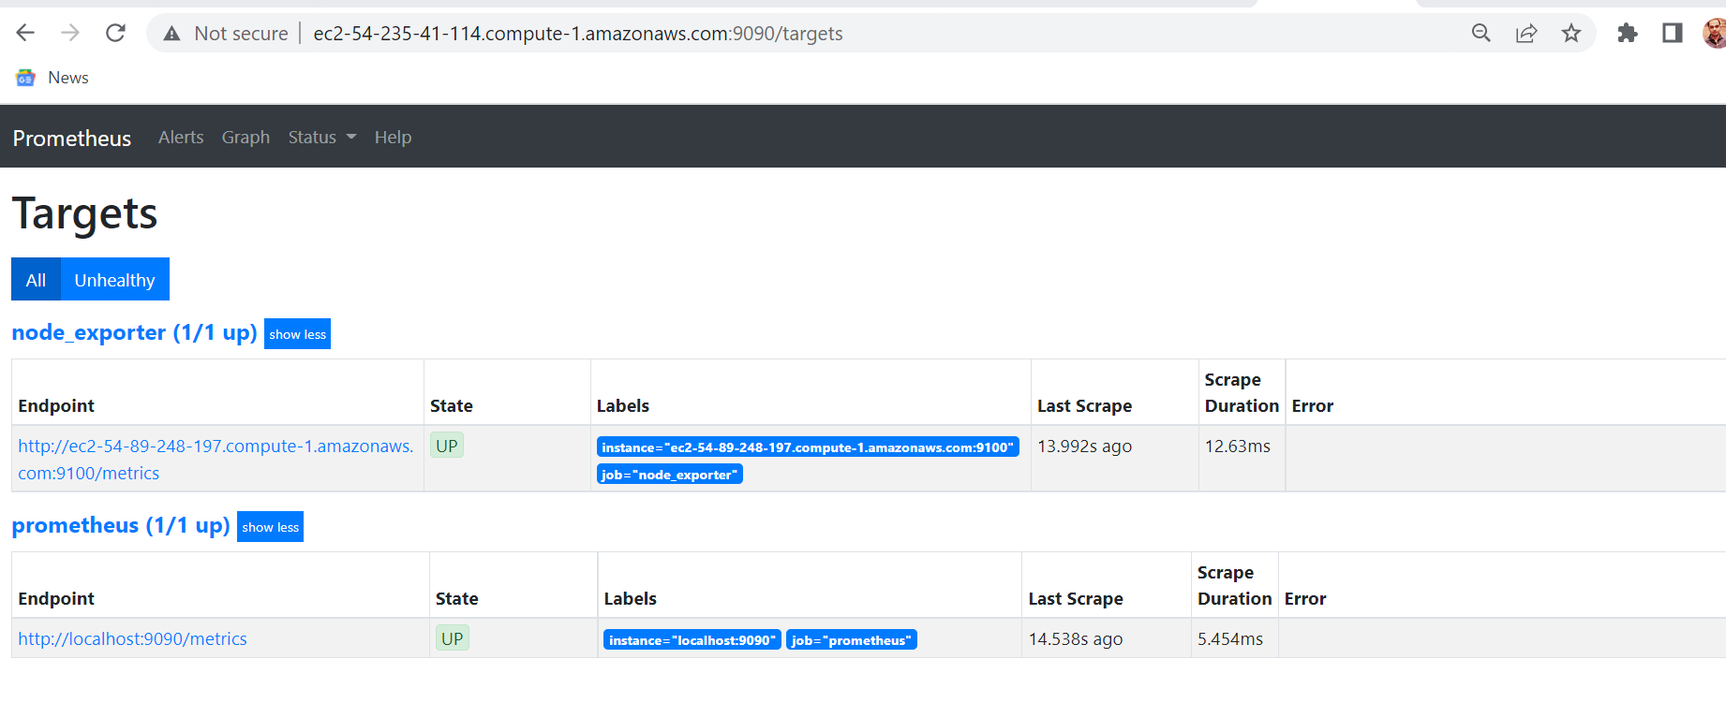

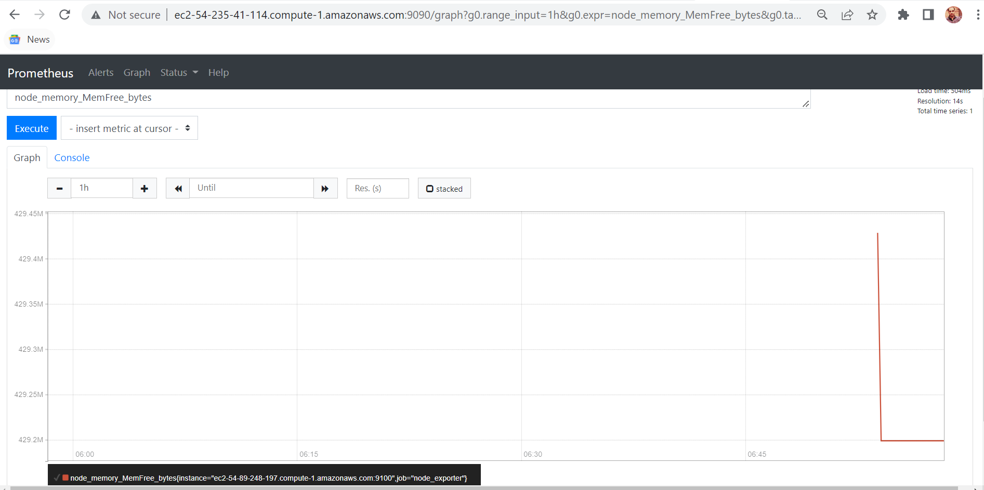

**SCREENSHOT12 “Alerts generated over gmail”**

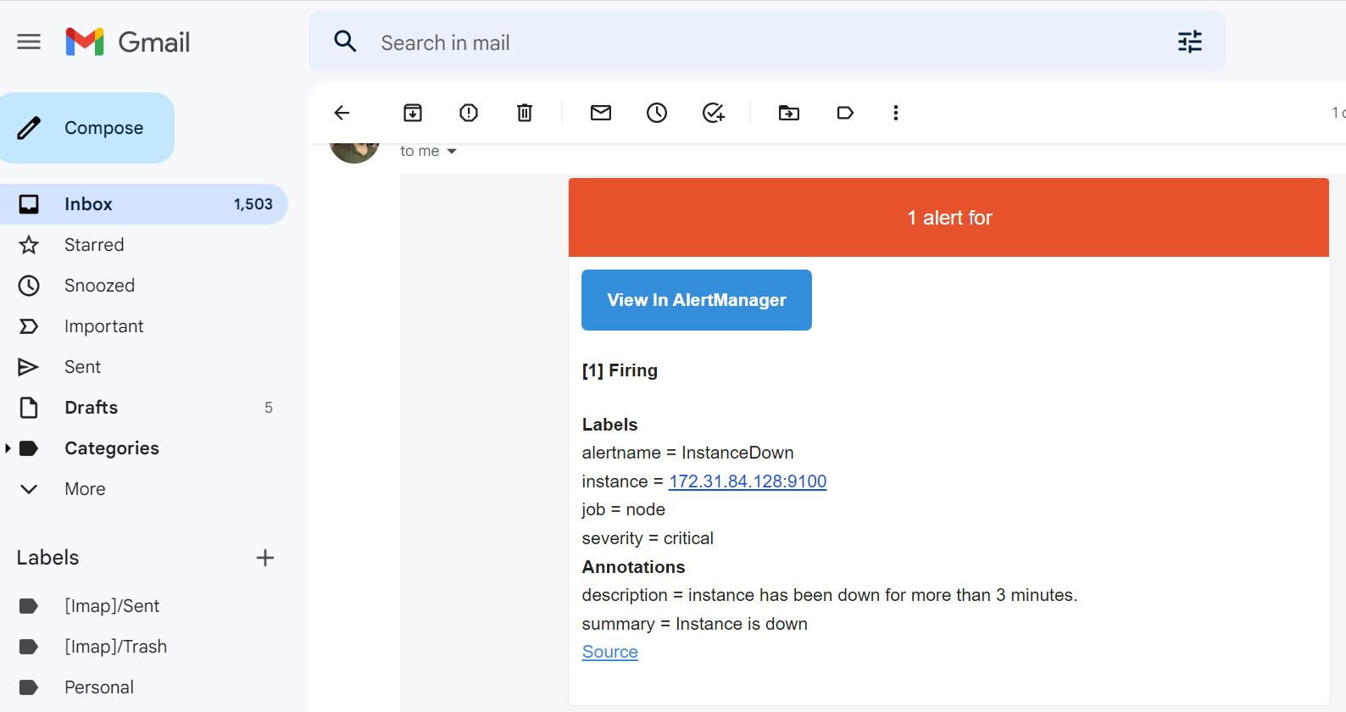

**Production FrontEnd “URL03_SCREENSHOT**”

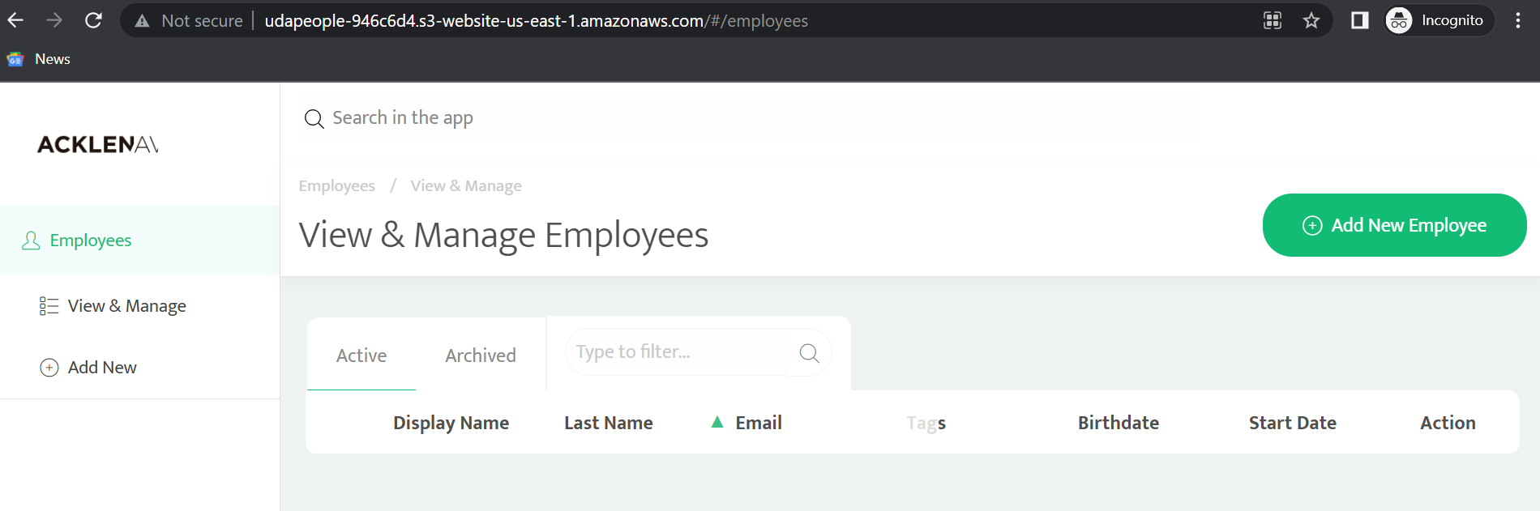

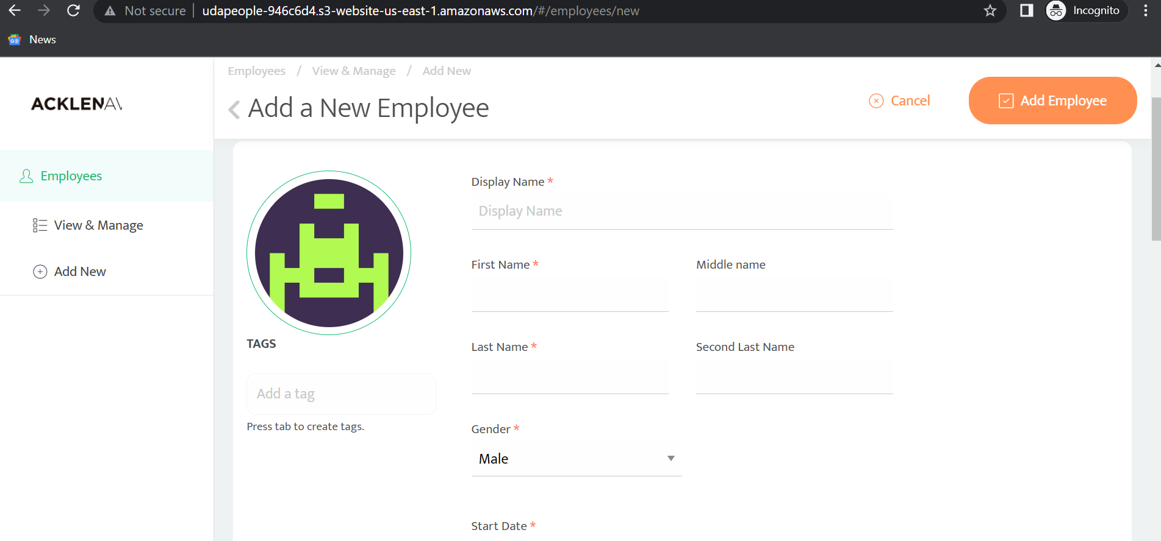

**Production Backend “URL04_SCREENSHOT**”

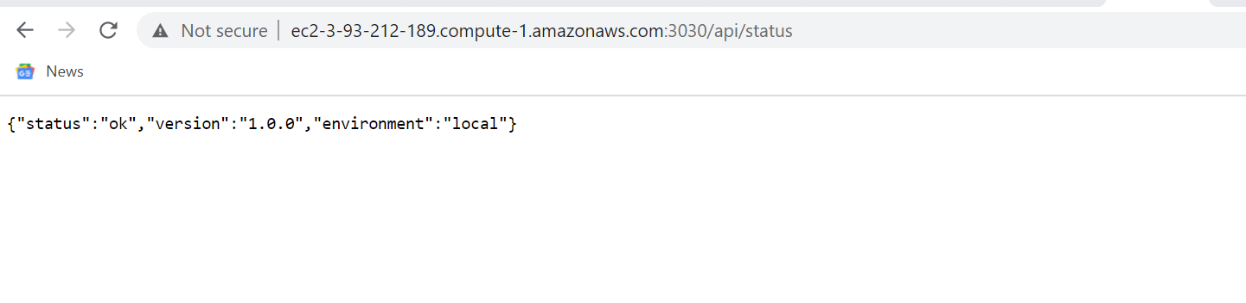

**Prometheus server “URL05_SCREENSHOT”**

