Converting Morpher json mapping into pillars configuration

Pillars take two configuration files as input:
info.txt (Ex. ii4_i_array_add.txt): Contains all the configurations
result.txt (Ex. ii4_r_array_add.txt): Contains constant configurations

TODO to Yujie: Convert morpher json mapping file to info.txt and result.txt

Use array_add_INNERMOST_LN1_PartPred_DFG.xmlstdnoc.jsonmapping.json and ii4_i_array_add.txt, ii4_2_array_add.txt as the test case:

1. Mux Configurations:

Morpher

"PE_MEM_Xx|_Yy|": {
"CONNECTIONS": {
"n (CGRA cycle)": {
"Source Port": [
"Destination Port"
],

Pillars

<n (CGRA cycle):cgra.tile_0.pe_y_x.(Multiplexer name connected to Dest Port).internalNode_0>
input port ID
output port ID (0 for single destination multiplexers)

Following table is valid for STDNOC

Destination Port | Multiplexer name connected to Dest Port
DP0_I1 | muxI1
DP0_I2 | muxI2
DP0_P | muxP
WP0 | muxWP0
WP1 | muxWP1
NORTH_O | muxNO
EAST_O | muxEO
WEST_O | muxWO
SOUTH_O | muxSO
 | muxT*

Multiplexer | Source Ports (port ID)
muxI1 | WEST_I (0), EAST_I (1), NORTH_I (2), SOUTH_I (3), RP0 (4), RP1 (5), T (6) *
muxI2 | WEST_I (0), EAST_I (1), NORTH_I (2), SOUTH_I (3), RP0 (4), RP1 (5)
muxP | WEST_I (0), EAST_I (1), NORTH_I (2), SOUTH_I (3), RP0 (4), RP1 (5)
muxWP0 | WEST_I (0), EAST_I (1), NORTH_I (2), SOUTH_I (3), T(4)
muxWP1 | WEST_I (0), EAST_I (1), NORTH_I (2), SOUTH_I (3), T(4)
muxNO | T (0), RP0 (1), RP1 (2)
muxEO | T (0), RP0 (1), RP1 (2)
muxWO | T (0), RP0 (1), RP1 (2)
muxSO | T (0), RP0 (1), RP1 (2)
muxT** | LSU_O (0), ALU_O (1)
*Stdnoc.json architecture description doesn’t contain T to muxI1 connection, but mapping file has that connection
** if memory instruction is mapped to a certain PE at cycle n, configure muxT to 0 at cycle n+1 (see example 2 in section 2)

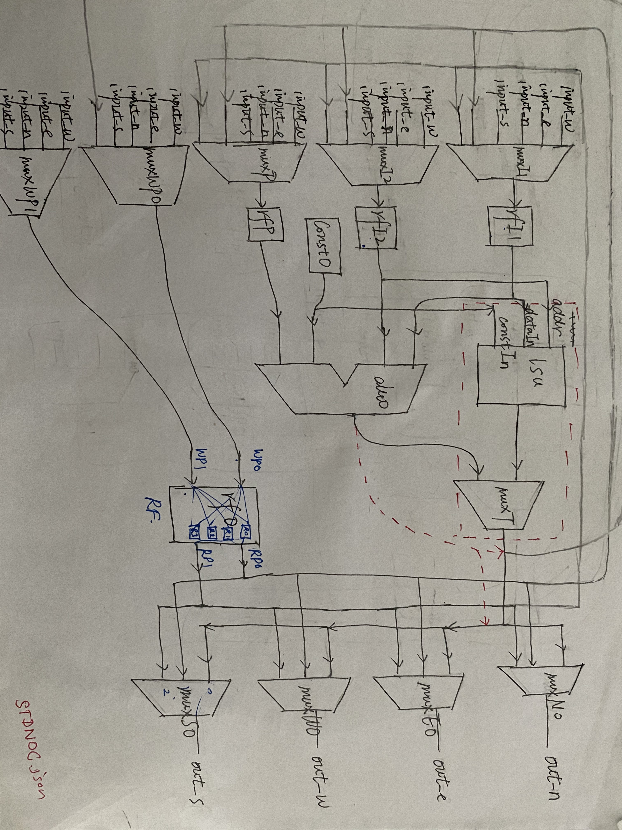

Example:

"PE_MEM_X0|_Y0|": {
"CONNECTIONS": {
"3": {
"THIS.EAST_I": [
"RF0.WP0"
]
}

<3:cgra.tile_0.pe_0_0.muxWP0.internalNode_0>
1
0

2. ALU and LSU Configurations:

Morpher:

"OPS": {
"<n (CGRA cycle)>: "STORE"
“<n (CGRA_cycle)>”: “ADD”
},

Pillars:

<(n+1)%II:cgra.tile_0.pe_y_x.<FU(loadStoreUnit)*>.internalNode_0>
SELECTED_OP
Op ID
<(n+1)%II:cgra.tile_0.pe_y_x.<FU(alu0)*>.internalNode_0>
SELECTED_OP
Op ID
*if memory instructions FU is loadStoreUnit, otherwise alu0

* if memory instruction is mapped to a certain PE at cycle n, configure muxT to 0 at cycle n+1 (see example 2). This configuration is not explicitly shown in the json mapping.

Example: 1)

"OPS": {
"0": "SELECT",
"1": "ADD",
"2": "CMP",
"3": "STORE"
},

<1:cgra.tile_0.pe_1_1.alu0.internalNode_0>
SELECTED_OP
25
<2:cgra.tile_0.pe_1_1.alu0.internalNode_0>
SELECTED_OP
33
<3:cgra.tile_0.pe_1_1.alu0.internalNode_0>
SELECTED_OP
35
<0:cgra.tile_0.pe_1_1.loadStoreUnit.internalNode_0>
SELECTED_OP
19
Example: 2)
<2:cgra.tile_0.pe_1_0.loadStoreUnit.internalNode_0>
SELECTED_OP
31

<3:cgra.tile_0.pe_1_0.muxT.internalNode_0>
0
0
Operations to Op ID mapping:

val NOP = Value("0")
val SEXT = Value("1")
val ZEXT = Value("2")
val TRUNC = Value("3")
val INPUT = Value("4")
val OUTPUT = Value("5")
val PHI = Value("6")
val CONST = Value("7")
val ADD = Value("8")
val SUB = Value("9")
val MUL = Value("10")
val DIV = Value("11")
val AND = Value("12")
val OR = Value("13")
val XOR = Value("14")
val SHLL = Value("15")
val LS = Value("15")
val SHRA = Value("16")
val CLT = Value("16")
val SHRL = Value("17")
val RS = Value("17")
val LOAD = Value("18")
val STORE = Value("19")
val GEP = Value("20")
val ICMP = Value("21")
val CMP = Value("21")
val SHR = Value("22")
val MOVC = Value("22")
val SLT = Value("23")
val CGT = Value("24")
val SLTU = Value("25")
val SELECT = Value("25")
val SHLA = Value("26")
val CMERGE = Value("26")
val LOADH = Value("27")
val STOREH = Value("28")
val LOADB = Value("29")
val STOREB = Value("30")
val LOADB_CONST = Value("31")
val STOREB_CONST = Value("32")
val ADD_CONST = Value("33")
val LS_CONST = Value("34")
val CMP_CONST = Value("35")
val CMERGE_CONST = Value("36")
val CMERGE_NPB = Value("37")
*If a instruction XXX has CONST value associated with it use XXX_CONST instruction.
*If a instruction XXX has NPB true with it use XXX_NPB instruction.
*Memory instructions : 18,19,27,28,29,30,31,32

3. Constants:

Morpher:
"n (CGRA cycle)": {
"CONST.constant_value": "DP0.I2"
},

Pillars Info.txt:
<<(n+1)%II>:cgra.tile_0.pe_1_0.const0.internalNode_0>
SELECTED_OP
7

Pillars Result.txt
const7 <(n+1)%II>:cgra.tile_0.pe_1_0.const0.internalNode_0 <(n+1)%II> 0
Pillars Tutorial.scala
const7 constant_value

Example:

"1": {
"CONST.4094": "DP0.I2"
},
,
"3": {
"CONST.2047": "DP0.I2",

Info.txt:

<2:cgra.tile_0.pe_1_0.const0.internalNode_0>
SELECTED_OP
7

Result.txt:
const11 2:cgra.tile_0.pe_1_0.const0.internalNode_0 2 0
Scala:
const11 = 4094
The order which placed constants in result.txt should be matched with the order constants are passed in Tutorial.scala file.

4. Register file configurations:

Morpher:
"RF0": {
"CONNECTIONS": {
"n (cgra cycle)": {
"THIS.<Reg_ID>_RI": [
"THIS.Read_Port"
]
},,
"n (cgra cycle)": {
"THIS.Write_Port": [
"THIS.<Reg_ID>_RO"
]
}

Pillars:
<n (cgra cycle):cgra.tile_0.pe_0_0.rf0.internalNode_<Reg_ID>>
-1
Read_Port ID
<3:cgra.tile_0.pe_0_0.rf0.internalNode_<Reg_ID>>
Write_Port_ID
-1
Read Port / Write Port | Read Port ID/ Write Port ID
RP0 | 0
RP1 | 1
WP0 | 0
WP1 | 1

Example:

"RF0": {
"CONNECTIONS": {
"2": {
"THIS.R1_RI": [
"THIS.RP0"
]
},
"3": {
"THIS.WP0": [
"THIS.R1_RO"
]
}
},
<2:cgra.tile_0.pe_0_0.rf0.internalNode_1>
-1
0
<3:cgra.tile_0.pe_0_0.rf0.internalNode_1>
0
-1

Temporary Bug fixes which need to be reversed in final version

1) Line 64 in ii4_i_array_add.txt and line 5 ii4_r_array_add.txt in is used to store byte as a replacement to STOREB (19) instruction. This is temporary fix. This mapping place the LOADB (11) and STOREB(19) in two different PE s (PE_1_0 and PE_2_0). However in current STDNOC architecture model, Each PE has separate memory. To avoid regenerating mapping and tedious manual conversion, I just placed STOREB instruction in PE_1_0 at cycle 1.

ii4_i_array_add.txt

Line 64: <1:cgra.tile_0.pe_1_0.loadStoreUnit.internalNode_0>
SELECTED_OP
32
ii4_i_array_add.txt
Line 5: const7 1:cgra.tile_0.pe_1_0.const0.internalNode_0 3 0
STOREB instruction in BasicChiselModules also change to store 0 always to support this.
Revert this change once automatic converter is available.

2) json architecture description doesn’t contain T to muxI1 connection but mapping file has it.

3) Default configuration for all configurations are set to 1 (In original pillars it was 0)

4) When Register file contains 4 registers default configuration for register write is 11. Therefore Register 3 will always be updated with the values in write ports. Current architecture doesn’tcontain write enable port in register file. As a temporary fix for this issue, I increased number of registers in register file to 8 (it only allows 2 to the power number, Line 315 in Blocks.scala).

5) Revert STOREB all 0 (Line 979 in BasicChiselModules.scala)

Array add mapping:

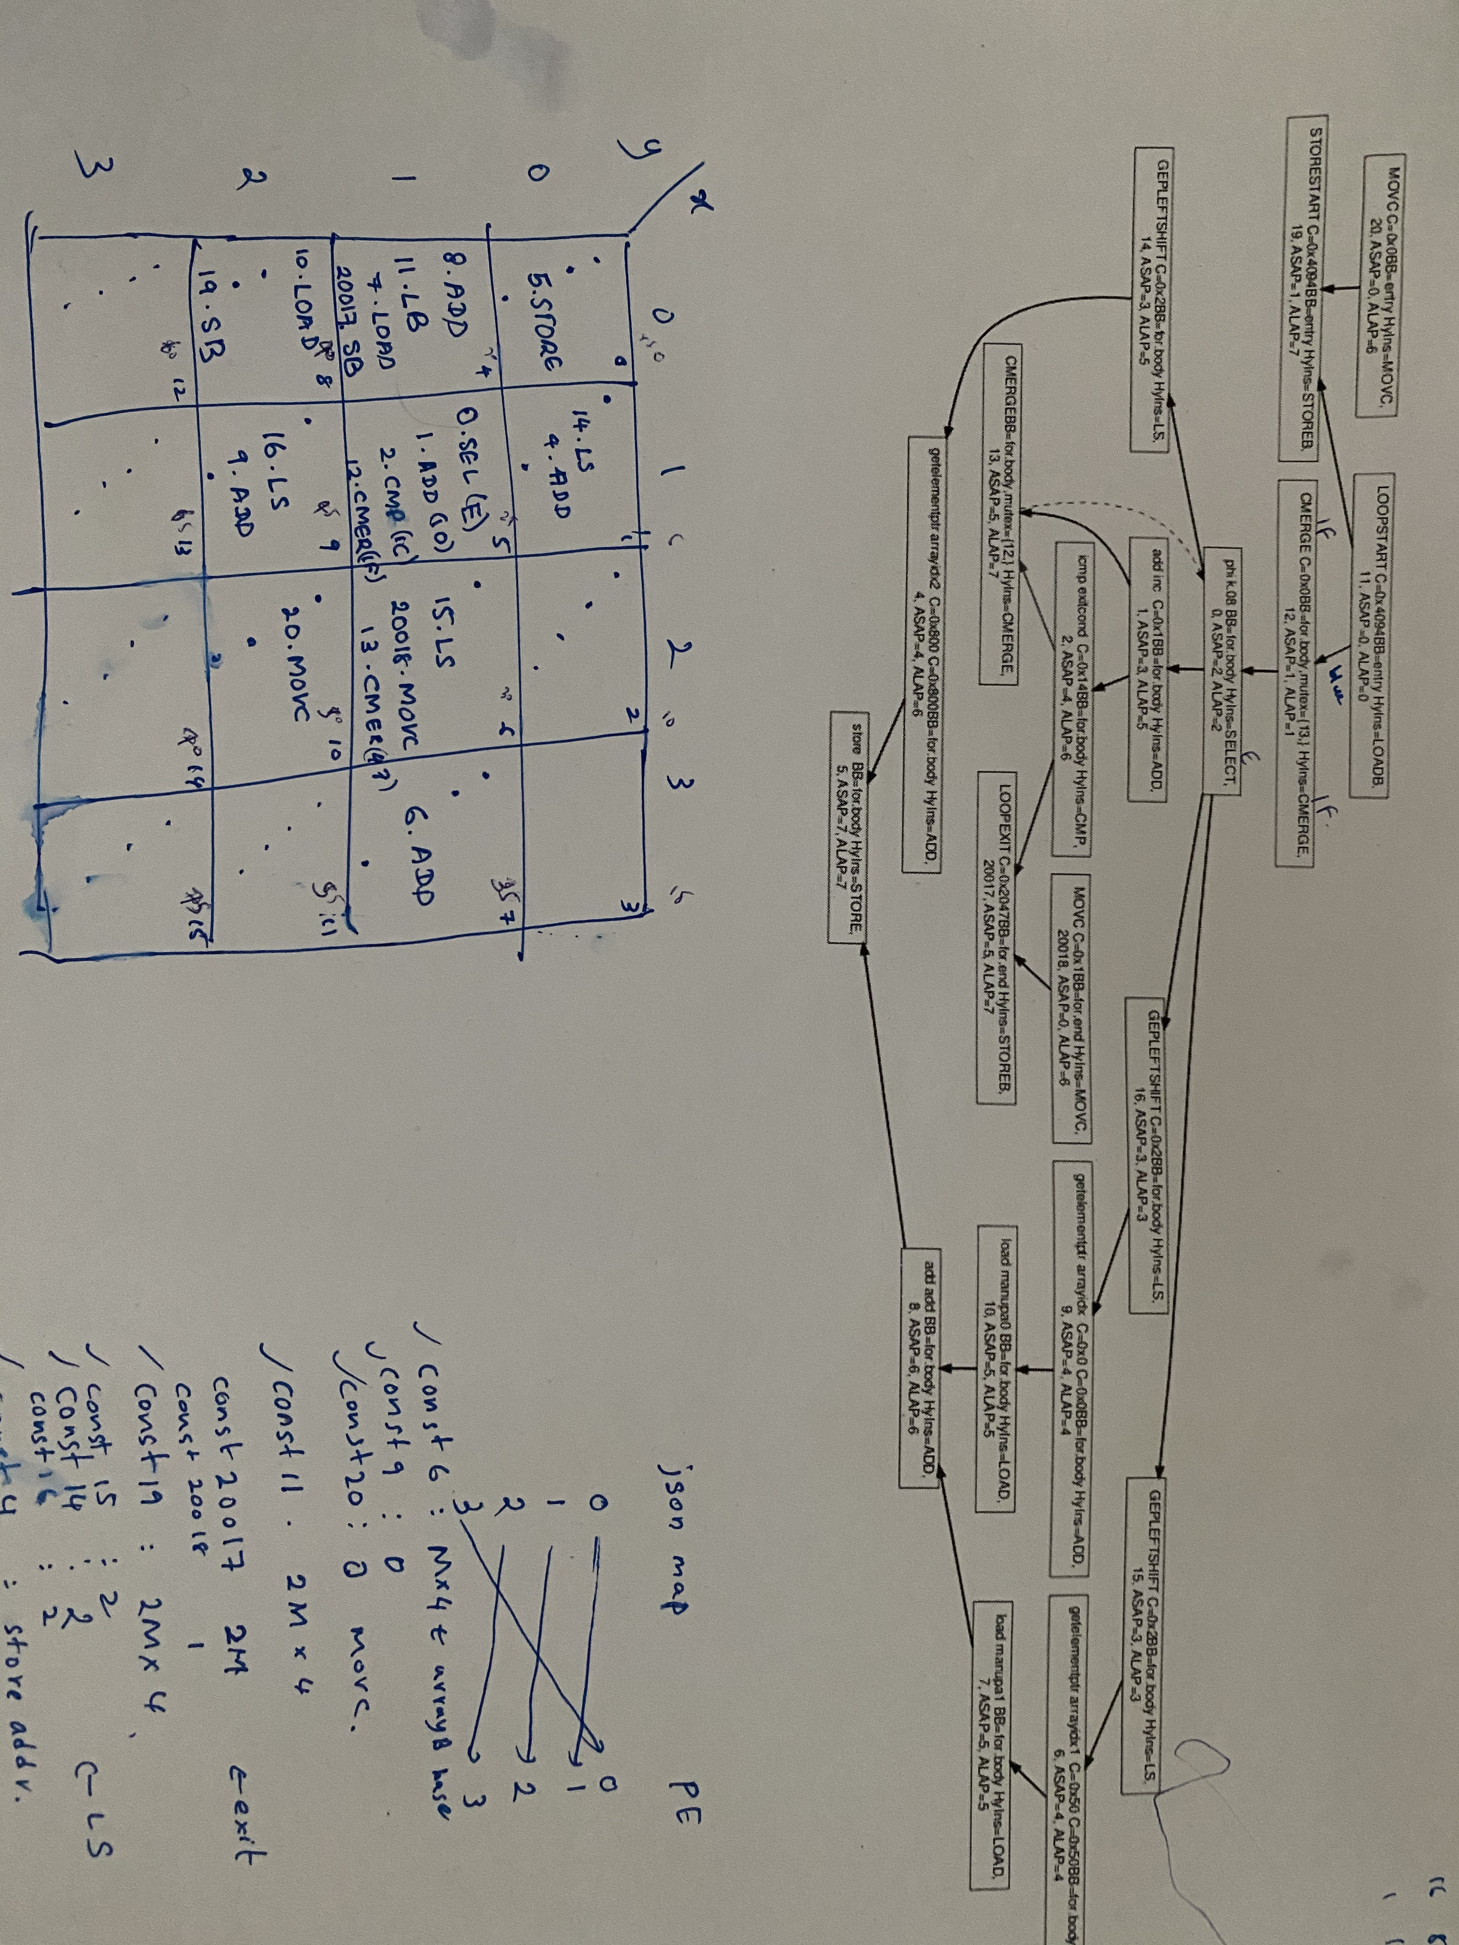
TODO:

1) Set different memory architectures
2) Name the modules using location based name to identify it easily. Or at least give module ID to component name map to make the debugging easy.
(Now module ID has no connection with the location and hard to locate certain component of known PE. To find a component, we have to search the corresponding configuration on cmd run output, find the identifier of the module, search again using identifier to find the module id))

