Full name : Pham Van Phuc

Student ID : 522H0068

LAB1

I. Classwork

1. Here is the run screen after I edited the source code provided as requested

Run file TestMyLinkedList1 with strings

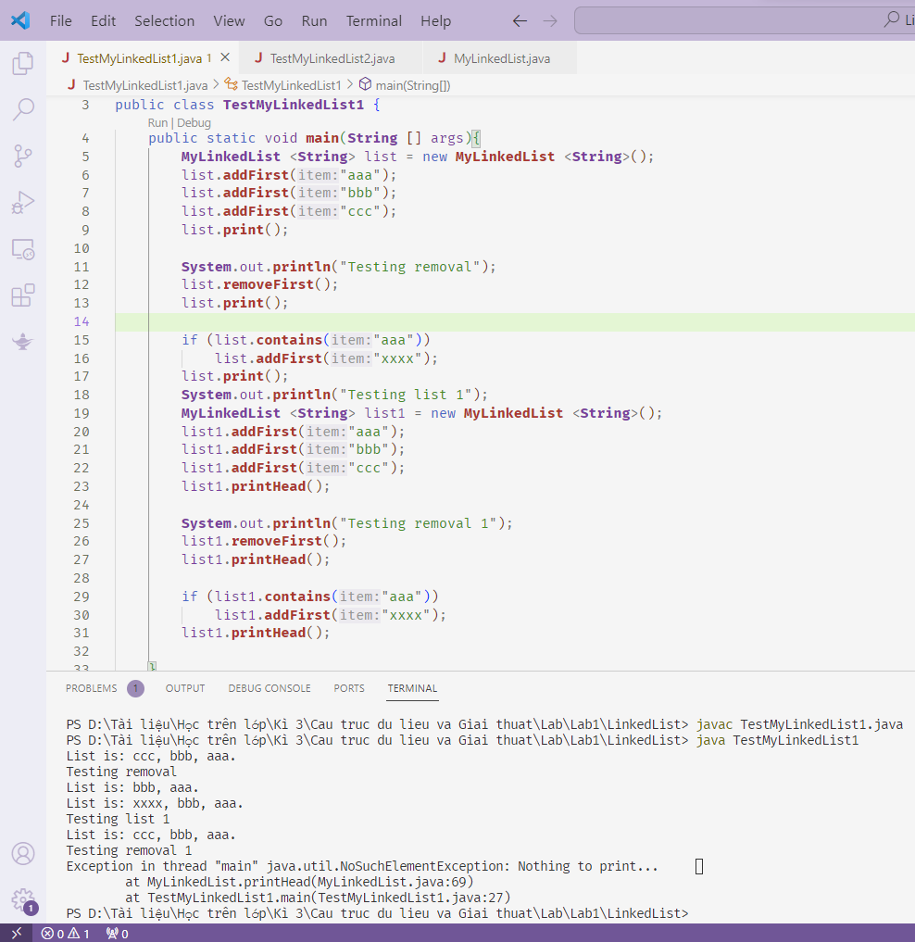

2.Run file TestMyLinkedList2 with Integer

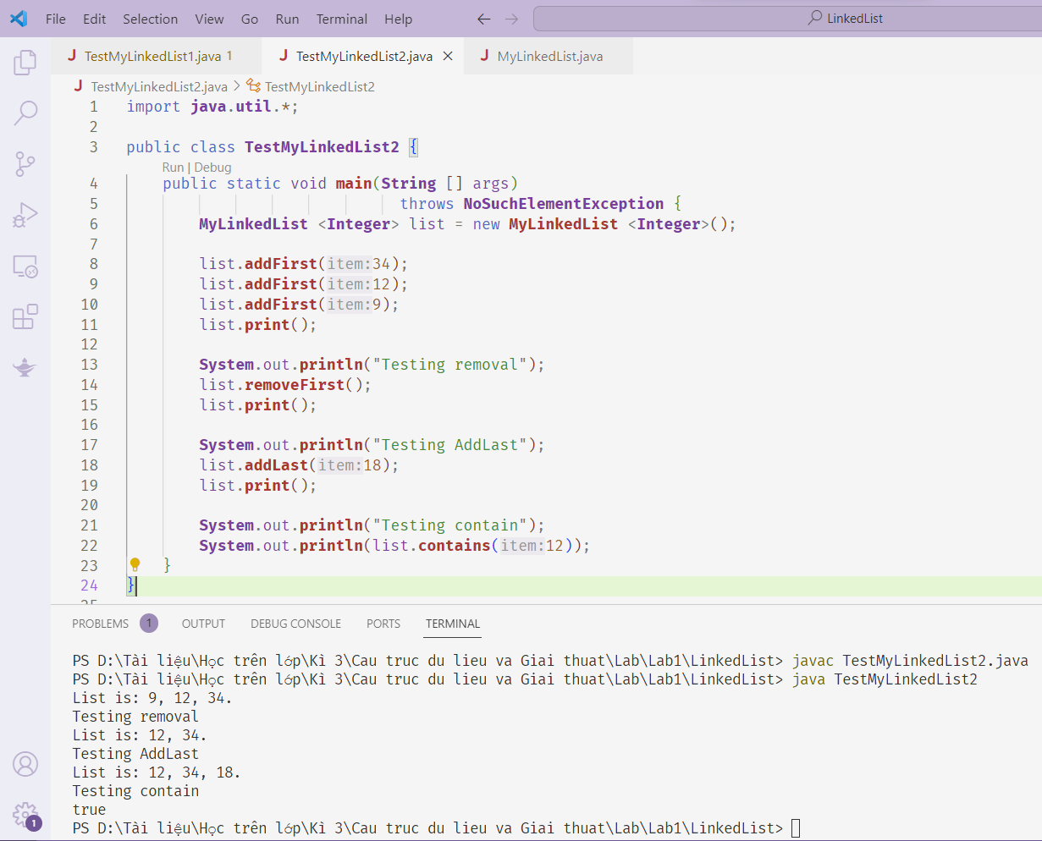

II.Homework

Exercise 1 : Implements the Fraction class that manipulates fractions

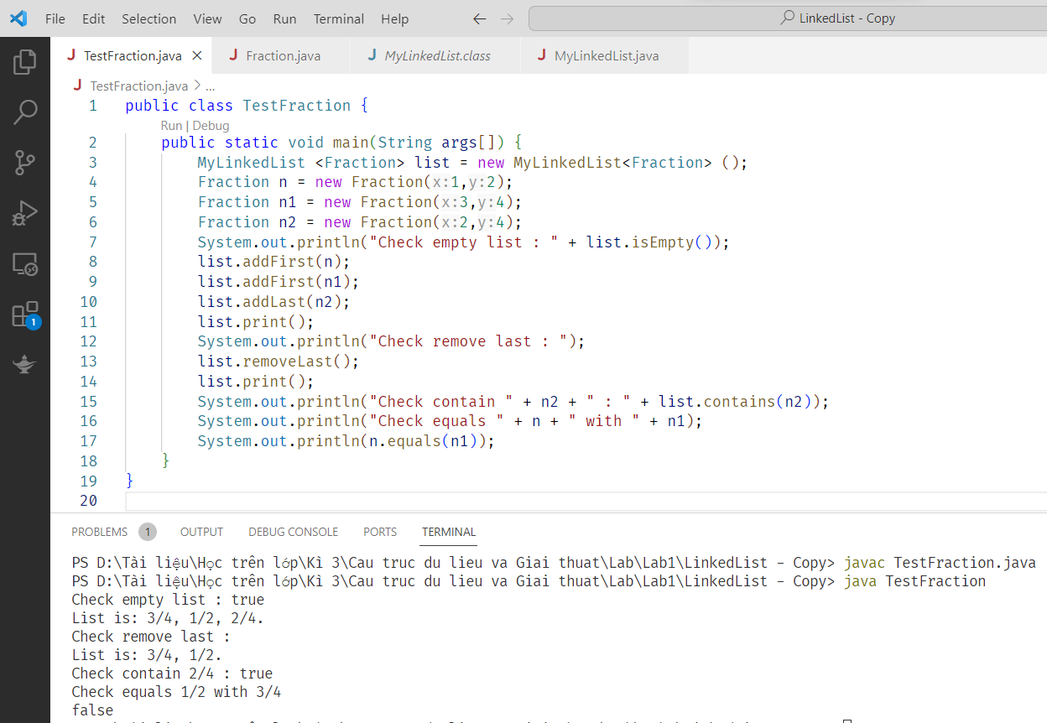

Exercise 2 : Remove node at position curr

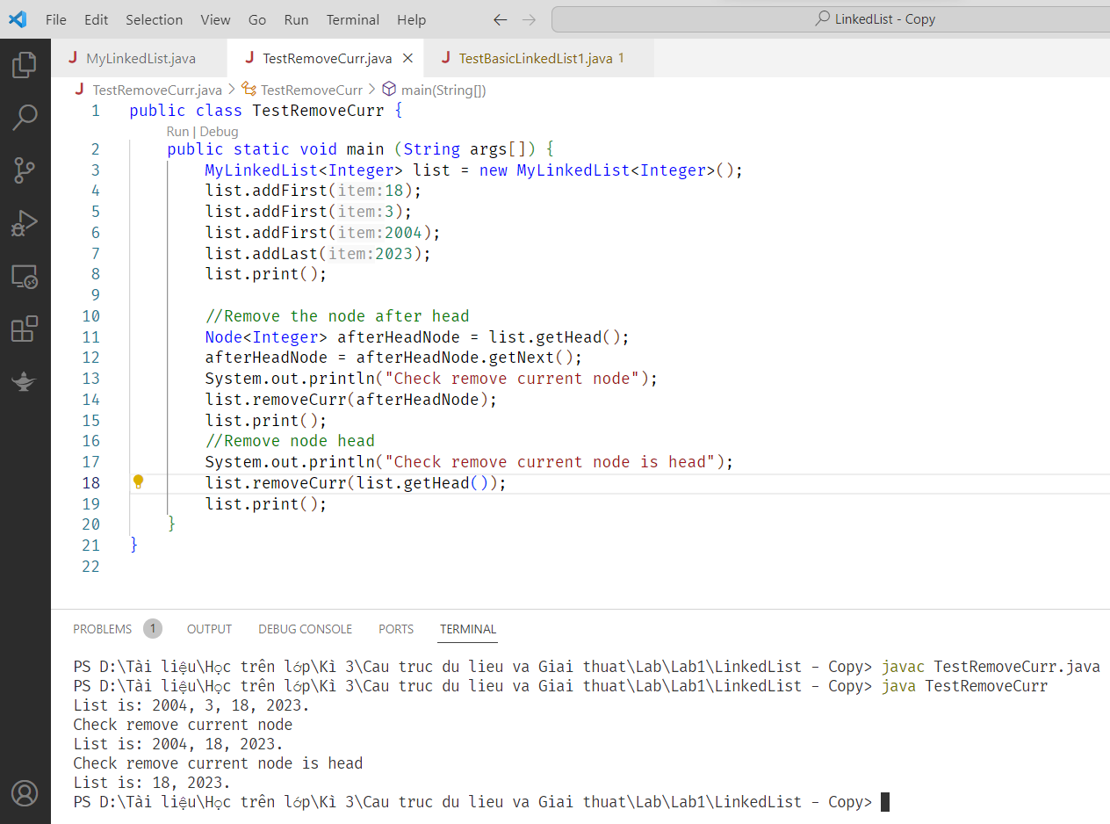

Exercise 3

Suppose we are having a list of integer numbers, do the following requirements:

(a) Count the number of even item in the list.

(b) Count the number of prime item in the list.

(c) Add item X before the first even element in the list.

(d) Find the maximum number in the list.

(e) (\*) Reverse the list without using temporary list

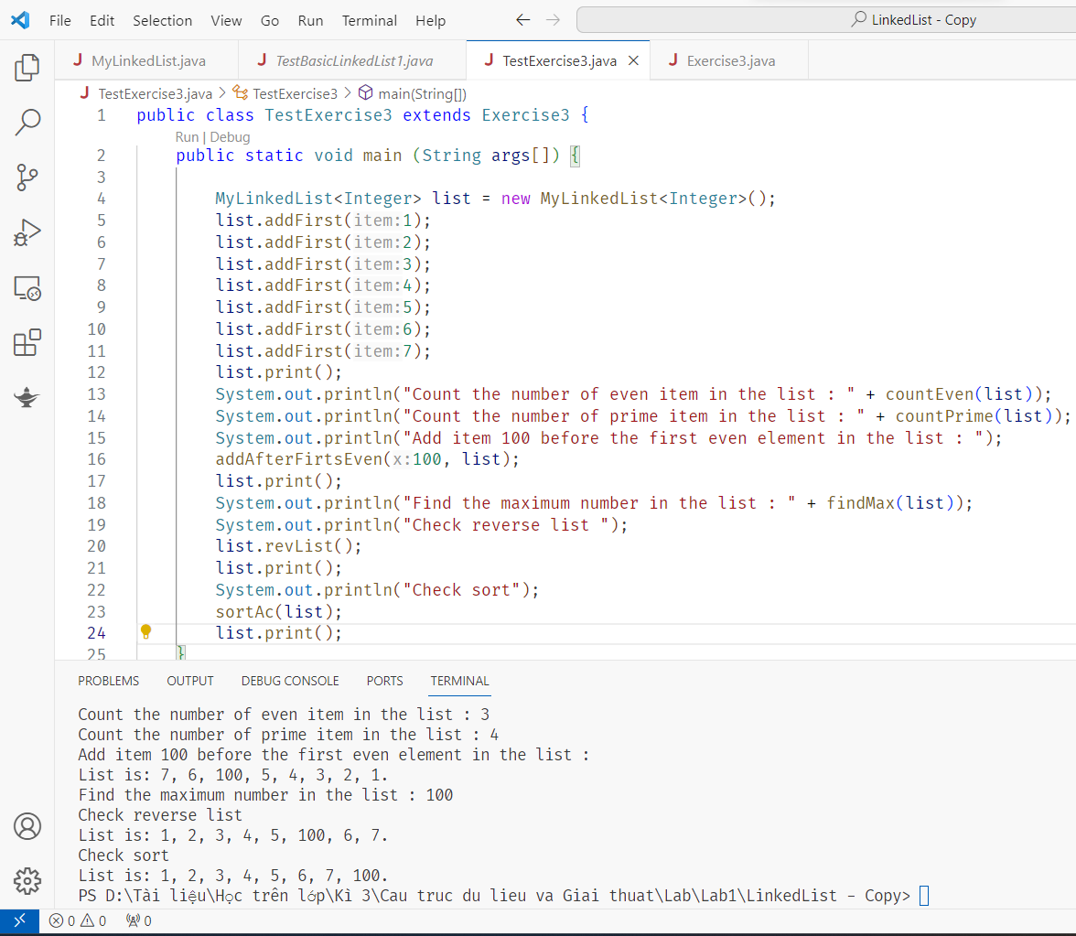

Exercise 2 : Double Linked List

