When computing the root of MR1024 MR1448 MR2048 with Mathematica’s RootIntervals, there are some unexpected results, we take MR1024 as an example.



In fact, there are 4 different roots of MR1024

The result of MR1024 with logcf is:



The result of MR1024 with logcf is:

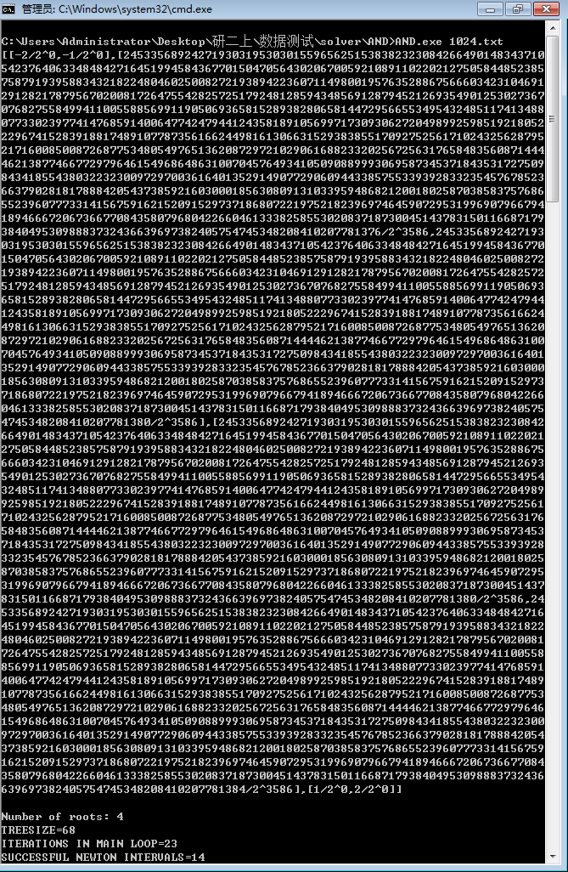

We can see that the distance between the second root and the third root is extremely small.

MR1024 with Maple can not get an solution in limited time.,but we might see the result of MR256 as well:

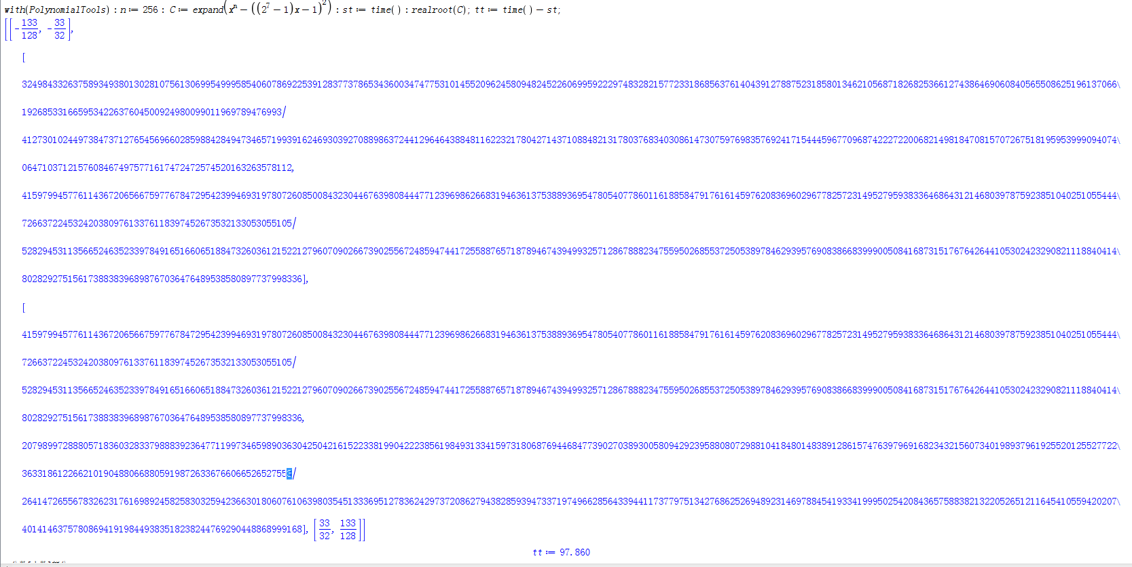

When we test MR1024 with Mathematica’s RootIntervals, the result shows that there is a double root ,we find the trace stack and get the information as follows:

Message[PossibleZeroQ::ztest1,-1+254 Root[{254-32258 #1+1024 #11023&,0.0078740157480314960630}]-16129 Root[{254-32258 #1+1024 #1^1023&,0.0078740157480314960630}]2+Root[{254-32258 #1+1024 #1^1023&,0.0078740157480314960630}]1024]

We refer PossibleZeroQ with helping system, and find that PossibleZeroQ

checks whether an expression is zero or not, but sometimes it can cause some mistake:

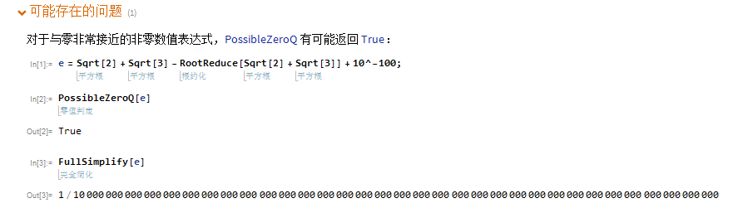

Therefore, we can infer that RootIntervals makes unreasonable approximate when calling PossibleZeroQ in the process of computing because of two narrow roots.