*OSPF v1.31 – Aaron Balchunas*  1

**- Open Shortest Path First -**

***OSPF (Open Shortest Path First)***

OSPF is a standardized Link-State routing protocol, designed to scale

efficiently to support larger networks.

OSPF adheres to the following Link State characteristics:   
 •OSPF employs a hierarchical network design using **Areas.**

•OSPF will form **neighbor** relationships with adjacent routers in the

same **Area.**

•Instead of advertising the *distance* to connected networks, OSPF

advertises the *status* of directly connected **links** using **Link-State**

**Advertisements (LSAs)**.

•OSPF sends updates (LSAs) when there is a change to one of its links,

and will *only* send the change in the update. LSAs are additionally

refreshed every **30 minutes**.

•OSPF traffic is multicast either to address **224.0.0.5 (**all OSPF

routers) or **224.0.0.6** (all Designated Routers).

•OSPF uses the **Dijkstra Shortest Path First** algorithm to determine

the shortest path.

•OSPF is a classless protocol, and thus supports VLSMs.

Other characteristics of OSPF include:   
 •OSPF supports only IP routing.

•OSPF routes have an administrative distance is **110**.

•OSPF uses **cost** as its metric, which is computed based on the

bandwidth of the link. OSPF has no hop-count limit.

The OSPF process builds and maintains three separate tables: •A **neighbor table** – contains a list of all neighboring routers.

•A **topology table** – contains a list of *all* possible routes to all known

networks within an area.

•A **routing table** – contains the *best* route for each known network.

*\* * \**

All original material copyright © 2007 by Aaron Balchunas (aaron@routeralley.com),

unless otherwise noted. All other material copyright © of their respective owners.

This material may be copied and used freely, but may not be altered or sold without the expressed written

consent of the owner of the above copyright. Updated material may be found at http://www.routeralley.com.

*OSPF v1.31 – Aaron Balchunas*  2

***OSPF Neighbors***

OSPF forms neighbor relationships, called **adjacencies,** with other routers in the same **Area** by exchanging **Hello** packets to multicast address **224.0.0.5**.

Only after an adjacency is formed can routers share routing information.

Each OSPF router is identified by a unique **Router ID.** The Router ID can be determined in one of three ways:   
 •The Router ID can be **manually** specified.

•If not manually specified, the highest IP address configured on any **Loopback interface** on the router will become the Router ID.

•If no loopback interface exists, the highest IP address configured on any **Physical interface** will become the Router ID.

By default, Hello packets are sent out OSPF-enabled interfaces every **10 seconds** for broadcast and point-to-point interfaces, and **30 seconds** for non-broadcast and point-to-multipoint interfaces.

OSPF also has a **Dead Interval**, which indicates how long a router will wait without hearing any hellos before announcing a neighbor as “down.” Default for the Dead Interval is **40 seconds** for broadcast and point-to-point   
interfaces, and **120** seconds for non-broadcast and point-to-multipoint interfaces. Notice that, by default, the dead interval timer is four times the Hello interval.

These timers can be adjusted on a *per interface* basis:

**Router(config-if)#** *ip ospf hello-interval 15*   
**Router(config-if)#** *ip ospf dead-interval 60*

*\* * \**   
All original material copyright © 2007 by Aaron Balchunas (aaron@routeralley.com), unless otherwise noted. All other material copyright © of their respective owners.

This material may be copied and used freely, but may not be altered or sold without the expressed written consent of the owner of the above copyright. Updated material may be found at http://www.routeralley.com.

*OSPF v1.31 – Aaron Balchunas*  3

***OSPF Neighbors (continued)***

OSPF routers will only become neighbors if the following parameters within

a Hello packet are identical on each router:   
•Area ID   
•Area Type (stub, NSSA, etc.)   
•Prefix   
•Subnet Mask   
•Hello Interval   
•Dead Interval   
•Network Type (broadcast, point-to-point, etc.) •Authentication

The Hello packets also serve as **keepalives** to allow routers to quickly

discover if a neighbor is down. Hello packets also contain a **neighbor field**

that lists the Router IDs of all neighbors the router is connected to.

A **neighbor table** is constructed from the OSPF Hello packets, which

includes the following information:   
•The **Router ID** of each neighboring router   
•The current “state” of each neighboring router   
•The interface directly connecting to each neighbor •The IP address of the remote interface of each neighbor

(Reference: http://www.cisco.com/warp/public/104/29.html)

*\* * \**

All original material copyright © 2007 by Aaron Balchunas (aaron@routeralley.com),

unless otherwise noted. All other material copyright © of their respective owners.

This material may be copied and used freely, but may not be altered or sold without the expressed written

consent of the owner of the above copyright. Updated material may be found at http://www.routeralley.com.

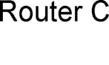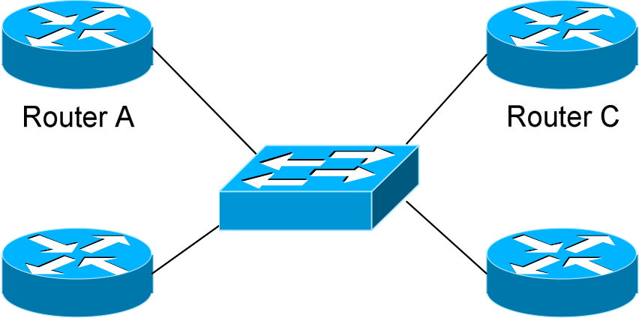

*OSPF v1.31 – Aaron Balchunas*  4

***OSPF Designated Routers***

In multi-access networks such as   
Ethernet, there is the possibility of

|  |  |
| --- | --- |
| *many* neighbor relationships on the same physical segment. In the above example, four routers are connected |  |

into the same multi-access segment.   
Using the following formula (where

|  |  |  |
| --- | --- | --- |
| “n” is the number of routers): |  |  |
| **n(n-1)/2** |

…..it is apparent that **6** separate adjacencies are needed for a fully meshed network. Increase the number of routers to five, and **10** separate adjacencies would be required. This leads to a considerable amount of unnecessary Link State Advertisement (LSA) traffic.

If a link off of Router A were to fail, it would flood this information to all neighbors. Each neighbor, in turn, would then flood that same information to all other neighbors. This is a waste of bandwidth and processor load.

To prevent this, OSPF will elect a **Designated Router (DR)** for each multi-access networks, accessed via multicast address **224.0.0.6**. For redundancy purposes, a **Backup Designated Router (BDR)** is also elected.

OSPF routers will form adjacencies with the DR and BDR. If a change occurs to a link, the update is forwarded only to the DR, which then forwards it to all other routers. This greatly reduces the flooding of LSAs.

DR and BDR elections are determined by a router’s **OSPF priority**, which is configured on a per-interface basis (a router can have interfaces in multiple multi-access networks). The router with the **highest priority** becomes the DR; second highest becomes the BDR. If there is a tie in priority, whichever router has the **highest Router ID** will become the DR.

To change the priority on an interface:

**Router(config-if)#** *ip ospf priority 125*

Default priority on Cisco routers is **1**. A priority of **0** will prevent the router from being elected DR or BDR. **Note:** The DR election process is ***not preemptive***. Thus, if a router with a higher priority is added to the network, it will *not* automatically supplant an existing DR. Thus, a router that should never become the DR should always have its priority set to 0.

*\* * \**   
All original material copyright © 2007 by Aaron Balchunas (aaron@routeralley.com), unless otherwise noted. All other material copyright © of their respective owners.

This material may be copied and used freely, but may not be altered or sold without the expressed written consent of the owner of the above copyright. Updated material may be found at http://www.routeralley.com.

*OSPF v1.31 – Aaron Balchunas*  5

***OSPF Neighbor States***

Neighbor adjacencies will progress through several **states**, including:

**Down** – indicates that no Hellos have been heard from the neighboring router.

**Init –** indicates a Hello packet has been heard from the neighbor, but two-way communication has not yet been initialized.

**2**-**Way** – indicates that bidirectional communication has been established. Recall that Hello packets contain a *neighbor* field. Thus, communication is considered 2-Way once a router sees its own Router ID in its neighbor’s Hello Packet. **Designated** and **Backup DesignatedRouters** are elected at this stage.

**ExStart** – indicates that the routers are preparing to share link state information. Master/slave relationships are formed between routers to determine who will begin the exchange.

**Exchange –** indicates that the routers are exchanging **Database Descriptors (DBDs).** DBDs contain a description of the router’s Topology Database. A router will examine a neighbor’s DBD to determine if it has information to share.

**Loading –** indicates the routers are finally exchanging **Link State**   
**Advertisements,** containing information about all links connected to each router. Essentially, routers are sharing their topology tables with each other.

**Full –** indicates that the routers are fully synchronized. The topology table of all routers in the area should now be identical. Depending on the “role” of the neighbor, the state may appear as:   
 •**Full/DR** – indicating that the neighbor is a Designated Router (DR) •**Full/BDR** – indicating that the neighbor is a Backup Designated Router (BDR)   
 •**Full/DROther –** indicating that the neighbor is neither the DR or BDR

On a multi-access network, OSPF routers will *only* form Full adjacencies with DRs and BDRs. Non-DRs and non-BDRs will still form adjacencies, but will remain in a **2-Way State**. This is normal OSPF behavior.

*\* * \**   
All original material copyright © 2007 by Aaron Balchunas (aaron@routeralley.com), unless otherwise noted. All other material copyright © of their respective owners.

This material may be copied and used freely, but may not be altered or sold without the expressed written consent of the owner of the above copyright. Updated material may be found at http://www.routeralley.com.

*OSPF v1.31 – Aaron Balchunas*  6

***OSPF Network Types***

OSPF’s functionality is different across several different network topology

types. OSPF’s interaction with Frame Relay will be explained in another

section

**Broadcast Multi-Access –** indicates a topology where broadcast occurs. •Examples include Ethernet, Token Ring, and ATM.

•OSPF *will* elect DRs and BDRs.

•Traffic to DRs and BDRs is multicast to 224.0.0.6. Traffic from

DRs and BDRs to other routers is multicast to 224.0.0.5. •Neighbors *do not* need to be manually specified.

**Point-to-Point –** indicates a topology where two routers are directly

connected.

•An example would be a point-to-point T1.

•OSPF *will not* elect DRs and BDRs.

•All OSPF traffic is multicast to 224.0.0.5.

•Neighbors *do not* need to be manually specified.

**Point-to-Multipoint** – indicates a topology where one interface can connect

to multiple destinations. Each connection between a source and destination

is treated as a point-to-point link.

•An example would be Point-to-Multipoint Frame Relay. •OSPF *will not* elect DRs and BDRs.

•All OSPF traffic is multicast to 224.0.0.5.

•Neighbors *do not* need to be manually specified.

**Non-broadcast Multi-access Network (NBMA) –** indicates a topology

where one interface can connect to multiple destinations; however,

broadcasts cannot be sent across a NBMA network.

•An example would be Frame Relay.

•OSPF *will* elect DRs and BDRs.

•OSPF neighbors must be *manually* defined, thus All OSPF traffic

is unicast instead of multicast.

**Remember:** on *non-broadcast* networks, neighbors must be **manually**

**specified**, as multicast Hello’s are not allowed.

*\* * \**

All original material copyright © 2007 by Aaron Balchunas (aaron@routeralley.com),

unless otherwise noted. All other material copyright © of their respective owners.

This material may be copied and used freely, but may not be altered or sold without the expressed written

consent of the owner of the above copyright. Updated material may be found at http://www.routeralley.com.

*OSPF v1.31 – Aaron Balchunas*  7

***Configuring OSPF Network Types***

The default OSPF network type for basic Frame Relay is **Non-broadcast Multi-access Network (NBMA).** To configure manually:

**Router(config)#** *interface s0*   
**Router(config-if)#** *encapsulation frame-relay*   
**Router(config-if)#** *frame-relay map ip 10.1.1.1 101* **Router(config-if)#** *ip ospf network non-broadcast*

**Router(config)#** *router ospf 1*   
**Router(config-router)#** *neighbor 10.1.1.1*

Notice that the *neighbor* was manually specified, as multicasting is not allowed on an NBMA. However, the Frame-Relay network can be tricked into allowing broadcasts, eliminating the need to manually specify   
neighbors:

**Router(config)#** *interface s0*   
**Router(config-if)#** *encapsulation frame-relay*   
**Router(config-if)#** *frame-relay map ip 10.1.1.1 101 broadcast* **Router(config-if)#** *ip ospf network broadcast*

Notice that the *ospf network* type has been changed to *broadcast,* and the *broadcast* parameter was added to the *frame-relay map* command. The neighbor no longer needs to be specified, as multicasts will be allowed out this map.

The default OSPF network type for Ethernet and Token Ring is **Broadcast Multi-Access.** To configure manually:

**Router(config)#** *interface e0*   
**Router(config-if)#** *ip ospf network broadcast*

The default OSPF network type for T1’s (HDLC or PPP) and Point-to-Point Frame Relay is **Point-to-Point.** To configure manually:

**Router(config)#** *interface s0*   
**Router(config-if)#** *encapsulation frame-relay*

**Router(config)#** *interface s0.1 point-to-point*   
**Router(config-if)#** *frame-relay map ip 10.1.1.1 101 broadcast* **Router(config-if)#** *ip ospf network point-to-point*

*\* * \**   
All original material copyright © 2007 by Aaron Balchunas (aaron@routeralley.com), unless otherwise noted. All other material copyright © of their respective owners.

This material may be copied and used freely, but may not be altered or sold without the expressed written consent of the owner of the above copyright. Updated material may be found at http://www.routeralley.com.

*OSPF v1.31 – Aaron Balchunas*  8

***Configuring OSPF Network Types (continued)***

The default OSPF network type for Point-to-Multipoint Frame Relay is *still* **Non-broadcast Multi-access Network (NBMA).** However, OSPF supports an additional network type called **Point-to-Multipoint,** which will allow neighbor discovery to occur automatically**.** To configure:

**Router(config)#** *interface s0*   
**Router(config-if)#** *encapsulation frame-relay*

**Router(config)#** *interface s0.2 multipoint*   
**Router(config-if)#** *frame-relay map ip 10.1.1.1 101 broadcast* **Router(config-if)#** *ip ospf network point-to-multipoint*

Additionally, a *non-broadcast* parameter can be added to the *ip ospf network* command when specifying *point-to-multipoint.*

**Router(config)#** *interface s0*   
**Router(config-if)#** *encapsulation frame-relay*

**Router(config)#** *interface s0.2 multipoint*   
**Router(config-if)#** *frame-relay map ip 10.1.1.1 101*   
**Router(config-if)#** *ip ospf network point-to-multipoint non-broadcast*

**Router(config)#** *router ospf 1*   
**Router(config-router)#** *neighbor 10.1.1.1*

Notice the different in configuration. The *frame-relay map* command no longer has the *broadcast* parameter, as broadcasts and multicasts are not allowed on a non-broadcast network.

Thus, in the OSPF router configuration, neighbors must again be manually specified. Traffic to those neighbors will be **unicast** instead of multicast.

OSPF network types must be set identically on two “neighboring” routers, otherwise they will never form an adjacency.

*\* * \**   
All original material copyright © 2007 by Aaron Balchunas (aaron@routeralley.com), unless otherwise noted. All other material copyright © of their respective owners.

This material may be copied and used freely, but may not be altered or sold without the expressed written consent of the owner of the above copyright. Updated material may be found at http://www.routeralley.com.

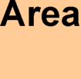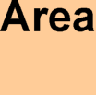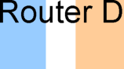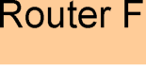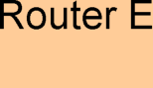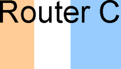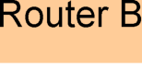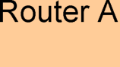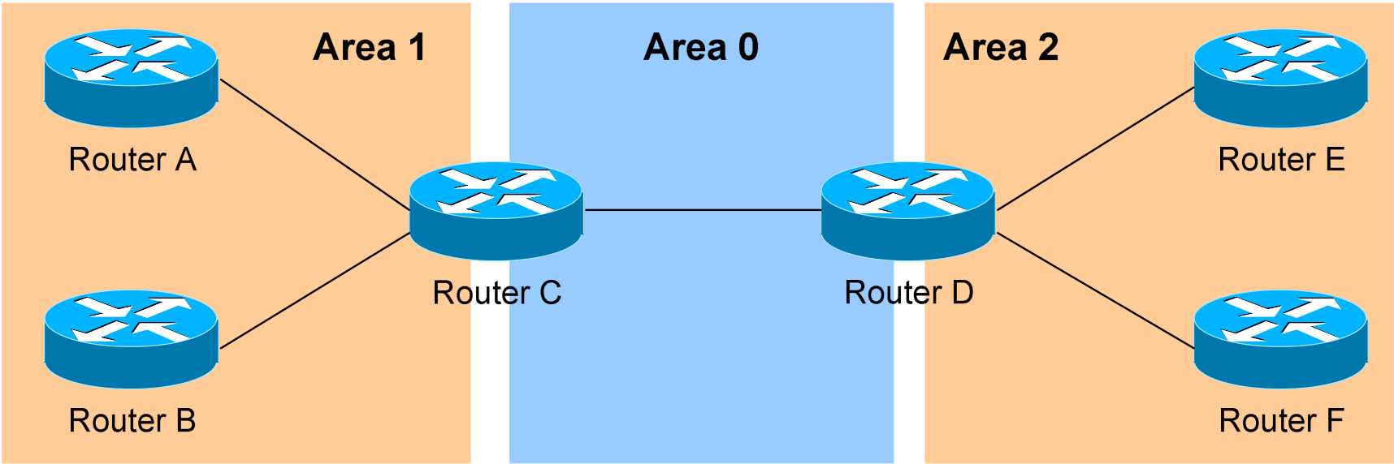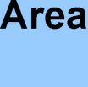

*OSPF v1.31 – Aaron Balchunas*  9

***The OSPF Hierarchy***

OSPF is a hierarchical system that separates an Autonomous System into individual **areas**. OSPF traffic can either be **intra-area** (within one area), **inter-area** (between separate areas), or **external (**from another AS).

OSPF routers build a **Topology Database** of all **links** within their area, and all routers within an area will have an *identical* topology database. Routing updates between these routers will *only* contain information about links local to their area. Limiting the topology database to include only the local area conserves bandwidth and reduces CPU loads.

**Area 0** is required for OSPF to function, and is considered the “**Backbone**” area. As a rule, all other areas must have a connection into Area 0, though this rule can be bypassed using **virtual links** (explained shortly). Area 0 is often referred to as the *transit* area to connect all other areas.

OSPF routers can belong to multiple areas, and will thus contain separate Topology databases for each area. These routers are known as **Area Border Routers (ABRs)**.

Consider the above example. Three areas exist: Area 0, Area 1, and Area 2. Area 0, again, is the backbone area for this Autonomous System. Both Area 1 and Area 2 must directly connect to Area 0.

Routers A and B belong fully to Area 1, while Routers E and F belong fully to Area 2. These are known as **Internal Routers**.

Router C belongs to both Area 0 and Area 1. Thus, it is an **ABR**. Because it has an interface in Area 0, it can also be considered a **Backbone Router**. The same can be said for Router D, as it belongs to both Area 0 and Area 2.

*\* * \**   
All original material copyright © 2007 by Aaron Balchunas (aaron@routeralley.com), unless otherwise noted. All other material copyright © of their respective owners.

This material may be copied and used freely, but may not be altered or sold without the expressed written consent of the owner of the above copyright. Updated material may be found at http://www.routeralley.com.

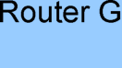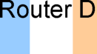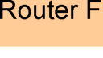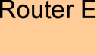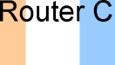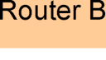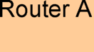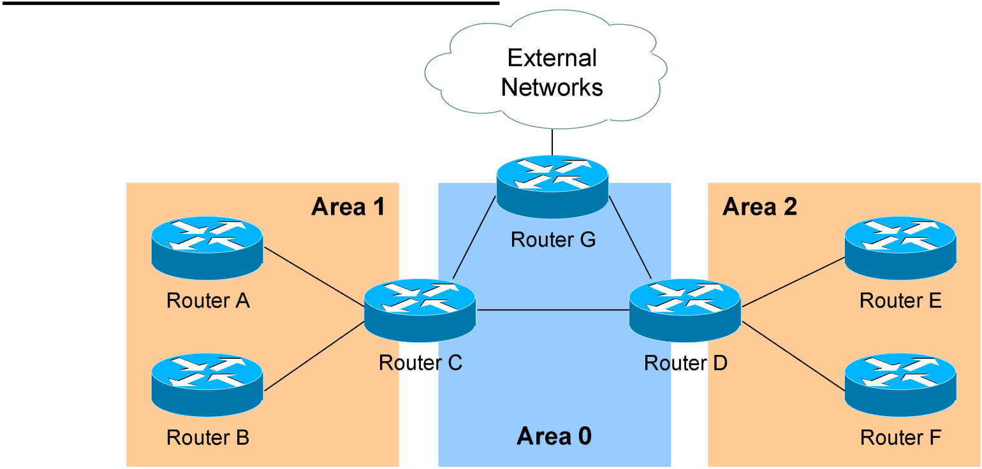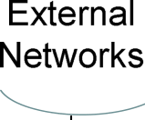

*OSPF v1.31 – Aaron Balchunas* 10

***The OSPF Hierarchy (continued)***

Now consider the above example. Router G has been added, which belongs to Area 0. However, Router G also has a connection to the Internet, which is outside this Autonomous System.

This makes Router G an **Autonomous System Border Router** (**ASBR**). A router can become an ASBR in one of two ways:   
 •By connecting to a separate Autonomous System, such as the Internet •By redistributing another routing protocol into the OSPF process.

ASBRs provide access to *external* networks. OSPF defines two “types” of external routes:   
 •**Type 2 (E2**) – Includes only the external cost to the destination network. External cost is the metric being advertised from outside the OSPF domain. This is the default type assigned to external routes. •**Type 1 (E1**) – Includes both the external cost, and the internal cost to reach the ASBR, to determine the total metric to reach the destination network. Type 1 routes are always *preferred* over Type 2 routes to the same destination.

Thus, the four separate OSPF router types are as follows:   
 •**Internal Routers –** all router interfaces belong to only one Area. •**Area Border Routers (ABRs) –** contains interfaces in at least two separate areas   
 •**Backbone Routers –** contain at least one interface in Area 0 •**Autonomous System Border Routers (ASBRs) –** contain a connection to a separate Autonomous System

*\* * \**   
All original material copyright © 2007 by Aaron Balchunas (aaron@routeralley.com), unless otherwise noted. All other material copyright © of their respective owners.

This material may be copied and used freely, but may not be altered or sold without the expressed written consent of the owner of the above copyright. Updated material may be found at http://www.routeralley.com.

*OSPF v1.31 – Aaron Balchunas* 11

***LSAs and the OSPF Topology Database***

OSPF, as a link-state routing protocol, does not rely on *routing-by-rumor* as RIP and IGRP do.

Instead, OSPF routers keep track of the status of **links** within their respective areas. A link is simply a router interface. From these lists of links and their respective statuses, the topology database is created. OSPF routers forward **link-state advertisements (LSAs)** to ensure the topology database is   
consistent on each router within an area.

Several LSA types exist:

•**Router LSA (Type 1) –** Contains a list of all links local to the router, and the status and “cost” of those links. Type 1 LSAs are generated by all routers in OSPF, and are flooded to all other routers within the local area.

•**Network LSA (Type 2) –** Generated by all Designated Routers in OSPF, and contains a list of all routers attached to the Designated Router.

•**Network Summary LSA (Type 3)** – Generated by all ABRs in OSPF, and contains a list of all destination networks within an area. Type 3 LSAs are sent between areas to allow inter-area communication to occur.

•**ASBR Summary LSA (Type 4)** – Generated by ABRs in OSPF, and contains a *route* to any ASBRs in the OSPF system. Type 4 LSAs are sent from an ABR into its local area, so that Internal routers know how to exit the Autonomous System.

•**External LSA (Type 5)** – Generated by ASBRs in OSPF, and contain routes to destination networks *outside* the local Autonomous System. Type 5 LSAs can also take the form of a **default route** to all networks outside the local AS. Type 5 LSAs are flooded to all areas in the OSPF system.

Multicast OSPF (MOSPF) utilizes a Type 6 LSA, but that goes beyond the scope of this guide.

Later in this section, **Type 7 NSSA External LSAs** will be described in detail.

*\* * \**   
All original material copyright © 2007 by Aaron Balchunas (aaron@routeralley.com), unless otherwise noted. All other material copyright © of their respective owners.

This material may be copied and used freely, but may not be altered or sold without the expressed written consent of the owner of the above copyright. Updated material may be found at http://www.routeralley.com.

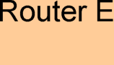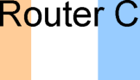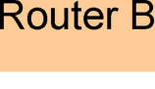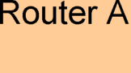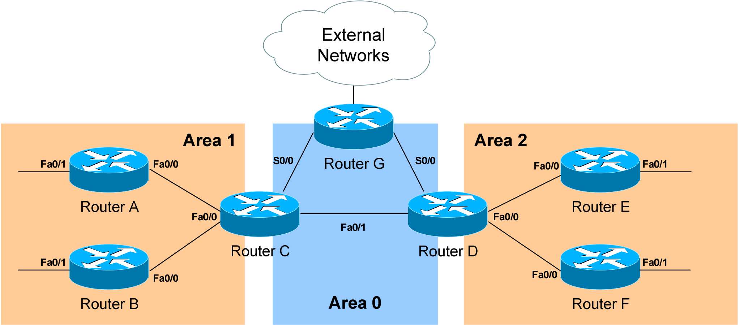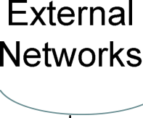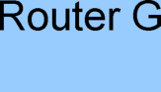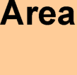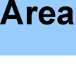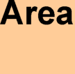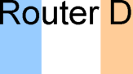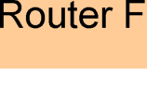

*OSPF v1.31 – Aaron Balchunas* 12

***LSAs and the OSPF Topology Database (continued)***

From the above example, the following can be determined: •Routers A, B, E, and F are **Internal Routers.**  
•Routers C and D are **ABRs.**

•Router G is an **ASBR.**

All routers will generate **Router** (**Type 1) LSAs**. For example, Router A will generate a Type 1 LSA that contains the status of links FastEthernet 0/0 and FastEthernet 0/1. This LSA will be flooded to all other routers in Area 1.

Designated Routers will generate **Network (Type 2) LSAs.** For example, if Router C was elected the DR for the multi-access network in Area 1, it would generate a Type 2 LSA containing a list of all routers attached to it.

Area Border Routers (ABRs) will generate **Network Summary (Type 3) LSAs**. For example, Router C is an ABR between Area 0 and Area 1. It will thus send Type 3 LSAs into *both* areas. Type 3 LSAs sent into Area 0 will contain a list of networks within Area 1, including **costs** to reach those networks. Type 3 LSAs sent into Area 1 will contain a list of networks within Area 0, *and* all other areas connected to Area 0. This allows Area 1 to reach any other area, and all other areas to reach Area 1.

*\* * \**   
All original material copyright © 2007 by Aaron Balchunas (aaron@routeralley.com), unless otherwise noted. All other material copyright © of their respective owners.

This material may be copied and used freely, but may not be altered or sold without the expressed written consent of the owner of the above copyright. Updated material may be found at http://www.routeralley.com.



*OSPF v1.31 – Aaron Balchunas* 13

***LSAs and the OSPF Topology Database (continued)***

ABRs will also generate **ASBR Summary (Type 4) LSAs.** For example, Router C will send Type 4 LSAs into Area 1 containing a route to the ASBR, thus providing routers in Area 1 with the path out of the   
Autonomous System.

ASBRs will generate **External (Type 5) LSAs.** For example, Router G will generate Type 5 LSAs that contain routes to network outside the AS. These Type 5 LSAs will be flooded to routers of all areas.

Each type of LSA is propagated under three circumstances: •When a new adjacency is formed.

•When a change occurs to the topology table.

•When an LSA reaches its maximum age (every **30 minutes,** by default).

Thus, though OSPF is typically recognized to only send updates when a change occurs, LSA’s are still periodically refreshed every 30 minutes.

*\* * \**   
All original material copyright © 2007 by Aaron Balchunas (aaron@routeralley.com), unless otherwise noted. All other material copyright © of their respective owners.

This material may be copied and used freely, but may not be altered or sold without the expressed written consent of the owner of the above copyright. Updated material may be found at http://www.routeralley.com.

*OSPF v1.31 – Aaron Balchunas* 14

***The OSPF Metric***

OSPF determines the best (or *shortest)* path to a destination network using a

**cost** metric, which is based on the bandwidth of interfaces. The *total* cost of

a route is the sum of all *outgoing* interface costs. Lowest cost is preferred.

Cisco applies default costs to specific interface types:

***Type***  ***Cost***

*Serial (56K) 1785*

*Serial (64K) 1562*

*T1 (1.544Mbps) 64*

*Token Ring (4Mbps) 25*

*Ethernet (10 Mbps) 10*

*Token Ring (16 Mbps)*  *6*

*Fast Ethernet*  *1*

On Serial interfaces, OSPF will use the configured *bandwidth* (measured in

Kbps) to determine the cost:

**Router(config)#** *interface s0*

**Router(config-if)#** *bandwidth 64*

The default cost of an interface can be superseded:

**Router(config)#** *interface e0*

**Router(config-if)#** *ip ospf cost 5*

Changing the cost of an interface can alter which path OSPF deems the

“shortest,” and thus should be used with great care.

To alter how OSPF calculates its default metrics for interfaces:

**Router(config)#** *router ospf 1*

**Router(config-router)#** *ospf auto-cost reference-bandwidth 100*

The above *ospf auto-cost* command has a value of *100* configured, which is

actually the default. This indicates that a 100Mbps link will have a cost of 1

(because 100/100 is 1). All other costs are based off of this. For example, the

cost of 4 Mbps Token Ring is 25 because 100/4 = 25.

*\* * \**

All original material copyright © 2007 by Aaron Balchunas (aaron@routeralley.com),

unless otherwise noted. All other material copyright © of their respective owners.

This material may be copied and used freely, but may not be altered or sold without the expressed written

consent of the owner of the above copyright. Updated material may be found at http://www.routeralley.com.

*OSPF v1.31 – Aaron Balchunas* 15

***Configuring Basic OSPF***



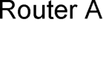 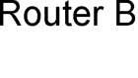

Routing protocol configuration occurs in Global Configuration mode. On Router A, to configure OSPF:

**RouterA(config)#** *router ospf 1*   
**RouterA(config-router)#** *router-id 1.1.1.1*   
**RouterA(config-router)#** *network 172.16.0.0 0.0.255.255 area 1* **RouterA(config-router)#** *network 172.17.0.0 0.0.255.255 area 0*

The first command, *router ospf 1*, enables the OSPF process. The “*1”*indicates the OSPF process ID, and can be unique on each router. The process ID allows multiple OSPF processes to run on the same router. The *router-id* command assigns a unique OSPF ID of *1.1.1.1* for this router.

Note the use of a wildcard mask instead of a subnet mask in the *network* statement. With OSPF, we’re *not* telling the router what networks to advertise; we’re telling the router to place certain interfaces into specific areas, so those routers can form neighbor relationships. The wildcard mask *0.0.255.255* tells us that the last two octets can match any number.

The first *network* statement places interface E0 on Router A into Area 1. Likewise, the second *network* statement places interface S0 on Router A into Area 0. The network statement could have been written more specifically:

**RouterA(config)#** *router ospf 1*   
**RouterA(config-router)#** *network 172.16.1.2 0.0.0.0 area 1* **RouterA(config-router)#** *network 172.17.1.1 0.0.0.0 area 0*

In order for Router B to form a neighbor relationship with Router A, its connecting interface must be put in the same Area as Router A:

**RouterB(config)#** *router ospf 1*   
**RouterA(config-router)#** *router-id 2.2.2.2*   
**RouterB(config-router)#** *network 172.17.1.2 0.0.0.0 area 0* **RouterB(config-router)#** *network 172.18.1.1 0.0.0.0 area 2*

If Router B’s S0 interface was placed in a different area than Router A’s S0 interface, the two routers would never form a neighbor relationship, and never share routing updates.

*\* * \**   
All original material copyright © 2007 by Aaron Balchunas (aaron@routeralley.com), unless otherwise noted. All other material copyright © of their respective owners.

This material may be copied and used freely, but may not be altered or sold without the expressed written consent of the owner of the above copyright. Updated material may be found at http://www.routeralley.com.

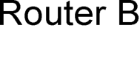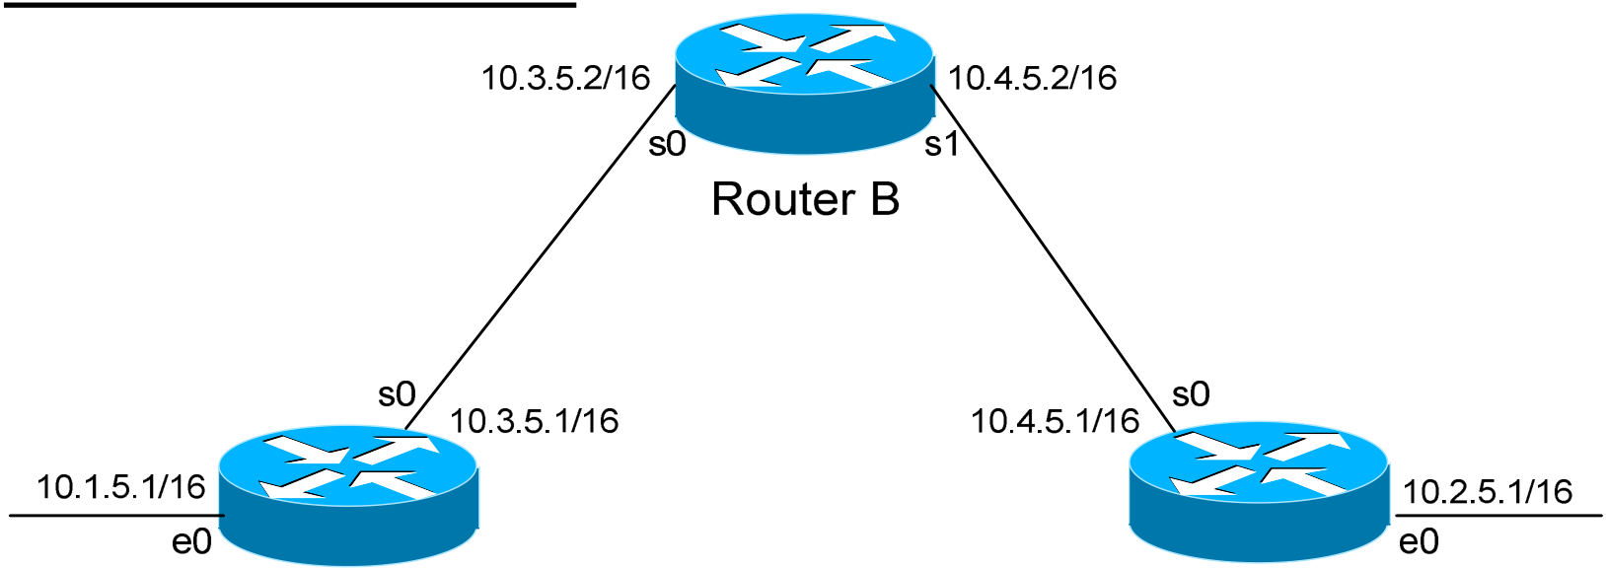

*OSPF v1.31 – Aaron Balchunas* 16

***OSPF Passive-Interfaces***

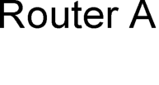 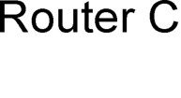

It is possible to control which router interfaces will participate in the OSPF process. Just as with EIGRP and RIP, we can use the *passive-interface* command.

**However,** please note that the *passive-interface* command works differently with OSPF than with RIP or IGRP. OSPF will no longer form neighbor relationships out of a “passive” interface, thus this command prevents updates from being *sent* or *received* out of this interface:

**RouterC(config)#** *router ospf 1*   
**RouterC(config-router)#** *network 10.4.0.0 0.0.255.255 area 0* **RouterC(config-router)#** *network 10.2.0.0 0.0.255.255 area 0* **RouterC(config-router)#** *passive-interface s0*

Router C will not form a neighbor adjacency with Router B.

It is possible to configure **all** interfaces to be passive using the *passive-interface default* command, and then individually use the *no passive-interface* command on the interfaces that neighbors **should** be formed on:

**RouterC(config)#** *router ospf 1*   
**RouterC(config-router)#** *network 10.4.0.0 0.0.255.255 area 0* **RouterC(config-router)#** *network 10.2.0.0 0.0.255.255 area 0* **RouterC(config-router)#** *passive-interface default*   
**RouterC(config-router)#** *nopassive-interface e0*

**Always remember**, that the *passive-interface* command will prevent OSPF (and EIGRP) from forming neighbor relationships out of that interface. **No** routing updates are passed in either direction.

*\* * \**   
All original material copyright © 2007 by Aaron Balchunas (aaron@routeralley.com), unless otherwise noted. All other material copyright © of their respective owners.

This material may be copied and used freely, but may not be altered or sold without the expressed written consent of the owner of the above copyright. Updated material may be found at http://www.routeralley.com.

*OSPF v1.31 – Aaron Balchunas* 17

***OSPF Authentication***



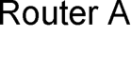 

OSPF supports authentication to secure routing updates. However, OSPF authentication is configured differently than RIP or EIGRP authentication.

Two forms of OSPF authentication exist, using either **clear-text** or an **MD5 hash.** To configure clear-text authentication, the first step is to enable authentication for the area, under the OSPF routing process:

**RouterA(config)#** *router ospf 1*   
**RouterA(config-router)#** *network 172.17.0.0 0.0.255.255 area 0* **RouterA(config-router)#** *area 0 authentication*

Then, the authentication *key* must be configured on the interface:

**RouterA(config)#** *interface s0*   
**RouterA(config-if)#** *ip ospf authentication*   
**RouterA(config-if)#** *ip ospf authentication-key MYKEY*

To configure MD5-hashed authentication, the first step is also to enable authentication for the area under the OSPF process:

**RouterA(config)#** *router ospf 1*   
**RouterA(config-router)#** *network 172.17.0.0 0.0.255.255 area 0* **RouterA(config-router)#** *area 0 authentication message-digest*

Notice the additional parameter *message-digest* included with the *area 0 authentication* command. Next, the hashed authentication key must be configured on the interface:

**RouterA(config)#** *interface s0*   
**RouterA(config-router)#** *ip ospf message-digest-key 10 md5 MYKEY*

Area authentication must be enabled on all routers in the area, and the form of authentication must be identical (clear-text or MD5). The authentication keys do *not* need to be the same on every router in the OSPF area, but must be the same on interfaces connecting two neighbors.

**Please note**: if authentication is enabled for Area 0, the same authentication must be configured on Virtual Links, as they are “extensions” of Area 0.

*\* * \**   
All original material copyright © 2007 by Aaron Balchunas (aaron@routeralley.com), unless otherwise noted. All other material copyright © of their respective owners.

This material may be copied and used freely, but may not be altered or sold without the expressed written consent of the owner of the above copyright. Updated material may be found at http://www.routeralley.com.

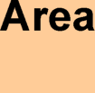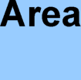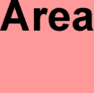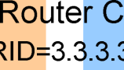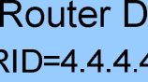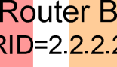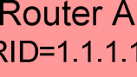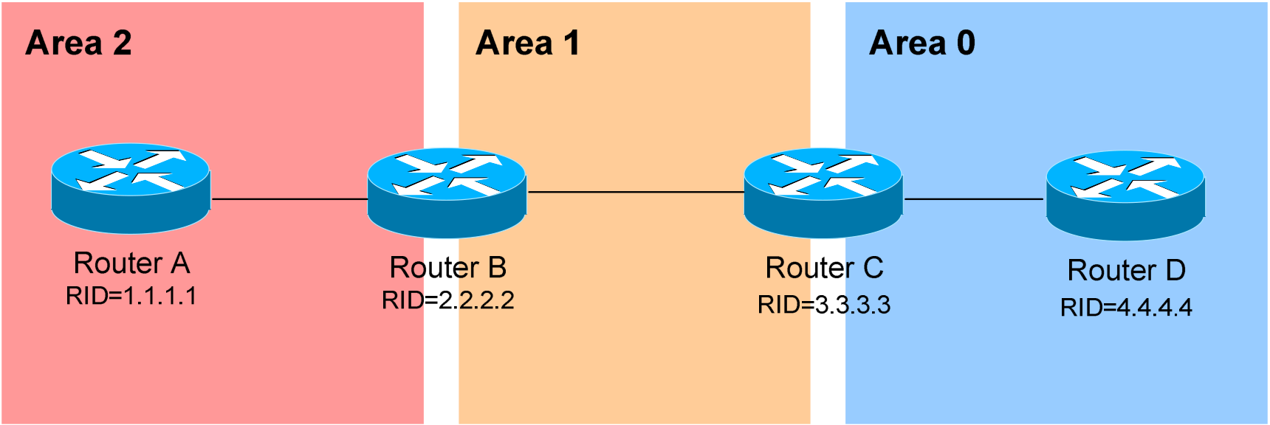

*OSPF v1.31 – Aaron Balchunas* 18

***OSPF Virtual Links***

Earlier in this guide, it was stated that all areas must directly connect into Area 0, as a rule. In the above example, Area 2 has no direct connection to Area 0, but must transit through Area 1 to reach the backbone area. In normal OSPF operation, this shouldn’t be possible.

There may be certain circumstances that may prevent an area from directly connecting into Area 0. **Virtual links** can be used as a workaround, to *logically* connect separated areas to Area 0. In the above example, a virtual link would essentially create a tunnel from Area 2 to Area 0, using Area 1 a **transitarea**. One end of the Virtual Link *must* be connected to Area 0.

Configuration occurs on the **Area Border Routers (ABRs)** connecting Area 1 to Area 2 (Router B), and Area 1 to Area 0 (Router C). Configuration on Router B would be as follows:

**RouterB(config)#** *router ospf 1*   
**RouterB(config-router)#** *router-id 2.2.2.2*   
**RouterB(config-router)#** *area 1 virtual-link 3.3.3.3*

The first command enables the *ospf* process. The second command manually sets the *router-id* for Router B to *2.2.2.2*.

The third command actually creates the *virtual-link*. Notice that it specifies *area 1*, which is the **transit area**. Finally, the command points to the remote ABR’s Router ID of *3.3.3.3*.

Configuration on Router C would be as follows:

**RouterC(config)#** *router ospf 1*   
**RouterC(config-router)#** *router-id 3.3.3.3*   
**RouterC(config-router)#** *area 1 virtual-link 2.2.2.2*

*\* * \**   
All original material copyright © 2007 by Aaron Balchunas (aaron@routeralley.com), unless otherwise noted. All other material copyright © of their respective owners.

This material may be copied and used freely, but may not be altered or sold without the expressed written consent of the owner of the above copyright. Updated material may be found at http://www.routeralley.com.

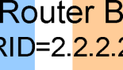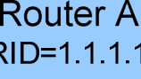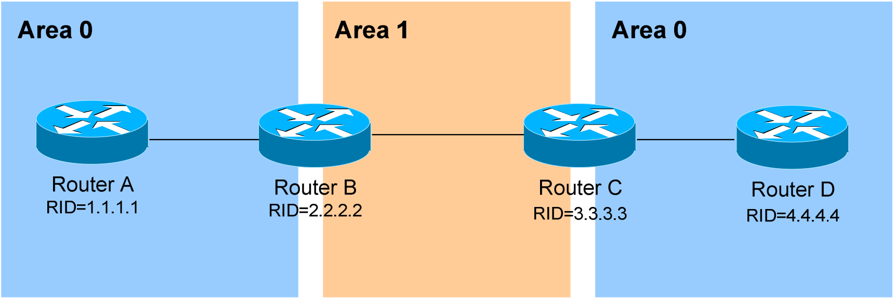

*OSPF v1.31 – Aaron Balchunas* 19

***OSPF Virtual Links (continued)***

It is also possible to have two separated (or discontiguous) Area 0’s. In order for OSPF to function properly, the two Area 0’s must be connected using a **virtual link**.

Again, configuration occurs on the transit area’s ABRs:

**RouterB(config)#** *router ospf 1*   
**RouterB(config-router)#** *router-id 2.2.2.2*   
**RouterB(config-router)#** *area 1 virtual-link 3.3.3.3*

**RouterC(config)#** *router ospf 1*   
**RouterC(config-router)#** *router-id 3.3.3.3*   
**RouterC(config-router)#** *area 1 virtual-link 2.2.2.2*

**Always remember**: the area specified in the *virtual-link* command is the **transit**area. Additionally, the transit area ***cannot***be a stub area.

As stated earlier, if authentication is enabled for Area 0, the same   
authentication must be configured on Virtual Links, as they are “extensions” of Area 0:

**RouterB(config)#** *router ospf 1*   
**RouterB(config-router)#** *area 1 virtual-link 3.3.3.3 message-digest-key 1 md5 MYKEY*

**RouterC(config)#** *router ospf 1*   
**RouterC(config-router)#** *area 1 virtual-link 2.2.2.2 message-digest-key 1 md5 MYKEY*

*\* * \**   
All original material copyright © 2007 by Aaron Balchunas (aaron@routeralley.com), unless otherwise noted. All other material copyright © of their respective owners.

This material may be copied and used freely, but may not be altered or sold without the expressed written consent of the owner of the above copyright. Updated material may be found at http://www.routeralley.com.

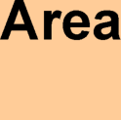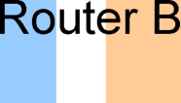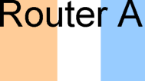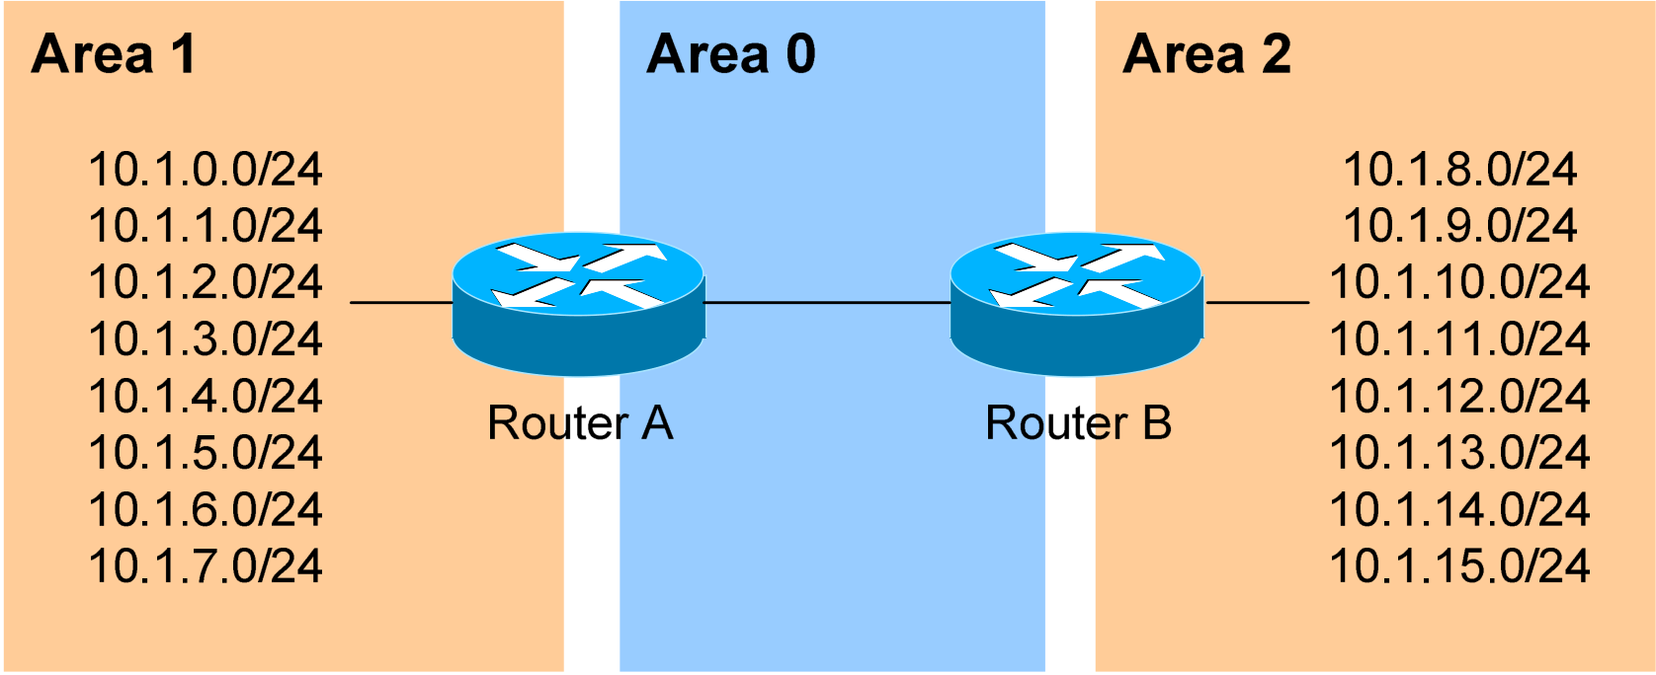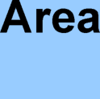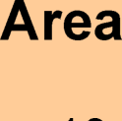

*OSPF v1.31 – Aaron Balchunas* 20

***Inter-Area OSPF Summarization***

Consider the above example. OSPF is a classless routing protocol, thus all of the listed networks would be advertised individually. This increases the size of the topology databases and routing tables on routers in the domain, and may be undesirable. Advertising *only* a summary route for inter-area   
communication can reduce the load on router CPUs.

For example, all of the networks in Area 1 can be summarized as   
**10.1.0.0/21.** Similarly, all of the networks in Area 2 can be summarized as **10.1.8.0/21.**

**Inter-area summarization** is configured on **Area Border Routers (ABRs)**. Configuration on Router A would be as follows:

**RouterA(config)#** *router ospf 1*   
**RouterA(config-router)#** *network 10.1.0.0 0.0.7.255 area 1* **RouterA(config-router)#** *area 1 range 10.1.0.0 255.255.248.0*

The *network* statement includes all of the 10.1.x.0 networks into Area 1. The *area 1 range* command creates a summary route for those networks, which is then advertised into Area 0, as opposed to each route individually.

Proper design dictates that a static route be created for the summarized network, pointing to the Null interface. This sends any traffic destined *specifically* to the summarized address to the bit-bucket in the sky, in order to prevent routing loops:

**RouterA(config)#** *ip route 10.1.0.0 255.255.248.0 null0*

In IOS versions 12.1(6) and later, this static route is created automatically.

*\* * \**   
All original material copyright © 2007 by Aaron Balchunas (aaron@routeralley.com), unless otherwise noted. All other material copyright © of their respective owners.

This material may be copied and used freely, but may not be altered or sold without the expressed written consent of the owner of the above copyright. Updated material may be found at http://www.routeralley.com.

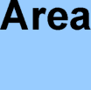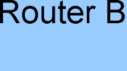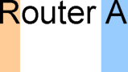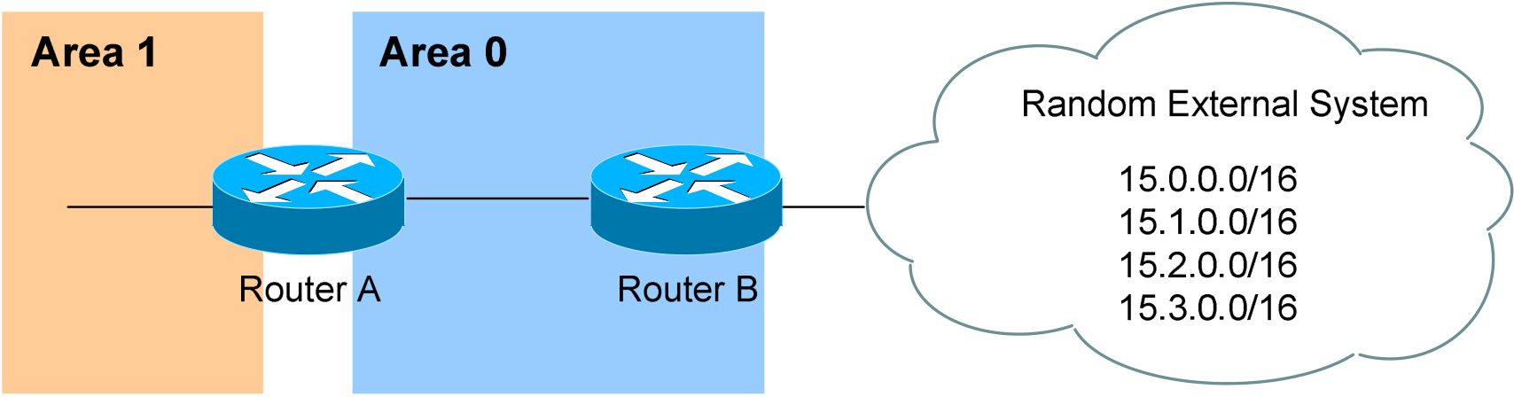

*OSPF v1.31 – Aaron Balchunas* 21

***External OSPF Summarization***

Consider the above example. Router B is an Autonomous System Border Router (ASBR). It is possible to redistribute the four “external” networks into the OSPF system. However, a separate route for each network will be advertised.

Again, this is wasteful. The four external networks can be summarized as **15.0.0.0/14**.

**External Summarization** is configured on ASBRs, and will only   
summarize external routes learned by route redistribution. Configuration on Router B would be as follows:

**RouterB(config)#** *router ospf 1*   
**RouterB(config-router)#** *summary-address 15.0.0.0 255.252.0.0*

This summarized route is now propagated to all routers in every OSPF area.

Summarization can be used to filter certain routes (true route filtering is covered in a separate guide). To force OSPF to advertise the 15.0.0.0 and 15.1.0.0 networks as a summarized route, but *not* advertise the 15.2.0.0 and 15.3.0.0 prefixes:

**RouterB(config)#** *router ospf 1*   
**RouterB(config-router)#** *summary-address 15.0.0.0 255.254.0.0*   
**RouterB(config-router)#** *summary-address 15.2.0.0 255.255.0.0 not-advertise* **RouterB(config-router)#** *summary-address 15.3.0.0 255.255.0.0 not-advertise*

The first *summary-address* command summarizes the 15.0.0.0/16 and 15.1.0.0/16 networks to 15.0.0.0/15, and advertises the summary as normal in the OSPF domain. The next two *summary-address* commands specifically reference the 15.2.0.0/16 and 15.3.0.0/16 networks, with the *not-advertise* parameter. As implied, these networks will *not* be advertised in OSPF.

*\* * \**   
All original material copyright © 2007 by Aaron Balchunas (aaron@routeralley.com), unless otherwise noted. All other material copyright © of their respective owners.

This material may be copied and used freely, but may not be altered or sold without the expressed written consent of the owner of the above copyright. Updated material may be found at http://www.routeralley.com.

*OSPF v1.31 – Aaron Balchunas* 22

***OSPF Area Types***

In order to control the propagation of LSAs in the OSPF domain, several area **types** were developed.

***Standard Area* –** A “normal” OSPF area.

•Routers within a standard area will share Router (Type 1) and Network (Type 2) LSAs to build their topology tables. Once fully synchronized, routers within an area will all have *identical*   
topology tables.

•Standard areas will accept Network Summary (Type 3) LSAs, which contain the routes to reach networks in all other areas.

•Standard areas will accept ASBR Summary (Type 4) and External (Type 5) LSAs, which contain the route to the ASBR and routes to external networks, respectively.

Configuration of standard areas is straight forward:

**Router(config)#** *router ospf 1*   
**Router(config-router)#** *network 10.1.0.0 0.0.7.255 area 1*

***Stub Area* –** Prevents external routes from flooding into an area.

•Like Standard areas, Stub area routers will share Type 1 and Type 2 LSAs to build their topology tables.

•Stub areas will also accept Type 3 LSAs to reach other areas. •Stub areas will ***not accept***Type 4 or Type 5 LSAs, detailing routes to external networks.

The purpose of Stub areas is to limit the number of LSAs flooded into the area, to conserve bandwidth and router CPUs. The Stub’s ABR will   
*automatically* inject a **default route** into the Stub area, so that those routers can reach the external networks. The ABR will be the *next-hop* for the default route.

Configuration of stub areas is relatively simple:

**Router(config)#** *router ospf 1*   
**Router(config-router)#** *network 10.1.0.0 0.0.7.255 area 1* **Router(config-router)#** *area 1 stub*

The *area 1 stub* command must be configured on **all** routers in the Stub area. No ASBRs are allowed in a Stub area.

*\* * \**   
All original material copyright © 2007 by Aaron Balchunas (aaron@routeralley.com), unless otherwise noted. All other material copyright © of their respective owners.

This material may be copied and used freely, but may not be altered or sold without the expressed written consent of the owner of the above copyright. Updated material may be found at http://www.routeralley.com.

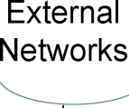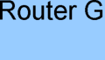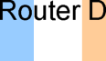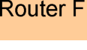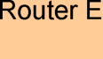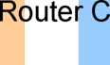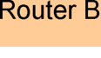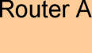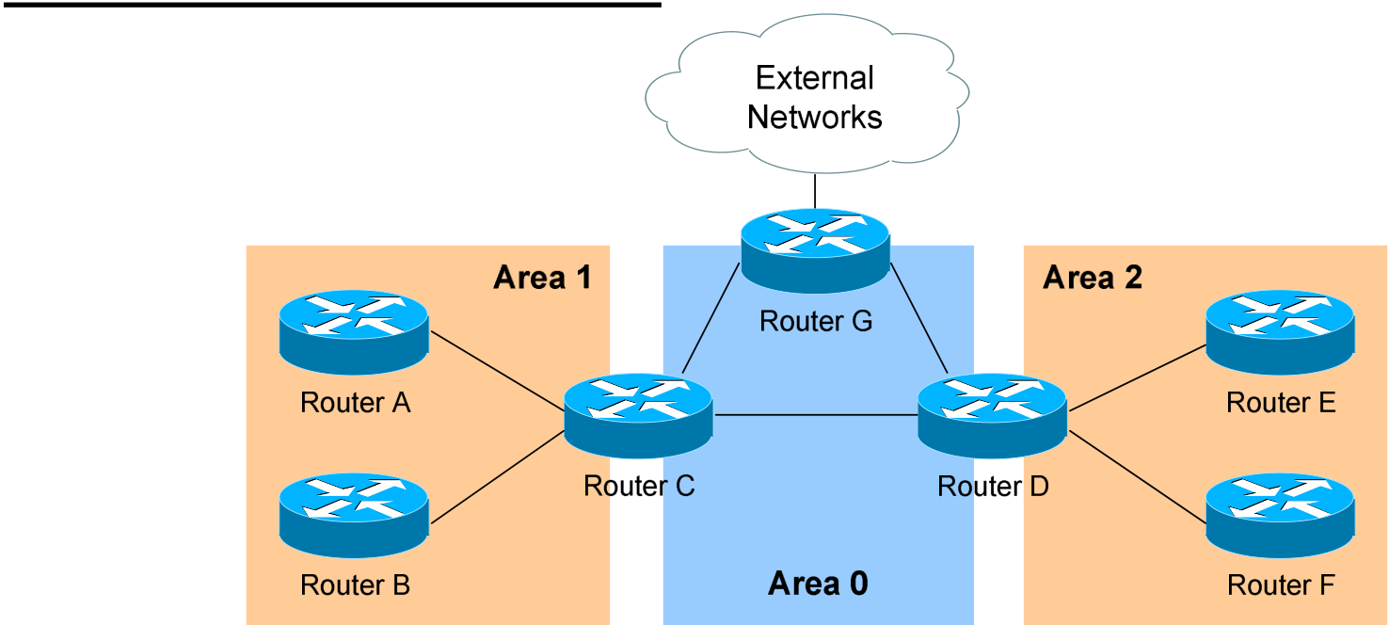

*OSPF v1.31 – Aaron Balchunas* 23

***OSPF Area Types (continued)***

***Totally Stubby Area* –** Prevents both inter-area *and* external routes from flooding into an area.

•Like Standard and Stub areas, Totally Stubby area routers will share Type 1 and Type 2 LSAs to build their topology tables.

•Totally Stubby areas will ***not accept*** Type 3 LSAs to other areas. •Totally Stubby areas will also ***not accept***Type 4 or Type 5 LSAs, detailing routes to external networks.

Again, the purpose of Totally Stubby areas is to limit the number of LSAs flooded into the area, to conserve bandwidth and router CPUs. The Stub’s ABR will instead *automatically* inject a **default route** into the Totally Stubby area, so that those routers can reach both inter-area networks and external networks. The ABR will be the *next-hop* for the default route.

Configuration of totally stubby areas is relatively simple:

**Router(config)#** *router ospf 1*   
**Router(config-router)#** *network 10.1.0.0 0.0.7.255 area 1* **Router(config-router)#** *area 1 stub no-summary*

The *area 1 stub no-summary* command is configured only on the **ABR** of the Totally Stubby area; other routers within the area are configured with the *area 1 stub* command. No ASBRs are allowed in a Totally Stubby area.

In the above example, if we were to configure Area 1 as a Totally Stubby area, it would not accept any external routes originating from the ASBR (Router G). It *also* would not accept any Type 3 LSAs containing route information about Area 0 and Area 2. Instead, Router C (the ABR) will inject a default route into Area 1, and all routers within Area 1 will use Router C as their gateway to all other networks.

*\* * \**   
All original material copyright © 2007 by Aaron Balchunas (aaron@routeralley.com), unless otherwise noted. All other material copyright © of their respective owners.

This material may be copied and used freely, but may not be altered or sold without the expressed written consent of the owner of the above copyright. Updated material may be found at http://www.routeralley.com.

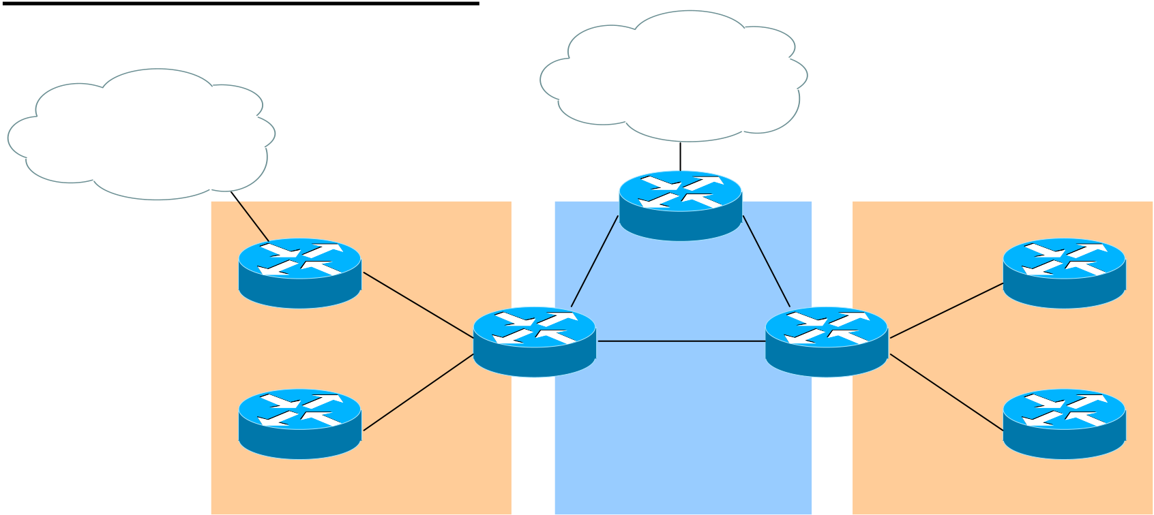

*OSPF v1.31 – Aaron Balchunas* 24

***OSPF Area Types (continued)***

External

|  |  |
| --- | --- |
| More External | Networks |

Networks

Area 1 Area 2

Router G

|  |  |  |  |  |
| --- | --- | --- | --- | --- |
| Router A | Router C | Area 0 | Router D | Router E |
| Router B | Router F |

***Not So Stubby Area (NSSA)* –** Similar to a Stub area; prevents external routes from flooding into an area, *unless* those external routes originated from an ASBR within the NSSA area.

•Like Standard and Stub areas, NSSA area routers will share Type 1 and Type 2 LSAs to build their topology tables.

•NSSA areas will also accept Network Summary (Type 3) LSAs, which contain the routes to reach networks in all other areas.

•NSSA areas will ***not accept***Type 4 or Type 5 LSAs, detailing routes to external networks.

•If an ASBR exists *within* the NSSA area, that ASBR will generate **Type 7 LSAs**.

Again, NSSA areas are almost identical to Stub areas. If Area 1 was configured as an NSSA, it would not accept any external routes originating from Router G (an ASBR *outside* Area 1).

However, Area 1 also has an ASBR *within* the area (Router A). Those external routes will be flooded into Area 1 as **Type 7 LSAs**. These external routes *will not* be forwarded to other areas as Type 7 LSAs; instead, they will be converted into Type 5 LSAs by Area 1’s ABR (Router C).

Configuration of NSSA areas is relatively simple:

**Router(config)#** *router ospf 1*   
**Router(config-router)#** *network 10.1.0.0 0.0.7.255 area 1* **Router(config-router)#** *area 1 nssa*

The *area 1 nssa* command must be applied to **all** routers in the NSSA area.

*\* * \**   
All original material copyright © 2007 by Aaron Balchunas (aaron@routeralley.com), unless otherwise noted. All other material copyright © of their respective owners.

This material may be copied and used freely, but may not be altered or sold without the expressed written consent of the owner of the above copyright. Updated material may be found at http://www.routeralley.com.



*OSPF v1.31 – Aaron Balchunas* 25

***OSPF Area Types (continued)***

External

|  |  |
| --- | --- |
| More External | Networks |

Networks

Area 1 Area 2

Router G

|  |  |  |  |  |
| --- | --- | --- | --- | --- |
| Router A | Router C | Area 0 | Router D | Router E |
| Router B | Router F |

***Totally Not So Stubby Area (TNSSA)* –** Similar to a Totally Stubby area; prevents both inter-area *and* external routes from flooding into an area, *unless* those external routes originated from an ASBR within the NSSA area.

•Like Standard and Stub areas, TNSSA area routers will share Type 1 and Type 2 LSAs to build their topology tables.

•TNSSA areas will ***not accept*** Type 3 LSAs to other areas.

•TNSSA areas will ***not accept***Type 4 or Type 5 LSAs, detailing routes to external networks.

•If an ASBR exists *within* the TNSSA area, that ASBR will generate **Type 7 LSAs**.

With the exception of not accepting inter-area routes, TNSSA areas are identical in function to NSSA areas.

Configuration of TNSSA areas is relatively simple:

**Router(config)#** *router ospf 1*   
**Router(config-router)#** *network 10.1.0.0 0.0.7.255 area 1* **Router(config-router)#** *area 1 nssa no-summary*

The *area 1 nssa no-summary* command is configured only on the **ABR** of the TNSSA area; other routers within the area are configured with the *area 1 nssa* command.

*\* * \**   
All original material copyright © 2007 by Aaron Balchunas (aaron@routeralley.com), unless otherwise noted. All other material copyright © of their respective owners.

This material may be copied and used freely, but may not be altered or sold without the expressed written consent of the owner of the above copyright. Updated material may be found at http://www.routeralley.com.

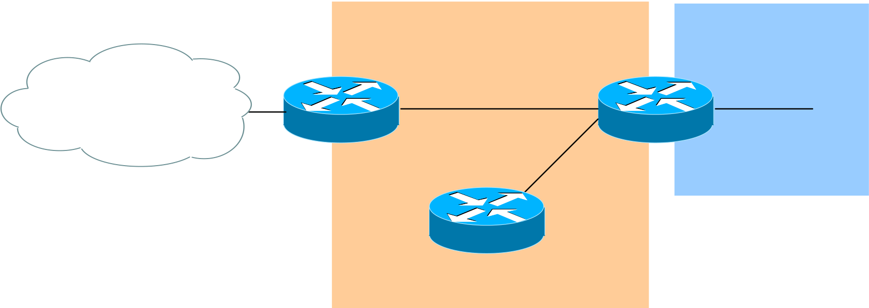

*OSPF v1.31 – Aaron Balchunas* 26

***OSPF and Default Routes***

We have learned about four types of OSPF areas:   
 •*Standard areas* •*Totally Stubby areas*   
 •*Stub areas* •*Not So Stubby areas (NSSA)*

The ABRs and ASBRs of **Standard areas***do not* automatically generate (or inject) default routes into the area. Consider the following example:

Area 1 Area 0

External   
Networks

Router A Router C

Router B

Assume that Area 1 is configured as a Standard area. Router C will forward Type 3 LSAs from all other areas into Area 1, allowing Router A and Router B to reach inter-area networks.

Notice also that Router A is an ASBR, connecting to an external   
Autonomous System. Thus, Router A will generate Type 5 LSAs, detailing the routes to these external networks.

To additionally force Router A to generate a **default route (**indicating itself as the next hop) for the external networks, and inject this into Area 1. This default route will be advertised as a Type 5 LSA to all other areas:

**RouterA(config)#** *router ospf 1*   
**RouterA(config-router)#** *default-information originate*

Router A *must* have a default route in its routing table in order for the above command to function. Router A’s default route would point to some   
upstream router in the external Autonomous System.

If a default route *does not* exist in its routing table, Router A can still be forced to advertise a default route using the *always* parameter:

**RouterA(config)#** *router ospf 1*   
**RouterA(config-router)#** *default-information originate always*

*\* * \**   
All original material copyright © 2007 by Aaron Balchunas (aaron@routeralley.com), unless otherwise noted. All other material copyright © of their respective owners.

This material may be copied and used freely, but may not be altered or sold without the expressed written consent of the owner of the above copyright. Updated material may be found at http://www.routeralley.com.

*OSPF v1.31 – Aaron Balchunas* 27

***OSPF and Default Routes (continued)***

The ABRs of **Stub***and* **Totally Stubby** areas *automatically* generate (and inject) a **default route (0.0.0.0/0)** into the area. Routers in Stub areas use this default route to reach *external* networks, while routers in Totally Stubby areas use the default route to reach both *inter-area* and *external* networks.

To control the “cost” metric of the default route in Stub or Totally Stubby areas (configured on the ABR):

**Router(config)#** *router ospf 1*   
**Router(config-router)#** *area 1 stub*   
**Router(config-router)#** *area 1 default-cost 10*

The ABRs of **NSSA areas** must be *manually configured* to generate (and inject) a default route into the area:

**Router(config)#** *router ospf 1*   
**Router(config-router)#** *area 1 nssa default-information-originate*

Additionally, the ASBR of an NSSA area can generate and inject a default route. This default route will be advertised as a Type 7 LSA, as Type 5 LSA’s are not allowed in NSSAs. The command is no different than injecting a default route from an NSSA ABR:

**Router(config)#** *router ospf 1*   
**Router(config-router)#** *area 1 nssa default-information-originate*

Reference: (*http://www.cisco.com/en/US/tech/tk365/technologies_tech_note09186a0080094a74.shtml)*

*\* * \**   
All original material copyright © 2007 by Aaron Balchunas (aaron@routeralley.com), unless otherwise noted. All other material copyright © of their respective owners.

This material may be copied and used freely, but may not be altered or sold without the expressed written consent of the owner of the above copyright. Updated material may be found at http://www.routeralley.com.

*OSPF v1.31 – Aaron Balchunas* 28

***OSPF SPF Timers***

To adjust the SPF timers in OSPF:

**Router(config)#** *router ospf 1*   
**Router(config-router)#** *timers spf 10 15*

The *timers spf* command includes two parameters, measured in **seconds**. The first (*10*) indicates the SPF-Delay, or how long the OSPF should wait after receiving a topology change to recalculate the shortest path. The second (*15*) indicates the SPF-Holdtime, or how long OSPF should wait *in between* separate SPF calculations.

The *timers spf* command has actually become deprecated. It has been replaced with:

**Router(config)#** *router ospf 1*   
**Router(config-router)#** *timers throttle spf 5 10000 80000*

The *timers throttle spf* command includes three parameters, measure in **milliseconds.** The first *(5)* indicates how long OSPF should wait after receiving a topology change to recalculate the shortest path. The second *(10000)* indicates the hold-down time, or how long OSPF should wait *in between* separate SPF calculations. If OSPF receives another topology change during the hold-time interval, it will continue to *double* the hold-time interval until it reaches the maximum hold-time *(80000*).

The purpose of the both SPF timer commands is to prevent OSPF from constantly converging, if the network links are “flapping.” The *timers spf* and *timers throttle spf* commands cannot be used together.

*\* * \**   
All original material copyright © 2007 by Aaron Balchunas (aaron@routeralley.com), unless otherwise noted. All other material copyright © of their respective owners.

This material may be copied and used freely, but may not be altered or sold without the expressed written consent of the owner of the above copyright. Updated material may be found at http://www.routeralley.com.

*OSPF v1.31 – Aaron Balchunas* 29

***Advanced OSPF Configuration***

To force the OSPF process to ignore OSPF Multicast (Type 6) LSAs:

**Router(config)#** *router ospf 1*   
**Router(config-router)#** *ignore lsa mospf*

To force an interface to filter all outgoing OSPF LSA’s:

**Router(config)#** *interface e0*   
**Router(config-if)#** *ip ospf database-filter all out*

Loopback interfaces are treated differently than other interfaces, when advertised in OSPF. OSPF will advertise a loopback interface as a specific “host” route (with a mask of /32 or 255.255.255.255). To force OSPF to advertise a loopback interface with its proper subnet mask:

**Router(config)#** *interface loopback0*   
**Router(config-if)#** *ip address 10.50.5.1 255.255.255.0* **Router(config-if)#** *ip ospf network point-to-point*

*\* * \**   
All original material copyright © 2007 by Aaron Balchunas (aaron@routeralley.com), unless otherwise noted. All other material copyright © of their respective owners.

This material may be copied and used freely, but may not be altered or sold without the expressed written consent of the owner of the above copyright. Updated material may be found at http://www.routeralley.com.

*OSPF v1.31 – Aaron Balchunas* 30

***Troubleshooting OSPF***

To view the OSPF Neighbor Table:

**Router#** *show ip ospf neighbor*

Neighbor ID Pri State Dead Time Address Interface

7.7.7.7 1 FULL/ - 00:00:36 150.50.17.2 Serial0

6.6.6.6 1 FULL/DR 00:00:11 150.50.18.1 Ethernet0

The Neighbor Table provides the following information about each

neighbor:

•The ***Router ID*** of the remote neighbor.

•The OSPF ***priority*** of the remote neighbor (used for DR/BDR

elections).

•The current neighbor ***state***.

•The ***dead interval*** timer.

•The connecting ***IP address***of the remote neighbor.

•The local ***interface*** connecting to the remote neighbor.

To view the OSPF topology table:

**Router#** *show ip ospf database*

OSPF Router with ID (9.9.9.9) (Process ID 10)

Router Link States (Area 0)

|  |  |  |
| --- | --- | --- |
| Link ID | ADV Router Age Seq# | Checksum Link count |

7.7.7.7 7.7.7.7 329 0x80000007 0x42A0 2

|  |  |  |
| --- | --- | --- |
| 8.8.8.8 | 8.8.8.8 | 291 0x80000007 0x9FFC 1 |

Summary Net Link States (Area 0)

|  |  |  |
| --- | --- | --- |
| Link ID | ADV Router Age Seq# | Checksum |

192.168.12.0 7.7.7.7 103 0x80000005 0x13E4

192.168.34.0 7.7.7.7 105 0x80000003 0x345A

The Topology Table provides the following information:

•The actual ***link*** (or *route*).

•The ***advertising*** Router ID.

•The link-state ***age*** timer.

•The ***sequence number*** and ***checksum*** for each entry.

(Reference: http://www.cisco.com/en/US/products/sw/iosswrel/ps5187/products_command_reference_chapter09186a008017d02e.html)

*\* * \**

All original material copyright © 2007 by Aaron Balchunas (aaron@routeralley.com),

unless otherwise noted. All other material copyright © of their respective owners.

This material may be copied and used freely, but may not be altered or sold without the expressed written

consent of the owner of the above copyright. Updated material may be found at http://www.routeralley.com.

*OSPF v1.31 – Aaron Balchunas* 31

***Troubleshooting OSPF (continued)***

To view the specific information about an OSPF process:

**Router#** *show ip ospf 1*

Routing Process "ospf 1" with ID 9.9.9.9   
 Supports only single TOS(TOS0) routes   
 Supports opaque LSA   
 SPF schedule delay 5 secs, Hold time between two SPFs 10 secs Minimum LSA interval 5 secs. Minimum LSA arrival 1 secs Number of external LSA 0. Checksum Sum 0x0   
 Number of opaque AS LSA 0. Checksum Sum 0x0   
 Number of DCbitless external and opaque AS LSA 0   
 Number of DoNotAge external and opaque AS LSA 0   
 Number of areas in this router is 1. 1 normal 0 stub 0 nssa   
 External flood list length 0   
 Area BACKBONE(0)   
 Number of interfaces in this area is 1   
 Area has no authentication   
 SPF algorithm executed 3 times   
 Area ranges are   
 Number of LSA 2. Checksum Sum 0xDDEC   
 Number of opaque link LSA 0. Checksum Sum 0x0   
 Number of DCbitless LSA 0   
 Number of indication LSA 0   
 Number of DoNotAge LSA 0   
 Flood list length 0

The *show ip ospf* command provides the following information: •The local ***Router ID.***

•***SPF Scheduling*** information, and various ***SPF timers.***

•The number of ***interfaces*** in specific ***areas***, including the ***type***of area. •The link-state ***age*** timer.

•The ***sequence number*** and ***checksum*** for each entry.

*\* * \**   
All original material copyright © 2007 by Aaron Balchunas (aaron@routeralley.com), unless otherwise noted. All other material copyright © of their respective owners.

This material may be copied and used freely, but may not be altered or sold without the expressed written consent of the owner of the above copyright. Updated material may be found at http://www.routeralley.com.

*OSPF v1.31 – Aaron Balchunas* 32

***Troubleshooting OSPF (continued)***

To view OSPF-specific information on an interface:

**Router#** *show ip ospf interface s0*

Serial0 is up, line protocol is up   
 Internet Address 192.168.79.2/24, Area 0   
 Process ID 10, Router ID 9.9.9.9, Network Type POINT_TO_POINT, Cost: 64 Transmit Delay is 1 sec, State POINT_TO_POINT,   
 Timer intervals configured, Hello 10, Dead 40, Wait 40, Retransmit 5   
 Hello due in 00:00:04   
 Index 1/1, flood queue length 0   
 Next 0x0(0)/0x0(0)   
 Last flood scan length is 1, maximum is 1   
 Last flood scan time is 0 msec, maximum is 0 msec   
 Neighbor Count is 1, Adjacent neighbor count is 1   
 Adjacent with neighbor 7.7.7.7   
 Suppress hello for 0 neighbor(s)

The *show ip ospfinterface* command provides the following information: •The local ***Router ID***.

•The interface ***network type***.

•The OSPF ***cost*** for the interface.

•The interface ***Hello*** and***Dead***timers*.*  
•A list of neighbor ***adjacencies***.

To view routing protocol specific information for OSPF:

**Router#** *show ip protocols*

Routing Protocol is “ospf 10"   
 Invalid after 0 seconds, hold down 0, flushed after 0 Outgoing update filter list for all interfaces is Incoming update filter list for all interfaces is Routing for Networks:   
 192.168.79.0 0.0.0.255 area 0   
 192.168.109.0 0.0.0.255 area 0   
 Routing Information Sources:   
 Gateway Distance Last Update   
 7.7.7.7 110 00:01:05   
 Distance: (default is 110)

The *show ip protocols* command provides the following information: •Locally originated ***networks*** that are being advertised.

•Neighboring ***sources*** for routing information   
•The ***administrative distance*** of neighboring sources.

*\* * \**   
All original material copyright © 2007 by Aaron Balchunas (aaron@routeralley.com), unless otherwise noted. All other material copyright © of their respective owners.

This material may be copied and used freely, but may not be altered or sold without the expressed written consent of the owner of the above copyright. Updated material may be found at http://www.routeralley.com.

*OSPF v1.31 – Aaron Balchunas* 33

***Troubleshooting OSPF (continued)***   
To reset an OSPF process, including neighbor adjacencies: **Router#** *clear ip ospf process*

To display information about OSPF virtual-links: **Router#** *show ip ospf virtual-links*

To display routes to both ABRs and ASBRs: **Router#** *show ip ospf border-routers*

To debug OSPF in realtime:   
**Router#** *debug ip ospf adj*   
**Router#** *debug ip ospf events*   
**Router#** *debug ip ospf hello*

*\* * \**   
All original material copyright © 2007 by Aaron Balchunas (aaron@routeralley.com), unless otherwise noted. All other material copyright © of their respective owners.

This material may be copied and used freely, but may not be altered or sold without the expressed written consent of the owner of the above copyright. Updated material may be found at http://www.routeralley.com.