1. **Check Device connected using Wi-Fi ports.**

Home>WLAN Devices: To check users connected using Wi-Fi. WAN Device list will be shown with assigned IP address & MAC address.

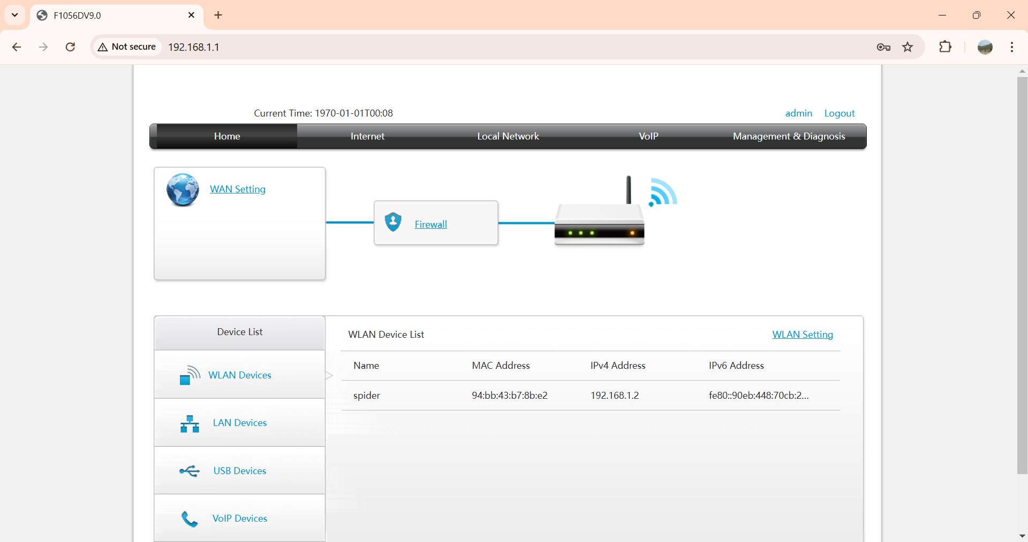

1. **Check Device connected using LAN ports.**

Home>LAN Devices: To check users connected using LAN ports of ONT. Devices will be shown along with MAC & IP addresses.

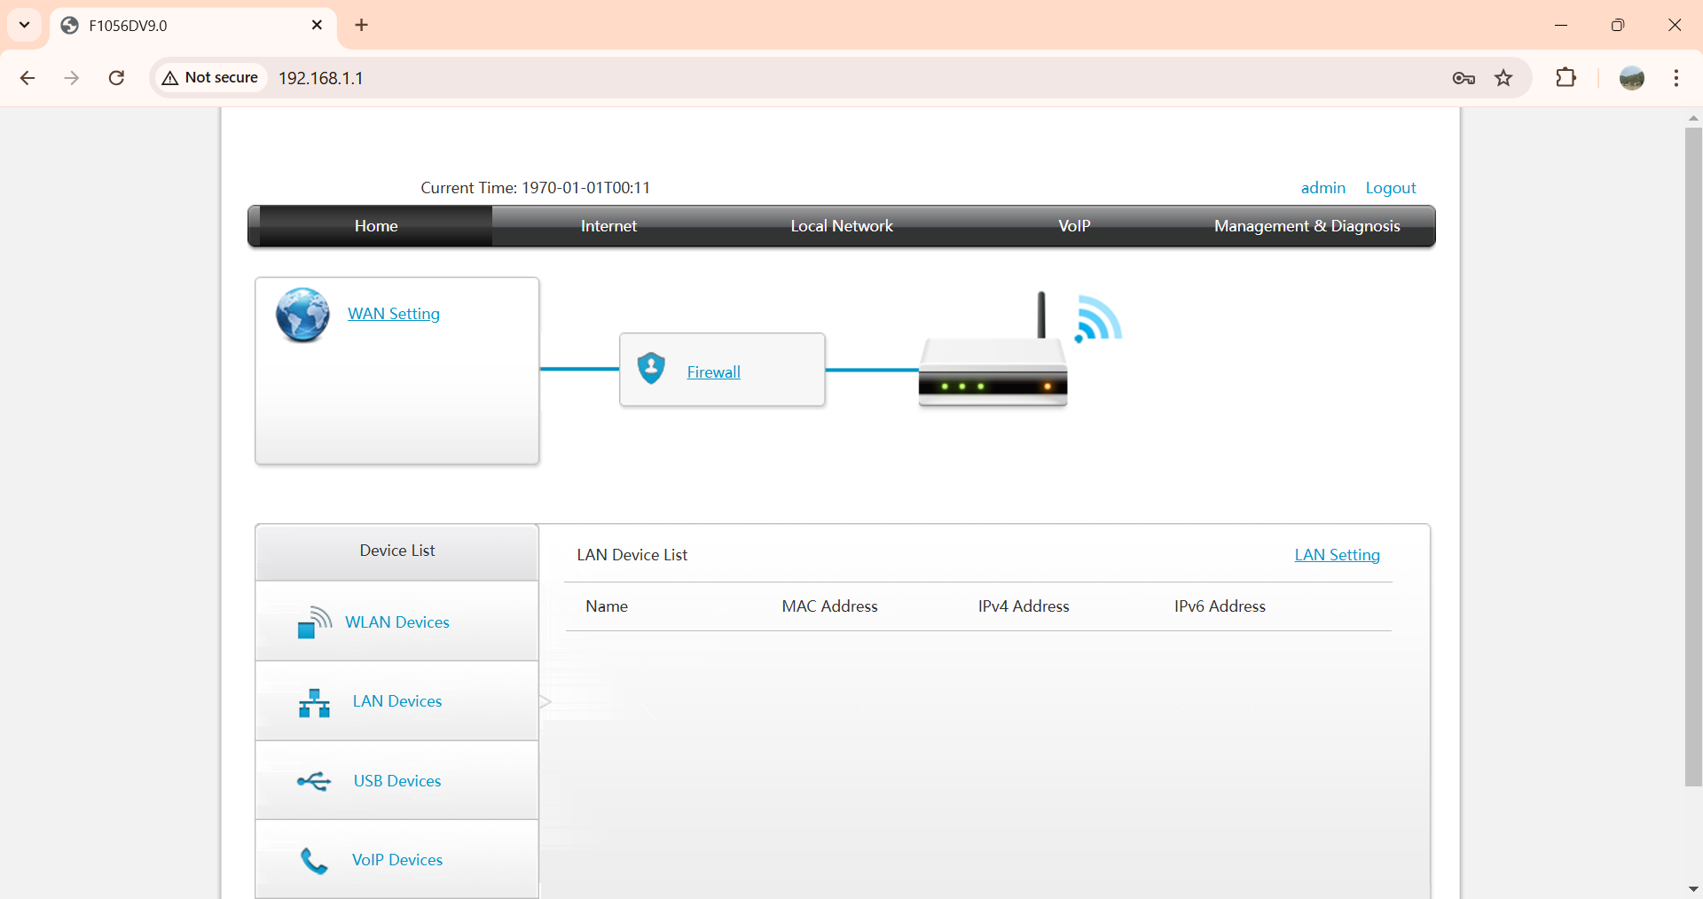

1. **Enabling MAC binding for specific devices for WLAN(Wi-Fi)**
2. **Check which SSID in ON:**

Local Network>WLAN>WLAN Basic>WLAN SSID Configuration: Check which SSIDs are enabled and go for next step.

1. 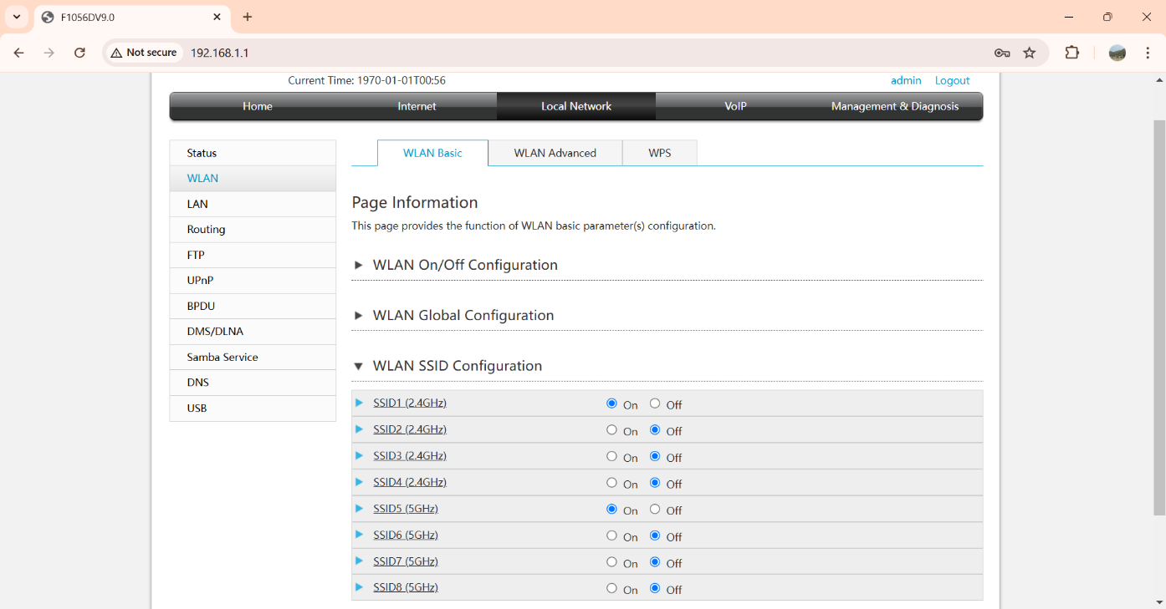**Change Access Control-Mode to “white list”**

Local Network>WLAN>WLAN Advanced>Access Control-Mode Configuration: Click on “White list” of each enabled SSIDs then click on “Apply”.

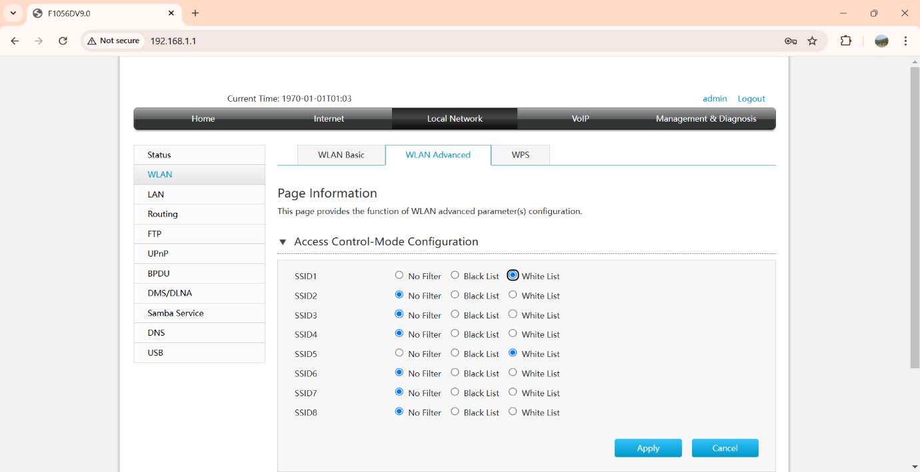

1. **Bind MAC for whitelisting and allowing**

Local Network>WLAN>WLAN Advanced>Access Control-Rule Configuration: Set the Device name, Select the enabled SSID then enter the MAC address of house hold devices and click on “Apply”. Click on “Create new item” to add more devices.

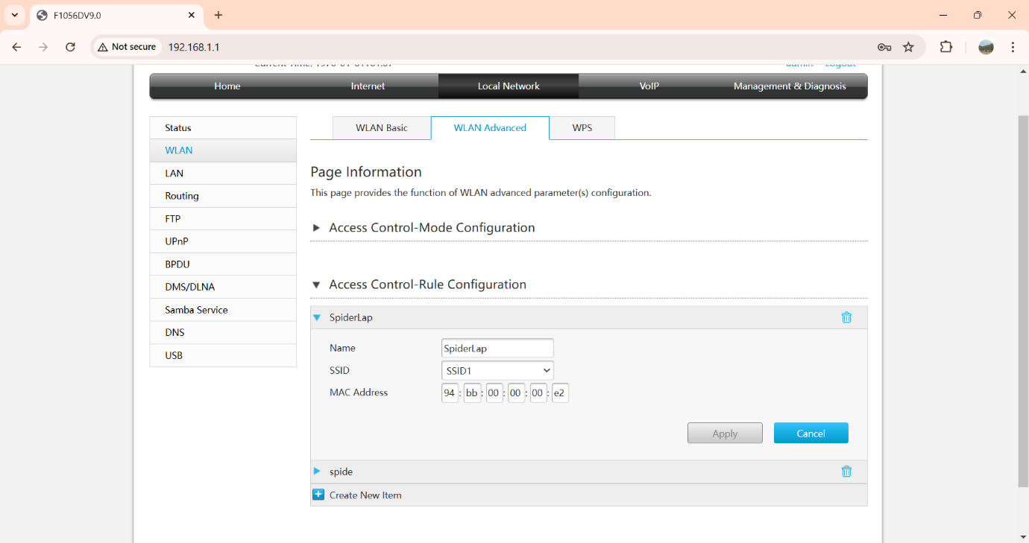 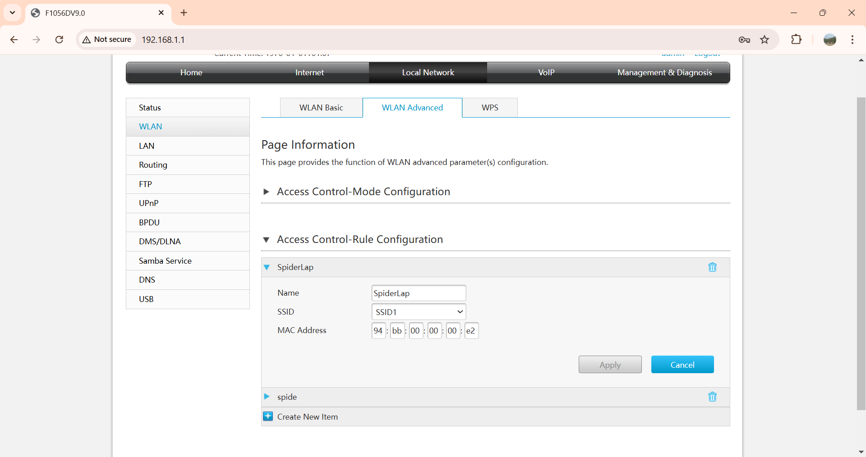

1. **Changing the ONT login password.**

Management & Diagnosis>Account Management>Admin Account management: Enter OLD password then enter new password then click on apply.

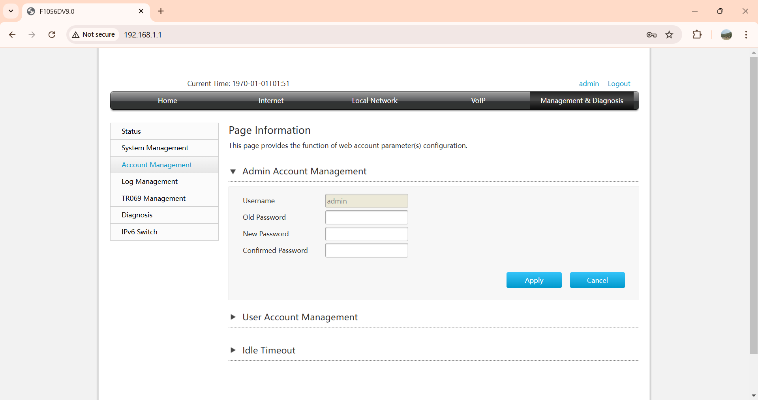

1. **Check Previously connected devices**Local Network>LAN>IPv4>Allocated Address (DHCP):Here all devices will be shown which have been connected. Device details will be visible for 24Hrs only.

